Berewick Alphabet Soup

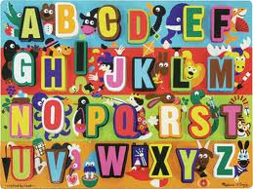

A guide to understanding all the terms we use at Berewick Elementary School.

Developed by:
Catherine Stovcsik
Linda Schultz
Erin Pugh

2012-2013

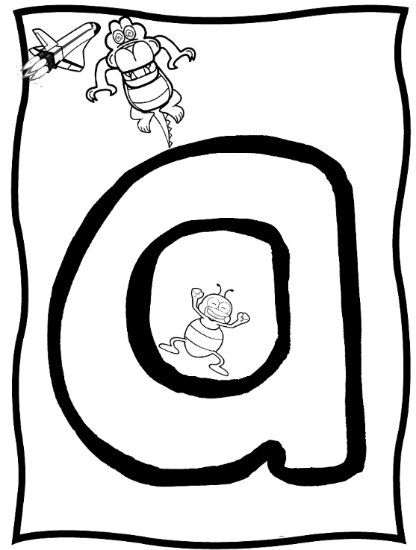
ASEP - After School Enrichment Program | The after-school program offered at many CMS schools.
Assessments | Tools teachers use to gauge student progress. These may be teacher observations, paper and pencil, computerized assessments, etc.
Awards Day | A day held each quarter to recognize the academic achievement of Berewick students. Awards are typically given for Mastery Level Achievement (A, A/B Honor Roll), Reading, Writing, Math, etc. Parents are invited and encouraged to attend these awards days.
AYP - Adequate Yearly Progress | A standard for student learning calculated each year. AYP was established under the No Child Left Behind Act, but it is calculated differently in each state. In North Carolina, student results on state-required tests are used to calculate whether schools and groups of students have made Adequate Yearly Progress.
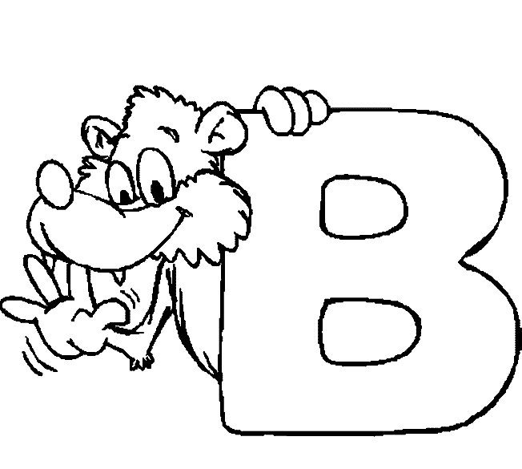
Balanced Literacy | Balanced Literacy incorporates word work, guided reading, writing, and independent reading throughout the school day.
Beginner’s Day/Night | An afternoon or evening event for Rising Kindergartners and their parents. Classroom visits, information on the coming year, and helpful transition tips are shared during this event.
Benchmark Books | These are assessments used by teachers to determine a student’s guided reading level. Teachers will have the child read the book, while listening for their fluency on a running record (reading along with the student); when finished reading the book, the teacher will ask the child some questions to determine their understanding (comprehension) of the book.
BES – Berewick Elementary School  http://schools.cms.k12.nc.us/berewickES/Pages/Default.aspx | Opened on August 25, 2009. Berewick is one of 88 elementary schools in the school district and one of 5 elementary schools in the Steele Creek area.
Blue Cards | These are cards that are kept in the office. They have emergency information for your child. EVERY STUDENT IS REQUIRED TO HAVE AN UPDATED BLUE CARD.
Bobcats | Berewick Elementary School Mascot
Book Fair | Held twice a year (fall & spring), the Book Fair is a week-long event of the PTA to raise funds for resources in the school. Scholastic Books and other items are displayed in the Media Center (library) for purchase.

Camp Invention | A science summer camp where your child becomes a scientist. Typically held at Berewick and other school locations.
Carnival | The spring PTA event held to celebrate the school and the community.
Character Education | Character Education in the Charlotte-Mecklenburg Schools is a partnership with parents and the community to foster honest, responsible and caring students. Each school integrates character education into three main areas: Academic Environment: established rules and procedures promote a productive, civil and safe school; Curriculum and Instruction: Character traits are integrated into the classroom lessons to promote understanding and decision making skills; and Service Learning: Students are involved in acts of service to help them develop a sense of responsibility and concern for the well being of others. It is through these "hands on" academic experiences that students reflect and learn how their actions can make a difference.
Clubs | Clubs at Berewick Elementary are extra-curricular activities offered after the school day ends. Clubs cover a variety of interests including Chess, Scrapbooking, Knitting, Book Club, Chorus and other hobbies. Clubs are typically available to students in 3rd – 5th grades.
CMS - Charlotte Mecklenburg Schools  http://www.cms.k12.nc.us/Pages/Default.aspx | The school district of the Charlotte-Mecklenburg metro area. The district consists of 159 and serves over 140,000 students.
Common Core Standards (CCSS) http://www.corestandards.org/ | These are the new academic standards used to guide instruction this year. Additional information will be provided to parents throughout the year. Read about and see the standards by visiting the website.
Cumulative Folder (cum) | This folder stays in a locked room at the school. It contains all pertinent information about each child and travels with the student if they transfer schools.
Curriculum Night | Typically held within the first 2 weeks of school, this event covers general information for the year as well as the opportunity to visit their child’s class and learn about the curriculum for the coming school year.


Developmentally Appropriate | This is a term many teachers use to describe classroom practices that are a good match for your child’s age and ability.
Differentiation | This is an instructional strategy in which the teacher matches instruction to students’ needs.

EC - Exceptional Children | A designation used for students with developmental, learning or other disabilities. These students are provided an IEP, outlining their education plan.
EOG - End of Grade tests | These are tests required by the state of North Carolina for students in grades three, four and five in reading, writing and math, as well as science in grade five. They are given at the end of each school year and measure a student’s progress during that year. All elementary students in those grades take the End-of-Grade tests, unless they qualify for an alternate kind of test. Alternate tests measure the same subject areas, but make accommodations for specific learning disabilities or other special needs of some students.
ESL - English as a Second Language | A teaching program used for students whose native language is not English.
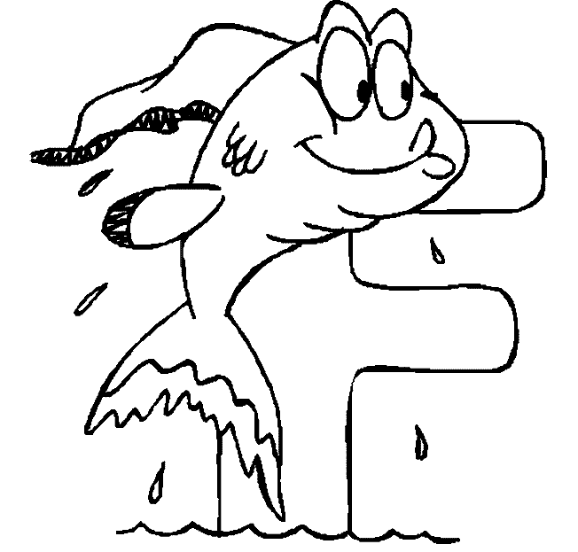
Formative Assessments | These can take many forms. Teachers will create formative assessments to determine student progress towards end of grade objectives. At times, the district will provide formative assessments that all students must take to determine the same goals.
Facilitator | There are two facilitators at Berewick. They are a part of the administrative team and work in the front office. They provide support to teachers and staff at our school, as well as create programs for parents.

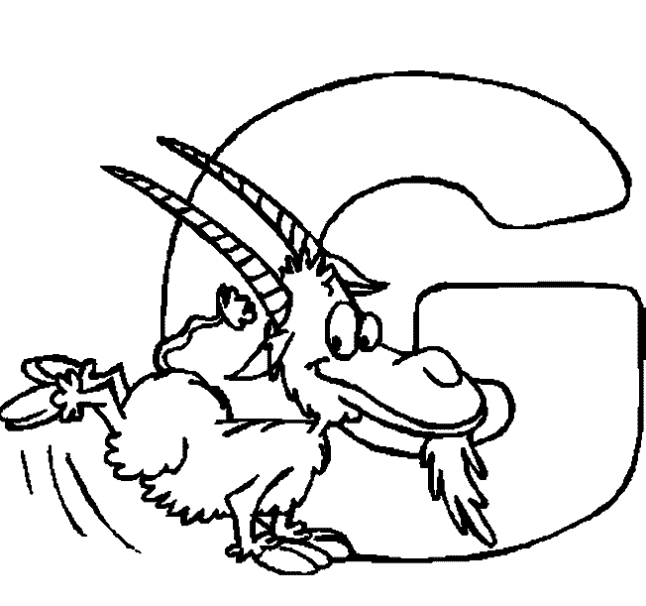
GOTR – Girls on the Run  http://gotrcharlotte.org | Girls on the Run is a life-changing, experiential learning program for girls age eight to thirteen years old (Grades 3-5). The programs combine training for a 3.1 mile running event with self-esteem enhancing, uplifting workouts. The goals of the programs are to encourage positive emotional, social, mental, spiritual and physical development. The objective of Girls on the Run is to educate and empower girls at an early age in order to prevent the display of at-risk activities in the future.
Grading Scale | CMS & Berewick Elementary utilize two grading scales – one for Kindergarten – 2nd grade and one for 3rd grade – 5th grade:  K -2nd  3 – Consistently meets grade level expectations  2 – Inconsistently meets grade-level expectations  1 – Does not yet meet grade-level expectations  3rd-5th  A 100-93 D 76-70  B 92-85 F Below 70, Failing  C 84-77

Horizons Information Portal  http://cms1.ipac.dynixasp.com/ipac20/ipac.jsp?profile=bee-kids | This is the portal through which you can search the school library for book titles, available videos, etc. Access is provided at school and through the school website.
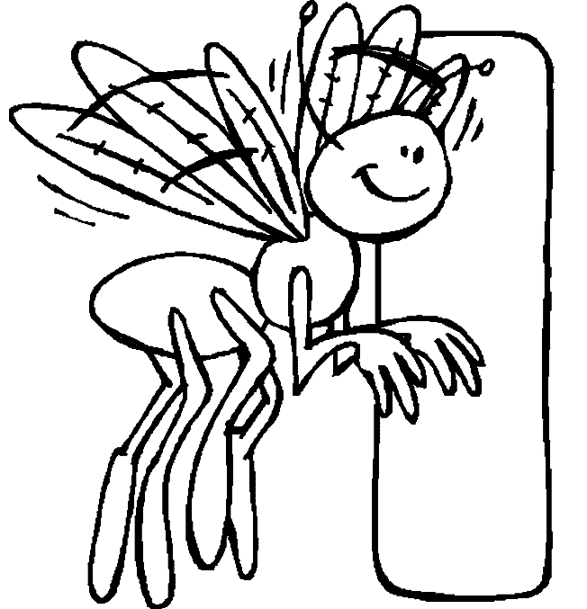
IEP - Individual Education Program | An IEP is created for each student identified in the Exceptional Children’s program in CMS to help ensure that each child gets the necessary support and instruction.

Intervention Team | A team of school professionals that will work with the parent to provide additional support for children who are struggling to meet grade level academic and behavioral expectations.
IXL.com | A website that supports math practice at each grade level. Access is provided for 20 problems per day, for free. Membership is required for further practice; K-2 students have access at our school.

Jump Rope for Heart  www.heart.org/jump/ | This is a spring event coordinated by the P.E. teacher. Students raise money for the American Heart Association. More information is provided closer to the event date.

Kindergarten Staggered Entry | Students are assigned a day to attend their first day of school in small groups. All kindergarten students begin on Aug. 31, 2012

Leveled Texts | These are books that are matched to students’ reading levels. Levels are a guide to help students find “just-right” books.
Lexile Levels  http://lexile.com/fab | This is another leveling system in which students are provided a range within they might find a “just-right” book. After taking a comprehension test, students will be given this level. You can find the lexile level of books at (find a book tool).
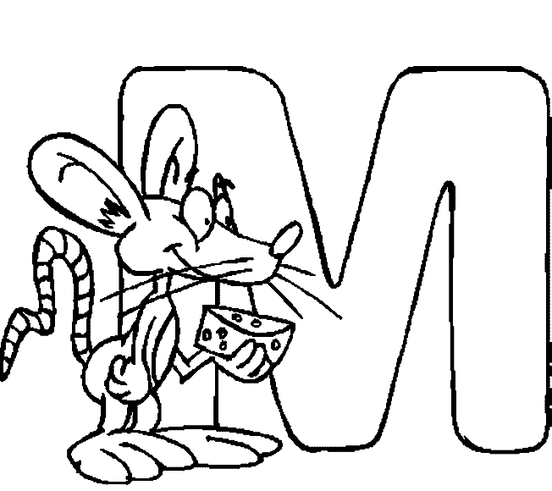
Magnet School | CMS offers various magnet themes, such as Visual and Performing Arts, World Languages, STEM, Montessori, International Baccalaureate, and many others. Parents are encouraged to consider their child's abilities, aptitudes, and talents when considering the magnet theme offerings in CMS. More information is provided on the CMS website.
Martin Luther King Jr. Essay | This is a contest provided by CMS typically in November. All students are encouraged to participate by writing an essay or creating an art piece centered on the yearly theme. Look for more information in the Fall!

Meet the Teacher | School event at which students and parents can meet their teacher, visit the classroom and learn about school services and programs.
Media Center | The media center is the school library. Students visit the media center once a week during their Specials, and are able to check out 2 books. Students also research, are introduced to technology, and are exposed to all genres of text in the media center.
Moving Up Night | Held in the late spring, this event allows parents to learn about the curriculum and expectations for their child in the next grade level.
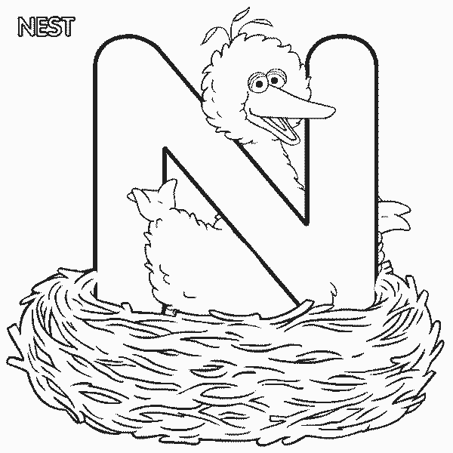
NAEP - National Assessment of Educational Progress | This national program measures student learning in all 50 states, and in 11 cities around the country, including Charlotte. It’s often called the Nation’s Report Card, because all students are given the same body of tests – making comparisons among states and cities possible.
NCSCOS - North Carolina Standard Course of Study | This is the state-mandated curriculum that every student in the state must be taught. The NCSCOS will now be the Common Core standards.
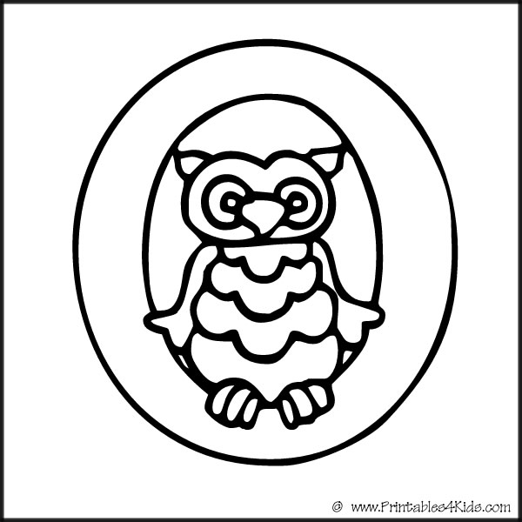

Parent Assistant  http://www.cms.k12.nc.us/parents/ParentAssistant/Pages/default.aspx | A user-friendly Web application to help parents and families become more involved in education. Parents can check their child’s homework assignments, attendance reports and grades from any computer, any time. Parent Assistant is a computer-access program that helps parents track their children’s progress in school. The program allows for easy communication between parents and teachers. It also allows parents to update their child’s personal information and family contacts. Parent Assistant is available to parents of all CMS students.
Parent University | Parent University is a compilation of resources and course offerings to help parents become full partners in their children’s education.

PayPams  https://paypams.com/HomePage.aspx | The electronic payment system CMS uses for cafeteria meals.
PEP (Personalized Education Plan): | Teachers will provide this type of plan for students who need additional support in certain subject areas. Parents will be invited to a conference to discuss the different strategies teachers plan to use for their child.
Phase 3 | This is a designation for our school; we will be implementing Balanced Literacy in all classrooms and working on professional development throughout the year with teachers and the district. Balanced Literacy is incorporating word work, guided reading, writing, and independent reading throughout the school day.
Progress Reports | These are preliminary reports sent home to parents halfway through each grading period to inform parents of their child’s progress. Teachers will share grades, attendance, and behavior information as well as some comments. If you have concerns, please schedule a conference with your child’s teacher to determine how to support your child from home.
PTA - Parent-Teacher Association: http://schools.cms.k12.nc.us/berewickES/Pages/BerewickPTAWebsite.aspx | PTA is a parent group that helps parents stay involved in children’s education. At Berewick Elementary, the PTA also enhances and supplements students’ education by providing resources and programs for the school.

Questions | Any general questions you have regarding Berewick can be addressed by calling the school at (980)344-1010.
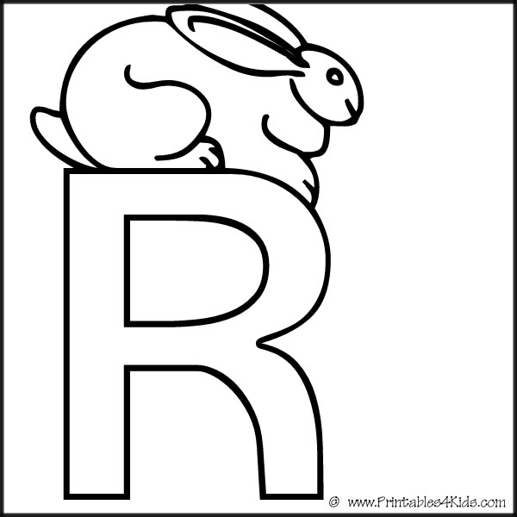
RAZ-Kids  http://raz-kids.com | An online reading resource to which all Berewick students have access. Students may log in at home and school to read leveled books and take comprehension quizzes online. They can earn stars each time they read, and spend their stars to build their Reading Rocket Room!
Reading Eggs/Reading Eggspress  http://readingeggs.com | An online reading resource to which all Berewick students have access. Students may log in at home and school to read books and take comprehension quizzes online. They can play reading games to earn golden eggs!
Reflections Essay  http://www.ncpta.org/pta/reflections_home.html | Essay and arts contest sponsored by the National PTA focused on a common theme. Each school holds its own contest and advances projects on to county and state contests with the hopes of reaching the National contest. The 2012/2013 Reflections Theme will be "The Magic of a Moment..."
Report Cards | These are quarterly reports to share your child’s progress in academics, attendance, and behavior. These are final grades for each grading period. They will be sent home in an envelope which is expected to be signed that you have seen the report card. If you have any concerns about your child’s report card, you are encouraged to schedule a conference with your child’s teacher.
Rigor | A characteristic of the learning experience which helps students understand content that is: complex and personally or emotionally challenging.
Robotics Team | A program for 4th and 5th grade students through Cyber Kids Robotics. The children build, learn to program, and compete with their robot. They learn to work as a team in practice and competitions.
RTI (Response to Instruction) | A combination of high quality, culturally and linguistically responsive instruction; assessment; and evidence-based intervention. Comprehensive RTI implementation will contribute to more meaningful identification of learning and behavioral problems improve instructional quality, provide all students with the best opportunities to succeed in school, and assist with the identification of learning disabilities and other disabilities.
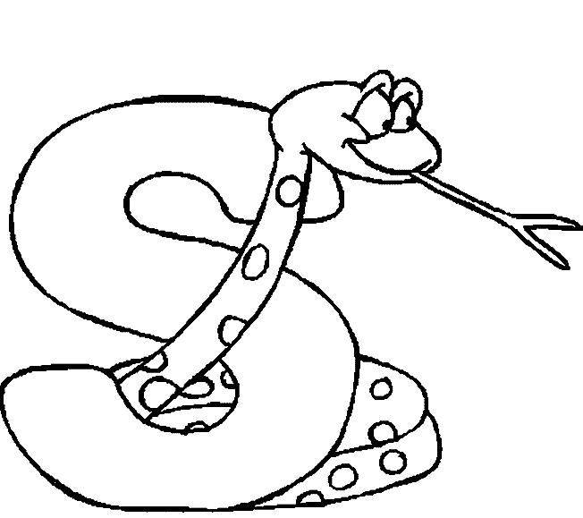
SIP - School Improvement Plan | School improvement planning provides a mechanism for identifying needs and establishing a common approach to meeting those needs to improve student performance at the school level. Effective planning contributes to overall school performance by:  - Establishing an understanding of the “big picture”  - Reaching consensus across the school community as to the highest priorities  - Identifying goals and strategies for implementation
SLT - School Leadership Team | - Facilitates the development of the School Improvement Plan  - Monitors, assesses and amends the School Improvement Plan  - Advances policies and procedures that enhance achievement and meet educational, safety and parent involvement goals  - Facilitates communication within the professional learning community  - Builds the capacity of the school to address parent and staff concerns  - Builds the capacity of the school to improve

Silent Lunch | This is a consequence used when students do not meet behavioral expectations. During silent lunch, students will eat without speaking to their peers. During some lunch times, students may sit at a different lunch table.
Specials | Students get 45 minutes of specials time each day with a different special area teacher. Students will go to: Art, Gym, Media center (Library), Science Lab, and Music.
Spelling Bee  http://www.spellingbee.com/ | This is a special fall event for students in grades 3-5. Students will compete in their classrooms to be a part of the school-wide spelling bee. The winner of the school-wide spelling bee will compete in the Southwest Zone spelling bee.
Spirit Night | Evenings when local businesses and/or restaurants sponsor our school by returning a portion of the evening’s profits to the school. Spirit Nights typically take place monthly at the sponsoring establishment.
Studentreasures Books  http://www.studentreasures.com/ | This is a school-wide publishing program. In every K-2 classroom, students will create a page in a class book. Additional copies of class books may be purchased for a discounted pre-order price. Every 3-5 student will create an individual book. The first copy is published for free and additional copies of student’s books may be purchased for a discounted pre-order price. Our publishing date this year is March 13, 2013.
Study Island  http://studyisland.com | This is an online study tool for students in grades 3-5. It provides practice, test-prep, and study games aligned to state standards. Login information is provided by classroom teachers at the beginning of the school year.
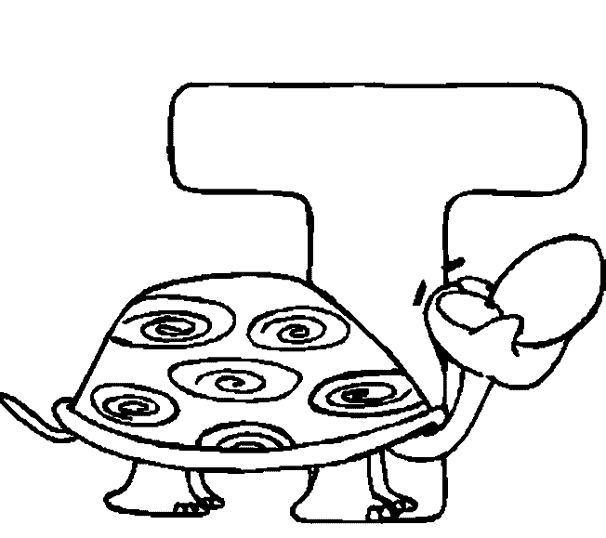
TD - Talent Development Program | In CMS, elementary students are identified when they demonstrate extraordinary problem solving or aptitude in a combination of areas including intellectual, academic, leadership, artistic, creativity, language arts, and math. The majority of identification takes place in the second grade; there are additional screenings in the fourth grade and on an as-needed basis. To grow academically, identified students have clear or extreme strengths that require differentiated curriculum. In our school’s catalyst model, implementation of the program is a joint effort by the classroom teachers and the Talent Development (TD) teachers who use the technique of "consultation and collaboration" as they develop curriculum and participate in professional development. The Catalyst model allows the classroom and TD teachers to design and implement frequent differentiated educational experiences for gifted children.

Teacher Appreciation Week | Typically held during the first week of May, Teacher Appreciation Week is a time to show teachers and staff how much they are appreciated.
Tier I | The core instruction provided to students in the classroom.
Tier II | Supplemental instruction provided to struggling students in the classroom.
Tier III | Intensive instruction provided to students who continue to struggle in Tier II.
Tutoring | Additional, special, or remedial instruction.


Volunteer Registration  www.cmsvolunteers.com | Each volunteer in the school must register with CMS and submit to a background check. Volunteers may register online. Volunteers can also enter the hours they volunteer at the website. Entering volunteer hours helps the district track volunteer involvement and assists the school in securing resources.
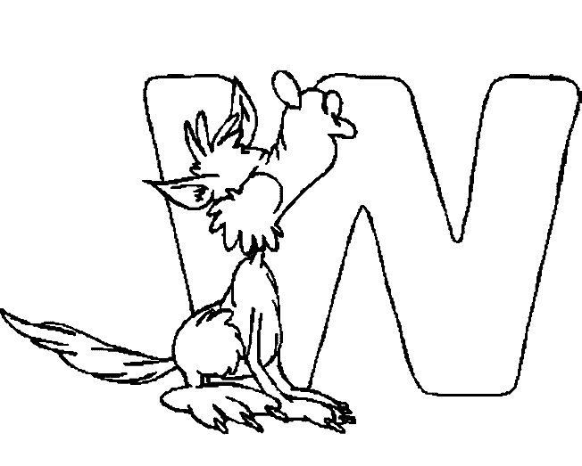
Websites of the teachers  http://schools.cms.k12.nc.us/berewickES/Pages/FacultyAndStaff.aspx | Coming soon! Once on our school website, you will be able to access websites for classroom teachers where you can find helpful information such as: homework tips, helpful websites, subjects, photos, and more!
