Department of County Human Services
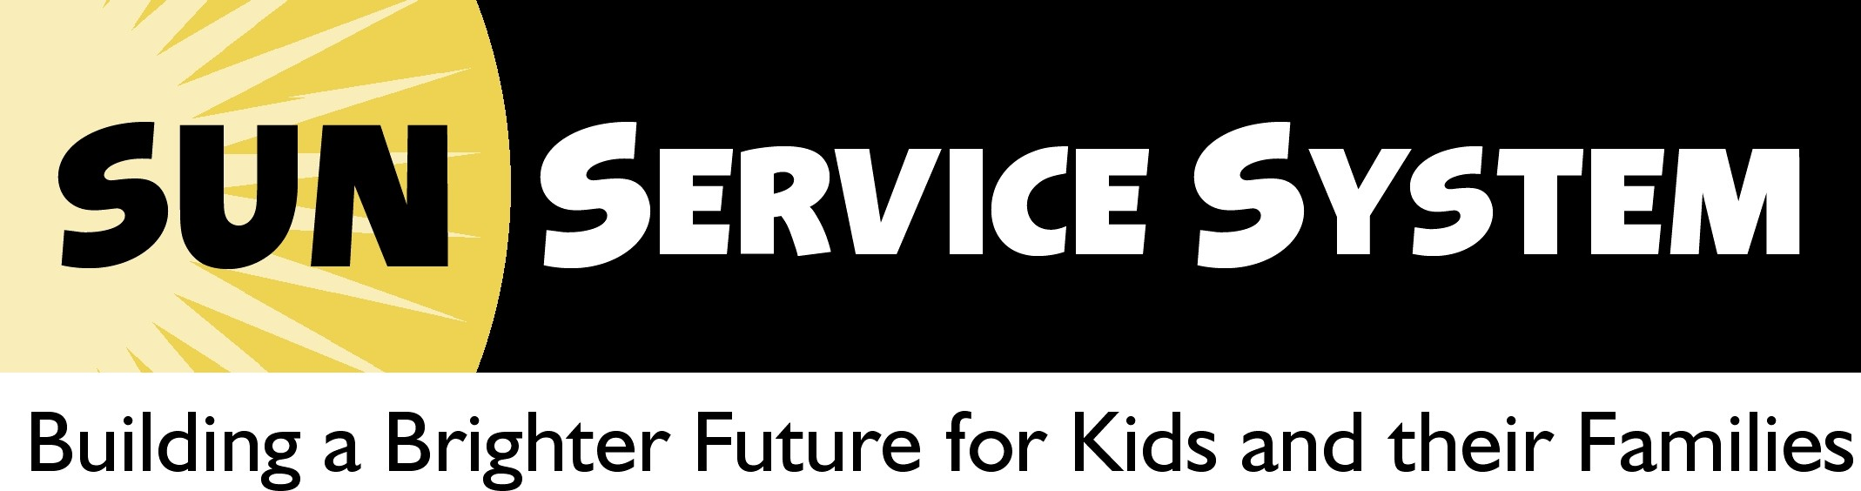
Multnomah County, Oregon

SUN Community Schools: FY 2010-11

SUN Community Schools (SUN CS) provide school-based educational support, recreation, social and health services, and parent engagement to students and their families. In 10-11, there were 60 community school sites located at 23 elementary schools, 13 middle schools, 6 high schools, and 18 schools serving grades K to 8 across Multnomah County.
Unduplicated Number Served in 2010-11
Total: 23,151
Children/Youth: 19,127
Adults: 3,810
Unknown: 214
Individuals attending educational,
cultural and social service events: 79,169
Students served 30 or more days: 7,385

Demographics: 30 or More Days Students

- Three quarters of the students were between 6 and 12 years: the average age was 9.8 years
- An equal number of females (51%) and males (49%) participated in services
- 70% of the children were of color or from a culturally-specific community compared to the Districts’ average of 46%
- 80% of the students qualified for Free and Reduced Lunch compared to the Districts’ average of 54%
- 21% of students were English Language Learners compared to the Districts’ average of 14%; 32% of these students were at the beginning or early intermediate level of language acquisition (as measured by the ELPA)
- 37% of the students’ families spoke a language other than English at home; In all, 61 non-English languages were spoken
- 16% were classified as special education students
- 30% of students did not meet the reading benchmark during the previous school year; 32% did not meet the math benchmark
- 52% of 9th grade students (N=284) were classified by the districts as academic priority because of 8th grade performance (attendance <=91%, not meeting two or more of the state testing benchmarks or failing one or more core courses).
Outcomes
Outcomes are reported for students who attended at least 30 days of SUN CS programming, who had signed releases and could be matched to the District data (N = 7,344).
Reading and Math State Benchmark Scores
 | Reading | Math
Students Showing Gains | 80% | 81%
Average Points Gained | 5.3 | 6.9
Met/Exceeded Benchmark | 70% | 51%
Met Growth Target | 43% | 39%
Met BM or GT | 74% | 57%
Expected and Average Actual Point Gains by Grade

Reading | Actual | Expected | Met | N
4th | 7.3 | 7 | √ | 866
5th | 4.4 | 7 |  | 750
6th | 5.7 | 4 | √ | 690
7th | 6.3 | 5 | √ | 531
8th | 1.9 | 4 |  | 537

Math | Actual | Expected | Met | N
4th | 10.5 | 7 | √ | 877
5th | 7.7 | 6 | √ | 761
6th | 3.8 | 3 | √ | 700
7th | 8.1 | 5 | √ | 537
8th | 4.2 | 4 | √ | 549

Percent of Students Who Met or Exceeded Benchmark by Grade
 | Reading (N) | Math (N)
4th | 79% (909) | 56% (924)
5th | 67% (788) | 43% (798)
6th | 72% (745) | 52% (747)
7th | 68% (559) | 50% (561)
8th | 58% (572) | 57% (572)

Percent of Students Not Meeting Benchmark who Met Growth Target to be on Track by 8th Grade
 | Reading (N) | Math (N)
4th | 48% (203) | 40% (255)
5th | 27% (174) | 36% (230)
6th | 58% (223) | 46% (199)
7th | 48% (187) | 41% (206)
8th | 31% (173) | 30% (141)

Students Who Met/Exceeded Benchmark or Met/Exceeded BM or Met Growth Target by Grade
 | Reading |  |  | Math
 | Met BM | BM or GT | Met BM |  | BM or GT
4th | 79% | 83% | 56% |  | 63%
5th | 67% | 70% | 43% |  | 50%
6th | 72% | 79% | 52% |  | 62%
7th | 68% | 75% | 50% |  | 60%
8th | 58% | 63% | 57% |  | 62%
Attendance
- Average daily attendance for SUNCS students served was 94.5%
- 80% of SUNCS students met or exceeded Oregon’s attendance benchmark of 92%
- 17% of SUNCS students were absent on more than 10% of school days compared to the districts average of 32%
High School Students
- Earned an average of 6.76 credit hours
- 75% earned the 6.0 credits expected for the school year
- 94% of 9th, 10th, and 11th grade students returned for their next year of high school
- 79% of seniors graduated; 91% either graduated or returned for a 5th year
Teacher Surveys
- Teachers reported that 89% of SUNCS students needed to improve in at least one area
- For students who needed improvement, teachers reported that overall, 74% improved in at least one area
Student Surveys
- 87% K to 3rd grade students say their SUN teacher helps them when they need it
- 86% 4th to 12th grade students report knowing at least one adult at school who cares about him/her
Summary
- SUN Community Schools are doing a good job of serving their intended population through targeting recruitment and providing culturally-appropriate and specific services. SUN serves a high percent of students eligible for free and reduced lunch, students of color and English language learners. The male-to-female ratio is equitable and services are spread across the highest need areas of the county.
- At the end of the school year, student academic outcomes were quite positive as evidenced by OAKS reading and math tests. As a system, we met our target: greater than 75% of students showed improvement in math and reading scores. In addition, almost three quarters of students were meeting their benchmarks or on track to meet their benchmark within 3 years in reading (74%). In math, fewer were on track (57%) in large part because the cutoff scores were made more rigorous this year. It was encouraging that students were meeting the expected amount of gain in math scores between 09/10 and 10/11.
- Students attended an average of 94.5% of required school days which is well above the state benchmark of 92%. Significantly fewer students (17%) are classified as chronically absent due to missing more than 10% of required school days compared to the districts average of 32%.
- High school students made significant progress in earning credits, averaging 6.76 credits during the school year. Of 12th graders participating in SUNCS, 79% graduated.
- SUNCS high school students, who are at risk of dropping out of school, were highly likely to re-enter school in the fall: 94% of 9th to 11th grade students returned and over half (56%) of the 12th grade students that didn’t earn enough credits to graduate, returned for a 5th year of high school.

The target for the number of youth served for 30 days was 5,825.
Oregon’s Assessment of Knowledge and Skills (OAKS) scores were available on 3,424 students in reading and 3,487 in math who had both 09/10 and 10/11 scores; benchmark scores for 10/11 were available on 4,727 students in reading and 4,790 in math; and growth target data was available on 962 students in reading and 1,032 in math
Cut scores on the math test have been raised this year to ensure that students are prepared for the more rigorous Common Core State Standards. As a result, fewer students met or exceeded math benchmarks than last year.
The benchmark cutoff scores needed to meet or exceed OAKS math test were significantly changed in 2010-11 to reflect higher expectations of what students should know in order to graduate. This is reflected in the significantly lower percents of students who met or exceeded benchmarks in 2010-11.
Statewide goal is 60% in reading and 59% in math
Attendance was available on 7,007 students
There were 186 seniors participating in SUN CS.
Teachers completed surveys on 4,968 students
1,915 K through 3rd grade students completed surveys; 2,265 4th to 12th grade students completed surveys

