Treating heterogeneous emphysema by lung volume reduction surgery using one-way valve stent implantation

Liangchao Wang, Yi Hu, Xinrong Wang, Su Zhao
Respiratory Medicine, Wuhan Centre Hospital, Wuhan, China

Running title: Heterogeneous emphysema by lung volume reduction surgery

Address correspondence to: Dr. Su Zhao, Respiratory Medicine, Wuhan Central Hospital, 26 Victory Street, Wuhan 430014, China. Tel: +86-27-82211466; Fax: +86-27-88187717; E-mail: zhaosusui@126.com

Disclosure of conflict of interest
None.
Abstract: Purpose: To retrospectively analyze the efficacy and complications of lung volume reduction surgery (LVRS) using one-way valve stent implantation in three heterogeneous emphysema cases. Methods: We performed bronchoscopic, lung CT, pulmonary function (PF) and 6-minute walk distance (6MWD) tests respectively before operation and 1 month, and 3 and 6 months after operation to estimate the surgical effects in the 3 cases by comparing the test results. Results: After operation, all the three cases had worsened symptoms of cough and expectoration; two of them had hemoptysis, EVB-related infections and acute exacerbation of chronic obstructive pulmonary disease (AECOPD), one of them had airway distortion and respiratory failure and still one of them had granulation hyperplasia. Postoperative reexamination results revealed that one patient had obviously increased forced expiratory volume in 1 second (FEV1), forced vital capacity (FVC) and 6-minute walk distance (6MWD) and right upper pulmonary atelectasis, but no apparent improvements in FEV1, FVC, and 6MWD were found in the other two patients. Conclusions: The patient with postoperative pulmonary atelectasis was found with significantly improved PF at the first month after surgery, but the PFs thereof had a drop at the sixth month after surgery due to EVB-related infections. No obvious improvements in the PFs of all the three patients were observed in the reexamination performed six months after surgery. The long-term effects of LVRS with one-way valve stent implantation are uncertain, and further studies should be carried out in the future.
Keywords: One-way valve stent implantation, heterogeneous emphysema, lung volume reduction surgery
Introduction

The morbidity of chronic obstructive pulmonary disease (COPD) is increasing year by year in China. The majority of the COPD patients have pulmonary functions (PFs) at III-IV stages, and severe diffuse emphysema is the pathological manifestation of COPD. Until now, the effects of conventional medical treatment on the disease have been ineffective and the life quality of the patients has been very poor. In addition, some of the COPD patients often suffer heterogeneous emphysema, and the surgical lung volume reduction method in which the lung lobe with emphysema is cut is now being used in an attempt to solve this issue. However, though the PFs of those COPD patients with heterogeneous emphysema can be improved by the method indeed, the application of this method is still limited due to the high surgical risk and serious postoperative complications . With the development in respiratory endoscope application, the clinical application of endoscopic lung volume reduction surgery (LVRS) with one-way valve stent implantation has become an important development direction in the treatment of heterogeneous emphysema at abroad because of its low surgery risk and minimal trauma. Nevertheless, the therapeutic effects as well as complications caused by the therapy remain to be further evaluated in the future. The method has been rarely applied domestically up to now, so there are not too much data about its curative effect and complications among Asian populations. Thus, we presented the therapeutic effects and follow-up results of the LVRS using one-way valve stent implantation in three heterogeneous emphysema patients for purpose of sharing.

Presentation of cases

Case 1 was a 57-year-old retired male patient. His causes of hospitalization were: a six-year history of cough, expectoration and wheeze, and worsened symptoms of cough, expectoration and wheeze accompanied by chest distress and dyspnea for 10 h after recurrence. The physical examination (PE) results of the patient were as follows: blood pressure (BP): 120/80 mmHg, heart rate (HR): 72 bpm, respiratory rate (RR): 22 bpm, and oxygen saturation (SpO₂): 90%. The patient had clear consciousness and chronic disease face. In addition, the breath sound in bilateral lungs was low, with clear wheezing in the right lower lung. The above symptoms of the patient could be aggravated with the changing of climates, and the MRC breathing difficulties assessment was at grade 3-4. The case 1 was required to continuously inhale in salmeterol and fluticasone propionate powder (50/500 µg) and tiotropium bromide powder for treatment. The preoperative evaluation results of case 1 were presented as follows: PF: forced expiratory volume in 1 second (FEV1): 0.78 L, FEV1%: 27%, residual volume (RV) %: 240%, total lung capacity (TLC)%: 121%, diffusing capacity of the lung for carbon monoxide (DLCO) %: 51%; 6-minute walk distance (6MWD): 336 meters; blood gas analyses: potential of hydrogen (PH): 7.463, partial pressure of carbon dioxide (PCO₂): 47.8 mmhg, partial pressure of oxygen (PO₂): 75 mmhg; lung CT: bilateral emphysema, with the right upper lobe having more severe symptoms. The conventional bronchoscopic Chartis test was performed before surgery and it was indicated that the right upper lobe had no obvious collateral ventilation. Then we generally anesthetized the patient using laryngeal mask airway and implanted two one-way valve stents (Pulmonx, Inc., Palo Alto, CA., USA) at the openings of anterior and apico-posterior segments of the right upper lobe. All procedures of the surgery were operated smoothly. However, slight hemoptysis occurred after surgery, and the symptom was relieved after hemostatic and anti-infectional treatments. Reexaminations were performed after surgery. The lung CT test results indicated right upper lobe atelectasis and a small amount of right pleural effusion; the blood gas analysis results showed no obvious change; the PF test results were: FEV1: 1.04 L, FEV1%: 31.1%, RV%: 160%, TLC%: 101%; and the result of 6MWD was 385 meters. Self-conscious dyspnea was improved after operation.
Case 2 was a 59-year-old retired male patient. He was hospitalized due to an 8-year history of recurrent cough and dyspnea as well as aggravated symptoms for 1 week during the recurrence. The PE results were: clear consciousness; BP: 122/82 mmhg, RR: 25 bpm, temperature (T): 36.6℃, and HR 72 bpm; die blausucht; diminished palpation vocal fremitus, low-pitched respiratory sound, and no clear dry or wet rales in bilateral lungs; and MRC breathing difficulties assessment at grade 4. The case 2 had been repeatedly hospitalized due to worsened conditions over the past year, and the current MRC assessment thereof was at grade 3-4. He received a long-term inhalation therapy of salmeterol and fluticasone propionate powder (50/500 µg), tiotropium bromide powder and doxofylline. Preoperative assessment results were: PF: FEV1: 0.74 L, FEV1%: 24.5%, RV%: 182%, TLC%: 116%; 6MWD: 285 meters; blood gas analyses: PH: 7.365, PCO₂: 46.8 mmhg, PO₂: 97 mmhg; and lung CT: bilateral emphysema, with bulla on the left upper lobe. The conventional bronchoscopic Chartis detection was carried out before operation and no apparent collateral ventilation was observed in the left upper lobe. The laryngeal airway was used to generally anesthetize the patient and then three one-way valve stents (Pulmonx, Inc., Palo Alto, CA., USA) were implanted at the openings of apical, anterior and lingular segments of the left upper lobe. The operative process was conducted successfully. However, the patient felt discomfort because of cough, wheeze and dys-expectoration after operation, which was then alleviated by anti-infection treatment. Postoperative reexaminations were executed. No significant change in blood gas analysis results was found. The PF examination results were: FEV1: 0.97 L, FEV1%: 32.1%, RV%: 162%, TLC%: 107%. The 6MWD result was 315 meters. Improvements in self-conscious dyspnea were observed after surgery.
Case 3 was a 53-year-old retired male patient. He complained of an over 8-year history of repeated cough and dyspnea and exacerbated symptoms for a week after recurrence. Before the surgery, he was clear in consciousness, and the PE results thereof were: T: 36.6℃, HR: 88 bpm, RR: 24 bpm, SpO_{2:} 96%, BP: 132/80 mmHg; low-pitched breath sound and no obvious dry or wet rales over both lund fields; and an MRC assessment at grade 3-4. This patient had been repeatedly hospitalized during the autumn and winter seasons over the past 8 years, and could only walk on flat ground at present. Long-term inhalation of salmeterol and fluticasone propionate powder (50/500 µg), tiotropium bromide powder and doxofylline was taken as a treatment for him. Preoperative evaluation results of PF, 6MWD, blood gas, and lung CT were respectively: FEV1: 0.74 L, FEV1%: 22.7%, RV%: 156%, TLC%: 105%; 322 meters; PH: 7.388, PCO₂: 44.6 mmhg, PO₂: 97 mmhg; and pulmonary emphysema especially in the upper lobe of both lungs. Preoperative conventional bronchoscopic Chartis detection revealed that the upper lobe of both the left lung and the right lung had no obvious collateral ventilation. After the patient was generally anesthetized with laryngeal airway, implantation of three one-way valve stents (Pulmonx, Inc., Palo Alto, CA., USA) at the openings of apical, anterior and posterior segments of the right upper lobe was performed. The operation was successfully accomplished and no special discomfort in the patient was observed after operation. Reexaminations after surgery revealed no remarkable change in blood gas analyses. The postoperative evaluation results for PF and 6MWD were: FEV1: 0.77 L, FEV1%: 23.8%, RV%: 160%, TLC%: 105%; and 325 meters. Self-conscious dyspnea was not significantly improved after operation.

Postoperative results and follow-up visits

All the three cases had aggravated symptoms of cough and expectoration after operation. Microscopically, the valve stents were blocked by purulent secretion. Two cases had intermittent hemoptysis. Three months after operation, right middle bronchial traction stenosis caused more severe dyspnea in case 1. Case 2 had granulation tissue hyperplasia caused by repeated infection six months after operation. After the surgery, case 1 had obviously increased FEV1, forced vital capacity (FVC), and 6MWD. In the mean time, the atelectasis of the lobes being treated had produced improvements in the volume reduction effects and other symptoms of case 1. Nevertheless, the PFs of case 1 had a significant decline owing to the obstructive pulmonary infection and right bronchial traction stenosis induced by atelectasis during the second to third month after operation. Under the above-mentioned circumstances, the PFs of case 1 had a serious drop at the sixth month after surgery, and we had to consider taking out the valve stent implanted at the opening of apicoposterior segment from case 1. The volume of the lobes being treated in case 2 and 3 was partly reduced, but their FEV1, FVC and 6MWD examination results were with no apparent improvement. In addition, Case 2 had higher frequencies of cough, expectoration and hemoptysis.

Discussion

The application of LVRS by implanting one-way valve stent for clinical treatment of terminal emphysema patients began from the start of this century . As a brand-new emphysema treatment method, it is mainly aimed at heterogeneous emphysema patients. The provisional inclusion criteria of patients who could receive this therapy include: (1) aged 40~75 years and being diagnosed with heterogeneous emphysema through lung CT; (2) PF: FEV1 being between 15%-45% of the predicted value, RV >150% of the predicted value, and TLC >100% of the predicted value; (3) blood gas analyses: PCO₂ <50 mmhg, and PO₂ >40 mmhg; (4) body mass index (BMI) <31.1 (male) or 32.3 (female); (5) 6MWD >140 meters; and (7) passing through the Chartis collateral ventilation test . Currently, the one-way valve stents on the market are divided into two kinds: EVB and IBV, with the former being more widely used due to the poor effects of IBV implantation .
Because of the strict inclusion criteria of the therapy, only a few patients have been treated with it up to now. In recent years, many European and American multi-center studies and clinical meta-analyses have evaluated postoperative changes of such indexes as PF (including FEV1, FVC and RV/TCL), St.George’s Respiratory Questionnaire (SGRQ) score, lung CT, and 6MWD,and have observed obviously improved FEV1, reduced lung volume, and partly improved SGRQ score and 6MWD . Some researchers have followed up the patients receiving this therapy for 1 year and have discovered that the above indicator changes are positive and significant. Therefore, European Respiratory Society identified the LVRS utilizing one-way valve stent implantation as a standard therapy for heterogeneous emphysema treatment in the year of 2013 . However, this therapy was rejected by American Thoracic Society and thus has had no further popularization . This therapy still has some limitations. For example, the number of application cases of this therapy is very small and some studies have not discovered any apparent improvement in postoperative SGRQ score and 6MWD .
Some researchers have made follow-up visits to the patients for a single year and have discovered that the patients have a certain extent of improvement in acute exacerbation chronic obstructive pulmonary disease (AECOPD), hemoptysis, pneumothorax, respiratory failure, endotracheal intubation and death rate . There have been no studies performing follow-ups for a period of more than one year up to now. The LVRS with one-way valve stent implantation is applied lately in China. In addition, the application case number is limited and there are no related studies with a large sample size.
In this study, we drew three curve graphs showing the reexamination results of PF (FEV1 and FVC) and 6MWD of the three cases at the first, third, and sixth month after surgery. As could be known from the graphs (Tables 1-3; Figures 1-3), case 1 had apparently enhanced FEV1, FVC and 6MWD at the first month after operation, but had obvious decreasing of FEV1, FVC and 6MWD at the third month after surgery; and the postoperative PF and 6MWD of the other two cases had no significant improvement. The postoperative reexamination results of lung CT showed that case 1 had apparent pulmonary atelectasis, and the other two cases had reduced volumes of the hyperinflated lungs. This has indicated that the surgical effect is good when atelectasis occurs in the lobe implanted with the valve stent. One study has suggested that good surgical effect is achieved in patients having pneumothorax and pulmonary atelectasis after the use of EVB, whereas the incidence of respiratory failure and the mortality can be increased by pneumothorax . Though case 2 and 3 had shrinked lung volume after surgery, their PF and exercise tolerance were found with no obvious improvement, and their FEV1 even had a drop at the sixth month after surgery. Considering from the perspective of clinical follow-ups, related reasons for the above situation may include: (1) though the selected patients accorded with the inclusion criteria, but the heterogeneous emphysema was not severe enough; and (2) the postoperative infections of related airways as well as aggravated cough and expectoration caused a drop in the PF of the patients.
Compared with the conventional LVRS, the bronchoscopic LVRS with one-way valve stent implantation can cause lower mortality and fewer complications. However, as the increasing of cases receiving valve stent implantation treatment, various known and unknown complications have gradually emerged. Felix et al. have compared the complications of patients who had received the surgery and patients who had not received the surgery during the 1-year follow-up and have suggested that the former ones have higher incidence of lung infection, AECOPD, pneumothorax, haemoptysis, respiratory failure, mechanical ventilation and death than the latter ones; and we should pay great attention to the increased death rate though no significant statistical difference is observed . For the three cases of the present study, one case had respiratory failure caused by granulation at the opening implanted with the valve stent 6 months after operation; and one case had postoperative pulmonary atelectasis and a significant drop in PF due to the tractional distortion in the right main bronchus at the sixth month after operation, and the valve stent implanted at the apicoposterior segment of the right upper lobe was eventually took out from him. All these suggested that granulation hyperplasia and airway distortion after atelectasis might be complications of the LVRS using one-way valve stent implantation.
In conclusion, despite the uncertain long-term efficacy and complications, the bronchoscopic LVRS with one-way valve stent implantation for heterogeneous emphysema treatment has favorable short-term efficacy and application prospect at present. Because of the short application time and the small number of application cases of this treatment method, we will make further investigations on the efficacy thereof with the further development of this method.
References
[1] Zahid I, Sharif S, Routledge T and Scarci M. Is lung volume reduction surgery effective in the treatment of advanced emphysema? Interact Cardiovasc Thorac Surg 2011; 12: 480-486.
[2] Toma TP, Hopkinson NS, Hillier J, Hansell DM, Morgan C, Goldstraw PG, Polkey MI and Geddes DM. Bronchoscopic volume reduction with valve implants in patients with severe emphysema. Lancet 2003; 361: 931-933.
[3] Herth FJ, Noppen M, Valipour A, Leroy S, Vergnon JM, Ficker JH, Egan JJ, Gasparini S, Agusti C, Holmes-Higgin D and Ernst A. Efficacy predictors of lung volume reduction with Zephyr valves in a European cohort. Eur Respir J 2012; 39: 1334-1342.
[4] de Oliveira HG, Macedo-Neto AV, John AB, Jungblut S, Prolla JC, Menna-Barreto SS and Fortis EA. Transbronchoscopic pulmonary emphysema treatment: 1-month to 24-month endoscopic follow-up. Chest 2006; 130: 190-199.
[5] Springmeyer SC, Bolliger CT, Waddell TK, Gonzalez X and Wood DE. Treatment of heterogeneous emphysema using the spiration IBV valves. Thorac Surg Clin 2009; 19: 247-253, ix-x.
[6] Wood DE, McKenna RJ Jr, Yusen RD, Sterman DH, Ost DE, Springmeyer SC, Gonzalez HX, Mulligan MS, Gildea T, Houck WV, Machuzak M and Mehta AC. A multicenter trial of an intrabronchial valve for treatment of severe emphysema. J Thorac Cardiovasc Surg 2007; 133: 65-73.
[7] Venuta F, Anile M, Diso D, Carillo C, De Giacomo T, D'Andrilli A, Fraioli F, Rendina EA and Coloni GF. Long-term follow-up after bronchoscopic lung volume reduction in patients with emphysema. Eur Respir J 2012; 39: 1084-1089.
[8] Gompelmann D, Eberhardt R and Herth FJ. Endoscopic lung volume reduction. A European perspective. Ann Am Thorac Soc 2013; 10: 657-666.
[9] Lee HJ, Shojaee S and Sterman DH. Endoscopic lung volume reduction. An American perspective. Ann Am Thorac Soc 2013; 10: 667-679.
[10] Shah PL, Slebos DJ, Cardoso PF, Cetti E, Voelker K, Levine B, Russell ME, Goldin J, Brown M, Cooper JD and Sybrecht GW. Bronchoscopic lung-volume reduction with Exhale airway stents for emphysema (EASE trial): randomised, sham-controlled, multicentre trial. Lancet 2011; 378: 997-1005.
[11] Wan IY, Toma TP, Geddes DM, Snell G, Williams T, Venuta F and Yim AP. Bronchoscopic lung volume reduction for end-stage emphysema: report on the first 98 patients. Chest 2006; 129: 518-526.
[12] Sciurba FC, Ernst A, Herth FJ, Strange C, Criner GJ, Marquette CH, Kovitz KL, Chiacchierini RP, Goldin J and McLennan G. A randomized study of endobronchial valves for advanced emphysema. N Engl J Med 2010; 363: 1233-1244.

Table 1. Complications after EVB LVRS
 | Postoperative complications
 | AECOPD | EVB related infection | Blood-stained sputum | Respiratory failure | Aerothorax | Death
Case 1 | Increased | Yes | Yes | Yes | No | No
Case 2 | Increased | Yes | Yes | No | No | No
Case 3 | Not increased | Yes | No | No | No | No
Table 2. Preoperative and postoperative bronchoscopic pictures
 | Before operation | 1 month after operation | 3 months later operation | 6 months after operation
Case 1 | 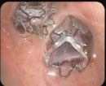 | 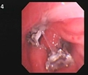 | 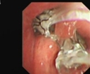 | 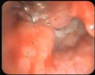
Case 2 | 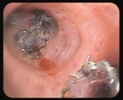 | 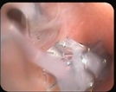 | Lack of follow-up | 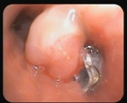
Case 3 | 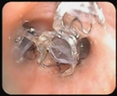 | 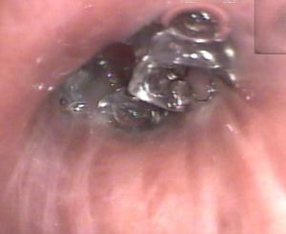 | Lack of follow-up | Lack of follow-up
Table 3. Preoperative and postoperative lung CT examination results
 | Before operation | 1 month after operation | 3 months after operation | 6 months after operation
Case 1 | 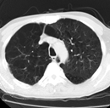 | 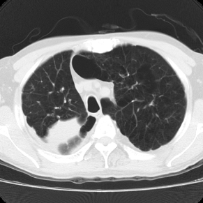 | 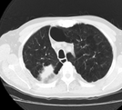 | 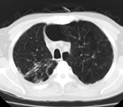
Case 2 | 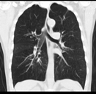 | 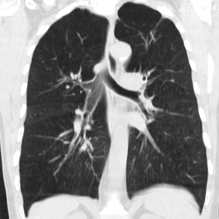 | 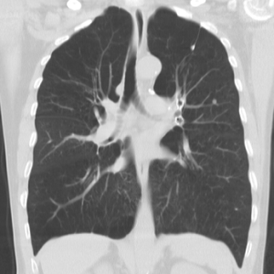 | 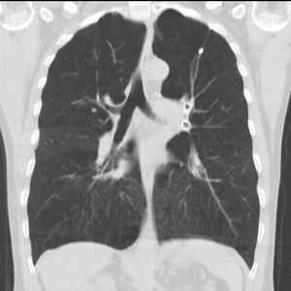
Case 3 | 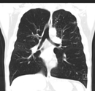 | Lack of follow-up | 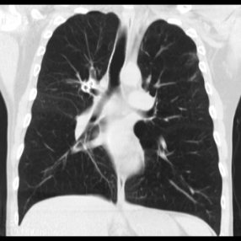 | 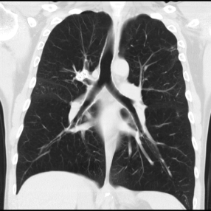
Figure legends
Figure 1. Preoperative and postoperative FVC examination results.
Figure 2. FEV1 changes before and after operation.
Figure 3. Preoperative and postoperative 6MWD changes.
Figure 1

Figure 2

Figure 3

