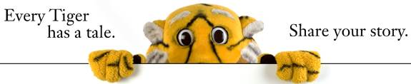
Mr. Vossler, Principal
Daryl.vossler@fridley.k12.mn.us
763-502-5301
February’s Edition

WHAT’S COOL IN OUR SCHOOL
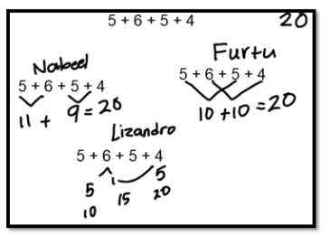
Our Primary Years Programme in Action!
Stevenson students are showing their thinking skills as they do Number Talks in classrooms! This year we have Dr. Terry Wyberg from the University of Minnesota working with our teachers to implement Number Talks at every grade level.
Number Talks are a quick daily math exercise that put students at the center of learning. Teachers pose a problem, provide thinking time, and then students share their strategies to problem solve. Students build off of ideas from their peers and make connections with their own thinking. Number Talks build confidence and help students have a rich understanding of mathematics.
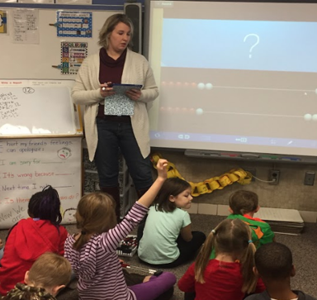
Ms. Carlson is doing a Number Talk with her 1st graders using Rekenreks, a hands-on tool for students to build number sense.

READING CORNER


Did You Know?

television.
FREE



Remember to turn in your Box Tops by February 3rd and shop at the Box Top Store on Friday, February 24th.

Friday, February 26th

Dress Up As Your Favorite Story Book Character
in honor of
“I LOVE TO READ” month


Grade 4 Stevenson

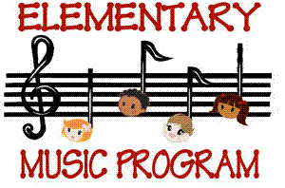

Thursday, February 16

2:15 p.m. – Rehearsal

7:00 p.m. – Program

At the District Auditorium

Spring Pictures
February 15

PTO Meeting
February 21
6-8 p.m.

REGISTRATION
Mon., Feb. 6th @ 6:15 p.m.

Do you have a child that will be 5 years old on or before Sept. 1, 2016?

If so, please come on February 6th at 6:15 p.m. with your child to complete one of the most important milestones in your child’s life.

No School

February 20

