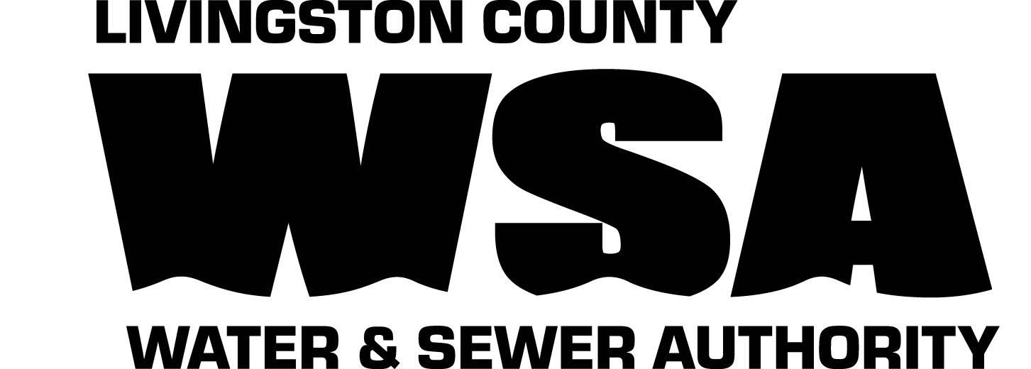
Livingston County Water & Sewer Authority
1997 D’Angelo Drive
PO Box 396
Lakeville, NY 14480
Phone: (585) 346-3523
e-mail: mbaines@lcwsa.us
Fax: (585) 346-0954
TTY NY: (800) 662-1220

Agenda
LIVINGSTON COUNTY WATER & SEWER AUTHORITY
ORGANIZATIONAL MEETING & REGULAR MEETING

January 20, 2021 8am
(VIA CONFERENCE CALL – see call-in info on page 3)
- Call to Order

- Organizational Items
- Appointment of Officers
  - Chairman
  - Vice Chairman
  - Treasurer
  - Secretary
- Establish 2021 Meeting Schedule & Location (previously approved at 12/18/20 Board Mtg)
- Designate official newspaper(s)
- Designate official Bank
- Payment of Bills
- Committee Assignments
  - Governance
  - Audit/Finance
  - Unity Task Force (Joint Village of Livonia/LCWSA Water & Sewer Committee)
- Appointments:
  - Engineer – Clark Patterson Lee
  - Attorney – James W. Campbell, Jr., Kruk & Campbell, P.C.
- Miscellaneous
  - Committee Charters – Discussion
  - Board Member Responsibilities – Discussion
  - NYSLRS – Establish Standard Work Day for Employees (Resolution No. 2021-xx)

- Approval of Agenda

- Approval of Minutes – December 18, 2020 Regular Meeting
January 6, 2021 Special Meeting

- Privilege of the Floor

- Financial Report

- 2020 Budget Transfer Request (Total $257,400)

- LCWSA Acct 14894 (Kircher Construction, Inc., 3090 Mt Morris Geneseo Rd, Mount Morris NY 14510)
  - Request for Review of Hardship/Leak Policy (December 4, 2020 Letter)

(see reverse)

- Approval of Bills

- Operations/Capital Reports

- LCWSA Capital Projects
  - P31131 County Wide Water System Improvements (DWSRF Project No. 18746)
    - Engineering Amendment #1 – Phase 2A Disinfection System Improvements

- 2021 Capital Improvement Program & Project Planning Discussion
  - See attached memorandum

- 2021 CFA Grant Funding: EPG & GIGP Program
  - Discussion + Approval to Submit Applications

- Other Business

- COVID-19 Impacts – Update & Discussion
  - Sick Leave
  - Vaccination Rollout/Prioritization (Phase 1c: All other essential workers (incl water/wastewater))

- LCWSA Staffing
  - Establish Wage Grades for Union Positions (not already listed in Wage Grade Table)
  - Proposed WWTP Staffing Plan – Discussion
  - Authorize to fill one (1) Sr WWTP Operator Position (Full-Time)
  - Authorize to fill one (1) Grade 3 WWTP Operator Position (Full-Time)
  - Authorize to fill one (1) Grade 2A WWTP Operator Position (Full-Time)
  - Authorize to fill one (1) WWTP Operator Trainee (Full-Time)
  - Authorize to fill one (1) Building Maintenance Person Position (Full-Time)

- Village of Livonia – January 14, 2021 Memo/Letter of Intent re: Development of Direct Agreement for Water System
  - Discussion + Next Steps

- Communications

- Unity Task Force (Joint Village of Livonia/LCWSA Committee) Meeting held virtually on Monday, January 11, 2021 at 5:30 pm re: proposed water system improvements at intersection of Big Tree Rd/Shelly Road. Next meeting scheduled for Monday, January 25, 2021 at 5:30 pm.

- Livingston County Water Supply Study Update – Report has now been finalized by CPL and can be downloaded from the following webpage: https://www.livingstoncounty.us/1177/Water-Study-Update-Project (Report: 284 pages, Appendices: 444 pages). Per Livingston County, “the equipment purchase for
this grant is on hold until the final contract is signed by the State.”

- Adjournment

Next Regular Meeting: Wednesday, February 17, 2021 @ 8 am
*Meeting type (In-person or via Conference Call) TBD, based on COVID-19 situation and status of Executive Orders issued by NYS Governor*

All attachments and reports referenced above may be found at
http://www.co.livingston.state.ny.us/lcwsa.htm
Go to Board meetings tab / current agenda.

Due to the ongoing COVID-19 pandemic, the Organizational Meeting/Regular Board Meeting scheduled for Wednesday, January 20, 2021, will be held via conference call versus in-person.

For members of the public who are interested in calling in and listening to the Board Meeting, please see instructions below:

Dial (for higher quality, dial a number based on your current location):
US: +1(646)3573664
+1(312)2630281
+1(470)8692200 (US East)
+1(773)2319226 (US North)
+1(623)4049000 (US West)
+1(650)2424929
+1(720)9027700 (US Central)
+1(213)2505700
+1(346)9804201
+1(469)4450100 (US South)
Meeting ID: 149 479 1823

