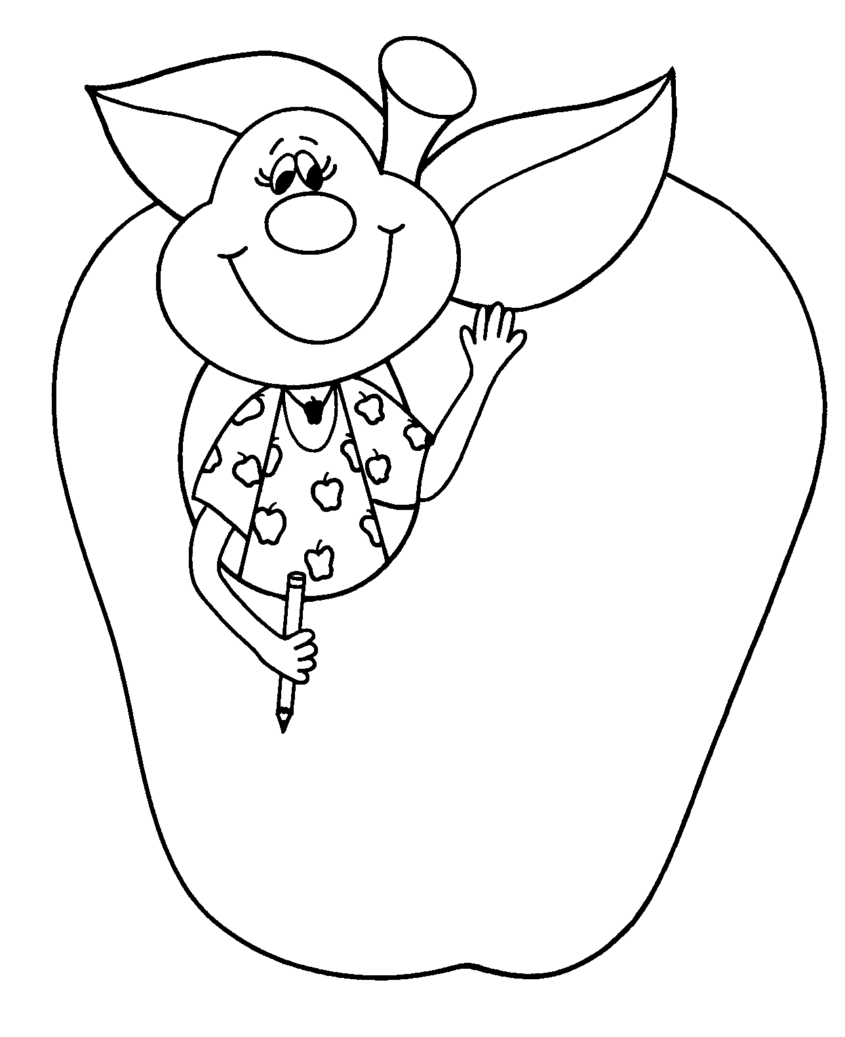

August 25, 2016

Dear Parents,

Welcome to Sullivan County Elementary School. This booklet

is a result of a cooperative effort on the part of the teaching staff of the Sullivan County Elementary School, representatives of the Parent Teacher Organization and the Elementary Principal.

The purpose of this booklet is to give you and your children an
understanding of the general rules and guidelines for attending and
receiving an education in our school. In a case of conflict between a
Board Policy and the provisions of this handbook, the Board Policy most recently adopted by the Board will prevail.

We hope you will read it carefully and place it in a convenient location for quick and easy reference as the need might arise. Please
read the handbook, complete the signature page located in the back
and return it to your child’s teacher.

May we extend to you a cordial invitation to call on any member of our staff whenever you have questions about our educational program and/or your child’s progress. We wish you and your child a successful year!


Sincerely,
Mrs. Mary Louise McClintock
Elementary Principal

-1-

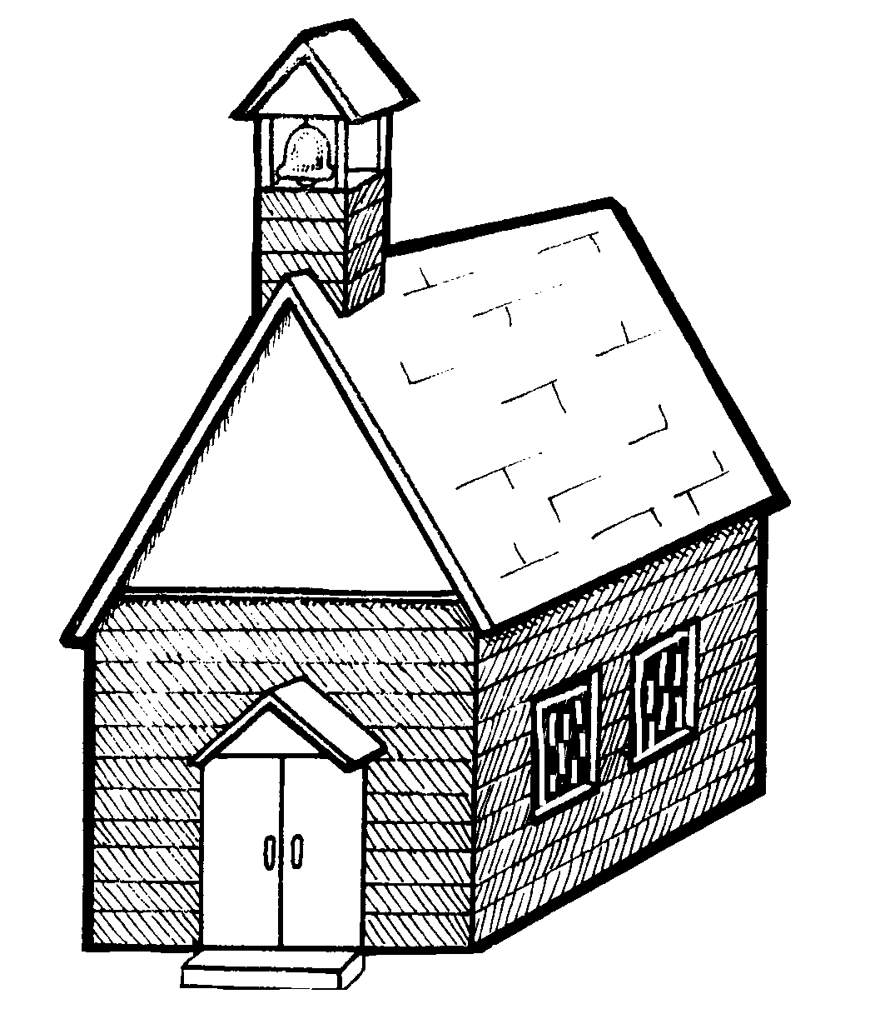
Table of Contents
Page 1 Opening Letter
2 Table of Contents
3 SCES Staff
4 Special Teachers
5 Breakfast Program
6 Lunch Program
7 Admission of Students/Kindergarten
8 Schedules
8 Computer & Internet Use
9 -12 Learning Services/Promotion & Retention Policy
13 Summer School 14 Report Cards/Student Records/Homework
15 Testing/Parent Teacher Conferences 16 Attendance 17 Family Trip Policy
18 Emergency Drills
18 Students of Divorced/Separated Parents
18 Child Abuse Reporting
19 Reporting of Suspicious Activity
19 School Emergency - Delays/Closings
19 Student Dress and Grooming
20 Medications
21 Medications Kept by Students/Health Exams & Screenings 22 Drugs and Alcohol/Tobacco
23 Weapons
23 Sexual/Unlawful Harassment/Bullying
24 - 27 Bus Behavior/Bus Discipline
27 Student Supervision/Surveillance Cameras
28 - 30 Student Behavior
31 Searches/Lockers
32 Lost & Found/Care of Property
32 Student Rights and Responsibilities/Student Expression
33 - 36 Special Services & Programs
36 “Hands-On” Statement
37 Support Services – Speech/Enrichment
38 Elementary Student Assistance Program (SAP)/
Paraprofessionals
39 The Library
40 Parent Involvement, PTO
41 Visitation Regulations
42 Parties, Field Trips
43 Intramurals/Hazing
44 Affirmative Action/Mission Statement
45 Index
46 School Calendar
47 Signature Page

-2-

Sullivan County Elementary School Staff

Principal Mrs. Mary Louise McClintock

Kindergarten Mrs. Shanda Devlin
Mrs. Charlene Ledger
Mrs. Stacie Peterman

First Grade Mrs. Susan Mullen
Mrs. Linda Schaad
Mrs. Amber Strain

Second Grade Miss Beverly Foust
Mrs. Maureen Myers
Mrs. Heidi Snyder

Third Grade Mrs. Amy Merrell
Mrs. Jennifer Wettlaufer

Fourth Grade Mrs. Amy Burgett
Miss Rosemary Finan
Mrs. Brandy Walker

Fifth Grade Mrs. Laura Holcombe
Mrs. Ellen Schaefer

Sixth Grade Mrs. Debbie Geist
Mrs. Jennifer Freeborn
Learning Support Mrs. Carrie Devlin (K-2)
Mrs. Diana Seery (3-4)
Mr. Brian Heisman (5-6)

Life Skills Mrs. Stacy Stabryla

Title 1 Reading Mrs. Megan Bohensky, Reading Supervisor
Mrs. Mary Reis

Secretary Ms. Nancy Klein
Ms. Lori Kowalski

Paraprofessionals Mrs. Cathy Harriman
Mrs. Colleen Metzger
Mrs. Brenda Miller
Mrs. Sherry Rex
Mrs. Maria Ritinski Ms. Marilyn Sysock
Library Aide Mrs. Kathy Phillips -3-

Special Teachers
2016 - 2017

Art Mrs. Melissa Swift

Music/Chorus/Instrumentals Miss Sarah Thornton

Physical Education/Health Mrs. Taryn Hill

Librarian Miss Katie Ellis

Speech Ms. Emily Cipolla

Counselor Mrs. Laura Fiester

School Nurse Mrs. Jennifer Manero

Health Room Assistant TBA



-4-

BREAKFAST PROGRAM

The START SMART Free Breakfast Program will be served in each classroom every morning before the start of classes. All students will be offered a FREE breakfast daily. It doesn’t matter if your child is eligible for reduced or paid breakfast; they may still have this complete, healthy breakfast free each day.

Eating a nutritious breakfast helps students achieve success in the classroom. National studies consistently confirm that breakfast helps children concentrate, learn, and behave.

Breakfast will be given out in the classroom starting at 8:20 a.m. The breakfast meal will include a breakfast entrée item, milk, and juice.

If you have any questions, please contact Cindy Fitzgerald, your Nutrition Group Food Service Director, by email at foodservice@sulcosd.k12.pa.us or by phone at (570) 946-6020.



-5-

LUNCH PROGRAM

Parents/caregivers are encouraged to promote their child’s participation in the school meal programs.

LUNCH

The school provides a well-balanced lunch program. The current
cost for elementary children is $1.90 per day or $9.50 per week. Reduced lunch price is $.40 per day or $2.00 per week.

Children may prefer to carry their lunch. If students opt to pack a lunch, parents/caregivers are encouraged to provide a healthy alternative. Children carrying lunch may purchase milk for $.50 per day or $2.50 weekly. Children who get free or reduced lunch MUST pay for milk when they carry lunch and choose not to get the school lunch.

Payment for lunch or milk can be made in the cafeteria during lunch. If sending a check, please make it out to “SCSD Cafeteria Fund”. The Sullivan County School District uses the SNAP computerized meal cash and accounting debit system. Each child has an account with a private PIN number.

Meal charges may not exceed $7.00. Notification will be made from school when charges reach $3.00, giving notice before the limit is reached. If charges exceed $7.00, an alternate meal will be provided and a mandatory meeting with the parent, child, and building principal will be scheduled.

Snack items, extra beverages, or ala-carte items cost additional money. There must be money in your child’s account or they must have cash in order to purchase these items.

Any questions about SNAP or the cafeteria should be directed to the Food Service Director at 946-6020.

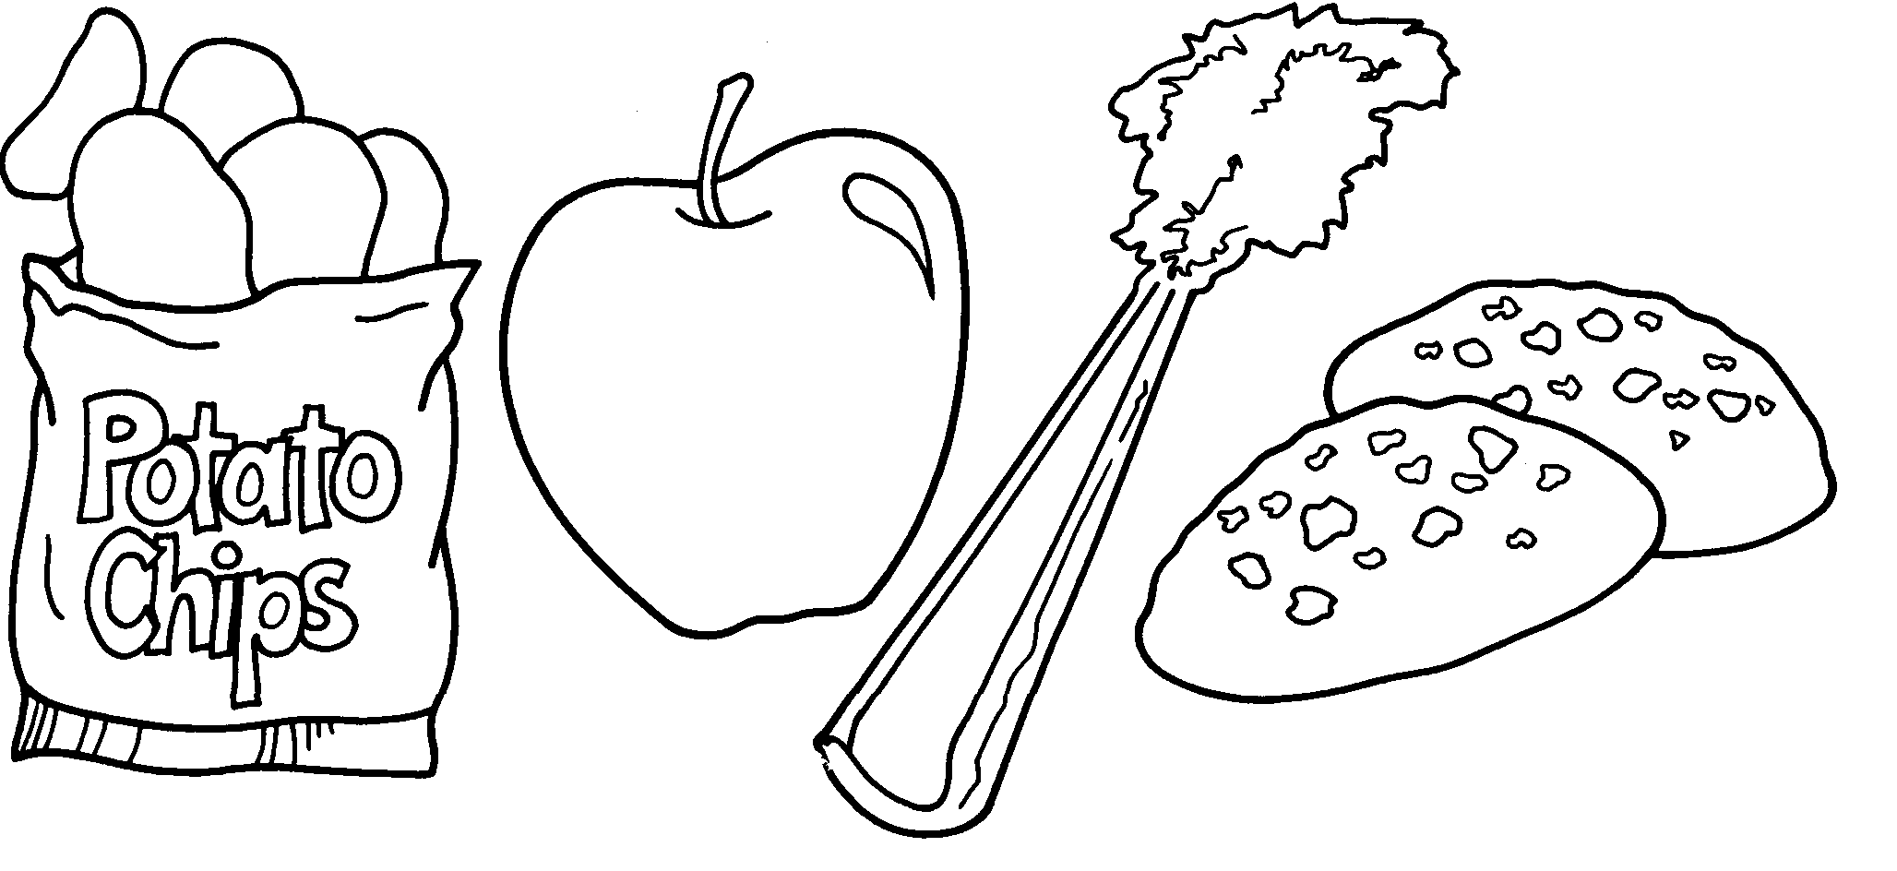

-6-

ADMISSION OF STUDENTS

A child is eligible for admission to kindergarten if s/he has
attained the age of five (5) on or before August 31. The superintendent or designee shall require that each student who registers for entrance to school exhibit his/her birth certificate or similar documentation as proof
of age and birth date, along with proof of required immunizations.

KINDERGARTEN

The Sullivan County School District provides a full day kindergarten program.
Kindergarten is the happy beginning to a lifetime of learning.
It is an area of education where the child is relatively free from
pressure. The pursuit of creativity, exploration, and experimentation is constantly encouraged. It is also an area where habits of acceptable conduct and consideration of others are strongly emphasized. Here,
the individual needs, interests, and abilities of each child are discovered and developed to the fullest possible extent.
Kindergarten lays the foundation of future learning. It provides various experiences through which the child acquires beginning concepts of numbers, language arts, reading, science, social studies,
art, music, physical education, and health. The child learns in kindergarten both as an individual and a member of a group.

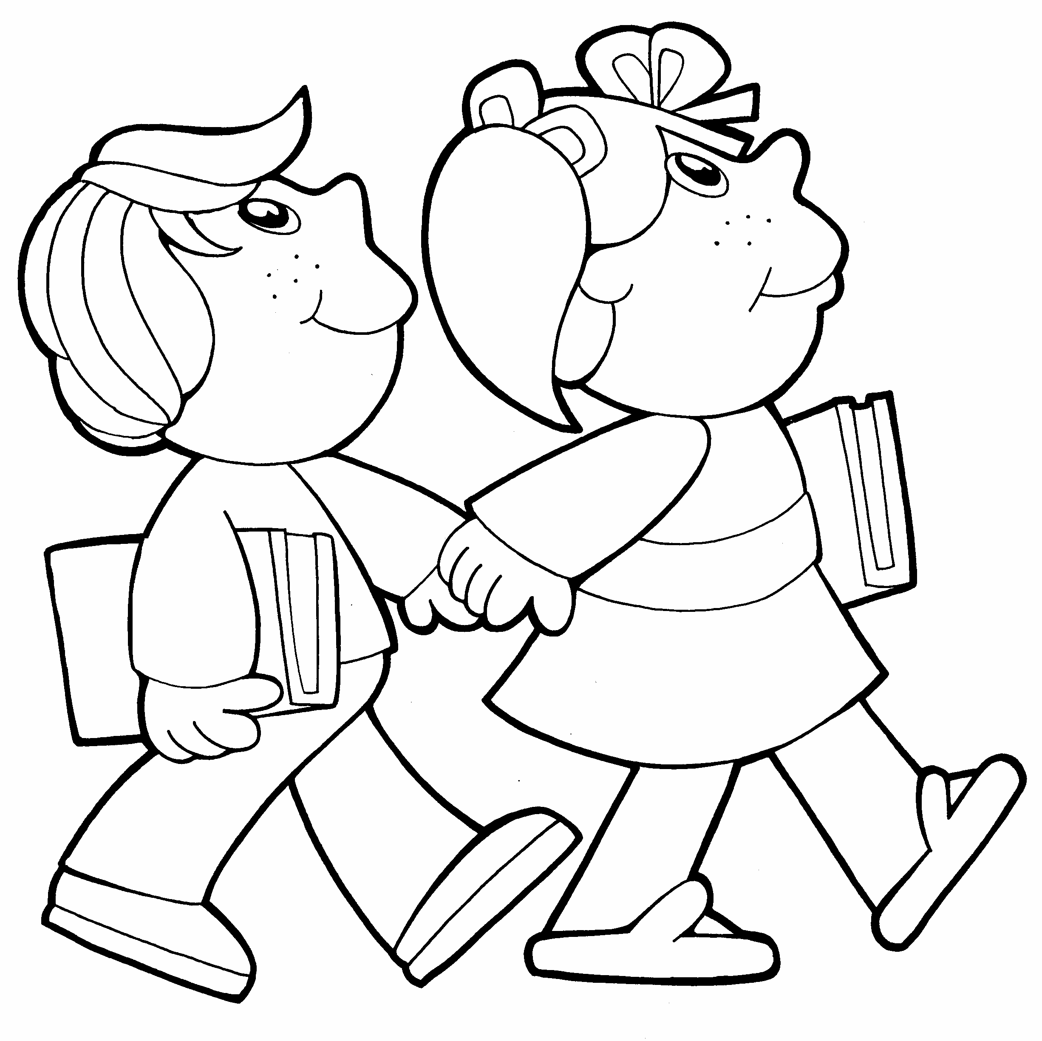

-7-

SCHEDULES

The elementary school runs on a six-day cycle. In essence, a
day name does not signify a schedule of classes, rather a day number -
1 through 6. Therefore, to ensure your child is prepared for a class
such as physical education, you must be aware of the day number and the number of the day your child is scheduled for physical education. Your child’s teacher will forward the necessary information to you. There are many advantages to the six-day cycle. Instructional time is evenly distributed among groups of children, and time is not lost
because of holidays or unanticipated school closings.

PRIMARY:
The primary schedule is formulated primarily by the individual teacher. Subjects include a morning and afternoon reading period, a math period, and a special instruction in art, physical education, music, and library. All other subjects are scheduled at the discretion of the teacher. This provides flexibility in meeting expressed interests and needs of the individual child. Many topics in the primary grades are covered on a unit approach, which allows the teacher to concentrate on a given topic for a longer period of time and affords opportunity to explore various related subjects.

INTERMEDIATE:
Grades 4, 5, and 6 are departmentalized, with large blocks of time devoted to Reading/Language Arts, Math, Science, and Social Studies.

COMPUTER AND INTERNET

It is the student’s responsibility to use computer communication technology in an ethical, responsible, and legal manner for school-related tasks only. Misuse of computer communication technology will result in the user’s access privilege being denied, revoked, or suspended. Misuse may also subject the user to disciplinary action under school policies. In addition, any illegal activities will be reported to the appropriate agencies.

Students are urged to refrain from putting personal information and photographs on the Internet or “chatting” with strangers on their home computers.

-8-

LEARNING SERVICES

Promotion and Retention

The District recognizes that the emotional, social, physical and
educational development of students will vary and that students should be placed in the educational setting most appropriate to their needs. The district establishes that each student shall be moved forward in a continuous pattern of achievement and development that corresponds with the student’s progress, system of grade levels, and attainment of the academic standards established for each grade.

A student shall be promoted when s/he has successfully completed the curriculum requirements and has achieved the academic standards established for the present level, based on the professional judgment of the teachers and the results of assessments. A student shall earn the right to advance to the next grade by demonstrating mastery of the required skills and knowledge.

Promotion of Students with Disabilities.

A student with disabilities, as identified by federal and state statues and regulations, will be subject to promotion criteria appropriate to the student’s age and grade placement unless the student’s Individual Education Plan (IEP), as developed by the IEP committee, addresses and defines alternative learning goals and promotion standards.



-9-

PROMOTION

Promotion of a student will be determined by an evaluation of the

student’s achievement, progress and potential for success during the next school year and the recommendation of district staff. In general, factors to be considered in retention of students include:

- Achievement/Performance

- Ability/Effort

- Attendance

- Chronological age

- Social, emotional, and physical development

Elementary students will be promoted to the succeeding grade level when they have:

- Completed of curriculum requirements of the presently assigned grade.

- Achieved of instructional objectives set for the present grade, as determined by the teacher(s).

- Demonstrated of proficiency to move ahead to the educational program at the next grade level.

- Demonstrated of the degree of social, emotional and physical maturity necessary for a successful learning experience at the next grade level.

-10-

RETENTION

It is not recommended that students repeat grades; however, there are times when a student may benefit from such action. Retention will be considered when, in the judgment of the district staff, it is in the best educational interest of the student involved.

A student who is failing two (2) or more core subjects or one (1) core subject and two (2) special subjects will be considered for retention in the present grade. Core subjects are Language Arts, Mathematics, Science and Health, and Social Studies.

The Child Study Team will gather data about a student in jeopardy of failing.

To promote the cooperation of the home and school and help each student achieve success, parents/guardians will be notified as early as possible if a student is failing to make expected progress in any area.

Alternatives to retention, such as tutoring and summer school, may be recommended by the Child Study Team, teachers and administration, in consultation with the student’s parents/guardians.

A student will not be retained more than two (2) years in any grade, and not more than once at the elementary level.

After two (2) years in the same grade in grades K-6, the Child Study Team may recommend assignment of a student to the next grade, in consultation with the teachers, principal and parents/guardians. If a student is assigned to the next grade, proper notation must be made on the student’s record, citing the reason for the assignment.

-11-

RETENTION PROCEDURES

Teachers will inform parents/guardians as early as possible that a student is having difficulty and that cooperative efforts between the home and school are necessary to assist the student. The teacher is responsible for monitoring the student’s progress and for communicating with the parents/guardians.

If a student continues to have difficulty or is failing courses, and a parent conference cannot be scheduled, the teacher will send a Lack of Progress Letter to the parents/guardians no sooner than the end of the second grading period and no later than the mid-point of the third grading period. Copies of this letter will be placed in the student’s file and forwarded to the building principal.

If a student continues to have difficulty or is failing courses and will be evaluated for retention, the established procedures will be followed:

- The teacher will inform the guidance counselor and principal prior to contacting the parents/guardians again.

- The teacher will notify the Child Study Team regarding the student’s lack of progress. The Child Study Team will meet to review the reasons for the retention, make a recommendation, and meet with the parents/guardians.

- The principal will review all documents and must approve the recommendation for retention. The recommendation for retention will be documented on the student’s permanent record.

- If retained, the principal will send a Retention Letter to the parents by the mid-point of the final grading period.

All parent/guardian requests for retention will be processed in accordance with the above procedures.

-12-

Summer School for Kindergarten through Six

A summer school will be provided at parent cost by the district if alternate funding is not available for students in grades kindergarten through six who evidence the greatest need for additional instruction to master grade-level state curriculum standards and district performance standards in core subject areas.

Promoted - Summer School Recommended

If the student has met all promotion criteria, but assessments indicate the student is not performing consistently at grade level, scoring in the
70 - 74% range in a core subject in grades one through six, then the student will be recommended to attend summer school. If the student does not attend summer school, an academic plan will be developed at the beginning of the next school year to accelerate the student’s learning.

Summer School Required

If the student has failed to meet promotion criteria, scoring below 70% in a core subject or has failed to satisfy the elements of an academic plan for the current year, then the student will be required to attend summer school. If the student shows substantial progress in the area of substandard performance, the student will be promoted to the next grade at the end of summer school. If the student attends summer school and shows minimal or no progress in the area of substandard performance, the student will be retained and an academic plan will be developed by the school at the beginning of the next school year to accelerate the student’s learning. If the student does not attend summer school, the student will be retained in the same grade for the next school year and an academic plan will be developed by the school at the beginning of the next school year to accelerate the student’s learning.

Retention

If the student has failed to meet promotion criteria, scoring below 70% in a core subject area, then the student will be encouraged to attend summer school as an academic assistance strategy to accelerate student learning, but the student will not be promoted to the next grade at the end of summer school. Progress achieved in summer school will be documented in the student’s academic plan for the subsequent school year.

-13-

REPORT CARD POLICY

Report cards are issued four times during the school term for grades K - 6. Your child is graded on the basis of his/her performance as compared with the general expected academic achievement of students at his/her grade level.

STUDENT RECORDS

Parents have the right to access, inspect and review their child’s education records. Furthermore, parents have the right to seek an amendment of their child’s education records that they believe to be inaccurate, misleading or otherwise in violation of the student’s privacy rights.

Parents have the right to consent to disclosures of personally identifiable information contained in the student’s education records, except to the extent that the Family Educational Rights and Privacy Act (FERPA) and its implementing regulations authorize disclosure without consent.

Parents have the right to file a complaint with the U.S. Department of Education concerning alleged failures by the district to comply with the requirements of the FERPA and its implementing regulations.

The district permits school officials with legitimate educational interests to access student records without prior consent of the parent. Those school officials include all teachers who instruct the child, the guidance counselor, school psychologist, and principal.

HOMEWORK

We, the staff, consider homework as an enriching activity, a reinforcement of what has been presented during the day, and/or a
preparation for tomorrow’s lesson.
Homework assignments should be able to be completed independently. In the case of preparatory-type homework, your child will be provided with a purpose for the assignment. This might include the main ideas of what is read or the key vocabulary words in the assignments.
The question of the amount of time a child should spend on homework is debatable, for it varies from individual to individual. The amount of homework assigned should not exceed 10 minutes per
grade. For example, third grade should not exceed 30 minutes; sixth grade should not exceed 60 minutes.

-14-

TESTING

Achievement and State testing is conducted in grades two through
six each spring. Parents have the right to review the assessments two weeks prior to their administration. If parents find the assessments in conflict with their religious beliefs, they may request in writing to have their children excused from the tests.

PARENT-TEACHER CONFERENCES

Parents and Teachers Must Become Partners

A parent-teacher conference is a two-way exchange of information
about your child. It serves as a supplement to the report card. It
provides you with an opportunity to ask the many questions which
you might have concerning the school’s curriculum and your child’s progress, both academically and socially.

For the teacher it is an opportunity to learn more about the needs of
your child. You and the teacher can share ideas.

In essence, both you and the teacher are working toward the same
goal -- the best possible education for your child. By getting together and talking things over, the reaching of this goal is more likely to
become a reality.

In the primary grades opportunity for parent-teacher conferences are planned once a year. These are usually held some time near the
middle of the year. In addition, you should feel free, when a need
arises, to contact the teacher to arrange any additional conferences.
The teacher may also find it necessary to request additional
conferences with you.

Although we have not instituted formally scheduled conferences at
the intermediate level, you should feel free to request conferences. Teachers may also invite you to meet with them.


-15-

ATTENDANCE

It is important that your child be in school every day, in order
to receive maximum benefit from the educational program that the
district provides. We realize that there are times that a student
must be absent from school, such as: illness; medical and dental
appointments; quarantine; impassible roads or inclement weather; required
court attendance; death in family; family emergency - one (1) day; educational trips - ten (10) days maximum - no more than two per
year - requires written pre-approval by the principal; educational tours and
trips with prior approval; and religious events.

The following reasons are illegal and unexcused: truancy (absence from school without a legal excuse), missing the bus - students should be at the bus stop five (5) minutes prior to the scheduled pick-up time, trips not approved in advance, shopping, hunting, fishing, attending sporting events, birthdays or other celebrations, gainful employment, and any reason not listed under
legal excuses. When a student has been absent, a written excuse
must be provided within three days of the return to school. Students
may have one (1) day to make up work for each day missed.

Excessive absences:

If a student accumulates seven (7) or more absences, the parent will be notified by the principal that absences have become excessive
and may be interfering with successful academic progress. Letters
will be sent after eleven (11) and fourteen (14) days of absence. After fifteen (15) days of non-medical absences, the school shall require a doctor’s excuse for every future absence. If the doctor’s excuse is
not provided, the excuse will be considered illegal.

Illegal absences:

After three illegal absences, the superintendent will be notified, and a notice of illegal absence be issued from the principal’s office. Subsequent illegal absences will be prosecuted in accordance with
the Pennsylvania School Code.



-16-

FAMILY TRIP POLICY

The Board recognizes the value of trips that are not a part
of the school’s activities. While these trips can be educationally beneficial, such trips that result in a child’s absence from school
shall require prior administrative approval and adhere to the following:

1. Parents must request approval at least 2 weeks prior to the period absence.
2. Parents shall present an outline of activities included in the trip, which are educationally beneficial to the child.
3. Parents shall assume the responsibility of monitoring assigned school work during the absence.
4. The principal shall make recommendation for approval if:

a. The student has an attendance rate of 90%.
b. The student is passing all subjects.
c. The student is not missing special school activities such
as the Otis Lennon test, which will be administered to third grade students September 26, 2016. The PSSA English Language Arts test will be administered to third through sixth grade students April 3-7, 2017; The PSSA Math test will be administered to third through sixth grade students April 25-28, 2017; and PSSA Science test will be administered to the fourth grade students May 1-5, 2017. The second grade students will take the SAT 10 Achievement Test May 1-5, 2017.
5. The student accepts the responsibility of completing assigned work during the absence and the taking of quizzes and tests missed upon his/her return.
6. Upon the student’s return from an approved trip, the teacher will correct assigned work, administer tests missed, and report to the parent within the general reporting policy and procedures of the school.
7. Educational trips shall be limited to no more than two (2) trips
each school year and shall not exceed ten (10) days of absence during any school year. Requests beyond this limitation shall be reviewed by the Superintendent of Schools and a recommendation made to the Board of Education.
- All days of absence count toward the fifteen (15) days of non-
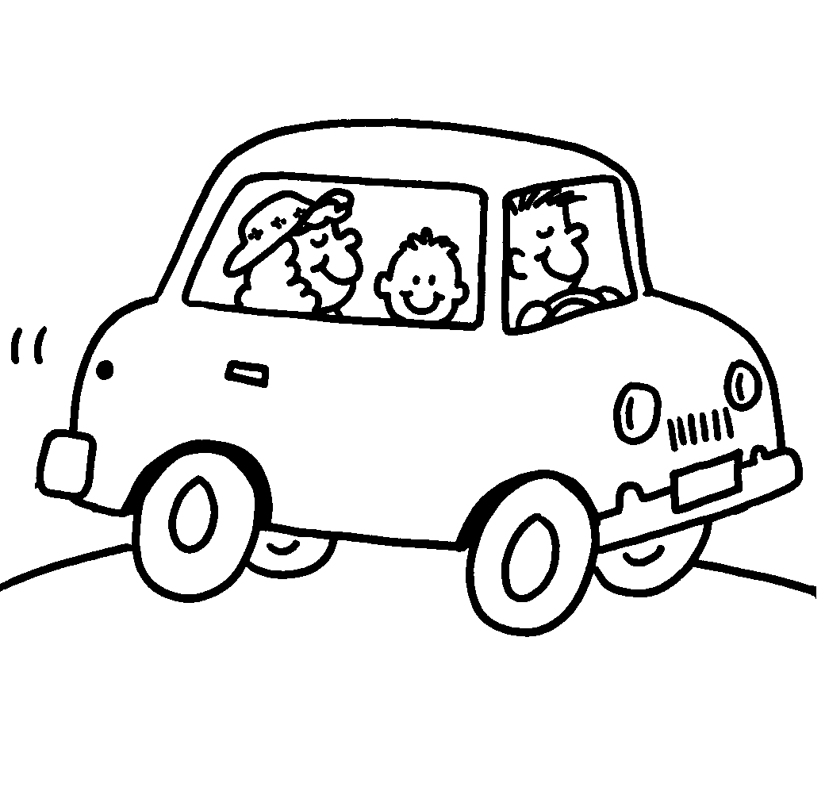
medical absences allowed by the School Code of the Commonwealth of Pennsylvania.

-17-
FIRE DRILLS

Fire drills are conducted once a month, or nine times throughout each school year. Students should know the posted fire drill directions and follow them at all times.
When the fire alarm sounds, students will leave the room. Before leaving, all windows and doors are to be closed and lights are to be turned off. Students should not run, but stay with their class and proceed to the assigned exit in an orderly manner. If an exit is blocked, the nearest exit should be used.
Students should not talk during a fire drill and should remain at least fifty (50) feet away from the building until the signal is given to re-enter. Students should remain quiet and orderly as they return to the building.

TORNADO DRILLS

Tornado drills are practiced at least twice each year, and a formal drill is done once. When a tornado emergency sounds, students will report immediately to their designated area.
Students should remain calm, listen closely for instructions, follow directions quickly, leave rooms and walk in single file with no crowding or talking. Students are to remain silent until they return to the classrooms.

EVACUATIONS AND LOCKDOWNS

Students should know the proper procedures for evacuating the building or implementing a lockdown. In the event of either of these drills, students should remain calm, listen closely for instructions and follow directions quickly. Students should not talk during these drills and should cooperate fully with staff members.

STUDENTS WITH DIVORCED OR SEPARATED PARENTS

The district shall give full rights to either parent unless the district
has been provided with evidence that there is a state law, court order, or a legally binding document governing such matters as divorce, separation, or custody that specifically revokes these rights.

CHILD ABUSE REPORTING

Under Act 151 of 1994, school personnel are required to make a report when they reasonably believe a child has been abused. Employees are to report this information to the administrator and the employee and/or administrator will call the Child Hot Line and/or Children and Youth.
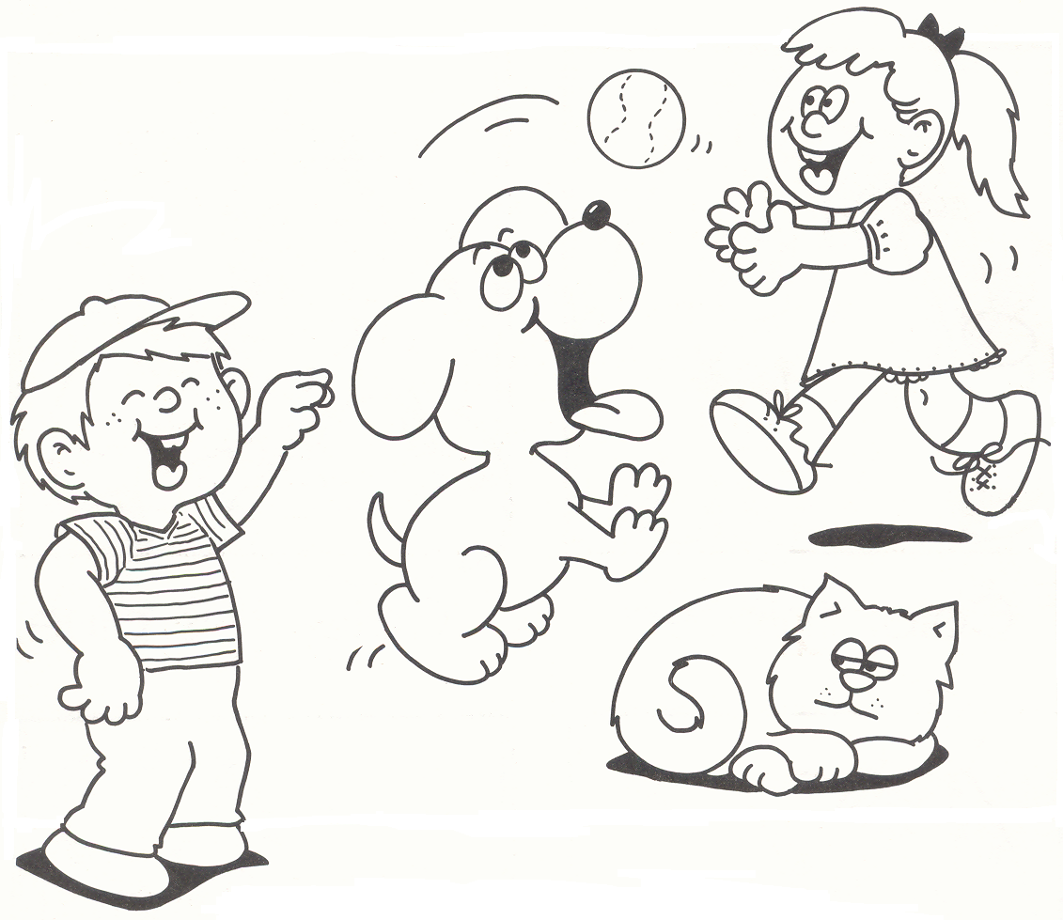
-18-

REPORTING OF SUSPICIOUS ACTIVITY

Students and their parents are also encouraged to report suspicious activity to the local law enforcement agency/State Police at (570) 946-4610.

SCHOOL EMERGENCIES - DELAYS/CLOSINGS

On days when school must be closed or delayed due to inclement weather or other unexpected emergencies, announcements will be made
from most local radio and TV stations. Announcements will be made as
early as possible. Calls will also be sent out via the district’s tele-
communication system at approximately 6:15 a.m.

STUDENT DRESS AND GROOMING

Students are expected to be dressed appropriately during the school day. Student dress should be neat, clean and not disruptive to the learning process. Final decisions regarding appropriate school dress will be made
by the building principal. Students who are inappropriately dressed will be required to change and withheld from class until they can do so.

Inappropriate dress includes, but is not limited to, the following:

1. Halter tops, strapless tops, bare midriffs, “muscle” shirts, tops with straps less than two inches wide or tops that expose cleavage when
sitting or standing.
2. Shorts more than six inches above the top of the knee.
3. Spandex or “biker” shorts.
4. “Cutoffs” unless they are hemmed or cuffed.
5. Holes above the knee in shorts, pants, or skirts.
6. Stretch pants, leggings, or any form-fitting pants without
appropriate length shorts or skirts worn over the top of them.
7. Form-fitting skirts or dresses.
8. Pajamas, pajama pants, or slippers.
9. Bare feet.
10. Shirts, patches, or slogans related to tobacco, drugs, alcohol, or
messages of a suggestive or obscene nature.
11. Hats, headbands and bandanas inside the building.
12. Sunglasses inside the building.
13. Clothing that exposes any part of undergarments.
14. Shorts, pants or skirts with any holes revealing skin above the
knee. Simply placing tape over any hole exposing skin is a
violation of the dress code. Holes exposing skin above the knee
need to be patched to be in compliance with the dress code.

Appropriate formal wear will be accepted at Sixth Grade Recognition.

-19-

MEDICATIONS

NOTE: Parents are advised to give medications at home and on a schedule other than during the school hours. Medication that is ordered by a physician to be given once a day must be given at home. If ordered twice daily it should be given before and after school, and three times daily should be given before and after school and prior to bedtime. If it is necessary that a medication be given during school hours, the following regulations must be followed:

- All medication, including over the counter, must be accompanied by a written order from the attending physician.

- Students are not permitted to transport medication to and from school. It must be delivered to the school nurse(s) by an adult.

- All medication must be brought to school in the original container with the prescription label intact. If medication is not properly labeled, and there is no physician’s authorization & parent permission, the medication will not be administered.

- Students are expected to come to the health room at the appropriate time to take their medications.

- School personnel will not administer or dispense the first dosage of medication to a student.

- A new form needs to be completed every school year.

SELF-ADMINISTRATION OF MEDICATION BY STUDENTS

- The nurse will evaluate medications that are deemed appropriate for self-administration.

- No students in grades K-2 are permitted to self-administer medication.

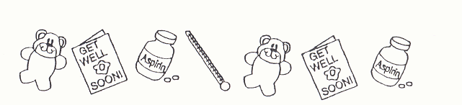

-20-

Medications Kept by Students

All medication must be administered through the health office. Unsupervised, self-administration of medication is not permitted unless a physician specifically writes an order for the student to self-administer the medication independent of the school nurse. In some situations such as inhalers used for asthma, the medication may be carried and self-administered by the student. When these situations arise, the school nurse will verify the medication and self-administration with the physician. Once approved, the school nurse will put a label on the medication with the students’ name, date, and signature of the school nurse to alert staff the medication has been cleared to be carried in the school. This student shall not share the inhaler with other students and shall notify the nurse or designee following each use of the inhaler, according to Policy #210.1.

No medication may be kept by the student at any time without the knowledge of the nurse and/or building principal.

The school nurse assumes no responsibility for storing, dispensing, or supervising medication (prescription or over the counter) which enters the school and is intended for use by a student if the provisions of the district’s medication policy have not been followed by the student or parent.

Cough drops are not considered a medication and may be brought in with a student if the parent or guardian feels they are necessary, as the school nurse’s office will not supply them.

Health Examinations/Screenings

Each student shall receive a comprehensive health examination conducted by the
school physician or private family physician upon original entry and in sixth
grade. Each student shall receive a comprehensive dental examination conducted
by the school hygienist or private family dentist upon original entry and in third
grade. The school nurse shall administer to each student vision tests, hearing
tests, other tests deemed advisable, and height and weight measurements, yearly.
Height and weight measurements shall be used to calculate the student’s weight-
for-height ratio (body mass).

Where it appears to school health officials or teachers that a student deviates from
normal growth and development, or where school examinations reveal conditions
requiring health or dental care, the parent/guardian shall be informed; and a
recommendation shall be made that the parent/guardian consult a private
physician or dentist. The parent/guardian shall be required to report to the school
the action taken subsequent to such notification.

Parents/Guardians of students who are to receive physical and dental
examinations or screenings shall be notified. The notice shall include the date and
location of the examination or screening and notice that the parent/guardian may
attend or may have the examination or screening conducted privately at the
parent’s/guardian’s expense. -21-

DRUGS AND ALCOHOL

Any student on school grounds, during school session, or anywhere
at a school-sponsored activity who is under the influence of alcohol, drugs, or mood-altering substances or who possesses, uses, dispenses, sells, or aids in the procurement of alcohol, narcotics, restricted drugs, mood-altering substances, or any substance purported to be a restricted substance or over-the-counter drug, or possesses drug paraphernalia, shall be subjected to discipline pursuant to the provisions and procedures outlined in Board policies.

TOBACCO

Students found using and/or possessing tobacco in any form are
subject to the following disciplinary procedures.

1st Offense:

1. Non-criminal complaint filed with the District Magistrate.
(If found guilty, subject to fine of up to $50.00 plus costs or alternative form of adjudication.)
2. Three (3) days of Special Study Hall. A conference with student and parent(s) will be required prior to the student’s return.

2nd Offense:

1. Non-criminal complaint filed with the District Magistrate.
2. Five (5) days of Special Study Hall with a parent conference during the five (5) days.

3rd Offense:

1. Non-criminal complaint filed with the District Magistrate.
2. Three (3) days of out-of-school suspension with a parent conference prior to the student’s return.

4th Offense:

Hearing before the Sullivan County School Board with administration recommending expulsion for the remainder of the year.

Ours is a tobacco-free campus. There is no smoking permitted at any school function or on school property. Electronic cigarettes are also
prohibited on school grounds.
-22-

WEAPONS, LOOK ALIKE WEAPONS AND

HAZARDOUS SUBSTANCES

Possession of a weapon including, but not limited to: a knife, cutting instrument, cutting tool, nunchaka, firearm, shotgun, rifle and other tools, instrument, or implement’s capable of inflicting serious injury are prohibited in the school, on the school grounds at any time, at school- sponsored events, or on school transportation. Look-alike weapons and
hazardous materials are similarly prohibited. Administration is required to
report weapons violations to the State Police.

Any student who is determined to have brought a weapon onto school property or who is in possession of a weapon on school property shall be expelled for not less than one year, unless the Superintendent recommends discipline short of expulsion on a case-by-case basis.

Possession of a look alike weapon or hazardous substances on
school property shall be handled on a case by case basis with review
by the Superintendent and may include an expulsion hearing.

SEXUAL/UNLAWFUL HARASSMENT/BULLYING

The policy of the Sullivan County School District is to maintain a
learning and working environment that is free of sexual or unlawful harassment and bullying.

It shall be a violation of this policy for any member of the district staff to harass a student through conduct or communications of a sexual/unlawful nature. It shall also be a violation of this policy for students to harass other students and/or staff through conduct or communications of a sexual/unlawful nature.

Bullying means an intentional electronic, written, verbal or physical act, or series of acts, directed at another student or students
which occurs in a school setting and/or outside a school setting, that is severe, persistent or pervasive and has the effect of doing any of the following:
- Substantial interference with a student’s education.
- Creation of a threatening environment.
- Substantial disruption of the orderly operation or the school.

Bullying, as defined in Policy #249, includes cyberbullying.

Any reported cases of sexual/unlawful harassment or bullying shall be investigated under the guidelines of Policy #248 or Policy #249 with the building principal being the first contact person. Discipline will follow the guidelines of Policy #218.
-23-

BUS BEHAVIOR

The school day begins when a student steps off his/her property to
board the bus. Therefore, the student is under the rules and regulations
of the Sullivan County School District at that time. All rules and regulations apply while being transported to and from school.

Students should exercise caution, good manners, and consideration for other people. Obey the driver; his/her first concern
is for safety.

Guidelines for Pupils Waiting for the Bus

    - Be at your stop five minutes prior to scheduled pick up time.
    - When the bus approaches, get in line.
    - Stay clear of the bus until it comes to a complete stop.
    - Let smaller children board first.
    - Your bus driver has a schedule to keep. It is your responsibility to
be at the bus stop; he/she is not responsible to wait for you.

Boarding The Bus

    - Use the handrail.
    - Go up the steps one at a time.
    - Do not push or crowd others.
    - Go directly to your seat and remain there.
    - The bus will not move until all passengers are seated.
    - Regulations do not permit passengers to stand
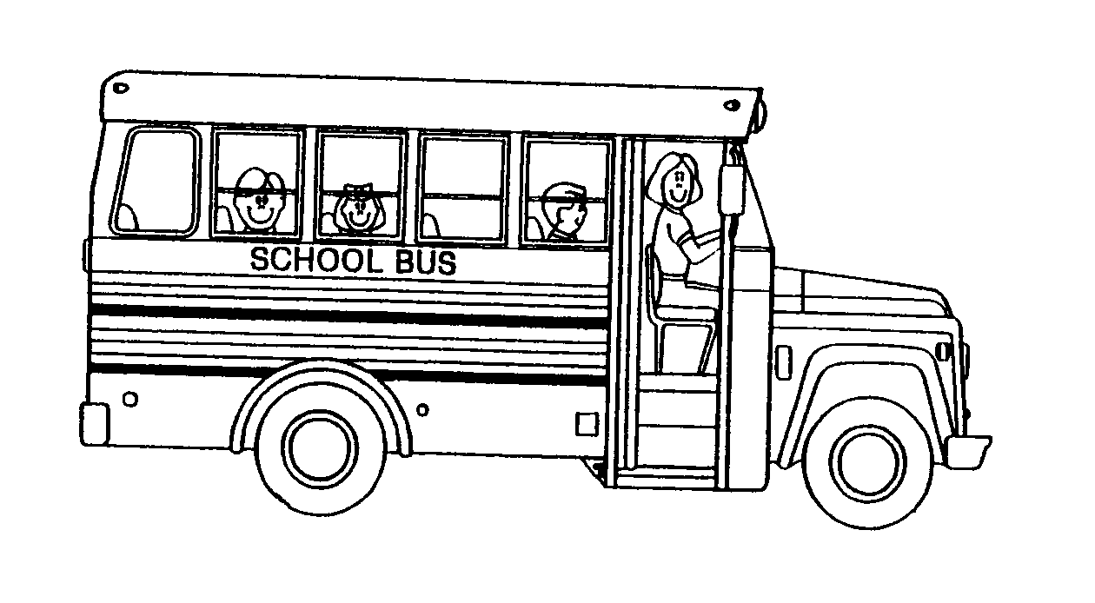
in a moving bus.

-24-

Conduct On the Bus

- Place books or parcels on your lap. Keep the aisle clear.
- Avoid loud talking, use of profanity, and confusion that might distract your driver.
- Do not talk unnecessarily to the driver while the bus is in motion.
- Ask the driver for permission before opening windows.
- Keep arms and head inside the bus.
- Do not throw anything in or out of the bus.
- Use emergency door and exit controls only during supervised drills
or actual emergencies.
- The bus is not a playground. Sit on your rear end with your feet on
the floor in front of you and your hands in your lap.
- Do not fight, push, punch, kick or bite. Keep hands to self!
- No alcohol or tobacco products are permitted.
- Remain seated until the bus has come to a complete stop.
- Help your drivers to keep the bus clean and in good shape.
- Do not eat or drink on the bus; do not write on the seat backs;
do not throw things on the floor.
- Do not damage the bus, property, or clothing of other people.
- Do not litter the bus or the highway.

Getting Off The Bus

- Use the handrail and take one step at a time.
- Do not push or crowd; this could cause an accident.
- After you leave the bus, go directly to your assigned place or home.

You must have a written request from your parents, approved by your building principal’s office, before you can ride a bus other than the assigned bus you ride on a daily basis or to get off at a different approved stop. The written request is also necessary to get off at a stop other than your own!

Requests SHOULD be written by parent/guardian and sent to the
school with your child. The office personnel should NOT be relied
upon to write notes, except rarely in emergency situations.

Parents and students should be aware that some buses in the Sullivan County School District are equipped with a video camera that records the students and their activities on the bus.

-25-

SCHOOL BUS DISCIPLINE

PUPIL CONDUCT ON BUS:

The bus driver has the primary responsibility of enforcing proper discipline on his school bus. When discipline on the bus is
unsatisfactory, the driver should first try to correct the matter
him/herself. When misconduct persists in spite of the efforts of the
driver to correct it, the driver shall make a written report to the
Elementary Principal. The report shall include a description of the
misconduct and a review of the efforts of the driver to correct it.
When the Principal receives this report, he/she shall talk to the pupil(s) involved and the bus driver. The principal will then
determine the action needed.

SUMMARY OF PROCEDURES:

To insure proper pupil behavior on the school bus, the following procedures will be in effect insofar as pupil offenses are
concerned:

1st Offense - Pupil will be reported by the bus driver to the High
School or Elementary Principal who will hold a
conference with the pupil and bus driver. Verbal
reprimand to the pupil. Parents will be notified by the Principal of the offense and advised of the next step if
the misconduct persists.

2nd Offense - Pupil will be reported by the bus driver to the Principal
who will hold a conference with the pupil and bus driver. The parent(s) will be informed by the Principal.
Disciplinary action, including suspension of transportation privileges for up to 3 days, as determined by the Principal will be taken against the pupil.

3rd Offense - Pupil will be reported to the Principal who will hold a conference with the pupil and driver. The Principal will inform the parent(s) and will report the case to the Superintendent. The Superintendent will give the parents an opportunity to attend a hearing. The Superintendent will determine the disciplinary action to be taken, which may include the suspension of transportation privileges for up to 10 days or other disciplinary action. If transportation privileges are suspended, the parents will be responsible for the transportation of the pupil to and from school on these days.

-26-

If the incident is serious enough to warrant it, the administrator(s) has or have the discretion to by-pass any particular step or steps.

If the offense is covered by the school discipline rules, they will apply.

A written report is required from the bus driver to the High School or Elementary Principal for each offense.

The parent of any pupil riding a school bus may contact the High School Principal, Elementary Principal, or Superintendent to report any violation of the transportation policy by a bus driver. The complaint will be investigated, and the results of the investigation will be reported to the parent.

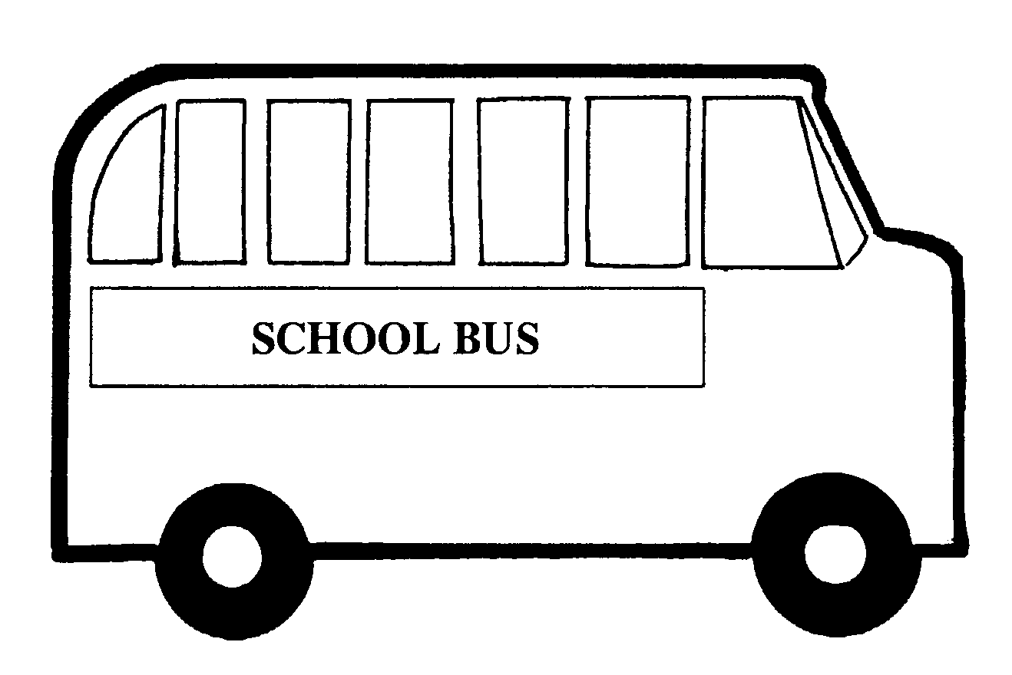

STUDENT SUPERVISION

Employees are responsible for students during the instructional hours of the school day in school; during the instructional hours of the school day on school district property; on school district vehicles; and at school district events held before, during, or after school that are directly observed and supervised by school district staff.

SURVEILLANCE CAMERAS

SCES is monitored by video cameras, both inside the building and outside
the building.

-27-

STUDENT BEHAVIOR K - 6

The disciplinary actions outlined below are minimums. The administration reserves the right to assign a more severe punishment
if the actions of the student warrant doing so.

A. Level One Offenses

1. Class Disruption
2. Dress Code Violation
3. Failure to Return Form or Excuse Card
4. Homework incomplete two or more times in one subject area
per week. (5 homework infractions equals 1 conduct point.)
5. Horseplay with No Intent to Harm
6. Inappropriate Language (1st time only – warning)
7. Insubordination
8. Lying
9. Physical Contact
10. Possession of “No” Item
11. Property Misuse

Level One Disciplinary Actions (1 point for each offense)

1. Warning (one time only) for conversational vulgarity
2. One day of after-school detention
3. Two days of after-school detention
4. Three days of after-school detention
5. Level Two Disciplinary Actions

B. Level Two Offenses

1. Inappropriate Language
2. Cheating/Forgery
3. Dangerous Behavior
4. Disrespect to an Adult
5. Harassment/Teasing (ability, gender, racial, religious, sexual)
6. In an Unassigned Area
7. Inappropriate Display of Affection/Body Parts
8. Physical Aggression
9. Technology Violation
10. Theft
11. Threat to Harm another Student
12. Tobacco Possession/Use (fine will also be imposed)
13. Multiple offenses of Level One items

-28-

Level Two Disciplinary Actions (2 points for each offense)

1. One day of special study hall
2. Two days of special study hall
3. Three days of special study hall *
4. Level Three Disciplinary Action

C. Level Three Offenses

1. Possession or use of drugs/drug paraphernalia or alcohol
3. Combustibles
4. Fighting
5. Vandalism
6. Verbal Assault or Threat to a Teacher
7. Multiple Offenses of Level Two Items

Level Three Disciplinary Actions (3 points for each offense)

1. Three days out-of-school suspension *
2. Five days out-of-school suspension *
3. Up to ten days out-of-school suspension *
4. Level Four Disciplinary Actions

D. Level Four Offenses

1. Arson
2. Terroristic Threats including a Bomb Threat
3. Physical Assault of a Teacher
3. Possession of a weapon
4. Multiple Offenses of Level Three Items

Level Four Disciplinary Actions (4 points for each offense)

1. No less than ten days of out-of-school suspension * OR
2. Placement in alternative education * OR
3. Recommendation to the superintendent for an expulsion hearing before the Board.

*Parent conference required

Offenses are leveled and will receive points accordingly. Students who accumulate six (6) points over the course of the year will be excluded from field trips on the basis of excessive conduct problems. The point(s) for each offense and the cumulative points for the year will be recorded on each Conduct Report.

-29-

Students with Disabilities

No child with a disability shall be punished for a behavior which is a manifestation of his or her disability. Positive strategies and consequences outlined in the district’s Board-approved Behavior Management Plan shall be utilized.

“NO” ITEMS

The following items and/or activities are not permitted in school
buildings during the school day from 8:00 a.m. to 3:35 p.m.:

- open beverage containers other than bottled water in clear store-bought
bottles
- gum
- lighters/matches
- beepers or pagers
- laser pointers or any other electronic device deemed unsafe by
administration
- inappropriate clothing (see Policy #221)
- cards/gambling
- water devices such as water guns
- other items deemed disruptive or dangerous by the building principal

The following items may not be used in the school building during the school day:

- cell phones
- Gameboys, DS/DSI devices
- portable entertainment devices (I-pods, video games, radios, CD players,
or any device with a wireless unfiltered Internet connection, etc.)
- sunglasses
- book bags
- trading cards
- comic books
- hats
- hackie sacs
- yo-yos

The administration has the right to update these lists regularly and change the lists anytime during the school year.

All confiscated items may be picked up by the parents.

-30-

SEARCHES

School district personnel may lawfully search students or their belongings, including but not limited to lockers, electronic devices, purses, backpacks, clothing and other possessions, without a warrant if there is reasonable suspicion that there is a threat to the health, safety or welfare of the student or the school population. This policy applies whenever students and/or their belongings are in school, on school property, attending school-sponsored functions (including extracurricular activities on or off school premises), on school-sponsored transportation, or otherwise under school supervision.

Additionally, the school district may lawfully conduct reasonable searches without specific suspicion in certain circumstances where there is a threat to the health, safety or welfare of the school population. Examples of threats to the health, safety or welfare of a student or the school population include, but are not limited to, the following: reasonable suspicion that a student is in possession of a weapon, drugs or paraphernalia; reasonable suspicion that a student is in possession of stolen property; reasonable suspicion that a student is in possession of pornographic or other inappropriate material; reasonable suspicion that a student has been “sexting” photographs of him/herself or others with his/her cell phone and/or other electronic device and/or is using his/her cell phone and/or other electronic device to bully another student and/or to send threatening messages.

The results of searches may be used as evidence against the student in disciplinary, juvenile, or criminal proceedings. The student generally will be notified and given an opportunity to be present during any search, unless there are exigent circumstances or it is impractical to do so. Parents/Guardians will be notified as soon as is practicable. Lockers, desks and other facilities made available to students are school district property and are subject to search. The school district will also cooperate with law enforcement and may, from time to time, partner with law enforcement to bring a canine on the premises to search for drugs or other illegal contraband.

LOCKERS

A hall locker will be assigned to each student. The locker should be kept clean. The school maintains the legal right to inspect any locker and its contents.

-31-

LOST AND FOUND

There will be many occasions throughout the school year when students will misplace personal belongings. All articles of this nature are to be sent to the main office and placed in an appropriate receptacle. If your child has lost something, please encourage them to inquire at the office. We encourage parents to label each student’s belongings so that they may be easily returned when misplaced.

CARE OF PROPERTY

Students are responsible for books and other instructional materials issued to them.
Lost items should be reported to the teacher immediately. Items not recovered will be paid for by the student before the close of the school year. Students are also responsible for the abuse to the desks, seats, school materials, including books, and lockers which they occupy.
Students responsible for damage to school property must pay the cost of repairing the damage.

STUDENT RIGHTS AND RESPONSIBILITIES

  - A student will not make another student or staff member in the school feel unsafe.
  - A student will not call any other student or staff member a name that will hurt them.
  - A student who participates in any destructive act in school will be disciplined accordingly under the rules of the school’s discipline code. In addition, any student who is involved in the planning of the act or is aware of an act of destruction that has or may take place without contacting the administration immediately will be disciplined accordingly, under the rules of the school’s discipline code.

STUDENT EXPRESSION

Although students have a constitutional right to freedom of speech
and expression, according to Tinker vs. Des Moines Independent Community School District, regulation of public school students’ speech is generally permissible only if the evidence in the records is sufficient to permit school officials reasonably to forecast “substantial disruption of or material interference with school activities” or an impingement “upon the rights of other students.” Likewise, Bethel School District No. 403 vs. Fraser states that a student’s “lewd, indecent, or plainly offensive speech” is not protected by the First Amendment and may be regulated.

-32-

SPECIAL EDUCATION PROGRAM AND SERVICES:

The Purpose of the Identification Process:

The Sullivan County School District is responsible for educating all children within its jurisdiction and providing a free and appropriate education. Each student has particular learning needs that can be met in either a regular education class, a special education class, or a special school. In order to provide the most effective educational program for a student, it is necessary to note each student’s strengths and needs. Through the identification process conducted by properly trained personnel, an appropriate educational program is selected. The Sullivan County School District provides a continuum of settings for its students.

Chapter 15/504 Services:

In compliance with state and federal law, the Sullivan County School District will provide to each qualified student with disabilities without discrimination or cost to the student or family, those related aids, services or accommodations which are needed to provide equal opportunity to participate in and obtain the benefits of the school program and extracurricular activities to the maximum extent appropriate to the student’s abilities. In order to qualify as a student with disabilities, the child must be of school age with physical or mental disability which substantially limits or prohibits participation in or access to an aspect of the school program. These services and protections for qualified individuals with disabilities are distinct from those applicable to all eligible or exceptional students enrolled (or seeking enrollment) in special education programs.
For further information on the evaluation procedures and provision of services to exceptional and qualified students with disabilities, contact the Special Education Coordinator, at (570) 946-8200.

Special Education Services and Programs:

The Sullivan County School District provides the following services and programs for exceptional students. These programs are either administered by the Sullivan County School District, by BLaST (I.U. 17), or by a neighboring school district. The services/programs reflect students with the following physical or mental disabilities.

(A) Autism
(B) Deaf-blindness
(C) Deafness
(D) Hearing Impairment
(E) Visual Impairment
(F) Intellectual Disability
(G) Multiple Disabilities
(H) Orthopedic Impairment
(I) Other Health Impairment
(J) Specific Learning Disability
(K) Speech or language Impairment
(L) Traumatic Brain Injury
(M) Emotional Disturbance

The multidisciplinary evaluation (MDE) team determines the need of special education
for individual students. Each exceptionality has specific criteria to determine eligibility for a special education service or program. (In addition there are also eligibility requirements for the mentally gifted.)

-33-

The following listing notes the type of service or program:

Academic Support Classes:

Gifted Support, Life Skills Support, Emotional Support, Learning Support

Sensory and Communications Support:

Deaf and Hearing Impaired Support, Blind and Visually Impaired Support, Speech
and Language Support, Occupational Therapy, and Physical Therapy.

Special Classes:
Physical Support, Autistic Support, Multiple Disability Support with regard to Chapter
15, other Qualified Students with Disabilities in State and Federal Law. The Sullivan
County School District will provide to each Qualified Student with Disabilities without
discrimination or cost to the student or family, those related aids, services or
accommodations which are needed to provide equal opportunity to participate in and
obtain the benefits of the school program and extracurricular activities to the maximum
extent appropriate to the students abilities and needs. In order to qualify as a Qualified
Student with Disabilities, the child must be of school age with a physical or mental
disability which substantially limits or prohibits participation in or access to an aspect of
the school program. The services and protections for Qualified Students with Disabilities
are distinct from those applicable to all eligible or exceptional students enrolled (or
seeking enrollment) in Special Education Programs.

Early Intervention:
Early Intervention Screening and Programs are operated and administrated by Intermediate Unit #17 (BLaST). For information about Early Intervention, please
contact BLaST IU #17 at (570) 323-8561. BLaST IU #17 personnel, in collaboration
with district staff, provide individual screening and evaluations of preschool aged
children at the Kindergarten registrations held at the elementary school during February of each year. Transition to school meetings are held each spring with parents, students, Head Start, BLaST IU #17, and district participating.
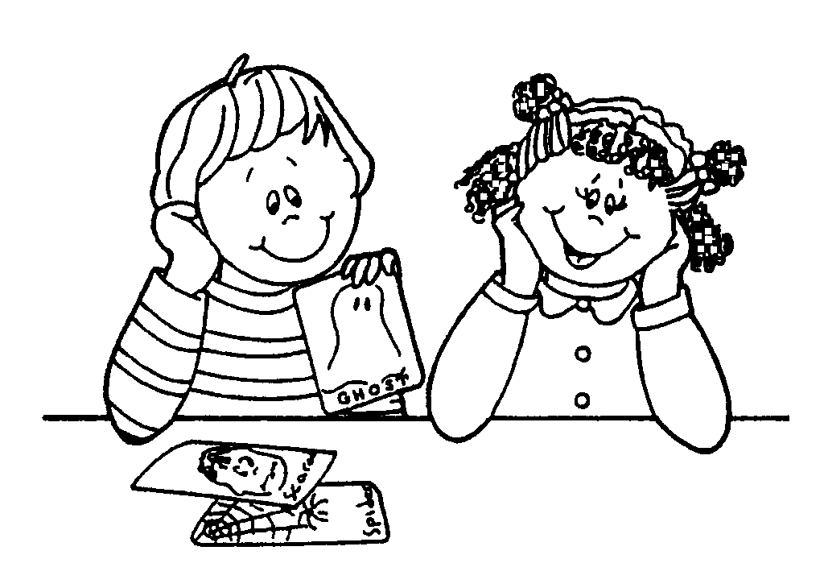

-34-

The Screening Process:

The Sullivan County School District uses the following procedures for
locating, identifying, and evaluating specified needs of school-aged
students requiring special programs or services.

The district, as prescribed by Section 1402 of the School Code,
routinely conducts yearly screening of a child’s hearing acuity in grades
K, 1, 2, 3, 7, 11, and Special Education, and visual acuity in all grades
at the Sullivan County Elementary and the Sullivan County High School.
Gross motor and fine motor skills, academic skills, and social emotional skills
are assessed by classroom teachers on an on-going basis. Height and weight
are assessed yearly for all students.

Screening information will be used within the student’s school to meet his/her
specific needs or to document the need for further evaluation. At the elementary level,
if it is determined that a child needs additional services, the classroom teacher(s) and specialist(s) will make adjustments relative to such things as the child’s learning style, behavior, physical inabilities, and speech problems to be more in keeping with the traditional classroom expectancies. Parents will be notified if a child is receiving additional services. If a student does not make progress, children will be referred to
the Child Study Team and Special Education Coordinator.

The Evaluation Process:

When the Child Study Team determines that a student referral needs to be made,
the parents will be asked to give written permission for necessary individual
professional evaluations. This written consent is called Permission to Evaluate.

After all of the evaluations are complete, an Evaluation Report will be complied
with parent involvement and include specific recommendations for types of
intervention necessary to deal with the child’s specified needs.

Parents are then invited to participate in a meeting (MDE Meeting), where the
results of the multidisciplinary evaluation will be discussed. At this meeting,
the MDE Team, which includes the parents, will determine if the child needs
Special Education Services. If the child needs Special Education, an Individual
Education Program (IEP) will be developed.

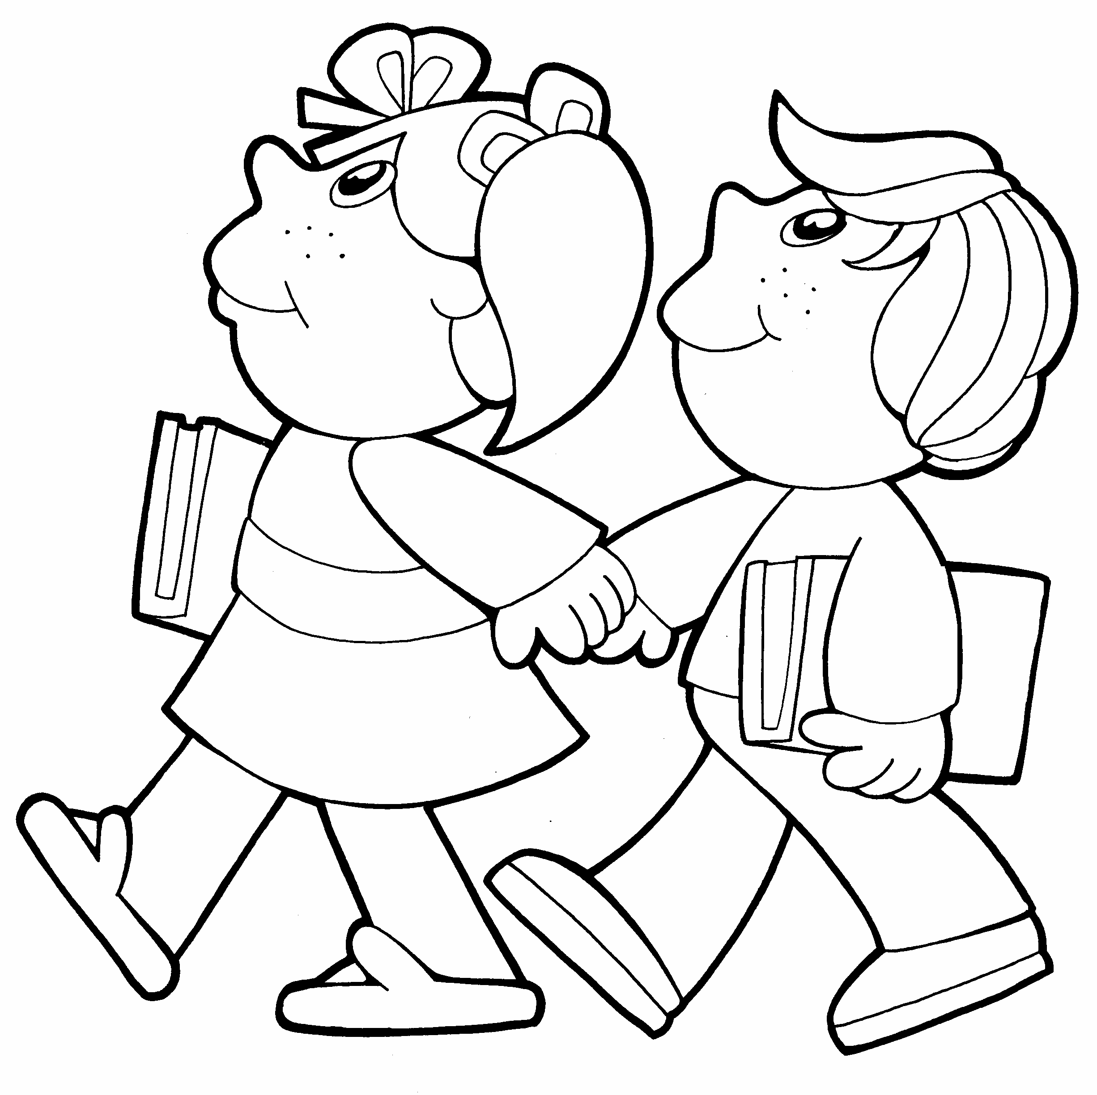

-35-

Parents are then presented with a Notice of Recommended Educational Placement
(NOREP) with which they may agree or disagree. If parents disagree with the
program being recommended, the issue may be taken to mediation or a Due
Process Hearing.

Information about parent rights, mediation or Due Procedures, and specific
Special Education services and programs offered by the district are available
upon request from the building Principal in the child’s school. A parent may
request that the district initiate a screening or evaluation about these procedures
may be obtained by calling the Special Education Coordinator at (570) 946-8200.

Privacy Rights of Parents and Students:

Federal and State legislation protect the rights of students. The foundation of these
rights is based on their Family Education Rights and Privacy Act of 1974 and State
Regulations in Chapter 12.

Education records and personally identifiable information can not be disclosed or
released without parent consent or, if the student is eighteen, without student consent.

All information at either the elementary or high school levels related to school
records is strictly confidential and must adhere to the district student records policy.
This policy is available in all school district offices.

If you have any questions or require further information, please contact:

Elementary Principal at 946-7471
High School Principal at 946-7001
Special Education Coordinator at 946-8200



“HANDS-ON” STATEMENT

Employees may place their hands on a child with no intent to harm in the following situations:

  - To separate students who are fighting or are about to fight.
  - To defend themselves.
  - To come to the aid of a student, or protect the student him/herself.
  - To escort them to the office after student had been given a direct order and the student refuses to follow through. After repeating the directive, if the student still refuses, the employees may place their hand between the student’s shoulder and elbow and escort them to the office.

-36-

SUPPORT SERVICES

SPEECH/LANGUAGE SUPPORT SERVICES

The Speech/Language Support Program provides speech and language screening for all students when they enter school. Direct intervention services are provided on a weekly basis for students as
indicated by their need for specially designed instruction to help in
remediation of error sounds and language skill development.

ENRICHMENT PROGRAM

Children recommended by the classroom teacher, who score two years above grade level on a standardized achievement test, and score well on an individual test are, with parental consent, entered into this program.
The purpose of the program is to provide enriched and challenging experiences beyond that which is normally possible in the classroom setting. In addition to special projects, the program
focuses on cognitive thinking, affective skills, creativity, and research
skills. Advanced experiences in reading, writing, math, and science
are also provided.

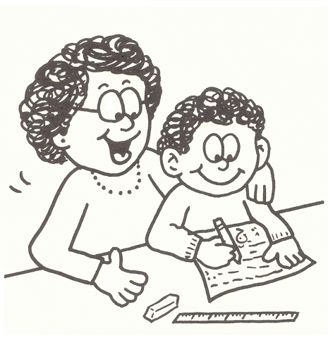

-37-

e.S.A.P. TEAM

The e.S.A.P. team focuses on helping children by removing barriers to learning by using a team approach. Parents and guardians are a crucial part of the process. A team member informs the parents that their child may benefit from services the school has to offer, be it academic, emotional, or social support.
The elementary Student Assistance Program (e.S.A.P.) is behaviorally-based and does not diagnose or treat the child. Student assistance at both elementary and secondary level is a confidential, voluntary process, requiring parent permission to proceed when personal information is involved.
Another key aspect of e.S.A.P. is the active collaboration with outside agencies and school personnel. Drug and alcohol and mental health providers not only provide consultation to school personnel but also can actually sit on the team with school personnel. The goal of this collaboration is to provide parents with information regarding community resources. Evaluations are often provided on-site at the school, and confidentiality is a key part of the process.

PARAPROFESSIONALS

The use of paraprofessionals is an important supportive ingredient
to education. A paraprofessional’s primary function is to support the
teacher in meeting the individual needs of children.
The paraprofessional’s responsibilities include only those things
that have been planned and are directed by the teacher:
1. Monitoring small group and individual learning activities.
2. Monitoring playground and indoor recess activities.
3. Securing, setting up, and running equipment for class lessons.
4. Assisting the teacher in providing a variety of learning
experiences and materials for children’s use.

5. Tutoring of a review nature as planned for and directed by the teacher.

-38-

THE LIBRARY

We believe that books and audio-visual materials are essential tools in encouraging and assisting each child in developing his individual talents and providing experiences which will help him to grow
in social usefulness to become a responsible, participating member
of our democratic society. No phase of the entire school program is
in a better position to foster the self-learning demanded by our ever changing society to bring meaning to and understanding of the community and world in which we live.

Objectives:

To provide a good climate for the cultivation of the school objectives and to cooperate with other teachers and the administrative staff in furthering these objectives.

To acquire and organize books and other materials which are appropriate to the curriculum and to the individual needs of the girls
and boys of this community.

To help children to interpret themselves in relation to others
and to develop in them a feeling of self-worth.

To develop in children a better understanding of life about them.

To arouse in them a true intellectual curiosity, with emphasis on the habit of personal investigation.

To introduce to them their rich cultural heritage.

To instill an understanding of the importance of reading and libraries in an informed nation, and for this reason, to develop skill
and resourcefulness in the use of libraries and materials through instruction suitable to the age and development of the child.
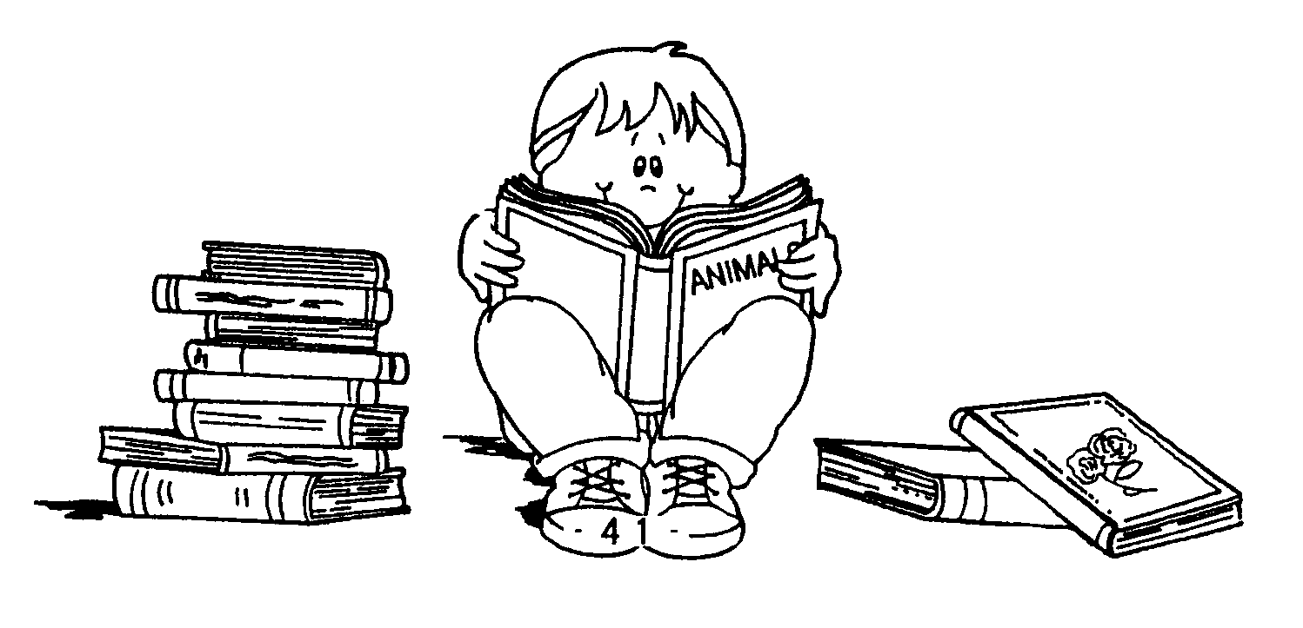

-39-

PARENT INVOLVEMENT

Attendance at scheduled Parent-Teacher Conferences is an excellent way to show your children you are concerned about them
and their school progress. We, the teaching staff, also encourage your attendance at P.T.O. gatherings. However, it should be kept in mind that this is not always the most opportune time to discuss, in- depth, your child’s progress. Therefore, we suggest that you limit inquiries about your child to general items and perhaps set a time when an in-depth conference can be held. We encourage you to contact teachers by phone at school at any other time and to arrange for meetings as needed.

PARENT-TEACHER ORGANIZATION

Our School PTO strives to:

- Develop a closer connection between school and home by encouraging parent involvement in their children’s lives, education, class and school.

- Enhance the educational experience by supporting academic and enrichment activities.

- Improve the environment at our school by providing volunteer and financial support.

- Support the extracurricular activities of the school.

- Coordinate, encourage, and fund programs and projects to support the curriculum.

-40-

VISITATION REGULATIONS

Parents are welcome and encouraged to visit our schools for
the purpose of classroom observation and meeting with staff members. The following procedures are set forth for the purpose of maintaining productive instruction for the benefit of all children and to facilitate observation by parents under the most ideal conditions. In no way does the school wish to discourage visitation - rather, we encourage
your visits.

1. Please arrange for your classroom visit one day in advance by contacting your child’s teacher.

2. Preschool children should not participate in classroom
visitation.

3. You may assist or check the work of only your child during
the visit.

4. Classroom visits are not advisable at the time of parent-teacher conferences.

5. Visits for the purpose of observation or conferences that have
not been previously arranged may be impossible to facilitate.

6. Visitation will not be permitted on days of Diagnostic, Mental Ability, Achievement, or other such testing.

7. Participation of parents in classroom parties is limited to
assigned room-mothers.

8. Visitors cannot be transported on a school bus.

9. At all times, visitors must report directly to the office and sign
in when they arrive and leave. Visitors are requested to wear an appropriate visitor’s badge, which is available in the office. Your cooperation in arranging school visits is appreciated and will result in a more profitable visit for you.

-41-

PARTIES

Halloween, Christmas, and Valentine’s Day are the only occasions
upon which classroom parties may be held.
Room-mothers may be called upon to aid teachers on these occasions. Notices concerning these parties will be sent to you in advance. Classroom parties shall offer minimal amounts of foods (maximum 2 or 3 items) that contain added sugar as the first ingredient. Items should be offered that contain greater than 2 grams of fiber/serving, are moderate in sodium, and have minimum to no trans fatty acids. Fresh fruits and vegetables should be included. Water, 100% fruit juice, or milk should be offered as the beverage choices. Parents/caregivers are asked to refrain from bringing preschool children to these parties.
Birthdays of individual children can be recognized within the guidelines of the Wellness Policy/PDE’s Nutritional Standards (in beginning packet). If you so desire, your child will be allowed to provide a nutritious treat for the children in the class.

Teachers should be given notice of this in advance.

FOOD AS REWARDS

Food will not be used as a reward for classroom or school activities unless the reward is an activity that promotes a positive nutrition message (i.e., guest chef or in conjunction with a curricular area).

FIELD TRIPS
A field trip is defined as “an educational experience outside the school which would supplement a unit of study of topic which is being undertaken in the classroom”.
The greatest value of a field trip is found when it serves as a culmination to that which is being studied. The teacher and the children develop objectives to be accomplished by the trip. Students may have a guide which might contain things to watch for, questions to be answered, and suggestions for children to aid them in formulating their own questions about what is seen.
The trip must contribute to and be supportive of a current educational happening that is being undertaken in the school.
While children are on the trip, they are subject to normal school rules for
behavior.
Parental authorization slips are required whenever children are transported for any school activity. Authorization forms will be sent to you prior to the date of the trip and must be returned before your child can participate in the planned activities. Failure to return authorization forms will preclude your child’s participation on the field trip.
Students may participate in field trips only if they are passing all subjects, or receive written permission from the teacher(s) of any classes they are failing. Students with outstanding disciplinary actions or having excessive conduct problems (incurring six or more conduct points throughout the year) will also be excluded from field trips, according to Policies #121 and #218.
-42-

INTRAMURALS

An intramural program is provided after school for grades four through six. This program is designed to extend those skills presented
in the physical education program. Team play and individual skill development are emphasized. Activities in our program include wrestling and basketball.

It is expected that students who are participating in intramurals
are receiving adequate grades and are not chronic behavior problems. If students have an F or two D’s at the time of intramurals or have numerous conduct referrals, they will not be permitted to participate.

Students participating in intramurals must be in attendance for the full day unless the absence for that day is an excused absence and has been pre-approved by the principal.

OTHER SCHOOL SPONSORED ACTIVITIES

Similarly, it is expected that students who are participating in other school sponsored activities, such as Reading Competition, Band, Chorus, Open Gym, etc., are receiving adequate grades and are not chronic behavior problems. If students have an F or two D’s at the time of activities or have numerous conduct referrals, they will not be permitted to participate.

HAZING

Hazing is defined as any activity that recklessly or intentionally endangers the mental health, physical health, or safety of a student for the purpose of initiation of membership in affiliation with any organization recognized by the Board.

If a student believes that he/she has been subject to hazing, the student shall promptly report the incident to the building principal who shall conduct a timely, thorough, impartial, and comprehensive investigation and report to the Superintendent. In addition, the principal shall prepare a written report summarizing the investigation and recommending disposition of the complaint. Copies of the report shall be provided to the complainant, the accused, and others directly involved, as appropriate.

-43-

AFFIRMATIVE ACTION AND COMPARABILITY

IN SCHOOL AND CLASSROOM PRACTICES

The Board declares it to be the policy of this district to provide an equal
opportunity for all children to achieve their maximum potential through
the programs offered in the district’s schools regardless of race, color,
handicap, creed, religion, sex, ancestry, or national origin.



SULLIVAN COUNTY SCHOOL DISTRICT MISSION STATEMENT

The mission of the Sullivan County School District, is to Educate, Engage, and Empower our Griffin Family!

-44-
INDEX

Page
Admission of Students 7
Affirmation Action 44
Attendance Policy/Absence Procedure 16
Breakfast Program 5
Bus Behavior 24 – 25
Bus Discipline 26 – 27
Care of Property 32
Child Abuse Reporting 18
Computer and Internet Use 8
Delays & Closings 19
Divorced/Separated Parents 18
Dress & Grooming 19
Drugs & Alcohol 22
Elementary Student Assistance Program (SAP) 38
Emergency Drills 18
Family Trip Policy 17
Food As Rewards 42
Field Trips 42
“Hands-On” Statement 36
Hazing 43
Homework 14
Intramurals 43
Kindergarten 7
Library 39
Lockers 32
Lost & Found 32
Lunch Program 6
Medications/Health Exams & Screenings 20 – 21
Mission Statement 44
Paraprofessionals 38
Parent Involvement 40
Parent Teacher Organization 40
Parent Teacher Conferences 15
Parties 42
Promotion/Retention Policy/Summer School 9 – 13
Report Cards/Student Records 14
Reporting Suspicious Activity 19
Schedules 8
School Calendar 46
Searches 31
Sexual/ Unlawful Harassment/Bullying 23
Special Services & Programs 33
Special Teachers 4 Staff 3
Student Behavior 28 – 30
Student Rights and Responsibilities 30 – 31
Student Supervision/Surveillance Cameras 27
Tobacco 22
Visitation Regulations 41
Weapons 23
-45-

SCHOOL CALENDAR
2016-2017

August 25 First Day for Students
October 31 End of Marking Period
January 18 End of Marking Period
March 27 End of Marking Period June 8 Students’ Last Day

NO SCHOOL

September 2 Teacher In-Service
September 5 Labor Day
October 10 Teacher In-Service
November 24 – 25 Thanksgiving Vacation
November 28 Deer Day
November 29*
December 23 – January 2 Winter Break
January 16 Teacher In-Service
February 17*
February 20 Teacher In-Service
March 20*
April 10*, 11* 12*, 13*, 14, 17* Easter Vacation
May 26*, 29 Memorial Day
June 8 Last Day for Students
June 9 Teacher In-Service
*SNOW MAKE-UP DAYS*

November 29 February 17 March 20 April 10 April 11
April 12 April 13 April 17 May 26

Any additional days will be added to the end of the school year.

PROGRESS REPORTS

K-6 September 27 December 6 February 21 May 4

REPORT CARDS

K-6 November 7 January 25 April 3 June 8

TESTING DATES

Sept. 26 Grade 3 Otis Lennon Ability Testing Week
April 3-7 Grade 3 – 6 PSSA English Language Arts Test
April 25-28 Grade 3 – 6 PSSA Math Test
May 1-5 Grade 4 PSSA Science Test
May 1-5 Grade 2 Stanford Achievement Test Week

-46-

SIGNATURE PAGE

Sullivan County Elementary School

Dear Parent or Guardian,

Please indicate that you have received a copy of the student handbook that contains important information regarding the building, curriculum, grading, attendance, discipline, student services, and extracurricular activities. Also, please take time to review the handbook with your child. Remember, the handbook is only a guide and is not all inclusive. Please sign below, tear out this page and return it to the school with your child. We look forward to a positive and productive year.

Sincerely,

Mrs. Mary Louise McClintock

Elementary Principal

Student’s Name: ______________________________

Room: _________________________

_____________________________
Parent/Guardian Date

THIS PAGE MUST BE SIGNED AND RETURNED TO THE SCHOOL BY THURSDAY, SEPTEMBER 1.


-47-

