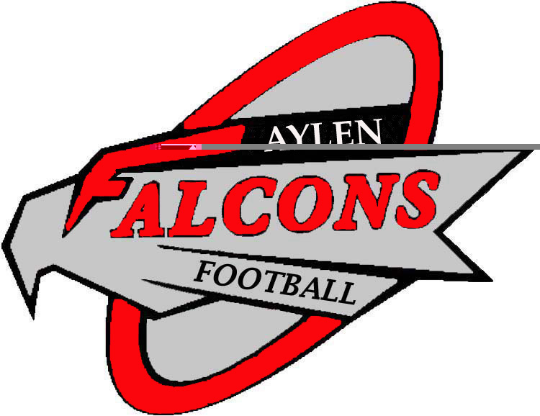
Aylen Football Pre-Season Checklist

Mark these important dates on your calendar:
Clearance Day: Wednesday, August 17th, from 1:00pm-3:00pm
Gear Handout: Monday, August 22nd, 8th grade 1-2pm; 7th grade 2-3pm
First Practice: Monday August 22nd Both teams 3-5:30pm

AUGUST 17TH IS OUR MANDATORY RED CARD CLEARANCE DAY! FOLLOW THE STEPS BELOW TO GET YOUR ATHLETIC CLEARANCE TAKEN CARE OF!
- First Step: Complete the digital forms found at https://puyallupschools.rankonesport.com
  - Cautions, Considerations and Responsibilities
  - Steroids Flyer
  - Athletic Eligibility Form
  - Concussion / Sudden Cardiac Arrest Information Sheet
  - Parent Permission
- Second Step: All football players are required to have a current physical and concussion screening (SCAT3 form which can be downloaded from the districts athletic page.) If you have not had a physical in the last two years you are required to get one. During that physical you will also need a concussion pre-screening. Not all doctors offer this service! If your doctor does not you can also go to ATI (www.atipt.com/concussion-psd) to complete this requirement.
- Third Step- All players will need to pay the district athletic fee and ASB card fee.
  - Athletic Fee/ASB Card-$70 total ($40 athletic fee, $30 ASB card), reduced for those who qualify for free/reduced lunch.
  - Paid online at: http://www.ezschoolpay.com/ or in the Aylen main office.
  - Bring your receipts with you for clearance!
- Fourth Step- Next, they will turn in all paperwork related to the red clearance card to the Aylen athletic director, Mr. Jones. All athletes must have the following documents completed and turned in before a clearance card (Red Card) is issued and participation allowed:
  - Aylen Red Card: Only the top portion of the front side (above the dotted line) needs to be completed unless your athlete has a life threatening condition. If your athlete has a condition we need to be aware of please include their student health care plan and/or a current medication form.
  - Participation History/Physical Examination Forms: Physicals are valid for two years.
  - SCAT3 Concussion Pre-Screening Test form: Also valid for two years.
  - Receipt: A receipt showing that you have paid for your ASB and athletic fees.
  - Signature: All of the above is brought to the Aylen athletic coordinator (Mr. Jones) who reviews the paperwork and signs the red clearance card.
- Fifth and final step- Football players must show a red clearance card and a receipt for the asb and athletic fees to the football coaches to receive their gear the following Monday August 22nd.

OTHER IMPORTANT DETAILS
- Players failing to make this date and time will have to wait until practice begins, which is scheduled for August 22nd to get a red card. Please note that delays in getting paperwork done could lead to a player being ineligible for the first athletic contest.
- Athletes will not be allowed to practice until a red card is turned in along with other required paperwork to be handed out on this day (August 17th).
- Our first week of practice is August 22nd – 26th. Information regarding practice times, gear handout, and location will be given out on August 17th during clearance and can also be found at:
  - http://ajh.puyallup.k12.wa.us/activities___athletics/athletics_home_page/football/

Have a great summer,
Coach Jones
Email: jonesbe@puyallup.k12.wa.us
Phone: 253-841-8723 (leave message)

