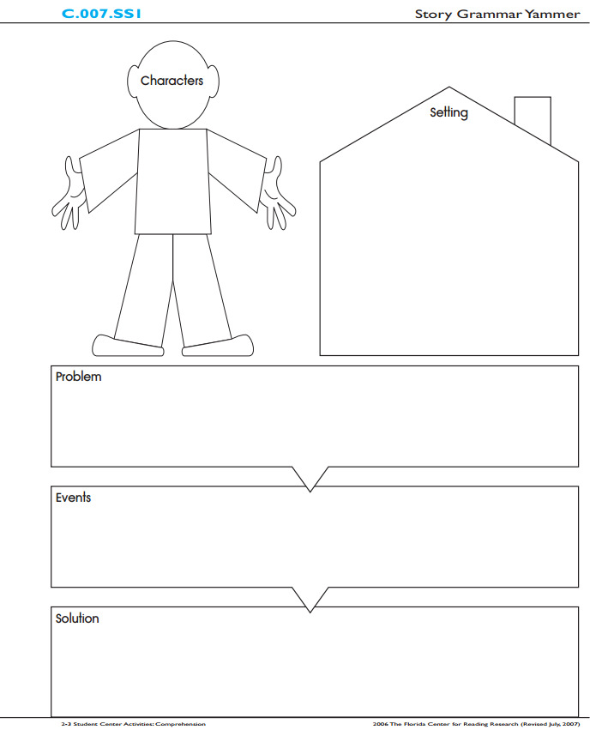
Content Objective: I can recount and describe a text in using story elements.

Level 1 - Story Elements Rubric
3 | 2 | 1
Student will accurately identify the story elements with a graphic organizer.  *Must have all of the following  Characters Setting Problem Solution | Student will identify some of the story elements with a graphic organizer.  * Only has some of the following  Characters Setting Problem Solution | Student is unable to identify the story elements with a graphic organizer.  *Has only 1 or none of the following  Characters Setting Problem  Solution

