Garden City Public Schools
56 Cathedral Avenue
Garden City, NY 11530

Coordinator of Public Information
Catherine Knight, Ed. D.
516 478-1079

May 29, 2018

For Immediate Release:

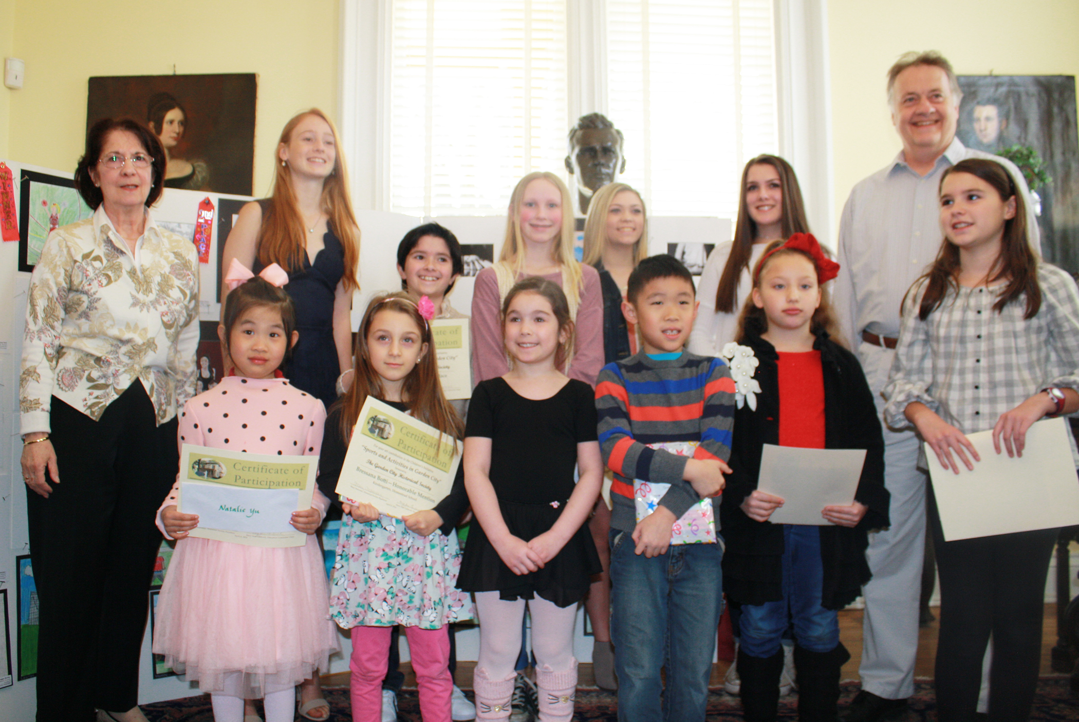

GCPS Art Students Win Awards in GC Historical Society Art Contest

Congratulations to 25 Garden City Public School students who won awards in this year’s Garden City Historical Society’s Art Contest. District students were awarded five First Place prizes, five Second Place awards and 15 Honorable Mentions.
Pictured here are several of the District’s winning students at the awards ceremony held on April 8th.

K – 1st Grade

1st Place – Natalie Yu – K - Homestead
2nd Place – Ava Reni – 1st Grade - Locust
HM – Tyler Chung – 1st Grade - Locust
HM – Bressana Botti – K – Homestead
HM – Danica Drewes – K – Hemlock
HM – Madeleine Maier – 1st Grade – Hemlock
HM - Cleo Hux – 1st Grade – Hemlock
HM – Lia Stoller – K – Hemlock

2nd – 5th Grades

1st Place – Michael Ragas – Grade 4 – Stratford
2nd Place – Alicia Zhang – Grade 5 – Stewart
HM – Ella Pocock – Grade 5 – Stratford
HM – Nicole Geiger – Grade 3 – Stratford
HM – Emily Racich – Grade 3 – Stewart
HM – Claire LeLeonee – Grade 3 – Stewart

Middle School

1st Place – Katie Heckelmann – Grade 7
2nd Place – Kyle Ippouti – Grade 7
HM – Ana Gaztanaga – Grade 6
HM – Aliyah Valdez – Grade 7
HM – Jan O’Keeffe – Grade 7

High School – Drawing

1st Place – Jenn Medjid – Grade 12 – Mr. Uttendorfer
2nd Place – Lily Malone – Grade 9 – Mr. Fediw
HM – Lauren Kuzma – Grade 9 – Mr. Fediw

High School – Media

1st Place – Amanda Galioto – Grade 10 - Denise Holz
2nd Place – Kristen Flynn – Grade 10 – Mr. Karp
HM – Tom Beal – Grade 12 – Mr. Uttendorfer

