East Columbus
High School

Thirty-two Gator Lane
Post Office Box 401
Lake Waccamaw, NC 28423

(910) 646-4094
Fax: (910) 646-3779

www.eastcolumbushs.com

“WHERE EVERY STUDENT COUNTS”
CONTENTS

Administration 2
Principal’s Message 3
Classroom & Teaching Assignments 5
Support Personnel 6
Department Chairpersons & Homerooms 7
The Block Schedule 8
Principal’s List/Honor Roll 8
School Traditions 9
School Calendar 10
School Map/Floor Plan 11
Bell Schedule 12
Bell Schedule (Early Release) 13
Bell Schedule (Two-Hour Delay) 14
Fees 15
Insurance 16
Gator Grub 19
Exit Standards 20
Class Rank, Marshals, and Honor Graduates 22
Grade Classification 23
Off-Campus and Dual Enrollment Course Work 24
Traditional Early Graduation Rules 24
Exit Documents 24
North Carolina Academic Scholars Program 24
Grading and Reporting 25
Report Card Release Dates 26
Diabetes Care Plan 27
Students’ Records 28
Lockers 35
Student Checkout 33
Clubs and Organizations 34
Motor Vehicles on Campus 37
Student Rules and Regulations 38
School Uniforms 70
Instruction: Wellness 59
Attendance 67
Assignments, Releases, Transfers 69
Use of Metal Detectors 72
Notification of Rights under PPRA 76
Interscholastic Athletics 79
Restraints & Management of Student Behavior 82
Freshman Success Academy Outline 87
East Columbus Alternative Academy 88
Notification before Non-Exempt Pesticide Applications 91
Annual Notification of Pest Management Program 93

ADMINISTRATION

Mark Bridgers ……………………….Principal

Tonya Hannah …………….......Assistant Principal

Bobby Vaughn ………………Assistant Principal

East Columbus High School
32 Gator Lane
Lake Waccamaw, North Carolina 28450
(910) 646-4094 – Fax (910) 646-3779

Principal’s Message

Dear Students:

Please allow me to welcome each of you to the 2011 – 2012 school year at the East Columbus High School, home of the Gator. Now that your summer break has ended, you are surely ready for another productive school year.

Here at ECHS, it is the goal of the faculty and staff to provide you with a meaningful and quality education. To accomplish this, it is necessary to emphasize regular attendance and punctuality
which are both vital for academic achievement. I would encourage you to read the County’s policy
on attendance and then monitor yourself to ensure that you are adhering to these requirements.

Each year brings new challenges, but it also brings new opportunities for you to grow. Our success
will begin with a great start to the 2011-2012 school year. Please take the time to read this handbook carefully; share it with your parents, and then govern yourself accordingly. You will especially note that the Columbus County Schools’ uniform policy will be in full effect this year. The ECHS family looks forward to helping you make this the most successful school year yet!

Sincerely,

Roy Mark Bridgers

Mark Bridgers, Principal

“Where Every Student Counts”

A North Carolina high Growth School – 1998, 1999, 2000, 2002, 2004, 2005
Adequate yearly Progress (AYP) – 2005

CLASSROOM & TEACHING ASSIGNMENTS

TEACHER ROOM SUBJECT

Baldwin, Jerlene 142 ISS
Barker, Mariel 201 Science
Bellamy, Edell (Sgt. Maj.) 316 JROTC
Best, Ray 304 Auto Tech
Bodie, Erin 218 Science
Bracey, Karl 134 Health/PE
Britt, Kathy 315 Business Education
Chestnutt, Dottie 214 Math
Collins, Belinda 211 English
Davis, Franklin 216 Math
Dove, Brooke 125 Dance/Theatre
Dowless, Tim 127 Art
Farnum, Valerie 116 Exceptional Children
Faulk, Jamie 129 Chorus/Band
Fowler, Brian 312 Horticulture
Frink, Crystal 204 Social Studies
Graham, Sharon 111-9 Social Worker
Haley, Karen 305 Social Studies
Hewett, Greg 310 Nova Net
Hill, Whitney 302 Agriculture
Damato, Brittany 203 Math
Hodnett, Kyle 306 Spanish
Ivey, Connie 111-6 School Nurse
Jones, Melissa 207 Exceptional Ed.
Jordan, Sherry 313 Business Education
Jernigan, Adam 219 Science
Kasell, Toby 146 Alternative Academy
Marlowe, Gretchen 206 English
Mercado, Linda 213 English
Moore, Jennie 319 Exceptional Children
Moss, Curtis 146 Alternative Academy
Munn-Goins, Ophelia 316 JROTC
Patillo, LaTonya 311 Business Education
Petteway, Judy 206 English
Powell, Amy 217 Science
Richardson, CeeGee 215 Math
Sellers, Ryan 212 Math
Shepherd, Patricia 111-3 Guidance
Slusarczyk, Karen 317 Home Economics
Stephens, Karlyn 205 Health/PE
Strickland, Dawn 303 Social Studies
Todd, Regina 110 Media Center
Tyson, Hope 300 Health Occupations
Church, Bruce Club Room Exceptional Ed.
Williamson, Tara 146 Alternative Academy

SUPPORT PERSONNEL

OFFICE/MEDIA/SUPPORT STAFF
Ellon Jacobs Secretary/Treasurer
Julie Bartrop Teacher Assistant
LaCinder Freeman Teacher Assistant
Renee Patrick NCWise Data Manager
Cheryl Shaw Job Coach
Wendy Suggs Receptionist
Lisa Thomas Clerical Assistant
CAFETERIA STAFF
Sharon Bowen Manager
Deborah Mitchell Assistant Manager
Toni Freeman Worker
Cathy Moore Worker
Stephanie Robinson Worker
Deloris Waddell Worker
CUSTODIAL STAFF
Reginald Murphy Head Custodian
Joe Gaskins Custodial Assistant
Lillian Johnson Custodial Assistant
Cathy Moore Custodial Assistant
Lisa Moore Custodial Assistant
ADDITIONAL PERSONNEL
Randy Faulk Special Populations
Sheila Spaulding Academically Gifted

DEPARTMENTAL CHAIRPERSONS

Agriculture – Bryan Fowler
Arts Education – Jamie Faulk
Business – Sherry Jordan
English – Belinda Collins
Foreign Language – Kyle Hodnett
Family & Consumer Science – Karen Slusarczyk
Physical Education – Karlyn Stephens
Science – Erin Bodie
Social Studies – Dawn Strickland
Exceptional Education – Valerie Farnum
Freshman Academy – Judy Petteway

HOMEROOM TEACHERS

NINTH GRADE TENTH GRADE

Mauriel Barker Dottie Chestnut
Judy Petteway Brooke Dove
Brittany Damato Tim Dowless
Crystal Frink Amy Powell
Karlyn Stephens Bruce Church
Melissa Jones Linda Mercado
Jenny Moore Gretchen Marlowe

ELEVEN TH GRADE TWELFTH GRADE

Karen Haley Ophelia Munn-Goins
Belinda Collins Dawn Strickland
Karen Haley Sherry Jordan
Kyle Hodnett Hope Tyson
Ryan Sellers Erin Bodie
Adam Jernigan Kathy Britt
CeeGee Richardson Karen Slusarczyk

THE BLOCK
SCHEDULE

East Columbus High School uses the block scheduling system. We are pleased that most results and comments are favorable. However, we will continue to work toward improving this concept.

Block scheduling is fairly simple. Students can earn eight units a year and will need to concentrate on only four courses at a time. We also feel that less student movement results in fewer disciplinary problems.

We recognize that the continued success of this program will be determined by what actually goes on during those ninety-minute class periods. Group activities, role playing, cooperative learning, and many other techniques should be more evident in all classes. Your input and feedback regarding block scheduling will be appreciated.

PRINCIPAL’S LIST & HONOR ROLL

Principal’s List: Students will be recognized each grading period plus first and second semester by earning all A’s.

Honor Roll: Students will be recognized each grading period plus first and semester by earning no grade below a B.

Please note that these are academic honors: do not include any conduct marks in the calculation (county policy).

A 93-100
B 85-92
C 77-76
D 70-76
E 69 and below

SCHOOL TRADITIONS

School Colors Green and Orange

School Mascot Gator

School Yearbook The Gator

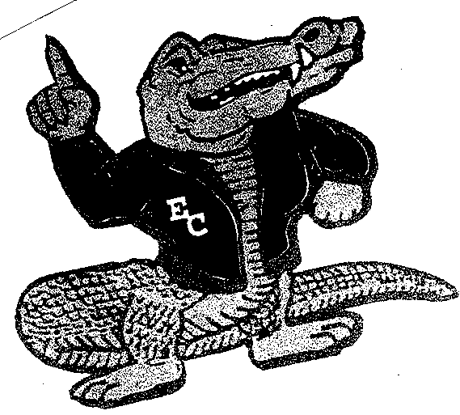

The symbol picture above was developed by students and teachers from Acme-Delco and Hallsboro
High Schools prior to consolidation in 1992. The group was polled for information concerning who
they were and what they wanted to become as they consolidated to form East Columbus High School.

First, the overall shape of this symbol represents the architectural design of plaza courtyard at the
main entrance of the school.

The two schools are consolidating to become the mighty Gators. The group said they would be confident
and would become number 1 in academics and athletics. The Gator in the middle is certainly assured and confident looking. His letter sweater indicates the number 1 status in athletics. His #1 indication with
his paw represents high academic performance.

The circle behind the paw represents a rising sun indicating a new birth as East Columbus High School
and the Gators.

The waves beneath the Gator represent Lake Waccamaw, the largest geographical landmark in the area.

The stripes at the top pay heritage to the Tigers of Hallsboro High School. The sword & shield at the
bottom pay heritage to the Trojans of Acme-Delco High School.

EAST COLUMBUS HIGH SCHOOL
MAP LEGEND

100 – Club/Special Use Room 212 – Mathematics
101 – Custodian 213 – English
102 – Custodian 214 – Mathematics
103 – Teacher’s Lounge 215 – Mathematics
104 – Teacher’s Workroom 216 - Mathematics
105 – Custodian 217 - Science
106 – Book Storage 218 - Science
107 – LAB 219 - Science
109 – Administration 300 – Health Occupations
110 – Media Center 301 – Social Studies
111 – Pupil Personnel Services (Guidance, etc.) 302 - Agriculture
112 – Girls Weight Room 302S – Agriculture Lab
113 – Storage 303 – Social Studies
114 – Storage 304 - Automotive
115 – Ticket Booth 304S – Automotive Lab
116 – Special Education 305 – Social Studies
117 – Custodian 306 – Spanish
118 – Student Commons 307 –
119 – Auditorium 308 – Special Education
120 – Gymnasium 309 – Special Education
121 – Cafeteria 310 – Nova Net
122 – Girls Locker Room 311 – Business Education
123 – Custodian 312- Agriculture
124 – Athletic Office 312 – Agriculture Lab
125 – Dance/Drama 313 – Business Education
126 – Laundry 314 - JROTC
127 – Art Room 314S – Electro Mech Tech
128 – Girls Team Locker Room 315 – Business Education
129 – Choral Room 316 - JROTC
130 – Boys Team Locker Room 317 - Home Economics
131 – Band Room 318 – Home Economics
132 – Injury Office 319 - Remediation
133 – Storage Room 320 - JROTC
134 – Athletic Office
136 – Boys Locker Room
138 – Weight Room
140 – Storage
142 – ISS
144 – Central Receiving
146 – Alternative
148 – Alternative
200 – Freshman Academy Storage
201 – Science – Freshman Academy
202 – Floater – Freshman Academy
203 – Math – Freshman Academy
204 – Social Studies – Freshman Academy
205 – Health – Freshman Academy
206 – English – Freshman Academy
207 – Lab – Freshman Academy
208 - English
209 - Lab
210 - English
211 – English

Bell Schedule

7:50 Breakfast

8:00 1st period

8:03 Warning Bell

8:06 Tardy Bell

9:36 2nd period

9:39 Warning Bell

9:42 Tardy Bell

11:09 Senior Bell

11:12 1st lunch bell (Rooms 208-219, 300-304, 306, 308)

11:12 3rd period bell (Rooms 125-148, 200-207, 305, 309- 320)
11:15 Warning Bell

11:18 Tardy Bell

11:40 3rd period bell (Rooms 208-219, 300-304, 306, 308)

11:43 Warning Bell

11:46 Tardy Bell

12:45 Senior Bell

12:48 2nd lunch bell (Rooms 125-148, 200-207,305 ,309- 320)
1:16 4th period bell

1:19 Warning bell

1:22 Tardy bell

2:52 Dismissal

EARLY RELEASE BELL SCHEDULE

7:50 - 8:00 Breakfast

8:03 Warning Bell

8:06 – 9:06 1st Period

9:09 Warning Bell

9:12 – 10:12 2nd Period

10:15 Warning Bell

10:18-11:18 3rd Period

11:21 Warning Bell

11:24-12:24 4th Period

12:24 – 1:00 Lunch

1:00 Dismissal

TWO HOUR DELAY BELL SCHEDULE

9:50 – 10:00 Breakfast

10: 06 – 11:06 1st Period

11:12 – 12:12 2nd Period

12:12 – 12:40 1st Lunch

12:18 – 1:18 3rd Period

1:18 – 1:46 2nd Lunch

12:46 – 1:46 3rd Period

1:52 – 2:52 4th Period

COLUMBUS COUNTY SCHOOLS
SCHOOL FEES
2010-2011

- ALL SCHOOLS – GRADES K-12 (All Students)

Instructional Materials 3.50
Physical Education 1.50

- HIGH SCHOOL

Guidance 1.00
Science and Lab Fees 5.00
Small Business/Entrepreneur 10.00
Keyboarding/Typewriting 20.00
Computer Courses 20.00
Arts, Band, Chorus, Dance, Theater Arts 20.00
Career and Technical Education 20.00
(Agriculture, Home Economics, Trade and Industrial
Technology, and Health Occupations)
Teacher Cadet Program 20.00

- MIDDLE GRADES

Art, Band, Careers, Chorus 5.00

- POLICIES

  - Membership dues in school clubs and organizations are optional with the student.
  - Instructional materials and special subjects fees shall be used only for the purpose for which they collected. Supporting invoices for expenditures from these accounts shall be a part of the school’s bookkeeping records.
  - School fees prescribed by the Columbus County Board of Education shall be set up in the school’s ledger books
as separate accounts.
  - Fees collected for students or their parents shall be made in accordance with GS 115C-103 and 1215C-47 (6) of North Carolina Public School Laws.

Some Students left unpaid bills at other schools. It should be noted that these debts have followed you to East Columbus
and you are expected to pay them immediately. If you cannot make full payment at this time, contact office personnel to
make arrangements.

CHILD FIND STATEMENT

Columbus County Schools is committed to identifying and serving all children with disabilities who
are in need of special and related services. If you know of a child or youth who has been diagnosed or
suspected of having a disability, please contact the principal or the exceptional children’s director.

AMERICAN ADVANTAG MARKETING GROUP, INC.
NCHSAA ENDORSED INSURANCE PLANS

STUDENT ACCIDENT
ONLY INSURANCE

North Carolina Voluntary Plan
Premium Rates for 2007-2008

This Policy Plan provides coverage up to the Maximum Benefit for each Injury and is designed to pay Covered Medical Expenses incurred as a result of accidental Injury. Certain specific benefits are limited.

Option 1: 24 Hour Coverage Single Option Double Option Triple Option
Provides coverage for Injuries sustained all year long;
24-hours a day until one year after the date the school
year begins (excluding Varsity Football).

With Extended Dental $62 $97 $147
Without Extended Dental $55 $90 $140

Option 2: AT-SCHOOL COVERAGE Single Option Double Option Triple Option
Provides coverage for Injuries sustained at school or
During school-sponsored activities until the end of the
regular school term (excluding Varsity Football).

With Extended Dental $19 $29 $40
Without Extended Dental $12 $22 $33

Option 3: FOOTBALL COVERAGE (Grades 10-12) Single Option Double Option Triple Option
Provides coverage for Injuries sustained while practicing
or participating in High School Varsity Football.

With Extended Dental $92 $157 $222
Without Extended Dental $85 $150 $215

NOTE: Any 9th or 10th grade student that plays with
the Varsity team must purchase Football Coverage.

EXTENDED DENTAL COVERAGE
Provides supplemental coverage for Injury to Sound,
Natural Teeth to students who are covered by At-School,
24-Hour or Football coverage.

Underwritten by: Administered by:
United HealthCare Insurance Company UnitedHealthcare StudentResources
PO Box 809066
Dallas, Texas 75380-9066

AMERICAN ADVANTAGE MARKETING GROUP, INC.
NCHSAA ENDORSED INSURANCE PLANS
ACCIDENT ONLY BENEFITS
2007-2008 NORTH CAROLINA VOULUNTARY PLAN
The Policy provides for loss due to a covered Injury up to the Maximum Benefit for each Injury. Provided that the treatment by a licensed physician begins within 30 days from the date of the injury, benefits will be paid for Covered Medical Expenses incurred within 52 weeks from the date of Injury up to the Maximum Benefit per service as scheduled below:
Single Option Double Option Triple Option
Maximum Benefit $50,000 Maximum Benefit $75,000 Maximum Benefit $100,000
Inpatient
Room & Board: Usual and Customary Charges Usual and Customary Charges Usual and Customary Charges
Hospital Miscellaneous: $500 first day/$250 each subsequent $750 first day/$375 each subsequent $1,000 first day/$500 each subsequent
Day/$5,000 maximum day/$7,500 maximum day/$10,000 maximum
Intensive Care: Usual and Customary Charges Usual and Customary Charges Usual and Customary Charges
Physician’s Visits: $25 per visit $40 per visit $60 per visit
(Benefits are limited to one visit per day and do not apply when related to surgery or physiotherapy)
Registered Nurse: Usual and Customary Charges Usual and Customary Charges Usual and Customary Charges
Outpatient
Day Surgery Misc: 80% of Usual & Customary Charges/ 80% of Usual & Customary Charges/ 80% of Usual & Customary Charges/
$1,000 maximum $2,000 maximum $3,000 maximum
(Usual and Customary Charges for Day Surgery Miscellaneous are based on the Outpatient Surgical Facility Charge Index)
Outpatient Miscellaneous: $250 maximum $500 maximum $750 maximum
Physician’s Visits: $25 per visit $40 per visit/$500 maximum $60 per visit
(Benefits are limited to one visit per day and do not apply when related to surgery or physiotherapy)
Physiotherapy: $25 per visit/5 days maximum $40 per visit/ 5 days maximum $75 per visit/5 days maximum
(Benefits are limited to one visit per day)
Emergency Room: $250 maximum $350 maximum $500 maximum
(Use of room and supplies; treatment must be rendered within 72 hours from time of Injury)
X-Rays: $150 maximum $250 maximum $300 maximum
(Including the professional interpretation)
CAT Scan/MRL: $500 maximum $750 maximum $1,000 maximum
Prescription Drugs: Usual & Customary Charges Usual & Customary Charges Usual & Customary Charges
Laboratory: Paid under Outpatient Miscellaneous Paid under Outpatient Miscellaneous Paid under Outpatient Miscellaneous
Injections: No Benefits No Benefits No Benefits
Orthopedic Braces &
Appliances: $300 maximum $400 maximum $500 maximum
Inpatient and/or Outpatient
Surgeon’s Fees: 80% of Usual & Customary Charges/ 80% of Usual & Customary Charges 80% of Usual & Customary Charges
$1000 maximum $2,000 maximum $3,000 maximum
(Specified Surgery based on data provided by Ingenix, Inc) (No more than one procedure through the same incision will be paid)
Anesthesist/
Assistant Surgeon: 25% of surgery allowance 25% of surgery allowance 25% of surgery allowance
Ambulance: $300 maximum/ Air ambulance is $400 maximum/ Air ambulance is $500 maximum/ Air ambulance is
Limited to $500 limited to $1,000 limited to $1,500
Consultant: No Benefits No Benefits No Benefits
Dental: $200 per tooth $400 per tooth $600 per tooth
(Injury to Sound, Natural Teeth only)
Replacement of Eye
Glasses, Contact Lenses,
Hearing Aids: $500 maximum $500 maximum $700 maximum
(When due to a covered injury)

Usual and Customary Charges are based on data provided by Ingenix, Inc. using the 75th percentile.
Benefits will be provided as mandated by the state of North Carolina for Emergency Services.

This is a brief illustration of coverage offered through the K12 Student Athletic and Accident Insurance.
The Master Policy issued will be the contract and will govern and control the payment of benefits.
The Policy is a non-renewable one year term policy.
The policy contains an Excess Provision for mandatory coverage. The entire premium must be paid by the policyholder and 100% of the participants must be insured.
No benefits are payable for expense incurred that is paid or payable by other valid and collectible insurance.

Gator Grub

BREAKFAST: Student: Reduced, 9-12 ……………………… $ .30
PK-8………………………………….. Free
Paying, 9-12 ………………………….. .90

Adult/Others: ..…………………………………. $ 1.75

LUNCH: Student: Reduced………………………………… $ .40
Paying, PK-8…………………………... 1.90
Paying, 9-12……………………………. 1.95

Adult/Others: ………………………………….. $ 3.25

Add new Exit Standards
pages here. (19 & 20)
EXIT STANDARDS

All students will graduate from a rigorous, relevant academic program that equips them with the knowledge, skills, and dispositions necessary to succeed in both post-secondary education and 21st Century careers and to be participation, engaged citizens. Academic rigor and relevance are based on established expectations that ensure that all students develop the capacity to master content that is complex and challenging.

A student must complete one of the following courses of study: College/Tech Prep, College/University Prep, or Occupational Prep. The Occupational Course of Study is available for certain students with an Individualized Education Plan (IEP). (See Course of Study Exit Standards Chart on the Following page.) Students entering high school in 2009 – 2010 or later will take “future-ready” courses.

In addition, each student must pass the reading and mathematics portions of the N.C. Competency Tests. Note that the attainment of at least Level III on the reading and/or mathematics parts of the Grade 8 N.C. End-of-Grade Tests will satisfy the appropriate competency testing requirements. (The one standard error of measurement which allows promotion form grade eight does not satisfy the competency requirements.) Students must satisfy the N.C. Online Test of Computer Skills requirements. All attendance requirements must be met. If a course has a N.C. End-of-Course Test, it serves as the final exam, and the student must take the test to earn the course credit.

Beginning with the students who enter nine in 2007-2008, the expanded high school exit standards will be effective.

Students must score at proficiency Level III or above in the following End-of-Course Test to earn a diploma:
- English I
- Algebra I
- Biology

If students do not pass, they will be given the opportunity to participate in remediation and a maximum of two retest.

Each student must also complete a graduation project that will include:
- a review process,
- an eight to ten page research paper written on an approved topic of student’s choice,
- a product related to the paper that requires significant hours of work,
- a portfolio that reflects the graduation project process,
- a presentation to a panel of community and faculty members, and
- literature, service-based learning, or work-based learning experiences as defined by state rubrics.

The potential to complete the high school course required for college entry in a three-year period will be an option.

CLASS RANK, MARSHALS, AND HONOR GRADUATES

- Class Ranking- Set by State Board of Education on February 3, 1994

  - Curriculum Organization (Grades 9-12)

- Course Levels -4
  - Advancement Placement
  - Honors
  - Standard
  - Remedial

- Definitions
  - Advancement Placement- Course that have the highest level of difficulty. Students enrolled in these classes can be exempt from certain college freshmen courses based upon performance on the Advanced Placement tests. Students must take the AP Test to receive AP credit.
  - Honors- Selected courses that have a high level of difficulty as designated by State standards.
  - Standard- Courses that have an average to high level of difficulty.

  - Class Ranking

High schools (grades 9-12) are required to use the N.C. Grading and Weighting Standards that started with the 1994-1995 school year.

GRADING AND WEIGHTING STANDARDIZATION

NUMERICAL GRADES FOR STANDARD COURSES

96-100=4.00 91 = 3.38 86 = 2.75 81 = 2.13 76 = 1.50
95 = 3.88 90 = 3.25 85 = 2.63 80 = 2.00 75 = 1.38
94 = 3.75 89 = 3.13 84 = 2.50 79 = 1.88 74 = 1.25
93 = 3.63 88 = 3.00 83 = 2.38 78 = 1.75 73 = 1.13
92 = 3.50 87 = 2.88 82 = 2.25 77 = 1.63 70-72 = 1.00
<69 = 0.0

WEIGHTING

  - Weighed grader point average should be based on the following:
- Honors courses may receive one additional grade point.
- Advanced Placement courses may receive two additional grade points.

II. School Marshals
The top ten percent of the students in the junior class will qualify to serve as marshals based on their academic performance as calculated at the end of the first semester of the junior year. This calculation will be based on freshmen and sophomore final weighted grade point average plus first semester of the junior year weighted grade point average.

III. Honor Graduates

    - Students ranked in the top ten percent of their graduating class, based on academic performance, will qualify for the designation of “Honor Graduate” and will receive the appropriate recognition for this accomplishment.

    - The academic performance referred to above will be based on the student’s total high school experience as determined by final weighted grade point averages as calculated by SIMS.

    - Schools will recognize the positions of valedictorian and salutatorian.

    - Class rankings will be established at the end of each semester.

PRINCIPAL’S LIST

Students will be recognized for the Principal’s List each grading period, plus first and second semesters, by earning
all A’s on courses attempted. A conduct grade is not included in the calculations.

HONOR ROLL

Students will be recognized for the Honor Roll each grading period, plus first and second semesters,
by earning no grade below a B. A conduct grade is not included in the calculations.

Note: Certain school-sponsored honor clubs/societies have their own published criteria which may consider character and conduct.

GRADE CLASSIFICATION

A high school student shall be classified according to units passed. No student may take two required
English course failure or a fourth-year student needing 11th or 12th grade English to graduate. The courses must be taken in sequence: English I, II, III, IV.

The basic graduation rule is that a student shall have earned his/her maximum potential credits minus four (potential - 4 = graduation).

To enter 9th grade: Must complete 8th grade

Potential Minimum
To Enter Credits Credits Required Calculation
10th grade 8 units 6 units 8 - 2 = 6
11th grade 16 units 14 units 16 – 2 = 14
12th grade 24 units 20 units 21 – 4 = 20
For graduation 32 units 28 units 32 - 4 = 28

OFF-CAMPUS AND DUAL ENROLLMENT COURSE WORK

Any Student who plans to seek course credit outside the Columbus County School District must have prior approval of her or his principal. In accordance with established policies and regulations of the North Carolina State Board of Education, the Columbus County Board of Education allow selected students enrolled in the secondary schools of Columbus County to be concurrently enrolled in an institution of the Community College System of North Carolina.

Students may be enrolled to be concurrently in a community college subject to the following conditions:

- Must be 16 years old.

2. A grade earned on the community college campus shall become part of the student’s record.

3. A qualifying senior must be enrolled at the high school in a minimum of two 90-minutes courses.

4. A dual enrollment application form must be submitted for the semester the student seeks to qualify for enrollment at the community college. The form shall be signed by the parent or legal guardian, school principal, and admissions offer of the community college. The form will be available at each high school.

- The student and the family shall be responsible for all costs associated with enrollment at a community college.

- Qualifying students enrolled in an approved program at a community college shall be fully responsible for transportation to and from such institution with no liability incurred by the Columbus County Board of Education.

- The student shall provide to the high school the original registration form and receipt for tuition and fees. The college shall provide the official grade report at the student’s request.

TRADITIONAL EARLY GRADUATION RULES

For students who have met all graduation requirements at the end of first semester of their senior year, the following traditional early graduations rules will apply:
- The early graduate may remain in contention for those honors and awards associated with his/her graduating class; e.g. valedictorian, scholarships.
- As a member of the adult community, a graduate in invited to all school functions which are open to the public.
- A graduate is not eligible to participate in student functions. Examples include, but are not limited to, athletic and academic competitions, club meetings/events/trips, and dances. Exceptions will include:
    - Spring commencement ceremonies
    - Junior-Senior Prom
    - Achievement ceremonies and special functions on approval of the principal.

EXIT DOCUMENTS
- Diploma
- Certificate of Achievement: A person who does not satisfy the N.C. Testing Program requirements but who meets all other North Carolina diploma requirements may receive a certificate of achievement. Opportunities will be available for student to satisfy the testing requirements. A public notice will appear in local newspapers before testing dates. If student does pass at some future date, the certificate may be traded for a diploma.
- Graduation Certificate: A vailable to certain students with Individual Education Plans.
- Attendance Certificate: A local certificate acknowledging that the student has attended high school for four years. Requires principal approval (Board Policy 8-45).

NORTH CAROLINA ACADEMIC SCHOLARS PROGRAM

The North Carolina Academic Scholars Program encourages students to pursue a well-balanced and rigorous high school program. Students who complete the requirements receive special recognition by the State Board of Education, including a special seal affixed to the diploma, recognition in the commencement program, and identification on all transcripts as a North Carolina Scholar. Candidates are identified by the end of grade 11 and their candidacy can be included in application forms to colleges and universities. To become a North Carolina Academic Scholar, the student must complete the College/University Course of Study and have an overall four-year unweighted grade point average of 3.5.

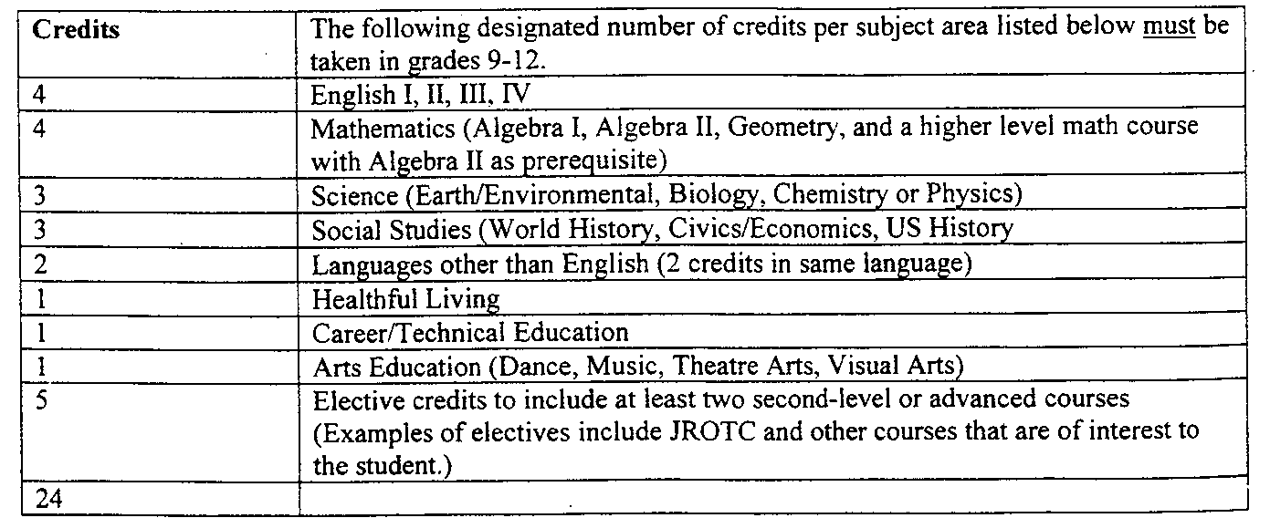

GRADES 9-12, GRADING AND REPORTING

Length of Grading Period- Six Weeks
Interim Reports- Selected students as per teacher judgment
Grading Conventions
- Numerical grades
- Non-numerical grade: Conduct only (use SIMS comment directory)
- INC (incomplete): The INC can be changed if enough data becomes available. An INC must be converted by the end of the year.
Report Card Subjects
Grades 9-12 –as per student’s schedule
Promotion Standards
- Attendance per course: Present at least 80 days per semester. No exclusions; applicable to all students.
- Grades per course
  - Average of 70 or above
  - Actual average may be recorded each six weeks. The teacher has the option to use a minimum of 60 in his/her classes.
- Credits: See Columbus County Secondary Program of Studies
Exceptional Children
- The subject listed on the IEP will be grades by the special education teacher; the special education teacher’s grade shall be the only grade for that subject on the report card.
- Where the special education teacher and regular classroom teacher both have instructional responsibilities for a subject listed on the IEP the teachers shall agree on one grade. The special educator shall complete the SIMS grade sheet. In case of a disagreement, the goals and objectives on the IEP shall govern.
Recording of Absences, Tardies and Early Dismissals
Procedure to be set by each school
Countywide Testing Policy – Grade 9-12
- Exams shall be required in grades 9-12. Each six-week grade will constitute one-fourth of the semester grade. The exam score will constitute one-fourth of the semester grade. There will be no exemptions. State multiple-choice end-of-course test shall be used as the final exam*.
- Other test shall be scheduled as required by the instructional program. Grading period-everywhere at the same time-are not required.
- Grading framework, grades 9-12
  - 75%- Evaluations (e.g., test, formal performance assessments)
  - 25%-Other (class participation, homework, ect.)
Release of final Report Cards
- Seniors
  - Each senior’s status for graduation must be verified by the principal before the ceremony.
  - The SIMS report card will be released to the seniors on the day of graduation.
- The SIMS report card for the ninth through eleventh graders will be released within six working days following graduation through the U.S. Postal Service or by parent pickup.

* Students entering the ninth grade for the first time in 2006-07 and beyond will be require to meet new exit standards. The Standards will only apply to students following the Career Preparation, College Technical Preparation, or College University Preparation courses to study. These students will be required to perform at Achievement Level III (with one standard error of measurement) or above on five end-of-course (EOC) Biology, English I, Civics & Economics, and U.S. History.

INTERIM PROGRESS REPORT RELEASE DATES

September 15, 2011 February 13, 2012
October 31, 2011 March 28, 2012
December 16, 2011 May 16, 2012

REPORT CARD RELEASE DATES

GRADES 9-12

End Six Weeks Release Date

October 7, 2011 October 17, 2011
November 22, 2011 December 5, 2011
January 20, 2012 February 6, 2012
March 6, 2012 March 15, 2012
April 26, 2012 May 7, 2012
June 8, 2012 June 18, 2012

(Seniors will receive their report cards on the day of graduation.)

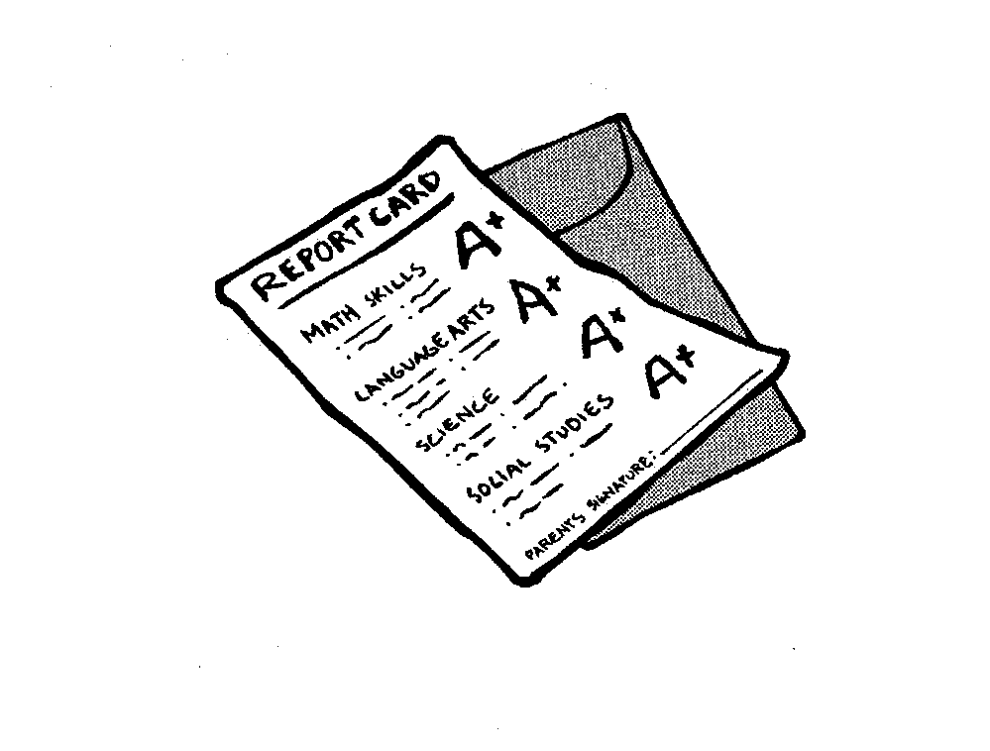

STUDENTS RECORDS

A copy of the school system’s policy regarding the Family Educational Rights and Privacy Act (FERPA) can be obtained in the principal’s office. FERPA ensures that the parent or eligible student has a right to:

- inspect and review the student’s educational records;
- request the amendment of the student’s education records to ensure that they are not inaccurate, misleading, or otherwise in violation of the student’s privacy or other rights;

- consent to disclosures of personally identifiable information contained in the student’s education records, expect to the extent that system policy authorizes disclosure without consent; and

- file with US Department of Education a complaint concerning alleged failure by the Columbus County School to comply with the Family Educational Rights and Privacy Act.

TRANSFER OF DISPLICIPLINARY RECORDS: SUSPENSION OR EXPULSION

The Columbus County School System will forward education records to other school that have requested the records and in which the student seeks or intends to enroll.

DIABETES CARE PLAN

North Carolina’s Senate Bill 911 requires that school have a diabetes care plan for children who are diabetic. The Columbus County Schools are in process of identifying every child in our system with diabetes and insuring that an appropriate plan is in place.

If your child is diabetic, please contact his/her principal by September 8, 2010, so a plan for your child’s care at school can be implemented for the 2010-2011 school year.

STUDENTS

8-44 Student Records Adopted February 28, 2005

The principal shall have the overall responsibility for maintaining and preserving the confidentiality of student records. He may, however, designate another school official to perform these duties for him.

The principal or his/her designee is responsible for classifying records and maintaining them so that each record can clearly be identified by classification. He is responsible for reviewing the files and deleting supplementary and tentative records when necessary. He is also responsible for granting and denying access to records on the basis of these regulations/

- Definitions

For the purpose of this policy, the Columbus County School have used the following definitions of terms.

“Student”- any person who attends or has attended a school in the Columbus County School District.

“Eligible student”- a student or former student who has reached age 18 or is attending a postsecondary school.

“Parent”- either natural parent of a student, a guardian, or an individual acting as a parent or guardian in the absence of the student’s parent or guardian.

“Education records”- any record maintained by the Columbus County School or an agent of the Columbus County School which is directly related to a student except:

  - A personal record kept by a staff member if it is kept in the sole possession of the maker of the record and is not accessible or revealed to other person except a temporary substitute for the maker of the record.

  - Records created and maintained by the Columbus County School for law enforcement purposes.

  - An employment record which is used only in relation to a student’s employment by the Columbus County Schools.

  - Alumni records which contain information about a student after he/she is no longer in attendance in the school system and which do not relate to the person as a student.
- Annual notification

Parents will be notified of the Family Educational Rights and Privacy Act (FERPA) rights annually by publication in their child’s student handbook.

- Procedure to inspect education records

Parents of students or eligible students may inspect and review the student’s education records upon request.

Parents or eligible students should submit to the student’s school principal a written request which identifies as precisely as possible the record or records he/she wishes to inspect.

The principal (or appropriate school official) will make the needed arrangements for access as promptly as possible and notify the parent or eligible student of the time and place where the records may be inspected. Access must be given in 45 days or less form the receipt of the request.

When a record contains information about students other than a parent’s child or the eligible student, the parent or eligible student may not inspect and review the portion of the record which pertains to other students.

- Refusal to provide copies

The Columbus County School will not provide a parent or eligible student a copy of the student’s education record unless failure to do so would effectively prevent the parent or eligible student the right to inspect and review the records.

If the records involve answers to a standardized test, the Columbus County Schools will not provide a parent a copy of standardized test questions.

- Fees for copies of records

The first record copy will be provided at no charge. The fees additional copies will be ten cents per page.

- Types, locations and custodians of education records

The following is a list of the type of records that the school system maintains, their locations, and their custodians.

Types Location Custodian
Cumulative School Record Principal’s Office Principal
Cumulative School Records Principal’s Office Principal
(Former students)

Other records Principal will collect and make Principal
Available at student’s school

- Disclosure of education records

The Columbus County Schools will disclose information from a student’s education records only with the written consent of the parent or eligible student except:

a. To school officials who have a legitimate educational interest in the records.

A school official is:

    - A person employed by the Columbus County Schools as an administrator, supervisor, instructor, or support staff member.

    - A person elected to the school board.
    - A person employed by or under contract to the Columbus County Schools to perform a special task, such as an attorney, auditor, medical consultant, or therapist.

A school official has a legitimate educational interest of the official is:

- Performing a task that is specified in his/her position description or by a contract agreement.

- Performing a task related to a student’s education.

- Performing a task related to the discipline of a student.

- Providing a service or benefit relating to the student or student’s family, such as health care, counseling, job placement, or financial aid.

  - To officials of another school, upon request, in which a student seeks or intends to enroll.

  - To certain officials to the US Department of Education, the Comptroller General, and state and local educational authorities, in connection will certain state or federally supported education programs.

  - In connection with a student’s request for or receipt of financial aid as necessary to determine the eligibility, amount, or conditions of the financial aid, or to enforce the terms and conditions of the aid.

  - If required by a state law requiring disclosure that was adopted before November 19, 1974.

  - To organizations conducting certain studies for or on behalf of the Columbus County Schools.

  - To accrediting organizations to carry out their functions.

  - To parents of an eligible student who claim the student as a dependent for income tax purpose.

  - To comply with a judicial order or a lawfully issued subpoena.

  - To appropriate parties in a health or safety emergency.

  - Directory information so designated by the school system.

- Record of requests for disclosure

The Columbus County Schools will maintain a record of all requests for and/pr disclosure of information from a student’s education records. The record will indicate the name of the party making the request, any additional party to whom it may be disclosed, and the legitimate interest the party had in requesting or obtaining the information. The record may be reviewed by the parents or the eligible student.

- Directory information

The Columbus County Schools designates the following items as directory information: student name, parents’ name , address, telephone number, date and place of birth, participation in officially recognized activities and sports, weight and height of members of athletic teams, dates of attendance, degrees and awards received, most recent previous school attended and photograph. The Columbus County School may disclose any of those items without prior written consent, unless notified in writing to the contrary by the end of the tenth school day of each school year.

- Correction of education records

Parents or eligible students have the right to ask to have records corrected that they believe are inaccurate, misleading, or in violation of their privacy rights. Following are procedures for the correction of records.

  - Parents or the eligible student must ask the Columbus County School to amend a record. In doing so, they should identify the part of the record they want changed and specify why they believe it is inaccurate, misleading, or in violation of the student’s privacy or other rights.

b. The school system may comply with the request or it may decide not to comply. If it decides not to comply, the school system will notify the parents or eligible student of the decision and advise them of their right to a hearing to challenge the information believed to be inaccurate, misleading, or in violation of the student’s rights.
c. Upon request, the school system will arrange for a hearing, notify the parents or eligible student, reasonably in advance, of the date, place, and time of the hearing.

d. The hearing will be conducted by a hearing officer who is a disinterested party; however, the hearing officer may be an official of the school system. The parents or eligible student shall be afforded a full and fair opportunity to present evidence relevant to the issues raised in the original request to amend the student’s education records. The parents or student may be assisted by one or more individuals, including an attorney.

  - The school system will prepare a written decision based solely on the evidence presented at the hearing. The decision will include a summary of the evidence presented and the reasons for the decision.
  - If the school system decides that the challenged information is not inaccurate, misleading, or in violation of the student’s right of privacy, it will notify the parents or eligible student that they have a right to place in then record a statement commenting on the challenged information and/or a statement setting forth reasons for disagreeing with the decision.
  - The statement will be maintained as part of the student’s education records as long as the contested portion is maintained. If the school system discloses the contested of the record, it must also disclose the statement.
  - If the school system decides that the information is inaccurate, misleading, or in violation of the student’s right of privacy, it will amend the record and notify the parents or eligible student, in writing, that the record has been amended.
  - Destruction of confidential records

  - All confidential records will be maintained in the last school the student attended for five years beyond the twenty-first birthday.

  - Public notice of intent to destroy scheduled records will be published in April of each year. Citizens will be informed that records may be needed for Social Security, legal proceedings, or other purposes. A copy of the written policy shall be given to eligible students and/or parents at the time of exit from school.

  - The policy will be included yearly in each child’s student handbook.

  - Copies of student records will be made available to eligible students or parents upon request.

  - Litigated inactive records will be forwarded to the Director for Exceptional Children.

  - Records scheduled for destruction will be boxed and sent to the Exceptional Children’s Department with an accompanying student roster.

  - A student roster of personally identifiable information will be maintained in data base indefinitely. That information shall include full name, last school attended, birth date, exceptionality, parent name, address, phone number, exit status, and date of exit.

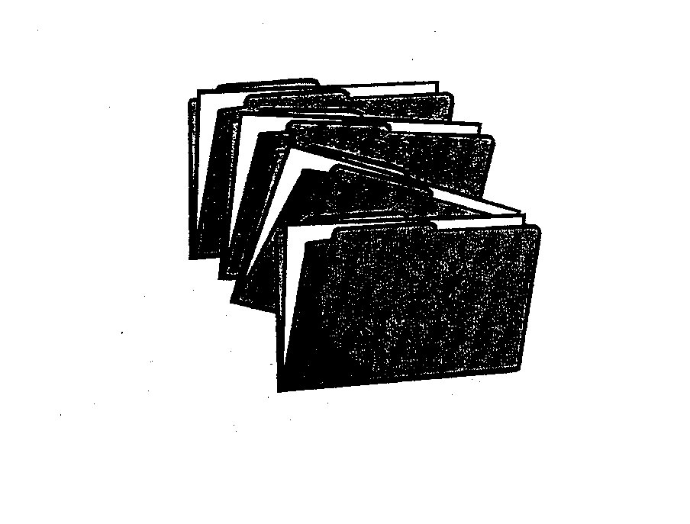
  - Destruction of eligible records will be conducted in July of each year.

LOCKERS
Confidential

We are fortunate to have enough lockers for each student to have a separate locker. Students will use their own locks. Homeroom teachers will issue lockers.

Student lockers are school property and remain at all times under the control of the school; however, students are expected to assume full responsibility for the security of their lockers. Periodic general inspections of lockers may be conducted by school officials for any reason at any time without notice, without student consent and without a search warrant.

STUDENT CHECKOUT

By law, the school is responsible for the student’s safety, health, and welfare from the time he/she leaves home until he/she arrives home from school in the afternoon. The school is operated on the policy of requiring parental presence or a signed note from the parent before the student is permitted to sign out of school. Random telephone calls will be made by the school to verify the legitimacy of the notes. Students who forge notes will the lose the privilege of bringing notes from home and will need their parents to come to school to check them out. STUDENTS PLANNING TO CHECK OUT OF SCHOOL SHOULD PRESENT THEIR NOTES IN THE MAIN OFFICE BEFORE 8:15. The note must include a telephone number where the parents can be reached and notes may be verified before a student is allowed to check out. Students should not attempt to check out just to be checking out. Only valid reasons will be honored.

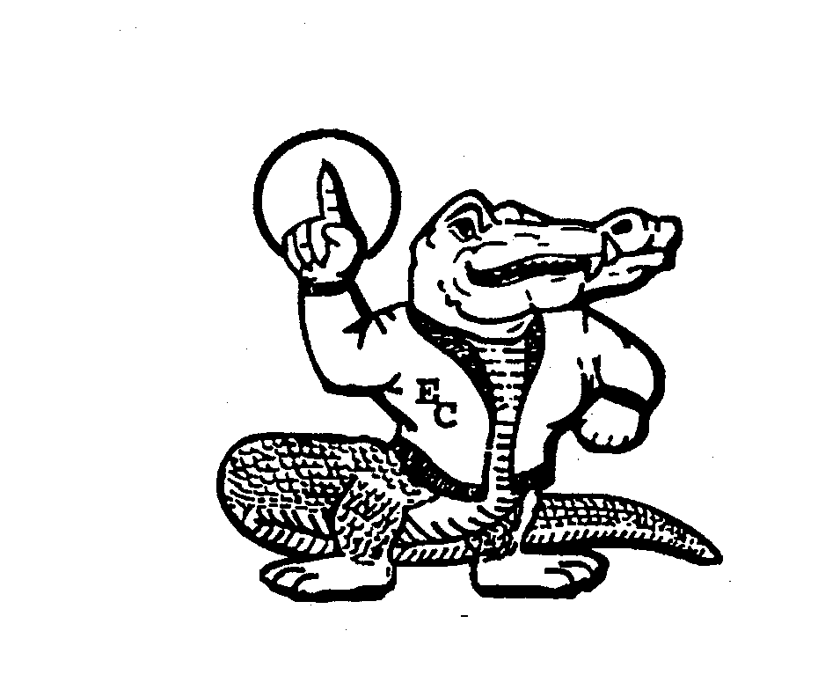

Clubs and Organizations

This is a partial list of youth organizations at East Columbus

Fellowship of Christian Athletes (FCA)
The FCA is a national organization for student athletes. FCA members strive to support the school’s athletic program and to encourage spiritual growth through Bible study. Members must participate in at least one sport and have the recommendation of their coach. Meetings are held after school.

Future Business Leaders of America (FBLA)

The FBLA is a national organization for students enrolled in the business program. The main purpose is to create more interest in and an understanding of the American Business Enterprise, and to encourage scholarship and promote school loyalty. Membership is open to all students enrolled in a business course.

Future Farmers of America (FFA)

The FFA is a national organization made up of students enrolled in agriculture who have a desire and interest in agriculture occupations. Its purpose is to develop rural and agricultural leadership. Membership is open to all students enrolled in an agricultural course.

Future Homemakers of America (FHA)

The FHA is a national organization made up of students studying Home Economics. The basic goal is to help youth assume their roles in society through home economics education, areas of personal growth, vocational preparation, and community involvement. Membership is open to all students enrolled in a Home Economics course.

Health Occupations Students of America (HOSA)

HOSA is a national organization made up of students enrolled in Health Occupations courses.

Math Club

The purpose of the Math Club is to create and stimulate interest in mathematics. A student must take Algebra 2 or Advanced Math to be eligible for membership

National Honor Society

The object of the National Honor Society shall be to create enthusiasm for scholarship stimulates a desire to render service, promote worthy leadership, and encourage the development of character in all students at East Columbus. Candidates eligible for election must be members of the junior or senior class and have a minimum unweighted scholastic average of 93 on courses taken in grades nine through the current grade. Their eligibility shall then be considered on their service, leadership, and character.

National Senior Beta Club

The ECHS Chapter of the National Beta Club will be a service organization for the school, community, state, and nation. Members must be sophomores, juniors, or seniors with overall unweighted averages of 92 or above and satisfactory conduct. Members are chosen from those who are academically eligible and are approved by the faculty.

Science Club

The purpose of the Science Club is to stimulate and encourage interest in science among young people. Participation in the club gives students an opportunity to work with others outside the classroom. They may also have opportunities to talk with professional scientists. Membership is open to students who have had at least one course in science.

Bible Club
Bible Club meets outside the regular school day and encourages students to grow spiritually. Membership is open to all students.

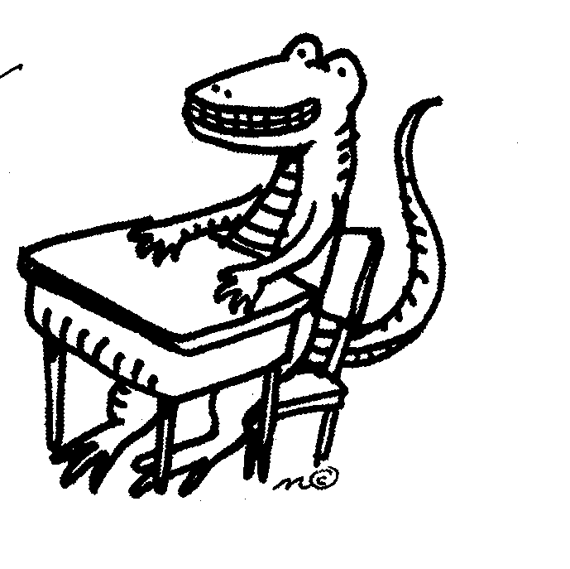

MOTOR VEHICLES ON CAMPUS

Any licensed driver may drive a vehicle to school under the following conditions:

1. Students must register vehicles and purchase a $3.00 parking tag. The plastic tag is removable and should be displaced on the rear-view mirror. The tag will be on sale for $2.00 during the first two weeks of school.

2. School rules and local and state traffic laws must be followed when operating a vehicle on campus.

3. The school accepts no responsibility for cars parked on campus.

4. Students must park in the designated area. This area will be off limits form the time of arrival on campus to the time of departure. Permission required form the office before visiting the parking area for any reason.

5. Careless and reckless operation of a vehicle will result in a loss of driving privileges.

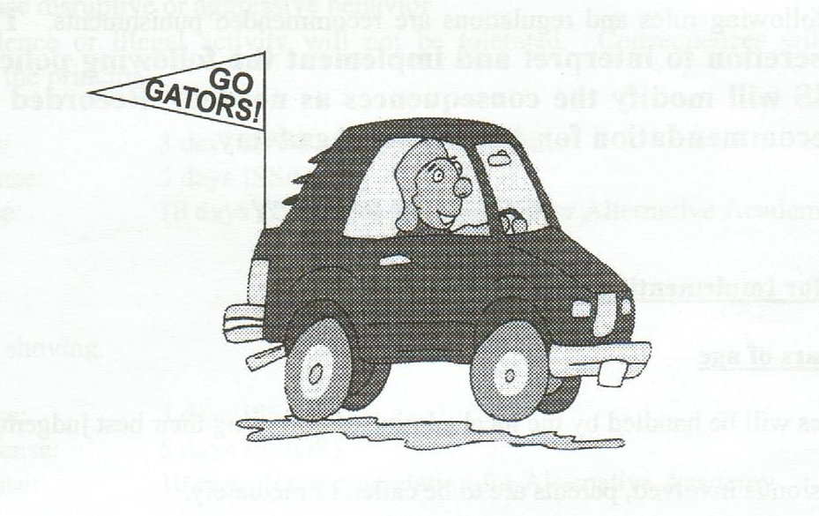

NOTICE TO: PARENTS OF STUDENTS
EMPLOYEES OF THE COLUMBUS COUNTY SCHOOL SYSTEM

As required by Federal Regulations, you are notified by this letter that an Asbestos Management Plan for your school location has been developed. It is on file in the Administration office at the school location and is available for public review. A copy is also on file at the office o the superintendent.

STUDENT RULES AND REGULATIONS
Grades 9-12

It is necessary for all students to abide by the rules and regulations established. The purpose of these rules and regulations is to promote an atmosphere conducive to learning and proper behavior. The following rules and regulations are adopted as county procedures for dealing with discipline situations in the 9-12 grades of Columbus County Schools.

Every student is expected to follow all instructions and directions given by teachers, the administration, or other school employees. This includes the school policies presented in this handbook and those conveyed orally by the teachers, substitute teachers, student teachers, school employees, or administrators. More importantly, students are expected to discipline themselves and assume full responsibility for their participation in the total school program. Infractions of written or verbal policies will be handled according to the established procedure to be found in the student handbook. Each student must be handled according to the established procedure to be found in the student handbook. Each student must remember that he is a student and is expected to conduct himself accordingly.

The following rules and regulations are recommended punishments. The principal has the discretion to interpret and implement the following policies. Schools without ISS will modify the consequences as needed. Recorded offense may result in recommendation for Alternative Academy.

COUNTY POLICY

Procedures for Implementing the Code of Conduct

Under 16 years of age

- Most cases will be handled by the local administration using their best judgment.

- If suspension is involved, parents are to be called immediately.

- For a student under 16, the principal can suspend a child and file a referral for a juvenile petition with juvenile services if the offense is of such nature to warrant more than suspension.

- All rules apply at school during transportation to and from school and during extracurricular activities.

5. Mandatory metal detector and book bag checks will be held.

16 years of age and over
- After a disturbance, investigate and call parents if necessary.

2. If the principal deems necessary, then call the sheriff’s department.

- If the sheriff’s department is called, they will do a brief investigation and where appropriate, issue a citation to the parties involved. (These citations serve purpose as a warrant. The student will have to appear in court).

4. The principal may suspend the student if warranted.

5. Once a citation has been issued, further contact will be with the sheriff and the parties involved. School personnel will serve only as witnesses when subpoenaed.

Gang Awareness/Activity

Gang activity, dress, and/or signs which may cause:

- A disruption in the learning environment
- Create or cause disruptive or aggressive behavior
- Lead to violence or illegal activity will not be tolerated. Consequences will be at the discretion of the principal.

First Offense: 3 days ISS/OSS/meet with parents
Second Offense: 5 days ISS/OSS
Third Offense: 10 days OSS, Recommendation for Alternative Academy.

- ASSAULT
Pushing or shoving.

First offense: 3 days ISS/OSS
Second offense: 5 days ISS/OSS
Third offense: 10 days, Recommendation for Alternative Academy

- BOMB THREAT
First offense: Recommendation for expulsion. Call Law Enforcement. File Juvenile petition. Recommendation for Alternative Academy.
- CHEATING

Cheating includes having a copy of a test about to be given, using notes during a test (without permission), or other evidence of any dishonest practice.

First offense: 3 days ISS, plus a zero will be recorded for the given test. Club constitutions, character, etc. may call for additional penalties and parent contact.
Second offense: 5 days ISS/OSS, plus a zero will be recorded for the given test, parent conference. Club constitutions, character, etc. may call for additional penalties.
Third offense: 10 days ISS/OSS, plus a zero will be recorded for the given test

- CONFRONTATIONAL FUSSING

Students become loud and boisterous toward each other causing other students to gather with the possibility of a fight occurring.

First offense: 3 days ISS/OSS, same day informal suspension, parent called
Second offense: 5 days ISS/OSS, same day informal suspension, parent conference
Third offense: 10 days OSS, Recommendation for Alternative Academy.

- ASSEMBLIES

1. Follow assembly instructions as given to you by a teacher, administrator, or adult
speaker .
2. Sit where you are assigned to sit. Sit only with the class with which you go to the
assembly.
3. Avoid talking, yelling, clapping, or indicating your approval or disapproval when such is not appropriate
4. Honor and respect the dignity of the program.

First Offense: 3 days ISS/OSS

Second Offense: 5 days ISS/OSS

Third Offense: 10 days ISS/OSS, Recommendation for Alternative Academy.

- UNAUTHORIZED AREA

Being in the auditorium, gym, classroom, restroom, hall, parking lot, bus courtyard, main lobby, front entrances, or any designated area without permission.

First Offense: 3 days ISS/OSS
Second Offense: 5 days ISS/OSS
Third Offense: 10 days ISS/OSS, Recommendation for Alternative Academy.
- COMMON AREAS

In order to protect property, maintain an orderly relationship among students, establish a clean eating environment, and make everyone's lunch break a pleasant and enjoyable time, we ask your cooperation with the following rules:

1. Do not sit on tables or on the back of chairs. Do not "beat" on the tables or stand or
walk on them.
2. Put all trays, trash, and food scraps in their proper places once you have eaten.

3. Cooperate with the cafeteria staff and follow instructions given by teachers and administrators

- Do not break line

5. Use only appropriate language, no profanity or vulgarity

FAILING TO KEEP HANDS AND FEET TO SELF/BODY FLUIDS
(Hitting, kicking, shoving, pushing, pinching another person, biting, spitting, etc.)

First Offense: 3 days ISS/OSS
Second Offense: 5 days ISS/OSS
Third Offense: 10 days OSS, Recommendation for Alternative Academy.

I. FAILURE TO SIGN OUT WHEN LEAVING SCHOOL EARLY

Regarded the same as skipping

First Offense: 3 days ISS/OSS, Parent called.
Second Offense: 5 days ISS/OSS
Third Offense: 10 days OSS, Recommendation for Alternative Academy.

J. REFUSAL TO ATTEND ISS

Recommend Alternative Academy or recommendation for expulsion

First Offense: 5 days OSS
Second Offense: 10 days OSS, Recommendation for Alternative Academy

K. REFUSAL TO IDENTIFY SELF

First Offense: 3 days ISS/OSS
Second Offense: 5 days ISS/OSS
Third Offense: 10 days OSS, Recommendation for Alternative Academy.

L. DISRUPTION

A student shall not, by noise, coercion, intimidation, fear, passive resistance, or any other conduct, cause substantial and material disruption or obstruction of any lawful right, mission, process, or function of any school, school bus (throughout these rules, “school bus” means any bus, public or private, being used at the time for school purposes), school personnel or student: nor shall any student engage in such conduct in an attempt to cause any such disruption or obstruction; nor shall any student urge others to engage in any such disruptive or obstructive conduct.

First offense: 3 days ISS/OSS
Second offense: 5 days ISS/OSS
Third offense: 10 days OSS, Recommendation for Alternative Academy.

- DISRESPECT TO STAFF/INSUBORDINATION

A student shall not direct to any school personnel or other adult language which is abusive, profane, or insulting. Students will comply with the reasonable requests of their teachers. Magnitude of offense will determine the extent of punishment.

First offense: 3 days ISS/OSS
Second offense: 5 days ISS/OSS
Third offense: 10 days OSS, Recommendation for Alternative Academy.

- DRUG POLICY (STUDENTS)

- Statement of belief

The Columbus County Board of Education has the responsibility of creating an atmosphere conducive to learning in our public schools. It further believes that the use of illicit drugs and alcohol is harmful, and that drug-free schools lead to drug-free communities. Therefore, with this in mind, the Columbus County Board of Education requires that all K-12 teachers within the Columbus County School System incorporate the drug education prevention/intervention strategies and curriculum provided through the Drug Free Schools and Communities Act of 1986 within their regular classroom content areas, and use all available resources to enhance the “no drug” message within all classrooms as appropriate.

- Possession, use, and/or sale of drugs including alcohol

  - No student shall possess, use, transmit, or be under the influence of any narcotic drug, hallucinogenic drug, amphetamine, barbiturate, marijuana, or other drug defined as a controlled substance pursuant to Chapter 90 of the North Carolina General Statutes, or any alcoholic beverage or other intoxicating liquor, as defined in Chapter 18A of the North Carolina General Statutes, or possess, use or transmit drug paraphernalia, as defined in Chapter 90 of the North Carolina General Statutes, or inhale or ingest any chemicals or products with the intention of bringing about a state of exhilaration or euphoria while in any school building, on any school premises, on any school bus, or off the school grounds at any school activity, function, or event before, during or after school hours, or during any period of time when he/she is subject to the authority of school personnel, unless such possession, use or transmission is authorized by law and school regulations.

    - The word “possession: shall mean having the power or intent to control a prohibited substance and shall include, but is not necessarily limited to, the possession of a prohibited substance in a student’s automobile, locker, book bag, desk, or on a student’s person at school or any school-related activity.

    - The word “use” shall mean the consumption, injection, inhalation, or absorption of a prohibited substance into a student’s body by any means at any time when they prohibited substance would influence a student’s behavior to any degree at school or a school-related activity.

    - The word “sale” shall mean the exchange of a prohibited substance for money or other consideration.

  - Over the counter medication/prescribed drugs/counterfeit controlled substance

    - No student shall distribute to any student an over the counter medication in their possession. Any student caught distributing over-the-counter medication to another student shall mean a 3 day out-of-school suspension. At the principal’s discretion, this may be adjusted to a 5 day period in ISS.

    - Use of a drug authorized by a valid medical prescription from a registered physician shall not be considered a violation of this rule when the drug is taken by the person for whom the drug is prescribed. All medications at school should be in pharmacy labeled and dispensed containers with the name of physician, date, name of medication, time and directions for administration, and student’s name.

  - Definition – prohibited substances include:

    - Wine, beer, and any other malt beverage, alcohol, liquor, liqueurs, and mixed alcoholic beverages

    - Any chemical compound which will induce a condition of intoxication when inhaled for the purpose (see NCGS 90-113.10)

    - Any drugs listed in the North Carolina Controlled Substance Act (NCGS 90-86 et. seq.) or its successor but not necessarily limited to: narcotics depressants, stimulants, hallucinogens, and cannabis which drugs are commonly known as: marijuana, acid, LSD, speed, Quaaludes, Valium, and other names: i.e., any substance which the student represents by reference or otherwise as being a controlled substance

  - Possession or use of a prohibited substance first offense

Violation of the above policy will mean an automatic 10-day out-of-school suspension and possible recommendation for placement in the Alternative Academy. In addition to the out-of-school suspension the student and parent/guardian must obtain a substance abuse evaluation by Columbus County Mental Health Center and participate in any recommended treatment and assume/pay the cost thereof. If a student or parent/guardian should decide against the program, the school will be notified and the principal may recommend expulsion.

The student also will be prosecuted under the juvenile or criminal laws of the state.

  - Second offense

The second offense will mean an automatic expulsion from school programs for the remainder of the year from all Columbus County Schools. In addition, in regards to possession, the student will be prosecuted under the juvenile or criminal laws of the state.

  - Sale of a prohibited substance

    - Any student caught selling, with the intent to sell, or distributing illegal drugs shall be expelled for the remainder of the school year without the option of attending any school under the jurisdiction of the Columbus County Board of Education. Also, the student will be prosecuted under the juvenile or criminal laws of the state.

    - The above policies will be enforced in grades 9-12 and/or 12 years of age in any grade. If the offender is a child below grade 7 and/or under 12 years of age, the Superintendent and/or principal may consider this a factor which can justify a less serious disciplinary action.

- Notification and involvement of parents/law enforcement officers

  - Notification and involvement of parents

    - The principal or his/her designee shall notify as soon as possible the parent/guardian of a student who has violated or is believed to have violated the above policy.

    - Following this notification, a scheduled conference will be held with all involved persons.

  - Notification and involvement of law enforcement officials

    - The principal or his/her designee shall inform the appropriate law enforcement agency when the controlled substance is possessed, used, sold or distributed at school or at any school related activity.

    - Any controlled substance confiscated by school officials shall be turned over to the police or sheriff for identification, if necessary, and for disposal. A signed receipt should be requested from the law enforcement officer. The report of the law enforcement agency attesting to the nature of any confiscated substance shall be admissible as prime factual evidence of the identity of the substance at any student disciplinary hearing.

    - School officials shall assist the law enforcement officials with prosecution of any person who has possessed, used, distributed, sold or who is believed to have sold any controlled substance at school or a school-related activity.

- Policy violations during the last ten (10) days of school

Students whose violations meet the criteria for long-term suspensions, during the last ten (10) days of school shall be suspended for the remainder of the year and allowed to take their exams after the end of the normal 180 days of instruction but before the teachers leave for summer vacation. The student and his or her parent/guardian must complete a substance abuse evaluation offered by the Columbus County Mental Health Center before his/her grades are finalized and transcripts and/or diplomas made available. In addition, a senior whose violation meets the above criteria during the last ten (10) school days or at any school related function after the end of the normal school year shall not participate in any remaining school related activities, including graduation ceremonies.

- Authority of school officials to search

  - Lockers and Desks: School officials have the authority to search a student’s locker and desk at any time. Students should have no expectation of privacy with respect to lockers and desks and shall be made aware of the condition. If a search is made of a locker or desk, it shall be made in the presence of the school administration and with a written record of the results of the search.

  - Personal possessions of students may be searched under reasonable suspicion of possession of a controlled substance. There shall be no frisk or strip searches. All searches shall be made in the presence of another staff member and not in the presence of the class. A written record of the results of the search shall be made.

  - Schools which allow students to drive to school shall require a permit. This permit must give consent for searches of vehicles driven to school if there is a reasonable suspicion that they may contain prohibited substances. All searches shall be made in the presence of a member of the school administration. A written record of the results of the search shall be made.

- A list of the in-county and out-of-county agencies, public and private, will be on file at the Columbus County Board of Education for persons who are interested in receiving help with their drug/alcohol problem. The contact person for this list is the Drug/Alcohol Abuse Coordinator and this office is located at the Central Office.

- Annual notification of parents, students and periodic review of Board policy

  - Parents and students will receive annual notification through the student handbook that compliance with this policy is mandatory, and disciplinary sanctions will be consistently reinforce.

  - This policy and the programs covered will be periodically reviewed to determine effectiveness.

- Methamphetamine protocol and strategic plan

Methamphetamine is a stimulant that can be snorted, smoked, taken orally or injected. Methamphetamine is the most common illicit amphetamine and is the most commonly synthesized controlled substance. Most of the chemicals needed to produce methamphetamines are easily obtained or can be manufactured in secret often in vehicles, abandoned buildings, and individual homes. The chemicals present hazards both during the production process and during disposal.

In an effort to combat the growing crisis of methamphetamine use and the multiple locations of methamphetamine labs, Columbus County Schools has developed a guide which will serve as a resource for all employees. This guide contains several strategic initiatives to provide a clear understanding of roles and responsibilities if methamphetamine use or exposure is detected. The plan will consist of three elements: Public Awareness, Training, and a Response Plan.

Columbus County Schools will develop a committee responsible for developing initiatives for public awareness, training, and a response plan. This will include training for all employees of the Columbus County School system in the proper procedures in detection or use of methamphetamine. Increasing public awareness of methamphetamine use and production will be addressed as well as who to contact and when contact is necessary.

- Public Awareness

Columbus County Schools will produce a flyer to distribute to all school employees. It will include telephone numbers of local agencies that need to be contacted as well as proper procedures when dealing with the use or detection of methamphetamine. It will include tips for recognizing methamphetamine use and procedures to follow if one should come in contact with methamphetamine. Steps to take if children have been exposed will also be included.

- Training

Every employee of the Columbus County School system will be trained annually to review procedures when exposed to methamphetamine. It will also include current information relating to use and detection of methamphetamine. Specific training will be provided for first responders as well as those whose jobs may take them to residents where methamphetamine may be detected. Training will also be included if children have been exposed.

c. Response Plan

A strategic plan developed by a committee of Columbus County School employees will contain specific protocol when dealing with children or school employees who have been exposed to methamphetamine.

d. Protocol

(1) Assessment of Scene by School Personnel - Not on School Property

Procedures will be as follows:

- Recognize location as methamphetamine site
- Vacate immediately
- Do not remove any items from location
- Find a safe location and call school administrator
- School administrator will call 911 for law enforcement
- Alert law enforcement if children are involved
- School administrator will contact school superintendent
- Follow law enforcement protocol
- After situation has been assessed by law enforcement and children have been assessed—responders should consult with their medical provider for an individual evaluation

(2) Assessment of Scene by School Employee - On School Property

Procedures are as follows:

- Recognize location as methamphetamine site
- Vacate immediately
- Do not remove any items from location
- Contact school administrator immediately
- School administrator will contact school resource officer
- School resource officer will call 911 for additional law enforcement
- Alert law enforcement if children are involved
- Follow law enforcement protocol
- After situation has been assessed—responders should consult with their medical provider for an individual evaluation

(3) Exposure to Children

For children who are not injured or ill:

- Perform a basic assessment of the situation
- Check vital signs—temperature, blood pressure and pulse
- Assess for heat or chemical burns
- Clothing should be changed from outside the methamphetamine site
- Alert School Social Worker to contact Department of Social Services
- If exposure is severe--call 911 for transport of child to hospital
- If exposure is limited—contact parents encouraging them to seek evaluation from their medical provider
- Alert school administrator if children other than those residing in residence are involved

O. EXTORTION/INTIMIDATION/BULLYING/HARASSMENT

A student shall not obtain or attempt to obtain from a person, by force or threat, money or other property, devices or considerations of any sort, nor shall a student frighten or deter by or as if by threats. Please refer to Columbus County Schools prohibition against discrimination, harassment and bullying policy code: 1710/4021/7230.

First offense: 5 days OSS
Second offense: 10 days OSS, Recommendation for Alternative Academy.
Recommendation for expulsion

- FALSE FIRE ALARM

First offense: 10 days OSS, call law enforcement
Recommendation for expulsion

- FELONIES

Any student, who has been charged with a felony and is waiting the disposition of the case by court, will be automatically suspended. If the suspension exceeds 10 days, the student may apply for admission to the Alternative Academy. Students are suspended from the public school until the case has been settled.

- FIGHTING

In the event a fight breaks out, students are advised to move away from the area of the disturbance, tend to their own business, and not get in the way of administration or teachers who are trying to deal with the situation. Standing around, standing on tables, standing in aisles so as to hinder school officials, and refusing to leave the scene when asked to do so are violations of the no fighting policy. If it can be determined by clear and convincing evidence who instigated a fight, that person may be punished to a greater degree than others involved in the fight. The amount of punishment will be at the principal’s discretion. This does not absolve any parties in the fight from their role. All parties involved in a fight will be disciplined.

First offense: 5 days OSS
Second offense: 10 days OSS, Recommended for Alternative Academy
Recommendation for expulsion.

- FIREWORKS/SMOKEBOMBS OR SIMILAR DEVICES

Students who are found with fireworks in their possession, or who discharge fireworks on the school grounds, are subject to suspension and/or expulsion. Call law enforcement.

First offense: 10 days OSS, Recommendation for Alternative Academy.
Recommendation for expulsion.

- HORSEPLAYING, WRESTLING

First offense: 3 days ISS/OSS
Second offense: 5 days ISS/OSS
Third offense: 10 days OSS, Recommendation for Alternative Academy.

- INAPPROPRIATE AFFECTION

First offense: 3 days ISS/OSS
Second offense: 5 days ISS/OSS
Third offense: 10 days OSS, Recommendation for Alternative Academy.

- INITIATING A FIGHT/BOOSTING A FIGHT, CARRYING NEWS/CAUSING DISSENSION

Any student who encourages, aids or abets any conduct which may or does result in physical violence against any person. Law Enforcement may be called. If it can be determined by clear and convincing evidence who instigated a fight, that person may be punished to a greater degree than others involved in the fight. The amount of punishment will be at the principal’s discretion. This does not absolve any parties in the fight from their role. All parties involved in a fight will be disciplined.

First offense: 3 days ISS/OSS
Second offense: 5 days ISS/OSS
Third offense: 10 days OSS, Recommendation for Alternative Academy.

- LEAVING CLASS WITHOUT PERMISSION

First offense: 3 days ISS/OSS
Second offense: 5 days ISS/OSS
Third offense: 10 days OSS, Recommendation for Alternative Academy.

- MODE OF DRESS

- General Grades 9-12

Clothing or jewelry must be age-appropriate, not disruptive to the teaching-learning process, and cannot be provocative, revealing, indecent, vulgar, or obscene.

a. For sanitary and safety reasons and in accordance with State Health regulations, all children are required to wear shoes to school.

b. Dress for special school sponsored activities that occur outside the regular school day may be determined and regulated at the discretion of the principal.

c. Sunglasses and hats are not to be worn inside. Headdress including kerchiefs, bandanas, sweatbands, and rags are not allowed.

d. There shall be no jewelry or any other article affixed to a student’s nose, tongue, lips cheek, eyebrow, or any other visible part of the body, with the exception of the ears. Articles on the ears must not promote alcoholic beverages, tobacco, or the use of controlled substances, depict violence, or are of a sexual or disruptive nature.

e. All tattoos must be covered.

f. No article shall be worn in the eyes other than medically prescribed corrective lenses.

g. All Shirts and blouses must be appropriately tucked in.

h. All pants that are made with belt loops must be worn with an appropriate length belt.

i. All belts buckles must not exceed the width of the belt worn.

2. Grades 9-12

Clothing will not be allowed which promotes alcoholic beverages, tobacco, and the use of controlled substances, depicts violence, is of a sexual nature, or is of a disruptive nature.

a. Clothing must not disrupt the learning environment and must be free of any provocative or suggestive symbols, words, slogans, and advertisements. Additionally, clothing that is torn, cut, sliced, or shredded is unacceptable. Altered gloves, chains, spikes, or any other accessories that would interrupt the learning environment are not acceptable.

b. Leggings may not be worn.

c. Garments for the upper body section must be attractive, neat, and, as a minimum, cover the upper torso. These garments include shirts, blouses, and any other appropriate apparel. Tank tops and halter tops are not to be worn at school.

Penalties for Body Piercing, Tattooing, Eye Lenses other the Prescribed Corrective Lenses and mouthpieces

First Offense: 3 days ISS/OSS, Parent Notification
Second Offense: 5 days ISSOSS
Third Offense: 10 days OSS, Recommendations for Alternative Academy.

- PROFANITY/INSULTING GESTURES

Punishment depends on severity.

First offense: 3 days ISS/OSS
Second offense: 5 days ISS/OSS
Third offense: 10 days OSS, Recommendation for Alternative Academy.

- RADIOS, TAPE PLAYERS, WALKMANS, CAMERAS, CELL PHONES, PAGERS, BEEPERS, IPODS AND OTHER ELECTRONIC DEVICES

The school is not responsible for the loss of any electronic devices.

Unauthorized electronic devices not allowed during the instructional day include but are not limited to: calculators with a typewriter-style (QWERTY) keyboard, calculators that include a computer algebra system (CAS) and are capable of doing symbolic algebra, cell phones (including cell phones with calculators), handheld microcomputers, pen-input devices (such as personal digital assistants, tablets, or pen scanners), digital cameras (or devices that have cameras) or laptop/notebook computers.

Punishment may be used at the discretion of the principal.

Any such item will be confiscated and may be returned to parents, at the discretion of the principal.
First offense: Take up and return to parents
Second offense: Keep until end of school year

- SKIPPING CLASS

A student who does not have his parents’ or guardians’ permission to miss school (the whole day or any portion of it) or to leave campus after arriving is skipping. Everyone must sign out in the office.

First offense: 3 days ISS/OSS
Second offense: 5 days ISS/OSS
Third offense: 10 days OSS, Recommendation for Alternative Academy.

- STEALING

ISS/OSS, Law Enforcement at principal’s discretion.

- SEXUAL HARASSMENT

Verbal, written, or physical conduct which is sexual in nature. Principal/designee should be contacted immediately for determination of facts. Magnitude of offense will determine the extent of punishment.

First Offense: 3 days ISSOSS
Second Offense: 5 days ISS/OSS
Third Offense: 10 days OSS, Recommendation for Alternative Academy.

- TARDIES

Tardy 1: Warning
Tardy 2: Warning
Tardy 3: 1 day ISS
Tardy 4: 2 days ISS
Tardy 5: 3 days ISS

The principals have the discretion to interpret and implement the following policies. Schools without ISS will modify the consequences as needed. Repeated offenses may result in recommendation for Alternative Academy.

- THREATS TO STUDENTS/BULLYING

A student shall not direct, to any student/staff, language which threatens force, violence, or bodily harm, language which is abusive, profane, or insulting; sign gestures or acts which constitutes a threat of force or violence. Students will comply with the reasonable request of their teachers. Magnitude of offense will determine the extent of punishment.

First Offense: 3 days ISSOSS
Second Offense: 5 days ISS/OSS
Third Offense: 10 days OSS, Recommendation for Alternative Academy.

- VANDALISM

Destruction of school property is a violation of public law, as well as school regulations.
First offense: 3 days ISS/OSS, plus restitution
Second offense: 5 days ISS/OSS, plus restitution
Third offense: 10 days OSS, Recommendation for Alternative Academy and restitution.

- TOBACCO

The possession or use of tobacco and non- tobacco products at school is a violation of the Columbus County Board of Education policy. (See attached policy.) Penalties are a follows:
First offense: 3 days ISS/OSS, Parent notification
Second offense: 5 days ISS/OSS
Third offense: 10 days OSS, Recommendation for Alternative Academy

- WEAPONS

The local school board requires that for any student who possesses a firearm or who brings a weapon onto school property will be suspended for 365 days. The local superintendent can modify the suspension on a case-by-case basis. The local Board of Education can provide an alternative school setting for any student removed under this act.

Any student who possesses a weapon, facsimile of a weapon, an object through which its usage becomes a weapon, and then attempts to inflict serious injury upon another student, or creates disruption in the school environment may automatically result in a warrant sought against the student. Punishment, depending upon the type of weapon may result in ISS, OSS, or expulsion.

II. SCHOOL BUSES
School buses are operated for the safe transportation of students traveling to and from school and school activities. Riding the bus is a privilege, which may be revoked when the general conduct of the student is detrimental to the safety and comfort of others on the bus.

General

- Each student is required to ride his/her assigned bus and get on and off at his/her designated stop.

- A student may be allowed to ride a bus other than the assigned bus and/or get off at a stop other than the designated stop if the student has written permission from the parent, approved by the school principal.

- Students are under the authority of the school board while riding the bus and while waiting at the bus stop.

Meeting the School Bus

- Students should be at their bus stop at least five minutes before the bus is scheduled to arrive.

- Students should stand away from the road when waiting for the bus.

- Student behavior, at the bus stop, should be comparable to behavior expected at school.

- Students must wait until the bus has stopped and walk to the front door. Students must not run along the side of a moving bus.

If the students are to board the bus across the road from a bus stop, they must proceed as follows:

- Wait until the bus has come to a complete stop.

- Walk to ten feet or more in front of the bus and wait for a signal from the bus driver to cross the road. Students should cross only in front of the bus.

- Students should board the bus in an orderly manner and be seated as quickly as possible.

Conduct on the Bus

- While riding on a bus, students are subject to all rules and regulations.

- The bus driver is in charge of all passengers and has the authority to assign seats and make other arrangements deemed necessary to maintain a safe and orderly environment. Students are required to obey the directions of the driver.

- Students should remain seated unless granted permission to stand, by the driver.

- Students must not engage in any behavior on the bus that might distract the driver or cause a safety hazard. This includes any form of misbehavior, rule violation, loud talking or laughter, or talking to the bus driver while the bus is in motion (except in an emergency).

- Waving or shouting to others, extending arms, legs, head, or objects through the window, or riding on the outside of the bus is prohibited.

- Food and beverages of any type are not to be consumed on the bus.

- Radios, televisions, tape players, IPODs, MP-3 players, cell phones and other items that may cause problems such as water bottles or pistols, noisemakers, etc. are similarly prohibited.

Leaving the bus

- Students are to remain seated until the bus has come to a full stop. They must leave the bus in an orderly manner with students in the front seat leaving first.

2. Students should go directly home when leaving the bus.

Consequences of Misbehavior on the Bus

First offense: a. A conference will be held to determine the facts.

b. A warning or bus suspension may be assigned.

Repeated offenses: All of the above and possible revocation of bus riding privileges for the remainder of the year.

SUSPENSION OF STUDENTS

If students persistently misbehave they may be suspended from school and their return contingent upon parents or guardians having a conference with their principal. Prior to their suspension, the principal shall give students notification of charges against them, and if students deny them, they will be given explanation of the evidence against them and an opportunity to present their side. However, in case the students are presenting a clear and present danger of disruption, the principal or designee shall have the option of suspending immediately. In this case, the necessary notice and hearing will follow as soon as possible.

Students and their parent/guardian have the right to appeal to the Superintendent regarding the suspension.

Short term suspension: Suspension from school for a period not exceeding 10 days.

Long term suspension: Suspension from school for a period exceeding 10 days and approval by the Superintendent.

Expulsion: A means by which the Board of Education may permanently bar a student from school. Three criteria are established for such action.

- Must be at least 14 years of age.

- Has been convicted of a felony.

- Constitutes a clear threat to the safety and health of other students or employees.

Procedures before Suspension

Before a student is suspended, the principal or designee must talk to the students in person, and the conversation must include the following:

- The student shall be informed of the act or conduct that is in violation of the stated school board policy or regulation and which gives rise to the question of suspension.

- The principal or designee shall make sure that the conversation informs the student of the basis for the belief that the student committed the offense.

- The student shall be afforded the opportunity to present his/her version of what occurred.

Criteria for Suspension
The suspension shall meet the following criteria:
- The suspension shall not exceed 10 school days.
- The principal or designee shall inform the student, the student’s parent/legal guardian, and the Superintendent the following, in writing:

- The reason for the suspension
- The length of the suspension
- The right to appeal the suspension to the Superintendent
In cases where the principal feels that the student should be kept out of school longer than 10 days, he/she shall refer the case to the Superintendent. The Superintendent will establish a hearing to determine the status of the recommendation.

Terms of the Suspension
- Except when a student is immediately suspended, the period of suspension shall begin at the end of the instructional day.

- The suspension does not end until the next school day following the student’s suspension.

- Suspended students are not to be on school property during the period of suspension and shall not participate in any school sponsored activities.

Immediate Removal of Students

Student whose conduct poses a danger to persons or property or a continuous disruption of the academic process may be immediately removed from school. In such cases, the necessary notice hearing shall follow as soon as possible.

In cases of serious or continuous misconduct, the principal or designee may suspend a student and request a joint conference with the parent/guardian and the student.

Appeals
The parent shall have the right to appeal to the Superintendent if they feel that the suspension is unreasonable.
After receiving the decision from the Superintendent, the parent may appeal to the School Board at its next regular meeting.

Student Dress Code, Policy 4316

The board believes that the dress and personal appearance of students greatly affect their academic performance and their interaction with other students. The board requests that parents outfit their children in clothing that will be conducive to learning. Generally, dress and grooming standards as determined by the student and his or her parents will be deemed acceptable. However, the board requires that appearance and clothing comply with the following board standards.

- For sanitary and safety reasons and in accordance with State health regulations, all students are required to wear appropriate shoes to school.

- Dress for special school sponsored activities that occur outside the regular school day may be determined and regulated at the discretion of the principal.

- Sunglasses and hats may not be worn inside. Headdress, including kerchiefs, bandanas, sweatbands and rags, are prohibited.

- No article shall be worn in the eyes other than medically prescribed corrective lenses.

- There shall be no jewelry or any other article affixed to piercings in a student’s nose, tongue, lips, cheek, eyebrow or any other visible part of the body, with the exception of the ears. Articles on the ears must not promote illegal drug, alcohol or tobacco use or be provocative, obscene or substantially disruptive.

- Visible tattooing which promotes illegal drug, alcohol or tobacco use or is provocative, obscene or substantially disruptive is not allowed.

- Clothing which promotes illegal drug, alcohol or tobacco use or is provocative, obscene or substantially disruptive is prohibited.

8. Clothing that is torn, cut, sliced or shredded is prohibited.

9. Garments for the lower body section must be attractive and neat and must fall to at least four inches above the kneecap when the student is standing erect. These garments include dresses, skirts, shorts and any other appropriate apparel. These garments, including uniforms, must fit snugly around the waist.

10. Garments for the upper body section must be attractive and neat and, as a minimum, must cover the upper torso. These garments include shirts, blouses and any other appropriate apparel. Tank tops and halter tops may not be worn at school.

A student who is not in compliance with this policy or a school dress code will be given a reasonable period of time to make adjustments so that he or she will be in compliance. Failure to comply will result in the student being removed from school until his or her appearance or clothing meets school system policy or rules. The student’s parent or guardian will be notified prior to any such removal.

Legal References: G.S. 115C-47, -390, -391

Cross References: School Plan for Management of Student Behavior (policy 4302), Disruptive Behavior (policy 4315)

Adopted: February 22, 2010

DISCRIMINATION, HARASSMENT AND
BULLYING COMPLAINT PROCEDURE Policy Code: 1720/4015/7225

The board takes seriously all complaints of unlawful discrimination, harassment and bullying. The process provided in this policy is designed for those individuals who believe that they may have been discriminated against, bullied or harassed in violation of policy 1710/4021/7230, Prohibition Against Discrimination, Harassment and Bullying. Individuals who have witnessed or have reliable information that another person has been subject to unlawful discrimination, harassment or bullying also should report such violations to one of the school system officials listed in subsection C.1. of this policy. Reports may be made anonymously.

- Definitions

  - Alleged Perpetrator

The alleged perpetrator is the individual alleged to have discriminated against, harassed or bullied the complainant.

  - Complaint

A complaint is an oral or written notification made by a person who believes he or she is the victim of unlawful discrimination, harassment or bullying.

  - Complainant

The complainant is the individual complaining of being discriminated against, harassed or bullied.

  - Days

Days are the working days, exclusive of Saturdays, Sundays, vacation days or holidays, as set forth in the school calendar. In counting days, the first day will be the first full working day following receipt of the complaint. When a complaint is submitted on or after May 1, time limits will consist of all weekdays (Monday–Friday) so that the matter may be resolved before the close of the school term or as soon thereafter as possible.

  - Investigative Report

The investigative report is a written account of the findings of the investigation conducted in response to a complaint.

  - Investigator

The investigator is the school official responsible for investigating and responding to the complaint.

  - Report

A report is an oral or written notification that an individual, other than the reporter, is a suspected perpetrator or victim of unlawful discrimination, harassment or bullying.

- Reporting by Employees or Other Third Parties

  - Mandatory Reporting by School Employees

Any employee who witnessed or who has reliable information or reason to believe that an individual may have been discriminated against, harassed or bullied in violation of policy 1710/4021/7230 must report the offense immediately to an appropriate individual designated in subsection C.1., below. An employee who does not promptly report possible discrimination, harassment or bullying shall be subject to disciplinary action.

  - Reporting by Other Third Parties

All members of the school community including students, parents, volunteers and visitors are also strongly encouraged to report any act that may constitute an incident of discrimination, harassment or bullying.

  - Anonymous Reporting

Reports of discrimination, harassment or bullying may be made anonymously but formal disciplinary action may not be taken solely on the basis of an anonymous report.

  - Investigation of Reports

Reports of discrimination, harassment or bullying shall be investigated sufficiently to determine whether further action under this policy or otherwise is necessary, and school officials shall take such action as appropriate under the circumstances. At the option of the alleged victim, the report may be treated as a complaint by the alleged victim under this policy.

- Complaints Brought by Alleged Victims of Discrimination, Harassment or Bullying

  - Filing a Complaint

Any individual, who believes that he or she has been discriminated against, harassed or bullied is strongly encouraged to file a complaint orally or in writing to any of the following individuals:

    - the principal or assistant principal of the school at which either the alleged perpetrator or alleged victim attends or is employed;

    - an immediate supervisor if the individual making the complaint is an employee;

    - the assistant superintendent of human resources if the alleged perpetrator or alleged victim is an employee of the school system (or the superintendent if the assistant superintendent of human resources is the alleged perpetrator);

    - the Title IX coordinator for claims of sex discrimination or sexual harassment; or

    - the Section 504 coordinator or the ADA coordinator for claims of discrimination on the basis of a disability.

  - Time Period for Filing a Complaint

A complaint should be filed as soon as possible but no later than 30 days after disclosure or discovery of the facts giving rise to the complaint. Complaints submitted after the 30-day period may be investigated; however, individuals should recognize that delays in reporting may significantly impair the ability of school officials to investigate and respond to such complaints.

  - Informal Resolution

The board acknowledges that many complaints may be addressed informally through such methods as conferences or mediation, and the board encourages the use of such procedures to the extent possible. If an informal process is used, the principal or other designated personnel must (1) notify the complainant that he or she has the option to request formal procedures at any time and (2) make a copy of this policy and other relevant policies available to the complainant. In those circumstances in which informal procedures fail or are inappropriate or in which the complainant requests formal procedures, the complaints will be investigated promptly, impartially and thoroughly according to the procedures outlined in the remainder of this policy.

- Process for Addressing Complaints of Alleged Incidents of Discrimination, Harassment or Bullying

  - Initiating the Investigation

    - Whoever receives a complaint of discrimination, harassment or bullying pursuant to subsection C.1. shall immediately notify the appropriate investigator who shall respond to the complaint and investigate. The investigator of a complaint is determined as follows:

      - If the alleged incident occurred under the jurisdiction of the principal, the investigator is the principal or designee, unless the alleged perpetrator is the principal, the assistant superintendent of human resources, the superintendent or a member of the board. If the alleged perpetrator is any other employee, the principal or designee shall conduct the investigation in consultation with the assistant superintendent of human resources or designee.

      - If the alleged perpetrator is the principal, the assistant superintendent of human resources or designee is the investigator.

      - If the alleged incident occurred outside of the jurisdiction of a principal (for example, at the central office), the assistant superintendent of human resources or designee is the investigator unless the alleged perpetrator is the assistant superintendent of human resources, the superintendent or a member of the board.

      - If the alleged perpetrator is the assistant superintendent for human resources, the superintendent or designee is the investigator.

      - If the alleged perpetrator is the superintendent, the board attorney is the investigator. (In such cases, whoever receives a complaint of discrimination, harassment or bullying shall immediately notify the assistant superintendent of human resources who shall immediately notify the board chair. The board chair shall direct the board attorney to respond to the complaint and investigate.)

      - If the alleged perpetrator is a member of the board, the board attorney is the investigator. (In such cases, whoever receives a complaint of discrimination, harassment or bullying shall immediately notify the superintendent who shall direct the board attorney to respond to the complaint and investigate. Unless the board chair is the alleged perpetrator, the superintendent shall also notify the board chair of the complaint.)

    - As applicable, the investigator shall immediately notify the Title IX, Section 504 or ADA coordinator of the complaint, and, as appropriate, may designate the coordinator to conduct the investigation.

    - The investigator shall explain the process of the investigation to the complainant and inquire as to whether the complainant would like to suggest a course of corrective action.

    - Written documentation of all reports and complaints, as well as the school system’s response, must be maintained in accordance with policy 1710/4021/7230.

    - Failure to investigate and/or address claims of discrimination, harassment or bullying shall result in disciplinary action.

  - Conducting the Investigation

    - The investigator is responsible for determining whether the alleged act(s) constitutes a violation of policy 1710/4021/7230. In so doing, the investigator shall impartially, promptly and thoroughly investigate the complaint. The investigator shall interview (1) the complainant; (2) the alleged perpetrator(s); and (3) any other individuals, including other possible victims, who may have relevant information.

    - Information may be shared only with individuals who need the information in order to investigate and address the complaint appropriately. Any requests by the complainant for confidentiality shall be evaluated within the context of the legal responsibilities of the school system. Any complaints withdrawn to protect confidentiality must be recorded in accordance with policy 1710/4021/7230.

    - The investigator shall review the factual information gathered through the investigation to determine whether the alleged conduct constitutes discrimination, harassment or bullying, giving consideration to all factual information, the context in which the alleged incidents occurred, the age and maturity of the complainant and alleged perpetrator(s), and any other relevant circumstances.

  - Investigative Report

    - The investigator shall submit a written investigative report to the superintendent and, as applicable, to the Title IX, Section 504 or ADA coordinator.

    - The investigator shall notify the complainant of the results of the investigation within 15 days of receiving the complaint, unless additional time is necessary to conduct an impartial, thorough investigation. The investigator shall specify whether the complaint was substantiated and, if so, shall also specify:

      - reasonable, timely, age-appropriate, corrective action intended to end the discrimination, harassment or bullying and prevent it from recurring;

      - as needed, reasonable steps to address the effects of the discrimination, harassment or bullying on the complainant; and

      - as needed, reasonable steps to protect the complainant from retaliation as a result of communicating the complaint.

    - Information regarding specific disciplinary action imposed on the alleged perpetrator(s) will not be given to the complainant unless the information relates directly to the complainant (e.g., an order requiring the perpetrator not to have contact with the complainant).

    - If the investigator determines that the complaint was substantiated, the perpetrator(s) shall be subject to discipline or other corrective steps, as described in policy 1710/4021/7230. If the corrective steps involve actions outside the scope of the investigator’s authority, the superintendent will be notified so that responsibility for taking the corrective steps may be delegated to the appropriate individual.

    - Each alleged perpetrator will be provided with a written summary of the results of the investigation in regard to whether the complaint was substantiated, whether the alleged perpetrator violated relevant law or board policies by his or her actions, and what, if any, disciplinary actions or consequences will be imposed upon the perpetrator in accordance with board policy. The perpetrator may appeal any disciplinary action or consequence in accordance with board policy and law. However, an appeal by the perpetrator of disciplinary action does not preclude school officials from taking appropriate action to address the discrimination, harassment or bullying.

  - Appeal of Investigative Report

    - If the complainant is dissatisfied with the investigative report, he or she may appeal the decision to the superintendent (unless the alleged perpetrator is the assistant superintendent for human resources or the superintendent, in which cases the complainant may appeal directly to the board in accordance with the procedure described in subsection E.4.b below). The appeal must be submitted in writing within five days of receiving the investigative report. The superintendent may review the documents, conduct any further investigation necessary or take any other steps the superintendent determines to be appropriate in order to respond to the complaint. The superintendent shall provide a written response within 10 days after receiving the appeal, unless further investigation is needed.

    - If the complainant is dissatisfied with the superintendent’s response, he or she may appeal the decision to the board within five days of receiving the superintendent’s response. The board will review the documents, direct that further investigation be conducted if necessary and take any other steps that the board determines to be appropriate in order to respond to the complaint. Upon request of the complainant, the board will hold a hearing pursuant to policy 2500, Hearings Before the Board. The board will provide a written response within 30 days after receiving the appeal, unless further investigation is necessary or the hearing necessitates that more time be taken to respond.

- Timeliness of Process

The number of days indicated at each step of the process should be considered a maximum. Every effort should be made to expedite the process.

If any school official charged with investigating the complaint or reviewing the investigation fails at any step in the process to communicate a decision within the specified time limit, the complainant will be entitled to appeal the complaint to the next step unless the official has notified the complainant of the delay and the reason for the delay, such as the complexity of the investigation, review or report. The school official shall make reasonable efforts to keep the complainant apprised of progress being made during any period of delay. Delays that interfere with the exercise of any legal rights are not permitted.

Failure by the complainant at any step in the process to appeal a complaint to the next step within the specified time limit will be considered acceptance of the decision at that step, unless the complainant has notified the investigator of a delay and the reason for the delay and the investigator has consented in writing to the delay.

- General Requirements

  - No reprisals or retaliation of any kind will be taken by the board or by an employee of the school system against the complainant or other individual on account of his or her filing a complaint or report or participating in an investigation of a complaint or report filed and decided pursuant to this policy, unless the person knew or had reason to believe that the complaint or report was false or knowingly provided false information.

  - All meetings and hearings conducted pursuant to this policy will be private.

  - The board and school system officials will consider requests to hear complaints from a group, but the board and officials have the discretion to hear and respond to complainants individually.

  - The complainant may be represented by an advocate, such as an attorney, at any meeting with school system officials.

  - Should, in the judgment of the superintendent or designee, the investigation or processing of a complaint require that an employee be absent from regular work assignments, such absences shall be excused without loss of pay or benefits. This shall not prevent the superintendent or designee from suspending the alleged perpetrator without pay during the course of the investigation.

- Records

Records will be maintained as required by policy 1710/4021/7230.

Legal References: Age Discrimination in Employment Act of 1967, 29 U.S.C. 621 et seq.; Americans With Disabilities Act, 42 U.S.C. 12101 et seq., 28 C.F.R. pt. 35; Family Educational Rights and Privacy Act, 20 U.S.C. 1232g; Rehabilitation Act of 1973, 29 U.S.C. 705(20), 794, 34 C.F.R. pt. 104; Title VI of the Civil Rights Act of 1964, 42 U.S.C. 2000d et seq., 34 C.F.R. pt. 100; Title VII of the Civil Rights Act of 1964, 42 U.S.C. 2000e et seq., 29 C.F.R. pt. 1604; Title IX of the Education Amendments of 1972, 20 U.S.C. 1681 et seq., 34 C.F.R. pt. 106; Racial Incidents and Harassment Against Students at Educational Institutions: Investigative Guidance, U.S. Department of Education, Office for Civil Rights (1994); Revised Sexual Harassment Guidance: Harassment of Students by School Employees, Other Students, or Third Parties, U.S. Department of Education, Office for Civil Rights (2001); Gebser v. Lago Vista Independent School District, 524 U.S. 274, (1998); Davis v. Monroe County Board of Education, 526 U.S. 629 (1999); G.S. 115C-407.10; State Board of Education Policy HRS-A-007

Cross References: Prohibition Against Discrimination, Harassment and Bullying (policy 1710/4021/7230), Student and Parent Grievance Procedure (policy 1740/4010), Hearings Before the Board (policy 2500), Assaults, Threats and Harassment (policy 4331)

Adopted: December 17, 2009

PROHIBITION AGAINST DISCRIMINATION,
HARASSMENT AND BULLYING Policy Code: 1710/4021/7230

The board acknowledges the dignity and worth of all students and employees and strives to create a safe, orderly, caring and inviting school environment to facilitate student learning and achievement. The board will not tolerate any form of unlawful discrimination, harassment or bullying in any of its educational or employment activities.

A. Prohibited Behaviors and Consequences

- Discrimination, Harassment and Bullying

Students, school system employees, volunteers and visitors are expected to behave in a civil and respectful manner. The board expressly prohibits unlawful discrimination, harassment and bullying.

Students are expected to comply with the behavior standards established by board policy and the student code of conduct. Employees are expected to comply with board policy and school system regulations. Volunteers and visitors on school property also are expected to comply with board policy and established school rules and procedures.

Any violation of this policy is serious, and school officials shall promptly take appropriate action. Students will be disciplined in accordance with the school’s student behavior management plan (see policy 4302, School Plan for Management of Student Behavior). Based on the nature and severity of the offense and the circumstances surrounding the incident, the student will be subject to appropriate consequences and remedial actions ranging from positive behavioral interventions up to, and including, expulsion.

Employees who violate this policy will be subject to disciplinary action, up to, and including, dismissal. Volunteers and visitors who violate this policy will be directed to leave school property and/or reported to law enforcement, as appropriate, in accordance with policy 5020, Visitors to the Schools.

When considering if a response beyond the individual level is appropriate, school administrators should consider the nature and severity of the misconduct to determine whether a classroom, school-wide or school system-wide response is necessary. Such classroom, school-wide or school system-wide responses may include staff training, harassment and bullying prevention programs and other measures deemed appropriate by the superintendent to address the behavior.

2. Retaliation

The board prohibits reprisal or retaliation against any person for reporting or intending to report violations of this policy, supporting someone for reporting or intending to report a violation of this policy or participating in the investigation of reported violations of this policy.

After consideration of the nature and circumstances of the reprisal or retaliation and in accordance with applicable federal, state or local laws, policies and regulations, the superintendent or designee shall determine the consequences and remedial action for a person found to have engaged in reprisal or retaliation.

B. Application of Policy

This policy prohibits unlawful discrimination, harassment and bullying by students, employees, volunteers, and visitors. “Visitors” includes persons, agencies, vendors, contractors and organizations doing business with or performing services for the school system.

This policy applies to behavior that takes place:

1. in any school building or on any school premises before, during or after school hours;

2. on any bus or other vehicle as part of any school activity;

3. at any bus stop;

4. during any school-sponsored activity or extracurricular activity;

5. at any time or place when the individual is subject to the authority of school personnel; and
6. at any time or place when the behavior has a direct and immediate effect on maintaining order and discipline in the schools.

C. Definitions

For purposes of this policy, the following definitions apply:

- Discrimination

Discrimination means any act or failure to act that unreasonably and unfavorably differentiates treatment of others based solely on their membership in a socially distinct group or category, such as race, ethnicity, sex, pregnancy, religion, age or disability. Discrimination may be intentional or unintentional.

- Harassment and Bullying

  - Harassment or bullying behavior is any pattern of gestures or written, electronic or verbal communications, or any physical act or any threatening communication that:

- places a student or school employee in actual and reasonable fear of harm to his or her person or damage to his or her property; or

- creates or is certain to create a hostile environment by substantially interfering with or impairing a student’s educational performance, opportunities or benefits.

“Hostile environment” means that the victim subjectively views the conduct as harassment or bullying and that the conduct is objectively severe or pervasive enough that a reasonable person would agree that it is harassment or bullying. A hostile environment may be created through pervasive or persistent misbehavior or a single incident, if sufficiently severe.

Harassment and bullying include, but are not limited to, behavior described above that is reasonably perceived as being motivated by any actual or perceived differentiating characteristic or motivated by an individual’s association with a person who has or is perceived to have a differentiating characteristic, such as race, color, religion, ancestry, national origin, gender, socioeconomic status, academic status, gender identity, physical appearance, sexual orientation, or mental, physical, developmental or sensory disability. Examples of behavior that may constitute bullying or harassment include, but are not limited to, verbal taunts, name-calling and put-downs, epithets, derogatory comments or slurs, lewd propositions, exclusion from peer groups, extortion of money or possessions, implied or stated threats, assault, impeding or blocking movement, offensive touching or any physical interference with normal work or movement, and visual insults, such as derogatory posters or cartoons. Legitimate age-appropriate pedagogical techniques are not considered harassment or bullying.

It is possible for harassment, including sexual or gender-based harassment, to occur in various situations. For example, harassment may occur between fellow students or co-workers, between supervisors and subordinates, between employees and students, or between non-employees, including visitors, and employees or students. Harassment may occur between members of the opposite sex or the same sex.

  - Sexual harassment is one type of harassment. Unwelcome sexual advances, requests for sexual favors and other verbal or physical conduct of a sexual nature constitute sexual harassment when:

- submission to the conduct is made, either explicitly or implicitly, a term or condition of an individual’s employment, academic progress or completion of a school-related activity;

- submission to or rejection of such conduct is used as the basis for employment decisions affecting the individual, or in the case of a student, submission to or rejection of such conduct is used in evaluating the student’s performance within a course of study or other school-related activity; or

- such conduct is sufficiently severe, persistent or pervasive that it has the purpose or effect of unreasonably interfering with an employee’s work or performance or a student’s educational performance, limiting a student’s ability to participate in or benefit from an educational program or environment, or creating an abusive, intimidating, hostile or offensive work or educational environment.

Sexually harassing conduct includes, but is not limited to, deliberate, unwelcome touching that has sexual connotations or is of a sexual nature, suggestions or demands for sexual involvement accompanied by implied or overt promises of preferential treatment or threats, pressure for sexual activity, continued or repeated offensive sexual flirtations, advances or propositions, continued or repeated verbal remarks about an individual’s body, sexually degrading words used toward an individual or to describe an individual, or the display of sexually suggestive drawings, objects, pictures or written materials. Acts of verbal, nonverbal or physical aggression, intimidation or hostility based on sex, but not involving sexual activity or language, may be combined with incidents of sexually harassing conduct to determine if the incidents of sexually harassing conduct are sufficiently serious to create a sexually hostile environment.

  - Gender-based harassment is also a type of harassment. Gender-based harassment may include acts of verbal, nonverbal or physical aggression, intimidation or hostility based on sex or sex-stereotyping but not involving conduct of a sexual nature.

D. Reporting and Investigating Complaints of Discrimination, Harassment or Bullying

Employees are required to report any actual or suspected violations of this policy. Students, parents, volunteers, visitors or others are also strongly encouraged to report any actual or suspected incidents of discrimination, harassment or bullying. All reports should be made in accordance with policy 1720/4015/7225, Discrimination, Harassment and Bullying Complaint Procedure, and reported to one of the school officials identified in that policy. Reports may be made anonymously, and all reports shall be investigated in accordance with that policy.

E. Training and Programs

The board directs the superintendent to establish training and other programs that are designed to help eliminate unlawful discrimination, harassment and bullying and to foster an environment of understanding and respect for all members of the school community. Information about this policy and the related complaint procedure must be included in the training plan.

As funds are available, the board will provide additional training for students, employees and volunteers who have significant contact with students regarding the board’s efforts to address discrimination, harassment and bullying and will create programs to address these issues. The training or programs should:

1. provide examples of behavior that constitutes discrimination, harassment or bullying;

2. teach employees to identify groups that may be the target of discrimination, harassment or bullying; and

3. train school employees to be alert to locations where such behavior may occur, including locations within school buildings, at school bus stops, and on cell phones and the Internet.

F. Notice

The superintendent is responsible for providing effective notice to students, parents and employees of the procedures for reporting and investigating complaints of discrimination, harassment and bullying. This policy must be posted on the school system website, and copies of the policy must be readily available in the principal’s office, the media center at each school and the superintendent’s office. Notice of this policy must appear in all student and employee handbooks and in any school system publication that sets forth the comprehensive rules, procedures and standards of conduct for students and employees.

G. Coordinators

The superintendent or designee shall publish the names, office addresses and phone numbers of the “Title IX coordinator” (for sex discrimination) and the “Section 504” and “ADA coordinator(s)” (for discrimination on the basis of disability) in a manner intended to ensure that students, employees, applicants, parents and other individuals who participate in the school system’s programs are aware of the coordinators. The coordinators shall coordinate the school system’s efforts to comply with and carry out its Title IX, Section 504 and ADA responsibilities, which include investigating any complaints communicated to school officials alleging noncompliance with Title IX, Section 504 or the ADA or alleging actions which would be prohibited by those laws.

H. Records and Reporting

The superintendent or designee shall maintain confidential records of complaints or reports of discrimination, harassment or bullying. The records must identify the names of all individuals accused of such offenses and the resolution of such complaints or reports. The superintendent also shall maintain records of training conducted and corrective action or other steps taken by the school system to provide an environment free of discrimination, harassment and bullying.

The superintendent shall report to the State Board of Education all verified cases of discrimination, harassment or bullying. The report must be made through the Discipline Data Collection Report or through other means required by the State Board.

I. Evaluation

The superintendent shall evaluate the effectiveness of efforts to correct or prevent discrimination, harassment and bullying and shall share these evaluations periodically with the board.

Legal References: Age Discrimination in Employment Act of 1967, 29 U.S.C. 621 et seq.; Americans With Disabilities Act, 42 U.S.C. 12101 et seq., 28 C.F.R. pt. 35; Rehabilitation Act of 1973, 29 U.S.C. 705(20), 794, 34 C.F.R. pt. 104; Title VI of the Civil Rights Act of 1964, 42 U.S.C. 2000d et seq., 34 C.F.R. pt. 100; Title VII of the Civil Rights Act of 1964, 42 U.S.C. 2000e et seq., 29 C.F.R. pt. 1604; Title IX of the Education Amendments of 1972, 20 U.S.C. 1681 et seq., 34 C.F.R. pt. 106; Racial Incidents and Harassment Against Students at Educational Institutions; Investigative Guidance, U.S. Department of Education, Office for Civil Rights (1994); Revised Sexual Harassment Guidance: Harassment of Students by School Employees, Other Students, or Third Parties, U.S. Department of Education, Office for Civil Rights (2001); Oncale v. Sundowner Offshore Services, 523 U.S. 75 (1998); G.S. 115C-335.5, -407.9 through -407.12; 126-16; State Board of Education Policy HRS-A-007

Cross References: Discrimination, Harassment and Bullying Complaint Procedure (policy 1720/4015/7225), Nondiscrimination on the Basis of Disabilities (1730/4022/7231), Prohibition Against Retaliation (1760/7280), School Plan for Management of Student Behavior (policy 4302), Professional Employees: Demotion and Dismissal (7930), Classified Personnel: Suspension and Dismissal (7940)

Adopted: December 17, 2009

COLUMBUS COUNTY SCHOOLS
UNIFORM POLICY
EFFECTIVE: 2011 – 2012 SY

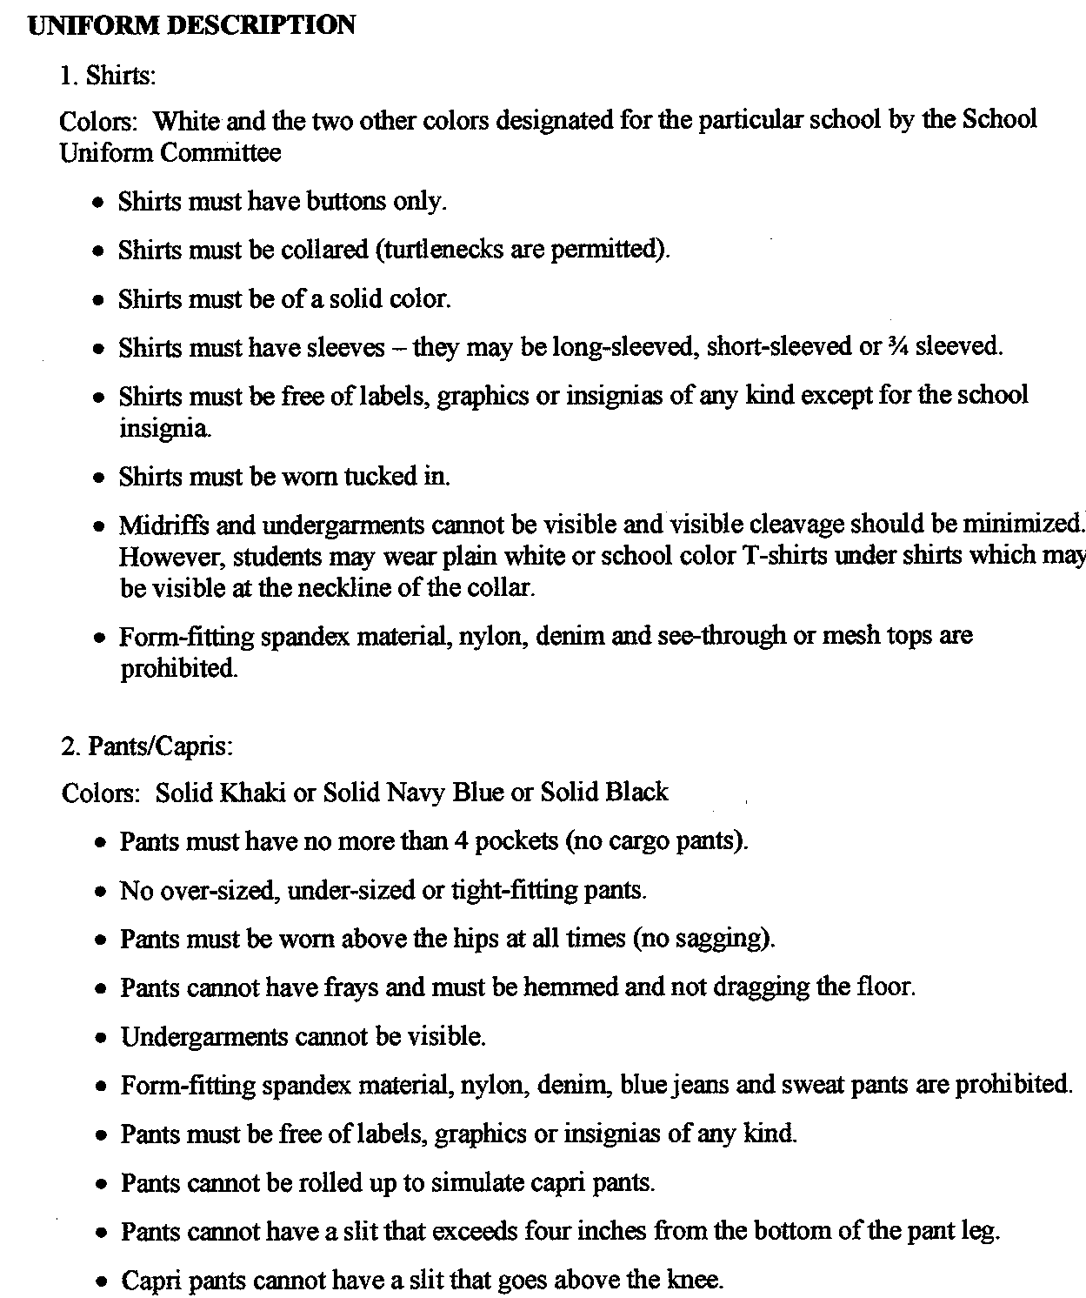

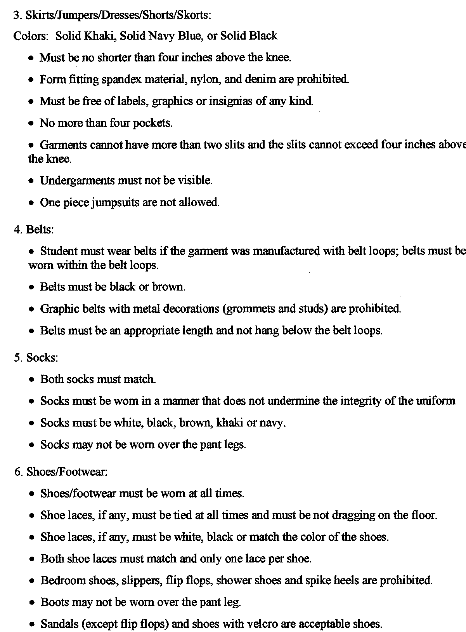

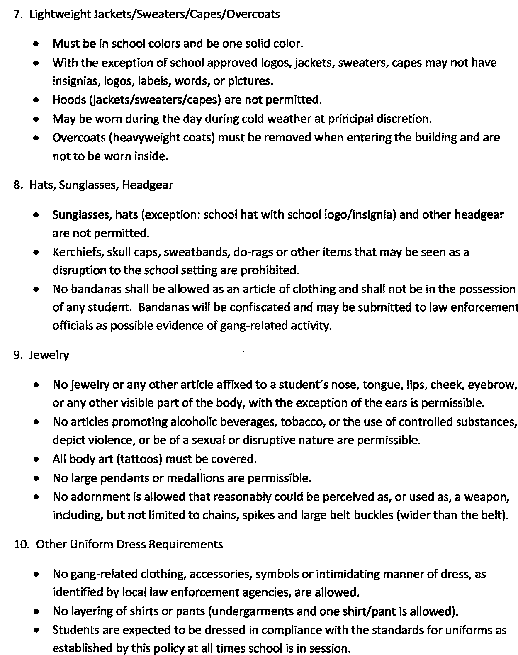

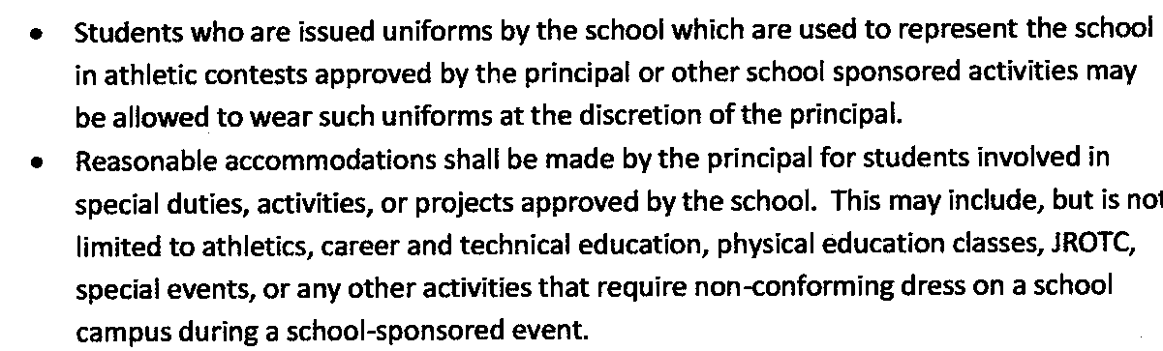

ATTENDANCE

North Carolina General Statute 115C-378 (Compulsory Attendance Law) states the following:

Every parent, guardian or other person in this State having charge or control of a child…shall cause such child to attend school continuously for period equal to t he time which the public school to which the child is assigned shall be in session… The parent, guardian, or custodian of a child shall notify the school of the reason for each known absence of the child, in accordance with local school policy.

The principal, superintendent, or teacher who is in charge of such school shall have the right to excuse a child temporarily from attendance on account of sickness or other unavoidable cause which does not constitute unlawful absence as defined by the State Board Of Education.

The principal or his/her designee shall notify the parent, guardian, or custodian of his/her child’s excessive absences after the child has accumulated three unexcused absences in a school year. After not more than six unexcused absences, the principal shall notify the parent, guardian, or custodian by mail that prosecuted if the absence cannot be justified under the established attendance policies of the State and local Board of Education. Once the parents are notified the school attendance counselor shall work with the child and his/her family to analyze the causes of the absences and determine steps, including adjustment of the school program or obtaining supplement services, to eliminate the problem. The attendance counselor may request that a law-enforcement officer accompany him/her if he/she believers that a home visit is necessary.

After ten accumulated unexcused absences in a school year, the principal shall review any report or investigation prepared under G.S. 115C-381 and shall confer with the student and his/her parents, guardian, or custodian if possible to determine whether the parent, guardian, or custodian has received notification pursuant to this section and made a good faith effort to comply with the law. If the principal determines that parent, guardian, or custodian has not, he/she shall notify the district attorney. If he/she determines that parent, guardian, or custodian has, he/she may file a complaint with the juvenile intake counselor under G.S. 7A-561 that the child is habitually absent from school without a valid excuse. Evidence that shows that the parent, guardian, or custodian were notified and that the child has accumulated ten absences which cannot be justified under the establishment attendance policies of the local board shall establish a prima facie case that the child’s parent, guardian, or custodian is responsible for the absences.

- Lawful Absences

Following an absence, the student must bring a signed statement from his/her parent or guardian which gives the date of the absence and the reason for the absence. The student must bring this statement to school on the day of his/her return from the absence. The principal/ designee will determine the absence as lawful or unlawful and code it accordingly. No note results in an unlawful absence; however, if the note is brought on the second day, the absence will be coded.

A lawful absence will allow the student to make up the work that was missed while he/she was away. To determine what assignments must be made up, students in grade 7-12 who have lawful absences are responsible for contacting their teachers the day they return to school. Teachers in grades K-6 are responsible for informing their students of make-up assignments. The student shall be entitled to five school days to make-up all work missed. This would include time for testing as arranged by the student – at the convenience of the teacher. Any work missed by the student while absent and not turned in will result in no credit for that assignment. Lawful absences include the following:

- Illness or injury (A statement from a physician may be required at the discretion of the principal.)
- Quarantine
- Death in the immediate family
- Medical or dental appointments (Documentation from physician required)
- Court or administrative proceedings
- Religious observances
- Education opportunity (prior approval and documentation by the principal is mandatory)

2. Unlawful Absences

Any absence that is not defined or determined lawful by the principal/ designee is unlawful. A student may work up any work or evaluations within five days following any absence, whether excused or not. Work missed during an extended absence will be addressed individually. The time and place for the make-up work shall be determined by the principal and teacher. If a student fails to be present for the make-up test(s), then he/she shall receive no credit for the test.

3. Excessive Absences (Both Lawful and Unlawful)
- A student in grades K-8 must be in attendance a minimum of one hundred sixty (160) days.
- A student in grades 9-12 must be in attendance a minimum of one hundred sixty (160) class contacts (80 per semester) to receive credit.
- Course credit will be withheld if more than the stipulated number of twenty (20) days (10 per semester) is missed. School-related absences are not included. All other absences will count against the maximum number permitted.
- Students who wish to appeal for special consideration due to extenuating circumstances can follow the regular grievance procedure policy established by the Columbus County Schools.
- All parents and students should be informed of this policy and parents of students with attendance problems should be warned at appropriate times.

ASSIGNMENTS, RELEASES, AND TRANSFERS

The Board of Education has the lawful authority to provide for the assignment of each child domiciled within Columbus County who is qualified under North Carolina law for admission to a public school. It is the policy of the Board that the student shall attend a school serving the geographical attendance zone in which they are domiciled in accordance with other rules and regulations promulgated by the Board as may appear in the Board’s policy manual.

1. Verification of domicile
- Domicile: The term “domicile” means a student’s permanent, established home as distinguished from a temporary, although actual, place of residence. It is a place in which the student intends to remain permanently or for an indefinite length of time or until some unexpected event shall occur to induce or cause the student to leave it.

- Guidelines for determining a student’s domicile: In general, the domicile of the student shall be determined by the domicile of the student’s parent(s), custodial parent(s), or legal guardian(s). If the child’s parents are divorced or separated, domicile generally shall be determined by the domicile of the custodial parent. If the custodial parent is a parent, the domicile may be determined by a court order or a written separation/child custody agreement awarding custody to the custodial parent(s) who is/are domiciled in Columbus County; however, if the person or persons are not the parents, a court order evidencing the placement of custody or establishing legal guardianship with the person who is domiciled in Columbus County is necessary.

  - A student who is 18 years of age or older, married, or emancipated may establish his/her parents or guardians.

  - A student who is abandoned by his/her parents may be domiciled with his/her next of kin, i.e., a grandparent, aunt, uncle, etc. A student may be considered abandoned by his/her when the parents willfully refuse or neglect to provide a home for their minor child. In these instances, a court order is necessary.

  - A final decision by the superintendent regarding domiciliary status and payment of tuition may be appealed to the board.

b. Verification of domicile: The principal or other appropriate school official is authorized to verify the permanent address / domicile of each student seeking to enroll in the Columbus County School System or to transfer within the school system. School officials have the authority to request appropriate documentation establishing the student’s permanent address or domicile in accordance with the school system’s regulations. If such information is unavailable or impossible to obtain, the student shall be allowed to enroll, provided however, that the parent/ custodian shall have ten days to verify the student’s address. If verification is not produced by the end of the ten day period, the student may be suspended or reassigned to the school serving the student’s last verified permanent residence/ domicile.

2. Prohibited conduct as a basis for non-admission: In order to be admitted to Columbus County School, the student cannot be currently under a term of suspension or an expulsion from a school for conduct that could have led to a suspension or an expulsion from the Columbus County School System and its administrative unit. The adult with whom the student resides and student’s parent, guardian, or legal custodian must complete and sign separate affidavits available through the Superintendent’s office attesting to information required by NCGS 115C-366 (a3). If it is found that a person willfully and knowingly provided false information in the affidavit, the maker of the affidavit will be guilty of a Class 1 misdemeanor and will pay to the local Board of Education an amount equal to the cost of educating the student during the period of enrollment. Repayment will not include state funds.

Exceptions to this policy:

1. Exceptional Children’s Program

Students enrolled in this program shall be considered for school assignment or release based on the student’s special needs. (Existing cooperative agreement with Bladen County and Whiteville City administrative units will continue.)

2. Reassignment of Students (domiciled) within the Columbus County Administrative Unit

- Request will be considered on a case-by-case basis.

- Only request based on substantiated hardship and/ or extenuating circumstances will be considered.

- Request must be submitted by July 15 of each year by the student’s parents. Requests received after this deadline will not be honored.

3. Release of Students (domiciled) to other school administrative units outside Columbus County

- A written request must be filed in the Superintendent’s office by July 15 of each year by the student’s parents. Requests received after this deadline will not be honored.

- Requests for release will be considered and action taken on a case-by-case basis.

4. Release of students (domiciled) to other school administrative units within Columbus County

a. A written request must be filed in the superintendent's office by July 15 of each year by the student's parents. Requests received after this deadline will not be honored.

b. Students in grades K-6 previously released for school attendance in Another administrative unit within the county will continue to be released on an annual basis and in accordance with established procedure.

c. Students in grades K-6 not previously released shall be considered for release for school attendance in another administrative unit within the county on a case-by-case basis. Such consideration will be based on the substantiated hardship or other proven extenuating circumstances. The established procedure for student release will be followed.

d. Students in grades 7-12 will not be considered for release for school attendance in another administrative unit within the county.

5. Appeal procedure

a. Any parent dissatisfied with the Board's decision may file with the Columbus County Board of Education written notice of appeal which shall specify the reasons for the appeal. The notice of appeal may be filed with the Superintendent as secretary of the board.

b. The Board shall duly and appropriately provide an opportunity for a hearing, if requested, or parents wishing to appeal the provisions of this policy. The Board shall give at least five days written notice by registered mail of the date, time, and place of the hearing.

c. Within five days following, the hearing, the Board shall send its written decision to the parent by registered mail.

USE OF METAL DETECTORS

It is the goal and vision of the Columbus County Board of Education that each and every student in the Columbus County School System will attend a school that is safe and secure and one that is free of fear and conducive to learning. Schools should be safe, secure, and orderly.

In deciding when it is necessary or appropriate to use metal detectors in public schools, school administrators must have a "compelling interest" to intrude upon the students' reasonable expectation of privacy as protected by the Fourth Amendment's protection against unreasonable searches and seizures by government officials.

In view of the escalating presence of weapons in schools, the Columbus County Board of Education authorizes the use of hand-held or walk-through metal detectors to check students' and visitors' personal effects on school sites. School officials or law enforcement officers may conduct metal detector checks of groups of individuals if the checks are done in a minimally intrusive, non-discriminatory manner (e.g., on all students in randomly selected class; on every third individual entering an athletic event). Metal detector checks of groups of individuals may not be used to single out a particular individual or category of individuals.

Administrative screening of an entire student body of a particular school or a random sampling thereof may be carried out when a search is necessary to accomplish any of the following objectives:

1. Foster student and parent confidence in the safety of our schools and school activities.

2. Deter the presence of weapons on school property, on school buses, and at school - related activities.

3. Dispel student and public concerns that there are "weapons at school."

4. Promote an environment conducive to orderly and disciplined learning and training that is free from fear of physical harm by persons with weapons.

If a school official has reasonable suspicion to believe that a particular individual or student is in possession of an illegal or unauthorized metal-containing object or weapon, he or she may conduct a metal detector check of the student's person and personal effects.

A student's failure to permit a metal detector check as provided in this policy will be considered grounds for disciplinary action including possible suspension. A non-student's refusal to permit a metal detector will be grounds for denial of entry to a school-sponsored event and immediate removal from school grounds. If the person refuses to leave law enforcement will be called.

PROCEDURES GOVERNING METAL DETECTOR CHECKS

The following procedures for the use of metal detectors in the Columbus County School System are developed pursuant to Board policy on metal detectors. The Superintendent may modify or expand these procedures in may manner consistent with Board policy.

A notice will be posted in central location at each school stating that weapons are not permitted at school and that students may be required to submit to metal detector checks. In addition, a copy of the metal detector policy will be provided for all students and will also be in all future publications of the student rules and regulations.

Metal Detector Checks of Classes of Students

1. When a principal decides to conduct a group metal detector check, he or she will select the class(es) to be checked at random from all classrooms within the school.

2. Before conducting the metal detector checks, the participating administrator will enter the classroom and explain the scanning process to students in the class, emphasizing that the checks are intended to maintain safe schools.

3. An administrator will check each student by visually searching the student's desk and then escorting the student with his personal effects into the hall to proceed with the metal detector check. An adult will closely observe students at their desks to make sure that not objects are removed form pockets or personal effects. All metal detector checks will be done in the presence of an adult witness.

4. In the hall, the administrator will ask the student to remove all metal-containing objects form his or her clothing and to remove their personal effects. The administrator will then scan the outside of the student's personal effects. The metal detector scan of the student's person will be done by an adult who is the same sex as the student. If the student refuses to cooperate, the administrator will contact law enforcement personnel.

5. If the metal detector is activated during the scanning of the student's effects, the administrator will open the bag, purse, ect. , and look for weapons. If the metal detector is activated during the scanning of the student's person, the student will be give an opportunity to remove any metal-containing object form his or her person. Upon refusal, the student will be given as a second opportunity to remove the object. If he or she refuses, the administrator will have the student detained and law enforcement will be called.

In all instance of metal detector checks of individual students and non-students, provisions of Board policy shall be followed.

INTERSCHOLASTIC ATHLETICS

ELIGIBILITY REQUIREMENTS

To represent your school in athletics, you

Must be a property enrolled student at the time you participate, be enrolled no later than the 15th day of the present semester, and be regular attendance at that school.

Must have been in attendance for at least 85% of the previous semester at an approved school

Must NOT have graduated or been eligible for graduation from high school.

Must be under 19 years of age on August 31, 2011.

Must have passed a minimum of 3 of 4 courses during the previous semester.

Must receive a medical examination once every 365 days by a licensed medical doctor. Students absent from practice for five or more days due to illness or injury shall receive a medical release by a physician licensed to practice medicine before readmittance to practice and contests.

Must NOT accept prizes, merchandise, money or anything that can be exchanged for money as a result of athletic participation.

Must NOT have signed a professional contract, have played on a junior college team or be enrolled and attending a class in college.

Must NOT participate in unsanctioned all-star or bowl games.

May NOT receive group instructions from your school’s coaching staff during the school year outside your sport’s season (from first practice through final game). Instruction is limited to coach and one individual.

Must NOT be guilty of unsportsmanlike conduct.

May NOT, as an individual or team member, practice or play during the school day (from first contest through conference tournament).

May NOT play, practice, or assemble as a team with your coach on Sunday.

Must NOT play more than three games in one sport per week with the exception of baseball, volleyball, and softball.

Pupils enrolled in “exceptional students” classes shall be eligible for participation in interscholastic athletics provided the program of instruction is in accordance with the recommendations of the Department of Public Instruction; and provided further that, in the opinion of the principal and teacher, such pupil is making “satisfactory progress.” “Satisfactory progress” is interpreted to mean that the pupil passes at least five subjects on his/her level. You may contact the Exceptional Children’s Director at 642-5168 for information regarding exceptional children and Section 504.

If the State Board of Education has granted a school or system a waiver for the 90 minute block scheduling format, then the NCHSAA will grant eligibility for athletics if a student passes three or four courses per semester.

This summary of key athletic regulations is provided to make students aware of rules that may affect their eligibility. Students must understand that the rules listed above are general statement only. See your principal, athletic director, or coach if you have questions or need further explanation of details and exceptions.

For the latest information on NCAA eligibility, go to www.ncaa.org.

Notification of Rights under the Protection of Pupil Rights Amendment (PPRA)

PPRA affords parents and students who are 18 or emancipated minors (“eligible students”) certain rights regarding our conduct of surveys, collection and use of information for marketing purposes, and certain physical exams. A copy of the school system’s policy regarding the Protection of Pupil Rights Amendment (PPRA) can be obtained in the Principal’s office. These include the right to:

- Consent before students are required to submit to a survey that concerns one or more of the following protected areas (“protected information survey”) if the survey is funded in whole or in part by a program of the U.S. Department of Education (ED)-
    - Political affiliations or beliefs of the student or student’s parent;
    - Mental or psychological problems of the student or student’s family;
    - Sex behavior or attitudes;
    - Illegal, anti-social, self-incriminating, or demanding behavior;
    - Critical appraisals of others with whom residents have close family relationships;
    - Legally recognized privileged relationships, such as with lawyers, doctors, or ministers;
    - Religious practices, affiliations, or beliefs of the student or parents; or
    - Income, other than as required by law to determine program eligibility.

- Receive notice and an opportunity to opt a student out of –
    - Any other protected information survey, regardless of funding;
    - Any non-emergency, invasive physical exam or screening required as a condition of attendance, administered by the school or its agent, and not necessary to protect the immediate health and safety of a student, except for hearing, vision, or scoliosis screenings, or any physical exam or screening permitted or required under State law; and
    - Activities involving collection, disclosure, or use of personal information obtained from students for marketing or to sell or otherwise distribute the information to others.

- Inspect, upon request and before administration or use –
  - Protected information surveys of students;
  - Instruments used to collect personal information from students for any of the above marketing, sales, or other distribution purposes; and
  - Instructional material used as part of the educational curriculum.

Columbus County Schools has developed and adopted policies, in consultation with parents, regarding these rights, as well as arrangements to protect student privacy in the administration of protected surveys and the collection, disclosure, or use of personal information for marketing, sales or other distribution purposes. Columbus County Schools will directly notify parents and eligible students of these policies at least annually at the start of each school year and after and substantive changes. Columbus County Schools will also directly notify parents and eligible students, such as through U.S. Mail or email, at least annually at the start of each school year of the specific or approximate dates of the following activities and provide an opportunity to opt a student out of participating in:
- Collection, disclosure, or use of personal information for marketing, sales, or other distribution.
- Administration of any protected information survey not funded in whole or in part by ED.
- And non-emergency, invasive physical examination or screening as described above.

Parents/ eligible students believe their rights have been violated may file a complaint with:

Family Policy Compliance Office
U.S. Department of Education
400 Maryland Avenue, SW
Washington, D.C. 20202-4605
GENERAL ASSENBLY OF NORTH CAROLINA

SESSION 2005

SESSION LAW 2005-205
HOUSE BILL 1032

AN ACT TO CLARIFY THE PERMISSBLE USE OF SECLUSION AND RESTRAINT IN PUBLIC SCHOOLS AND TO PROVIDE TRAINING IN MANAGEMENT OF STUDENT BEHAVIOR.

The General Assembly of North Carolina enacts:

SECTION 1. This act shall be known as the “Deborah Greenblatt Act”.
SECTION 2. Chapter 115C of the General Statutes is amended by adding a new section to read:
“S 115C-391.1. Permissible of seclusion and restraint.
(a) It is the policy of the State of North Carolina to:
(1) Promote safety and prevent harm to all students, staff, and visitors in the public schools.
(2) Treat all public school students with dignity and respect in the delivery of discipline, use of physical restraints or seclusion, and use of reasonable force as permitted by law.
(3) Provide school staff with clear guidelines about what constitutes use of reasonable force permissible in North Carolina public schools.
(4) Improve student achievement, attendance, promotion, and graduation rates by employing positive behavioral interventions to address student behavior in a positive and safe manner.
(5) Promote retention of valuable teachers and other school personnel by providing appropriate training in prescribed procedures, which address st student behavior in a positive and safe manner.
(b) The following definitions apply in this section:
(1) “Assistive technology device” means any item, piece or equipment, or product system that is used to increase, maintain, or improve the functional capacities of a child with disability.
(2) “Aversive procedure” means a systematic physical or sensory intervention program for modifying the behavior of a student with a disability which causes or reasonably may be expected to cause one or more of the following;
- Significant physical harm, such as tissue damage, physical illness, or death.
- Serious, foreseeable long-term psychological impairment.
- Obvious repulsion on the acceptable, standard reconcile extreme procedures with acceptable, standard practice, for example: electric shock applied to the body; extremely loud auditory stimuli; forcible introduction of foul substances to the mouth, eyes, nose, or skin; placement in a tub of cold water or shower; slapping, pinching, hitting, or pulling hair; blindfolding or other forms of visual blocking; unreasonable withholding of meals; eating one’s own vomit; or denial of reasonable access to toileting facilities.
- “Behavioral intervention” means the implementation of strategies to address behavior that is dangerous, disruptive, or otherwise impedes the learning of a student or others.
- “IEP” means a student’s Individualized Education Plan.
- “Isolation” means a behavior management technique in which a student is placed alone in an enclosed space from which the student is not prevented form leaving.
- “Law enforcement officer” means a sworn law enforcement officer with the power to arrest.
- “Mechanical restraint” means the use of any device or material attached or adjacent to a student’s body that restricts freedom of movement or normal access to any portion of the student’s body and that the student cannot easily remove.
- “Physical restraint” means the use of physical force to restrict the free movement of all or a portion of a student’s body.
- “School personnel”means:
    - Employees of a local board of education.
    - Any person working on school grounds or at a school function under a contract or written agreement with the public school system to provide educational or related services to students.
    - Any person working on school grounds or at a school function for another agency providing educational or related services to students.

- “Seclusion” means the confinement of a student alone in an enclosed space from which the student is:
    - Physically prevented from leaving by locking hardware or other means.
    - Not capable of leaving due to physical or intellectual incapacity.

- “Time out” means a behavior management technique in which a student is separated from other students for a limited period of time in a monitored setting.
- Physical Restraint:
  - Physical restraint of students by school personnel shall be considered a reasonable use of force when used in the following circumstances.
    - As reasonably needed to obtain possession of a weapon or other dangerous objects on a person or within the control of a person.
    - As reasonably needed to maintain order or prevent or break up a fight.
    - As reasonably needed for self-defense
    - As reasonably needed to ensure the safety of any student, school employee, volunteer, or other person present, to teach a skill, to calm or comfort a student or to prevent self-injurious behavior.
    - As reasonably needed to escort a student safely from one area to another.
    - If used as provided for in a student’s IEP or Section 504 plan or behavior intervention plan.
    - As reasonably needed to prevent imminent destruction to school or another person’s property.
  - Except as set forth in subdivision (1) of this subsection, physical restraint of students shall not be considered a reasonable use of force, and its use of prohibited.
  - Physical restraint shall not be considered a reasonable use of force when used solely as a disciplinary consequence
  - Nothing in this subsection shall be construed to prevent the use of force by law enforcement officers in the lawful exercise of their law enforcement duties.
(d) Mechanical Restraint:
(1) Mechanical restraint of students by school personnel is permissible only in the following circumstances:
(a) When properly used as an assistive technology device included in the students IEP or Section 504 plan or behavior intervention plan or as otherwise prescribed for the student by a medical or related service provider.
(b) When using seat belts or other safety restraints to secure students during transportation.
(c) As reasonably needed to obtain possession of a weapon or other dangerous objects on a person or within the control of a person.
(d) As reasonably needed for self-defense.
(e) As reasonably needed to ensure the safety of any student, school employee, volunteer or other person present.

(2) Except as set forth in subdivision (1) of this subsection, mechanical restraint, including the typing, taping, or strapping down of a student shall not be considered a reasonable use of force, and its use is prohibited.

- Nothing in this subsection shall be construed to prevent the use of mechanical restraint devices, such as handcuffs by law enforcement officers in the lawful exercise of their law enforcement duties.
- Seclusion:
  - Seclusion of students by school personnel may be used in the following circumstance:
    - As reasonably needed to respond to a person in control of a weapon or other dangerous object.
    - As reasonably needed to maintain order or prevent or break up a fight.
    - As reasonably needed for self-defense.
    - As reasonably needed when a student’s behavior poses a treat of imminent physical harm to self or others or imminent substantial destruction of school or another person’s property.
    - When used as specified in the student’s IEP, Section 504 plan, or behavior intervention plan; and
      - The student is monitored while in seclusion by an adult in close proximity who is able to see and hear the student at all times.
      - The Student is released form seclusion upon cessation of the behaviors that led to the seclusion or as otherwise specified in the student’s IEP or Section 504 plan.
      - The space in which the student is confined has been approved for such use by the local education agency.
      - The space is appropriately lighted.
      - The space is appropriately ventilated and heated or cooled.
      - The space is free of objects that unreasonably expose the student or others to harm.
  - Except as set forth in subdivision (!) of this subsection, the use of seclusion is not considered reasonable force, and its use is not permitted.
  - Seclusion shall not be considered a reasonable use of force when used solely as a disciplinary consequence.
  - Nothing in this subsection shall be construed to prevent the use of seclusion by law enforcement officers in the lawful exercise of their law enforcement duties.
- Mechanical Restraint:
      - Mechanical restraint of students by school personnel is permissible only in the following circumstances:
        - When properly used as an assistive technology device included in the student’s IEP or Section 504 plan or behavior intervention plan or as otherwise prescribed for the student by a medical or related service provider.
        - When using seat belts or other safety restraints to secure students during transportation
        - As reasonably needed to obtain possession of a weapon or other dangerous objects on a person or within the control of a person/
        - As reasonably needed for self-defense.
        - As reasonably needed to ensure the safety of any student. School employee, volunteer, or other person present.
(2). Except as set forth in subdivision (1) of this subsection. Mechanical restraint, including the
typing, taping, or strapping down of a student shall not be considered a reasonable use of force and its use is prohibited.
(3) Nothing in this subsection shall be construed to prevent the use of mechanical restraint devices, such as handcuffs by law enforcement offivers in the lawful exercise of their law enforcement duties.
(e) Seclusion:
(1) Seclusion of students by school personnel may be used in the following circumstances:
a. As reasonably needed to respond to a person in control of a weapon or other dangerous object
b. As reasonably needed to maintain order or prevent or break up a fight.
c. As reasonably needed for self defense.
d. As reasonably needed when a student’s behavior poses a threat of imminent physical harm to self or another person’s property.
e. When used as specified in the student’s IEP, Section 504 plan, or behavior intervention plan; and;
1. The student is monitored while in seclusion by an adult in close proximity who is able o see and hear the student at all times.
2. The student is released from seclusion upon cessation of the behaviors that led to the seclusion or as otherwise specified in the students IEP or Section 504 plan.
3. The space in which the student is confined has been approved for such use by the local education agency.
4. The space is appropriately lighted.
5. The space is appropriately ventilated and heated or cooled.
6. The space is free of objects that unreasonably expose the student or others to harm.
(2) Except as set forth in subdivision (1) of this subsection, the use of seclusion is not considered reasonable force, and its use is not permitted.
(3) Seclusion shall not be considered a reasonable use of force when used solely as a disciplinary consequence.
(4) Nothing in this subsection shall be construed to prevent the use of seclusion by law enforcement officers in the lawful exercise of their law enforcement duties.
(f) Isolation. – Isolation is permitted as a behavior management technique provided that:
(1) The space used for isolation is appropriately lighted, ventilated, and heated or cooled.
(2) The duration of the isolation is reasonable in light of the purpose of the isolation.
(3) The student is reasonably monitored while in isolation.
(4) The isolation space is free of objects that unreasonably expose the student or others to harm.
(g) Time-Out. - Nothing in this section is intended to prohibit or regulate the use of time out as defined in this section.
(h) Adversive Procedures – the use of aversive procedures as defined in this section is prohibited in public schools.
(i) Nothing in this section modifies the rights of school personnel to use reasonable force as permitted under G.S. 115C-390 or modifies the rules and procedures governing discipline under G.S. 115C-391(a).
(j) Notice, Reporting, and Documentation.
(1) Notice of procedures. – Each local board of education shall provide copies of this section and all local board policies developed to implement this section to school personnel and parents or guardians at the beginning of each school year.
(2) Notice of specified incidents:
(a). School personnel shall promptly notify the principal or principal’s designee of:
1. Any use of adversive procedures.
2. Any prohibited use of mechanical restraint.
3. Any use of physical restraint resulting in observable physical injury to a student.
4. Any prohibited use of seclusion or seclusion that exceeds 10 minutes or the amount of time specified on a student behavior intervention plan.
(b) When a principal or principal’s designee has personal knowledge or actual notice of any of the events described in this subdivision, the principal or principal’s designee shall promptly notify the student’s parent or guardian and will provide the name of a school employee the parent or guardian can contact regarding the incident.
(3) As used in subdivision (2) of this subsection. “promptly notify” means by the end of the workday during which the incident occurred when reasonably possible, but in no event later than the end of the following workday.
(4) The parent or guardian of the student shall be provided with a written incident report for any incident reported under this section within a reasonable period of time, but in no event later than 30 days after the incident. The written incident report shall include:
a. The date, time of day, location, duration, and description of the incident and interventions.
b. The events or events that led up to the incident.
c. The nature and extent of any injury to the student
d. The name of a school employee the parent or guardian can contact regarding the incident.
(5) No local board of education or employee of a local board of education shall discharge, threaten, or otherwise retaliate against another employee of the board regarding that employee’s compensation, terms, conditions, location, or privileges of employment because the employee makes a report alleging a prohibited use of physical restraint, mechanical restraint, aversive procedure, or seclusion, unless the employee knew or should have known that the report was false.
(k) Nothing in this section shall be construed to create a private cause of action against any local board of education, its agents or employees, or any institutions of teacher education or their agents or employees or to create a criminal offense.”

Freshman Success Academy Outline
East Columbus High School

Mission: To instill in freshman students the academic and social skills essentials for responsible and productive citizenship in a global society.
List of Guiding Principles:
Integrated, relevant, and rigorous curriculum is essential to academic success.
Students must be actively engaged in meaningful learning experiences that reflect differentiated learning philosophies.
Parental and community involvement is sought and encouraged through consistent and purposeful communication.

Important components are Strategic Reading
Transition to Advanced Mathematics
Freshman Seminar
Freshman Seminar is a key component.

Will be operated as a school-within-a-school
A smaller learning community

Common planning period-----2nd period

All freshman will be scheduled for Earth Science or World History during first semester in order to expose all
Students to Freshman Seminar during the first semester (Freshman Seminar will be taught by NON-E.O.C.
course teachers----- Earth Science and World History)

Students will be housed in what was the English hall. Room assignments have been made.

Students will be kept together in the morning after departing their buses. They will participate in cooperative
activities and then escorted to the Freshman Success Academy hall.

Students’ lockers will be in a specific, close location to the F.S.A. hall.

Students will eat lunch together.

An orientation day will be held for students and parents on Friday, August 17. Many activities (tours, rules,
cooperative, competitive, social, get-acquainted, etc.) will be held. Parents will be invited to sign up for
individual conferences with teachers.

Three staff members were involved in extensive Talent Development Training at Johns Hopkins, June 10-16.

Current Freshman Success Academy Staff: Judy Petteway, English, Coordinator
Brittany Damato, Math
Adam Jernigan, Earth Science
Crystal Frink, World History
Karlyn Stephens, Health & PC
Melissa Jones, Exceptional Children
Principal Mark Bridgers will work with Freshman Success Academy

East Columbus Alternative Academy
“A Second Chance for Success”

Mission Statement

The Mission of East Columbus Alternative Academy is to instill in students who are unreceptive to traditional
classroom settings the academic and social skills essential for responsible and productive citizenship in a global
society.

I. What is the East Columbus Alternative Academy?
The East Columbus Alternative Academy is a program designed to help the staff, at both the high school and middle school, better meet the needs of a students who are having difficulty controlling their behavior. It is an alternative educational program nested within the high school for students demonstrating severe and persistent behavioral problems that hinder their ability to be successful in a typical classroom.

II. What are the objectives of the East Columbus Alternative Academy?
  - Provide troubled students an opportunity for intensified academic access and success in a positive, personal, inviting learning environment.
  - Provide structured behavioral, developmental and motivational activities with students on a regular basis to address fundamental issues necessary for personal success;
  - Prepare students to master a rigorous, relevant curriculum;
  - Ensure that students will graduate ready to work and/or continue their education by providing career awareness education.
  - Provide students reentering the school system from juvenile justice agencies a smoother transition back into the regular school setting.
  - Equip students with coping skills and strategies to self-regulate their behavior;
  - Monitor and mentor student making the transition from the East Columbus Alternative Academy to the regular school setting.

Who benefits from the East Columbus Alternative Academy?
The East Columbus Alternative Academy is intended for students whose conduct patterns create ongoing problems for classmates and teachers. The student can pose a threat to a school and classroom environment by exhibiting behavior not conducive to learning. Potential candidates for the East Columbus Alternative Academy include not only unmanageable students from within the school, but also students who are long-term suspended from other schools as well as those re-entering the school system from various juvenile justice agencies.

How does it work?
All current alternative school policies regarding referrals will apply to the East Columbus Alternative Academy (School Handbook). The high school principal will have executive authority over the East Columbus Alternative Academy’s programs and activities. The principal will supervise qualified and certified teachers to provide coursework for the East Columbus Alternative Academy.
All federal, state, local, and board requirements for public high schools and middle schools will be followed by East Columbus Alternative Academy, including but not limited to,
- curriculum
- instructional calendar
- transportation
- provision of textbooks and related materials
- provisions of physical education
- provision for lunch
- provision of health services
- including counseling compliance with laws and regulations governing the education of students with disabilities
- compliance with federal laws governing privacy of students records
- compliance with state laws governing the health and safety of minors
- discipline, unless otherwise prohibited.

The East Columbus Alternative Academy is in session every weekday, after the regular school day begins. Students will enroll in six one-hour classes and earn academic credit. In addition, students will receive ongoing counseling from their counselor, the school psychologist, the school social worker, drop-out prevention coordinator, behavior modification counselor, and other in-school support personnel, as needed. The staffing of the East Columbus Alternative Academy consists of the assistant principal, at least two core subject area teachers, an Exceptional Children’s teacher, along with a resource officer. Tentative bell schedule:
9:46 – 10:55 1st Period
11:00 – 11:55 2nd Period
12:00 – 12:55 3rd Period
1:00 – 1:30 Lunch
1:35 – 2:30 4th Period
2:35 – 3:30 5th Period
3:35 – 4:30 6th Period

Class sizes are generally small, but will be determined based on referrals from the feeder schools (East Columbus High School, Acme-Delco Middle School and Hallsboro Middle School.) Academic achievement is emphasized in the East Columbus Alternative Academy.
All Students participating in the East Columbus Alternative Academy will be required to ride the supervised transportation provided by Columbus County. Upon arrival and departure, students will be chaperoned by the bus monitor and/or the resource officer. They will be escorted directly to a designated area on the Athletic Wing of ECHS (rooms 148, 146, or 142). Also, participants must be uniformed: white shirts and khaki pants. Shirts will be tucked in, a belt required, and pants will be worn at or above the waist, no exceptions. Other rules and regulations stipulated in the East Columbus High School handbook will be followed.
The school cafeteria staff will provide and deliver nutritious meals in a timely manner to the assigned area. Students will be chaperoned on bathroom breaks and whenever they must go outside the designated area. Students must be present the entire school day with no checking in or out.
A contract shall be signed by the student, parent and teacher, agreeing with East Columbus Alternative Academy policies. Parents are expected to attend a progress report session every three weeks.

Request for Notification before Non-Exempt Pesticide Applications

Dear IPM Coordinator, Columbus County Schools,

I am writing to request notification in advance of non-exempt pesticide applications at my child’s school, and/or at the school or other site where I am employed by the school district, as per my legal right under the NC School Children’s Health Act.
I understand that I can request 72 hour advanced notification for pesticide applications that are not already listed on the school district’s annual schedule, if it has one. If there is an annual schedule of pesticide applications for my school site, it has been sent to me, and I can view it any time by [contacting IPM coordinator or visiting website].
I also understand that notification requirements apply to all non-exempt pesticide applications at the relevant school or other non-school site (office building, garage, workshop, etc.), both indoor and outdoor pesticide applications, and including applications planned for summer recess, holidays, weekends, or after school.
Pesticide products exempt from notification requirements include: antimicrobial cleansers, disinfectants, self-contained baits and crack-and-crevice treatments, and any pesticide products classified by the United State Environmental Protection Agency (EPA) as belonging to the US EPA Toxicity Class IV, “relatively nontoxic.”
In addition, I understand that should a pest control emergency require a pesticide application for which there is not adequate time to notify me 72 hours in advance, I will receive a notice of emergency pesticide use less than 72 hours, or as soon as possible after, the emergency pesticide application.

I am requesting notification of pesticide use in the following schools or other sites:

1) Name of Student or Employee:
School or other site, homeroom or office number:
2) Name of Student or Employee:
School or other site, homeroom or office number:
3) Name of Student or Employee:
School or other site, homeroom or office number:
4) Name of Student or Employee:
School or other site, homeroom or office number:
5) Name of Student or Employee:
School or other site, homeroom or office number:

I would like my primary notification method to be (please check one):

() Mail.
Mailing address:
() Phone.
Home phone:
Work phone:
Mobile or other phone:

() Email.
Address:

In case of a problem with my primary notification method, I would like my back up notification method to be (please check one):
() Mail.
Mailing address:
() Phone.
Home phone:
Work phone:
Mobile or other phone:
() Email.
Address:

I understand that it is my responsibility to maintain communication through the means I have designated above, and that the school is required to try to contact me only once about a pesticide application. If I do not receive the notification because I have not updated my mailing address; my voicemail or answering machine are full or not functioning; or because my email account is not functioning, over quota, or notification from the school is auto-filtered as spam; it is my responsibility to correct the problem. Though they will attempt to alert me to the issue, the school system is not liable.

Sincerely,

Full Name (please print):
Signature: Date:

Annual Notification of Pest Management Program For School Year 2011 – 2012

Dear Parent, Guardian, or Staff Member:

This notice is being distributed to comply with the North Carolina School Children’s Health Act. Columbus County Schools has adopted an Integrated Pest Management (IPM) Policy to comply with this law. IPM is a holistic, preventive approach to managing pests that minimizes pesticide use in our schools and on school grounds. IPM is explained further in the school’s Pest Management Policy, a copy of which is included with this notice.

The IPM Coordinator for our school district is:
Name Billy Hobbs
Title Director’s Assistant / Plant Operations
Phone number 910-642-0161
Email address bhobbs@columbus.k12.nc.us
Office address 5487 Silverspoon Road, Whiteville, NC 28472

Your on-site contact for questions about the IPM program is:
Name
Title
Phone number
Email address
Office address

The IPM Coordinator and your on-site contact maintain the pesticide product label and the Material Safety Data Sheet (MSDS) of each pesticide product that may be used on school property. The label and the MSDS are available for review upon request by a parent, guardian, staff member, or student attending the school. Also, the IPM Coordinator is available to help answer any questions you might have about the school system’s pest management program and pesticide use decisions.

Notification of Pesticide Use: Our school system may find it necessary to use pesticides to control pests at your school or other school system site. North Carolina state law gives you the right to be notified annually of our school system’s pesticide application schedule, and 72 hours in advance of pesticide applications made outside that schedule, but the latter only if you request notification ahead of time using the enclosed form.

Exemptions: Certain relatively low-risk pesticides are exempted from these notification requirements, including antimicrobial cleansers, disinfectants, self-contained baits and crack-and-crevice treatment, and any pesticide products classified by the US Environmental Protection Agency (EPA) as belonging to the US EPA’s Toxicity Class IV, “relatively nontoxic.” Your right to be notified extends to all nonexempt pesticide applications at your school or other non-school site (office building, garage, workshop, etc.), both indoor and outdoor pesticide applications, and including applications that take place over summer recess, holidays, weekends, or after school hours.

Emergency Pesticide Use: In the event that a non-exempt pesticide must be used for a pest control emergency at your school or other site and there is not adequate time to notify you more than 72 hours in advance, and you have requested advance notice, you will receive a notice of emergency pesticide application less than 72 hours before, or as soon as possible after the pesticide application.

To request advanced notification of non-exempt pesticide applications at your school or other site, please return the enclosed form to your school contact person. People wishing to receive pesticide use notification for multiple school district sites can list up to 5 sites on each form. You will need to submit a new copy of this form each year, and every time you wish to update or change your preferred contact information. Additional copies of this form are available by contacting your school contact person.

