KINGS PARK
CENTRAL SCHOOL DISTRICT
REMOTE LEARNING PLAN
FALL 2020

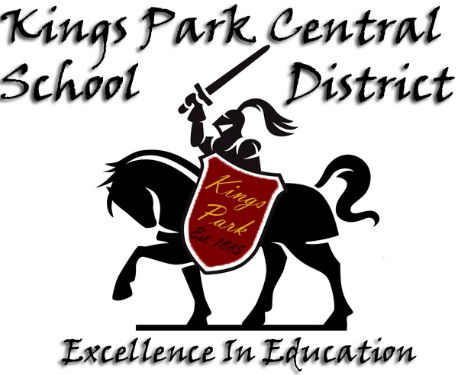
Timothy T. Eagen, Ed.D., Superintendent of Schools
Ralph J. Cartisano, Ed.D., Deputy Superintendent
John T. Craig Assistant Superintendent for Personnel & Administrative Services
Danielle Colby-Rooney, Ed.D., Administrator for PPS
Shannon L. Meehan, C.P.A., Assistant Superintendent for Business

Diane Nally, Board of Education President
Joe Bianco, Board of Education Vice President
Pam DeFord, Board Trustee
Kevin Johnston, Board Trustee
Dan Tew, Board Trustee
INTRODUCTION
This document was produced from the official KPCSD Re-Entry Plan to conform with the Governor’s August 7, 2020 directive to post the Remote Learning Plan separately in an easily accessible location on the district’s website. This is a small portion of the larger Re-Entry Plan, which can be accessed through the link below:
https://www.kpcsd.org/ourpages/auto/2020/7/21/46436733/KPCSD_Re-Entry_Plan_2020-2021.pdf
PRIDE stands for:
Planning for all scenarios for
Re-entry and
Instruction, because we are
Devoted to providing the best possible
Education and mental health services possible during this crisis.

There are 11 different workgroups addressing the following important areas:
- Extracurricular & Gatherings
- Furniture & Classrooms
- Health & Wellness
- ***Instructional Program***
4A – Elementary (K-6) Program
4B – Secondary (7-12) Program
4C – Specials
4D – Special Education/ELL
- Instructional Support of Plans B & C
- Mental Health and Social Emotional Learning (SEL)
- Safety & Cleaning
- Transportation & Arrival/Dismissal
The committee is composed of over 90 KPCSD employees, parents, and students. The committee has regular scheduled virtual meetings on Wednesdays throughout the months of July and August, 2020. Every aspect of school operations was examined while assembling this plan.

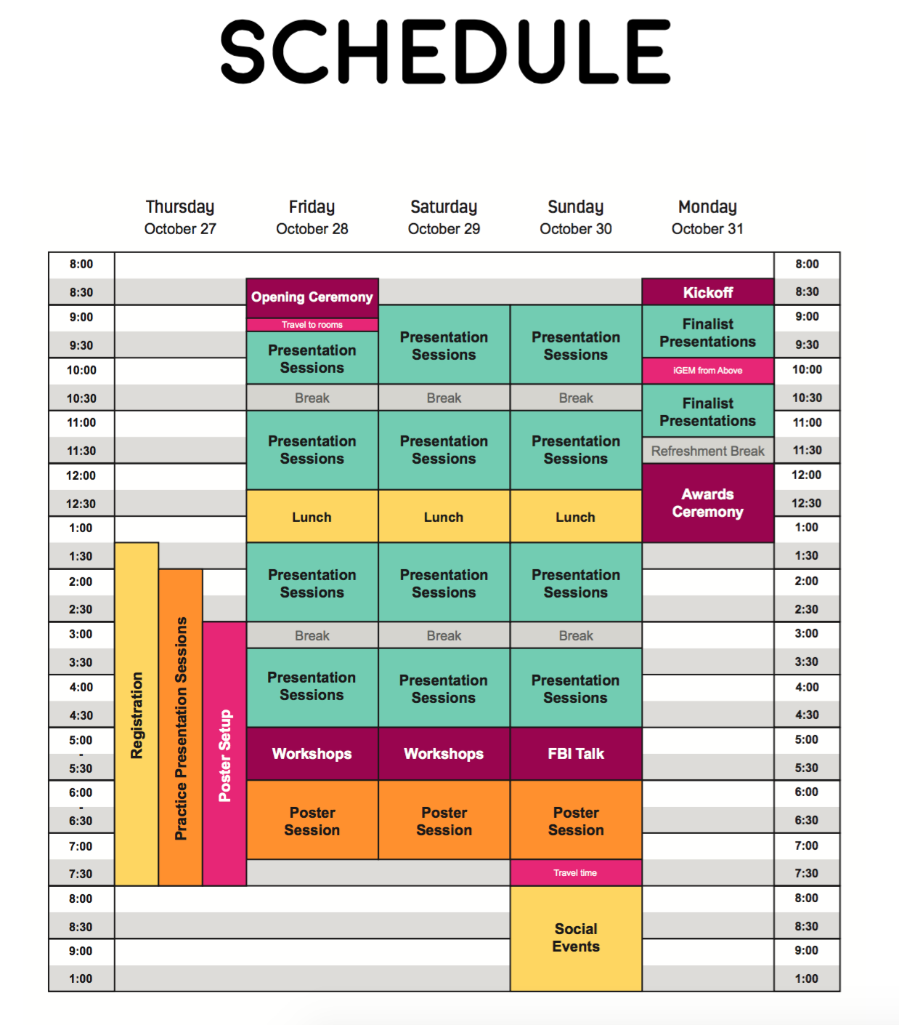

SCHOOL SCHEDULES
(will vary for each building)

eLearning/Remote Model (Red)
The following schedules will be utilized for a remote or red model:
Park View Elementary School and Fort Salonga Elementary School- These schools have students in Kindergarten through 3rd grade. The following schedules were developed for each grade level. Kindergarten and Grade 1 schedules were modified to accommodate the developmental needs of the students. Please note that students will receive reading, writing, and math lessons each day. Teachers will assign the students to small groups and provide the necessary schedule and frequency. The school will endeavor to schedule RTI support for days that students are not assigned to a small group. This will help to balance the amount of screen time for students that is developmentally appropriate.
Kindergarten and First Grade Schedule
8:45-9:15 | PV TV-morning meeting | Whole class
9:15-9:35 | Bathroom break and movement
9:35-9:45 | Morning Independent Work
9:45-10:15 | Fundations/Reading  Shared reading | Whole group or Small group- ½ class with teacher and ½ working on independent work -then switch
10:15-10:35 | SNACK/ bathroom break
10:35-11:35 | Math | Small group- ½ class with teacher and ½ working on independent work -then switch
11:35-11:45 | Mindfulness /Movement break
11:45-12:15 | Guided writing and wrap up | Whole Class
12:15-1:00 | Lunch and recess
1:00-1:40 | Special Areas
1:45- 2:45 | RR/ENL  Office Hours (Extra Help, Enrich., etc.)  Related Services  RTI (Math & Reading Support) | **Times subject to change as the year progresses, children build stamina for learning, and routines are established.**

Second and Third Grade Schedule
Time | Second Grade | Third Grade
8:45-9:00 | Morning Meeting (Recorded Announcements - PVTV) | Morning Meeting (Recorded Announcements - PVTV)
9:00 - 9:45 | Math Lesson 9:00-9:20  Small Groups 9:20-9:45 | (Specials) Art/ Music/ PE
9:45-10:30 | Small Groups 9:15 - 9:40  Reading Lesson 9:40 - 10:00 | Writing Lesson 9:15 - 9:35  Small Group 9:35 - 10:00
10:30- 11:15 | RTI (Math and Reading Support) | Math Lesson 10:45 -11:05  Small Groups 11:05-11:30
11:15-12:00 | LUNCH | LUNCH
12:00-12:45 | RR/ENL/Classroom Teacher Office Hours | RTI (Math and Reading Support)
12:45-1:30 | Writing Lesson 1:00-1:20  Small Group 1:20-1:45 | Reading Lesson 12:45 - 1:05  Small Groups 1:05-1:30
1:30-2:15 | (Specials) Art/ Music/ PE | RR/ENL/Classroom Teacher Office Hours

RJO Intermediate School - Students in Grade 4 and Grade 5 attend this school. The following remote schedule will be utilized for a remote or red model. Class periods will be 45 minutes and broken up into a 20 minute large group instruction (Synchronous) and 25 minute independent practice or small group instruction (Asynchronous) for select groups of students. This may take place off-line, thus reducing the amount of screen time and providing for additional break time for the students. The asynchronous instructional portion may include pre-recorded videos. Teachers will have the flexibility to add to the amount of synchronous time if needed. The students in Small Group will continue to have access to their teachers for workshop instruction, extra help, enrichment and support. Students selected for small group instruction will not experience more than two sessions per day.
RJO Schedule Fourth Grade
Time | Subject
9:20-9:30 | Morning Meeting (Announcements)
9:30-10:15 | Reading Lesson 9:30-9:50, Small Groups 9:50-10:15 | Small group is as needed and scheduled throughout the week with different students.
10:15-11:00 | Writing Lessons 10:15-10:35, Small Groups 10:35-11:00
11:00-11:45 | Math Lesson 11:45-12:05, Small Group 12:05-12:30
11:45-12:30 | Lunch
12:30-1:15 | Specials: Times are dependent on class schedules. Specials will be scheduled between 12:30 and 3:30 | Specials would be given based upon the RJO Schedule. Synchronous learning approximately 20 minutes
1:15 - 2:00 | RR/ENL  Office Hours (Extra Help, Enrich., etc.)  Related Services  RTI (Math & Reading Support) | Support services will be provided on separate days avoiding extended screen time.
2:00 - 2:45
2:45 - 3:30
RJO Schedule Fifth Grade
Time | Subject
9:20-9:30 | Morning Meeting (Announcements)
9:30-10:15 | Specials | Specials would be given based upon the RJO Schedule. Synchronous learning approximately 20 minutes
10:15-11:00 | RR/ENL  Office Hours (Extra Help, Enrich., etc.)  Related Services  RTI (Math & Reading Support) | Support services will be provided on separate days avoiding extended screen time.
11:00-11:45
11:45-12:30
12:30-1:15 | Lunch
1:15-2:00 | Reading Lesson 1:15-1:35, Small Group 1:35-2:00 | Small group is as needed and scheduled throughout the week with different students. Team teachers will balance time within this schedule.
2:00-2:45 | Writing Lesson 2:00-2:20, Small Group 2:20-2:45
2:45-3:30 | Math Lesson 2:45-3:05, Small Group 3:05-3:30

William T. Rogers Middle School - Students in Grades 6 through 8 attend this school. The regular block schedule with a 4-day cycle will be utilized during this time, along with the students broken into two cohorts (A/B). Students will follow the regular bell schedule and daily announcements will be provided. In the event of a long-term closure that required the extended use of the remote or red model, the times may be adjusted. Class periods will be held for their traditional duration of approximately 80-minutes. The block format reduces the amount of transitions (hallway and passing time) in a school day. In order to provide a balance of screen time and allow for independent practice, the following guidelines will be applied: Standard approximate 80-minute lessons will include 50 minutes of instruction (25 minutes of synchronous and 25 minutes of asynchronous). The asynchronous instructional portion may include pre-recorded videos. Teachers will have the flexibility to add to the amount of synchronous time if needed. The remaining 30 minutes will be designated as independent practice. This may take place off-line, thus reducing the amount of screentime and providing for additional break time for the students. The students will continue to have access to their teachers for extra help and support during the full class period as well as during the regular A-Block period (Academic Block). Below is a sample schedule for students.
WTR Grade 7 Sample Schedule
*All grade levels include regularly-scheduled lunch period.
 | Day 1 | Day 2 | Day 3 | Day 4
Period 1/2  8:11 - 9:31 | English | Math | English | Math
Period 3/4  9:34 - 10:59 | Project STEM/Humanities | A-Block | Physical Ed | A-Block
Period 5  11:02 - 11:40 | *Lunch/Recess | Lunch/Recess | Lunch/Recess | Lunch/Recess
Period 6/7  11:43 - 1:02 | LOTE | Science | LOTE | Science
Period 8/9  1:05 - 2:23 | Social Studies | Tech/Art/Music | Social Studies | Tech/Art/Music

Kings Park High School- Students in Grade 9 through 12 attend this school. A block schedule with a 4-day cycle will be utilized during this time. Students will follow the regular bell schedule and daily announcements will be provided. In the event of a long term closure and use of the remote or red model, the times may be adjusted. Class periods are 80 minutes and the block format reduces the amount of transitions (hallway and passing time) in a school day. In order to provide a balance of screen time and allow for independent practice. The following guidelines will be applied: 50 minutes of instruction which will include 25 minutes of synchronous and 25 minutes of asynchronous (pre-recorded video of screencastify). Teachers will have the flexibility to add to the amount of synchronous time if needed. The remaining 30 minutes will be designated as independent practice. This may take place off line, thus reducing the amount of screentime and providing for additional break time for the students. The students will continue to have access to their teachers for extra help and support during the class and Seminar period. Below is a sample schedule for students.
KPHS Grade 11 Sample Schedule
Day | 1 | 2 | 3 | 4
Period 1  (7:35-8:55) | Chemistry Honors | AP European History | Chemistry  Honors | AP European History
Period 2  (8:59-10:19) | AP American History 11H | Seminar 11 | AP American History 11H | Seminar 11
Period 3  (10:23-11:03) | Crim. Justice | Lunch | Crim. Justice
Period 3-4  (10:23-11:43) |  |  |  | PE Team Activities
Period 4  (11:04-11:40) | Lunch |  | Lunch
Period 4-5  (11:03-12:23) |  | Chemistry  Honors
Period 5  (11:47-12:23) | Crim. Justice |  | Crim. Justice | Lunch
Period 6  (12:27-1:47) | Alg. II/Trig | English 11R | Alg. II/Trig | English 11R


TECHNOLOGY AND CONNECTIVITY
- General
Adequate access to a computing device and high-speed broadband is essential for educational equity. The district will utilize a detailed parent/guardian survey in August to determine the level of access all students have in their places of residence to devices and Wi-Fi/internet; to the extent practicable, address the need to provide devices and internet access to students who currently do not have sufficient access; and provide multiple ways for students to participate in learning and demonstrate their mastery of the learning standards in remote and hybrid instructional models.
The Kings Park Central School District will provide instruction on using technology and IT support for students and families and provide professional development for parents and teachers on the tools that will be used to deliver instruction, provide feedback, and assess students. Parental education will occur remotely through Parent University in the fall.
- Instructional Technology Support
Parents, students, and teachers can receive technology support by visiting the following help page: https://sites.google.com/kpcsd.org/remote-learning-help
The district is working on a two-track system to give students access to their own help desk.
The district has begun to develop a library of screencasts to help students and parents navigate through challenges in the spring. The district will continue to solicit feedback from parents and students so that this library can be updated throughout the year. A link was added to the district’s website, which can be found on the “Digital Learning Tools & Applications” page under the Parents and Students menu and also as a link under Technology. Additional support can be obtained by:
- Calling our Technology Department at (631) 269-3318. Students and families can leave a message that includes a brief summary of the issue and a phone number or email where they can be reached. They will then be contacted.
- Emailing the above information to helpdesk@kpcsd.org.

- Student Devices
The district recently purchased a sufficient number of Chromebooks to provide a device to each student in grades 7-12. These devices will be issued in August, and students will retain these devices throughout the school year (both in and out of school). Additionally, the district will be administering a student-specific survey in August to determine device need on a per student basis in grades K-6. The district will endeavor to provide each student with a device in cases where the student does not have a device at home. These devices will be used if the hybrid (orange) or remote (red) instructional models are employed.
- Student Wi-Fi
The district will be purchasing approximately 35 Wi-Fi hotspots to distribute to families who do not have access to Wi-Fi/internet in the home. The count was determined from data collected during the spring of 2020 through the PPS Office.
- Student Email Accounts
Students in grades 5-12 will receive KPCSD email accounts. The following security features will be in place:
- Emails can be sent/received only within the KPCSD.org domain.
- Email archiving will be performed nightly for the purposes of collection and archiving of all inbound/outgoing emails from the previous day.
- The district will also have the ability to verify timestamps and trace email content. Much like lockers, students have no expectation of privacy when it comes to email. The Code of Conduct will apply to all correspondence.

- Student Online Learning Platforms
The district will be utilizing the Google Classroom online learning platform. Teachers have been directed to be proficient in utilizing Google Classroom by September. The district has provided professional development for teachers that is focused on this platform for the past two (2) years to teachers. This is under the current KPCTA CBA, and contractual language exists and is clear that teachers should have attended this in-service training. To address areas where this might not have occurred, the district is offering courses that support the Google applications for education during the month of August to ensure that all teachers are ready for September. Tutorial videos are available to assist teachers who were unable to participate in the course at this time. Again, it is the clear expectation that Kings Park is a Google Classroom district.

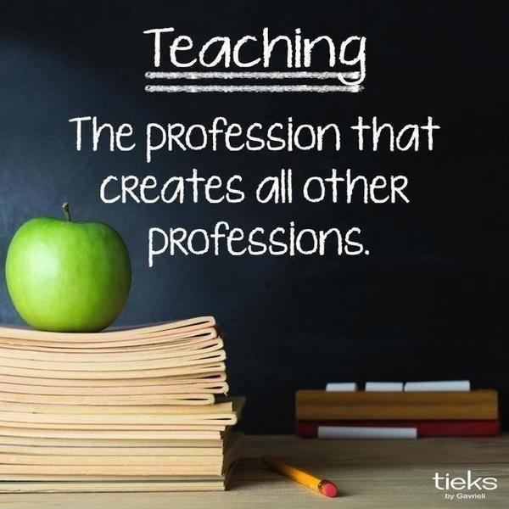

TEACHING AND LEARNING
- General
The district has established the following mandatory teaching and learning requirements:
- Providing clear opportunities for equitable instruction for all students;
- Ensuring continuity of learning regardless of the instructional model used;
- Providing standards-based instruction;
- Ensuring substantive daily interaction between teachers and students; and
- Clearly communicating information about instructional plans with parents and guardians.
To allow for schools and districts to adapt to complications caused by the pandemic, the State Education Department is permitting certain flexibilities will be authorized, including: extended time for kindergarten screening to be completed; flexibility with the 180 minutes per week Unit of Study requirement; flexibility in the delivery of physical education; and allowance for a blend of hands-on and virtual science laboratory experiences.
- Cohorts
As was previously mentioned, the district will endeavor to develop “cohorts” of students to the greatest extent possible. This will prevent the intermingling of students outside of their assigned group, and thus help to improve the health and safety of students and staff. On the primary level (Park View and Fort Salonga), a cohort is a class of students. At RJO, where classes are teamed (grade 5), the teacher will switch classes rather than the students. At WTRMS, cohorts will be assigned among each academic team.
- Educational Program
Each school and/or district reopening plan must include an educational program that is aligned to the New York State Learning Standards regardless if instruction is delivered in-person, remotely, or in a hybrid model.
Equity is at the heart of all school instructional decisions. All instruction will be developed so that whether delivered in-person, remotely, or through a hybrid model due to a local or state school closure, there will be clear opportunities for instruction that are accessible to all students. As previously mentioned, such opportunities will be aligned with State standards and include routine scheduled times for students to interact and seek feedback and support from their teachers.
Either the Governor or local department of health (SCDHS) will provide guidance on whether school can be in-person or not (hybrid/remote). Based on these directives, the district will employ the appropriate model. Regardless of the model employed, the program includes regular substantive interaction between teachers and students whether delivered in- person, remotely or through a hybrid model of instruction. Those plans are included below.
Grades K-3 (Fort Salonga Elementary School /Park View Elementary School)
eLearning/Remote (Red) Model - A schedule has been developed for parents to help provide a structured day for students. The daily schedule will consist of both asynchronous and synchronous learning activities. The schedule for K-3 students can be found in section VII of the district’s learning plan. Students will begin each day with announcements and a morning meeting with their teacher and classmates. This followed by lessons in Reading, Writing and Mathematics. Students will receive feedback from their teachers through the use of Google Classroom. Resources to accomplish this may include Google Meet and Kami.
Grades 4-5 (RJO Intermediate School)
eLearning/Remote (Red) Model - A schedule has been developed for parents to help provide a structured day for students. The daily schedule will consist of both asynchronous and synchronous learning activities. The schedule for students in grades 4-5 can be found in section VII of the district’s learning plan. Students will begin each day with announcements and a morning meeting with their teacher and classmates. This followed by lessons in Reading, Writing and Mathematics. Students will receive feedback from their teachers through the use of Google classroom. Resources to accomplish this may include Google Meet, Homework Helpers and Kami.
Grades 6-8 (William T. Rogers Middle School)
eLearning/Remote (Red) Model - A schedule has been developed for parents to help provide a structured day for students. The regular bell schedule will be followed for students in grades 6-8 and will begin each day with morning announcements. A model can be found in section VII of the district’s learning plan. In the event of a long-term closure and use of the remote or red model, the times may be adjusted. Students will receive feedback from their teachers through the use of Google classroom. Google Meet and Kami may be used as resources. In addition, the A-Block (Academic Block) will be scheduled for all students. This is an extra help period that meets 2 out of the 4 day cycle. Teachers will be available through their Google Classroom.
Grades 9-12 (Kings Park High School)
eLearning/Remote (Red) Model - A schedule has been developed for parents to help provide a structured day for students. The daily schedule will consist of both asynchronous and synchronous learning activities. The schedule for 9-12 students can be found in section VII of the district’s learning plan. In the event of a long term closure and use of the remote or red model, the times may be adjusted. Students will begin each day with daily announcements. This will be followed by the regular bell schedule. Each 80-minute period will consist of 50 minutes of instruction followed by 30 minutes of independent practice. Students will receive feedback from their teachers through the use of Google Classroom. Google Meet and Kami may be used as resources.
Curriculum and Assessment - Each school, grade level and/or course will be reviewed for curriculum standards and alignment to each of the models (In-person, Hybrid, or Remote). Students will be assessed for their pre-requisite skills to help get an understanding of their current level of proficiency and identify any learning gaps for individuals and groups of students. The results of these assessments will help to guide instruction.
- Students in Kindergarten through Grade 3 - Kindergarten students are currently participating in remote (virtual) screening. This will provide some initial data and information for the classroom teachers at the beginning of the school year. All students will participate in the Star Renaissance Assessments for Math and Reading. These will serve as a universal screener and for monitoring the student’s performance throughout the school year. The Star assessment will be administered 3 times throughout the school year (fall, winter, and spring), in addition for progress monitoring for our students that receive additional support. The district is currently exploring additional pre-assessments that are linked to the enVision Math program that serves as our primary instructional resource for mathematics.
- Students in Grades 4 and 5 - All students will participate in the Star Renaissance Assessments for Math and Reading. These will serve as a universal screener and for monitoring the student’s performance throughout the school year. The Star assessment will be administered 3 times throughout the school year (fall, winter, and spring), in addition for progress monitoring for our students that receive additional support. We are currently exploring additional pre-assessments that are linked to the enVision Math program, which serves as our primary instructional resource for mathematics.
- Students in Grades 6 through 8 - Students will participate in the Star Renaissance Assessments for Math and Reading. These will serve as a universal screener and for monitoring the student’s performance throughout the school year. The Star Assessment will be administered 3 times throughout the school year (fall, winter, and spring), in addition for progress monitoring for our students that receive additional support. The students are part of a team of teachers in each grade level. Teachers on each team will work together and meet to discuss curriculum integration and learning standards as well as individual student’s progress. Common assessments (quarterly exams) and planning will remain a focus along with feedback for students. Teachers will continue to use the student management system (eSchool) to post grades for assessments and assignments. These will be available in the Parent/Student Portals. Report card grades for an in-person and hybrid model will follow department grading practices. In the event of the use of a required long-term remote plan, the building administration will work with the lead teachers and faculty to modify the grading practices to balance student participation with proficiency.
- Students in Grade 9 through 12 - Each academic department will work collaboratively with their lead teacher and building administration to discuss the learning standards and assessments for each course. Common assessments and planning will remain a focus along with feedback for students. Teachers will continue to use the student management system (eSchool) to post grades for assessments and assignments. These will be available in the parent /student portal. Report card grades for an in-person and hybrid model will follow department grading practices. In the event of the use of a required long-term remote plan, the building administration will work with the lead teachers and faculty to modify the grading practices to balance student participation with proficiency.
The district has developed a clear communication plan for how students and their families/caregivers can contact the school and teachers with questions about their instruction and/or technology. This information is accessible to all on the school district website, available in multiple languages through our website translation tool, and widely disseminated. Parents/guardians and students (at the higher grade levels) will be able to email their teachers. Email addresses can be easily obtained from the KPCSD website. Additionally, office staff will be taking phone messages from parents/guardians. The main office at each school can be reached at:

- Fort Salonga Elementary School (631) 269-3364/3367
- Park View Elementary School (631) 269-3770/3771
- RJO Intermediate School (631) 269-3798
- WTR Middle School (631) 269-3369
- Kings Park High School (631) 269-3345
- IT Department (631) 269-3318
helpdesk@kpcsd.org

