HENRY HUDSON REGIONAL SCHOOL
2019 SUMMER READING PROGRAM
GRADES 7 – 12



“Reading is to the mind what exercise is to the body.”
J. Addison

June 2019

Dear Students, Parents, and Guardians:

The English Language Arts teachers at Henry Hudson Regional are proud to present to you the summer reading program. Building on the positive feedback they received from previous years, the teachers wanted to accomplish several goals with this year’s program:
- This year’s list would retain the titles that students liked last year.
- This year’s list would encourage students to read by providing an even wider range of choices. Please note that this year’s assignment again includes the option for a student to select a book that has not been placed on the suggested list.
- The assessment of summer reading would be simple and fair.
- The assessment would allow teachers to acquire an early measure of each student's ability to engage in meaningful discussion about a text. This skill is emphasized in the New Jersey Student Learning Standards for English Language Arts.

I think you will agree that our teachers have achieved these goals.

Attached you will see three components of the program:
- The Suggested Summer Reading List, including the procedure for selecting alternative books not identified on the list.
- Summer Reading Assignment: Please choose one option.
Option 1: A Summer Reading Synopsis Sheet that is due on the first day of school (September 5th, 2019) and is worth 50% of each student’s first major assessment in English Language Arts class.
OR
Option 2: An Annotation Assignment is due on the first day of school. (September 5th, 2019) and is worth 50% of each student’s first major assessment in English Language Arts class.
- A Book Discussion that will comprise the remaining 50% of the first major assessment in English Language Arts class. This discussion will take place in the first week of school.

As always, we strongly encourage parents to preview the selections and even read the texts with their children: this provides an opportunity for discussion about the text that not only prepares the student better for the assessment but also helps readers learn more by thinking on a deeper level.

We hope you enjoy the selections, and we look forward to seeing our students return to school well rested and well read! As always, please feel free to contact me with any of your questions about the program. Have a great summer!

Sincerely,

Adrienne Spano
Tri-District Supervisor of Curriculum and Instruction
732-872-0900, ext. 2054
aspano@tri-district.us

Suggested Summer Reading Titles—Students are expected to choose titles from the list or an alternative title as per the instructions below.

All students are required to read one book and turn in one SUMMER READING SYNOPSIS SHEET or ANNOTATION ASSIGNMENT on September 5th. Honors Students are required to read two selections. Honors Students must also complete two SUMMER READING SYNOPSIS SHEETS or ANNOTATION ASSIGNMENTS. NOTE: AP English students will be given a separate assignment(s).

Entering Grade 7
Brooklyn Bridge (Hesse)
Click Here (Vega)
Football Genius (Green)
Freak the Mighty (Philbrick)
Life of Pi (Martel)
The Outcasts of 19 Schuyler Place (Konigsburg)
Travel Team (Lupica)

Entering Grade 8
Access Denied (Vega)
Call It Courage (Sperry)
I Am a Seal Team Six Warrior (Wasdin)
*Lord of the Rings (Tolkien)
Max the Mighty (Philbrick)
*The Miracle Worker (Gibson)
Paper Towns (Green)
Something for Joey (Peck)

Entering Grade 9
The Color Purple (Walker)
The DaVinci Code (Brown)
Go Ask Alice (Anonymous)
The Help (Stockett)
I am the Messenger (Zusak)
Go Set a Watchman (Lee)
Room (Donoghue)
Water for Elephants (Gruen)

Entering Grade 10
The Awakening (Chopin)
The Crystal Cave (Stewart)
The Eyes of the Dragon (King)
Lady of Avalon (Zimmer)
Left Hand of God (Hoffman)
Lightning (Koontz)
Rabbit, Run (Updike)
Shadow Fires (Koontz)
Snow Falling on Cedars (Guterson)
The Sound and the Fury (Faulkner)
What I Talk About When I Talk About Running (Murakami)

Entering Grade 11
Angela's Ashes (McCourt)
The Crystal Cave (Stewart)
Dolores Clairborne (King)
Dragon Tears (Koontz)

Entering Grade 11 (Continued)
Heart of Darkness (Conrad)
Icebound (Koontz)
Hollow Hills (Stewart)
Lady of Avalon (Zimmer)
The Mists of Avalon (Zimmer)
Prodigal Son (Koontz)
Steve Jobs: The Man Who Thought Different (Blumenthal)

Entering Grade 12
The Adoration of Jenna Fox (Pearson)
The Alchemist (Coehlo)
The Double Helix (Watson)
Everyday (Levithan)
The First Time She Drowned (Kletter)
Friday Night Lights (Bissinger)
The Glass Castle: A Memoir (Walls)
A House in the Sky (Lindhout)
How the Garcia Girls Lost their Accents (Alvarez)
Infinite in Between (Mackler)
Into the Wild (Krakauer)
The Immortal Life of Henrietta Lacks (Skloot)
The Longitude Prize (Dash)
The Memory Keeper’s Daughter (Edwards)
We Were Liars (lockhart)

Alternative Title Selection: Teaching staff at Henry Hudson Regional recommended the titles listed above. While the newest additions to the summer reading list fall within the suggested ranges of text complexity as identified in the Summer Reading Lexile Chart below, some of the titles that remain from last year’s list may not fall within these ranges. The staff decided to keep these titles for continuity and because students enjoyed them. However, all new titles are within the ranges, and any student who wishes to select a text that is not on his/her grade-level list may do so by following this procedure:
- Go to https://fab.lexile.com input the title of a book for which you’d like to know a Lexile score. If a Lexile score is available, it will appear on the bottom of the page.
If the title falls within the appropriate grade-level range listed in the chart below and is an appropriate text for discussion at school, the student’s parent/guardian must email aspano@tri-district.us to request approval of the selection. PLEASE NOTE: student Google account “gmails” (the accounts we use for Google Classroom that end in “@henryhudsonreg.k12.nj.us”) are not actually email accounts and do not allow for incoming email; please DO NOT contact Ms. Spano with this account, as it will not allow for any email responses to arrive. Please, instead, use a family email account.
- Requests cannot be processed after July 12th. If you need help or have questions, please contact aspano@tri-district.us

Option 1
HHRS Middle/High School Summer Reading Assignment

SUMMER READING SYNOPSIS SHEET
Summer Reading Lexile Chart
Grade Band | Summer Reading Lexile Range
Going into 7 or 8 | 760L - 960L
Going into 9 or 10 | 960L - 1070L
Going into 11 or 12 | Above 1070L

Name_________________________________________

This sheet is due on the first day of school, and it is worth 50% of your first test grade. You may handwrite or type your responses below, but you are expected to turn in and utilize this sheet only (one single page, front and back). You will use this reference tool for the book discussions that will take place upon your return to school. It is also important to avoid plagiarism by not copying and pasting discussion or analyses from websites, etc. In other words, please submit your own responses in your own words.

Title_______________________________________ Author___________________________________

1. Identify and explain the main characters/key participants and a brief description of each:
2. Identify and examine the setting (time and place):
3. Identify and explain the main conflict and how it is resolved:
4. Identify and explain 5-7 key events from the book in chronological order:
5. Identify and explain a theme (major idea) found in the book:
6. Identify three examples of evidence from the book that helped you identify the theme (major idea):
7. Choose a short passage you think is important in this book. Write the passage and page number, and
tell why you chose the passage.

Option 2
HHRS Middle/High School Summer Reading Assignment

*Please note, if you do not own your summer reading book do not write your annotations in the margin of the book. In order to complete the annotation assignment you must write the page number and the corresponding annotated notes on a separate sheet(s) of paper which can submitted for scoring by your teacher.

For your summer reading assignment, you will annotate a book as you read. Annotation is a note-taking skill that encourages close reading and keeps students engaged in a text by having them record their thoughts during the reading process. To annotate a text, write meaningful questions, comments, and observations within the text of the book. These annotations will be submitted to your English teacher for a grade in September.

What does annotate mean?
- To take notes while reading.

What is the point of annotation?
- Annotation encourages you to read actively and thoughtfully.
- The reader gets a deeper initial reading and an understanding of the text that lasts
- Annotation provides you with a useful overview to consult before discussions or writing assignments.

As you read your text, consider all of the ways that you can connect with what you are reading. Don’t overuse the same type of annotation. Instead, use a variety of approaches to record your reactions to your book. Here are some suggestions that will help you with your annotations.

The objective of our summer reading assignment is keep all of our students in continuously tune with all educational practices that are required of them to become a successful student in college and beyond.
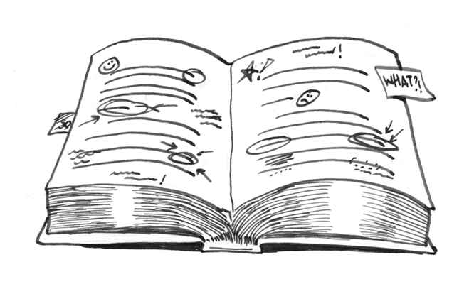

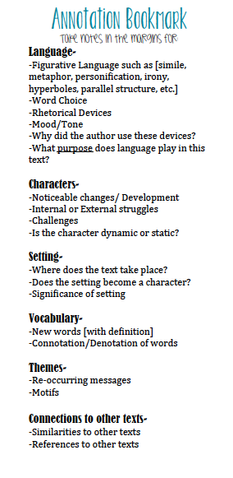
Directions: Use the following rubric & annotation bookmark to guide your progress.

High School Rubric

Mastery: A (90-100)
- Annotations demonstrate analysis and interpretation – thinking beyond the surface level of the text. Thoughtful connections made to other texts, or other events throughout the novel.
- Annotations contain a thorough mixture of significant questions, observations, comments, and reflections.

Proficient: B (80-89)
- Annotations demonstrate some analysis and interpretation – thinking somewhat beyond the surface level of the text. Attempts at making connections.
- Annotations contain a mixture of reasonable questions, observations, comments and reflections.

Average: C (70-79)
- Annotations are mostly at the surface level. The commentary shows some deeper thought but not throughout the text.
- Annotations contain a mixture of brief questions, comments, and observations.

Below Average: D (65-69)
- Annotations are random and show little understanding of the novel.
- Annotations only ask brief questions or only have one-word comments.

Incomplete: F(64 and below)
- There are little to no annotations throughout
the novel.

Mastery/Proficient Example:
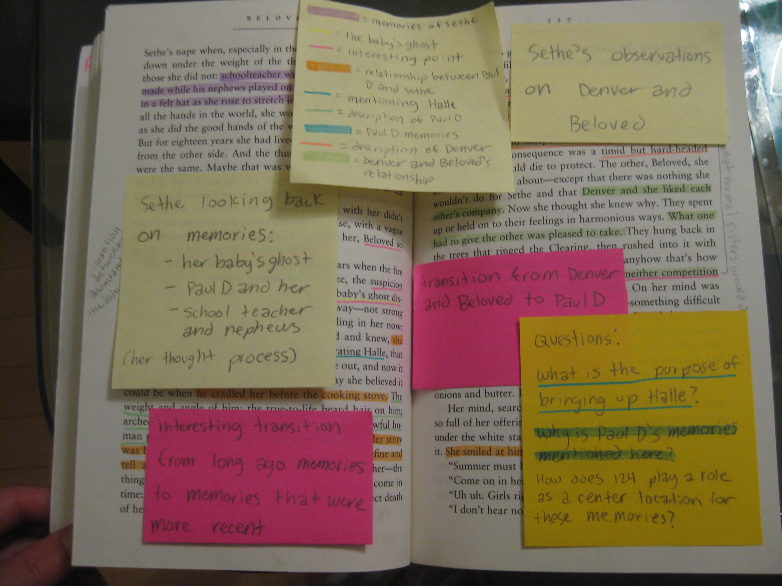

Average Example:

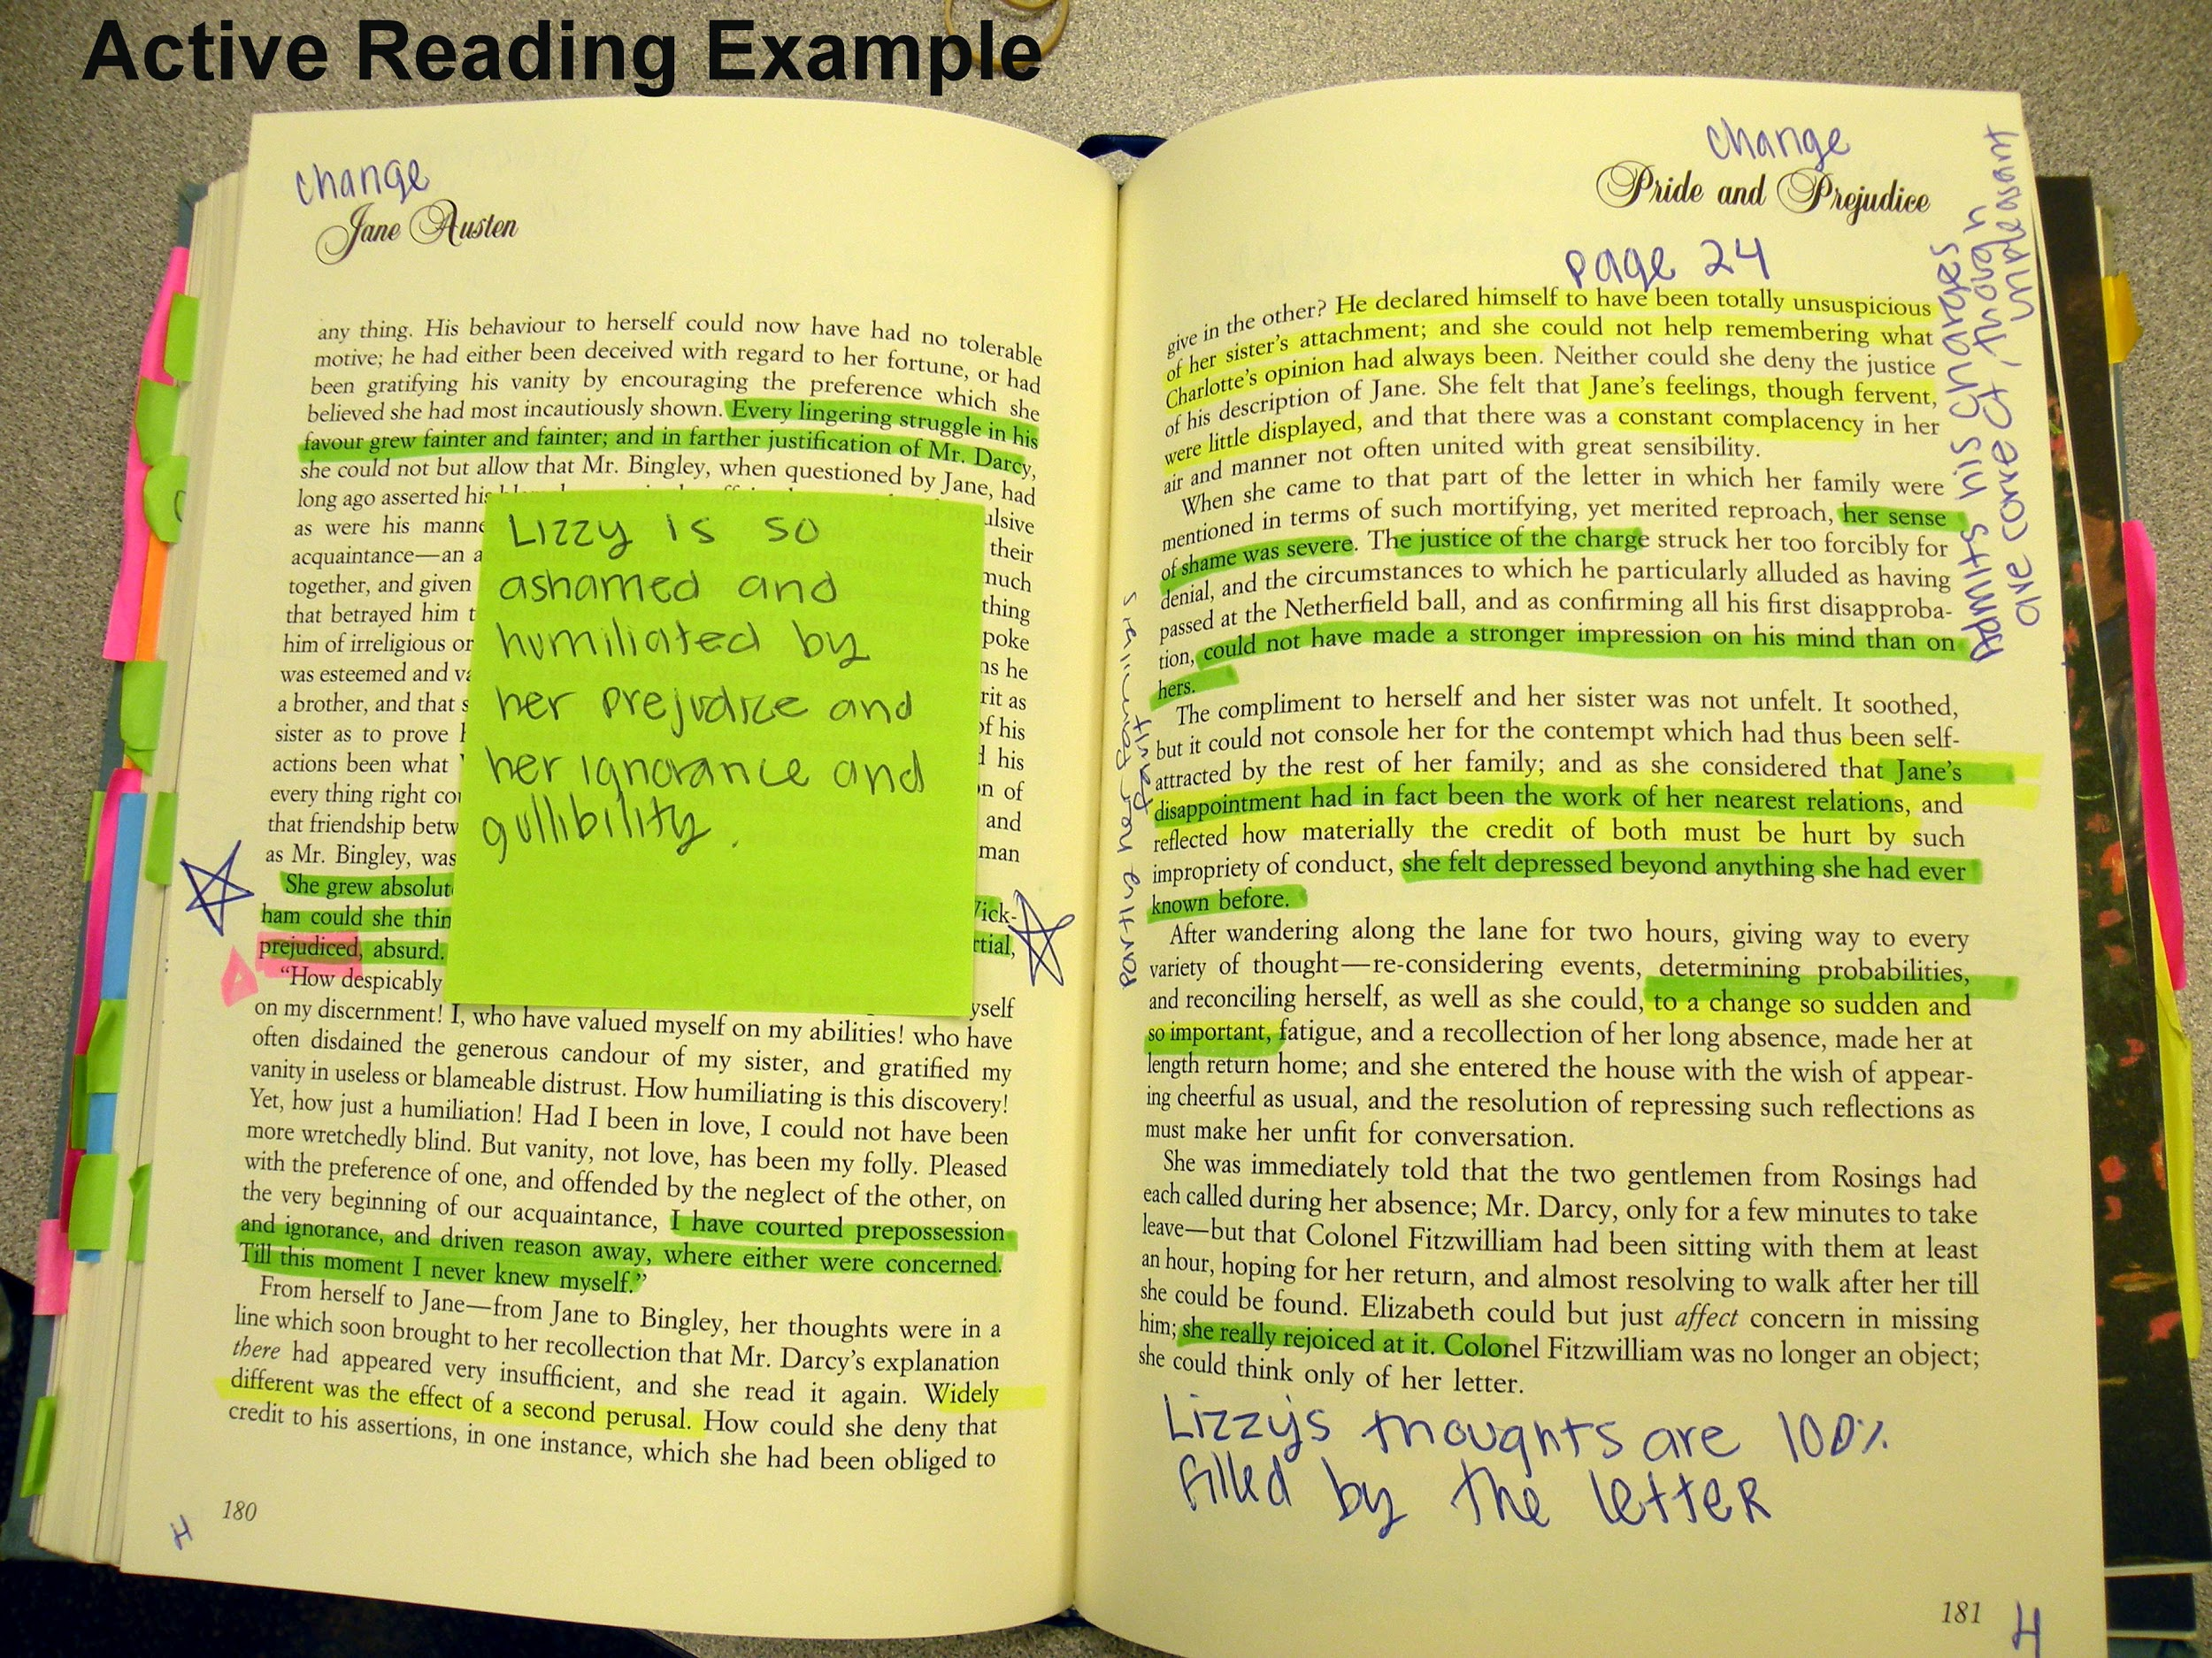

Below Average/ Failing Example :

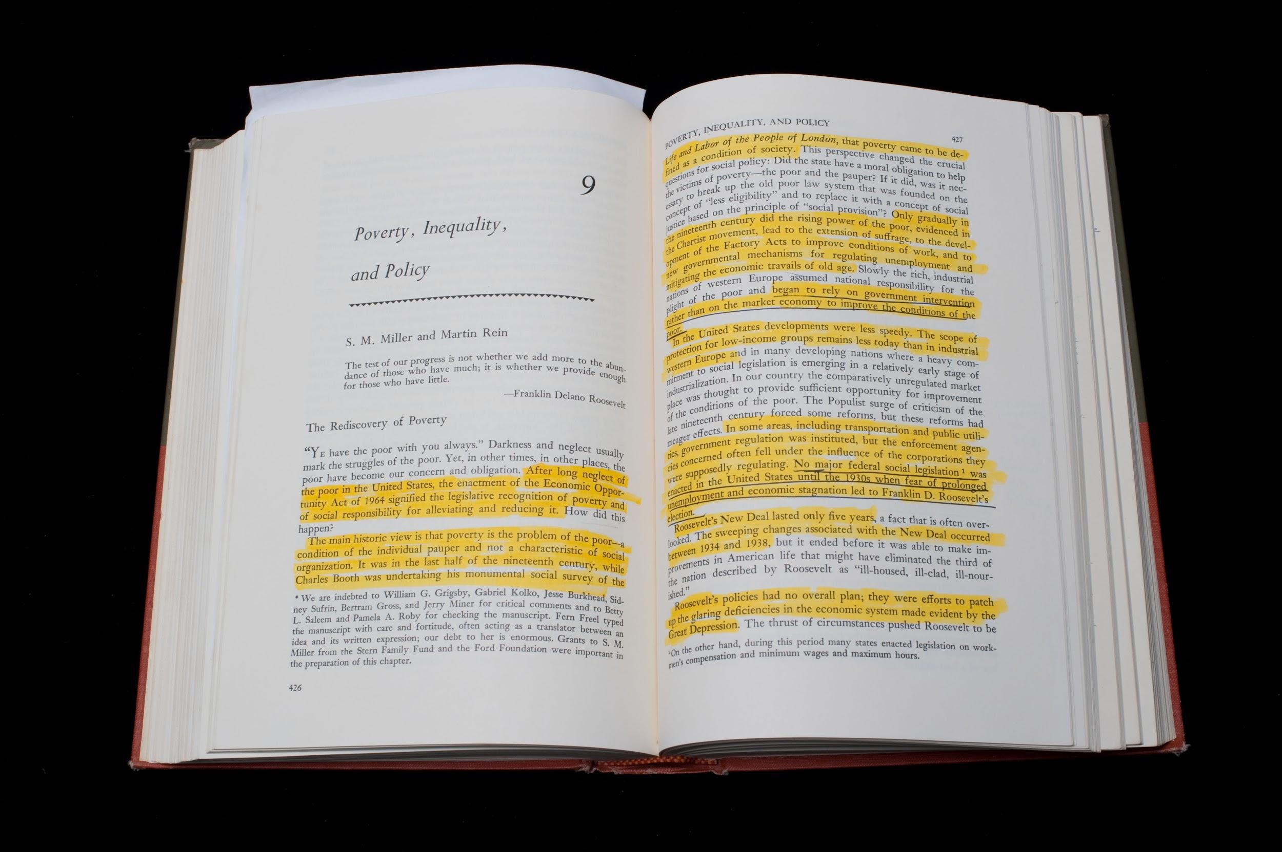

This form is modified from one created by teachers at North High School in California: www.northhighschool.org

BOOK DISCUSSION RUBRIC

Procedures:
Bring your Summer Reading Synopsis Sheet, book (if you have it), and a supportive attitude. For this assignment, your teacher will arrange a discussion for you with a partner or small group of students. Please note that 50% of your summer reading test grade will come as a result of your participation in this discussion. Your participation in the discussion will be assessed according to this rubric:

Item | Outstanding | Strong | Developing | Insufficient
Preparedness | Student comes to the discussion with well-prepared notes and refers specifically to the notes and/or the text throughout the entire discussion. | Student comes to the discussion with notes and refers specifically to the notes from time to time throughout the discussion. | Student comes to the discussion with notes but only refers to them infrequently. | Student participates in the discussion but may not have notes or may not refer to the notes even one time.
Collaboration  and  Engagement | Student supports his/her classmates by responding positively to their discussion points and actively engaging with them throughout the entire discussion. | Student supports his/her classmates by responding positively to their discussion points and engaging with them in much of the discussion. | Student supports his/her classmates by responding positively to some of their discussion points and engaging with them for some of the discussion. | Student may not support his/her classmates, or may not respond positively to discussion points, or may not engage with his/her classmates during the discussion.
Nonverbal  Communication | Student communicates his/her attention and respect during the discussion by maintaining eye contact with the speaker and using appropriate body language, such as sitting up in an active listening position, throughout the entire discussion. | Student communicates his/her attention and respect during the discussion by maintaining eye contact with the speaker and using appropriate body language, such as sitting up in an active listening position, throughout most of the discussion. | Student communicates his/her attention and respect during the discussion by maintaining eye contact with the speaker and using appropriate body language for some of the discussion. | Student may not communicate his/her attention and respect during the discussion by maintaining eye contact with the speaker or using appropriate body language during the discussion.

