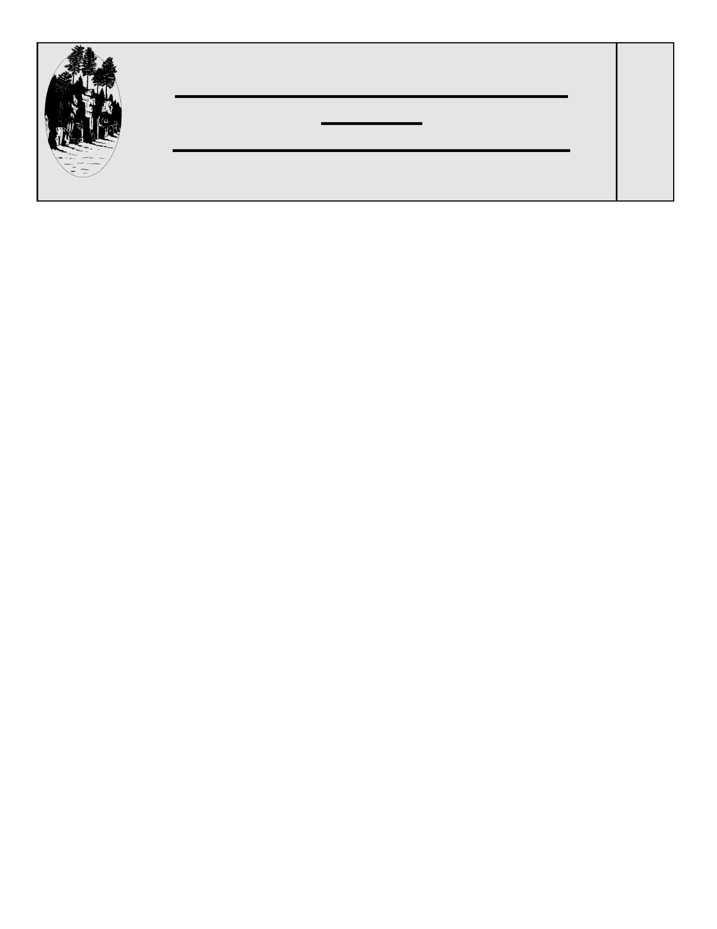
A SPECIAL EDUCATION GUIDELINE
FOR THE
ALTERNATE ASSESSMENT PROCESS AND TESTING ACCOMODATIONS
N
U
MBER
18

TO: Special Education Case Managers, Counselors, Principals & Superintendents
FROM: Holly Windram, Jeff Menigo, Jamie Nord
RE: Alternate Assessments and State and District-Initiated Testing
DATE: November 2010

This is a revised Guideline. Please file.

The purpose of this guideline is to clarify the alternate assessment process with students for whom the
Minnesota Statewide Accountability Testing, GRAD, and/or District-Initiated Testing are not
appropriate and to provide guidance on allowable testing accommodations for students on IEPs and Section 504 Plans.

Minnesota Statewide Accountability Testing
The Minnesota Comprehensive Assessments-II (MCA-IIs) are given to students for the purpose of documenting progress for No Child Left Behind (NCLB) and Annual Yearly Progress (AYP). Students in grades 3-8 and 10 are tested in the area of reading. Students in grades 3-8 and 11 are tested in the area of math, and students in grade 9 are tested in the area of writing.

MCA-II tests are used to judge schools and districts in two areas: participation and proficiency. Participation refers to the number of students taking the test. Proficiency refers to the scores obtained by the students in a particular grade. Currently, NCLB allows districts to substitute an alternate assessment for the MCA-II. Every student who takes an alternate assessment in place of the MCA-II counts as having participated. There are two allowable options.

MTAS
The Minnesota Test of Academic Skills (MTAS) is appropriate for students who’s IEP team determines that they:

- are not eligible to take the MCA-II and MCA-M;
- have instructional programming linked to the general education curriculum to the extent appropriate;
- have documented cognitive functioning that is significantly below age expectations AND this causes a significant impact on the student's ability to function in multiple environments, including home, school and community;
- need explicit and intensive instruction and/or extensive supports in multiple settings to acquire, maintain and generalize academic and life skills in order to actively participate in school, work, home and community environments.

The IEP team must document, in the IEP, reasons the MCA is not an appropriate measure of the student's academic progress and how the student would participate in statewide testing. Only 1% of the district's total number of students in those grades that are tested may count as being "proficient" by taking and passing the MTAS. For example, 344 students are expected to be tested in reading at Sunny Delight School District this year (that's the enrollment on the date of testing for grades 3-8 and 10, the grades in which the reading MCA-II is given). So, up to 3 students in the district can be counted as proficient by taking the MTAS. All of the students who take the MTAS are counted as participating, even if that exceeds 3 students - but only 3 will be counted as proficient.

Please note: This does not mean that a district should restrict the number of alternate assessments it provides,
in order to remain below 1%. Requiring a student to take an assessment that is inappropriate for them is not
likely to result in a score high enough to be counted as "proficient."

MCA-Modified
Students who are in the bottom 2 and 3% of district-wide (not building-wide) performance on state tests may take the MCA-Modified (MCA-M). The MCA-M will be available for students to take in Spring 2011. The decision for a child to take the MCA-M is made by the child’s IEP team. The IEP team must follow these eligibility guidelines set for by MDE. In summary, a child is considered eligible to take the MCA-M under the following conditions:
- Low performance on MCA for 2 years in a row OR
- The student has topped out on MTAS for 2 years in a row.
This means that the earliest a child will be able to take the MCA-M is 5th grade.

Districts may not determine who is taking the MCA-M by assigning their lowest 1% of students to take the MTAS and then assign their next lowest 2% of students to take the MCA-M. The decision for which students take the MTAS or the MCA-M is done through the IEP team process.

The MN Department of Education has provided the following for eligibility requirements for the MCA-M.

In summary, the IEP team should be able to answer “Yes” to the following items in order to determine if a child is eligible for the MCA-M:

 | YES | NO
- Does the student have an IEP?
- Does the student demonstrate persistent low performance on the MCA, e.g., not proficient 2 years in a row? OR
- Has the student demonstrated top performance on the MTAS for 2 years in a row?
- Does the student have access to instruction on grade-level content standards?
- Does the student have standards-based IEP goal(s) in either or both reading or math?
- Has the IEP team gathered data and documented that the student will likely not achieve grade level proficiency within the year covered by the IEP (and, consequently, should take the MCA-II and not the MCA-M)?

*See Appendix I - MDE Eligibility Requirements for the MCA-Modified (MCA-M) & MTAS

IEP Requirements for Students Taking MCA-M
If an IEP team determines that a student will take the MCA-M in either or both reading and math, the team must write a standards-based IEP goal in that area. NCLB Title 1 Sec. 200.1(f)(2)(ii)(A) and (B) requires that the IEP of a student assessment based on modified academic achievement standards include the IEP goals that are based on the academic content standards for the grade in which the student is enrolled, and be designed to monitor the student’s progress in achieving the student’s standards-based goals. IEP teams may write a standards-based IEPs for students not taking the MCA-M, but it is not required.

Standards-Based IEPs

Q&A on Standards Based IEPs

- Will IEP goals based on grade-level academic standards look different than other IEP goals?

No. IEP goals based on grade-level academic content standards should conform to the same specifications that are required by federal and state laws.
- The goals must be measureable. This includes having a clear baseline (or starting level) and a clear target, or ending level. The starting level is documented in the PLAAFP. The goal statement must also support the degree of need that is identified in the PLAAFP statement.
- There must be two short term objectives for each gal.
- The goal must be set for one year with the intention of the student meeting that goal in a year’s time.

The CIMP rubric used for quality checks and assistance with writing IEPs follows state and federal requirements for IEP PLAAFPs and goals, as well as the MDE Compliance and Monitoring Record Review. The CIMP rubric can be found on the SCRED website under Special Education, Topical Guidance and Procedures, CIMP.

- Can a student have a standards based IEP goal in one area, e.g., reading, and not in another area, e.g. math?

Yes. Based on the individual needs of the student, teams may choose to have reading, writing, and math goals that are standards-based and other goals that are not standards-based. In addition, teams may choose to write only one standards-based IEP goal in the area that the team has determined the child will take the MCA-M. Teams may also decide to write all IEPs goals as standards-based IEP goals. This has some benefit in encouraging teams to more closely consider the child’s performance in the general education curriculum. It is not, however, required.

- Should an IEP goal be based on grade-level academic content standards focus on a grade-level standard or on one or more of the more specific benchmarks associated with that standard?

This is an IEP team decision. As long as the standards-based goal and objectives meet the requirements listed the focus can be on either the standard or an associated benchmark.

* Please see Appendix II – SCRED MCA-M Math and Reading Examples

- What if I’ve already had my IEP meeting this fall and think that there is a student that should take the MCA-M? What are the due process requirements?

Making the decision to take the MCA-M is an IEP team decision. That said, with parent consent, a change could be made to the IEP through an Amendment process. A change will need to be made on the Assessments page of the IEP AND to the reading and/or math PLAAFPs. Further, a Prior Written Notice will need to accompany these changes. The changes do not go into effect until a parent’s signature is received or passive consent occurs.

5. What if our district goes over the 2% of students taking the MCA-M?

One issue to troubleshoot is to re-visit if IEP teams applied the eligibility criteria for making the determination appropriately. That is, have the students who are currently indicated as taking the MCA-M been correctly identified by the IEP team?

The 2% will only influence the AYP calculation. Chances are pretty good that the students who are being identified are unlikely to be proficient on the MCA-II anyhow. They would “count against” the district in either case; however, districts may request a waiver to go over the 2%. The local district DAC can assist, or please contact one of the SCRED Unique Learners Managers.

6. Is there a checklist that can assist with walking through the steps of the process?

Yes. Please see attached.

* Please see Appendix III - Beginning of the Year Systems Checklist for Supporting Standards-Based IEPs

7. How should casemanagers explain the MCA-M and why the team may or may not consider this option at IEP meetings?

A discussion guide has been created for this purpose. Please see attached.

* Please see Appendix IV – MCA-M Modified (MCA-M) Discussion Guide for Casemanagers and Parents

8. Can a student take the MCA-M in one area, e.g., math only, and the MTAS in another area, e.g., reading only?

Yes. Be sure that the IEP team follows the eligibility guidelines for both MTAS a nd MCA-M to make the determination for each type of alternative assessment.

Minnesota GRAD Test
The Minnesota GRAD tests are administered in Grade 9 for writing, Grade 10 for reading and Grade 11 for math. Students must pass the GRAD tests in order to obtain a high school diploma. Special education students may pass the GRAD at state level with accommodations, or the IEP team may determine the passing score for an individual student (adjusting the passing score is considered a modification), or the IEP team may provide an alternate assessment to a student to replace the GRAD. Students who pass the GRAD tests with or without accommodations receive a score of "Pass at the State Standard" (PS) on their diploma.
Students who pass the GRAD with modifications or who pass an alternate assessment receive a score of "Pass Individual" (PI) on their diploma.
It is strongly encouraged that the IEP team make the decision for the student to receive a “PI” for the GRAD after the student has attempted to pass the test during their senior year or last year of school. Many times, students that take the test will improve their scores over time, increasing their chances of passing at the state level.

District-Initiated Tests
In addition to the MCA-II and GRAD, districts may administer additional standardized tests such as the Measures of Academic Progress (MAP). Special education students may participate in these tests without
accommodations, with accommodations, or the IEP team may determine that an alternate assessment should
substitute for the district-initiated assessment. Students may still participate in District-Initiated Tests, even if
they have taken an alternate assessment in place of the MCA-II or GRAD.

The Alternate Assessment Process

Determining When a Student Should Receive an Alternate Assessment

Each year, the IEP team must make a decision about a student's participation in standardized testing
Procedures. In preparation for a new school year, case managers need to do the following:

1.
2.

3.

4..
Review incoming IE's to check whether the section on participation in assessments is completed.
If information is missing and a student will be administered an MCA-II, GRAD, or District-Initiated Assessment during the school year, the case manager should convene an IEP meeting.
Case manager should provide the DAC and/or due process secretary in each district with a list of students who will be taking an alternate assessment in place of an MCA-II, GRAD, and/or District-Initiated Assessment.
Anytime a new student begins receiving special education services, the case manager should provide the due process secretary or DAC with information on whether the student will be taking an alternate assessment in place of an MCA-II, GRAD, and/or District-Initiated Assessment.
4.

Accommodations on State Testing for Students with IEPs or 504 Plans

The following information has been excerpted from the

2009-2010 Procedures Manual for Minnesota Assessments (chapter 5, pages 40-47).

The full document is available at the MDE website.

Accommodations are practices and procedures that provide equitable access to grade-level content for students with disabilities. Students with IEPs or 504 Plans are provided accommodations in the areas of presentation, response, setting and timing/scheduling. Accommodations are designed to allow students with IEPs or 504 Plans to show what they know and can do on the academic content standards rather than simply showing the impact of their disability.

Many accommodations provided to a student during statewide assessments must also be provided during classroom instruction, classroom assessments and district assessments. In general, new accommodations should not be introduced at the time of statewide assessments as there may be a negative impact on student performance. There are some accommodations, however, that are not practical to provide during instruction and classroom assessments, and students’ lack of prior experience with them is unlikely to hinder performance. Some examples include use of a scribe or listening to a read-aloud from a script or CD.

Note that some instructional accommodations may not be appropriate for use on certain statewide assessments. Educators should consult state policies before determining which accommodations will be provided on statewide assessments. Accommodations must be selected and implemented in ways that maintain the integrity of the assessment so that valid judgments can be made about what students know and can do.

Who May Receive an Accommodation?
Only students who have an IEP or 504 Plan or are identified as LEP may receive accommodations. The student record in MARSS must be coded for special education, 504 or LEP before providing the student with an accommodation during the testing window. Specific information about accommodations for ELLs is provided in Chapter 6.

When an eligible student demonstrates the need for an accommodation, it must be provided as long as it does not invalidate the assessment.

Purpose of Accommodations
Accommodations play a key role in promoting access to the general education curriculum for students with disabilities. The purpose of accommodations is to reduce or eliminate the effects of a student’s disability on an assessment measuring academic content. Accommodations do not lower expectations for student learning.

Some students with IEPs or 504 Plans may require accommodations on state assessments to accurately measure their achievement of state content standards. These accommodations must be provided based on individual need as long as they do not invalidate the assessment and should be documented in the IEP or 504 Plan.

Description of Accommodation Categories used in Minnesota Assessments for Students with IEPs or 504 Plans
Three accommodation categories are used in Minnesota:

- Presentation Accommodations change how an assessment is given to a student. These include alternate modes of access that may be auditory, multi-sensory, tactile or visual.
- Response Accommodations allow students to complete assessments in different ways (alternate format or procedure) or to solve or organize problems using some type of assistive device or organizer.
- Timing and Scheduling Accommodations increase the allowable length of time to complete an assessment or change the way the time is organized. While extended time or frequent breaks may be specified as accommodations in a student’s IEP or 504 Plan, they are considered an accommodation only for a student taking the TEAE, which is a timed test, or when testing of a segment/section is extended over multiple days. For all other Minnesota assessments, extended time in the same day and frequent breaks are a general practice available to all students.

General test taking practices are small changes in test administration procedures that may be provided to all students, as needed. These practices include setting accommodations such as small group or individual administration. They do not need to be documented in a student’s IEP or 504 Plan although it is recommended. See the General Information about Practices that are NOT Accommodations section later in this chapter.

Who is Responsible for Making Decisions Regarding Accommodations?
For students with IEPs, the IEP team is responsible for making annual assessment and accommodation decisions, which must be based on individual need in accordance with state and federal guidelines. For students with the most significant cognitive disabilities, the IEP team may determine that the MTAS is the most appropriate measure of academic skills in reading, mathematics and science. Only students with disabilities under IDEA may be considered for the MTAS.

For students with disabilities under Section 504, the 504 team should determine the appropriateness of accommodations and document their decisions in the 504 Plan. Students with 504 Plans are not eligible for the MTAS, but they may take the alternate assessment in writing.

Selecting Appropriate Accommodations for Instruction and Assessment
To assure that students with disabilities are engaged in standards-based instruction and have an opportunity to learn skills that are measured on Minnesota assessments, all members of the IEP and 504 Plan teams need to be familiar with the Minnesota Academic Standards and district academic content standards. Making appropriate accommodations decisions for instruction is facilitated by gathering and reviewing information about the student’s characteristics, identified needs and levels of performance in relation to the Minnesota Academic Standards. In essence, the process of making decisions about accommodations is one in which the IEP or 504 Plan team attempts to “level the playing field” so that students with disabilities can participate equitably in the general education curriculum.

The first question asked by those who make accommodation decisions should not be, “What accommodations are available?” This practice does not promote sound decision-making or advance equal opportunities for students to participate in the general education curriculum. Research has demonstrated that more is not necessarily better when it comes to accommodations and that providing students with accommodations that are not truly needed may have a negative impact on student performance.

The better approach when making accommodation decisions is to focus on a student’s identified needs within the general education curriculum. The decision-making process for state assessment accommodations should include at least these three factors:
- Student characteristics (e.g., disabilities, assistive technologies used, accommodations used in classroom instruction and assessment).
- Individual test characteristics (i.e., knowledge about what tasks are required on state assessments and allowable ways to remove physical and other barriers to a student’s ability to perform those tasks).
- State accommodation policies for the assessment or part of an assessment and consequences of decisions.

Documenting the Use of an Accommodation
Many accommodations have a special code that should be entered on the student’s answer book/document or in the online system. Districts will be able to correct code-entry errors in Test WES. Chapter 9 of this manual
provides information about the process. These accommodation codes are used by MDE to help analyze test results. Individual Student Reports and Summary Reports do not mention accommodations used.

It is the IEP team’s responsibility to determine which testing accommodations are needed by a student who receives special education services. For a student who has a disability under IDEA, all needed accommodations are documented annually in the IEP prior to testing. Likewise, a 504 team should document in the 504 Plan its decision to provide an accommodation. It is recommended to list all accommodations on the IEP or 504 Plan for all assessments, including those outside the Minnesota statewide assessment system (i.e., ACT, SAT).

When Accommodations Conflict
Some accommodations can be used together and others cannot. Some examples of accommodations that are not compatible are: a Braille book and a Large Print test book; a mathematics script and a mathematics script read on a CD; or a Spanish version of the mathematics BST and a large print version. Make sure pairs of accommodations that involve a translation or large print are compatible and that you fill in the accommodation codes correctly. Table 8 lists the abbreviations for these codes. Contact mde.testing@state.mn.us if you have questions.

General Information about Practices that are NOT Accommodations

General Test-Taking Practices Available to All Students
General test-taking practices are available for any student who needs them, including general education students, and are not considered accommodations. The practices listed below are considered general test-taking practices and documentation of their use is not required. The only students who may receive accommodations, which represent changes in standardized administration procedures, are students with IEPs, students with 504 Plans and students identified as LEP (see Chapter 6). Accommodations are only available for general education students when an injury prevents normal response (see Tables 7 and 8 for specifics). These practices are not considered accommodations and are allowable for all students.

- Presentation
  - Test Monitor repeats test directions as written.
  - Student uses a highlighter, color overlay, marker, or magnifier.
  - Test Monitor reads the writing prompt aloud to a student.
  - Any monitor screen size and resolution may be used for computer-delivered assessments.
- Setting
  - Assessment is administered in a special setting (e.g., certain lights, acoustics).
  - Student is tested individually or in a small group setting (the size of group should be determined. locally based on what best meets student needs).
- Timing/Scheduling
  - Testing time in same day is extended (not applicable to TEAE, a timed test).
  - The time of day assessment is given is changed.
- Response Format
  - Student uses a calculator (except where specifically prohibited).
  - Student writes responses directly in the test book and transcribes those responses from the test book onto the regular, scannable answer book/document.
  - Student uses an abacus (except where specifically prohibited).

May modifications be made for any students taking Minnesota Assessments?
The Basic Skills Tests may be modified only for some students with an IEP or section 504 accommodation Plan. When the BSTs were introduced in 1996, the IEP Team or 504 Team was able to make adjustments in the testing conditions or even in the test itself as long as test security was not compromised. These adjustments, called modifications, change the meaning of the test score. No modifications are available for the MCA. For more information on modifications for the BST, see the 2004–05 Guidelines for Accommodations found at: http://education.state.mn.us/mdeprod/groups/Assessment/documents/Publication/000782.pdf.

The Graduation-Required Assessments for Diploma allow for a student to achieve the statewide standard at an individually modified level of difficulty. A Minnesota alternate assessment must be used when an IEP team chooses to replace the GRAD. Adoption of modifications for a student must occur concurrently with the adoption of transition goals and objectives as required by Minnesota Statutes, section 125A.08, paragraph (a), clause (1). The student’s IEP or section 504 must define an appropriate assessment of the statewide standard at a modified level of difficulty. Achievement of the individually modified standard shall be certified through documented student performance of the defined assessment.

Accommodations for Diploma Tests

Minnesota students may take up to three kinds of statewide tests: those that are part of the Title I accountability system, those that are part of the Title III accountability system and those that are required for a diploma. For students who first entered grade 8 in 2005–06 or later, the assessments required for a diploma are the GRAD. For students who first entered grade 8 before 2005–06, the assessments required for a diploma are the BST. The content of this chapter so far has applied to all of these tests.

Accommodations for the Reading, Mathematics and Written Composition GRAD
Accommodations that are available for the Reading GRAD are large print, Braille, 12 pt font accommodated test books, made tape, scribe and translate directions. The Mathematics GRAD accommodations are large print, Braille, 12 pt font accommodated test books, script, scribe, translate directions and an accommodated computer delivered version of the test. The writing test has large print, Braille, translated directions, scribe and computer-assisted response.

Accommodations for the Reading and Mathematics BST Retests
There are some accommodations (test books being translated into Hmong, Somali, Spanish and Vietnamese) that are available only for the BSTs and are not available for the other Minnesota assessments. Beginning April 1 of a BST student’s senior year, a student can have any accommodation without having an IEP or 504 Plan. This policy remains in effect for the length of time that a student needs to pass the BST test or the BST is offered. All of the accommodations and modifications in the 2004–05 Guidelines for Accommodations continue to apply to students who were in grade 8 prior to 2005–06 (see pages 10–11 for details and related information). A copy can be found at: http://education.state.mn.us/mdeprod/groups/Assessment/documents/Publication/000782.pdf.

Appendix I

MDE Eligibility Requirements for the
MCA-Modified (MCA-M) & MTAS

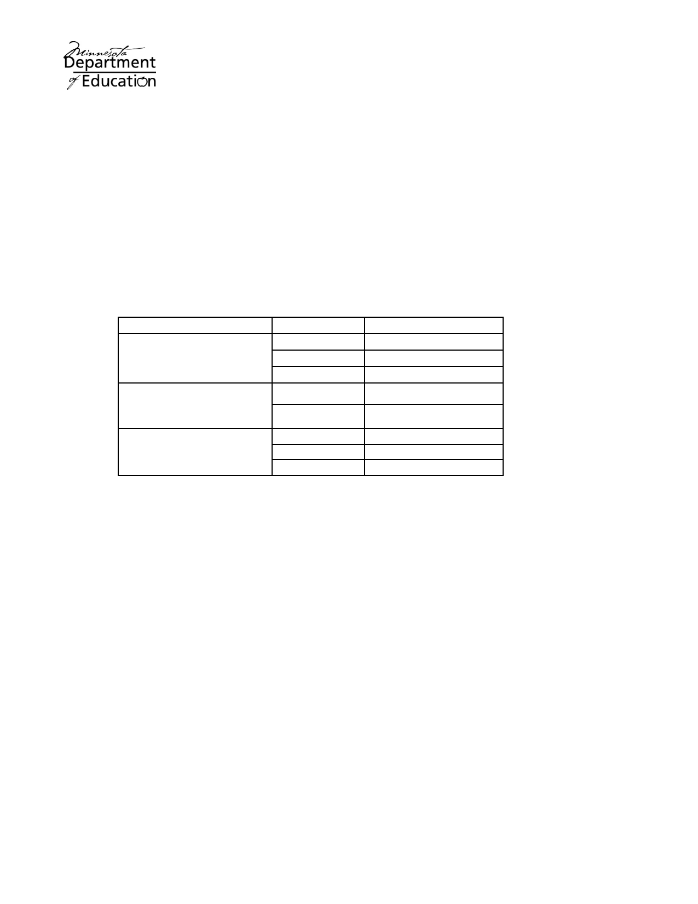

Alternate Assessment Eligibility Requirements

The current reauthorizations of both the Elementary and Secondary Education Act (ESEA) and Individuals
with Disabilities Education Act (IDEA) require that students with disabilities participate in statewide assessment systems designed to hold schools accountable for the academic performance of students.

The Individualized Education Program (IEP) team is responsible for applying the criteria outlined in this
document when determining how a student with a disability will participate in statewide testing. Decisions
should not be based on factors such as AYP calculations. There is no limit on the number of students in a school or district that may be eligible to participate in an alternate assessment.

Participation decisions must be made annually and documented in the student's IEP. The participation decision should be made separately for mathematics, reading and science.

These are the Title I assessment options for students served by special education:

Assessment Subject Grades
Reading 3 - 8 & 10
Minnesota Comprehensive Mathematics 3 - 8 & 11

Assessments (MCA)
Science
5, 8 & High School

Minnesota Comprehensive Reading 5 - 8 & 10
Assessments-Modified

(MCA-Modified)
Minnesota Test of
Mathematics
Reading
5 - 8 & 11
3 - 8 & 10

Academic Skills (MTAS) Mathematics 3 - 8 & 11

Science 5, 8 & High School

These are the initial steps in the IEP decision-making process.

• Consider the MCA: IEP teams must first consider student participation in the MCA, with or without
accommodations, before considering student participation in an alternate assessment.
• Establish that the MCA is not an appropriate measure: If the IEP team establishes that the MCA
is not an appropriate measure of the student's knowledge and skills on grade-level content standards,
even when the student is provided allowable and appropriate accommodations, the IEP team may consider the administration of the MCA-Modified or the MTAS.
• Ensure access: The IEP team must ensure that the student has access to the general education
curriculum, which means the student has opportunities to actively engage in learning the content and skills of the general education curriculum.
o MCA-Modified: For students participating in the MCA-Modified, access means instruction
on grade-level content standards. Because students taking the MCA-Modified demonstrate persistent academic difficulties, they are likely to need specialized services and supports to access grade-level curriculum.
o MTAS: For students participating in the MTAS, access means instruction linked to the
general education curriculum to the extent appropriate. It is likely that the general education curriculum will be substantially simplified for this group of students.

The purpose of this document is to help IEP teams determine the most appropriate assessment option for a student with a disability. It consists of the eligibility requirements and decision-making flowcharts for the MCA-Modified and MTAS and a glossary of frequently used terminology.
October 2010

MCA-Modified Eligibility Requirements

The IEP team is responsible for making annual decisions about student participation in the statewide
assessment program. The MCA-Modified, an alternate assessment based on modified achievement standards, is one component of that program. The MCA-Modified is designed to appropriately measure progress toward state standards for students who meet all of the criteria listed below.

Eligibility for the Reading and Mathematics MCA-Modified is determined for each subject separately. The MCA-Modified may be appropriate for a student with disabilities if all of the following requirements have
been met:

1. The student demonstrates persistently low performance as defined by performance at the lowest
achievement level (Does Not Meet the Standards) on the MCA and/or MTELL for the past 2 years.
Although not a requirement, IEP Teams may also consider students who were administered the
MTAS in the previous year if other eligibility requirements are met; generally, students considered
for the MCA-Modified achieved Meets or Exceeds the Alternate Achievement Standards in the previous administration.

2. The student has access to instruction on grade-level content standards.

3. The student has an IEP based on grade-level content standards in the content area(s) being assessed
by MCA-Modified.

4. The IEP team determines that the student is highly unlikely to achieve proficiency on the grade-level
content standards within the year the test is administered, even with specially designed instruction.
• Objective and valid data from multiple measures should be collected over time to confirm that
the student is not likely to achieve proficiency on grade-level content standards within the year. Examples of objective and valid measures include state assessments, district-wide assessments, curriculum-based measures and other repeated measures of progress over time.
• Appropriate accommodations, such as assistive technology, are provided as needed on
evaluations of classroom performance, and the student's accommodation needs are carefully
considered before the IEP team makes a determination that the student is not likely to achieve proficiency on grade-level content standards.

Decision‐Making Process for the MCA‐Modified
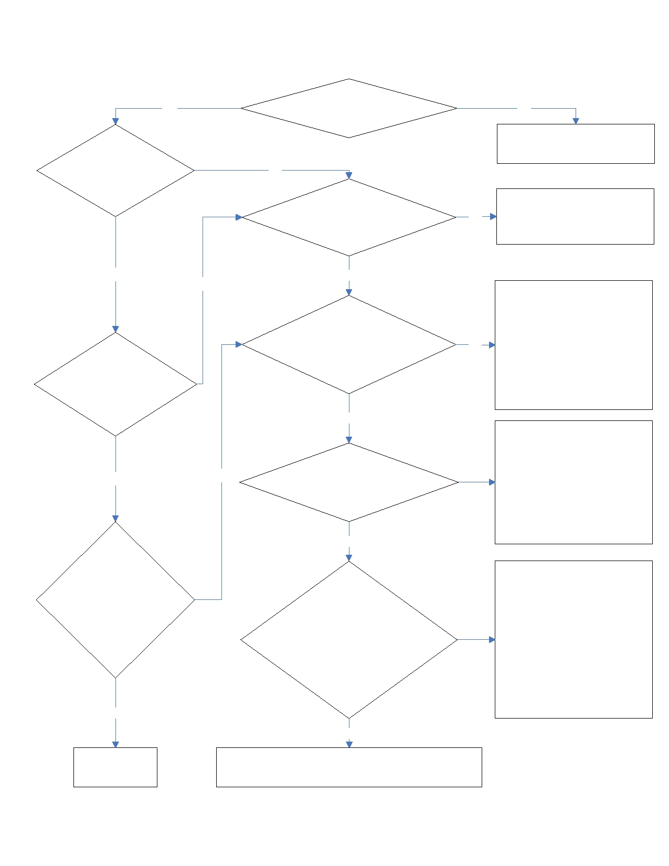

Yes Does the student have an IEP? No

The student participates in the MCA.
Does the student
have a significant No
cognitive disability?
The student participates in the

Does the student demonstrate
persistently low performance on
the MCA?
No
MCA, with or without accommodations.

Yes

Does the
student meet the
eligibility
requirements for
the MTAS?

Yes

Has the IEP team
determined that the
student may be
appropriately assessed
on the
MCA‐Modified?

No

No

Yes

Yes

Does the student have access to
instruction on grade‐level
content standards?

Yes

Does the student have a
standards‐based IEP?

Yes

Has the IEP team
documented its expectation
that the student will not
achieve grade‐level proficiency
within the year the test is
administered?

Yes

No

No

No

Instruction must be adjusted to
include grade‐level content
before student may participate in the MCA‐Modified; until this
condition is met, student participates in the general
education assessment, with or
without accommodations, or the MTAS.

A standards‐based IEP is
required before student may
participate in the
MCA‐Modified; until this condition is met, student participates in the general
education assessment, with or
without accommodations, or the MTAS.

Before the student may participate in the MCA‐ Modified, multiple valid
measures of the student's
progress over time must
document that the student will
not achieve grade‐level
proficiency; until this condition is met, the student participates
in the general education
assessment with or without
accommodations, or the MTAS.

The student
participates The student participates in the MCA‐Modified with
in the MTAS. or without accommodations.


MTAS Eligibility Requirements

The IEP team is responsible for making annual decisions about student participation in the statewide
assessment program. The MTAS, an alternate assessment for students with the most significant cognitive disabilities, is one component of that program. The MTAS is designed to appropriately measure progress toward state standards for students who meet each of the criteria listed below.
The MTAS may be appropriate for a student with a significant cognitive disability if all of the following
requirements have been met:
1. The IEP team first considered the student's ability to access the Minnesota Comprehensive Assessment
(MCA), with or without accommodations. For reading and mathematics, the IEP team also considered the student's eligibility for the MCA-Modified.
2. The IEP team reviewed the student's instructional program to ensure that the student is receiving
instruction linked to the general education curriculum to the extent appropriate. If instruction is not linked to the general education curriculum, then the IEP team must review the student's goals and determine how access to the general curriculum will be provided.
3. The IEP team determined the student's cognitive functioning to be significantly below age expectations.
The team also determined that the student's disability has a significant impact on his or her ability to function in multiple environments, including home, school and community.
4. The IEP team determined that the student needs explicit and intensive instruction and/or extensive
supports in multiple settings to acquire, maintain and generalize academic and life skills in order to actively participate in school, work, home and community environments.
5. The IEP team documented, in the IEP, reasons the MCA would not be an appropriate measure of the
student's academic progress and how the student would participate in statewide testing.

The careful use of this document will help IEP teams ensure that participation decisions
are NOT made based on the following factors:
• the student's disability category;
• placement;
• participation in a separate, specialized curriculum;
• the expectation that the student will receive a low score on the MCA or MCA-Modified;
• language, social, cultural or economic differences; or
• a concern for Adequate Yearly Progress (AYP) calculations.

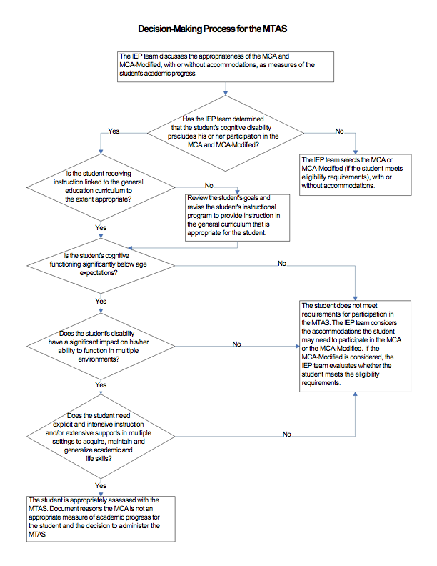
Glossary of Frequently Used Terminology
ACCOMMODATIONS
Changes in assessment administration such as setting, scheduling, timing, presentation format, response
mode, etc., that do not change the construct intended to be measured by the assessment or the meaning of resulting scores. Used for equity, not advantage.

ACCESS
Active engagement in learning the content and skills of the general education curriculum.

ADEQUATE YEARLY PROGRESS (AYP)
A provision of the federal ESEA legislation that requires schools, districts and states to demonstrate, based
on test scores, that students are making academic progress.

APPROPRIATE INSTRUCTION
Instruction that (1) meets the child's unique needs resulting from the disability and (2) allows the child to participate and make progress in the general education curriculum.

ASSISTIVE TECHNOLOGY
A device or service that is used to increase, maintain or improve the functional capabilities of a student
with a disability.

CURRICULUM-BASED MEASURES
Assessments that mirror instructional materials and procedures related to the curriculum resulting in an
ongoing process of monitoring progress in the curriculum and guiding adjustments in instruction, remediation, accommodations or modifications provided to the student.

DISABILITY CATEGORY
Individuals with Disabilities Education Act (IDEA) specifies 13 disability categories: mental retardation,
hearing impairment (including deafness), speech or language impairment, visual impairment (including blindness), serious emotional disturbance, orthopedic impairment, autism, traumatic brain injury, other health impairment, specific learning disability, deaf-blindness, multiple disabilities and developmental delay.

EXPLICIT AND INTENSIVE INSTRUCTION
During explicit instruction, skills are taught sequentially and directly. No assumptions are made about what
students might acquire on their own. Intensive instruction is most often achieved in an individual and/or small group setting.

EXTENDED STANDARDS
Content standards that have been reduced in depth, breadth and complexity while maintaining the essence of that standard.

EXTENSIVE SUPPORTS
Supports may include an array of services provided by school personnel, such as augmentative and
adaptive communication systems and assistive technology devices. Supports may be considered extensive if they require specific instruction and ongoing teacher support.

GENERAL EDUCATION CURRICULUM
The body of knowledge and range of skills that all students in the state are expected to master. Minnesota
school districts determine their curriculum, which must align to the Minnesota K-12 Academic Standards.

GRADE-LEVEL CONTENT STANDARDS
Statements of the subject-specific knowledge and skills schools are expected to teach students at each
grade level.

MULTIPLE ENVIRONMENTS
Indicates more than one of the environments in which the student spends a typical day (i.e., home, school and community).

PERSISTENTLY LOW PERFORMANCE
For the purposes of eligibility for the MCA-Modified, persistently low performance is defined as
performance in the lowest achievement level on the MCA in one or more content areas for the past two years.

PROFICIENCY
Level of knowledge or skills that demonstrates a mastery level of achievement. For ESEA accountability
purposes, a student who earns an achievement level of meets or exceeds the standards is considered proficient on the Minnesota Academic Standards.

PLACEMENT
Where a student with a disability will receive special education services; decided by an IEP team.

SIGNIFICANTLY BELOW AGE EXPECTATIONS
Significantly below the average cognitive functioning of typically developing peers; determined by:
• At least "two standard deviations below the mean, plus or minus one standard error of
measurement" (Minn R. 3525.1333) on a standardized norm-referenced measure of cognitive
functioning; OR
• When formal cognitive assessments are inappropriate or invalid, other data-based measures may be
used to document functioning significantly below age expectations consistent with IDEA Sec 614(d)(1)(A)(i)(VI)(bb).

SPECIALIZED CURRICULUM
A curriculum differing from that for non-disabled students (e.g., a life skills curriculum).

STANDARDS-BASED IEP
A process and a document that is framed by the state standards and that contains goals aligned with, and chosen to facilitate, the student's achievement of grade-level academic achievement standards.

VALIDITY
The appropriateness or correctness of inferences, decisions or descriptions made about individuals,
groups or institutions from test results. There is no such thing as a generally valid test. Validity must be considered in terms of the correctness of a particular inference.

Appendix II

SCRED Standards Based IEP PLAFFP and Goal Examples
Example Standards Based Reading IEP PLAFFP and Goal

Minnie has made progress on her general reading skills based upon last year’s progression from 19 wrc on level 3 in the fall to 37 wrc on level 3 in the spring. As of this fall, Minnie is reading 15 wrc on level 7 probes. Same-grade peers are expected to read 151 wrc on a level 7 probe in the fall. Minnie is currently reading 40 wrc on level 2 probes, which is the expected rate for second grade students reading level 2 probes in the fall. Minnie is currently reading 35 wrc on level 3 probes.

Based on a review of Minnie’s performance on the Measures of Academic Progress (MAP), the team has identified comprehension of informational text as a relative weakness. The MAP assessment is aligned with the Minnesota academic standards as measured by the Minnesota Comprehensive Assessment – II.

The Grade 7 Minnesota Language Arts Standard for Comprehension states “the student will understand the meaning of texts, using a variety of strategies, and will demonstrate literal, interpretive, inferential and evaluative comprehension.” The IEP team has identified the following benchmark(s) for focused instruction in support of standards attainment: 7.C.1.4 Make inferences and draw conclusions based on explicit and implied information from texts, and 7.C.1.7 Critically read and evaluate to determine then author’s purpose, point of view, audience and message.

Minnie needs explicit, broad reading instruction including support to develop specific skills in the benchmark areas identified above. Since Minnie is discrepant from her peers, instruction towards this goal will be provided in a special education classroom.

To monitor progress toward this goal, the team has chosen the Reading Curriculum Based Measurement (R-CBM) tool based on its technical features and high correlation to other broad measures of total reading skill.

Goal: By October 2011, when given a level 3 R-CBM reading probe and one minute to read, Minnie will read 107 words correct per minute. This will be measured weekly by special education staff.
Example Standards Based Math IEP PLAFFP and Goal

James has made progress on his general math skills based upon last year’s increase from 8 correct to 11 correct on Grade 3 math application probes. As of this fall, James had 4 correct on Grade 7 math applications probe. Same-grade peers are expected to have 12 correct on Grade 7 math application probes. James is currently completing 9 correct problems on Grade 4 probes, which is the expected performance of students in Grade 4 at the beginning of the school year. James is currently completing 6 correct problems on grade 5 probes.

Based upon review of James’ performance on Measures of Academic Progress (MAP), the team has identified Number Sense, Computation, & Operations as a relative weakness. The MAP assessment is aligned with the Minnesota Academic standards as measured by the Minnesota Comprehensive Assessment-II.

The Grade 7 Minnesota Math standard for Number & Operation states students will “calculate with positive and negative rational numbers, and rational numbers with whole number exponents, to solve real-world and mathematical problems”. The IEP team has identified the following benchmark(s) for focused instruction in support of standards attainment: (list 1-2 specific benchmarks from the standard listed that the team feels are of central instructional need for the student.)

James needs explicit, broad math instruction including support to develop specific skills in the benchmark areas identified above. Since James is discrepant from his peers, instruction towards this goal will be provided in a special education classroom.

To monitor progress toward this goal, the team has chosen the Math Concepts and Applications Curriculum Based Measurement (CBM) tool based on its technical features and high correlation to other broad measures of total math skill.

Goal: By October 2011, when given a level 5 Math Concepts and Applications CBM probe, James will complete 12 problems correct in 10 minutes. This will be measured twice per month by special education staff.

Appendix III

Beginning of the Year Systems Checklist for
Supporting Standards-Based IEPs

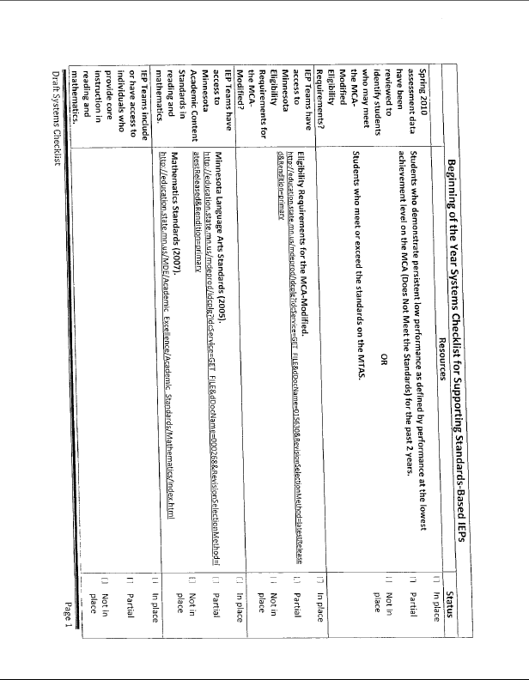
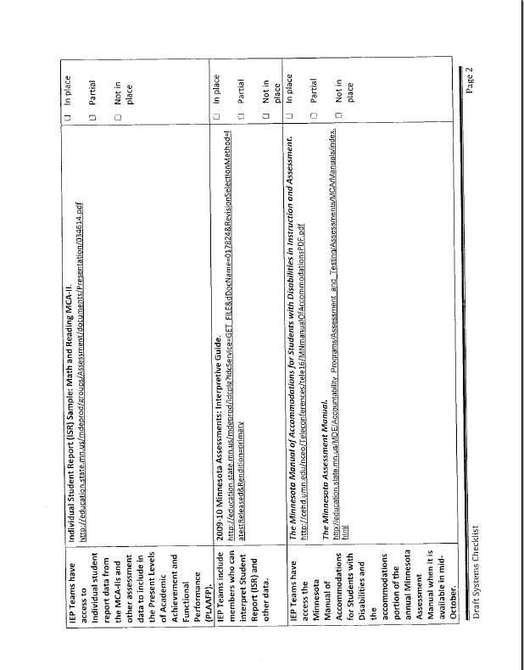

Appendix IV

MCA-Modified (MCA-M) Discussion Guide for
Casemanagers and Parents

MCA-Modified (MCA-MOD) Discussion Guide

- The state of MN requires that all students in targeted grades be assessed in reading, math, and science each spring. This assessment is conducted through the Minnesota Comprehensive Assessment II (MCA-II).
- There is a new modified version of the MCA-II that is available to your child called the MCA-Modified (MCA-M).
- Here are some reasons we’d like the team to consider having your child take the MCA-M assessment this spring:
  - Your child has persistently struggled with low performance on the traditional MCA-II
    - i.e. - Two consecutive years of not proficient two years in a row OR
    - FOR STUDENTS TAKING THE MTAS: Your child has achieved top performance on the MTAS for two consecutive years.
  - Your child has (or will have after this meeting) a standards based IEP, which is required in order for your child to take this test.
    - Having a standards based IEP means that your child’s IEP goal(s) are directly tied to the MN standards in a particular academic area.
  - Your child has access to grade-level content standards
  - Although we have an expectation that your child will make solid progress towards their goals this year, it is unlikely that they will be caught up with grade level proficiency within the next year.
- Here are some possible advantages if the team decides to have your child take the MCA-M:
  - It is likely that the tasks with which your child is presented will be a more appropriate fit for their ability, which will hopefully reduce any frustration that could arise from taking a test that is extremely difficult.
  - Because the test is a more appropriate fit for your child’s skill level that the MCA-II, it’s likely that they will leave the testing situation feeling better about themselves and their skills.
  - The score your child achieves is likely to be a more accurate representation of their academic skills and will hopefully provide you and the team at school with more useful data.

Appendix V

Summary of Accommodations for Minnesota Assessments for Students with IEP or 504 Plan

Table 7. Summary of Accommodations for Minnesota Assessments for Students with IEP or 504 Plan ^{1, 2}
ACCOMMODATIONS FOR STUDENTS WITH IEP OR 504 PLAN | Code for answer book | Order from Pearson
Presentation
Assistive Technology for computer-delivered assessments | AT
Braille edition of assessment | BR | X
Large print test book | 18 or 24 | X
Made tape (with transcription into test book) | MT
Mathematics scripts presented in English to student via CD | MC | X
Mathematics and Science scripts presented to student in sign language (OL code only applies to BST) | OA  or  OL
Mathematics and Science scripts read in English to student | MS | X
Mathematics (MTELL) and Science online audio | MC | X
Noise buffer (e.g., earplugs, headphones, white noise) | OA
Voice feedback device (whisper phone) | OA
Segmented test book (BST only) | SS | X
Signed interpretation of test directions and writing prompts | TD
Templates to reduce visual print, low vision aids | OA
12 pt Font Accommodated Test Book (GRAD Retest Only) | 12 | X
Timing/Scheduling
Extended testing time (considered an accommodation for TEAE and when testing is extended over multiple days) | OA
Response Format
Answer orally or point to answer³ | SC
Assistive Technology (for computer-delivered tests) | AT
Braille writers | AT
Large print answer book (grade 4 and above for Reading and Mathematics) | OA | X
Scratch paper or graph paper (allowed for MTELL, Science MCA, TEAE writing and GRAD retest) | OA
Scribes (with transcription into answer book or into online test) ³ | SC
Voice-activated computer | AT
Word processor or similar assistive device³ | CA
Other Accommodations
If an IEP or 504 team decides to use an accommodation not on this list, contact MDE at mde.testing@state.mn.us. | OA
¹ Accommodations are available for Minnesota Assessments unless otherwise specified. Table 8 contains detailed explanations of each accommodation. Accommodations must be documented by the IEP or 504 team before testing begins.
² Coding of accommodations for the MTAS is not required. Accommodation is integral to the MTAS, and adaptations to meet individual student needs are allowed. For information on allowable administration activities, see the MTAS Task Administration Manual or Chapter 3 of this Procedures Manual.
³ In some cases, a general education student with an injury that prevents normal responding may be allowed to use this response format. The instance must be documented on the Test Administration Report.

