Name _______________________ Period _____ Date _______________

Grade 8 Unit 3 Model Curriculum Assessment

1. Indicate whether each statement is true for all functions of x in the
xy-plane by checking the appropriate box in the table below.

 | True of  All Functions | Not True of  All Functions
No vertical line drawn through the graph of a function will intersect it more than once.
No horizontal line drawn through the graph of a function will intersect it more than once.
Each y-value of a function is mapped to exactly one x-value.
Each x-value of a function is mapped to exactly one y-value.

2. Ron is given an assignment to create a table that represents a function. The directions for the assignment state that he needs to include four x-values with corresponding y-values. Which of the following pairs of an x-value and a y-value could Ron add to the table below so the table will represent a function of x ?

x | y
-5 | 2
-1 | 6
0 | 3

a.
b.
c.
d.
3. Use the tables below to create two quantitative relationships. Use the first table to create a quantitative relationship that is a function of x, and use the second table to create a quantitative relationship that is NOT a function of x. Beside each table, explain why the corresponding quantitative relationship is or is NOT a function of x.

Function of x
x | y

NOT a Function of x
x | y

4. Indicate whether each quantitative relationship is a function of x
by checking the appropriate box in the table below.

 | Is a  Function of x | Is Not a Function of x
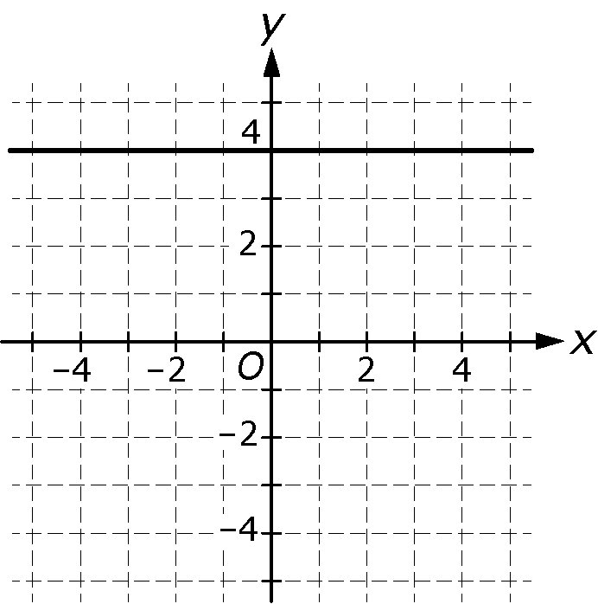
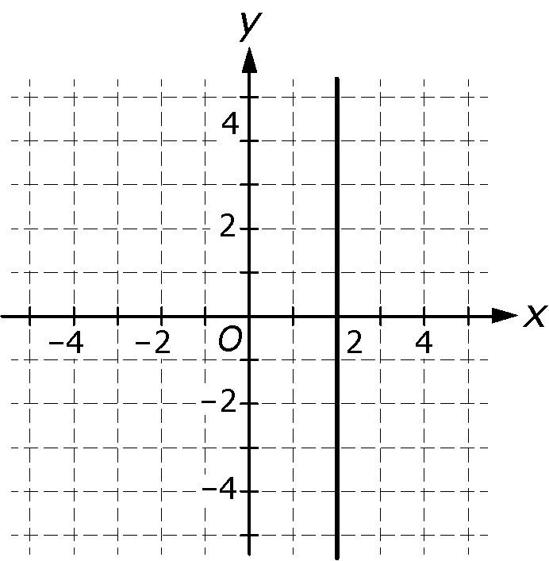
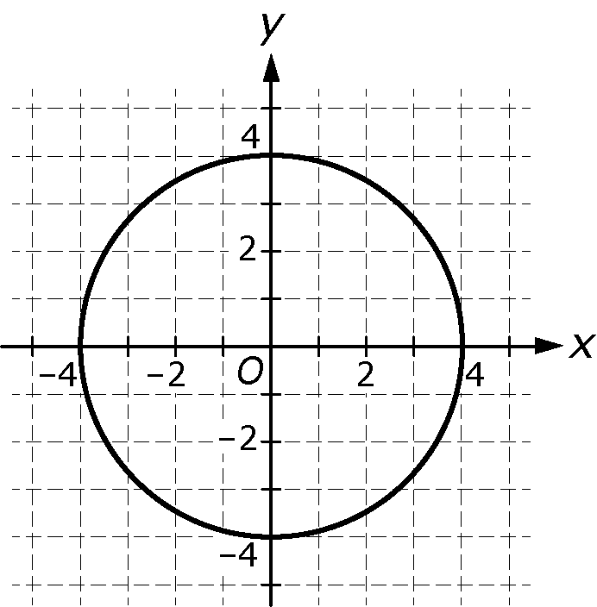

5. Indicate whether each quantitative relationship is a function of x
by checking the appropriate box in the table below.

 | Is a  Function of x | Is Not a Function of x
x | y
0 | 0
1 | 1
2 | 4
3 | 9

x | y
4 | -2
1 | -1
0 | 0
1 | 1

x | y
-1 | 1
0 | 3
1 | 5
2 | 7

6. For the values of the slope and the y-intercept of the two linear functions of x shown below, indicate if the value for function 1 is greater than, equal to, or less than the corresponding value for function 2 by checking the appropriate box in the table below.

Function 1  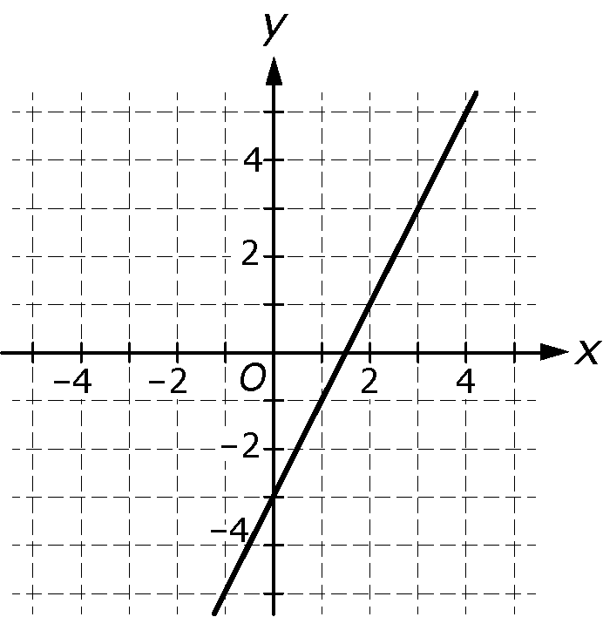 | Function 2
  x | y
  -2 | 4
  2 | 2
  4 | 1
  6 | 0
  8 | -1

 | The value for function 1 is greater than the value for function 2 | The value for function 1 is equal to  the value for function 2 | The value for function 1 is less than  the value for function 2
Slope
y-intercept

7. Function 1 and function 2 defined below are both functions of x.

Function 1  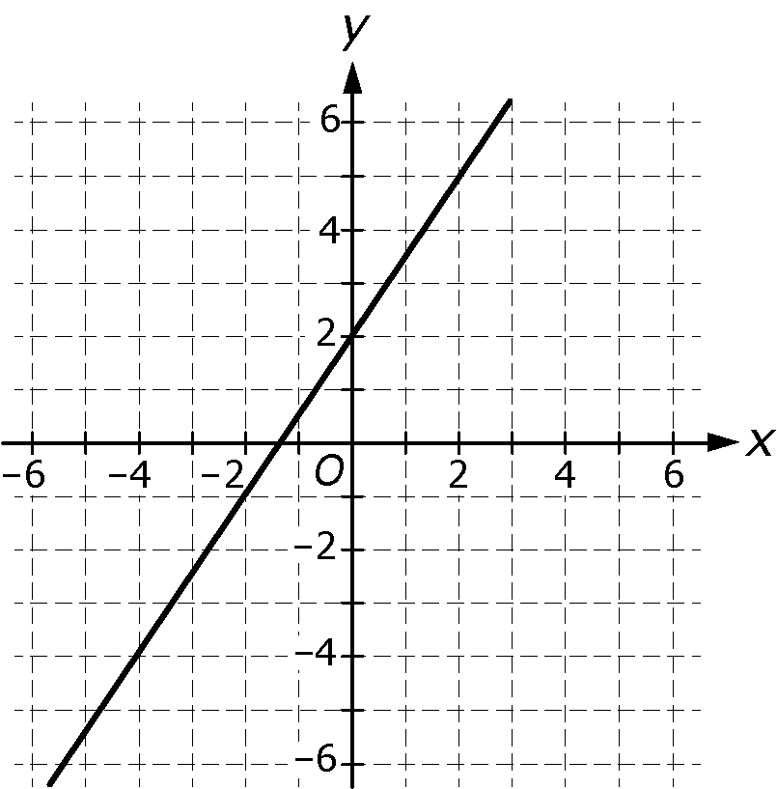 | Function 2

Part A: Does one of the two functions have a greater y-intercept than the other? If so, which one? Explain your answer.

Part B: Does one of the two functions have a greater slope than the other? If so, which one? Explain your answer.

8. Which of the following is the graph of a line that has a slope that is
greater than the slope of the line and a y-intercept that is
less than the y-intercept of the line

a. b.
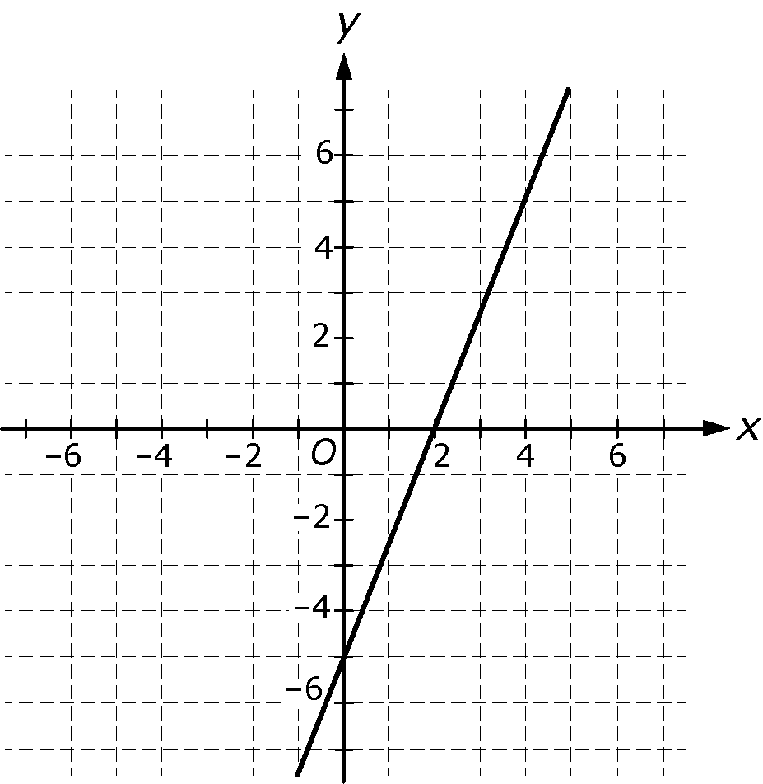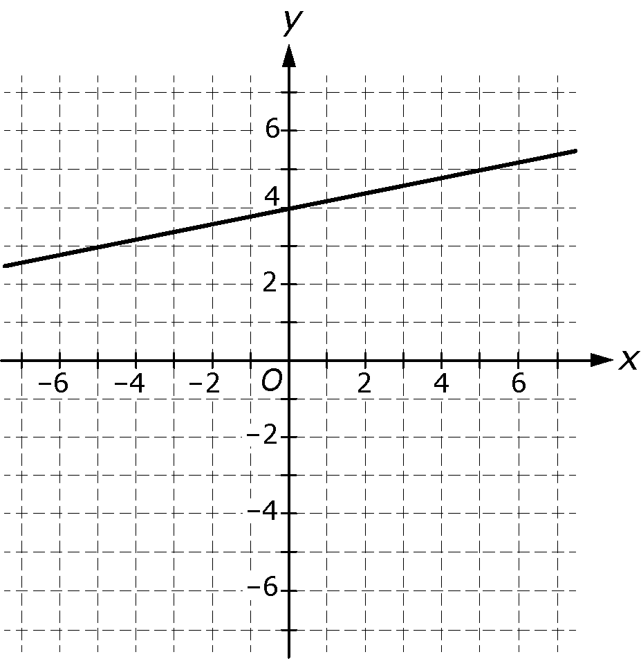

c. d.
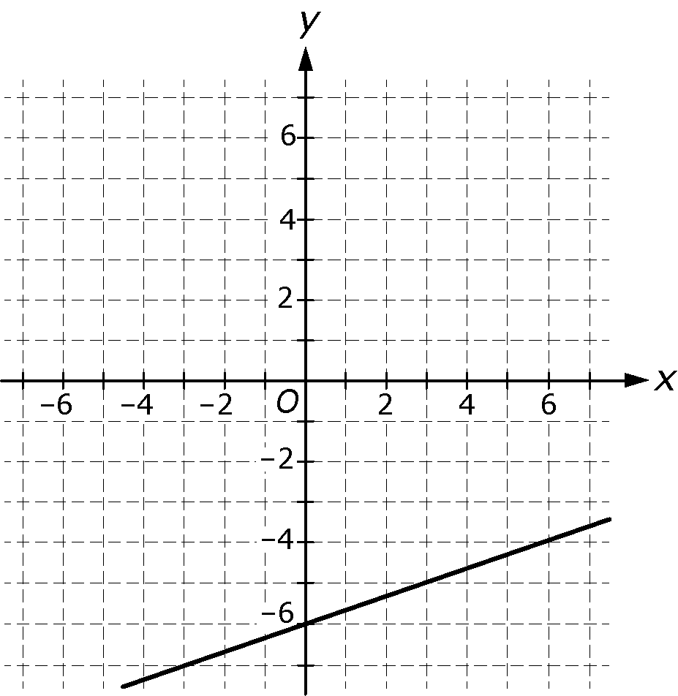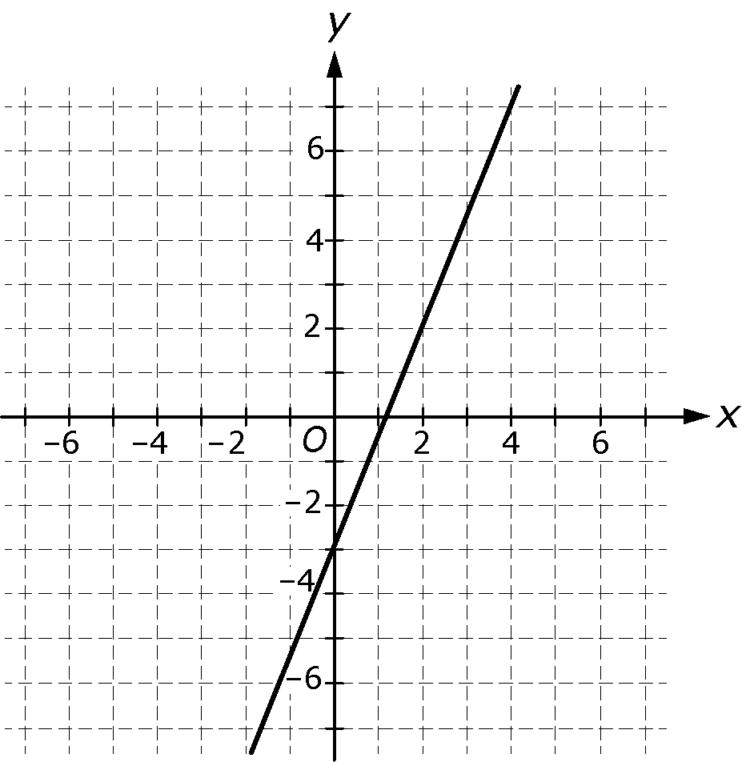

9. For each of the following pairs of functions, fill in the blank with
>, <, or = to make a true statement about the two functions.

A | B
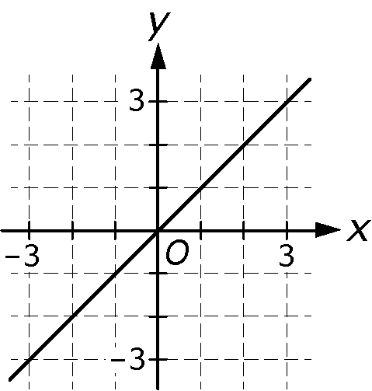 |  | The absolute value of the rate of change of function A __________ the absolute value of the rate of change of function B.
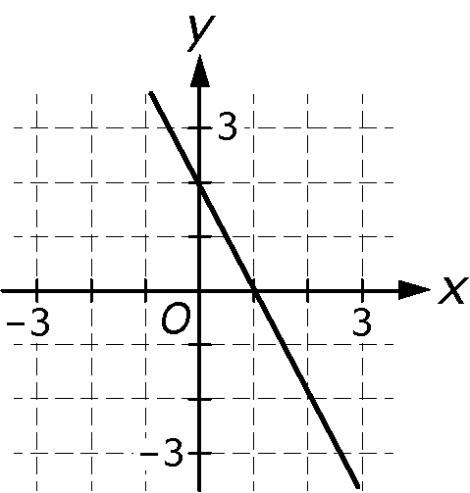 |  | The absolute value of the rate of change of function A __________ the absolute value of the rate of change of function B.
  x | y
  1 | 2
  2 | 4
  3 | 6
  4 | 8
y is 1000 more than of x. |  | The absolute value of the rate of change of function A __________ the absolute value of the rate of change of function B.
  x | y
  10 | 2012
  15 | 2018
  20 | 2024
  25 | 2030
 |  | The absolute value of the rate of change of function A __________ the absolute value of the rate of change of function B.
  x | y

10. Indicate whether each statement about linear functions A and B shown below is true or false by checking the appropriate box in the table.

Function A | Function B  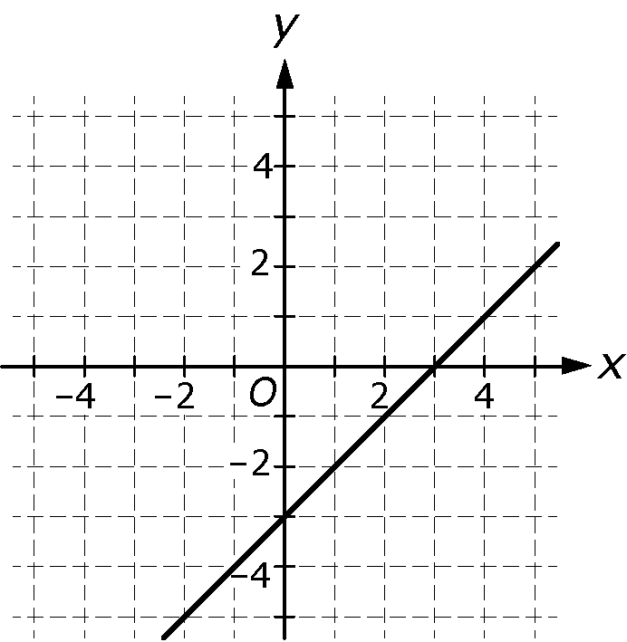
  x | y
  1 | 3
  2 | 7
  3 | 11
  4 | 15
  5 | 19

 | True | False
The rates of change for both function A and function B are positive.
The rate of change for function A is 3 times the rate of change for function B.
The y-intercepts for both function A and function B are positive.

11. Indicate whether each quantitative relationship is a linear function by checking the appropriate box in the table.

 | Linear  Function | Not a Linear  Function
x |  | 0 | 1 | 2
y | 1 | 0 | 1 | 2
x |  | 0 | 1 | 2
y | 1
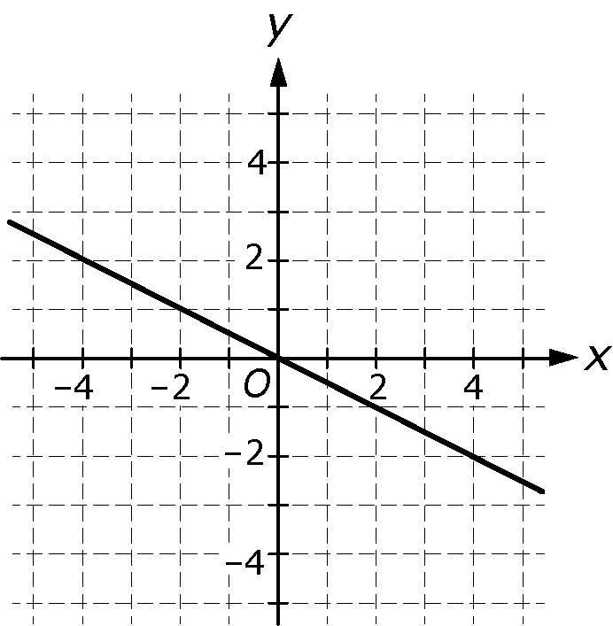
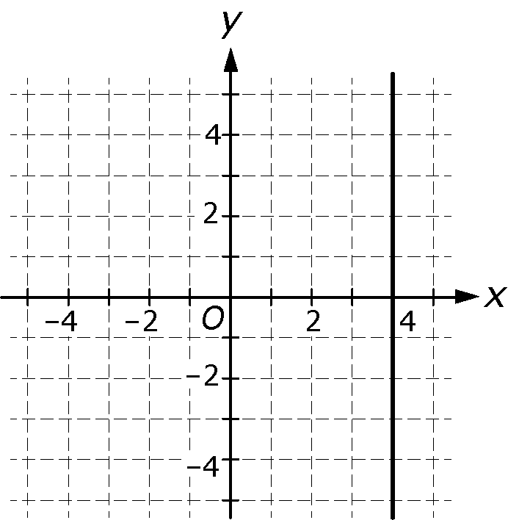

12. Which of the following functions is NOT linear?

a. b.
x | y
 | 2
0 | 4
6 | 8
15 | 14
x | y
0
2
4 | 0
8 | 5

c. d.
x | y
0
1 | 1
4 | 17
x | y
1 | 5
4 | 11
10 | 23

13. Edin says that the function below is linear. Mya says the function is not linear. Which person is correct? Explain your answer.

x | y
0
2

14. The graph of a function is shown below.

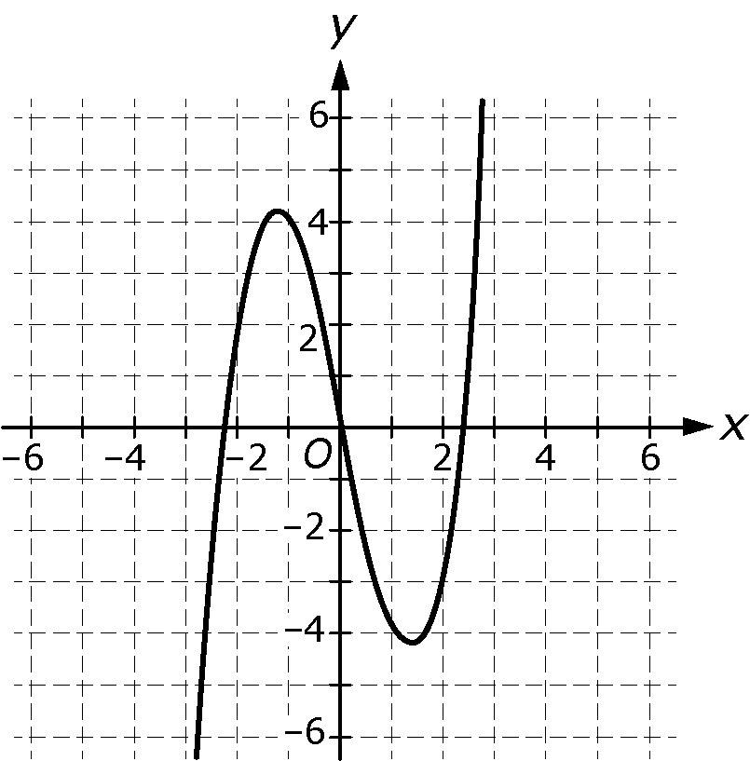

Is the function linear? Explain your answer.

15. Alice bought a new cell phone. The cell phone company she bought the phone from charges $50 per month for cell phone service, $200 for the new phone, and a fee of $175 if the contract is terminated before
2 years have expired. Which of the following linear equations models Alice’s total cost in dollars, y, as a function of the number of months after she purchased the phone, x, if she terminates her contract before 2 years?

a.
b.
c.
d.

16. Johnny rode his bicycle down a hill. It took him 15 seconds to ride from the top of the hill to the bottom of the hill. The equation models his height, h, in feet, above the bottom of the hill as a function of the time, t, in seconds, after he started riding down the hill.

Part A: How much did Johnny’s height above the bottom of the hill decrease each second after he started riding down the hill until he stopped at the bottom?

Part B: What is the height of the hill?

17. Sheila is running a 3-mile race. She runs at a constant rate of mile per minute. Write an equation that gives the number of miles
remaining in the race, y, in terms of the number of minutes that have
elapsed since Sheila started running, x.

18. The manager at a theater collects the data below on the ticket price and attendance for eight other theaters over the course of one month.

Theater | Ticket Price  (dollars) | Attendance  (hundreds of tickets sold)
Theater 1 | 10.00 | 415
Theater 2 | 8.75 | 420
Theater 3 | 7.50 | 505
Theater 4 | 11.00 | 400
Theater 5 | 11.75 | 388
Theater 6 | 8.00 | 485
Theater 7 | 12.00 | 320
Theater 8 | 9.50 | 425

Part A: Create a scatterplot of the data on the graph below.

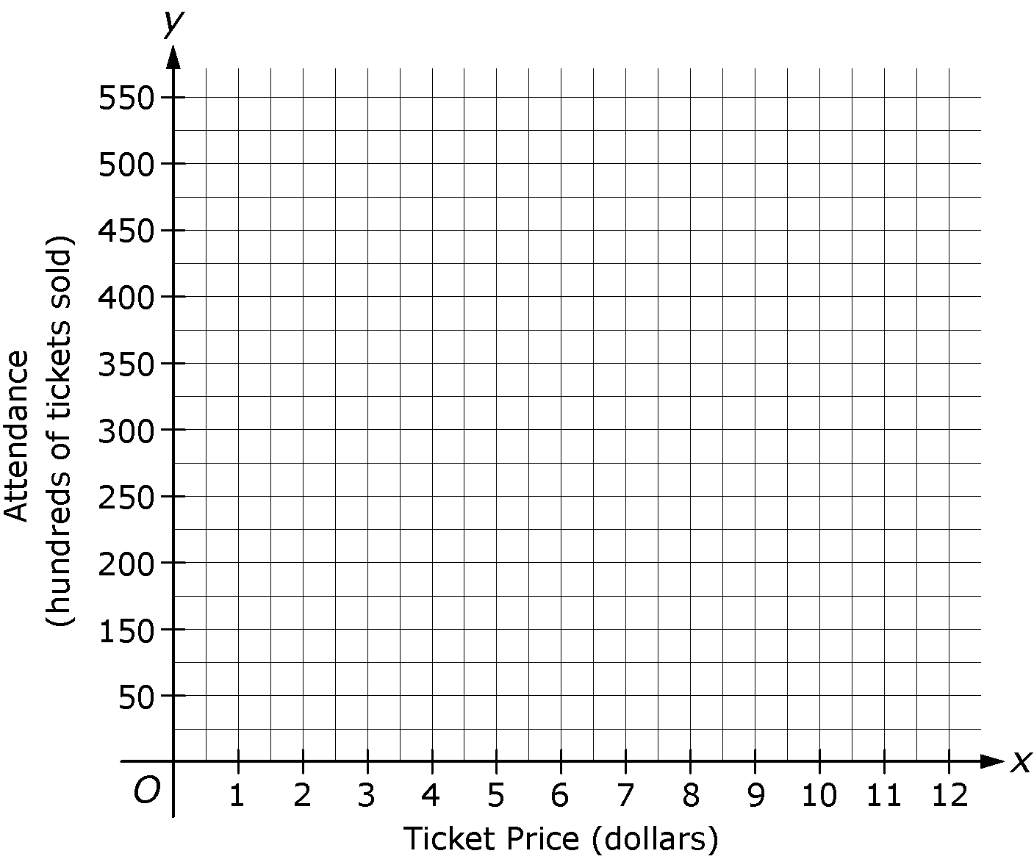

Part B: If a line of best fit for the data is drawn on the graph above, will it have a positive slope or a negative slope? Explain your answer.

19. Which of the following scatterplots most likely shows the relationship between the weights of cars with a particular engine type, in pounds, and the gas mileages, in miles per gallon, for each car?

a. b.
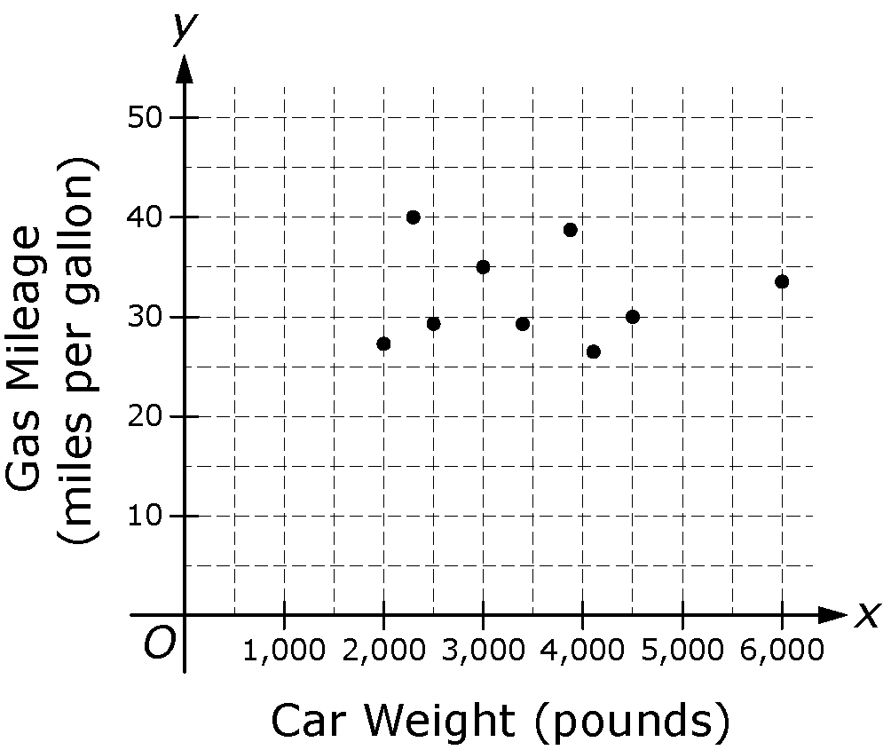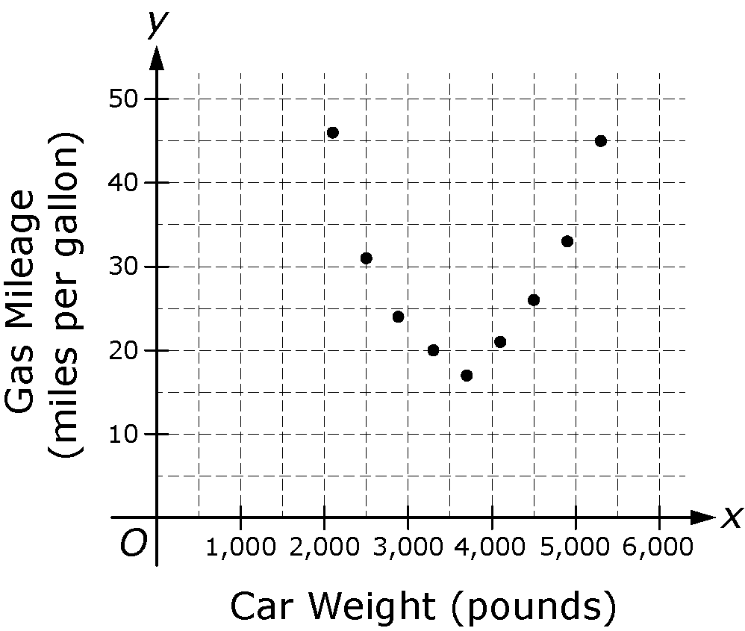

c. d.
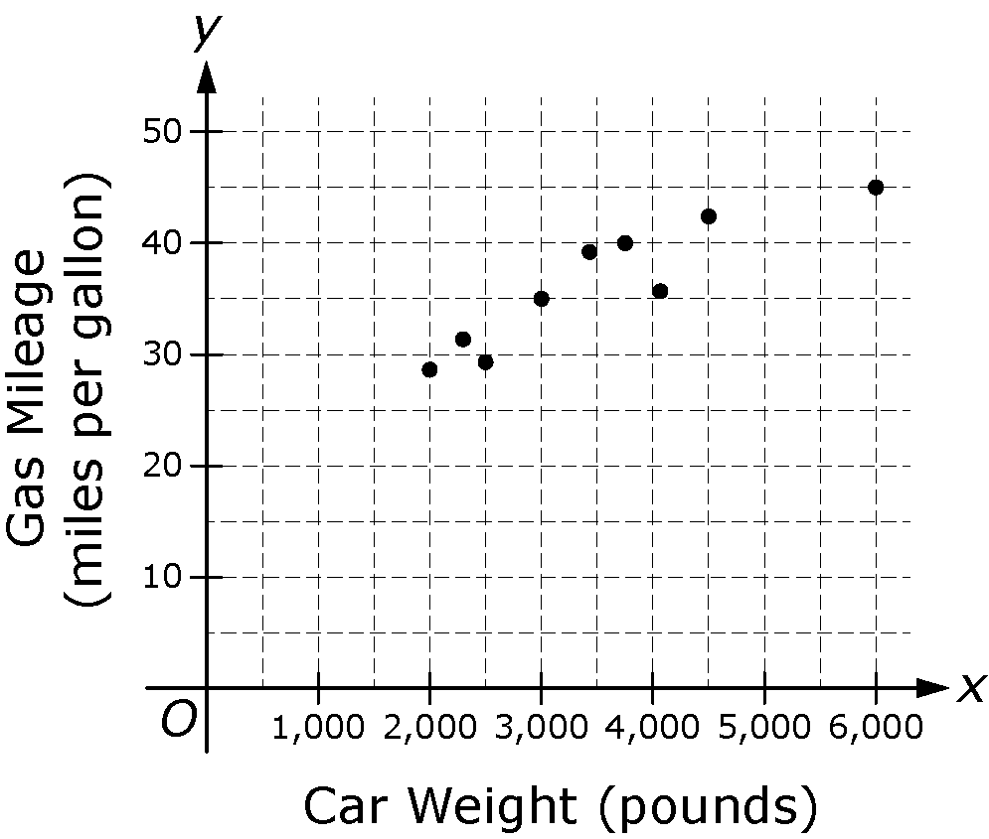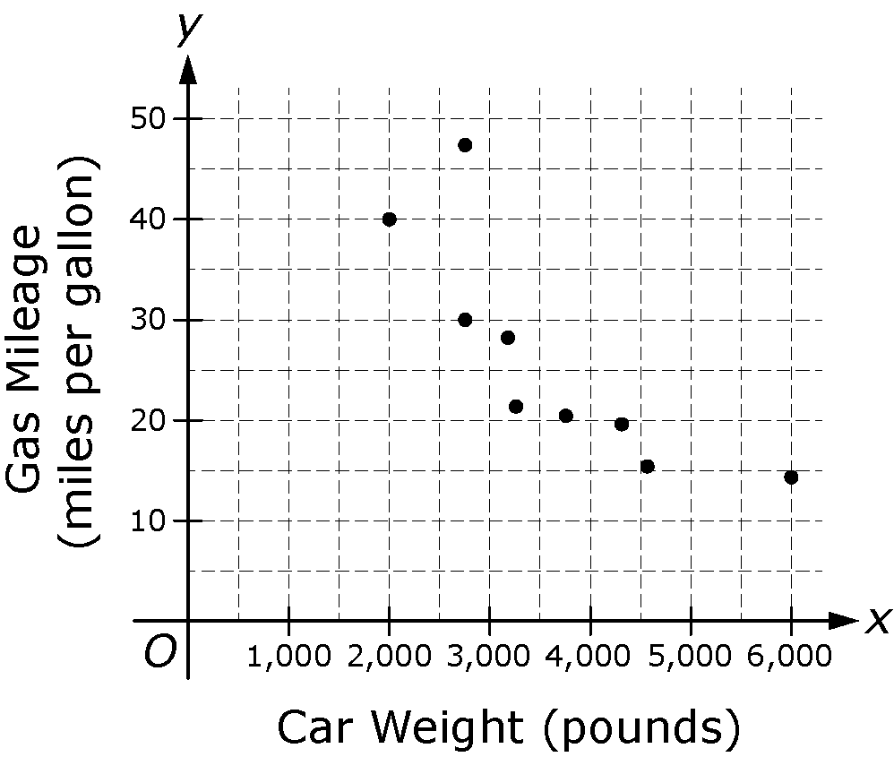

20. Sara is reading a book. Which of the following scatterplots most likely shows the relationship between the number of pages Sara has read so far and the number of pages she still has left to read?

a. b.
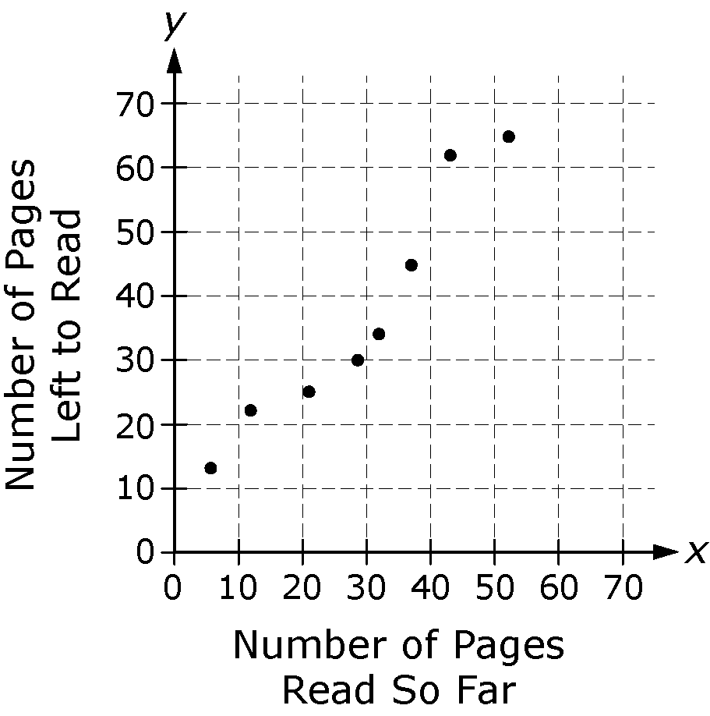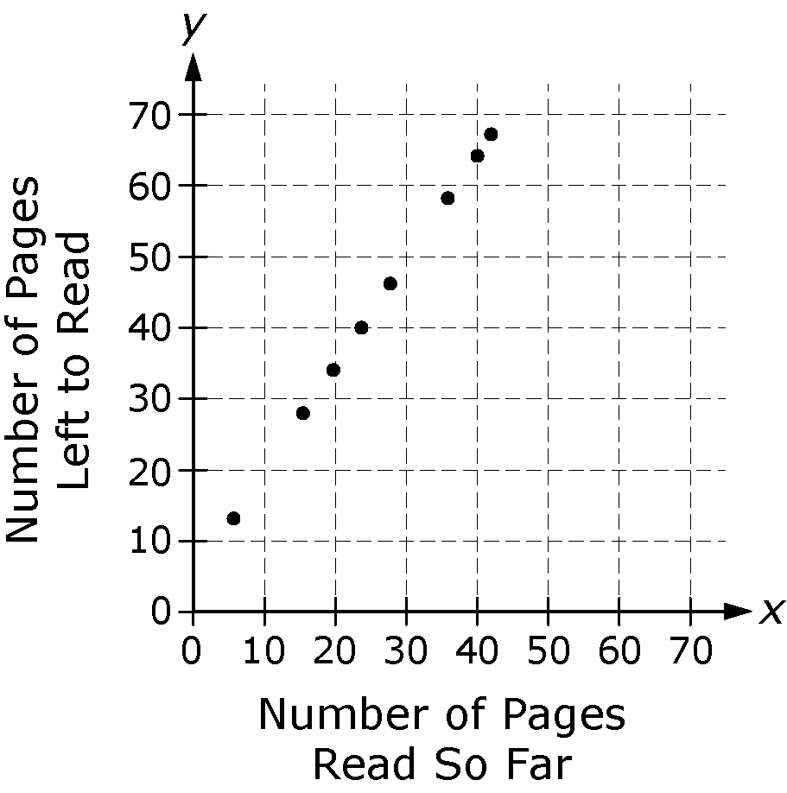

c. d.
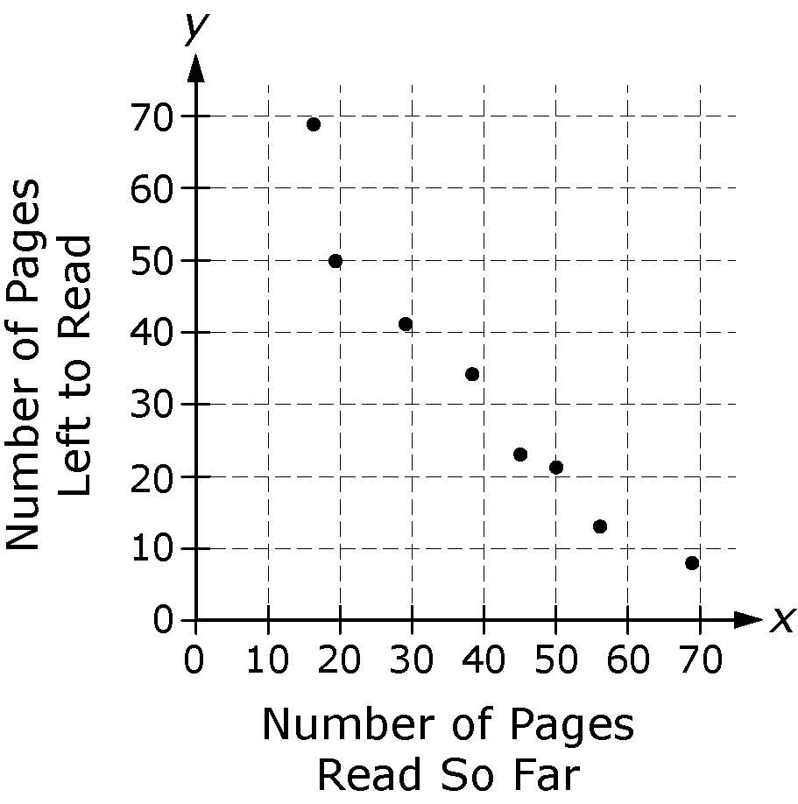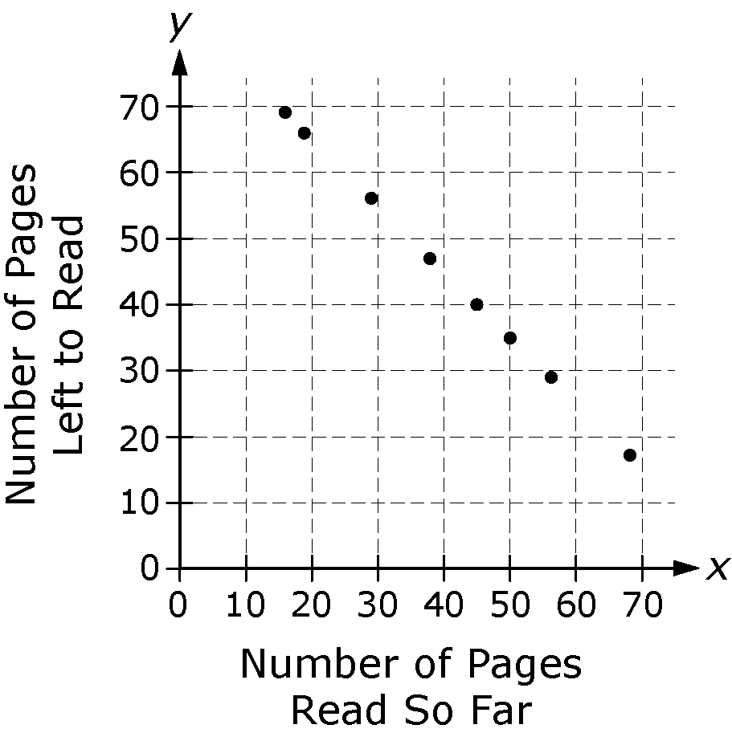

21. The boys varsity basketball coach collects data about the players on his team. The table below shows the height of each player and whether the player is a senior or a junior.

Player | Height (inches) | Squad | Player | Height (inches) | Squad
Taj | 69 | Senior | Kevin | 72 | Senior
Fred | 65 | Junior | John | 60 | Junior
Tom | 65 | Senior | Carlos | 68 | Senior
Alex | 60 | Junior | Vinny | 67 | Junior
Greg | 61 | Junior | Ted | 63 | Senior
Rex | 71 | Senior | Jared | 68 | Senior

Use the data to complete the frequency table below.

 | 60–64 inches | 65–69 inches | 70–74 inches | Total
Senior
Junior
Total

22. All of the 48 students in the fifth grade class at Parker Elementary School voted for the favorite of their two teachers. Of the 25 girls in the fifth grade, 11 voted for Mr. Ackerman. Of the 23 boys in the
fifth grade, 7 voted for Ms. Husted.

Part A: Complete the two-way frequency table below.

 | Boys | Girls | Total
Mr. Ackerman
Ms. Husted
Total

Part B: Which teacher was voted favorite by the greater number of students in the fifth-grade class?

Part C: Which teacher was voted favorite by the greater number of boys in the fifth-grade class?

Part D: What percent of the girls in the fifth-grade class voted for Ms. Husted as their favorite teacher?

