Physical Examinations
Students entering Pre-K, Kindergarten, grade 6 and grade 10
are required to have a complete physical examination
performed by a licensed physician (MD or DO), Physician’s
Assistant (PA) or Advanced Practice Nurse (APRN).
All students entering the district from another state or country as well as those entering from private schools outside of Milford must have a physical examination performed within one year of entering the Milford Public Schools.
The physical exam must be documented on the State of CT Physical Exam form (HAR-3), commonly referred to as “the blue form”. This form can be downloaded by clicking on the School Health Downloadable Forms link.

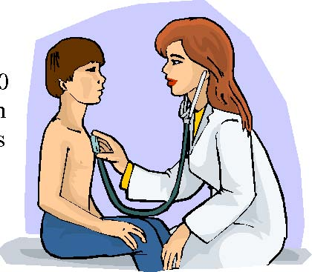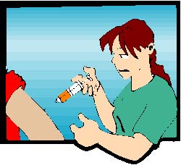
Immunizations
All entering students must provide documentation of immunizations that are required by the State of Connecticut. A current list of required immunizations can be found on this website by clicking the School Health Downloadable Forms link.
Your primary care provider may administer immunizations. The
Milford Health Department also offers an Immunization Clinic on the second Tuesday of every month from 2:30-4:30 pm. All required childhood immunizations are available and no appointment is necessary.



Medication Administration
All students who require medication (prescription or over-the-counter) to be administered at school must have a completed Medication Authorization Form signed by their primary care provider and parent/guardian. Medications must be supplied in their original labeled container. A 90-day supply of medication is the maximum amount that the school nurse can accept; refills can be delivered to the school nurse as needed.
Students who have parental and physician permission to self administer their medication(s), such as Epi Pen injectors or inhalers, are also required to submit a medication authorization form every school year.
Medications are to be picked up by the parent by the last day of school in June or they will be destroyed.
Please visit the Milford Board of Education website (www.milforded.org) for a complete and current reference of the Medication Policy for Students.
Sports Physicals
Sports physicals must be submitted to the school nurse every 12 months. The sports physical differs from the routine physical, as the medical provider performs a more extensive assessment of the musculoskeletal system and also evaluates prior injuries such as concussions, soft tissue injuries and broken bones.
The sports physical can be performed by your primary care provider.
The sports physical form must be completed by the parent/guardian, the student athlete, and the primary care provider and be submitted to the school nurses BEFORE the student is allowed to practice or play.
AS OF JUNE 2010, THE SPORTS PHYSICAL FORM AND THE ROUTINE PHYSICAL FORM (BLUE FORM) ARE THE SAME FORM.
It is the student’s responsibility to maintain a current sports physical on file with the school nurse. A lapse in providing a current physical will result in suspension from participation according to CIAC rules.


Screenings
The following State mandated health screenings are performed every school year in the following grades. Please keep in mind that they are screening exams and are not meant to take the place of professional vision, hearing and other medical evaluations.
Vision Screening: All students in grades K, 1, 3, 4 and 5
Hearing Screening: All students in grades K, 1, 3, 4, and 5
Postural Screening: Females in grades 5 and 7, Males in grade 8
Height & Weight & BMI: All students in grades K-12
Although screenings are conducted annually in specific grades, they can also be performed on request for any child if a parent, teacher or nurse has a concern about the student’s ability to see, hear or perform in school.

