Name: __________________________________ No. ____ Date: _______________________________
Math Test – Fractions -Topic A
Read each question. Circle or write in the correct answer.

__
20
6. Kim’s teacher decomposed seven eighths as follows:
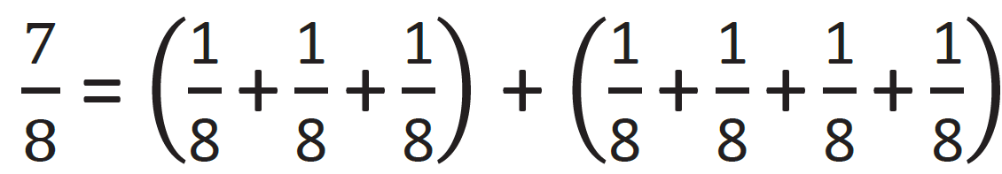
Kim wanted to decompose seven eighths in a different way. Her work is shown below. What should Kim write in the space marked with the question mark?
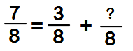

A. 12 B. 3
C. 4 D. 10

7. Which of the following is a unit fraction?

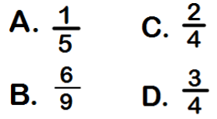

8. Shade in the rectangle to show ½.

1. Which number sentence is illustrated by the tape diagram below?
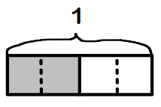
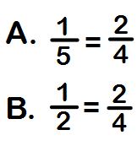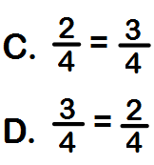

2. Add the fractions
¼ + ¾ + ¼ + = ______

3. What fraction of the circle is shaded?

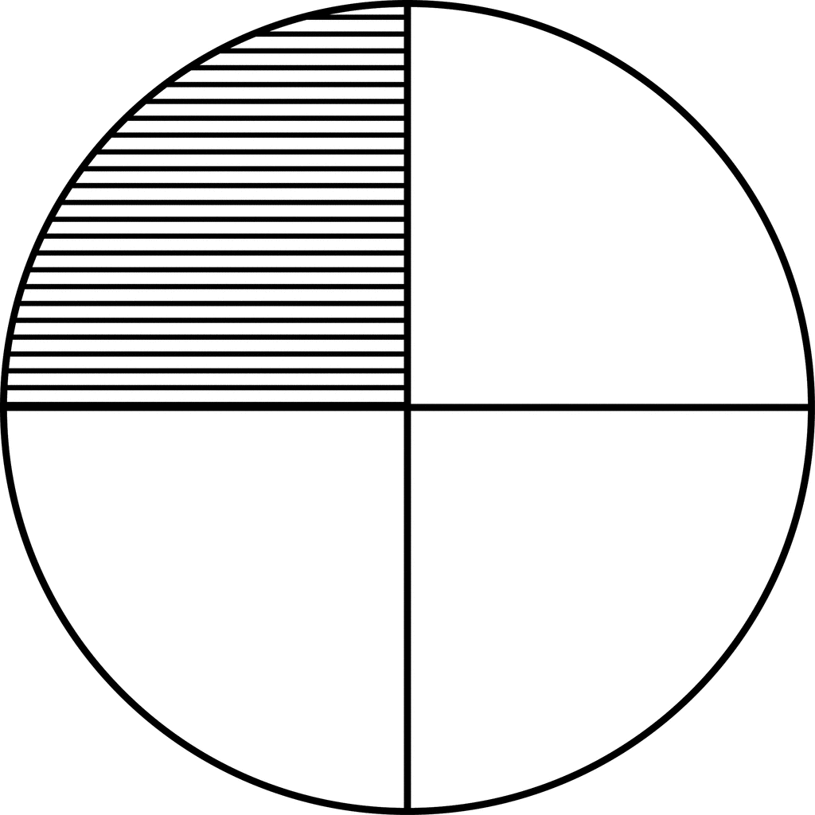
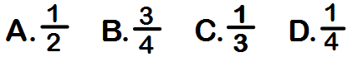

4 .Add the fractions
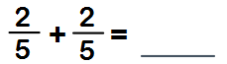

5. Add the fractions
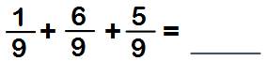
9. Decompose the fraction as sums of unit fractions.

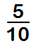

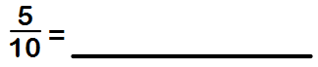
10. Chef Harvey was baking cookies.
The recipe said he would need ½ cup of milk to make 10 cookies. Chef Harvey wanted to make 30 cookies. How much milk will he need?

Answer: _________________________

Constructed Response
Directions: This question has more than one part. Show all of the work you do to find your answers. Even if you cannot answer all parts, answer as many as you can. You may still get points for answering part of the question. Be sure to write clearly.

11. Alex created this area model to find a fraction that is equal to ¼. His teacher asked him to explain further using addition and multiplication sentences. Help Alex by completing the equations below. (5 points)

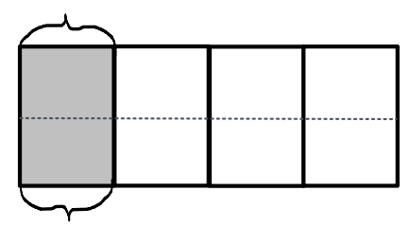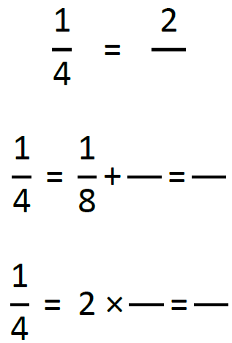

12. Draw an area model to prove the number sentence below. Show the decomposition as a sum of unit fractions and as a multiplication sentence. (5 points)
