Name: __________________________________ No. ____ Date: _______________________________
Math Test – Topic A - Place Value
Read each question. Circle or write in the correct answer.

__
20
6. Examine this statement.
10 times as many as ___ hundreds is 70 hundreds or ___ thousands.
How would you complete the statement using your knowledge of place value?
A. fill in the blanks with a 7 then a 7
B. fill in the blanks with a 70 then a 700
C. fill in the blanks with a 7 then a 700
D. fill in the blanks with a 70 then a 7

7. Write a three-digit number using the digits 2, 4, and 6 so that the digit 4 means four tens and the digit 6 means six hundreds.

Answer: _________________________

8. Tyrone is trying to win a prize at a carnival. He has to guess the number of jellybeans in a jar. He gets these clues. The number has 43 thousands and 19 hundreds. What should Tyrone’s answer be?
A. 4,319
B. 4,300,190
C. 44,900
D. 4,193

9. Compare the following:
A. < B. >
C. = D. ?

10. What number is 10 more than 5,237?
A. 5,238 B. 5,247
C. 5,337 D. 6,237

1. Cara’s Uncle Dino is 30 years old. Her little brother Jim is 3 years old. Which statement about Jim and Uncle Dino is correct?
A. Uncle Dino is 3 times as old as Jim.
B. Jim is 10 times as old as Uncle Dino.
C. Jim is 33 times as old as Uncle Dino.
D. Uncle Dino is 10 times as old as Jim.

2. Examine this statement.
10 times as many as 2 hundreds is ____ hundreds or ___ thousands.
How would you complete the statement using your knowledge of place value?
A. fill in the blanks with a 2 then a 20
B. fill in the blanks with a 20 then a 2
C. fill in the blanks with a 10 then a 200
D. fill in the blanks with a 20 then a 20

3. Howie wrote this expression on his personal white board. 10 X 5 tens. His shoulder partner Cory has to write the answer in unit form. What should Cory write?
A. 5 tens
B. 50 tens
C. 500 tens
D. 5000 tens

4. Mr. Martin saved $565 for a new boat. The boat he wants costs 10 times that. How much does the boat cost?
A. 565 ones
B. $5,650
C. $56,500
D. 5,650 tens

5. How many whole tens are in 3,200?
A. 3 B. 32
C. 320 D. 3,200

Constructed Response – 10 points

Directions: This question has more than one part. Show all of the work you do to find your answers. Even if you cannot answer all parts, answer as many as you can. You may still get points for answering part of the question. Be sure to write clearly.
A dartboard has three separate areas.
Darts that land in the inner circle earn 100 points each.
Darts that land in the middle ring earn 10 points each.
Darts that land in the outer ring earn 1 point each.

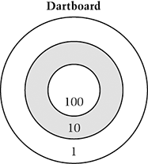

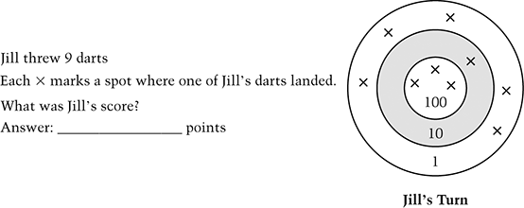

Jill threw 9 darts.
Each X marks a spot where one of Jill’s darts landed.
What was Jill’s score?
Answer: ______________ points

‘

Kevin threw 7 darts and they landed as shown.
He has 2 more darts to throw

‘
Ruth threw 7 darts and they landed as shown.
She has 2 more darts to throw

‘

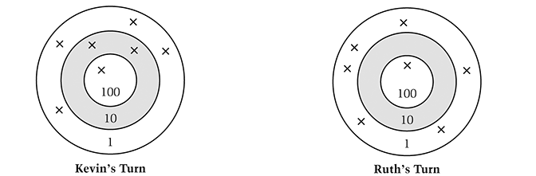

The person who has the highest score after throwing 9 darts wins the game.
Can Jill win the game? Yes No
Can Kevin win the game? Yes No
Can Ruth win the game? Yes No
Explain how you know which players can win and which players cannot win.
_____________________________________________________________________________________________________________________________________________________________________________________________________________________
____________________________________________________________________________________________________________________________________________________________________________________

