Grade 3 Module 4 Topic D Quiz

For problems 1-3, find the other side length.

1.  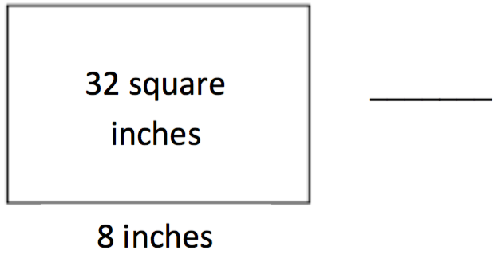 | 2.  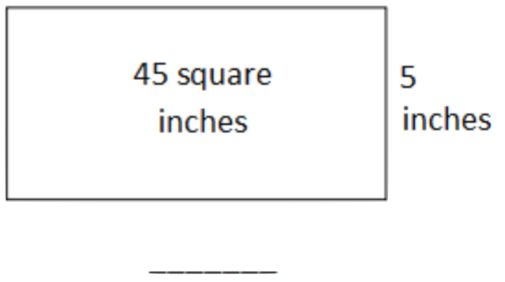 | 3.  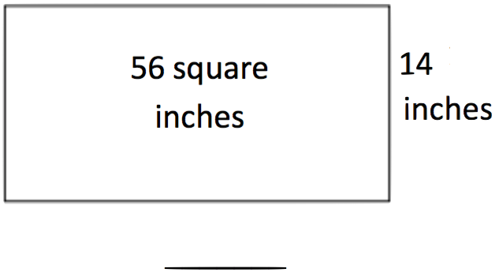

4. The following shaded figure is made up of 2 rectangles. Find the total area of the shaded figure.

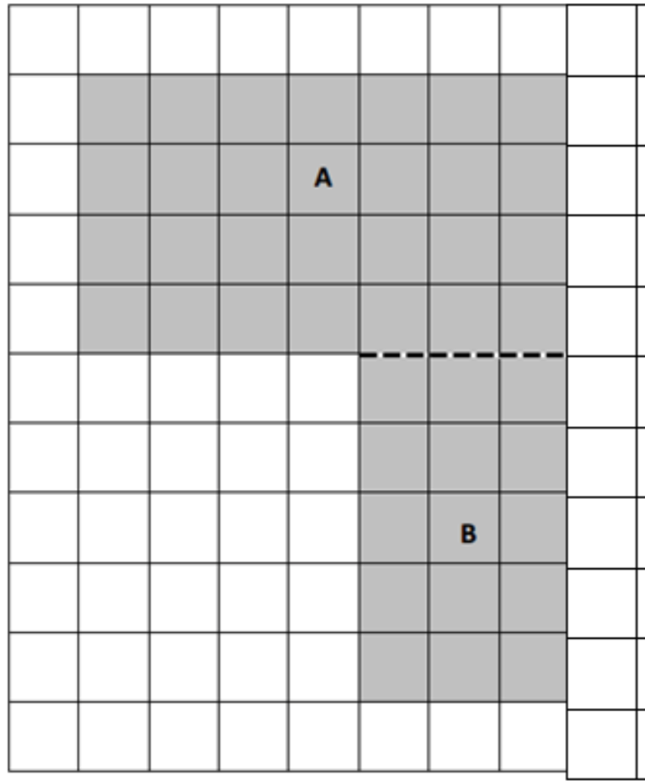

Area of A + Area of B = ________ + ________ = ________ sq units

5. Bobby draws a 7 cm by 9 cm rectangle on her grid paper. She shades a square with a side length of 4 cm inside her rectangle. What area of the rectangle is left unshaded?

6. The area of a rectangle is 72 square units. One side has a length of 9 units. What is the other side length? Explain how you know using pictures, equations, and words.

7. Half of the rectangle to the right has been tiled with unit squares.

- How many more unit squares are needed to fill in the rest of the rectangle? How do you know?

- What is the total area of the large rectangle? Explain how you found the area.

8. Superior Elementary School uses the design below for their swimming pool. Shapes A, B, and C are rectangles.
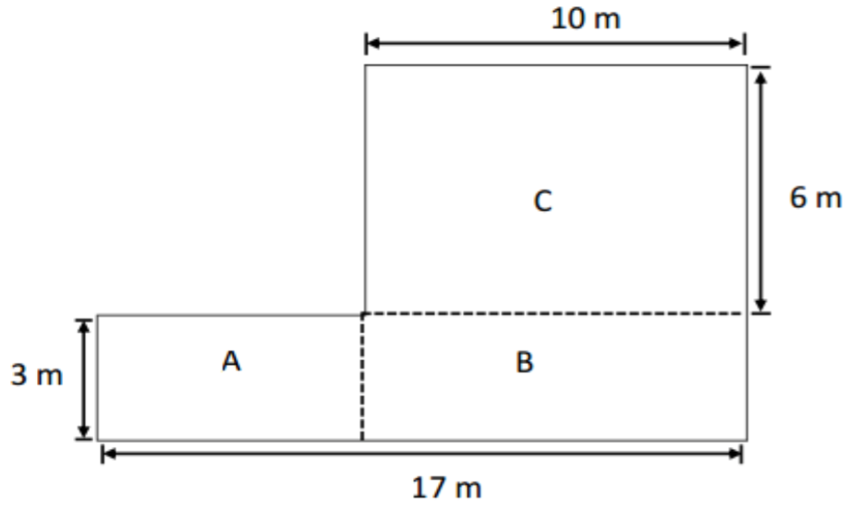
- Label the sides of Rectangles A and B on the drawing.

- Find the area of each rectangle.

Area of Rectangle A = _______________

Area of Rectangle B = _______________

Area of Rectangle C = _______________

- Find the area of the entire pool. Explain how you found the area of the pool.

