Geometry – Multiple Transformations Name: _____________________

You should already know how to do the following:
- Translations (slides)
- Reflections (flips, like with a mirror)
- Rotations (spins or turns)
- Dilations (stretches or shrinks)

Let’s review to get “warmed-up”.

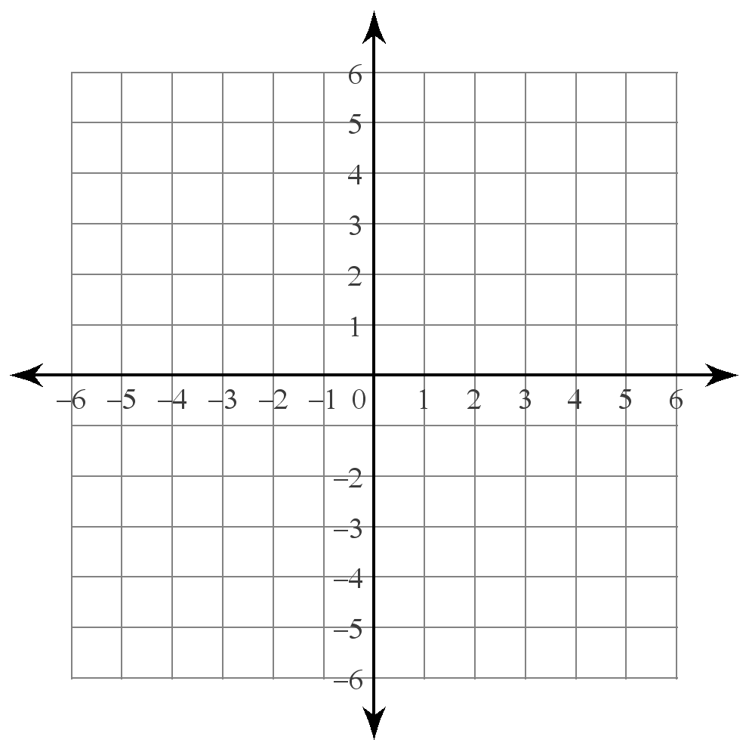
1) Translate QRS if Q(4,1), R(1,-2), S(2,3) 2)Reflect Q’R’S’ if Q’(1,-3), R’(-2,-6),
by moving it left 3 and down 4. and S’(-1,-1) over the x-axis.

3) Rotate CAR if C(-1,-4), A(2,6), R(-4,-2) 4) Dilate C’A’R’ if C’(2,4), A’(-2,-6),
around the origin. and R’(4,2) by a scale factor of ½ from the
origin.

5) What did you notice in problems 1&2 and problems 3&4? How were the shapes related? Explain how you could transform QRS by translating it left 3 and down 4 and then reflecting the image over the x-axis. Where does the final image end up?

6) How would you rotate CAR about the origin and then dilate it by a scale factor of ½?

7. Now you are going to try some multiple transformations:

a) Translate ALT if A(-5,-1), L(-3,-2), T(-3,2) b)Reflect TAB if T(2,3), A(1,1),
by moving it right 6 and down 3, then reflect the and B(4,-3) over the x-axis, then reflect
image over the y-axis. the image over the y-axis.

c) Rotate ALT if A(-5,-1), L(-3,-2), T(-3,2) d)Reflect TAB if T(2,3), A(1,1),
clockwise around the origin, then reflect the and B(4,-3) over the y-axis, then translate
image over the x-axis. the image by moving it right 2 and down 1.

e) Rotate ALT if A(-5,-1), L(-3,-2), T(-3,2) f)Reflect TAB if T(2,3), A(1,1),
clockwise around the origin, then reflect and B(4,-3) over the x-axis, then translate
the image over the y-axis. the image by moving it left 5 and down 4.

