Chemistry
Lecture 3-3
Molecular Geometry

The Lewis structure of a molecule only shows the bonds between the atoms in the molecule. How are the bonds arranged around the central atom in the molecule? A central atom is any atom that is connected to at least two other atoms. The molecular geometry describes the angles between the bonds in the molecule.

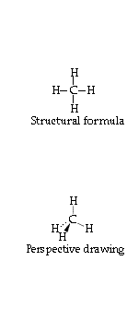
The top diagram shows that the four hydrogen atoms are attached to the central carbon atom. This Lewis structure does NOT correctly show the angles between the bonds. As the formula is drawn you would be mislead into believing the bond angles are all 90º. The lower drawing actually depicts the molecular geometry of the molecule and shows the three-dimensional aspect of the geometry.

What factors determine the molecular geometry of a molecule? After we draw the Lewis structure, how can we determine what the molecular geometry will be? A simple theory with a very long name will come to our rescue! The theory is called the Valence Shell Electron Pair Repulsion theory (VSEPR for short). The main idea of this theory is that covalent bonds REPEL each other! This is logical since a bond is made up of a pair (or pairs) of electrons and electrons should repel each other because they are negative.

Let us consider the molecule CH4 (methane) in which the central carbon atom is connected with four single covalent bonds to the four hydrogen atoms. How will the four bonds arrange themselves so as to be as far away from each other as possible?

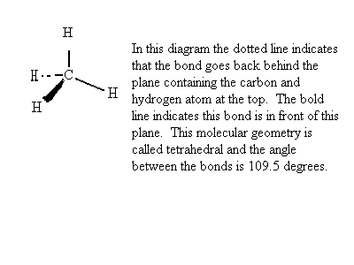

What if the central atom is only connected to three other atoms? The compound ethene, C₂H₄, has a double bond between the two carbon atoms. Each of the carbon atoms is a central atom that is attached to three other atoms (the other carbon and the two hydrogens). The three bonded atoms will try to get as far away from each other as possible. The bond angles will be 120º and the centers of all atoms will lie in a plane. This geometry is called trigonal planar.

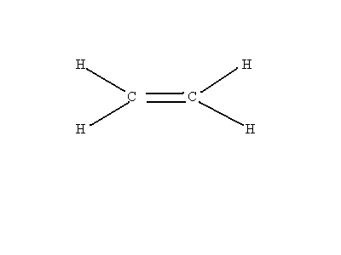
What if the central atom is only attached to two other atoms? The molecule called ethyne, C₂H₂, has two central carbon atoms that are attached to two other atoms (the other carbon and the hydrogen). These two bonded atoms will try to get as far away from each other as possible. The two bonded atoms would then be on opposite sides of the
carbon and the bond angle would be 180º. This geometry is called linear.

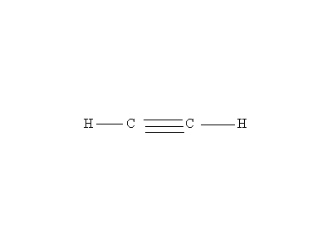

What is the central atom has unshared pairs? If we draw the Lewis structure for ammonia, NH₃, we see that the central nitrogen atom has 3 shared pairs and 1 unshared pair.

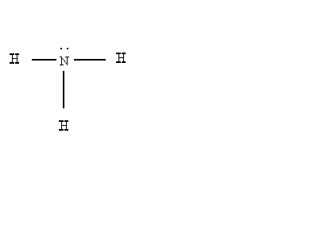
How will the three bonded atoms be oriented around the central N atom? You might guess that the tetrahedral geometry would result since there are four pairs of electrons around the N atom. This would be true if all four pairs of electrons repelled each other equally. It turns out that unshared pairs repel shared pairs MORE than shared pairs repel shared pairs. This leads to a trigonal pyramid geometry. The bond angles would be a little less than the tetrahedral angle of 109.5º.
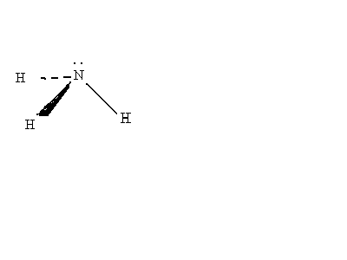
The three hydrogen atoms lie in the base of a pyramid with the nitrogen atom at the apex of the pyramid.
What if the central atom has more than one unshared pair of electrons? In water, H-O-H, the central oxygen atom has two unshared pairs of electrons and two shared pairs.

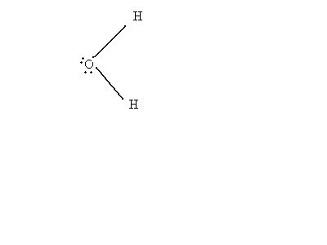

If there were no unshared pairs on the oxygen atom, then the shared pairs would be 180º apart and the geometry would be linear. The shared pairs are pushed together as a result of trying to get away from the unshared pairs. The bond angle in water is 104.5º and the geometry is called bent or V-shaped.

We can see that the geometry of a molecule depends on the number of shared pairs and unshared pairs on the central atom. The positions of the electron pairs around the central atom are called electron domains. Each shared pair and each unshared pair count as one electron domain. A double or triple bond only counts as one electron domain because the multiple bond holds the central atom to just one other atom.

What about the geometry of molecules with expanded octets? What would be the geometry if a central atom has 5 electron domains? An example of such a molecule is PH₅. The 5 covalent bonds will be oriented around the central P atom such that two of the bonds are 180 degrees apart (one bond above and one bond below the P atom). These two bonds are said to be in the axial positions. The other three bonds lie in a plane which is perpendicular to the axial line with bond angles of 120 degrees. These three bonds are said to be in the equatorial positions. This geometry is called trigonal bipyramid.

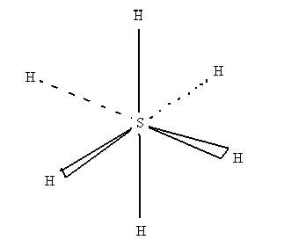
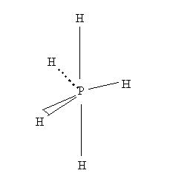
In the diagram above on the right the sulfur atom is surrounded by 6 covalent bonds. The axial positions are 180 degrees apart. The other 4 bonds are in a plane perpendicular to the axial plane with 90 degree bond angles. Since all of the bond angles are 90 degrees with the exception of the axial angle, all positions are equivalent. We do not distinguish between axial and equatorial positions as we did in the geometry on the left. This geometry is called octahedral.
We can summarize the types of molecular geometry by counting the number of electron domains around the central atom and noting how many of the electron domains are unshared pairs.

number of electron domains | number of unshared pairs | molecular geometry | bond angle
2 | 0 | linear | 180
3 | 0 | trigonal planar | 120
4 | 0 | tetrahedral | 109.5
4 | 1 | trigonal pyramid | < 109.5
4 | 2 | bent or V-shaped | << 109.5
5 | 0 | trigonal bipyramid | 180, 120, 90
6 | 0 | octahedral | 180, 90

Chemistry Name_________________________________
HW 3-3 Period _____ Date________________
Molecular Geometry

(1 point for each blank)
number of shared pairs | number of unshared pairs | molecular geometry | bond angle
4 | 0 |  | 109.5
 | 1 | trigonal pyramid | about 107.5
2 |  | bent (V-shaped) | about 104.5
3 | 0 | trigonal planar
2 | 0 |  | 180
 | 0 | trigonal bipyramid | 90, 120, 180
6 | 0 |  | 90, 180

Draw a Lewis structure for a compound with the following condensed structural formula.

CH₃OCH₂NHCHO

8. What is the molecular geometry at the central oxygen atom?

9. What is the molecular geometry at the nitrogen atom?

10. What is the smallest bond angle in the molecule?

