Geometry Name: ______________________________ Period:____

Chapter 8 Tool Kit: Polygons and Circles

Definition of a polygon: |  |  | Parts of a Regular Polygon:
 | 8.1.1 | 8.1.1 | 8.1.2 | 8.1.3 | 8.1.3 | 8.1.3
Number of Sides | Name of Regular Polygon | Central angle | Sum of Interior Angles | One Interior Angle | One Exterior Angle | Sum of Exterior Angles
3 | Equilateral Triangle
4 | Quadrilateral
5 | Pentagon
6
7
8
9
10
11
12 | Dodecagon
n

Regular Polygon Web 8.1.4

Convex polygon |  | 4 steps to find the area of a Regular Polygon:
Non- convex polygon/Concave
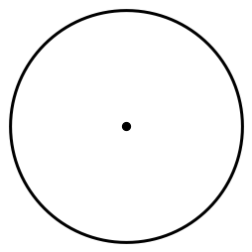  Why is a circle not a polygon? It has curves and the set of all points in a plane (in a flat surface – 2D) are a given distance (circumference) from a given point, the center. |  | Area of a Circle:
 |  | Circumference of a Circle:
Sector Area: |  | Arc Length of a sector:
R is used for = ZOOM FACTOR = SCALE FACTOR = create ratios/fractions/proportions
R1: | R2: |  | R3:
For two similar figures, the following is true:
Ratio of Perimeters: Scale Factor → (Original Perimeter) (ScaleFactor) = New Perimeter
Ratio of Areas: (Scale Factor)² → (Original Area) (Scale Factor)² = New Area
Ratio of Volumes: (Scale Factor)³ → (Original Volume) (Scale Factor)³ = New Volume

