Geometry

Section 1.1

Patterns and Inductive Reasoning

Definitions :
conjecture – unproven statement based on observations
inductive reasoning – process involving making conjectures and looking for patterns
counterexample – An example that shows the conjecture is false.

1. Describe a pattern in the sequence of numbers. Predict the next number.
a. 1, 3, 9, 27, … b. -3, -1, 3, 9, …

2. Complete the conjecture.
The sum of the first n odd positive integers is _____.

3. Show the conjecture is false by finding a counterexample.
For all real numbers x, the expression x² is greater than or equal to x.

Geometry

Section 1.2
Points, Lines, and Planes

Definitions :
Undefined terms – words such as point, line, or plane that have no definition.
Point – has no dimension. Usually represented by a small dot.
 Point A
Line – Extends in one dimension. Usually represented by a straight line with two arrowheads to indicate that the line extends without end in two directions.
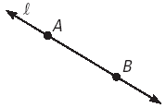 Line l or Line AB
Plane – Extends in two dimensions. Usually represented by a figure that resembles a tabletop or wall.
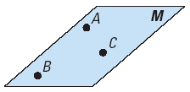Plane M or Plane ABC
Collinear Points – points that lie on the same line
Coplanar Points – points that lie on the same plane
Segment – subset of a line that consists of two endpoints and all collinear points in between
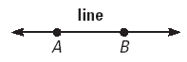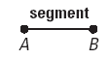
Endpoints – two outer point of a segment (A and B)
Ray – subset of a line that consists of an initial point and travels in a single direction infinitely.
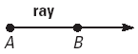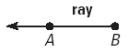
Initial Point – The starting point of a ray (Point A)
Opposite Rays – Collinear rays with the same initial points traveling in the opposite direction
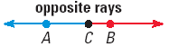

Intersect – Two figures with one or more points in common.
Intersection – Set of points those figures have in common.

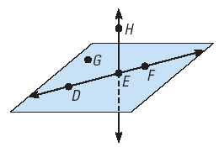
- Name three points that are collinear.
- Name four points that are coplanar.
- Name three points that are not collinear.
- Draw the intersection of two lines

- Draw the intersection of a line and a plane in one point.

- Draw the intersection of two planes in a line.

Geometry

Section 1.3 Segments And Their Measure
Definitions :
Postulate or Axiom – Rules accepted without proof.
Coordinate – Real number that corresponds with a number on a number line.
Distance – The absolute value of the difference between the coordinates of two points.
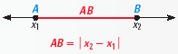
The distance between two points A and B is written a AB. AB is also the length of segment AB.
Between – The middle point of three collinear points
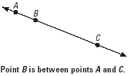

Postulate 1 : Ruler Postulate – Points that lie on a line match up one to one with a real number. Any point can match up with zero.
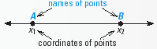
Postulate 2 : Segment Addition Postulate – If B is between A and C, then AB + BC = AC.
If AB + BC = AC, then B is between A and C.
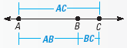

Distance Formula – Computing the distance between two points on a coordinate plane.
Congruent Segments – Segments with the same length.

- Find the length of AB.
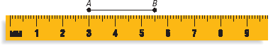
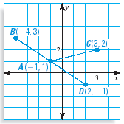
- Find the distance between A and C.
- Find the distance between B and D.
- Find the distance between A and D.
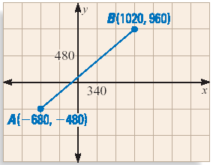
- What is the walking distance between A and B? (Use the horizontal and vertical lines as the streets.)
- If there was a diagonal road between A and B, what would the distance be?

Geometry

Sec. 1.4 Angles and Their Measure
Definitions :
Angle – Two rays that have the same initial point
Sides – Rays of the angle are called the sides
Vertex – The shared initial point is called the vertex
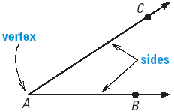
The name of the above angle is ∠CAB, ∠BAC, or ∠A.

Congruent Angles – Angles with the same measure.

Postulate 3 : Protractor Postulate
The sides of the angle can be matched one to one with the degrees on a protractor from 0 to 180.
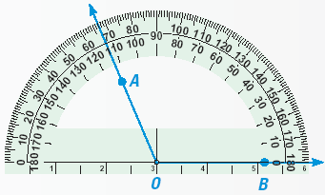
Measure of ∠AOB or ∠BOA or ∠O is |113°-0°| = |113°| = 113°

Interior – Set of points between the sides of the angle.
Exterior – Set of points outside the sides of the angle.
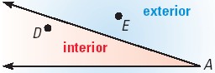

Postulate 4 : Angle Addition Postulate
If P is in the interior of ∠RST, the m∠RSP + m∠PST = m∠RST.
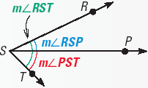

Acute – Angle whose measure is between 0° and 90°.
Obtuse – Angle whose measure is between 90° and 180°.
Right – Angle whose measure is 90°.
Straight – Angle whose measure is 180°.
Adjacent Angles – Two angles that share a vertex and side, but no interior points.
∠RSP and ∠PST are adjacent angles.
∠RST and ∠RSP are not adjacent angles. ∠RST and ∠PST are not adjacent angles.
Examples
- Name the angles in the figure (3 Angles).
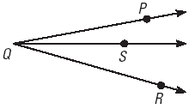
- In ∠RAD AD matches up with 130° and AR matches up with 80° on a protractor, what is m∠RAD?
- In ∠MNP NM matches up with 10° and NP matches up with 153° on a protractor, what is m∠MNP?
- In the figure above, if m∠PQR = 53, m∠PQS = 2x + 10, and m∠RSQ = 3x – 7. Find x, m∠PQS, and m∠RSQ.
On a graph plot the points L(-4,2), M(-1,-1), N(2,2), Q(4,-1), and P(2,-4).
Classify the angles :
- ∠LMN
- ∠MNQ
- ∠PQL

Geometry

Sec. 1.5 Segment and Angle Bisectors
Definitions :
Midpoint – point that divides the segment into two congruent segments
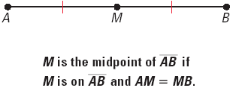

Segment Bisector – line, ray, segment, or plane the intersects a segment at its midpoint

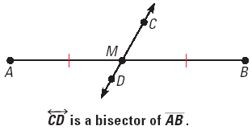

Construction – geometric drawing that uses a limited set of tools

The Midpoint Formula : Average of the x’s and the average of the y’s in coordinate form.
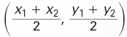
Angle Bisector – a ray that divides an angle into two congruent angles.
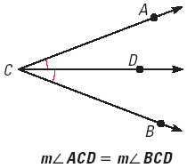

- Find the midpoint between (3, -2) and (-5, -1).
- The midpoint of segment RP is (1, -3). One endpoint is R(-6, 2). What is the coordinate of P?
- The ray GM bisects ∠LGN. m∠LGN = 160. What are the measures of ∠LGM and ∠MGN?
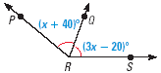
- In the figure above RQ bisects ∠PRS. The measure of the two congruent angles are (x + 40)° and (3x – 20)°. Solve for x.
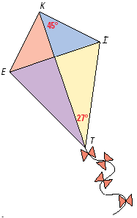
- In the kite above, two angles are bisected.
∠EKI is bisected by KT
∠ETI is bisected by TK
Find the measures of all angles.

Geometry

Sec. 1.6 Angle Pair Relationships
Definitions :
Vertical Angles – two angles that share a vertex and their sides are opposite rays.
Linear Pair – two adjacent angles with non-common sides forming opposite rays.
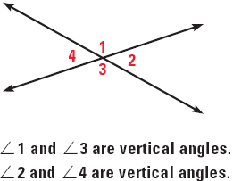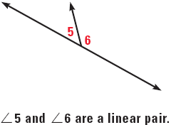

Complementary Angles – two angles whose sum is 90◦
Complement – each angle is a complement of the other.
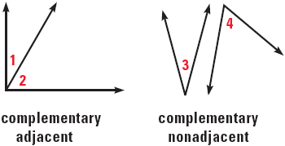

Supplementary Angles – two angles whose sum is 180◦
Supplement – each angle is a supplement of the other.
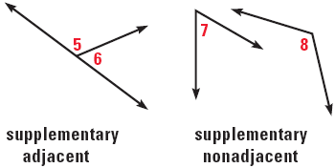
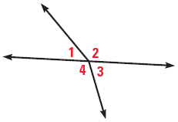
- Are 2 and 3 vertical angles?
- Are 3 and 4 vertical angles?
- Are 1 and 3 vertical angles?
- Are 2 and 4 vertical angles?

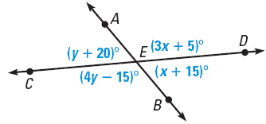
- Solve for x and y. Then find the angle measures.

- State whether the two angles made by the hands of the clocks are complementary, supplementary or neither.

Geometry

Sec. 1.7 Perimeter, Circumference, and Area
Definitions :
Perimeter – distance around a figure
Area – amount of space inside a figure
Circumference – distance around a circle
Base – side perpendicular to the height
Height – distance from a vertex to a point on the base
Radius – distance from the center of the circle to a point on the circle
Diameter – distance from a point on the circle to another point on the circle while going though the center of the circle.
Shapes :
Triangle - P = a + b + c A = ½ bh
Square - P = 4s A = s²
Rectangle - P = 2l + 2w A = lw
Circle - C = 2r or C = d A = r²

