Name: ____________________________________ Block:________________

Chapter 6

Similarity

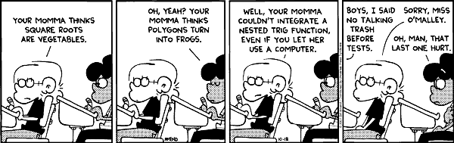

Sections Covered:
6.1 Ratios, Proportions, and Geometric Mean
6.2 Proportions in Geometric Problem Solving
6.3 Similar Polygons
6.4 Prove Triangles Similar by AA
6.5 Prove Triangles Similar by SSS and SAS
6.6 Proportionality Theorems

SOL G.7
The student, given information in the form of a figure or statement, will prove two triangles are similar, using algebraic and coordinate methods as well as deductive proofs.

Unit 5 Syllabus: Ch. 6 Similarity

Block | Date | Topic | Homework
11 | M 12/8  T 12/9 | 6.1 Ratios, Proportions and Geometric Mean  6.2 Use Proportions to Solve Geometry Problems  6.3 Use Similar Polygons | Worksheet 6.2 and 6.3
12 | W 12/10  Th 12/11 | 6.4 Prove Triangles Similar by AA  6.5 Prove Triangles Similar by SSS and SAS | Worksheet 6.4 and 6.5
13 | F 12/12  M 12/15 | 6.6 Use Proportionality Theorems | Worksheet 6.6
14 | T 12/16  W 12/17 | Ch 6 Review | Worksheet Ch 6 Review
15 | Th 12/18  F 12/19 | Ch 6 Quest | Mid-Term Review Packet

***Syllabus subject to change due to weather, pep rallies, illness, etc

Need Help?
Email your teacher to set up a time before or after school!
Peer Tutoring is available through Mu Alpha Theta is Monday, Tuesday, Thursday, and Friday mornings in L403.

Need to make up a test/quiz?
Math Make Up Room is open Tuesday, Thursday, and Friday mornings
and Monday, Wednesday, and Thursday afternoons.

6.1-6.3 Ratios, Proportions and Similar Polygons

____________________________________________

Ratio of a to b ⇒ $\frac{a}{b}$ ⇒ a:b
1 m = 100 cm 12 in = 1 ft
16 oz= 1 lb 3 ft = 1 yd
5, 280 ft = 1 mi
1,760 yd = 1 mi
Simplifying Ratios: ⇒ denominators cannot be zero
- must have the same units
- must be simplified

6. The area of a rectangle is 108 cm². 7. If the measures of the angles in a triangle
The ratio of the width to the length is 3:4. have the ratio of 4:5:6, classify the triangle
Find the length and the width. as right, obtuse or acute.

8. In the diagram, . Find BA and BD.
9. In the diagram, . Find AC.

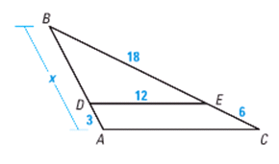

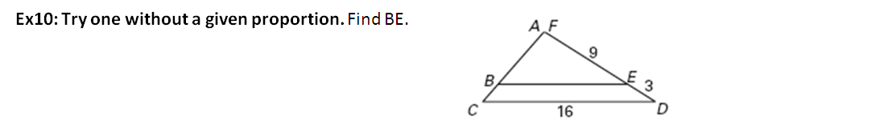

Geometric Mean
The ____________________ of two positive numbers a and b is the positive number x that satisfies:

11. Find the Geometric Mean of:
a. 4 and 9 b. 16 and 18 c. 6 and 20 d. 8 is the geometric mean of 4 and what number?

Notes: 6.2 Use Proportions to Solve Geometry Problems
____________________________________________

Proportion: equation that equates two ratios $\frac{a}{b}=\frac{c}{d}$
Properties:
a. Cross Products b. Reciprocal

c. If $\frac{a}{b}=\frac{c}{d}$, then . d. If $\frac{a}{b}=\frac{c}{d}$, then .

Practice: Complete each statement.

1. If 2. If

3. If 4. If

Decide whether the statement is True or False.

5. If 6. If 7. If

8. If 9. If

Solve for x.

Solve for the variable.

13. MN:MO is 3:4 14. ΔPQR side lengths: ΔSTU side lengths is 1:3
M
N
O
x
9
Q
R
P
5
12
S
x
T
U
36

Use the diagram and the given information to find the unknown length.
15. Given 16. Given

.

Notes: 6.3 Use Similar Polygons
____________________________________________

Similar Polygons: SYMBOL for SIMILAR: ________

Corresponding angles are _____________________________________________

Corresponding sides are _______________________________________________

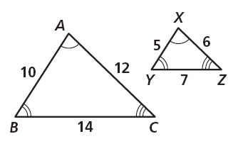
Writing Similarity Statements:
Corresponding <’s:

Proportional Sides:


If 2 polygons are _____________, then the ratio of the lengths of 2 corresponding sides is called the ___________________.

What is the scale factor of ∆ABC to ∆XYZ? ________________
Practice:

1.) If polygon , completing proportions and congruence statements.
Hint: Draw a diagram!!

2.) In the diagram, polygon ABCD ~ GHIJ.
A
B
8
G
H
y

11
11
5.5
x
I
J
8
D
C
x

- Find the scale factor of polygon b. Find the scale factor of polygon
ABCD to polygon GHIJ. GHIJ to polygon ABCD.

- Find the values of x and y. d. Find the perimeter of each polygon.

- Find the ratio to the perimeter of ABCD to perimeter of GHIJ.

If 2 polygons are ___________, then the ratio of their perimeters is equal to the ratios of their ___________.

3.) The ratio of one side of ∆ABC to the corresponding side of similar ∆DEF is 3:5. The perimeter of ∆DEF is 48in. What is the perimeter of ∆ABC?

6.4-6.5: Triangle Similarity

Similar Triangle Postulates:
Postulate: | Example: | Practice with Hidden Tools:
AA:  If two angles of one triangle are congruent to two angles of another triangle, then the two triangles are ___________________ | 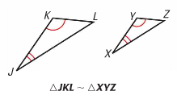 | ∆SVR and ∆UVT  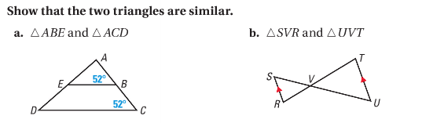
SSS:  If the corresponding side lengths of two triangles are _____________________ then the triangles are similar | 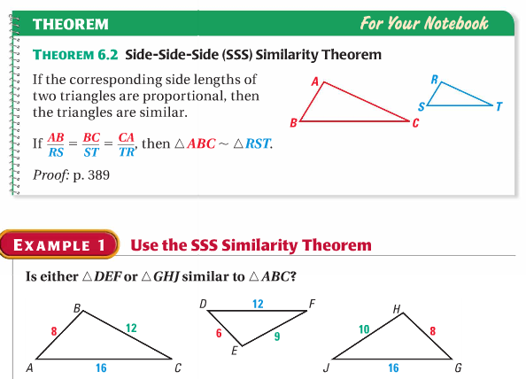 | ∆RQU and ∆SQU
SAS:  If an angle of one triangle is congruent to an angle of a second triangle and the lengths of the sides including these angles are _______________, then the triangles are similar. | 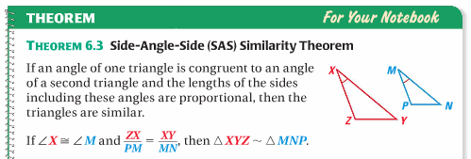 | 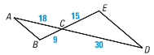  Match order!!

Ex. 1: Practice with AA: Determine if the two triangles are similar by AA.
a. ∆ABE and ∆ACD b. ∆DEC and ∆GHK c. ∆CDE and ∆ BDA
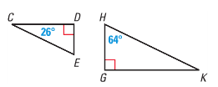

Ex. 2: Practice with SSS: Determine which triangle is similar to ∆ABC by SS. Write a similarity statement and find the scale factor?

Ex. 3: Practice with SAS: Determine if the two triangles are similar by SAS.

a. ∆LNM and ∆JNK b. ∆CDB and ∆CEA

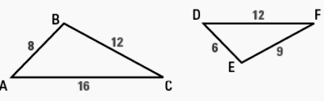
Ex. 4: Mixed Practice: Determine whether the triangles are similar. If they are, state what postulate or theorem you used and write a similarity statement.
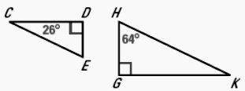
1.) 2.)

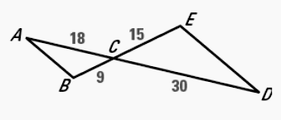

3.)

Show that the two triangles are similar. Write a similarity statement.

4.) ∆ABE and ∆ACD 5.) ∆SVR and ∆UVT
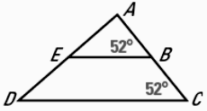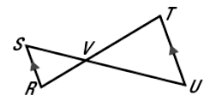

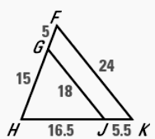
6.) ∆SRT and ∆PNQ 7.) ∆HGJ and ∆HFK
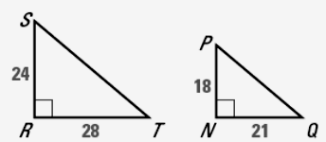

8.) A flagpole casts a shadow that is 50 feet long. At the same time, a woman standing nearby who is five feet four inches tall casts a shadow that is 40 inches long. How tall is the flagpole to the nearest foot?

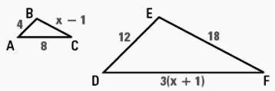
9.) Find the value of x that makes ∆ABC ~∆DEF.

KEY CONCEPT: If 2 triangles are ________________________, then they are _________________________.

As a result, the scale factor will be _________.

Proving Triangles Similar:

Complete the proofs.
1.
Statements
Reasons

Statements
Reasons
2.

3.
Statements
Reasons

4.

6.6: Proportions in Similar Triangles
____________________________________________

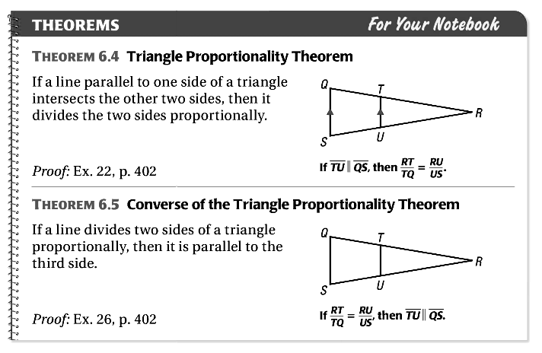
Theorem 6.4: Triangle Proportionality Theorem

If a line parallel to one side of a triangle
intersects the other two sides, then it
divides the two sides proportionally.

Theorem 6.5: Converse of the Triangle Proportionality Theorem
If a line divides two sides of a triangle
proportionally, then it is parallel to the
third side.

Practice Theorems 6.4-6.5:

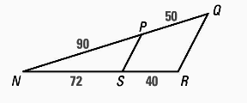
1.) In the diagram, , RS = 4, ST = 6, 2.) Determine whether
and QU = 9. What is the length of ?
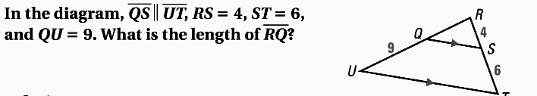
T

On your Own:
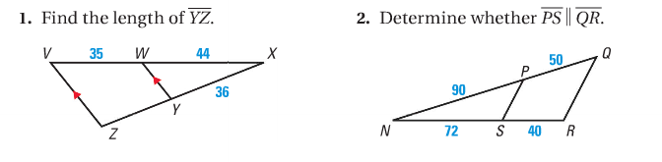
a. Find the length of. b. Determine whether.

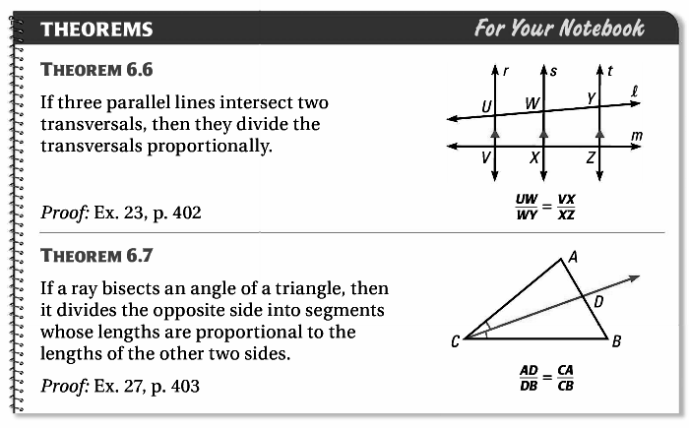
Theorem 6.6

If three parallel lines intersect two transversals,
then they divide the transversals proportionally.

Theorem 6.7

If a ray bisects an angle of a triangle, then it
divides the opposite side into segments whose
lengths are proportional to the lengths of the
other two sides.

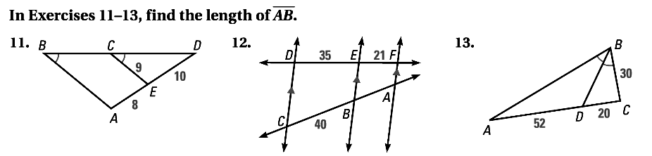
Practice Theorems 6.6-6.7:

3.) Find the length of . 4.) Find the length of .
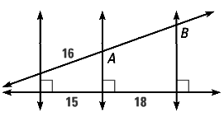

Use the diagrams to find the value of each variable.
5. 6. 7.

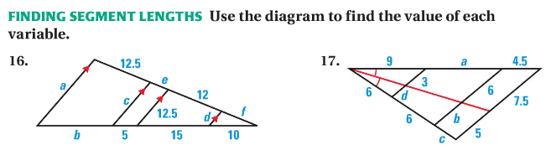
8.

Mixed Practice (Theorems 6.4-6.7)

#9-13: Use the diagram to find the value of each variable.

9.) 10.)

x

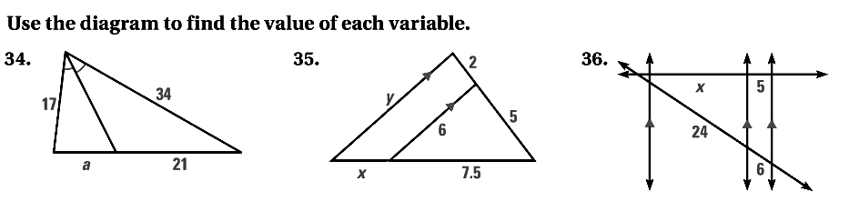
11.) 12.)

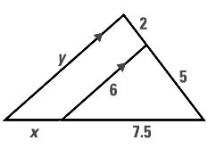
13.)

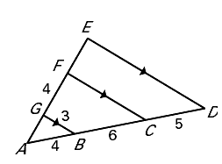
#14-17: Determine the length of each segment.

14.) 15.)

16.) 17.)

