The Use of Regular and Irregular Polyhedra in Architectural Design
Ana-Maria Graur¹, Carmen Mârza², and Georgiana Corsiuc²
1. Faculty of Architecture and Urban Planning, Technical University of Cluj-Napoca, Romania
2. Department of Building Services Engineering, Technical University of Cluj Napoca, Cluj Napoca, Romania

Abstract: With the advent of the computer are dramatically influenced, both the shape and materialization of architecture, and of course the representation in architectural design. New trends, theories and styles appear in the architecture produced by digital. A new language of architectural forms, the so-called free forms, makes its presence felt in the built environment. The relationship between the shape of these free volumes and simple geometric volumes represents an evolution whose result is the change of the architectural paradigm towards a digital architecture. At the base of this new architecture is geometry, with its primary volumes. In this paper we want an inventory of buildings that use irregular and regular polyhedra as geometry. These polyhedral volumes allow modularity and repetitiveness, and this process can be extended to give rise to more complex forms such as free forms. Descriptive geometry must provide basic knowledge about the creation of space, shapes and methods by which they can be represented.

Key words: regular polyhedrons, irregular polyhedrons, architectural design, descriptive geometry, applied geometry

1. Introduction
Over the course of time, from antiquity to the present, the relationship between geometry and architecture has been intensively studied and theorized, but only since the 16th century, starting with architect Andrea Palladio (1508-1580), geometry becomes the basis of all architectural rules and typologies. As well noted by Galileo Galilei (1564-1642), also during that period: [The universe] cannot be read until we have learnt the language and become familiar with the characters in which it is written. It is written in mathematical language, and the letters are triangles, circles and other geometrical figures, without which means it is humanly impossible to comprehend a single word.
Later, in 1784, Étienne-Louis Boulléems (1728-1799), the visionary french neoclassical architect, has developed a distinctive architecture based on pure geometrical forms, characterized by the removal of all unnecessary ornamentation and inflating geometric shapes to a huge scale. At the beginning of the 20th century, the Formalism, as its name suggests, emphasizes the form, and the architect becomes interested in the visual relationship between the parts of the architectural object and the object as a whole. The shape, often on a monumental scale, is the center of attention, which is dominated by rigid geometric lines and shapes. In the same direction, the Bauhaus style and modernism are oriented, which through the visual vocabulary of straight, curved and diagonal lines of Friedrich Wilhelm August Fröbel (1782-1852), were oriented towards a purist image of geometry. A number of common features can be identified from the analysis of these examples: the use of simple and primary geometries, capable of symbolizing by themselves monumentality.
But with the advent of the computer, architecture began to operate with increasingly complex geometries, abandoning traditional Platonic forms in favor of formal complexity. The new technology is dramatically changing our approach to design; it also allows us to work with a vector geometry which marks the end of the rule of the Euclidean geometry. This breaking off involves our conceptual and designing potentials as much as their implementation. We could say that, somehow, this also increases our designing abstraction skills. Increased production, reduced designing costs, improved communication of the executive building choices, and a new conception of the architectural space are just some of the major consequences of the use of new technology in architectural design [1].
In this paper we want to show that complex shapes can be obtained precisely by using simple geometric volumes. Firstly, we will represent through descriptive geometry irregular and regular volumes of polyhedral, and later, we will present some examples of buildings that use these polyhedral as an epicentre in the design of the architectural form. This exercise gives students in architecture faculties a starting point in thinking about the space and the design of the architectural form, helping them to imagine and control the increasingly complex forms of contemporary architecture.
2. Material and Methods
At the beginning of any project there is an idea that materializes by drawing, and the shape catches volume with the help of descriptive geometry by searching for geometric schemes that synthesize the complex form of architecture. The student sees drawing as instrument of conceptual control and communication of the architectural process. Along with drawing, models take a significant place in student practice, the realization of models at small scale and makes them understand better the process. However, at the core of his practice are the drawings, from earliest conception right through the realization of project. To design the architecture under its various forms, a student in architecture needs to know the geometry of these volumes, which can be composed of regular and irregular polyhedral. The main mission of descriptive geometry, as a discipline in architectural education, is the development of three-dimensional thinking, the formation of a precise and logical spatial vision and implicitly the development of strategies for effective solutions to various problems. Once this knowledge is obtained, we can more easily control complex shapes with the help of the computer, in this case Archicad 24 — GRAPHISOFT was used. Practical examples with architectural projects motivate the students to actively participate in the realization of models at small scale and makes them understand better the space and form.
3. Irregular Polyhedrons
Throughout history, architects and builders have sought to perfect the shapes of buildings, but the built environment is mainly composed of primary volumes, polyhedra. A polyhedron is the natural generalization of the polygon from two-dimensional space to three-dimensional space:
It is a region of space whose boundary is composed of a finite number of polygonal surfaces, any two polygonal surfaces are disjoint or have common edges and vertices. The polyhedra can be convex or concave, (Fig. 1). Convex polyhedra are those polyhedra that cannot be sectioned by the planes of their faces.

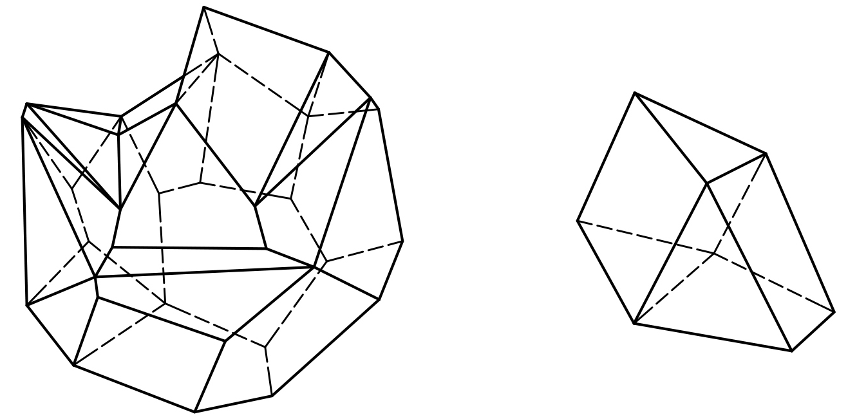
Fig. 1 (a) concave polyhedra, and (b) convex polyhedr.

3.1 The Graphical/Descriptive Representation of the Irregular Polyhedrons
An irregular polyhedron is that polyhedron that does not meet the conditions of the regular one. It is a geometric volume bordered by flat faces, various polygons. His faces can be polygons with a certain number of sides. The sides of these polygons determine the edges of the polyhedron and result from the intersection of two adjacent faces of the polyhedron (Fig. 2). Several edges of a polyhedron are competing in a polyhedron vertex, which is also common for at least three faces of the polyhedron.
3.2 Achievements in the Field of Architecture
In nature we can rarely see order and symmetry, the elements of nature are in a relationship of asymmetry, implicitly, dynamism. Extrapolating we can say that the built environment adapted to nature will approach a complex, asymmetrical volume. It will allow the planimetry a greater freedom, than in the case of using the symmetry. Each architectural volume will be able to develop freely, presenting different images depending on the facade we are looking at. The building is much better adapted to the site where it is located and will be able to respect the requirement of the architectural theme. This image is also presented by Futuroscope, theme park in Poitiers, Poitou-Charentes Region, France, opened on May 31, 1987, which uses as a formal design, the prism (Fig. 3a). Architect Denis Laming led the design of the pavilions, which include buildings shaped like spaceships, crystals formations emerging from the ground, and triangular wedges. What we study are the crystals formations that seem to come out of the site, giving the feeling of a continuous dynamic. Irregular polyhedral surfaces are most often found in the materialization of complex architectural forms due to flat faces (Fig. 3b). One such case is the folded facade that can generate free forms. It has the advantage of generating more visual directions by the different inclination of the various planes, it can be molded on an already existing structure or it can take over the load-bearing structure by its own shape. Folded plate geometries cand take a varieety of patterns, such as saw-tooth or polyhedral facets [2]. As we see multiplication of irregular prismatic volumes can generate a complex architecture.
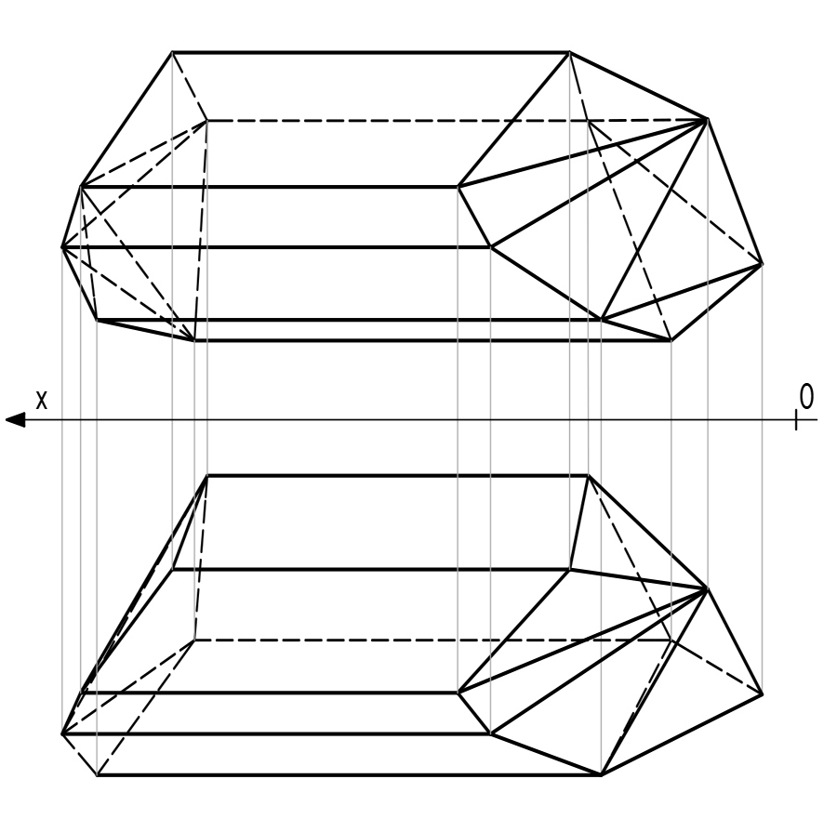
Fig. 2 Irregular polyhedron.

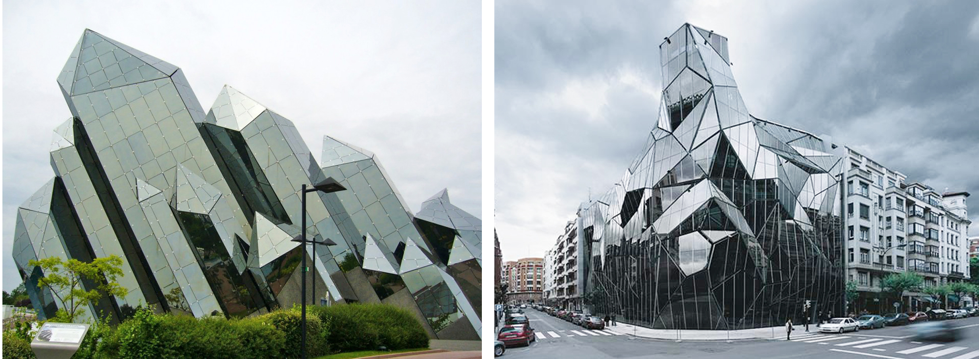
Fig. 3 (a) Futuroscope Theme Park, Poitiers, France, [3], (b)Basque Health Department Headquarters, Bilbao, Spain [4].

4. Regular Polyhedrons
These polyhedra have been studied for hundreds of years. The Greeks made the first attempt to “mathematize harmony”, that is, to express the harmony in numerical and geometric form. In his works, Plato develops the Pythagorean doctrine, especially emphasizing the cosmic significance of harmony. He is firmly convinced that the harmony of the world can be expressed in numerical proportions [5]. The regular polyhedrons (platonic) have the faces formed by regular polygons with the same number of sides, and all dihedral and polyhedral angles are equal. We can say that this concept of regularity is related to the repetition of the chosen geometric elements (equilateral triangle, square, pentagon) that generates a symmetry, both in the geometric figure and in the regular volume. The regular polyhedra are inscribed to a sphere and are circumscribed to a sphere of the same center. In three-dimensional space there are five regular polyhedra (Fig. 4), namely: regular tetrahedron (4 equilateral triangle faces), octahedron (8 faces are equal equilateral triangles), cube or hexahedron (6 equal square faces), icosahedron (20 faces equal equilateral triangles), dodecahedron (12 faces equal pentagons).

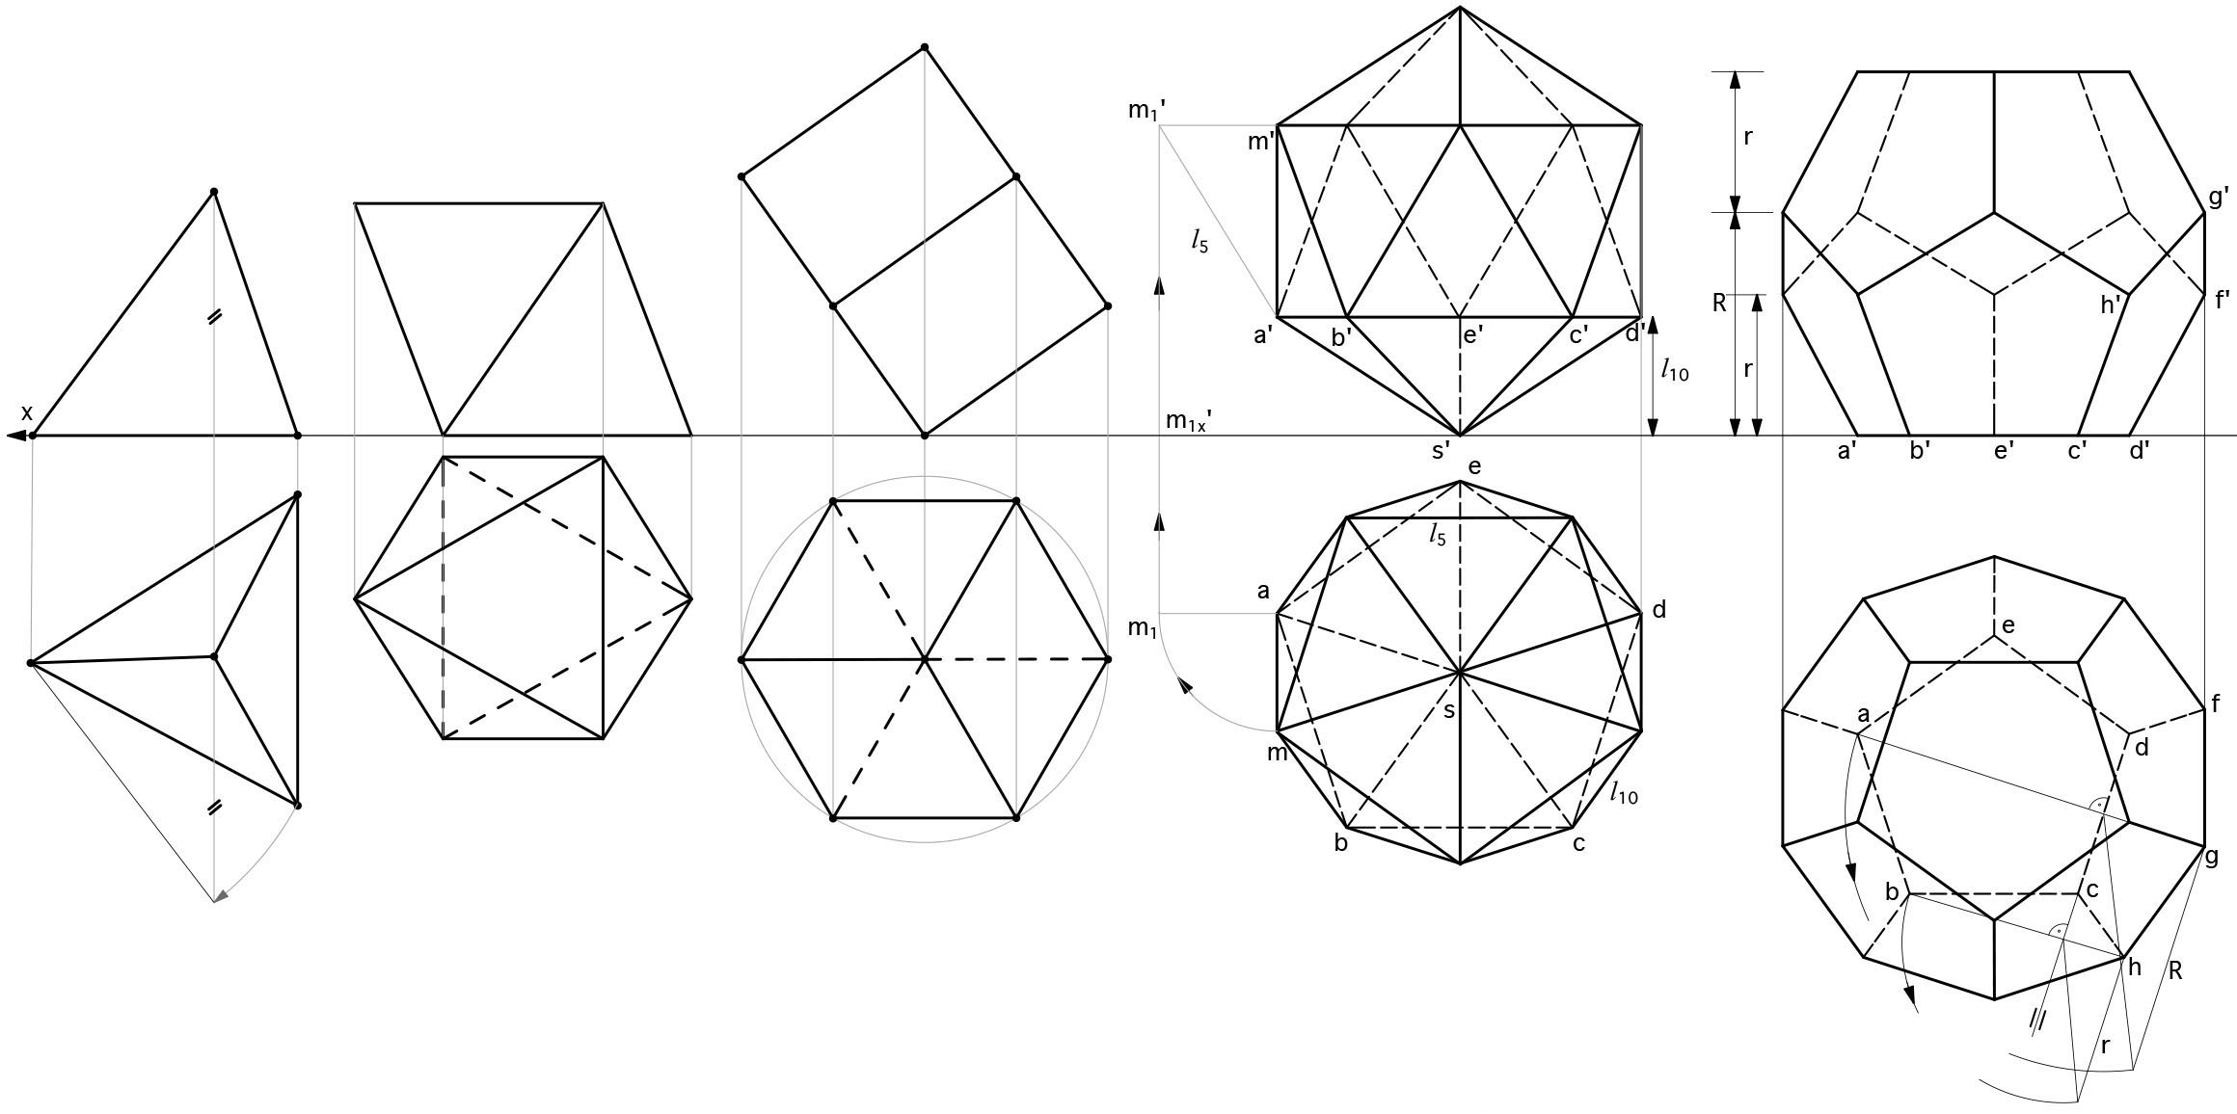
Fig. 4 Platon’s polyhedra - tetrahedron, octahedron, hexahedron, icosahedron and dodecahedron.

This fact is a result of Euler’s theorems as follows: if a convex polygon is divided into a certain number of polygons, then the sum between the faces of the polygons and the number of the vertices exceeds by one unit the number of the sides; in any convex polyhedron the sum between the number of faces and that of the vertices is equal to the number of edges increased by 2; there can be no more than five covex polyhedra having all faces having the same number of sides and all angles polyhedrons having the same number of edges [6]. Regular polyhedra are polyhedra that enjoy the following properties: all faces are equal regular polygons; the vertices are equal solid regular angles; they can be inscribed or circumscribed to spheres with the same center.
4.1 Achievements in the Field of Architecture
The architectural object is unique in relation to nature, more precisely to the site, and in relation to the city, socio-cultural, historical context. In this sense, the architecture uses the same interface language that also describes the physical reality, which it simulates and even more competes with through the organic architecture. But beyond the copying of nature, architecture aims, the other operating language of reality, geometry. When the geometry of regular polyhedra is used, harmony appears in the architecture, symmetry and regularity appear.
4.2.1 The Tetrahedron
Looking at The Great Pyramid of Giza we see a wonder of the ancient world that today still attracts people from all over the world. The pyramid managed to survive the present, defining our attractiveness to this simple and powerful form. Architects continue to design pyramids, in other forms, for example an identical repetitive linear sequence of a tetrahedron structure to generate a bridge. It is the case The Tetrahedron project by Christopher Charles Benninger Architects in 2011, Kolkata, West Bengal, India (Fig. 5a).
The architect invented a system of interconnected tetrahedrons along a line. He eventually called this unique structure The Tetrahedron. The result is a number of geometries within one another, at one level being composed of three parallel and horizontal pipes, forming in section a triangle, with two pipes below a carriageway hung between them for pedestrian movement. The users walk under the third pipe above their heads, and amongst the diagonal pipes forming the tetrahedrons [8].
Finally we see that the triangular polyhedrons are not deformable, and among them the tetrahedron is the only one which can constitute on it own a covering surface [9]. To generate a complex architecture we will use the tetrahedron in a chaotic assembly. In this way we can obtain spaces both inside the tetrahedra and outside them, by joining several tetrahedra (Fig. 5a). We can use this design on office or apartment buildings, which can be developed both horizontally and vertically, multi-storey buildings. Tetrahedron can be used to create a complex spatial surface or envelope resulting from joining according to the (Fig. 5b).

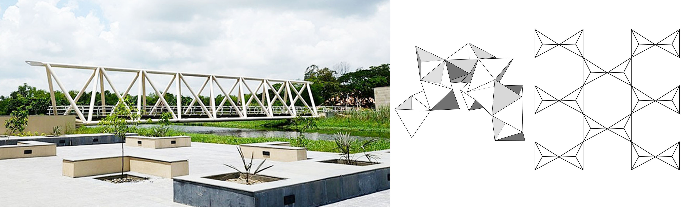
Fig. 5 (a) The tetrahedron, West Bengal, India [7], (b) Multiplication of the tetrahedron.

4.2.2 The Cube
The cube represents an important form in architecture because it is the basis of the geometric principle of forces in a building of most frame type structures. But we want to present a less obvious example of the use of the cube as a form of inspiration in architecture, the Kubuswoningen is located in the Oude Haven, the most historic section of Rotterdam’s port, Netherland, architect Piet Blom, completed in 1984 (Fig. 6a).
Inside, the houses are divided into three levels accessed via a narrow staircase.The lower level is a triangular area used as the living room. The middle level houses the sleeping and bathing area, and the highest level is a spare area used either as a second bedroom or another living area [10].
Such an agglomeration of cubic spaces uses proximity to relate the spaces to each other. There are cellular spaces, repetitive with the same use. Using the cube as a closing surface, by a slight sliding or translating, you obtain tubes that vary in size, and the generated surface constantly surprises. This is also the case of the Serpentine Pavilion 2016 project (Fig. 6b). Bjarke Ingels declares: “we have attempted to design a structure that embodies multiple aspects that are often perceived as opposites: a structure that is free-form yet rigorous, modular yet sculptural, both transparent and opaque, both box and blob” [13]. In this example we are dealing with the principle of reverberation, like an increasing repetition, which has to do with elements similar in shape but different in size, hierarchically graded.
4.2.3 The Octahedron
The architect Christian Norberg-Schulz (1926-2000) said that the purpose of the architecture is to give meaning to a solid and implicit matter, obtaining an identity resulting by uniqueness and identification. One of the projects we will present is an interactive and experimental pavilion made in United States, in 2013 by LMNTechStudio (Fig. 7a). This architectural object attracts the passer-by and invites the Seattle community to interact. The pavilion is clad with over 400 triangular panels. The inner face was the canvas for 54 sets of CNC cut patterns generated as part of a technology training exercise. The outer face was a canvas that addressed the community, with the help of chalk, the passer-by completely transformed the outer surface of the Octahedron [14]. With the multiplication of the octahedron we can obtain a complex shape that incorporates in each octahedron an architectural space
Joining the volumes is done either on one side or on one side of the octahedron. Another approach is to join in a flat spatial network, full or aerated by octahedra, (Fig. 7b). The design of roofs or facades is varied, and different sizes of geometric bodies can be combined.

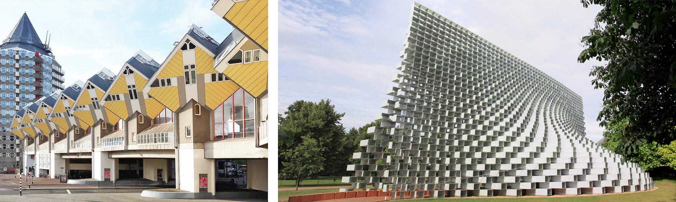
Fig. 6 The Kubuswoningen, Rotterdam, Netherland [11], (b) Serpentine pavilion and summer houses 2016 [12].

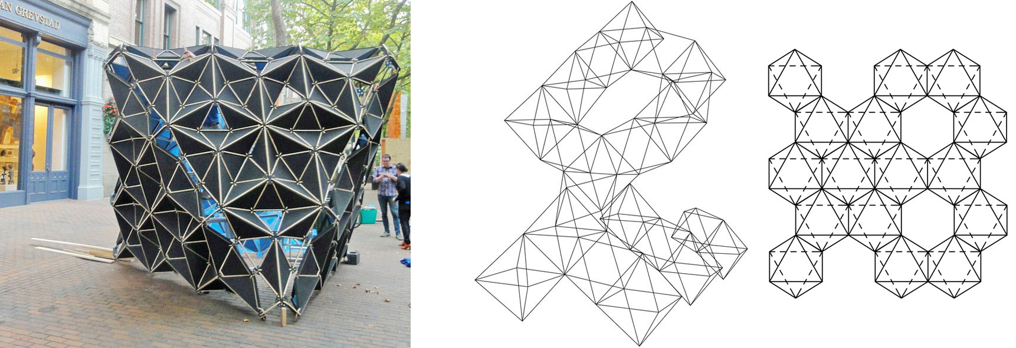
Fig. 7 (a) The Octahedron, Seattle, United States [15], (b) Multiplication of the Octahedron.

4.2.4 The Dodecahedron
Within this section, the dodecahedron, we will present a residential project presented at a competition by the Tammo Prinz architecture office in 2014, Platonian Tower in Lima, Peru. The concept was the introduction of a cube in a dodecahedron to create a unique living space, with the possibility of extension. Obtaining such a module attempts to join them, resulting in a modular tower. The matching flat surfaces fit together perfectly for stacking. The internal cube hosts the interior spaces, while the extruded spaces can be used as additions, exterior living or just open outdoor air. Flexibility in these external sections allows for residents to change or adapt spaces as needed [16]. This repeated and combined module in terms of architectural composition generates harmony, (Fig. 8a). This example deals with the singular geometric volume, but through a repetitiveness of the octahedron we can obtain an image of a complex architecture developed according to the architectural theme. A much more complex configuration can be obtained through a surface defined by the dodecahedron (Fig. 8b).
4.2.5 The Icosahedron
Joseph Mikrut, a graphic designer, lives in Costa Rica and initially thought of building this icosahedron structure on the ground (Fig. 9a)., but he noticed the trees that attracted his attention through the branches of the branches that could sustain through the five branches the vertices of the bottom pentagon, a perfect support point.
Another icosahedron structure is suspended by cables between five Melina trees [19]. These structures are grouped by proximity and have the common feature of the architectural form, the icosahedron. Here monumentality was obtained by capitalizing on only one geometric body, the icosaerd. The way to get an architecture with free forms is, as we noticed before, the repetitiveness. The geometric body has a modularity that allows the association of other icosahedrons and, thus, we extend the building in any direction we want. By using this multiplication of regular polyhedra we can also imagine envelopes that form spatial structures of simple (flat facades) or complex (volumes with a complex geometric design) architectural volumes. A surface that can become a facade can be obtained by joining icosahedrons placed on a face (Fig. 9b). Having no rigid plan, a crowded organization allows flexibility, accepting growth and change without changing its character.

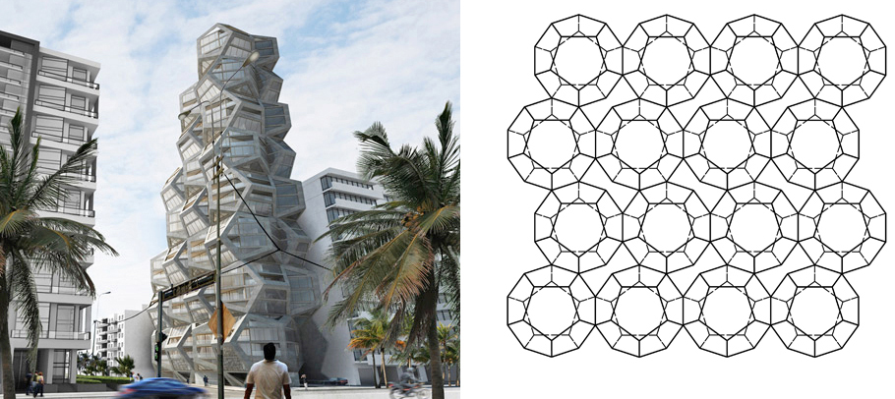
Fig. 8 (a) The Platonian Tower in Lima, Peru,[17] (b) Multiplication of the Dodecahedron.

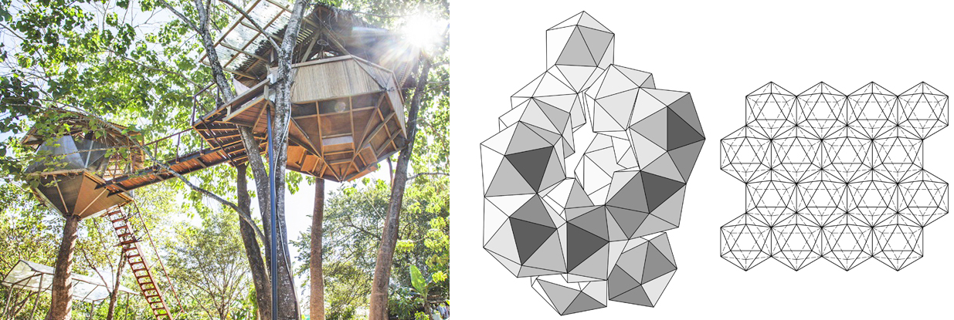
Fig. 9 (a) The Icosahedron Structure, Costa Rica [18], (b) Multiplication of the Icosahedron.

5. Research Directions
Today, the great test of architecture is the implementation of non-standard, non-Euclidean geometries, and especially those of complex sciences (fractals, strange attractors, dissipative systems). The structural efficiency and the expression or form of the building become paramount criteria in the materialization of the architecture. These complex shapes can be materialized from a geometry based on that of polyhedra, in some situations the architecture can be designed in the form of geodesic domes or parts of them, combined with other portions of free surfaces. An important feature of free-form architecture is that it structures a type of fluid space, which simultaneously forms the form, structure and facade.
The approximation of a surface with a polyhedron is more accurate as the polyhedron has smaller edges. Otherwise the two-dimensional equipartition in space lead, as particular cases, to the five regular or Platon’s polyhedra.
To achieve large opening reticular domes, it is necessary to multiply the faces and vertices of these polyhedra, such as to result as many equal edges (struts) and identical solid angles (knodes). This multiplication, which is performed according to certain laws, involve that the polyhedron to follow a sphere through a series of quasi-regular polyhedra having increasingly smaller edges and faces, closer in size to the surface of the sphere or, in generally to the curved surface which supports. The reticular surfaces can be treated as a succession of joined polygons, lying on a surface [20]. We can make an infinite number of polygons that are regular, so that their peaks are located on the circumscribed circle and all their faces reach the inscribed circle.
6. Conclusion
People have always studied nature and found inspiration in everything around them. This imitation finds its answer in the geometry of the construction and in the optimization of the design solution in terms of structural and functional efficiency. Fernand Léger (1881-1955) said “Architecture is not an art, but an organic function. It grows on the ground like animals and plants, it is a function of social order. " This organic function denotes an increase and development of the architectural form, from simple to complex derived from simple geometric solids, polyhedra. In this paper we analyzed several architectural volums and how complex surfaces in descriptive geometry are easy to materialize if they are known under the analytical aspect. Thus, we can extract some features from this analysis: first of all the call in architecture to simple, primary geometries, polyhedra of all types, capable of symbolizing by themselves the monumentality and symmetry in architecture. But in the complex architectural programs that lead to compositions with large proportions, to follow the geometric symmetry becomes a nonsense, due to the proportions it would be difficult to observe the symmetry visually. Thus, in the second variant one resorted to complex geometries using the multiplication of the same geometric volume or combined with other geometric volumes resulting in complexity, dynamism, growth, asymmetry. The possibility to multiply polyhedra in order to obtain free forms in architecture offers flexibility and can directly meet the requirements of the place, the site, becomes a spontaneous, more interesting, more natural architecture and allows in the future a possible expansion/extension of space, but without changing the original character of the architecture.
References
- P. Fiamma, Architectural design and digital paradigm: From renaissance models to digital architecture, Crossroads of Digital Discourse: Proceedings of the 2003 Annual Conference of the Association for Computer Aided Design in Architecture, Indianapolis (Indiana), 2003, pp. 247-253.
- C. Hachem-Vermette, Solar Buildings and Neighborhoods: Design Considerations for High Energy Performance, Springer, Calgary, Canada, 2020, p. 149.
- Futuroscope Theme Park, Poitiers, France, available online at: https://europevideoproductions.com/france-travel- photos /futuroscope-theme-park-poitiers-vienne-france/.
- Basque Health Department Headquarters, Bilbao, Spain, available online at: https://www.archdaily.com/7093 /basque-health-department-headquarters-in-bilbao-coll-barreu-arquitectos.
- A. Stakhov, The mathematics of harmony. proclus’ hypothesis and new view on euclid’s elements and history of mathematics starting since euclid, Applied Mathematics 5 (2014) 3335-3352.
- A. Tănăsescu, Descriptive geometry. Perspective. Axonometry, Didactic and Pedagogical Publishing House, Bucharest, 1975, pp. 115-121.
- The Tetrahedron, West Bengal, India, available online at: https://worldarchitecture.org/cdnimgfiles/extuploadc/2-11-.jpg.
- TETRAHEDRON, 2014, available online at: https://worldarchitecture.org/architecture-projects/hzhfn/the_tetrahedron_new_steel_bridge_at_the_indian_institute_of_management_calcutta-project-pages.html.
- G. Ankerl, Experimental Sociology of Architecture: A Guide to Theory, Research, and Literature, The Hague: Mouton, 1981, p. 195.
- Available online at: https://allthatsinteresting.com/cubic- houses-rotterdam.
- The Kubuswoningen, Rotterdam, Netherland, available online at: https://steemit.com/architecturalphotography /@jarosalawszafran/travel-to-the-netherlands-rotterdam-3-the-cube-houses-8-photos.
- Serpentine Pavilion and Summer Houses 2016, available online at: https://archello.com/project/serpentine- pavilion-2016.
- CUBE, 2016, available online at: https://archello.com/project/serpentine-pavilion-2016
- OCTAHEDRON, 2013, available online at: https://architizer.com/projects/the-octahedron-1/
- The Octahedron, Seattle, United States, available online at: https://www.arch2o.com/the-octahedron-lmntechstudio/2013
- DODECAHEDRON, 2014, available online at: https://www.archdaily.com/500635/tammo-prinz-architects-propose-platonian-tower-in-lima.
- The Platonian Tower in Lima, Peru, 2014, available online at: https://www.archdaily.com/500635/tammo-prinz- architects-propose-platonian-tower-in-lima.
- The Icosahedron Structure, Costa Rica, 2015 available online at: http://www.hometreehome.it/icosahedron- treehouse/.
- ICOSAHEDRON, 2015 available online at: http://www.hometreehome.it/icosahedron-treehouse/.
- C. Marza, G. Corsiuc and A. M. Graur, Applying the theory of the plane in the civil engineering field, JIDEG 12 (2017) (1) 59-64.

 Corresponding author: Ana-Maria Graur, Ph.D., Lecturer; research area: architecture. E-mail: anamaria.graur@arch.utcluj.ro.

