SUMMER REVIEW PACKET OF ALGEBRA SKILLS
FOR ALL STUDENTS TAKING GEOMETRY

COMPLETE ALL PROBLEMS IN THIS PACKET
WRITE ANSWERS ON ANSWER SHEETS PROVIDED
BE PREPARED TO TURN IN YOUR WORK AND TAKE A QUIZ ON THE SKILLS INCLUDED IN THIS PACKET WHEN YOU RETURN TO SCHOOL IN AUGUST!!!!
2012

Dear Geometry Student,

The math department at Linglestown Middle School wants you to be a successful student. We also want you to be able to score proficient or advanced on the PSSA tests. This summer packet was put together for you to help reach this level of success in your mathematics career.

This packet is a review of the skills that you should have mastered prior to taking the Geometry course that you have signed up for. Please take time this summer to look over the packet and complete ALL of the problems included. If you need additional help with any of the concepts you can go to Glencoe.com for additional examples and information. Please show all of your work either in the packet or one a separate sheet of paper and write ALL of your answers neatly on the answer sheets provided for you at the back of the packet. We have also included an additional list of helpful websites at the bottom of this page that could give you additional help.

When you return in August, your teacher will be collecting your answer sheets for a grade. You will have the opportunity to ask questions to review any concepts that you were unable to complete on your own over the summer. Math Help will also be available the first week of school if you request the additional help. At the end of the first week of school you will be given a quiz on the prerequisite skills that is in this packet to see if you are ready for Geometry. The results of that quiz will be given to both you and your parents to ensure that you are properly placed. It is up to you to work on this packet during the summer to make sure you have the necessary skills mastered in order to be successful in Geometry, we look forward to seeing you in Geometry in the fall.

We hope that you have an enjoyable summer and return to school ready to be successful in Geometry.

See you in August!

Sincerely,
The Math Department at Linglestown Middle School

Helpful Websites
www.glencoe.com
www.regentsprep.org
www.purplemath.com/modules
www.Aleks.com (this is a website where you can subscribe for individual math lessons)
www.khanacademy.org

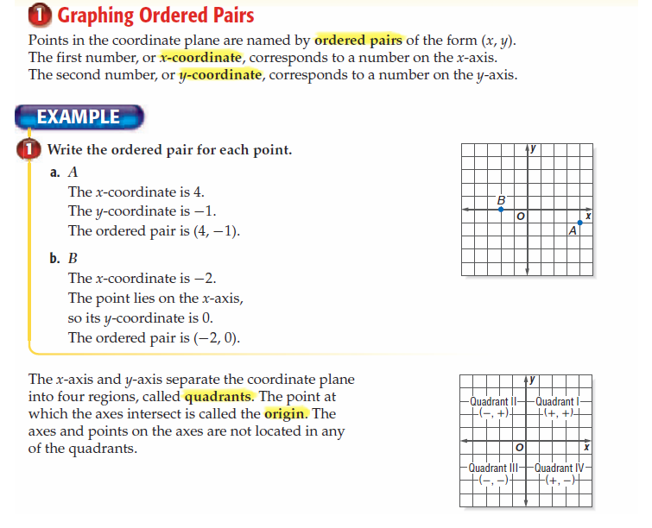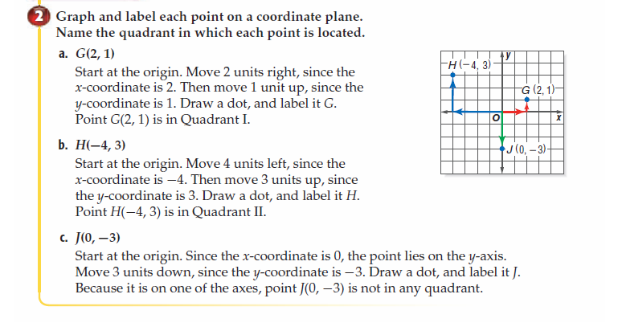

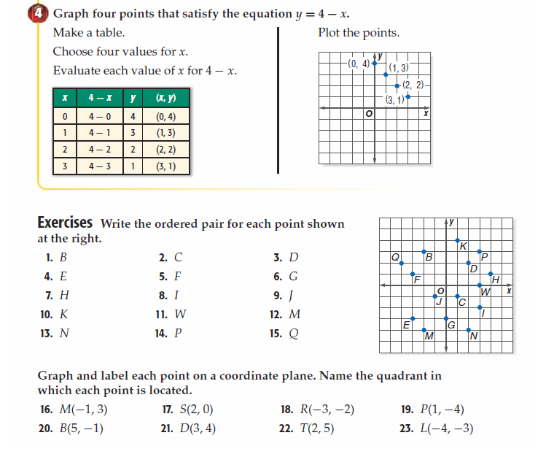
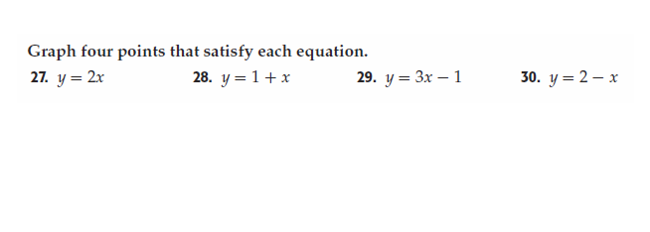

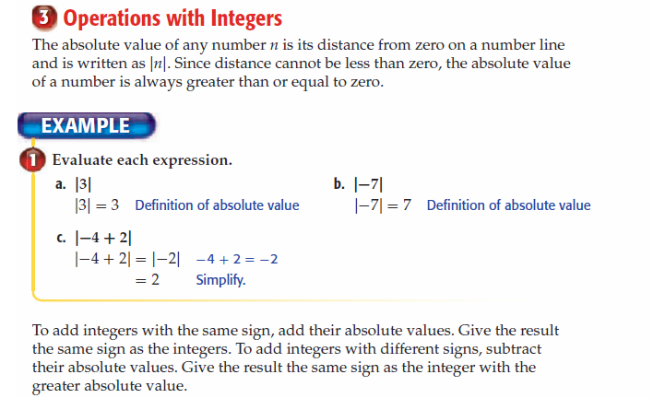
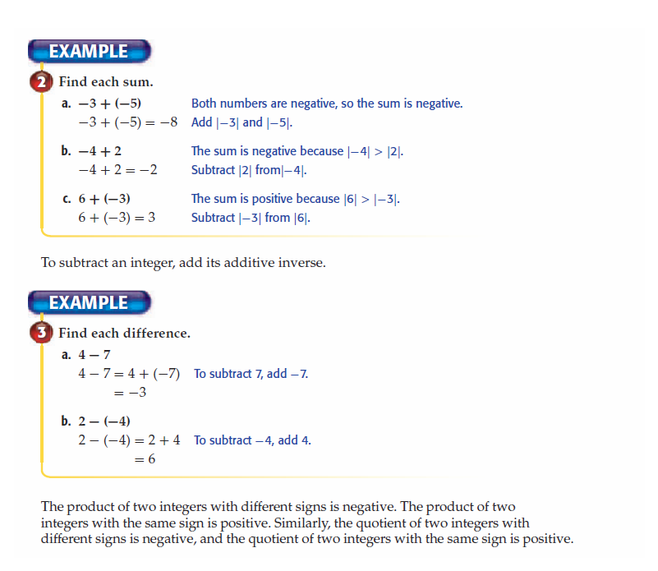
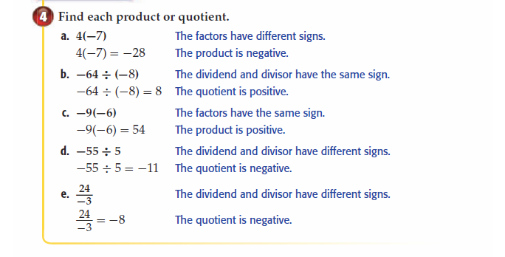
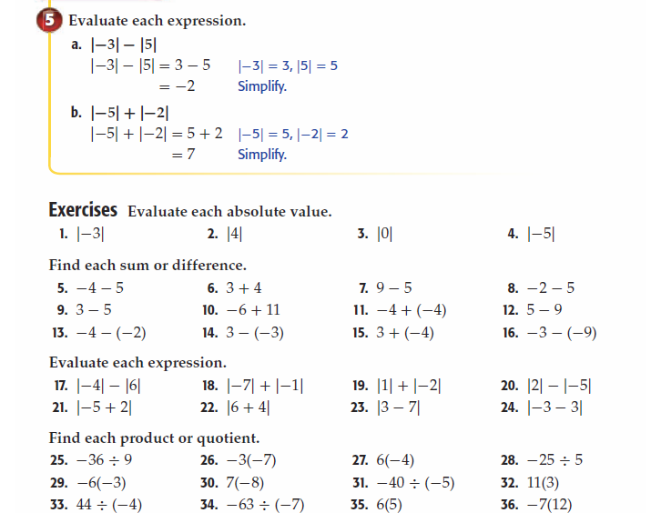

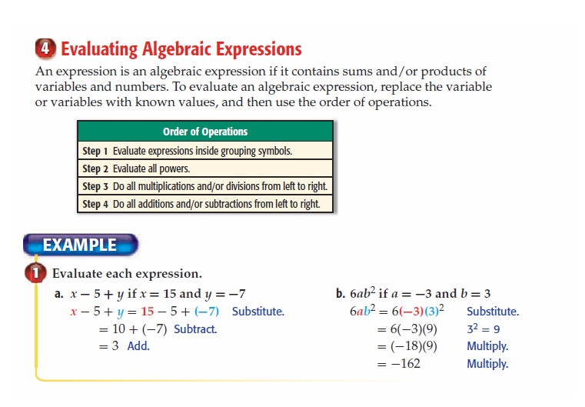
PEMDAS
1st - Parentheses
2nd - Exponents
3rd - Multiplication/Division
4th -Addition/Subtraction
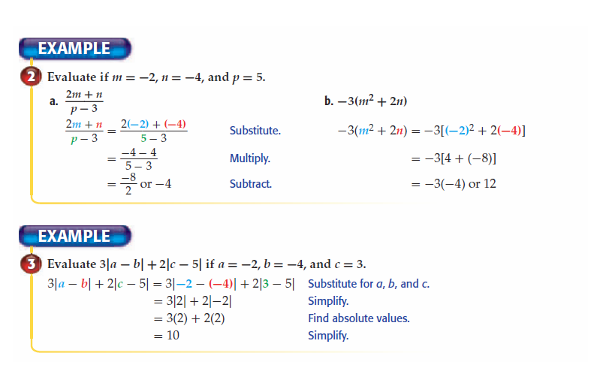
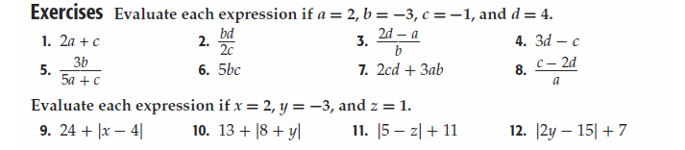
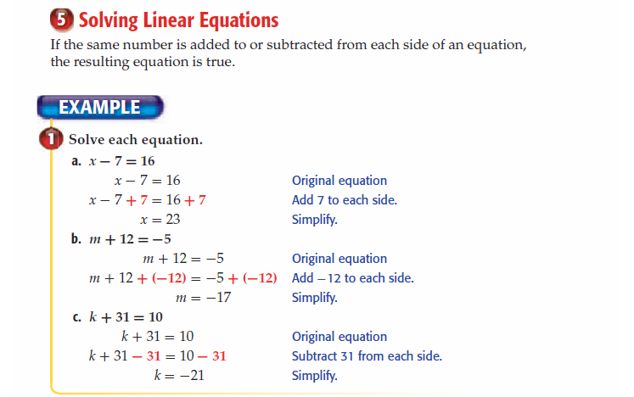
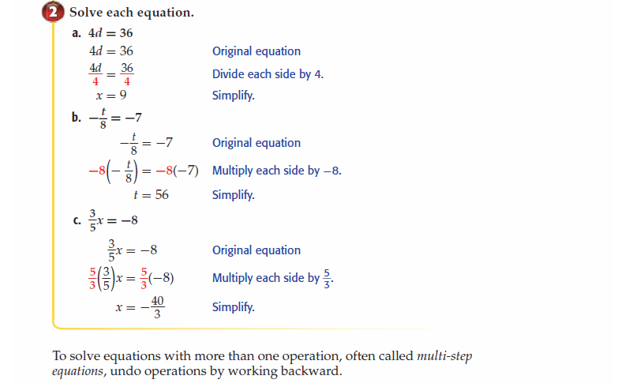

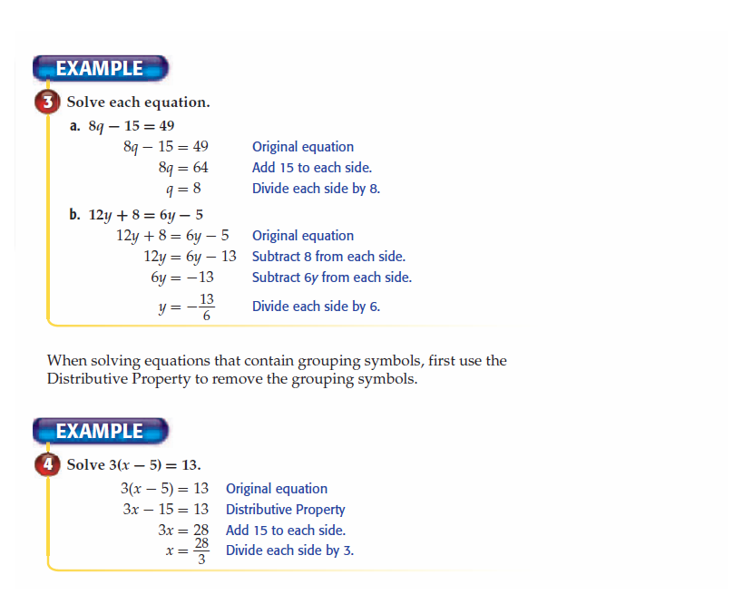
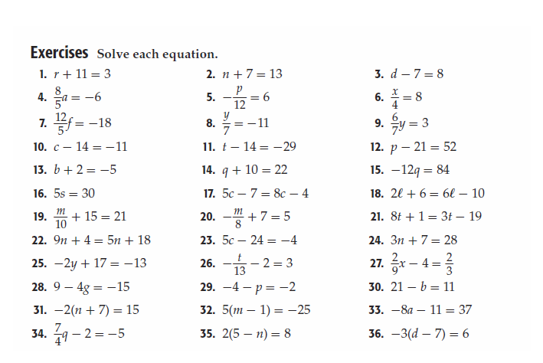

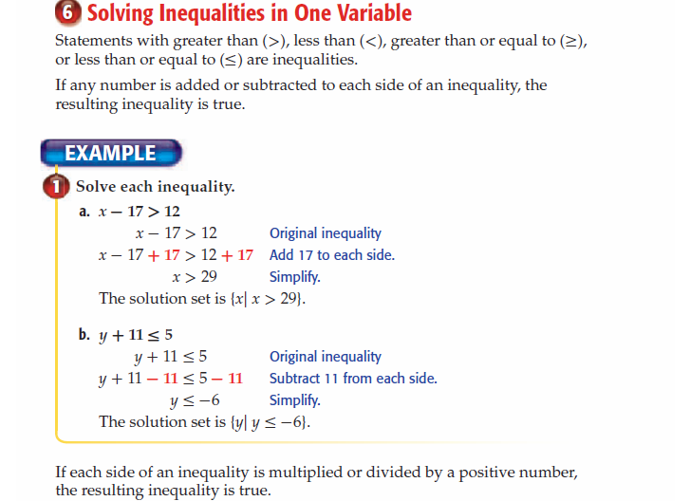
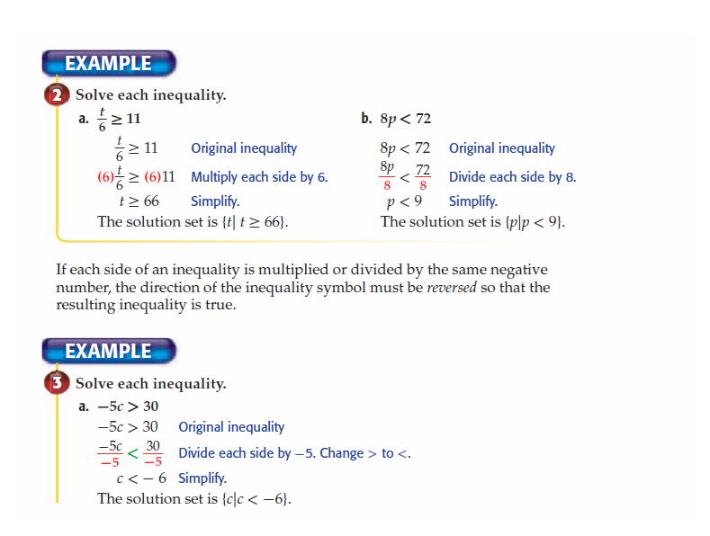

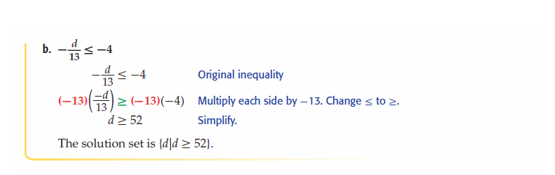
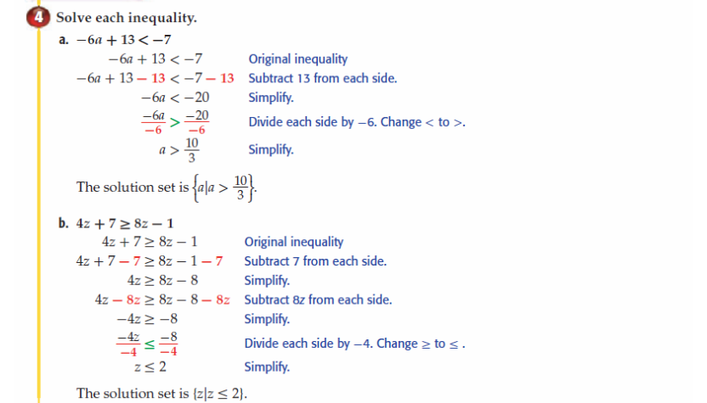

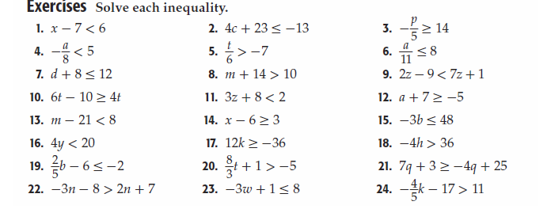

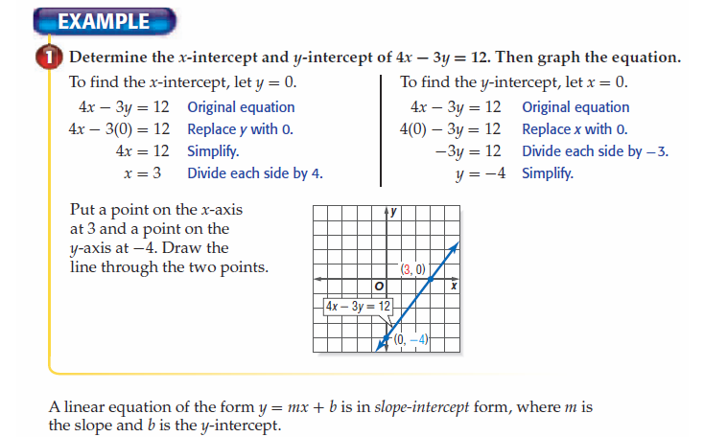

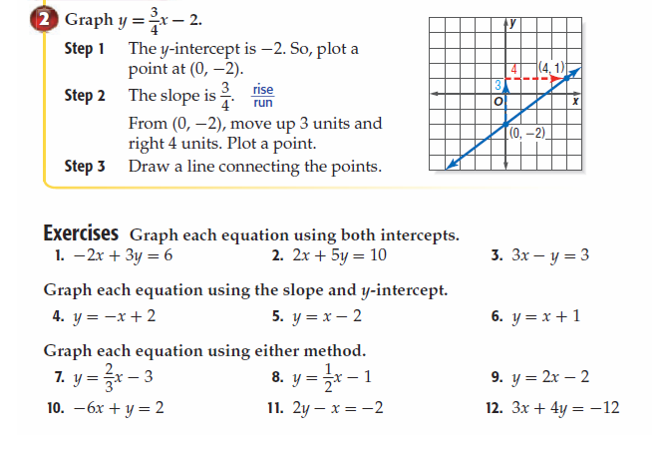

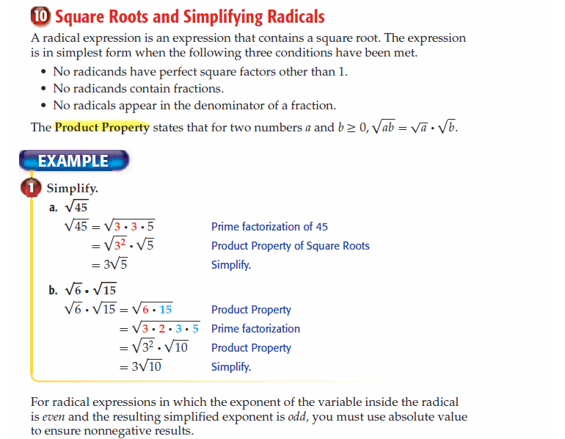
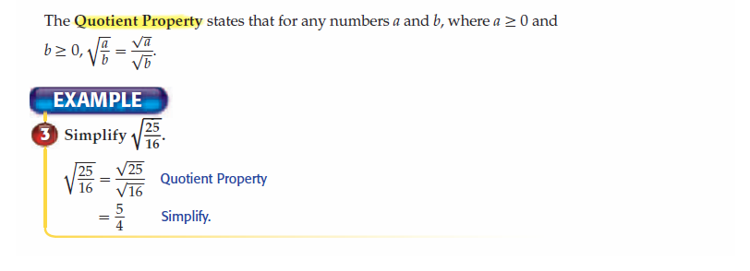
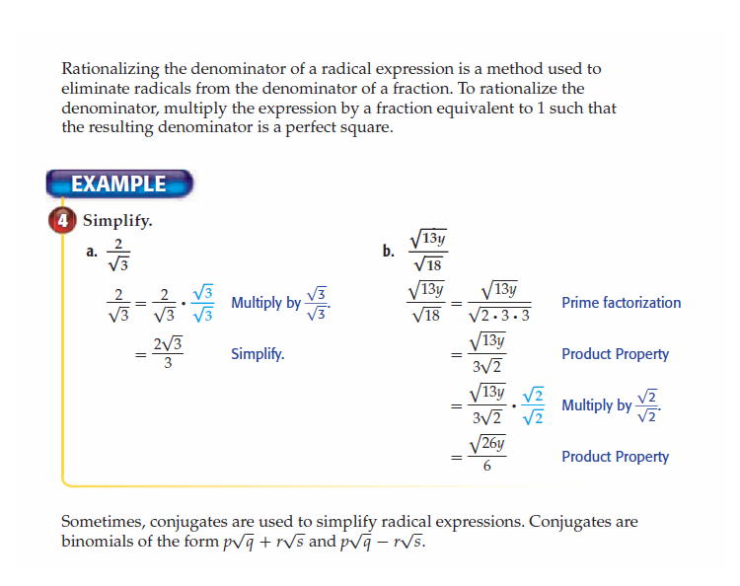
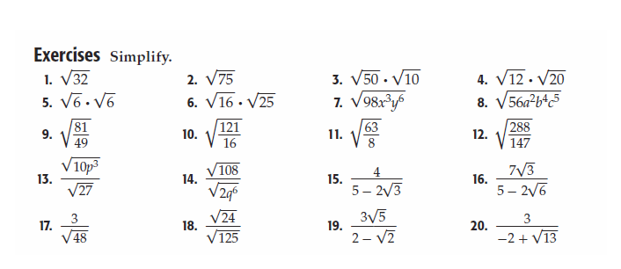

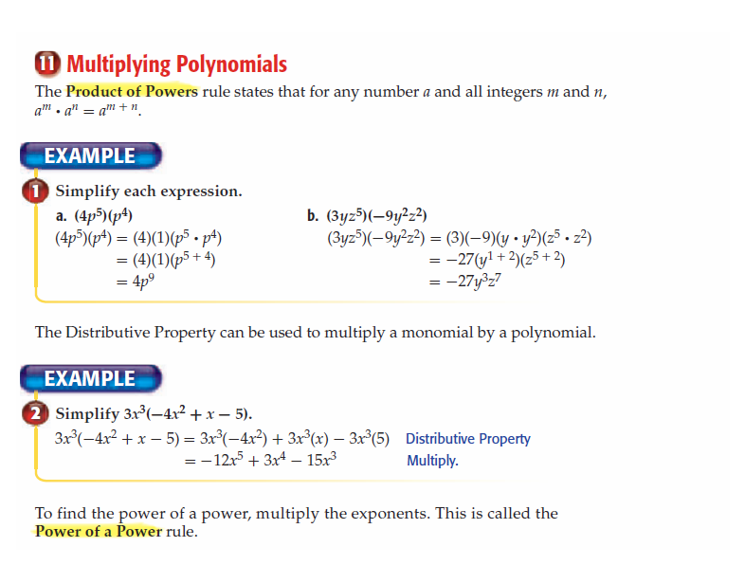
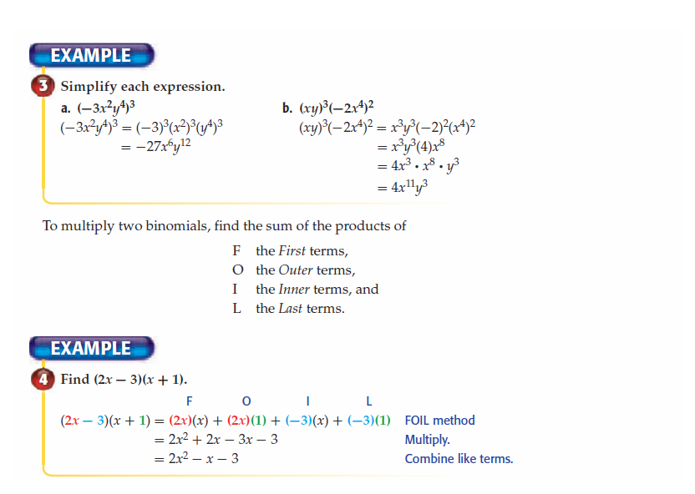
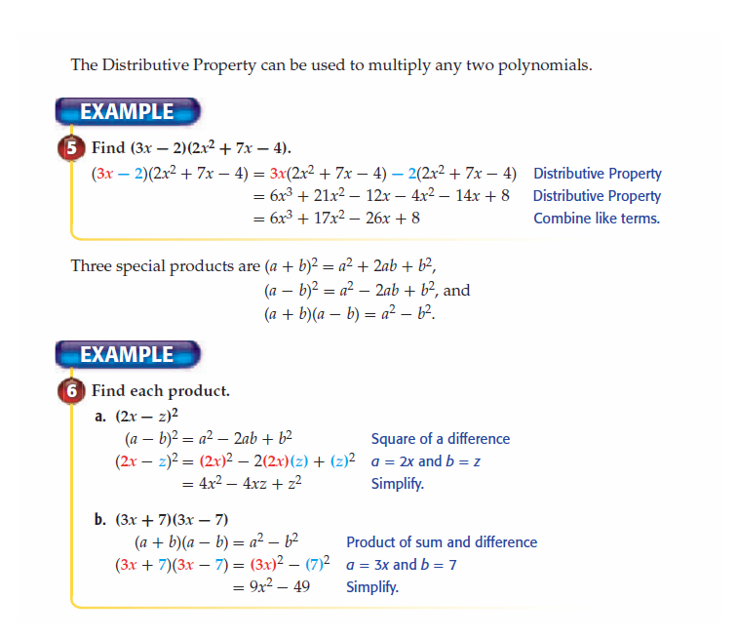
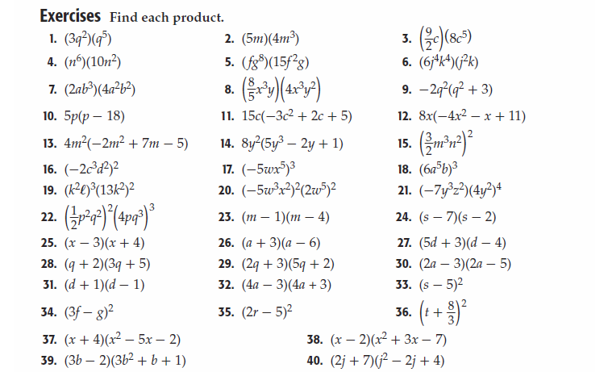

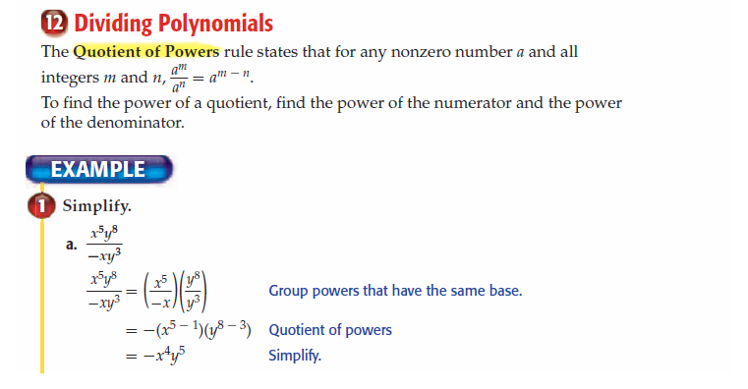
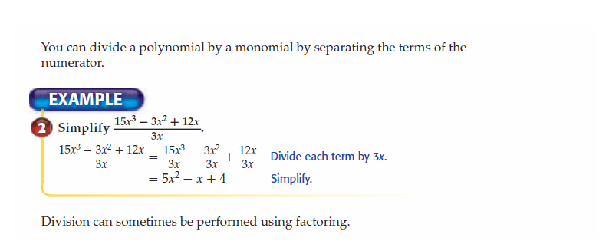
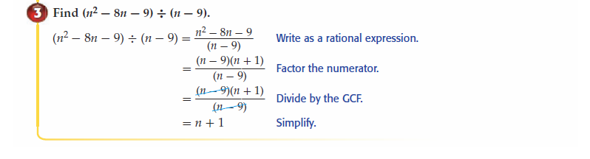

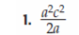 | 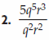 | 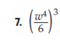 | 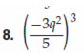
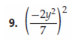 | 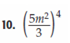 | 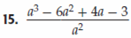 | 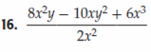

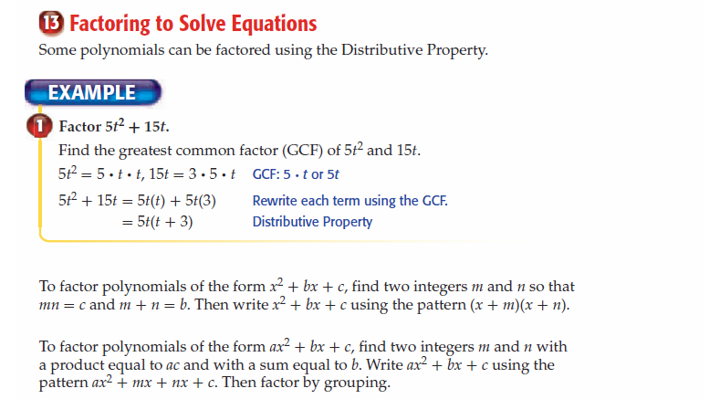
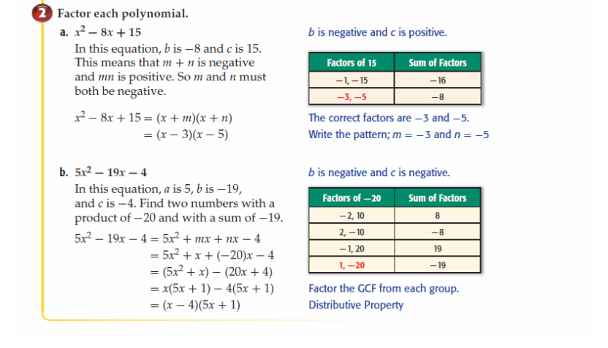
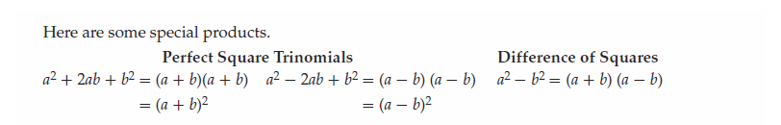

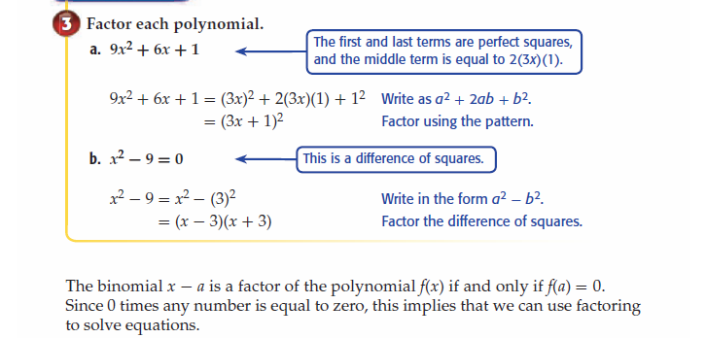

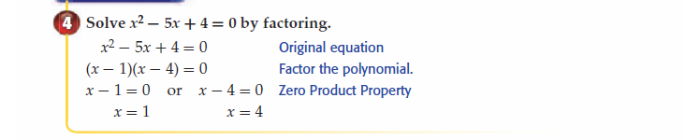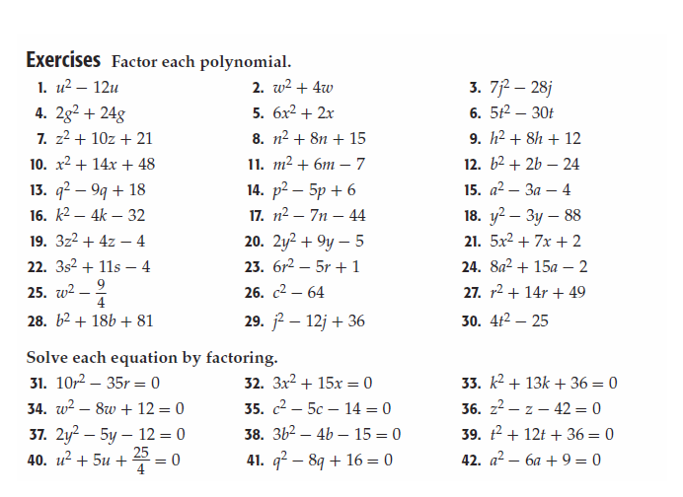

Geometry CP Summer Packet Name:_______________________
Answer Sheet Teacher:_____________________

Skill #1 Graphing Ordered Pairs

1.__________  2.__________  3.__________  4.__________  5.__________  6.__________  7.__________  8.__________  9.__________  10.__________  11.__________  12.__________  13.__________  14.__________  15.__________ | 18.  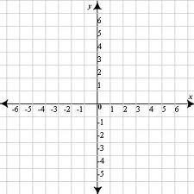
16  . | 19.
17. | 20.
21. | 28.
22. | 29.
23. | 30.
27.
Skill # 2 Operations With Integers | Skill #4 Solving Linear Equations
1.__________  2.__________  3.__________  4.__________  5.__________  6.__________  7.__________  8.__________  13. __________  14. __________  15. __________  16. __________  17. __________  18. __________  19. __________  20. __________  21. __________  22. __________  23. __________  24. __________  25. __________  26. __________  27. __________  28. __________  33. __________  34. __________  35. __________  36. __________ | 4.__________  5.__________  6.__________  10.__________  11.__________  12.__________  16.__________  17.__________  18. __________  22. __________  23. __________  24. __________  28. __________  29. __________  30. __________  34. __________  35. __________  36. __________
Skill #3 Evaluating Algebraic Expressions  2. __________  3. __________  5. __________  8. __________  9. __________  10. __________  11. __________  12. __________ | Skill # 5 Solving Inequalities  4.__________  5.__________  6.__________  10.__________  11.__________  12.__________  16.__________  17.__________  18. __________  22. __________  23. __________  24. __________
Skill #6 Graphing Lines
1. | 7.
3. | 9.
4. | 10.
6. | 12.
Skill #7 Simplifying Radicals
1.__________
2.__________
3.__________
5.__________
6.__________
7.__________
9.__________
10.__________
11. __________
27. __________
18. __________

Skill #8 Multiplying Polynomials  1.__________  2.__________  3.__________  7.__________  8.__________  9.__________  13.__________  14.__________  15. __________  19.__________  20.__________  21.__________  25.__________  26.__________  27.__________  31.__________  32.__________  33.__________  37.__________  38.__________  39.__________  40.__________ | Skill #10 Factoring  1.__________  2.__________  3.__________  7.__________  8.__________  9.__________  13.__________  14.__________  15 __________  19 __________  20. __________  21.__________  25.__________  26.__________  27.__________  31.__________  32.__________  33.__________  37.__________  38.__________  39.__________
Skill #9 Dividing Polynomials
1.__________
2.__________
7__________
8__________
9.________
10_________
11._______
12._______
13. __________
14. __________
15. __________
16. __________

