Valence Shell Electron Pair Repulsion Theory (VSEPR) POGIL
Read This!
Why Should I Care About Molecular Geometry?
The valence shell electron pair repulsion (VSEPR) theory was developed as a way to predict molecular geometries based on Lewis electron dot diagrams. The molecular geometry of a molecule influences its physical properties, chemical properties, and biological properties. Molecular geometry is associated with the chemistry of vision, smell and odors, taste, drug reactions and enzyme controlled reactions. As you learned in Honors Biology, most enzymes will react with molecules possessing only a certain, specific shape. Small, sometimes seemingly trivial, changes in a molecule may prevent it from interacting with the enzyme. The shapes of substances can have a significant impact on their reactions and on their physical properties. For example: Pentane and 2,2-Dimehylpropane both have the same chemical formulas, but different shapes, and different boiling points.
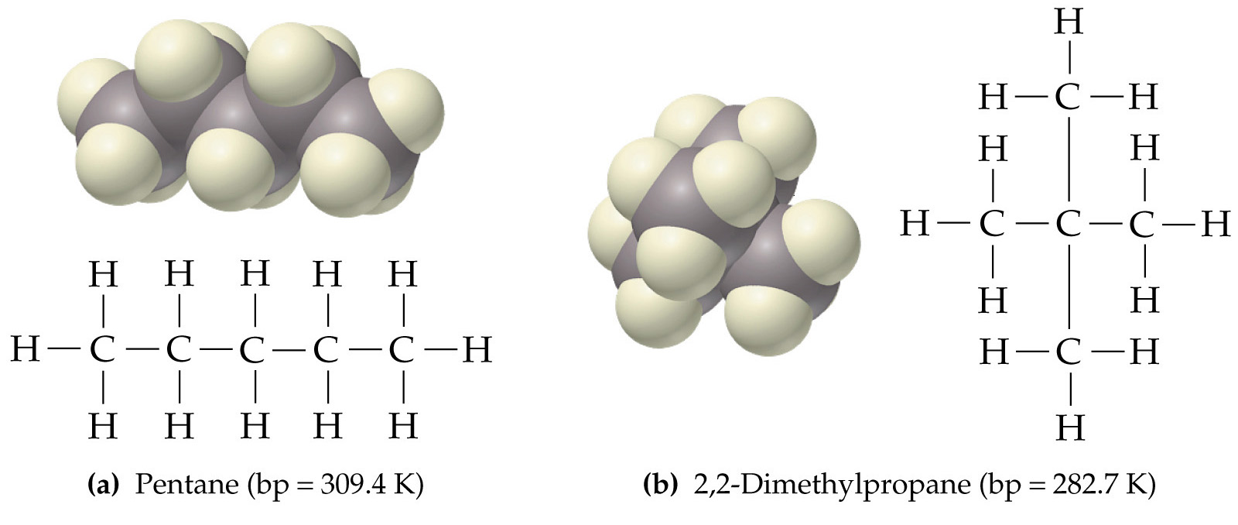
LEWIS STRUCTURE: | VSEPR STRUCTURE: | GEOMETRY: | STRUCTURE
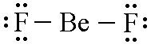 | 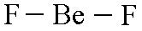 | LINEAR | 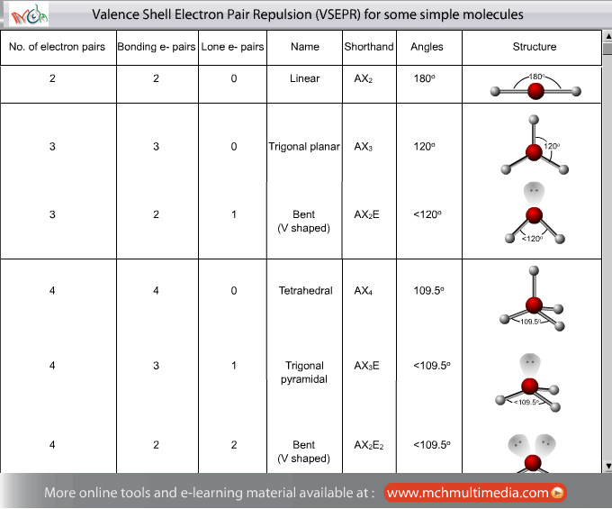
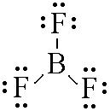 | 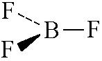 | TRIGONAL PLANAR
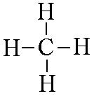 | 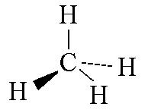 | TETRAHEDRAL
Model I

- Refer to the chart in Model I, do each of these molecules have a central compound? If yes, what are they?

- Based on the geometry and structure which two molecules would you expect to be two dimensional rather than 3 dimensional?

- Why would these molecules have 2-D molecular shapes?

- Look carefully at the Lewis Dot diagram for BF_{3.} What do you notice about the number of

Valence Shell Electron Pair Repulsion (VSEPR) theory allows the Chemist to predict the 3-dimensional shape of molecules from knowledge of their Lewis Dot structure. The basic principle of the VSEPR theory is that electrons repel one another because of their like (negative) charges. The shapes of covalently bonded molecules can be determined by the repulsion of electrons (either bonding or nonbonding). This theory offers the simplest means available to account for (or to predict) the structures of molecules and ions, which can be divided into two categories. These categories include species in which: only bonding electrons surround the central atom or, the central atom is surrounded by both bonding and nonbonding electrons. In VSEPR theory, the position of bound atoms and electron pairs are described relative to a central atom. The VSEPR theory assumes that each atom in a molecule will achieve a geometry that minimizes the repulsion between electrons in the valence shell of that atom. For example, there are only two places in the valence shell of the central atom in CO₂ where electrons can be found. Repulsion between these pairs of electrons can be minimized by arranging them so that they point in opposite directions. Thus, the VSEPR theory predicts that CO₂ should be a linear molecule, with a 180⁰ angle between the two C - O double bonds. The shape can be predicted by determining the AXE formula, whereby A= central atom, X= the number compounds attached to the central atom, and E= the number of lone pairs on the central atom. In this example, the AXE formula would be AX₂: A for the C; X₂ for the 2 Os; and there is no E because there are no lone pair electrons on the central atom.

- Refer to the above diagram of CO₂, if A represents the central atom Carbon, what does X represent, and what is its numerical value?

- Are there any lone pair electrons on the central atom, C, in CO₂?

- What should the AXE formula be for CO₂?

- Review the chart in Model I, what would the AXE formulas be for BeF₂, BF₃, CH₄?

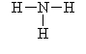
- Refer to the Lewis dot structure for NH_{3.} What is the AXE formula?


Your group will check your answers with the instructor before moving on.
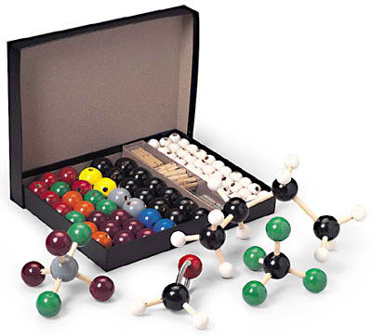

Model II
Building 3-D molecular molecules

Read This!
Open at your container of atoms carefully to ensure you do not lose any of them. It is your responsibility to keep track of each of the parts in your kit and return them to the container when you are finished. Utilize the container to prevent the pieces from dropping on the floor. Do not take piece from another container. Notify your instructor if you are missing a piece.
The colors will represent different atoms in different molecules. However, because we want to show lone pairs we cannot use the same ball color for every time for each atom:
As a general rule, you will use Black for central atoms.

Don’t panic, you will be instructed as to what to use

- Examine the Nitrogen (blue), Carbon (black) and Hydrogen (white) atoms, why do you think the holes are drilled where they are and differ from atom to atom.

- What part of your kit may be used to represent single bonds? Double bonds?

Read This!
Each of the colored balls represents a different atom. Note the number and position of the
holes in each atom. These place their intentionally to enable you to create, for example, the
following molecular shapes:

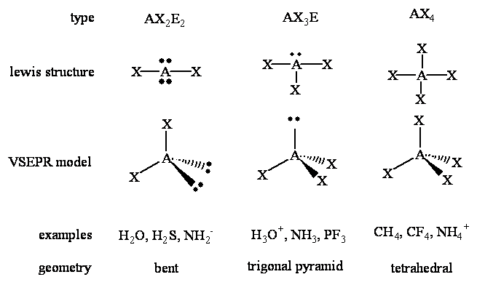
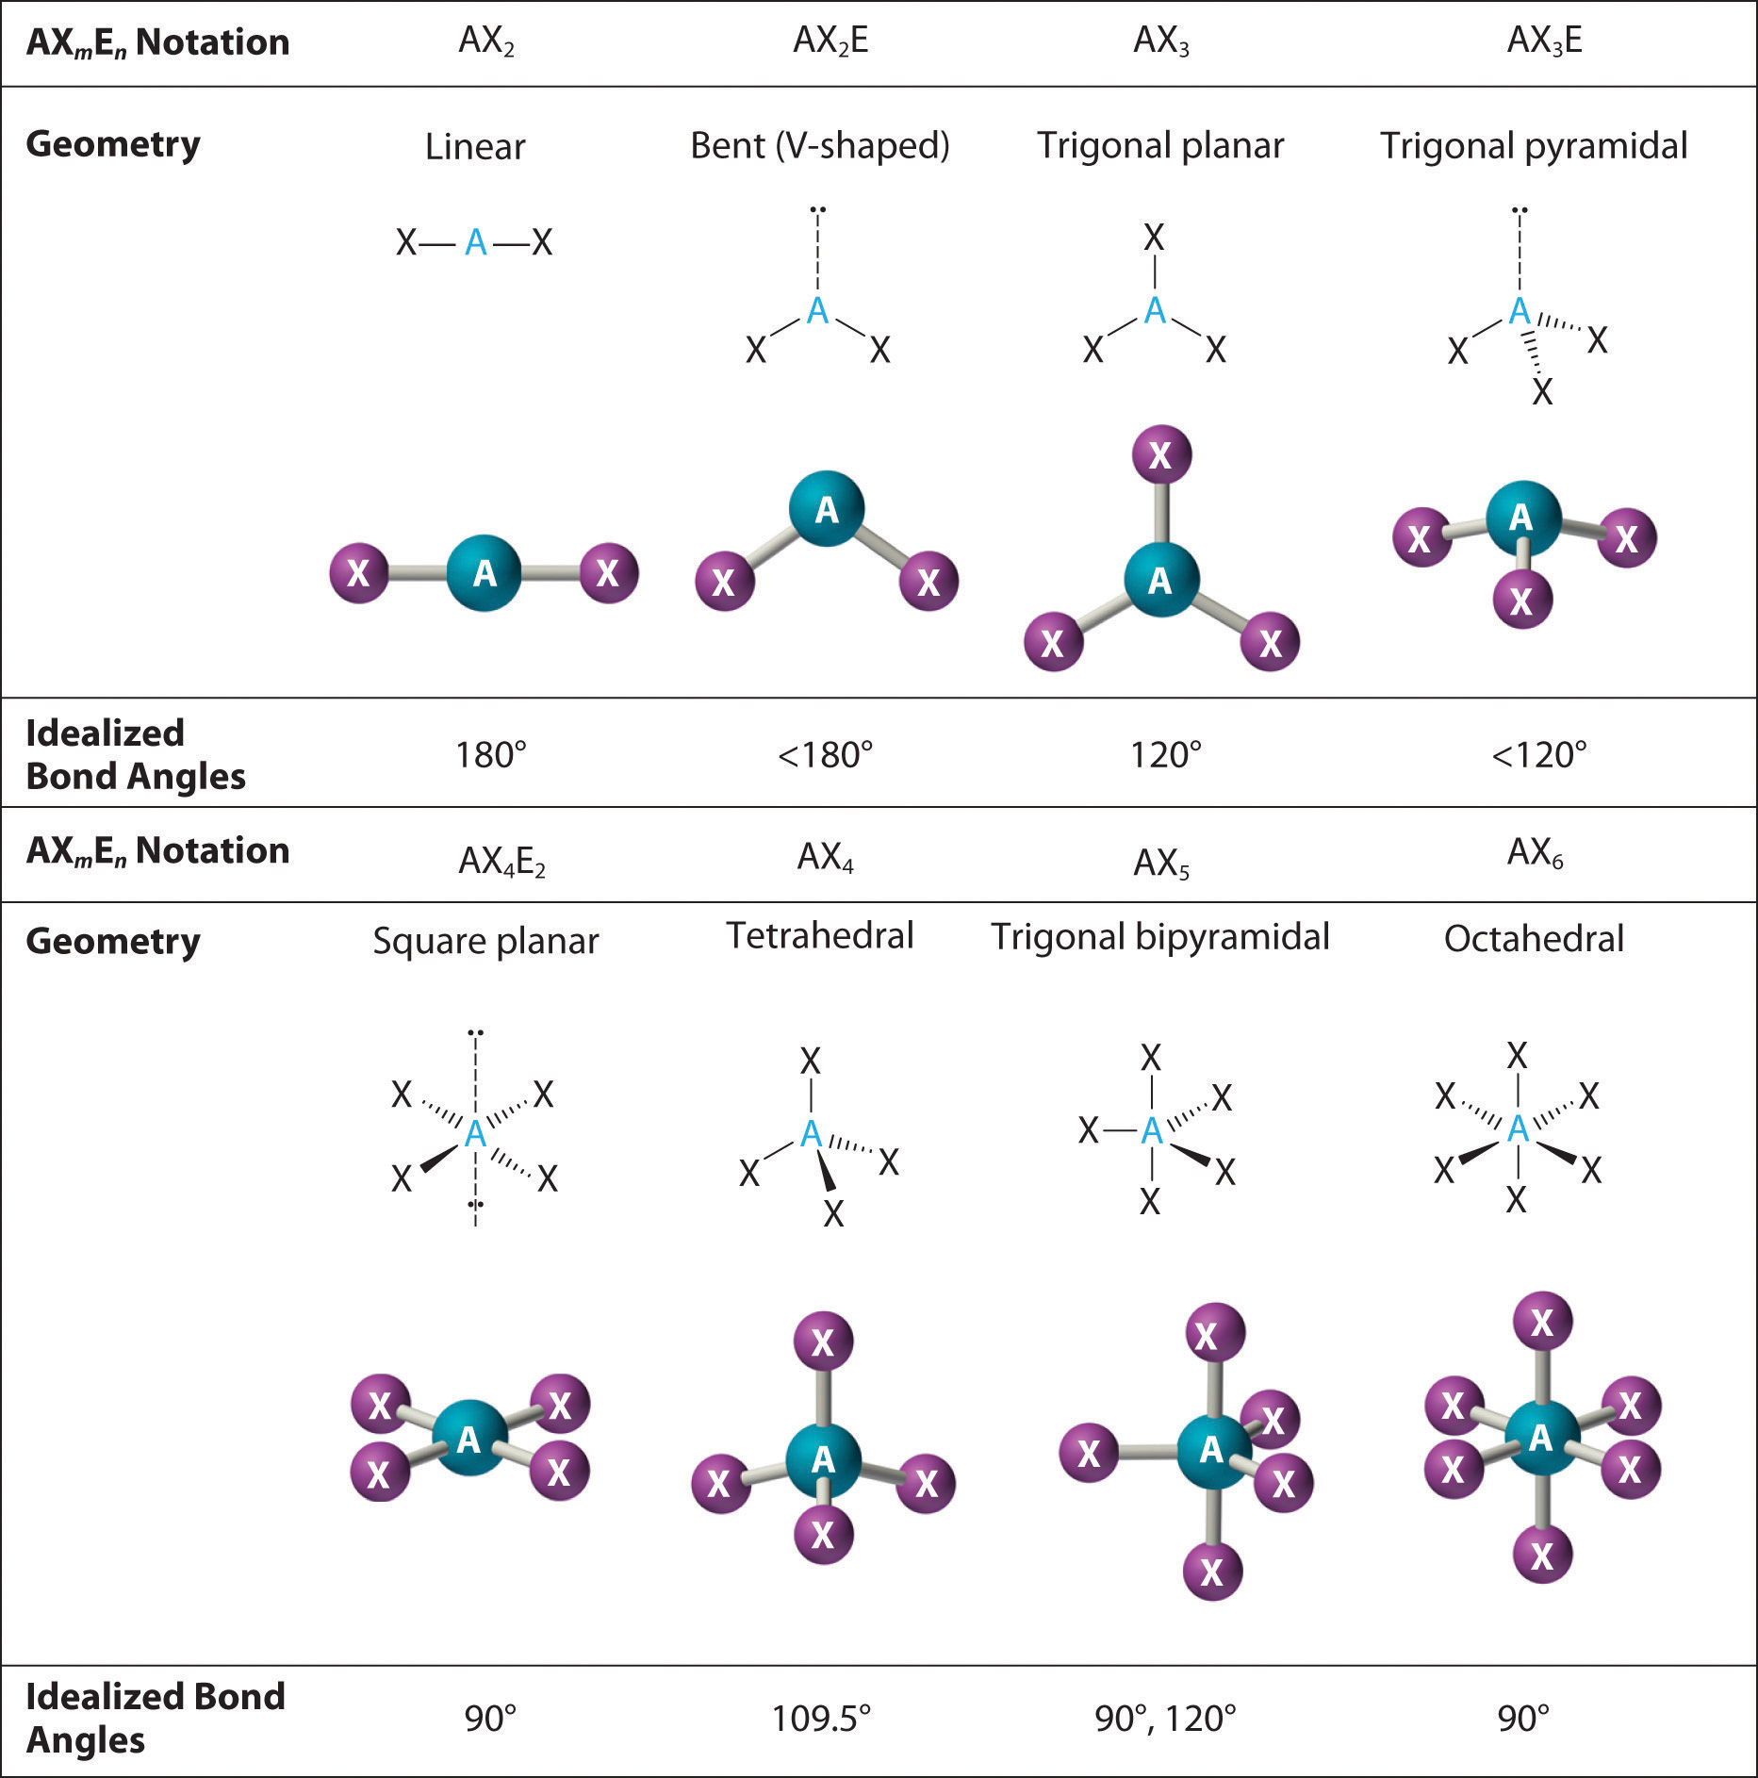
AX₄
Tetrahedral

< 120⁰
< 109.5⁰ white = hydrogen (H)
20⁰
AX₂E₂

Bent
109.5⁰ white = hydrogen (H)
20⁰
< 109.5⁰
Electron group arrangement

Molecular
Shape

- Draw the Lewis Dot structure of H_{2.}

- Begin building by selecting two H (white) atoms and one single bond (short grey stick). Build H₂. Compare your model to those of other students at your table. Examine your model and the chart above (Model II). After reviewing, what do you think the AXE formula, geometric shape, and bond angle is? Set this model aside.

- Draw the Lewis Dot structure for water.

- Now select an 2 H atoms and one O (black) atom. Build H₂0. Note, you may indicate the lone pairs with a purple connectors. Compare your model to those of other students at your table.

- What do you notice about the shape of your molecule when you just consider the atoms?

- What is the shape when you take into consideration the lone pairs?

- Record its AXE formula, geometric shape, and bond angle. Set this model aside.

- What happened to the geometric shape of water? Why is it not linear?

- Draw the Lewis Dot structure for oxygen gas.

- Notice the Lewis dot diagram for O_{2.} What type of bonds are present in O₂?

- Select two O atoms (black). Build O_{2.} Use the long grey bendable connectors as your bonds. Indicate lone pairs with the purple connectors. Compare your model to those of the other students at your table. Record the AXE formula, geometric shape, and bond angle. Set this model aside.

- Compare your three models. What are the similarities and differences?

Your group will check your answers with the instructor before moving on
Extension - VSEPR Worksheet #2
For this activity, you will need to refer to your Lewis Dot Worksheet # 1. Use the ball and stick model kit to create the molecules below. Please note, the black ball will always be the central atom. Use the purple connectors to show lone pairs on the central atom. Then, draw a ball and stick model to show the 3-D structure for each molecule. Only draw the lone pairs on the central atoms unless it is an AX model. Identify the AXE formula, name of the 3-D geometry and the bond angle of the central atom. Use colored pencils to indicate the different atoms present.
AXE
formula
AXE
formula
AXE
formula
# Valence
electrons
# Valence
electrons
# Valence
electrons
CH₄ H₂O CO₂

Atom Kit: Black =C, White=H Atom Kit: White=H, Black =O Atom Kit: Black=C, Red=O

Shape Angle
Shape Angle
Shape Angle

N₂ OF₂ CO
AXE
formula
AXE
formula
# Valence
electrons
# Valence
electrons
# Valence
electrons
AXE
formula

Atom kit: 2 Blue = N Atom kit: Black=O, Green= F Atom kit: 2 Black = C and O

Shape Angle
Shape Angle
Shape Angle
# Valence
electrons
# Valence
electrons
# Valence
electrons
AXE
formula
AXE
formula
AXE
formula
PCl₃ CCl₄ NH₃
Atom Kit: Black=P, White=Cl Atom kit: Black=C, White=Cl Atom kit: Black=N, White=H

Shape Angle
Shape Angle
Shape Angle
SO₂ NO₃⁻
# Valence
electrons
AXE

AXE

# Valence
electrons
Atom Kit: Black=S, Red=O Atom kit: Black=N, Red=O

Shape Angle
Shape Angle
SO₃ SO₄²⁻
# Valence
electrons
# Valence
electrons
AXE

AXE

Atom Kit: Black=S, Red=O Atom kit: Black=S, White=O

Shape Angle
Shape Angle

Your group will check your answers with the instructor before moving on

Big Idea
- Compare AX₃ to AX₂E in terms of shape and bond angle. Provide some examples.

- Compare AX_{4,} AX₃E, AX₂E₂ in terms of shape and bond angle. Provide some examples.

You are now ready to build your atomic molecule mobile! Congratulations.

