Geologic Time and Rock and Fossil Records Station Activity

Station 1: Finding Clues to Rock Layers Turn to page 322 in the Earth Science textbook.

Write the Problem (look on pg. 322):

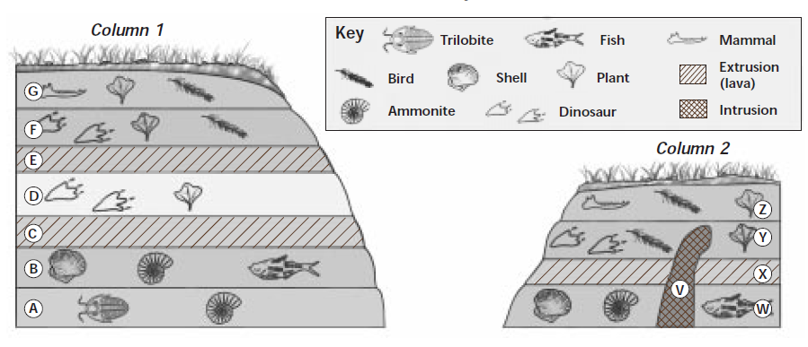
Column 1:
- List the layer (A-G) in order of oldest to youngest:
____ , ____ , ____ , ____ , ____ , ____ , ____
Oldest-------------→ Youngest

Column 2:
- List the layer (W-Z) in order of oldest to youngest:
____ , ____ , ____ , ____ , ____
Oldest-------------→ Youngest

Questions:
- Define the Law of Superposition:

- How did you know which layers were the oldest and which were the youngest?

Questions Continued:
- What “fossils clues” in layers A and B indicate the kind of environment that existed when these rock layers were formed?

- How did the environment change in layer D?

- Why are there no fossils in layers C and E?

- What kind of fossils occurred in layer F?

- Which layer at Site 1 might have formed at the same time as layer W at Site 2?

- Which is older, intrusion V or layer Y? How do you know?

- Think About It: Working as a geologist, you find a rock containing fossils. What information would you need in order to determine this rock’s age relative to one of the rock layers at Site 1?

Geologic Time and Rock and Fossil Records Station Activity

PROBLEM: What are the different kinds of fossils and what can they tell us about the environment?

Station 3: Examine the four fossils at this station and fill in the table below for EACH fossil. Please handle the fossils with care. Some of them are fragile and will break easily. Remember to handle the property of others with respect!

You may write your responses in this data table.
Fossil Number | What type of fossil do you think this is (plant, fish, insect, etc.)?  How do you know? | What environment (desert, ocean, etc.) do you think existed when this fossil formed? How do you know? | Sketch of fossil, colored and labeled
Fossil
#1
Fossil
#2

Fossil
#3

Reflection Questions:

- Choose one fossil. Describe how you think it was formed.

- How did you determine what environment (desert, ocean, etc.) existed when this fossil formed?

- How did you determine what type of fossil it was? (plant, fish, insect, etc.)?

- What other information do you think you could learn just by looking at a fossil?

Geologic Time and Rock and Fossil Records Station Activity

PROBLEM: What are the different kinds of fossils and what can they tell us about the environment?

Station 4 – Make your own fossils by following the directions below.
- Flatten a piece of playdough into an approximately 1.5 cm thick round shape.
- Select an object from this station.
- Press the object into the playdough.
- Remove the object from the playdough.
- Answer the questions below. Use pages 310 to 313 of the Earth Science textbook to help you.

Answer these questions

- Sketch the fossil you created

- In what type of environment do you think this organism live? How do you know?

- What type of fossil did you create (mold, cast, petrified, carbon film, trace)? How do you know? Use pages 310 to 313 of the Earth Science textbook to help you.

- What is the definition of “fossil”?

- Use page 311 in the textbook (see Figure 1) to explain the steps involved in fossil formation.

1.

2.

3.

4.

- Sketch the process by which you formed your fossil.

- What can scientists learn about the Earth and it’s environments from fossils?

Geologic Time and Rock and Fossil Records Station Activity

PROBLEM: You will use the Law of Superposition to arrange rock layers and fossils in order of youngest to oldest.

Station 6 – Principle or Law of Superposition
Examine the picture titled “Principle of Superposition”. Do NOT mark on this picture. Use pages 318 to 320 of the Earth Science book to help you.

A. Number the events below in the order they occurred in time, 1 – 9.

SKY
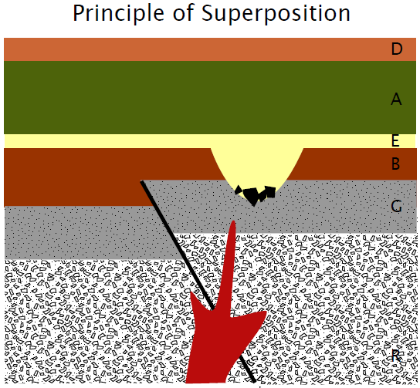
____ Earthquake

____ Deposit D

____ Deposit B

____ Deposit G

____ Intrusive Lava

Evidence of an earthquake
____ Rocky Deposit R

____ River cuts through

____ Deposit E
Intrusive lava

R

____ Deposit A

B. Answer the questions below. Use pages 317-321 in the Earth Science textbook.

- What does relative age mean?

- What does the term absolute age mean?

- What does the “Law of Superposition” state?

- Do you think the green and yellow layers were moved by the fault? Why or why not?

- If there were fossils present in these layers, would how would that help geologists determine the age of these layers?

- Did a volcano erupt during the time these layers were formed? Why or why not?

