Was the environment of Mesopotamia a blessing or a burden?

Read
Mesopotamia
Mesopotamia means "between the rivers" in the Greek language. It is a fertile region situated around the Tigris and Euphrates Rivers and runs from the Persian Gulf to the coast of the Mediterranean Sea. Its characteristic fertility and shape account for its commonly known nickname, the Fertile Crescent. A number of ancient river valley civilizations developed in this region. The most well known were Sumer and Babylon.

Environment
A region's environment is pivotal in the development of its culture. Religion, economic and government systems, fashions, and even food choices all reflect the various adaptations that groups of people have made to the climate and geography they live in. The fact that some of the world's earliest civilizations developed in the harsh climate of the Mesopotamian region is a credit to the adaptability of the people who lived in these ancient civilizations.

Civilization
Civilizations can be characterized by certain basic features that they have in common. These features include:
- The existence of cities
- Job specialization
- Institutions of government and religion
- Some form of record keeping
- Technology
Each of these characteristics were present in the civilizations that developed in the Fertile Crescent. For example, the Sumerian city of Ur was home to over 25,000 people. The Sumerians invented the wheel and the world's first system of writing, called cuneiform. These characteristics indicate ways in which the people of Sumer adapted to their environment.

Research
Part 1
- Use the following maps to answer questions 1-5 on the Respond sheet.

Ancient Cities
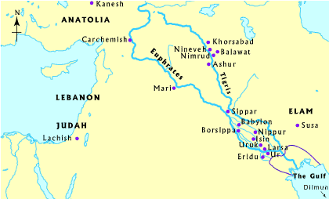
Modern Political Map
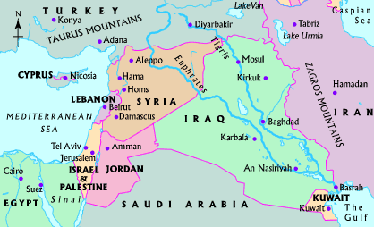

Civilizations over Time (1750 BC)
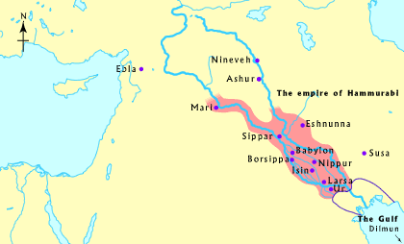

Natural Resources
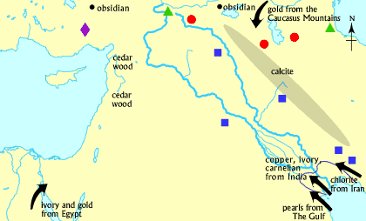

Part 2
- Read sections on the Tigris and Euphrates, climate, and trade.
- Use the information to fill in the chart in Part I.

Tigris and Euphrates:
Babylonia rests on a flat plain with the two large rivers flowing through it, the Tigris and Euphrates. Their course runs from Anatolia and Syria to the Persian Gulf. Mountains surround the East and North sides of the plain, the Zagros chain and Kurdistan, and the Syrian and Arabian deserts guard the west and south.

Climate:
In the summertime the climate is hot and dry, and the winter is cold and wet. In the spring the Tigris and Euphrates rivers overflow their banks, flooding great portions of the plain. Lots of water and proper control enabled man in ancient times to produce abundant crops, mostly barley and sesame, with abundant grazing land in the lush meadows for the cattle, sheep and goats.

As the hot dry south wind came faithfully the date palm was cultivated and its fruit was ripened. The abundant clay was formed into bricks to build houses and monumental structures, and also provided clay tablets for writing purposes.

In order to acquire precious metals, stones and sturdy timber the inhabitants engaged in foreign trade. The vast resource of petroleum was all but useless to ancient man. Today the physical features of the region along with its climate are similar to how it was in the ancient world, and the Arabs who live there still live in a manner very similar to their ancient predecessors.

Ideal for Trade :
Because Babylon was situated on the river Euphrates it was an ideal place for trade. To the north they could trade up the river to Syria and beyond and could act as a staging post with the cities of Sumer to the south. When Babylon became important, people would have wanted to live there because of the economic benefits it would give being in a large city with lots of merchants and tradesmen passing through. An important city like Babylon would also give a greater degree of security to its inhabitants.

In Babylonia and in all of southern Mesopotamia there is lots of clay which people could bake and make into bricks with which to build houses. This helped the development of civilization in the area.

Part 3
- Read the following information on the human use of rivers.
- Use the information to fill in the chart and answer question 6.

Human use of the rivers:
Man have been attracted to both rivers since prehistoric times. As water ways they make inland navigation possible. The rivers yearly flood its banks, producing fertile land. The character of Euphrates and Tigris are different. The Tigris is rough and fast flowing. `Tigris' is the Greek pronunciation of the Akkadian name idiqlat. Sumerian idigna meaning `fast as an arrow'. The upper course in particular is difficult to pass. The river cuts deep in the surrounding land and the water flow can hardly be used for irrigation. The Euphrates is a lifeline. It can more easily be used by ships. The banks are lower, suitable for irrigation, with less violent floods. Precipitation in the mountains to the north is large and rainfall-agriculture is possible. In the Babylonian low lands precipitation is low and moreover rain is concentrated in shortly lasting showers in the winter period December-February. Intensive sunshine after a short spring parch the soil in the summer. Without irrigation agriculture is not possible.
Part 4
- Read the following on favorable geographic circumstances and water supply in the region.
- Use the information to complete the chart and answer question 6.

Mesopotamia’s Favorable Geographic Circumstances:
Archaeological excavations in Mesopotamia, conducted since about 1840, have revealed evidence of settlement back to about 10,000 BC. Favorable geographic circumstances allowed the peoples of Mesopotamia to evolve from a hunter-gatherer culture to a culture based on husbandry, agriculture, and permanent settlements. Trade with other regions also flourished, as indicated by the presence in early burial sites of metals and precious stones not locally available.

Mesopotamia is a flat, fertile land. Between Baghdad and the mouth of the confluence of the Tigris and Euphrates, where it empties into the Persian Gulf, there is a difference in height of only about one hundred feet. As a result of the slow flow of the water, there are heavy deposits of silt, and the riverbeds are raised. Consequently, the rivers often overflow their banks, and may even change their course, when they are not protected by high dikes. In recent times they have been regulated above Baghdad by the use of escape channels with overflow reservoirs. The extreme south is a region of extensive marshes and reed swamps, called hawrs, which, probably since early times, have served as an area of refuge for oppressed or displaced peoples.

Water Supply in the Region:
The supply of water in this region is not regular. As a result of the high average temperatures and a very low annual rainfall, the ground of the plains of latitude 35 degrees north is hard, dry, and unsuitable for plant cultivation for at least eight months of the year. Consequently, agriculture without risk of crop failure, which seems to have begun in the higher rainfall zones and in the hilly borders of Mesopotamia in the tenth century BC, began in Mesopotamia itself, the real heart of civilization, only after artificial irrigation had been invented. This brought water to large expanses of territory through a widely branching network of canals. Since the ground is actually extremely fertile and, with irrigation and the necessary drainage, will produce in abundance, southern Mesopotamia became a land of plenty that could support a considerable population. The cultural superiority of north Mesopotamia, which may have lasted until about 4,000 BC, was finally overtaken by the south when the people there had responded to the challenge of their situation.

Respond
Use Part 1 to respond to the following:

- Look at the Ancient Cities map. Identify four cities located at the mouth of the Tigris and Euphrates, where the rivers meet along the ancient coastline (noted by the purple boundary).

- Look at the Modern Political map. What modern-day country makes up most of the Mesopotamian Region?

- Look at the Civilizations Over Time map. According to the map, during the reign of Hammurabi, the Babylonian Empire stretched from Ur in the south to the city of __________________ in the north.

- Look at the Natural Resources map. Develop a hypothesis as to why it was so important for the people of southern Mesopotamia to develop trade with the people of other regions.

- Use Parts 2, 3, and 4 to chart the positive and negative environmental features of the Mesopotamia.
POSITIVE CHARACTERISTICS | NEGATIVE CHARACTERISTICS

- Recall the cities you identified at the mouth of the Tigris and Euphrates rivers in question #1. The ancient city of Ur became a heavily populated, prosperous city. Explain how Ur's location contributed to its development as one of the world's first urban areas. If necessary, review the information from Parts 3 and 4.

- Now, imagine that you are a chief advisor to King Mursili I of the Hittites. The year is 1595 BCE, and the Hittite Empire exists in what is now Turkey. The King wants to invade and take over the Babylonian Empire in Mesopotamia. As his advisor you must decide whether the possible rewards of taking over Mesopotamia outweigh the risks of its harsh environment. Write a speech to encourage or discourage the King's invasion plan. Be sure that your speech answers the Focus Question: Was the environment of Mesopotamia a blessing or a burden?

