Escape by Night: A Civil War Adventure
By Laurie Myers, Illustrated by Amy June Bates

LOUISIANA YOUNG READERS’ CHOICE NOMINEE 2014
GRADES 3-5

Submitted by Liz Nelson – Librarian, North Highlands Elementary School, Shreveport, LA and Angela Germany- Children and Teen Services Consultant State Library of Louisiana

Laurie, Myers. Escape by Night: A Civil War Adventure. Henry Holt and Co., 2011, 120pages.

SUMMARY
This is a short picture book that was inspired by the childhood of President Woodrow Wilson. While watching a hospital wagon roll through his Georgia town, Tommy sees one of the soldiers
drop a notebook. He returns the notebook and befriends the man named Redmon. Later, Tommy learns that Red is a Union soldier hiding in Confederate clothing. As Red improves, Tommy must decide if he will help Red escape. His decision will change the life of more than one person.

AUTHOR’S BIOGRAPHY
Laurie Myers is the award-winning author of chapter books for children, including Surviving Brick Johnson, an ALA Notable book, and Lewis and Clark and Me, winner of the Pennsylvania Children's book award and Honor book for Michigan. Her books have been on the International Reading Association's Children's Choice, Teachers' Choice and Parents' Choice lists, as well as Junior Library Guild selection and many state master lists and nominations for the Crown Award. She has collaborated with her sister, Betsy Duffey and her mother Betsy Byars on several popular books, which have been nominated for state awards and won the Louisiana and South Carolina children's book awards. www.lauremyers.com

ILLUSTRATOR’S BIOGRAPHY
When Amy was a kid she loved to draw and read. She spent the time that she wasn't reading and drawing trying to keep her six brothers and sisters from drawing on her pictures and losing her place in whatever book she was reading. She loved the mountains quite a bit. She grew up and learned to draw a lot better. She currently lives in Pennsylvania with her three children and husband. She reads and she draws quite a bit. www.amybates.com
CLASSROOM CONNECTIONS
Social Studies
Louisiana Civil War Submarine: The Louisiana State Museum in downtown Baton Rouge has a Civil War submarine that is very interesting to learn about. The museum has a virtual exhibit for this early Louisiana submarine here http://www.crt.state.la.us/museum/online_exhibits/Civil_War_Submarine/.

Geography in the book: The story is set in Augusta Georgia. Ask your students to find Augusta on a map. The book also mentions Atlanta Georgia, South Carolina, the Savannah River and Ohio. Locate these places on a map. Ask your students to calculate the distance between Atlanta and Augusta Georgia. Ask your students to figure out the distance from Augusta to Ohio to understand how far Red will have to travel to get home.

Information about Augusta, Georgia in the Civil War: http://www.researchonline.net/tour/

Civil War Lesson Plans: Elementary http://www.civilwar.org/education/teachers/curriculum/civil-war-curriculum/elementary/lesson-plans-elementary.html

Union prisoner's letter reveals Civil War past of Augusta, Ga.
http://www.toledoblade.com/Nation/2012/12/31/Union-prisoner-s-letter-reveals-Civil-War-past-of-Augusta-Ga.html#poefrvkMFVuJ2FZQ.99

Slavery & Abolitionist Movement/Abraham Lincoln
http://www.proteacher.com/090053.shtml
Underground Railroad (interactive)
http://education.nationalgeographic.com/education/multimedia/interactive/the-underground-railroad/?ar_a=1

Civil War Food
This is a link to a recipe for hardtack, one of the stapes for civil war soldiers. There are also links to more civil war foods http://www.educationworld.com/a_lesson/00-2/lp2001.shtml.

Battling Boredom
This is a lesson plan exploring what Civil war soldiers did day to day to battle boredom and it asks your students to compare that to what they do today when bored, http://www.educationworld.com/a_lesson/00-2/lp2009.shtml. They can draw a Venn Diagram to compare.

Art

Educational Projects for Kids:

Cool things you can make with your students that are Civil War related:

http://www.arkansascivilwar150.com/research-education/kids-projects/

English Language Arts

Read-Aloud Picture Books :

Sweet Clara and the Freedom Quilt. Hopkinson, D. (1993). New York: Dragonfly Books.
Summary: Clara is a slave who works in the cotton fields. Clara worked with her Aunt Rachel who was a seamstress and taught Clara how to sew. Clara became good enough as a seamstress that she was able to work with her aunt instead of in the fields. Using scraps of cloth, Clara sewed together a quilt with a map on it to help slaves get to freedom.

Just in Time, Abraham Lincoln by Patricia Polacco
When two brothers visit a museum in Harper's Ferry, West Virginia, with their grandmother, they find themselves in a very realistic Civil War setting where they see the Antietam battlefield and meet historical figures from the aftermath of that momentous battle. Includes author's note on the Battle of Antietam.

Pink and Say by Patricia Polacco
Say Curtis describes his meeting with Pinkus Aylee, a black soldier, during the Civil War, and their capture by Southern troops. Based on a true story about the author's great-great-grandfather.
The Last Brother: A Civil War Tale - Trinka Hakes Noble
Eleven-year-old Gabe enlists in the Union Army in Pennsylvania along with his older brother Davy and, as bugler, does his best to protect Davy during the Battle of Gettysburg.

Alec's Primer - Mildred Pitts Walter
A young slave's journey to freedom begins when a plantation owner's granddaughter teaches him how to read. Based on the childhood of Alec Turner (1845-1923) who escaped from slavery by joining the Union Army during the Civil War and later became a landowner in Vermont.

SCIENCE

Dog Breeds
In the book the dog Samson is a Greyhound. Ask your students to look up information about that breed of dog and report out. Be sure they include cool facts about greyhounds. They can do this individually or in groups, using multiple resources: nonfiction books, encyclopedias and online resources. Another option is to ask students to look up and find information about their dream dog. They can imagine what dog breed they would get if they could have any dog they want, write about it and why this is their favorite breed.

Civil War Medicine
In the book, Tommy’s father’s church has been turned into a hospital. During the Civil War, medicine and medical knowledge was very different from today. Consider sharing some of the information found on the National Museum of Civil War Medicine’s website with your students. They have (http://www.civilwarmed.org/) some virtual tours like this one http://www.civilwarmed.org/pry-house-field-hospital-museum/exhibits/. There is also a short video about Clara Barton, who was a famous nurse and relief worker during the civil war. Clara founded the American Red Cross.
Discussion: You could ask your students to think about the things they have seen and have used on them at their Dr.’s office. They have probably had their ears checked, their throats inspected with a wooden stick holding down their tongue. They have probably had their heart and breathing listened too with a stethoscope. They will know what a shot is and perhaps they have had their throat swabbed with an extra-long Q-tip too. Now show them a picture of a Civil War doctor’s tools. Just by looking at the picture, what do they think? Is this different from what they are used to seeing a doctor use? Why or why not?

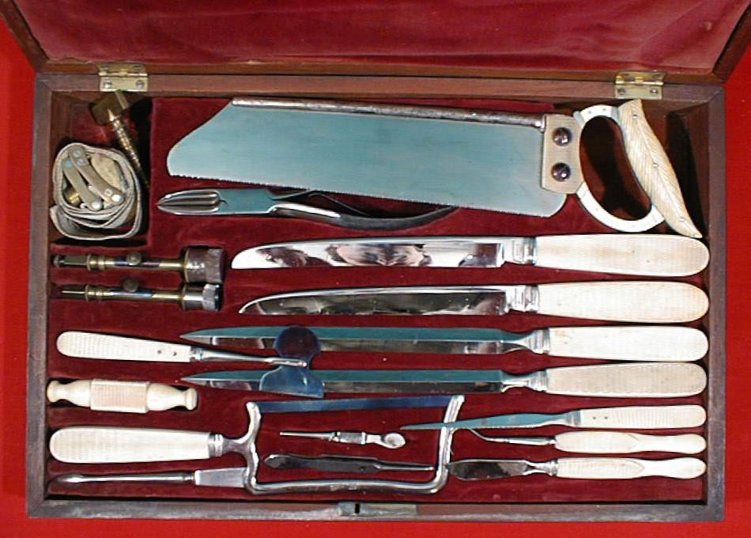

Here is a breakdown of what some of the items are for http://www.nps.gov/wicr/forteachers/upload/Medical-Tools-for-teachers.pdf.

VOCABULARY

Confederate Sovereign Robert E. Lee
Union Secede strategy
Confidence Nagging grimace
Greyhound Reverend vitality
Battle of Chickamauga Yankee trestle

CROSSWORD PUZZLE ANSWER KEY

Confederate - South
Union - North
Greyhound - Samson
Tommy - Boy who found the book
Henry - Slave
Red - One armed soldier’s name
CivilWar - When the North and South fought
McKnight - Tommy’s last name
Poem - What Mr. Red read out of his book
Yankee - Another name for a Union Soldier
Atlanta - Capital of Georgia
Augusta - Town Tommy is from

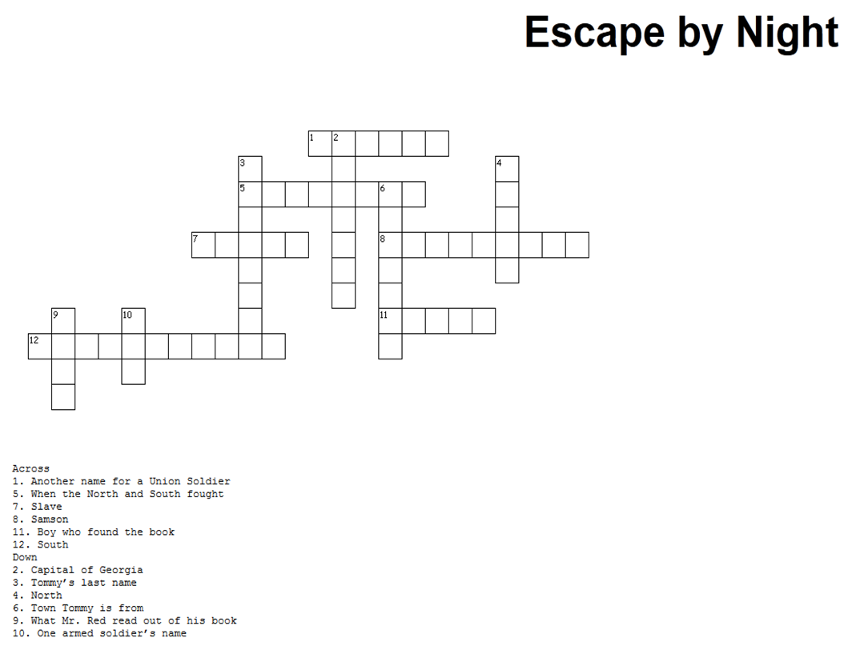

DISCUSSION QUESTIONS

Chapter 1
How did Tommy get the book the soldier dropped in the road?
Did Tommy open and read what was in the book? Why or why not?

Chapter 2
Why does Tommy think the war is getting worse?
Why was Samson hesitant to enter the hospital?
Who is Henry?

Chapter 3
What kind of Dog is Samson?
What did Redmon Porter do that Tommy found unusual?
What battle did Mr. Red say he was in?
What did Mr. Red read to Tommy and Henry?

Chapter 4
What is Big Steve and what does it ring for?
What does Tommy think of Mr. Red?

Chapter 5
What happens to Union prisoners?
Why does Tommy begin to suspect that Mr. Red may be a Union soldier?

Chapter 6
What does Tommy’s family do in the evenings together?
What does Tommy’s father say about how the war is going?

Chapter 7
How does Tommy treat and talk to his dog Samson? What do you think of this?
What is going on with Red at the hospital? Who is he talking to and why?

Chapter 8
How does Tommy feel about Red now that he knows Red is a Yankee? Why?
What does Henry tell Tommy? Why do you think he said that?
What does Tommy’s sister say that she knows and that she is going to do?

Chapter 9
What is the deal that Tommy makes with his sister?

Chapter 10
What did Tommy’s mom tell him that made him nervous? Why does it make him nervous?
What does Tommy think God wants him to do about Red? Why?

Chapter 11
What is the plan to help Red escape?
Who do you think is going to try to escape with Red?

Chapter 13
After Red and Tommy leave what are some things that startle them?

Chapter 14
What is the Steve bell ringing for?
What does Tommy tell his sister to do to cause a distraction?

Chapter 15
Does their distraction work?

Chapter 16
What do you think will happen now? Do you think Red will make it home? Why?
It was against the law for Tommy to help Red. Do you think Tommy made the right decision by helping Red? Why or why not?

