Global History & Geography Name: __________________
Imperialism Ms. Masseo
Mock Berlin Conference

You will be representing one of four nations: Great Britain, France, Belgium or Germany.

Your country: _______________________

With your group member, study the map below that shows the important resources on the African continent. Keep in mind that you are living in the 1800’s, so some resources that are useful now, such as uranium, were not useful then.
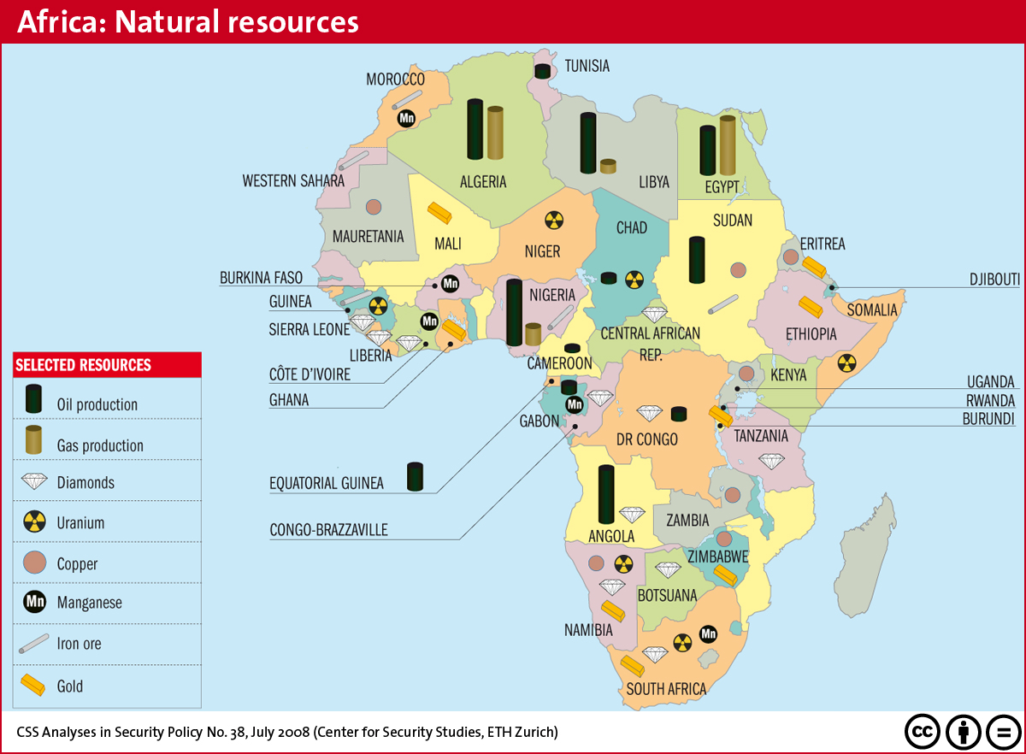

With this knowledge, divide up the continent for your country by drawing (in pen) the regions you wish to control.

Here are a few guidelines:

-You cannot control more than approximately 50% of the continent. (Use your best judgment)

-Keep in mind the geography of the region (i.e. where are the major deserts?)

-You should not abide by the modern territorial lines currently drawn on the map above. Put your own territories wherever you wish.

Global History & Geography Name: __________________
Imperialism Ms. Masseo
“The Scramble for Africa”
1. The Berlin Conference (1884-1885):
14 European nations met in Berlin, Germany to prevent conflict over territory in Africa. There they laid down the rule for the partition (division) of Africa by notifying other nations of its claims and showing it could control the area. By 1914, Liberia and Ethiopia were the African countries that remained free from European control.

Question: What conclusion(s) can you develop from the information above?

2. Map of Imperialism in Africa 1914
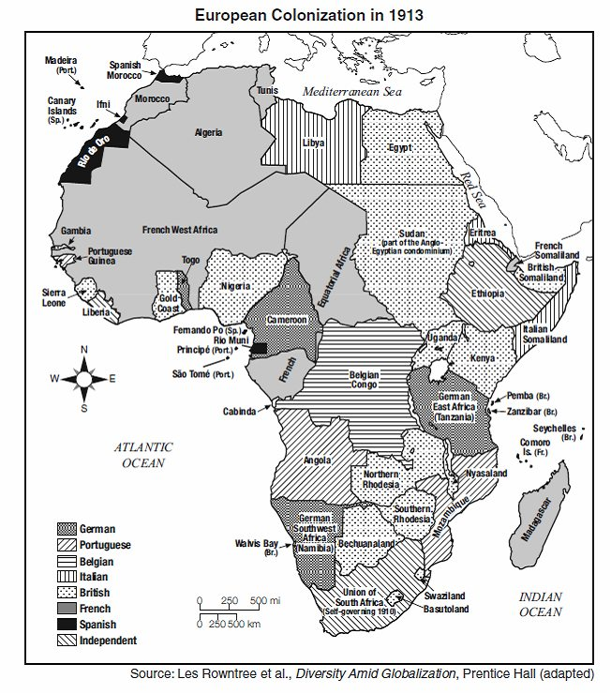
Questions:
- What 2 countries controlled the most territory in Africa? ___________ & ___________

- COWs

