Project Title: On the Road Again

Project Idea: Students will create a game kit for children to use while traveling. The kit is to include a movie and game which will entertain and teach children to read a map, identify each of the 50 states, place them in the correct regions, and basic United States geography. Once the project is underway, the teacher will present students with a “twist” via another memo. (See below) This twist will require students to play each others’ games and evaluate their movies. Not only will this provide opportunity for project refinement, but will also allow students to learn the content presented by each group. (Note: This project was designed to support and extend the concepts learned in the FOSS science kit, Landforms.)
Entry Event: Students will be given a letter (see below) from Travel America Automobile Agency, executive Bob Darby, challenging them to create a geography travel kit for children.

Content Standards:

Standards Directly Taught or Learned Through Discovery | Identified Learning Targets | Evidence of Success in Achieving Identified Learning Target
SS.5.14  Explain how aspects of the terrain (e.g., the principal mountain ranges, rivers, vegetation and climate of the region, etc.) affected westward and settlement | In the United States:  locate major rivers  identify major rivers  compare major rivers  locate major landforms  identify major landforms  compare major landforms  locate major natural resources  identify major natural resources  compare major natural resources  locate major climate regions  identify major climate regions  compare major climate regions  locate major soil regions  identify major soil regions  compare major soil regions  locate major deserts  identify major deserts  compare major deserts  use a variety of maps to analyze the frequency or lack of urban areas within these regions | Groups will create a movie using Windows MovieMaker which will define the geography of their region. This project will be assessed using the Movie Maker Rubric. (See below)
SS.5.17  Compare and contrast the various regions of the United States; locate each of the fifty states and correlate them with their regions  SS.5.19  Display information on maps, globes, geographic models and in graphs, diagrams and charts (e.g., designing map keys and legends, etc.). | compare the various regions of the United States  contrast the various regions of the United States  locate each of the fifty United States  correlate [the states] with their regions | Students will create some sort of a travel game for children. This game is to be designed to teach children major US landforms, basic map skills, and the location of the 50 states. Students will assess each other’s games using the Customer Satisfaction Survey. (See below) The teacher will meet with each group once surveys are completed and recommend changes upon student and teacher feedback. At the completion of this pbl, games will be shared with other classes in the school.  After students participate in the “twist”, they will have had reason to compare and contrast the regions. Students will be assessed with a quiz using responders. After comparing/contrasting, student groups will help write the questions based upon their own learning. They will be submitted on the Test Question Form. (See below) Teacher will supervise to ensure content is reflected in questions and will create and deliver quiz.
TCS.3-5.4  Create original work through the use of age appropriate technology and digital tools  TCS.3-5.8  Demonstrate creativity and learning through technology (e.g., digital storytelling, keyboarding, portfolio creation, digital media displays, and other media, etc.). | Teacher will meet with small groups on a regular basis. Movie Maker Rubric will be used in these meetings to guide self and group evaluation of the project | Movie Maker Rubric (See below)
TCS.3-5.12  Research information on topics of interest through the use of age appropriate technology and digital resources.  TCS.3-5.16  Use appropriate digital and non-digital tools to plan and manage a design process.  DSS.3-5.4  Set goals, develop a plan, and follow it through to completion. | The entire process from brainstorming to product creation of the movie and game will be chronicled in their Project Folder. Both students and teacher will be able to evaluate individual and group thinking and reasoning. | Project Folder Checklist includes all documents required and allows for room to add content pages which would be a reflection of what students need to know.  Project Folder includes:  Project Folder Checklist  Personal Workplace Skills Survey (2 for pre and post)  Personal Goal Setting I  Movie Brainstorming  Game Brainstorming  Project Task Chart  My Learning Log (multiple)  Personal Goal Setting II  Topographic Maps  Final Evaluation
DSS.3-5.10  Persist in activities to achieve goals. | At the beginning of the project students will rank themselves on a Personal Workplace Skills Survey. This will be used to set goals for self improvement through conference with teacher. At the culmination of the project, students will complete the survey again to determine growth and development | Personal Workplace Skills Survey (before and after project)  Completion of Personal Goal Setting I, Personal Goal Setting II, and Final Goal Setting Entry in the Project Folder

Performance Objectives:

Know Geography vocabulary: geography, cartographer, landform, landmark, latitude, longitude, archipelago, bay, butte, canyon, cape, channel, cove, gulf, island, marsh, mesa, mountain, peninsula, plain, plateau, sea, sound, strait, swamp, valley, wetland
Understand the role of elevation in creating and understanding a topographic map
The benefits of effective group work
How a rubric can be used for self-assessment
Physical geographic features of regions of the US
Identify state outlines and name the region where it is found

Do Read and understand US maps
Locate 50 states on US map
Match state to US region
Learn and use geography vocabulary in authentic context
Use a rubric for self-assessment
Maintain a Project Folder
Solve problems with group members to complete their collaborative projects
Participate in various methods of self assessment
Write a script for Movie Maker project
Select graphics which support movie script
Complete a storyboard for Movie project
Use Windows Movie Maker
Create geography game
Create questions for class quiz
Play geography games created by other groups
Complete surveys

Driving Question: What makes the US regions unique and how does this uniqueness contribute to where we choose to live?

Assessment Plan:

Major Group Products | US Regional Topographical Maps (See below) –  This project will be completed in conjunction with FOSS Landforms kit where students have learned to read and draw conclusions from topographical maps. The creation of this map is a vehicle by which students will begin uncovering the regional geography. Using plaster and paint, small groups will create regional topographical maps of the United States on plywood cut outs as a vehicle to learn the regional geography. Paint will be applied to reflect elevation as well as geographic features such as: rivers, landforms, deserts. Whole group will determine scale in elevation prior to creation of regional maps so that cut outs can be placed together like a puzzle which will create a completed US Topographical Map. (See below)  US Region Movie Maker Project-  (This will require students to use and explain the information gained in the plaster map creation.) Groups will create a movie which highlights the geography of their region. They must include major rivers, landforms, natural resources, climate regions, soil regions, and deserts found in their area. The movie must culminate with a connection or conclusion between these geographic features and the population distribution in this region.
Major Individual Products | Project Notebook - Students will be maintaining a notebook throughout the project. This notebook will have certain required components as well as a place for the inclusion of materials added by the teacher. These materials will be directly related to student responses to the Know/Need to Know chart. For example, if students need to know how to read a map, the materials completed from the lesson should be integrated in the notebook. For more details and suggestions use the Project Folder Checklist (See below) as well as Evaluation Journal Entries. (See below)

Assessment and Reflection:

Rubric(s) I will use: (Check all that apply.) | Collaboration |  | Written Communication
Rubric(s) I will use: (Check all that apply.) | Critical Thinking & Problem Solving |  | Content Knowledge
Rubric(s) I will use: (Check all that apply.) | Oral Communication |  | Other  Movie Maker Rubric (See below)  Regional Map Rubric (See below) | X
Other classroom assessments for learning: (Check all that apply) | Quizzes/ tests | X | Practice presentations
 | Self-evaluation |  | Notes
 | Peer evaluation |  | Checklists/observations (See below) | X
 | Online tests and exams |  | Concept maps
Reflections: | Survey (See below) | X | Focus Group
Reflections: | Discussion |  | Task Management Chart
Reflections: | Journal Writing/ Learning Log (See below) | X | Other

Map the Product:
Product:

Knowledge and Skills Needed | Already Have Learned | Taught Before the Project | Taught During the Project
1. How to research and cite sources |  | X
2. Storyboarding |  |  | X
3. How to use Windows MovieMaker |  |  | X
4. Geography of US Region |  |  | X
5. 5-Step Writing Process | X
6. Matching images to text |  | X
7. Oral reading fluency for narration | X

Resources:

School-based Individuals: None needed

Technology: access to computers with Windows MovieMaker, Microsoft Word for games, internet access for suggested on-line games

Community: volunteer to cut plywood for 3-D plaster maps, parents to help with plaster maps

Materials: folders (1 per student) for Project Folder, [Project Folder should contain: Project Folder Checklist, Personal Workplace Skills Survey (2 for pre and post), Personal Goal Setting I, Movie Brainstorming, Game Brainstorming, Project Task Chart, My Learning Log (multiple), Personal Goal Setting II, Topographic Maps, Regional Map Rubric, Storyboard, and Final Evaluation. (See below for all.)] art materials for games-will be determined by teacher request, plywood, plaster materials for maps—air-drying clay or Activa Fast Mache, paint, paint brushes, Krylon Triple Thick Crystal Clear Glaze, labels for game logos, blank CDs for students to record their MovieMaker movies, selection of books, magazines, and atlases to assist students in their research

Books:
Maps and Globes by Jack Knowlton
Geography from A to Z by Jack Knowlton
How I Learned Geography by Uri Shulevitz

Websites:
Games
http://www.sheppardsoftware.com/web_games.htm
http://www.sheppardsoftware.com/states_experiment_drag-drop_Intermed_State15s_500.html

Research
http://www.netstate.com/state_geography.htm

Manage the Process:
Classroom Management - This is the first pbl experience for the year. In order to ensure its success, as well as the success of my students, we have been building a collaborative environment since the first day of school. Building a collaborative environment through direct modeling, experiences, and simulation is absolutely necessary for this unit to be successful. Nearly all classroom rewards and benefits are based upon the group rather than the individual.

Grouping - My students conducted their own debate in preparation for their presentation to me regarding grouping. One group wanted me to select groups. Their primary argument was they were more productive. The other group wanted to be given the privilege citing they work well with certain people and not so well with others. We held a class vote after all issues were raised. The majority wanted to self-select groups based on strengths. They asked that I reserve the right to intervene if I saw disaster ahead for any of their choices. Students had to sign up for the job they do best—artist, organizer, typist, proofreader—with the understanding they will be doing all four throughout the project. The class requested a balance of skill when they self-select. Typically, I would operate much the same way my students requested, but considering work habits and other characteristics. Since this is their first pbl, I would want to ensure success as foundation for all other pbls.

Project Reflection and Evaluation:
Project Timeline includes approximate sequencing of lessons and learning. The actual time would vary from class to class and teacher to teacher. The daily lessons and speed would be based directly upon the Know/Need to Know chart. This drives all activity and learning. Of course, teacher assessment will be another determining factor.

Project Folder-Students are to complete a project folder which includes self-evaluation throughout the project. The teacher will use this as feedback opportunities along the way. Students will complete the Final Evaluation found in the Project Folder.

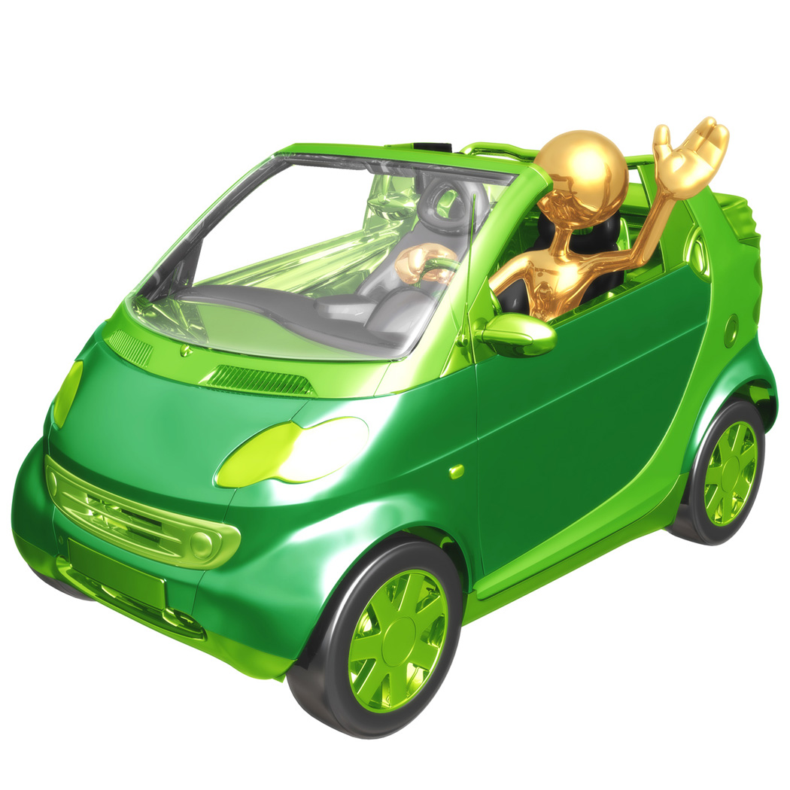

Dear 5th Grade Students:
I hope this letter finds you hard at work. The folks here at TAAA are excited to see your work and the fresh perspective you will give our geography kits for young travelers.
Last week my project staff suggested we request you “road test” each others’ games. We feel that each group must watch each other’s DVD and play the games to ensure these products connect with children. Mrs. Hull said she would provide you with a rubric, but also having children critique your product will surely make it better.
Sincerely,
Bob Darby
President and CEO

Dear 5th Grade Students:
TAAA, Travel America Automobile Association, has spent more than 100 years assisting travelers across America. In our early days we printed and distributed maps, as well as hotel guides. In the 21st century we are making every effort to meet the needs of the modern American traveler.
As you know, the economy is keeping many families home. We want to help put Americans back on the road. This is where we need your help.
Our executives believe you have a unique perspective which will help us in our task. By asking for your assistance, we will communicate more effectively with families with children. Mrs. Hull has assured us that you will participate and use this opportunity to learn 5th grade content.
TAAA would like your help in creating kits for children to use while traveling. These kits should be designed to educate and entertain a child between the ages of 8 and 12. We would like for you to submit a separate kit for each of the U.S. regions. Kits should include opportunities for reading and interpreting maps and the identification of states and geographic features within these regions. In order to occupy children, we would like you to design something to be played on a portable DVD player and at least one game. Please consider convenience for the child and make the kit easy to manage in the back seat of a car. Your teacher will provide you with the specific details for each component of the project.
We are excited to see your work!
Sincerely,
Bob Darby
President and CEO

Movie Maker Rubric
 | Above Standard | At Standard | Below Standard
Organization | - Information is presented in logical sequence.  - Information is highly interesting to the audience | - Information is somewhat logical. May jump around at time.  - Information is factual, but opening and closing lacks interest for audience. | - Audience cannot understand the focus and purpose of project.  - Information is difficult to understand and not interesting.
 | 15……………………………………….11 | 10…....................................................6 | 5………………………………………0
Content | - Subject content is accurate.  - Well-developed details related to content | - Subject content has one or two errors, but mostly accurate.  - Some details, but weak. | - Subject content includes many errors.  - Few to no details to develop content for audience.
 | 15………………………………………..11 | 10…………………………………………6 | 5………………………………………0
Graphics | - Graphics support and reinforce content.  - Each graphic is used only once.  - Graphic quality is clear. | - Graphics are weakly related to content.  - Graphic quality is blurry. | - Graphics fail to enhance the meaning of the content.  - Graphics are used more than once.  - Graphic quality is poor.
 | 15…………………………………………11 | 10…………………………………………6 | 5……………………………………….0
Text | - Script is grammatically correct. | - Script has one or two grammar errors. | - Script has multiple grammar errors.
 | 15…………………………………………11 | 10…………………………………………6 | 5……………………..………………..0
Effects | - Use of music and effects enhance the message of the project. | - Some use of effects and/or music is distracting to the audience. | - Effects or music are not incorporated in the movie.
 | 15…………………………………………11 | 10…………………………………………6 | 5……………………………………….0

Evaluating Members: __________________________________________
Game: _____________________________________________________
Directions: After your group has played the game a few times, evaluate the effectiveness of each component. Group consensus should be reflected in the score. Place a check in the box which corresponds to your group experience and evaluation in playing the game.
 | Fantastic! | Good | Ok | Unacceptable
Packaged Attractively for Kids 8-12
Immediately Interesting
Manageable in the Backseat of the Car
Easy to Learn the States in this Region
Basic Map Reading Skills are Taught
Major Landforms and Physical Features of this Region are Included

Comments:

Question Submitted By: __________________________________________________

Question:
Correct Answer:
A.

B.

C.

D.

Regional Map Rubric
 | Above Standard | At Standard | Below Standard
Elevation | - All areas of the region are correct elevation and connect with other regions. | - Nearly all areas of the region are correct elevation and connect with other regions. | - Some areas of the region are correct but does not connect with other regions.
 | 15……………………………………….11 | 10…....................................................6 | 5………………………………………0
Color | - Elevation is correctly painted to reflect elevation levels. | - Elevation is mostly correct and painted to reflect elevation levels. | - Elevation and/or paint reflect multiple errors.
 | 5………………………………………..4 | 3…………………………………………2 | 1………………………………………0
Geography  Content | - Correctly identified all major geographic features of this region (rivers, landforms, deserts) | - Identified nearly all major geographic features of this regions (rivers, landforms, deserts) | - Identified some of the major geographic features of this region (rivers, landforms, deserts)
 | 15…………………………………………11 | 10…………………………………………6 | 5……………………………………….0
Legend | - All geographic features are correctly identified using the map legend. | - All but 1 or 2 geographic features are correctly identified using the map legend. | - 3 or more geographic features are correctly identified using the map legend.
 | 15…………………………………………11 | 10…………………………………………6 | 5……………………..………………..0
Neatness | - All painting and construction is neat and easy to identify. This regional section compliments the other regions. | - Nearly all painting and construction is neat and easy to identify. | - Painting and construction include multiple errors.
 | 5…………………………………………4 | 3…………………………………………2 | 1……………………………………….0

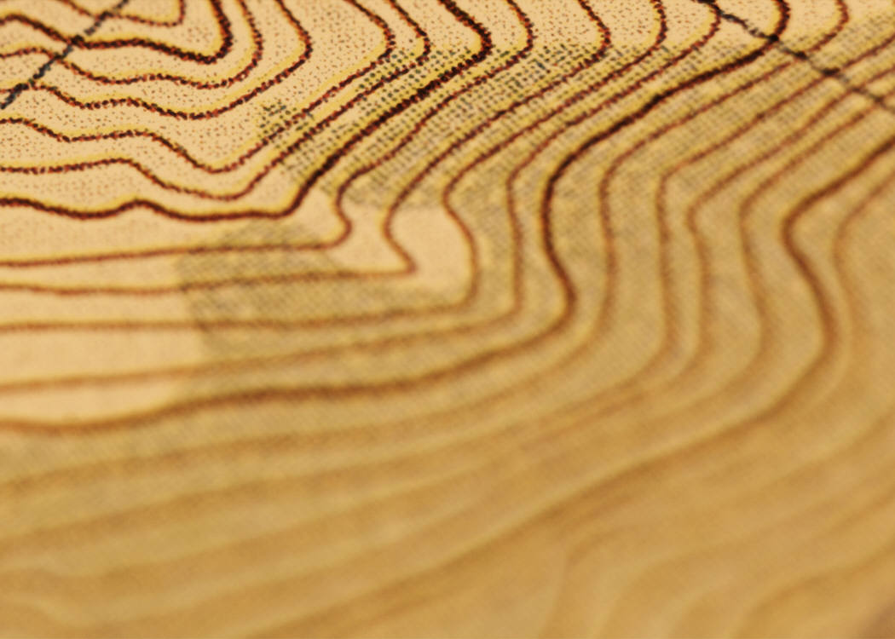
Prompt: Consider the process of making your topographic map. What was the most difficult part? What information is reflected in your topographic map? Where does your map illustrate the effects of erosion and deposition? What do you want to know now?
___________________________________________________________________________________________________________________________________________________________________________________________________________________________________________________________________________________________________________________________________________________________________________________________________________________________________________________________________________________________________________________________________________________________________________________________________________________________________________________________________________________________________________________________________________________________________________________________________________

Student Name: ____________________________________
Page  # | Page Description: | √
1 | Project Folder Checklist
2 | Personal Workplace Skills Survey (1)
3 | Personal Goal Setting I
4 | Movie Brainstorming
5 | Game Brainstorming
6 | Project Task Chart
7 | My Learning Log
8 | My Learning Log
9 | My Learning Log
10 | My Learning Log
11 | Personal Goal Setting II
12 | My Learning Log
13 | My Learning Log
14 | My Learning Log
15 | My Learning Log
16 | Topographic Maps
17 | Personal Workplace Skills Survey (2)
18 | Final Evaluation
19 | Content:
20 | Content:
21 | Content:
22 | Content:
23 | Content:
24 | Content:
25 | Content:
26 | Content:
27 | Content:
28 | Content:
29 | Content:
30 | Content:


Prompt: Consider everything in your Project Journal. What have you learned about US geography over the course of this unit?
__________________________________________________________________________________________________________________________________________________________________________________________________________________________________________________________________________________________________________________________________________________________________________
What have you learned about your own learning?
__________________________________________________________________________________________________________________________________________________________________________________________________________________________________________________________________
What goals do you have for your own learning?
______________________________________________________________________________________________________________________________________________________________________________________________________________
What would you still like to know?
__________________________________________________________________________________________________________________________________________________________________________________________________________________________________________________________________________________________________________________________________________________________________________
If you were teaching this unit what would you change?
__________________________________________________________________________________________________________________________________________________________________________________________________________________________________________________________________
How do you see your new learning relating to the “real world”?
__________________________________________________________________________________________________________________________________________________________________________________________________________________________________________________________________________________________________________________________________________________________________________________________________________________________________________________________________________________

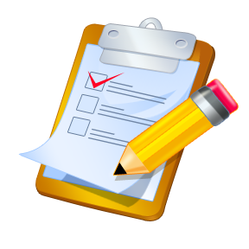
Directions: Read each statement in the far left-hand column. Consider how this behavior applies to you. Place a checkmark in the descriptor closest to your performance. As a student you are just beginning to focus on these skills. Your teacher does not expect you to have mastered these. This survey will help you self-assess and then allow you to set age-appropriate goals. We are in this together!
 | A Personal  Strength | Making  Progress | Just  Started | Need to  Start
When solving problems I am comfortable in making changes.
Throughout a task I stop along the way to evaluate my work and make changes.
I consider more than one way to complete a task.
I consider the input and opinions of my peers.
If something isn’t working I am ok with abandoning the idea.
I know how to adjust time and materials needed when I to make changes.

Student Name: _____________________ Date: _____________________
Prompt: You just completed the Personal Workplace Skills Survey. Based upon your responses, select one or two areas on which you would like to focus and improve. In writing, explain the following:
- What are the areas you’ve selected for self-improvement?
- Why do you believe these are most important for your focus?
- What steps are you going to take to get there?

______________________________________________________________________________________________________________________________________________________________________________________________________________________________________________________________________________________________________________________________________________________________________________________________________________________________________________________________________________________________________________________________________________________________________________________________________________________________________________

Project Description:

Person(s) Assigned: | Task:

My Learning Log:
Date:
Content Learning:

Metacognative Learning:

Questions I need to Ask:

Teacher
Response:

My Learning Log:
Date:
Content Learning:

Metacognative Learning:

Questions I need to Ask:

Teacher
Response:

Prompt: You have been working focused on improving your personal workplace skills. Take a minute to look back to the survey you completed and the goals you set for yourself. Please write and answer the following questions:
- How are you doing in working towards your goals?
- What are the successes you’ve had?
- What changes might you need to make in your plans for improvement?

___________________________________________________________________________________________________________________________________________________________________________________________________________________________________________________________________________________________________________________________________________________________________________________________________________________________________________________________________________________________________________________________________________________________________________________________

___________________________________________
___________________________________________
___________________________________________
___________________________________________
___________________________________________
___________________________________________
___________________________________________
___________________________________________
___________________________________________
___________________________________________
___________________________________________
___________________________________________
___________________________________________
___________________________________________
___________________________________________
___________________________________________
___________________________________________
___________________________________________

Note: These times are approximate.
Day 1 | Entry Event  (Students have completed half of the FOSS Landforms kit.)
Day 2 | Students given time to talk among themselves about the entry event. Allows preparation for Day 3.
Day 3 | Class will express what they KNOW for the successful completion of the entry event, as well as what they NEED to KNOW. Their responses will drive what the teacher plans. If students need to know something—that is what the teacher will teach.  Students will complete their Personal Workplace Skills Survey and Personal Goal Setting I form in the Project Folder.
Day 4-7 | Lessons based on student need. Students will begin researching the physical features of their region. These will become part of their topographic map.  **Teacher should ask students to complete My Learning Log entries throughout the project.
Day 8-10 | Groups will begin planning and drawing to complete their plaster 3-D topographic map. Display in school.  Complete Topographic Journal Entry in Project Folder.
Day 11-15 | Students will research in preparation for movie and game. Teacher will also provide whole group, small group, and individual lessons based on the Know/Need to Know chart as well as informal assessments.
Day 16 | Teacher will provide an introductory lesson on how to use Windows MovieMaker. Go over MovieMaker rubric. Answer student questions.
Day 17-19 | Create Region Movie. Teacher should meet with small groups, using rubric, to provide scaffolding to ensure success.
Day 20 | Groups will begin planning and working on game. Teacher will go over Customer Satisfaction Survey.
Day 21-23 | Work on games.
Day 24-25 | Play games created by other groups. Complete Customer Satisfaction Survey.
Day 26 | Make adjustment to games based upon feedback.
Day 27 | Prepare all projects for submission to TAAA.  Complete all materials and evaluations in journal.  Submit everything for final assessment.

Prompt: You’ve spent the past few weeks focused on improving your personal workplace skills. Review your first and final survey, your two journal entries, and evaluate your progress. Consider the following:
- In what areas were you most successful in meeting the goal(s) you set for yourself?
- Upon what will you continue focusing?
- How do you see these goals impacting your life beyond school?
______________________________________________________________________________________________________________________________________________________________________________________________________________________________________________________________________________________________________________________________________________________________________________________________________________________________________________________________________________________________________________________________________________________________________________________________________________________

