Name: _____________________________ Date: __________________

HISTORICAL CONTEXT

As the American Revolution ended, the United States began to emerge as an independent world power. It became the job of the first few presidents to guide the young nation through this difficult time. Through their actions, they influenced the future of American foreign policy.

DIRECTIONS

The question is based on the accompanying documents (1-5). This question is designed to test your ability to work with historical documents. Some of the documents have been edited for the purposes of the question. As you analyze the documents, take into account the source of each document and any point of view that may be presented in the document.

TASK

Using information form the documents and your knowledge of social studies, answer the questions that follow each document in Part A. Your answers to the questions will help you write the Part B essay in which you will be asked to:

- Identify three policies
- For each of the policies you identified, explain why the president believed that policy would benefit the United States.

Part A (15 points)

DOCUMENT #1:

Directions: Study the quote below and then answer the questions that follow.

President Washington’s Farewell Address
I have already intimated to you the danger of political parties in the state, with particular reference to the fouding of them on geographical discriminations.Let me now warn you against them….

It is our true policy to steer clear of permanent alliances with any portion of the foreign world. There can be no greater error than to expect upon real favors from nation to nation…

- According to Washington what kind of relations should the United States extend to foreign nations?
________________________________________________________________________

________________________________________________________________________

- Why do you suppose President Washington warned America against establishing political parties?
________________________________________________________________________

________________________________________________________________________

- In Washington’s Farewell address, he warns future United States presidents to remain isolated when
dealing with foreign nations. Why do you believe he thought this was necessary for America to be
successful?

________________________________________________________________________

________________________________________________________________________

DOCUMENT #2:
Directions: Study the map and quote below and then answer the questions that follow.

Letter from President Thomas Jefferson to William Dunbar, July 17, 1803

Before you receive this, you will have heard, through the channel of the public papers, of the cession of Louisiana by France to the United States…That the treaty may be ratified in time, I have found it necessary to convene Congress on the 17th of October…
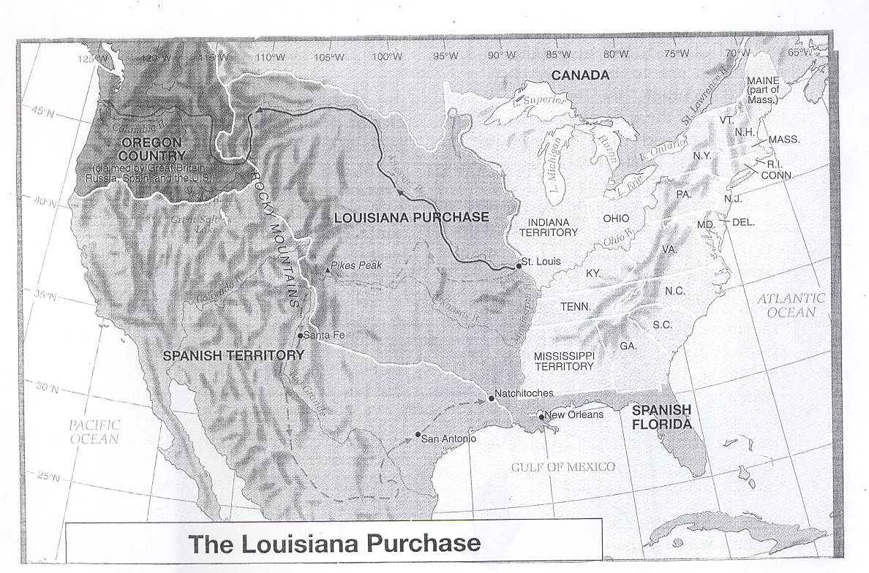
- In the letter, Thomas Jefferson states “the treaty may be ratified [between France and USA] in time”. If the agreement signed is called a treaty, does that give Pres. Jefferson the constitutional right to make the purchase? Explain your answer.
________________________________________________________________________

- Explain one (1) way the Louisiana Purchase benefited the United States?
________________________________________________________________________

________________________________________________________________________

DOCUMENT # 3:

Directions: Study the caption and chart below and then answer the questions that follow.
The United States was very angry with Britain and France for interfering with trade. In 1807, President Jefferson convinced Congress to pass the Embargo Act. This law stated that Americans could not trade with other countries. Jefferson thought the embargo would hurt France and Britain by cutting off their supplies. However, it also hurt Americans by reducing trade. (See graph). The law was replaced by the Nonintercourse Act. It allowed Americans to trade with all nations except France and Britain.

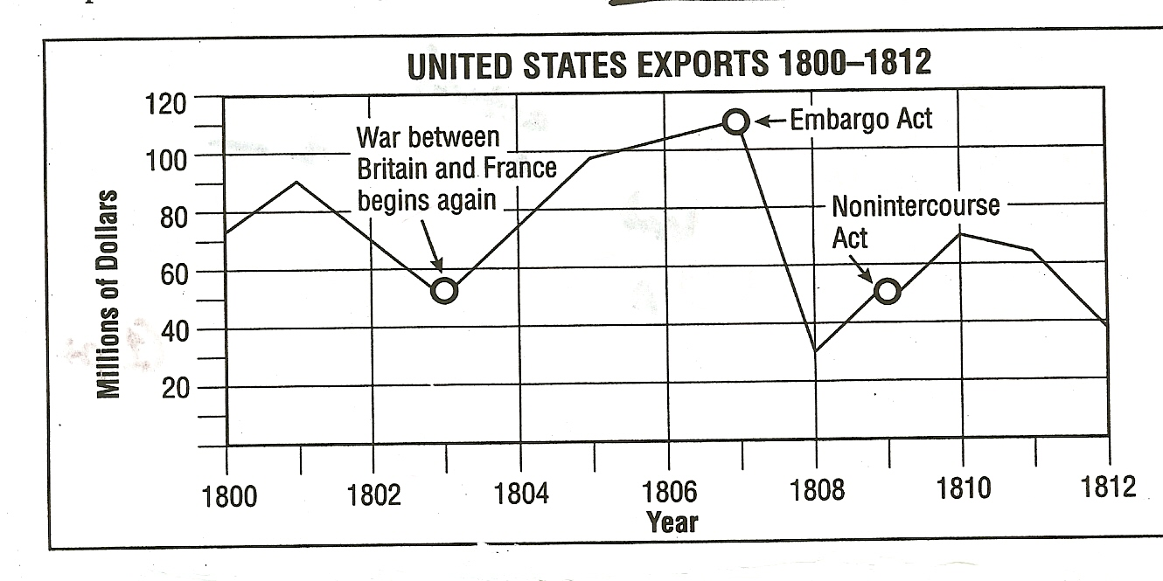
- How much money did the United States lose in exports in the first year after the Embargo Act was passed?

________________________________________________________________________

________________________________________________________________________

- Describe the effect the Embargo Act had on American trade?

________________________________________________________________________

________________________________________________________________________

DOCUMENT # 4:

Directions: Study the quote and answer the questions that follow.

“British cruisers (ships) have been in the practice of violating the rights and the peace of our coasts…Our commerce has been plundered (taken) in every sea, the great staples of our country have been cut off from our legitimate markets and a destructive blow aimed at our agricultural and maritime interest and now we behold…on the side of Great Britain a state of war against the United States.”

President James Madison sends a war message to Congress June 1, 1812.

- After reading the message, do you believe Pres. Madison was for going to war with Britain or against?
________________________________________________________________________

- List two complaints the President is making in this quote?

1.______________________________________________________________________

2.______________________________________________________________________

DOCUMENT # 5
Directions: Study the quote and cartoon below and answer the questions that follow.

President Monroe Enforces The Monroe Doctrine - 1823
President James Monroe boldly proclaimed The Western Hemisphere
Closed to European colonization.
If Europe observed this, The U.S. would not intervene in Europe’s affairs.
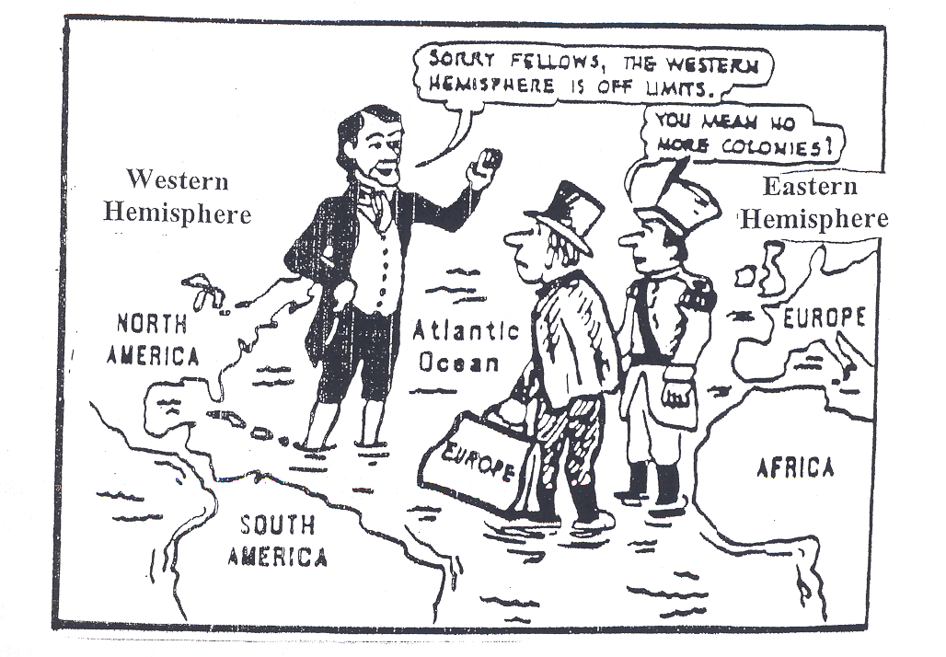

“…the American continents, by the free and independent condition which they have assumed and maintain, …henceforth not to be considered as subjects for future colonization by any European powers…”

President Monroe’s message to Congress, December 2, 1823

- Who does the man in the black suit represent? ________________________________________________________________________

- According to the quote, what are the European powers prohibited to do in the American continents?
________________________________________________________________________
________________________________________________________________________

- Why would the United States want to keep European Nations out of North and South America? ________________________________________________________________________

________________________________________________________________________

________________________________________________________________________

Part B (10 points)

Essay

Directions: Write a well-organized 5-paragraph essay that includes an introduction, several paragraphs, and a conclusion. Use evidence from at least three documents in the body of the essay to answer the following question. Support your response with relevant facts, examples, and details. Include additional outside information if possible (class notes, book reference, etc.).

Historical Context and Essay Prompt:
The first few Presidents of the United States influenced the future of American foreign policy to become an isolated country that focused on its own issues. Using the information from the documents and your knowledge of social studies, identify (3) three actions these presidents took and explain how it kept America isolated from European nations.

Guidelines:
In your essay, be sure to:

- Address all aspects of the Task by accurately analyzing and interpreting at least three documents.
- Incorporate information from the documents in the body of the essay.
- Incorporate relevant outside information.
- Support the theme with relevant facts, examples, and details.
- Use a logical and clear plan of organization.

Name: _______________________ Date: ____________________

Essay

__________________________________________________________________

__________________________________________________________________

__________________________________________________________________

__________________________________________________________________

__________________________________________________________________

__________________________________________________________________

__________________________________________________________________

__________________________________________________________________

__________________________________________________________________

__________________________________________________________________

__________________________________________________________________

__________________________________________________________________

__________________________________________________________________

__________________________________________________________________

__________________________________________________________________

__________________________________________________________________

__________________________________________________________________

__________________________________________________________________

__________________________________________________________________

__________________________________________________________________

