FREE PRESCHOOL
FRASER PUBLIC SCHOOLS
FOCUS FOUR PRESCHOOL
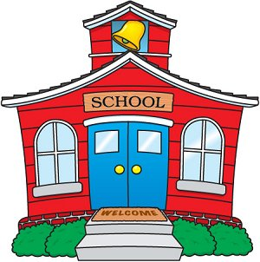

Focus Four – A school readiness program designed to prepare children for kindergarten and to pave the way for success in school.

Who May Attend:
Children must live in Macomb County. (Fraser Public School families are prioritized first)
Children must be 4 years old by September 1, 2020
Children must meet Income Guidelines

What is it like?
Meets Monday through Thursday: 3 hours a day
16 Children in the class (2 teachers)
Age Appropriate pre-kindergarten readiness activities
Parent participation and home visits are required
Transportation is supplied
Located at Dooley

What does it cost?
FREE to children who qualify (if your school age child receives free or reduced lunch than you may qualify)
Funded through a State of Michigan grant

What do I do next?
Call Mrs. Jill Rice at 439-7665 for information regarding qualifications and registration.


