What Time Is It?
(Time to get a new watch!)

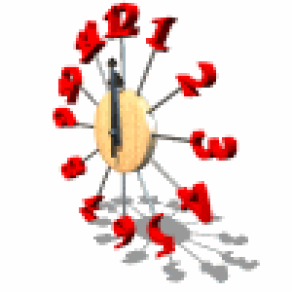

Practice telling time with some of the games below.

Move the Hands
http://www.amblesideprimary.com/ambleweb/mentalmaths/clock.html

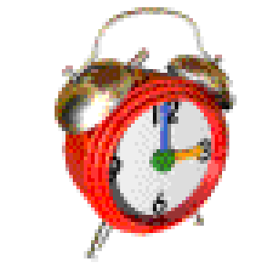

Clock Flash Cards
http://www.aplusmath.com/Flashcards/AnalogClock.html

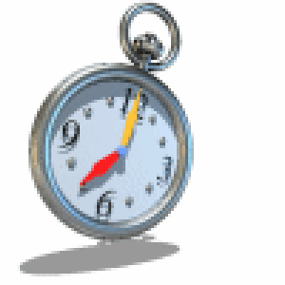

Time to Play Games!
http://classroom.jc-schools.net/basic/math-time.html

