WLHS / Biology

Unit Review / Study Guide: CELLS and CELL PROCESSES (Chapter 7)

1. List the three parts of the cell theory
a.

b.

c.

2. Explain the differences between prokaryotic and eukaryotic cells in terms of their parts and what types of organisms fit into that group.
Cell Type | Parts | Organisms
Prokaryotic

Eukaryotic

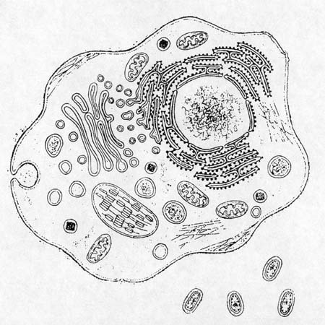

3. Compare the cellular characteristics of plant and animal cells. (list at least 4 differences)

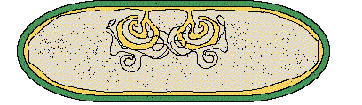
4. List all of the cell parts that have something to do with the nucleus.

5. List all of the cell parts that have to do with storage, packaging and transport.

6. List all of the cell parts that have to do with energy production or conversion.

7. What do lysosomes do?

8. What do ribosomes do?

7. Draw a plant cell, label the parts below and describe each of their functions.

lysosome smooth ER Golgi apparatus cell wall rough ER
nuclear envelope vacuole plasma membrane chloroplast ribosome
mitochondria nucleus nucleolus

8. Describe how an animal cell and a plant cell are different:

Characteristic | Plant Cells | Animal Cells
Shape

Organelles

Outer covering

9. Label The Parts of a typical light microscope (and know their uses).
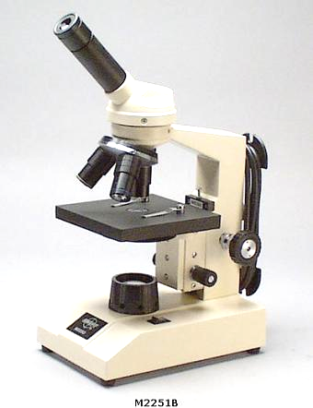
__________ __________
__________
__________
__________
__________
__________
__________ __________
__________ __________

10. Describe the steps you should follow to properly view a specimen with a light microscope.

11, What is passive transport?
a. Give 2 examples.

12. What is active transport?
a. Give 2 examples.

13. Draw and label a cell membrane. Point out examples of structures -of and within- the membrane that support its function in the life of a cell.

13. What passes freely through the cell membrane?

14. What is osmosis?

15. The core of all cell membranes is a double-layered sheet called a(an) ______________________________.

16. What is the function of the carbohydrate chains (glycoproteins) attached to the outside of the membrane?

Type of solution | Hypertonic | Isotonic | Hypotonic
Picture of a cell after water movement.

What happened?

If you do not already have flashcards for the vocabulary in Chap 7, it would be wise to make them. Knowing those terms is a good start. Understanding the connections between them is the big ticket to doing well. Practice pulling 3-5 flashcards from the deck and either drawing a T-chart for them or creating a concept map to connect them. Practice making the connections. It would also be good practice to make a concept map of the 7 properties of life and then figure out which organelles support which property or properties of life.
There are two self assessments at the end of the chapter in the text book. Not that the exam will come straight from the text, but you’d be silly to not practice with these two exams, and keep practicing until you know the material.

