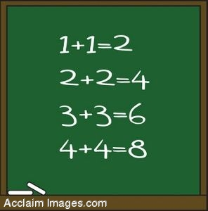Addition  Addition Pyramid  Addition Hidden Picture  Addition Math O  Math Baseball  Batter's Up Baseball  Math Mayhem  Mathcar Racing  Operation Order  Line Jumper  Function Machine  Space Shuttle Launch  Save the Math Apples  Robotic Calculator  Tic Tac Toe Squares  Power Football  Spacey Math  Number Monster  Arthim Attack  Math Journey  3 Monkeys Addition | Subtraction  Math Baseball  Math Mayhem  Mathcar Racing  Operation Order  Line Jumper  Function Machine  Space Shuttle Launch  Save the Math Apples  Robotic Calculator  Tic Tac Toe Squares  Power Football  Spacey Math  Number Monster  Arthim Attack  Math Journey
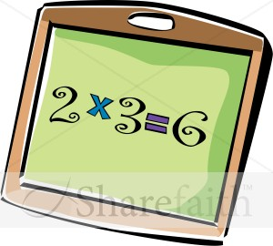Multiplication  Function Machine  Batter's Up Baseball  Math Mayhem  Operation Order  Mathcar Racing  Factor Game  Interactive Times Table  Multiplication Math O  Multiplication Mystery  Multiplication Magician  Multiplication.com  Product Game  Arrays  Lemonade Larry  Multiplication Flashcards  Space Shuttle Launch  Save the Math Apples  Robotic Calculator  Tic Tac Toe Squares  Power Football  Spacey Math  Number Monster  Arthim Attack  Math Journey | 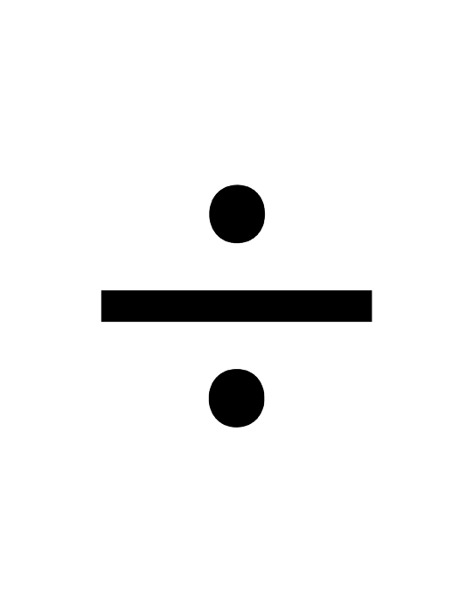 Division  Math Mayhem  Mathcar Racing  Operation Order  Function Machine  Division Math O  Division Bingo  Space Shuttle Launch  Save the Math Apples  Robotic Calculator  Tic Tac Toe Squares  Power Football  Spacey Math  Number Monster  Arthim Attack  Math Journey
Numbers &  Number Patterns  Number Cracker  Guess the Number  Skip Counting Game  Patterns  Cookie Dough  One False Move | 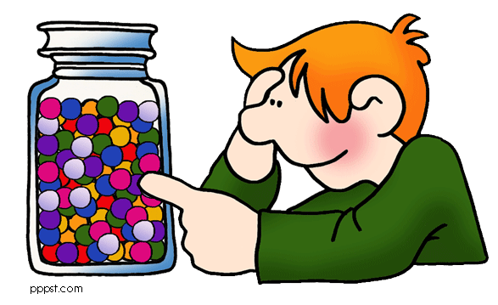 Estimating &  Rounding  Rounding Seashells  Rounding Flashcards  Rounding Decimals  Rounding Numbers:  Rounding Decimals To:  Rounding Decimals  Estimating
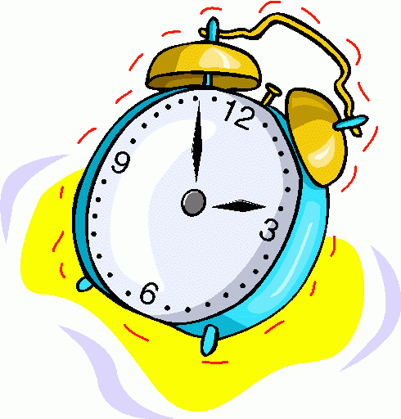Telling Time  Time Clock  What Time is it?  The Right Time  Stop the Clock Level 1  Stop the Clock Level 2  Stop the Clock Level 3  Stop the Clock Level 4  Stop the Clock Level 5 | Money &  Making Change  Change Maker  Lemonade Stand  Coffee Shop  Lemonade Larry  Counting Coins Money  Counting Money  How Many Cents?  Counting Change  Cash Out  Spending Spree game  Practice Counting Money  Learn To Count Money  Change Maker  Counting Money  Counting Money  Grandpa's Game  Discovering Coin Values  Let's Do Lunch  Let's Go Shopping
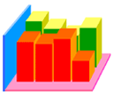 Graphing  Create a Graph  Bugs in the System  Let's Graph | 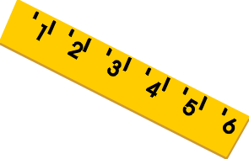Measurement  The Ruler Game  Shape Surveyor  Measure It!  Perimeter and Area Booster
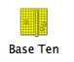Place Value &  Decimals  Place Value Game  Base 10 Blocks  Decimal Jeopardy  Place Value Puzzler  Naming Decimals  Adding Decimals  Subtracting Decimals  Multiplying Decimals  Dividing Decimals  Rounding Decimals  Place Values  Comparing Decimals  Mystery Picture | 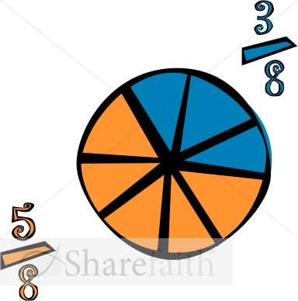 Fractions  Basic Fractions  Adding Fractions  Comparing Fractions  Comparing Fractions 2  Converting Fractions  Subtracting Fractions  Pizza Party  Name that Fraction  Fractron
 General Math Links
Sheppard Software
Arcademic Skill Builders
Math Slice
Math Manipulatives
Study Island
Fun Brain
I Know That
Telling Time
Kids Bank
Kings Math
AAA Math

