Teachers:
These flashcards were created by Kelly Riedell for students in Biology at Brookings High School.

Copy onto cardstock. Have students put labels on back, cut apart, punch with a hole puncher, and string with a piece of yarn.

You can also copy one sided to two sided with the labels on back for extras to keep in class, tutor room, or for students who need notetaking assistance.

This organelle looks like a stack of Sac of digestive enzymes that
pancakes. It modifies, sorts, & packages breaks down food or unwanted
molecules the cell makes for export. cells or cell parts.

Storage space for food, waste, enzymes, Membrane sacs inside chloroplasts
that is larger in plant cells that contain the enzymes for
and smaller in animal cells. photosynthesis

Contains the genetic material (DNA) Dark spot in the nucleus of a
& acts as the control center of the cell non-dividing cell where RNA for ribosomes is made

Molecule used by cells to Powerhouse of the cell with its own store and transport energy for DNA that burns glucose for energy and cell activities stores it as ATP

Found outside the cell membrane in Photosynthesizing organelle that
plants and bacteria, this supports and contains chlorophyll in thylakoid protects cells. sacs & its own DNA found in plants

Membrane system which modifies Cell which has a nuclear
& transports molecules made on its membrane and membranes
attached ribosomes around its organelles

Folded inner membrane in Phospholipid & protein bilayer
mitochondria which increases surface that surrounds ALL cells and controls
area for chemical reactions which molecules enter or leave

Cell which has NO nucleus or Small internal structure in a cell
organelles surrounded by membranes which carries out a specific job

Molecule with a polar head and Network of microtubules and
two hydrophobic tails which microfilaments that give the cell
forms cell membranes shape, support, and help in movement

Many, short hair-like structures made Few, long hair-like structures
of microtubules that are attached to made of microtubules that are
the outside of cells which help move attached to the outside of cells
the cell or move things past the cell which help move the cell

Small structures, free or attached to Network of membranes WITHOUT
ER, which synthesize proteins RIBOSOMES which regulate calcium,
make steroids, & break down toxins

DNA and proteins that are spread Gel-like material containing organelles
out in the nucleus of non-dividing found between the nucleus and cell
cells membrane

DNA and proteins that are scrunched Membrane proteins with
up into rod shaped structures in carbohydrates attached that help cells
dividing cells recognize “self”

Log-like structures that organize the Describes membranes which allow
spindle and guide chromosomes apart certain substances to pass through
in dividing cells but keeps other out
Openings in the nuclear membrane Group of similar CELLS that work
that allow molecules to pass in together to carry out a specific job
and out of the nucleus

Membrane that surrounds the Groups of ORGANS that work
genetic material & controls together to carry out a specific function
what enters and leaves nucleus

Group of different TISSUES that
work together to carry out a specific
function

LYSOSOMES GOLGI BODY (APPARATUS)

THYLAKOIDS VACUOLE

NUCLEOLUS NUCLEUS

MITOCHONDRIA (ATP) ADENOSINE
TRIPHOSPHATE

CHLOROPLASTS CELL WALL

ROUGH ENDOPLASMIC
EUKARYOTE RETICULUM (RER)

CELL
MEMBRANE CRISTAE

ORGANELLE PROKARYOTE

CYTOSKELETON PHOSPHOLIPID

FLAGELLA CILIA

SMOOTH ENDOPLASMIC RIBOSOMES
RETICULUM (SER)

CYTOPLASM CHROMATIN

GLYCOPROTEIN CHROMOSOMES

SELECTIVELY PERMEABLE CENTRIOLES
Semi-permeable

TISSUES NUCLEAR PORES

ORGAN SYSTEMS NUCLEAR
ENVELOPE

ORGAN

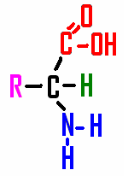
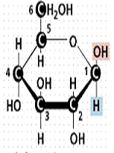

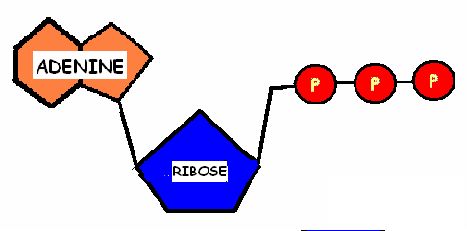
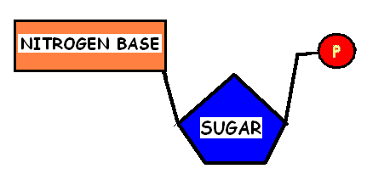

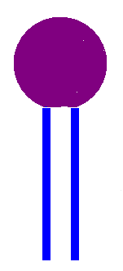
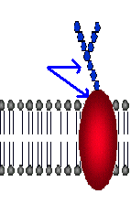

GLUCOSE AMINO ACID

NUCLEOTIDE ATP

GLYCOPROTEIN PHOSPHOLIPID

