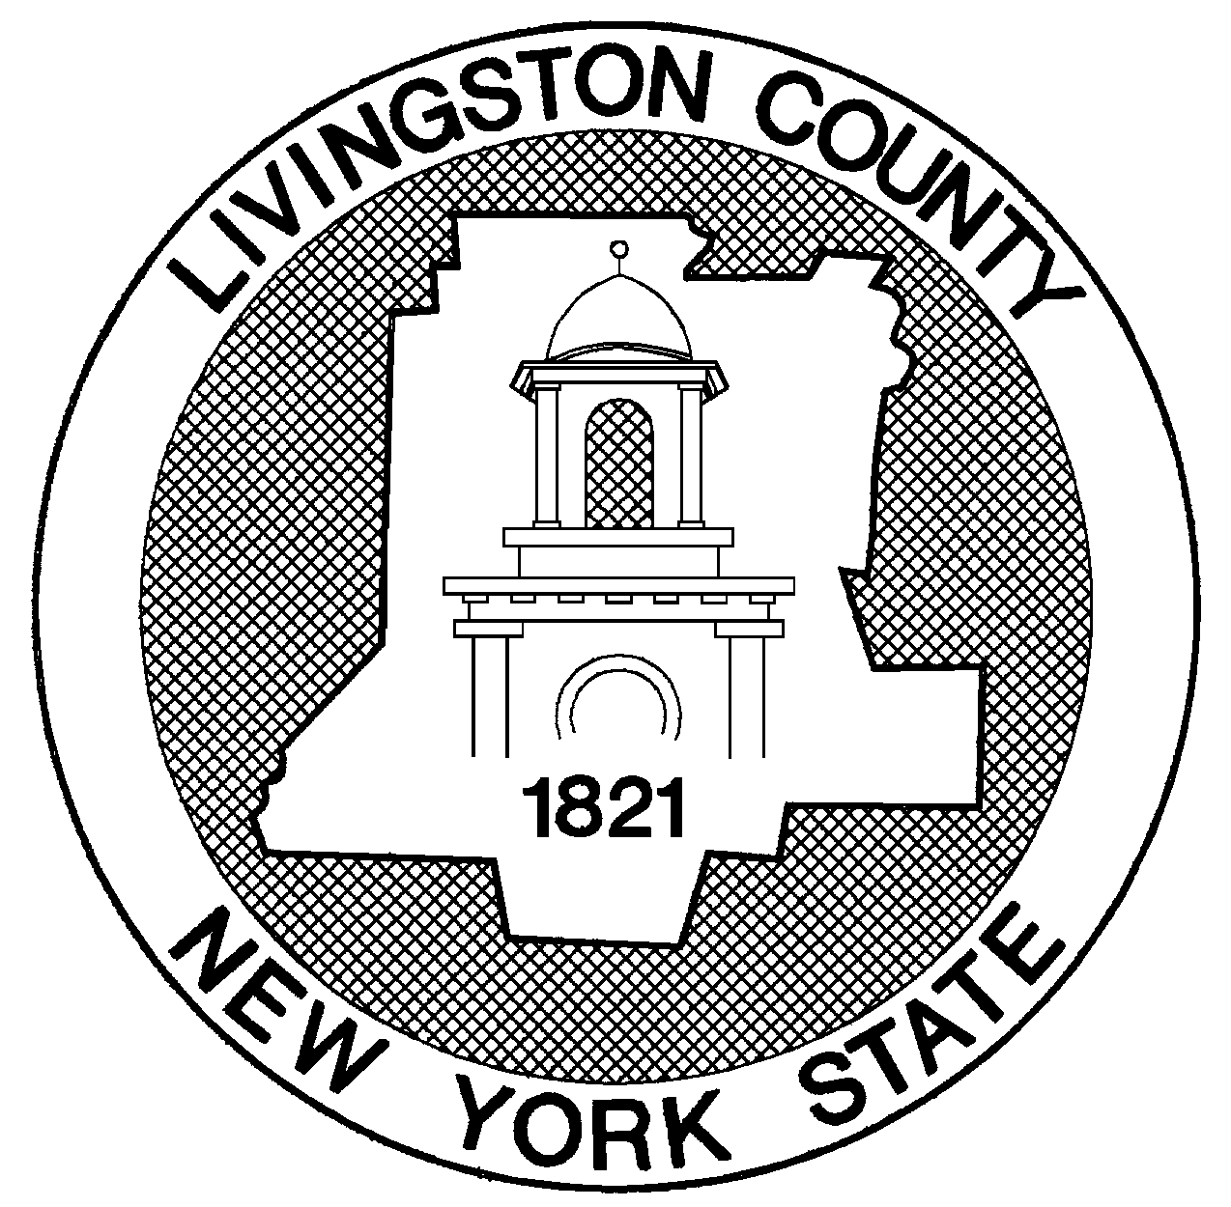
LIVINGSTON COUNTY PERSONNEL OFFICE
ANNOUNCES THE FOLLOWING
CIVIL SERVICE EXAMINATION

FOR

SOCIAL WORK ASSISTANT - OC
EXAM NUMBER: 62-198

April 3, 2017 May 13, 2017

LAST FILING DATE EXAMINATION DATE

PAY RANGE: $20.92 - $28.47

LOCATION: Center for Nursing and Rehabilitation, Mt. Morris, NY

DUTIES: This position exists in a skilled nursing facility and requires the performance of social work in aiding patients with social, emotional and related difficulties associated with their medical condition. The work is performed under supervision of a qualified master’s level social worker under New York State regulations who is available either on a consulting or direct supervisory basis. Independence of action varies depending on whether or not the incumbent is under direct daily supervision. Employees in this class confer with professional staff members in other departments of the County service and public or private agencies outside of the facility to obtain social services for patients. The incumbent does related work as required.

REQUIRED QUALIFICATIONS:

Applicants must meet the following requirements to be approved to take the exam:
Residency – Candidates must have been legal residents of the following jurisdiction(s) for at least four months immediately preceding the date of the written test:
- Livingston County

MINIMUM QUALIFICATIONS:

- Graduation from a regionally accredited or New York State registered four year college or university
with a Bachelor’s degree in social work; or
2. Graduation from a regionally accredited or New York State registered two year college with an Associate’s degree in human services; or

3. Graduation from high school or possession of a GED diploma and four years of full-time, paid experience in social work in a social work agency adhering to acceptable standards; or

4. An equivalent combination of training and experience.

#62-198 – Social Work Assistant – OC

APPLICATION PROCESS:

Submit to the Livingston County Personnel Office by the last filing date:
- A fully completed Livingston County Application for Examination or Employment, and
(2) The exam fee or waiver request.

Applications may be obtained from the Livingston County Personnel Office or on the Personnel Department page of the Livingston County website. If you are applying for more than one exam, a separate application is required for each exam.

APPLICATION FEE: $10.00 Fee must be paid in cash, money order, certified check or cashier’s check. Write the examination number on your certified/cashier’s check or money order. Personal checks, credit cards and debit cards are not accepted.

APPOINTING EMPLOYER(S):
Appointing employers may include: Livingston County, any town or village within Livingston County, any school district under Livingston County’s Civil Service jurisdiction, and Genesee Valley BOCES

Exam Subjects, Retest Policies and Scoring, Etc.

SUBJECTS OF EXAMINATION: A written test designed to evaluate knowledge, skills and/or abilities in the following areas:

- EDUCATING AND INTERACTING WITH THE PUBLIC – These questions test for knowledge of techniques used to interact effectively with individuals and/or community groups, to educate or inform them about topics of concern, to publicize or clarify agency programs or policies, to negotiate conflicts or resolve complaints, and to represent one’s agency or program in a manner in keeping with good public relations practices. Questions may also cover interacting with others in cooperative efforts of public outreach or service.

- INTERVIEWING – These questions test for knowledge of the principles and practices employed in obtaining information from individuals through structured conservations. These questions require you to apply the principles, practices, and techniques of effective interviewing to hypothetical interviewing situations. Included are questions that present a problem arising from an interviewing situation, and you must choose the most appropriate course of action to take.

- PREPARING WRITTEN MATERIAL – These questions test for the ability to present information clearly and accurately, and to organize paragraphs logically and comprehensibly. For some questions, you will be given information in two or three sentences followed by four restatements of the information. You must then choose the best version. For other questions, you will be given paragraphs with their sentences out of order. You must then choose, from four suggestions, the best order for the sentences.

#62-198 – Social Work Assistant - OC

- PRINCIPLES AND PRACTICES OF SOCIAL CASEWORK – These questions test for knowledge of the principles and practices used to provide casework services. Questions may cover such topics as developmental, mental, physical, and social disabilities and/or impairments; assessing client strengths and needs; building and maintaining relationships with clients and their support network; ability to make and advocate for appropriate service referrals; ability to provide advocacy and support; and professional and ethical concerns in casework practice.

Admission notice: All applications will be reviewed after the application deadline. If there is a problem with your application, you will be notified in writing and given an opportunity to submit additional information to support your application. If there are no problems with your application, you will be sent an admission notice approximately one week before the exam date. If you have not received your admission notice three days before the date of the exam, call the Livingston County Personnel Office.

PERMISSIBLE TOOLS/EQUIPMENT FOR USE DURING WRITTEN EXAM: Unless otherwise notified, candidates are permitted to use quiet, hand-held solar or battery operated calculators. Devices with typewriter keyboards, such as computers, spell checkers, personal digital assistants, address books, language translators, dictionaries, phones and any similar devices are not permitted. You may not bring books or other reference materials into the exam room. Any phones that are brought into the exam room must be out of sight and silenced for the duration of the exam. Candidates may not use such phones in any way during the exam.

EXAM GUIDE: The New York State Department of Civil Service has not prepared a test guide for this examination. However, candidates may find information in the publication “How to take a written test” helpful in preparing for this test. This publication is available on line at: www.cs.ny.gov/testing/localtestguides.cfm.

EXAMINATION RATING: This written examination is being prepared and rated by the New York State Department of Civil Service in accordance with Section 23-2 of the Civil Service Law. The provisions of the New York State Civil Service Rules and Regulations dealing with the rating of examinations apply to this written test.

GENERAL INFORMATION

EDUCATIONAL DEGREE: If an educational degree is a minimum qualification for this title, you may be
approved to take the examination if you have not received the degree but expect to receive it no later than
the date of the examination. In order to be conditionally approved, you will need to clearly indicate on
your application for examination the degree you expect to receive and the date on which you expect to
receive it. If your application is conditionally approved, you will be issued an admission letter and will
be permitted to take the examination on the scheduled date. Within thirty (30) calendar days following
the date of the examination, you must provide to the Livingston County Personnel Office written proof of
your receipt of the required educational degree. Failure to do so will result in the disapproval of your
examination application. Candidates whose applications are disapproved will not have their names
placed on the eligible list resulting from the examination, regardless of their performance on the
examination, nor will they be eligible for permanent appointment to positions for which such eligible list
is certified. Exam fees will not be refunded.

#62-198 – Social Work Assistant – OC

EXAM LOCATION: This exam will be held at the Livingston County Government Center unless another location is noted in the admission notice.

TAKING Multiple Exams: Persons also applying for examinations offered by another Civil Service agency within New York, which are held on the same date, must complete a cross filer form, available from the Livingston County Personnel Office, which will provide for special arrangements.

Arrangements must be made to take all examinations at one test site. Unless this form is filed with the Livingston County Personnel Office at least three weeks prior to the exam date, we cannot ensure that
such arrangements will be made. Candidates taking multiple exams on the same date with Livingston County do not have to file a cross-filer form.

Candidates taking more than one exam in a different exam series will be allowed the specified length of time for each exam, up to a maximum of eight hours. Example: candidates taking one exam which
allows six hours and another exam in a different series which allows four hours, must complete both tests in eight hours, but may spend no more time on each exam than the time allotted for that exam.

APPLICATION FEE WAIVER: A waiver of application fee will be allowed if you are unemployed and primarily responsible for the support of a household. In addition, a waiver of application fees will be
allowed if you are determined eligible for Medicaid, or receiving Supplemental Security Income payments, or Public Assistance (Temporary Assistance for Needy Families/Family Assistance or Safety Net Assistance) or are certified Job Training Partnership Act/Workforce Investment Act eligible through
a State or local social service agency. All claims for application fee waiver are subject to verification. To request a fee waiver, complete a “Request for Application Fee Waiver and Certification” form and submit it with your application by the close of business on the last filing date as listed on this announcement. Application waiver forms are available at the Livingston County Personnel Office.

VETERANS CREDITS: Additional credits are available to veterans who meet certain established requirements. Veterans who have not used their credits may make application for their use. The Veterans Credits application form is available at the Personnel office or on our website: www.livingstoncounty.us and must be accompanied by a copy of the candidate’s DD214 form.

CHILDREN OF FIRE FIGHTERS AND POLICE OFFICERS KILLED IN THE LINE OF DUTY: In conformance with Section 85-a of the Civil Service Law, children of firefighters and police officers killed in the line of duty shall be entitled to receive an additional ten points in a competitive exam for original appointment in the same municipality in which his or her parent served. If you are qualified to participate in this exam and are a child of a firefighter or police officer killed in the line of duty in this municipality, please inform this office when you submit your application for examination. A candidate claiming such credit has a minimum of
two months from the last filing date to provide the necessary documentation to verify additional credit eligibility. No credit may be added after the eligible list has been established.

DISABILITY ACCOMMODATIONS: Any person with a disability requesting reasonable accommodations in order to participate in examinations will be accommodated. To request accommodation, candidates must complete a Livingston County Civil Service Exam Accommodation Request form and submit it to the Livingston County Personnel Office at least two weeks prior to the date of the exam. Forms may be obtained from the Personnel Office.

#62-198 – Social Work Assistant – OC

RELIGIOUS OBSERVER ACCOMMODATIONS: If you need an alternate test date because you are a Religious Observer (for religious reasons, cannot be tested on date of examination(s)), you must provide written notice of your need to the Livingston County Personnel Office by the last filing date. Such
notice must include: (1) the exam title, (2) the exam number, and (3) the reason(s) why you cannot take the exam on the scheduled date. The request must be supported by documentation regarding your need.

Active Military Members: Special testing arrangements may be available to applicants who are active military members. For further information contact the Livingston County Personnel Office before submitting an application.

ALTERNATE TEST DATE: Under very limited circumstances, a candidate may be allowed to take an exam on an alternate test date. If you cannot take the exam on the scheduled date, please consult the Livingston County Alternate Test Date Policy. A copy may be obtained from the Livingston County Personnel Office. (Please note that alternate test dates are not provided for continuous recruitment examinations.)

CANDIDATE NAME AND ADDRESS CHANGES: It is the responsibility of the candidate to notify the Livingston County Civil Service Office of any changes of name and/or address. NO attempt will be made to locate candidates who have moved.

EQUAL EMPLOYMENT OPPORTUNITY: Livingston County is an Equal Opportunity Employer and, as such, offers equal opportunities for all qualified applicants with no discrimination as to race, color, creed, sex, sexual orientation, national origin, disabilities or any other class protected by law.

PUBLIC EMPLOYERS UNDER LIVINGSTON COUNTY’S CIVIL SERVICE JURISDICTION: The following public employers are under Livingston County’s Civil Service jurisdiction and use Livingston County’s eligible lists to fill competitive class positions:

County: Livingston

Villages: Avon, Caledonia, Dansville, Geneseo, Leicester, Lima, Livonia, Mt. Morris, Nunda.

Towns: Avon, Caledonia, Conesus, Geneseo, Groveland, Leicester, Lima, Livonia, Mt. Morris, North Dansville, Nunda, Ossian, Portage, Sparta, Springwater, West Sparta, York.

Schools: Avon, Caledonia-Mumford, Dansville, Geneseo, Keshequa, Livonia, Mt. Morris, Wayland-Cohocton, York.

Special District: Genesee Valley BOCES.

FURTHER INFORMATION: Contact the Personnel Office or visit the County’s website at:
Livingston County Personnel Office
6 Court St., Room 206
Geneseo, NY 14454
(585) 243-7570
Livingston County website, Personnel Dept. page
www.livingstoncounty.us/departments.htm 3/1/2017

An “educational degree” is an Associate’s, Bachelor’s, Master’s or Doctorate degree issued by a New York State or regionally accredited college or university.

