Chemistry Final Exam Review

Stoichiometry

Good things to know:

- standard temperature and pressure (STP)
- Avogadro’s Number, mole
- atom, formula unit, molecule

Problems:
1. What is the formula mass of :
a. CH₄ b. C₆H₁₂O₆ c. Mg(ClO₃)₂

2. What is the mass of 7.03 moles of silver carbonate?

3. How many liters of space are occupied by 2.33 x 10²² molecules of methane (CH₄) gas at STP?

4. How many atoms are there in 10.3g of silver?

5. What is the percent composition of :
a. CO₂ b. CuSO₄

6. If you have 20.0g of a compound which is composed of 16.6g of potassium and 3.40g of oxygen,
what is the empirical formula?

7. If you have a compound which is composed of 43.7% phosphorus and 56.3% oxygen, and has a formula
mass of 284 g/mol, what is the empirical formula? What is the molecular formula?

8. Use the following equation: C₆H₁₂O_{6(s)} + 6 O_{2(g)} → 6 CO_{2(g)} + 6 H₂O_{(l)}

a. How many moles of carbon dioxide will you get if you begin with 2.50 mol of glucose?

b. How many liters of oxygen gas are needed to produce 0.430 mol of water at STP?

c. How many grams of water would you expect if you began with 15.0g of glucose?

d. How many liters of carbon dioxide would you expect if you began with 15.0g of glucose at STP?

9. 3 Fe_{(s)} + 4 H₂O_{(l)} → Fe₃O_{4(s)} + 4 H_{2(g)}

If you begin with 30.0g of iron and 25.0g of water:

a. What is the limiting reactant? What is the excess reactant?

b. How many grams of iron oxide and liters of hydrogen gas do you expect?

c. How many grams of the excess reactant will be left over?

Phases of Matter
Good things to know;
- solid, liquid, gas - Kinetic Theory of Phases; fluid
- pressure - barometer, manometer, standard pressure
- boiling, melting, freezing, condensation, evaporation, sublimation, deposition
- vaporization - evaporation vs. boiling
- hydrate, anhydrous, dessicant, deliquescent substance
- crystal lattice, viscosity
- density of solids, liquids, and gases; density of water at 4ºC
- heats of: vaporization, fusion, crystallization, condensation
- phase diagrams - triple point, critical temperature, unique properties of water

Problems:
1. Solve the following pressure unit conversions:
a. 355 kPa = ? atm b. 1022 Torr = ? kPa

The Gas Laws

Good things to know:
- Kinetic Theory of Gases
- directly proportional, inversely proportional
- 5 assumptions for Ideal Gases - conditions in which ideal behavior is not exhibited
- Standard Temperature and Pressure (STP)

Problems:
1. If you have 35.0 mL of a gas in a closed container under 1.23 atm of pressure, what will the volume be if the
pressure is increased to 3.00 atm with no change in temperature?

2. If you have a 1.50L container at room temperature, what will the volume be if you place it in some boiling
water with no change in pressure?

4. If you have a container with a mixture of nitrogen and oxygen gases showing 1023 Torr of pressure, and
the pressure of the nitrogen alone is 544 Torr, what is the pressure of oxygen gas?

5. If I have 2.43 mol of gas at 35.0ºC and a pressure of 789 Torr, what volume will it occupy?
6. What is the relative rate of helium (He) gas vs. chlorine (Cl₂) gas? Which one diffuses faster?

7. What volume (in L) of oxygen gas would you collect over water at 755 mmHg of atmospheric pressureand a room temperature of 22ºC if you decomposed 5.00g of potassium chlorate via the following reaction:
*NOTE: The vapor pressure of water at 22ºC is 2θ mmHg

2 KClO_{3(s)} → 2 KCl_{(s)} + 3 O_{2(g)}

Solutions

Good things to know:
- mixtures (how are they different from substances?), solution, solvent, solute, 5 properties of solutions
- saturated, unsaturated, supersaturated, concentrated, dilute solutions
- examples of: gas, solid in liquid, liquid in liquid, gas in liquid, and solid solutions
- Kinetic Theory of solutions (“pirhana and cow theory”)
- factors affecting solution rate: temperature, surface area, stirring
- factors affecting solubility: temperature, nature of solute and solvent, pressure(gases)
- tincture, alloy, aqueous solution, colloid, suspension, emulsion
- “like dissolves like”, solubility curve
- colligative properties - antifreeze

Problems:
1. What is the molarity of a solution in which you dissolve 5.22 mol of NaCl into a 3.00L solution?

2. What is the molarity of a solution in which you dissolve 40.0g of NaCl into a 0.500L solution?

3. How many grams of silver sulfate (Ag₂SO₄) are needed to make 2.00L of a 0.0220M solution?

4. If you dilute 50.0 mL of a 6.00M HCl solution to 400.0 mL, what will the new concentration be?
7. Use the solubility chart below to answer the following:
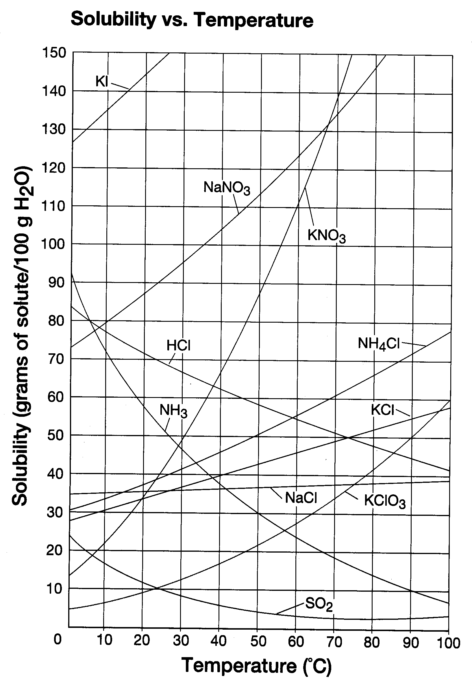
a. How many grams of KNO₃ can be dissolved in 100g of water at 20ºC and 60ºC?

b. Which of the following is most soluble at 20ºC: KNO₃, NaCl, KClO₃, or NH₃? Which is most soluble at 50ºC?

c. How many grams of potassium nitrate can be dissolved in 150.0g of water at 50ºC?

d. If you put 50.0g of potassium nitrate in 100g of water at 40ºC, is the solution saturated, unsaturated,
or supersaturated? How much is left over?

e. What is the molarity of a saturated NaNO₃ solution at 50ºC?

Acids and Bases

Good things to know:
- Arrhenius definitions of acid and base
- Lowry-Bronsted definitions of acid and base
- 5 properties of acids and bases
- salts, electrolyte, nonelectrolyte
- ionization vs. dissociation
- self-ionization of water, pH, pOH, what is acidic and basic on each scale
- buffers, common-ion effect
- titration
Problems:
1. Identify each of the following as Arrhenius (A)cid, Arrhenius (B)ase, (S)alt, or (N)either:
a. NaCl b. H₂SO₄ c. KOH d. NH₄Cl e. Ba(OH)₂
f. K₃PO₄ g. CH₄ h. Al₂(SO₄)₃ i. HBr j. CO₂

2. Complete and balance the following dissociation equations:

a. NaOH_{(s)} → b. Ba(OH)_{2(s)} →

3. Complete and balance the following ionization equations:

a. HCl_{(aq)} → b. H₃PO_{4(aq)} →

4. Complete and balance the following neutralization equations:

a. HCl_{(aq)} + NaOH_{(aq)} → b. H₂SO_{4(aq)} + KOH_{(aq)} →

5. What is the concentration of hydrogen ions [H⁺] in a:
a. solution with a pH of 3.54 b. 0.500M HF solution

c. solution in which concentration of hydroxide = 0.00120M

6. For each of the following Lowry-Bronsted reactions:
- name the acids and bases
- list the conjugate pairs
- name any amphoteric substances

a. HCl_{(aq)} + H₂O_{(l)} Cl⁻¹_{(aq)} + H₃O⁺¹_{(aq)}

b. NH_{3(aq)} + H₂O_{(l)} NH₄⁺¹_{(aq)} + OH⁻¹_{(aq)}

c. H₂SO_{4(aq)} + CO₃⁻²_{(aq)} HSO₄⁻¹_{(aq)} + HCO₃⁻¹_{(aq)}
7. What is the pH for a solution in which:
a. [HCl] = 2.00 M b. [HC₂H₃O₂] = 2.00 M

c. pOH = 2.05

d. you dissolve 3.54L of HCl gas in 3.00 L of water

e. you dissolve 0.0325g of NaOH in 0.500 L of water

8. What is the pOH for a solution in which:
a. [OH⁻¹] = 0.012M b. concentration of hydrogen = 0.00435M

c. pH = 7.93

9. If you have 500 mL of a 6.00M HCl solution, how much water must be added to make it 1.50M HCl ?

10. If you titrate 50.0mL of an unknown solution of HCl with 35.4mL of 0.600M NaOH, what is the concen-
tration of the acid?

11. If you titrate 35 drops of vinegar to the equivalence point with 43 drops of 0.600M NaOH, what is the
concentration of the vinegar?

