Sixth Grade Science Final Exam Review Packet

Microscopes and the Cell

Microscopes

- The purpose of the microscope is to allow us to see things that we would not ordinarily be able to see, such as cells. There are many different types of microscopes. The microscopes we used are called compound microscopes, which means that they have two sets of lenses.

- Parts of a compound microscope:
- Eyepiece: this is where you place your eye. It has a magnifying lens inside.
- Coarse focus adjustment: a knob that makes large adjustments to the focus
- Fine focus adjustment: a knob that makes small adjustments to the focus (it is often smaller than the coarse focus knob)
- High and low power objective lenses: these are the first of the two lenses that the image passes through [the second being the eyepiece]. By rotating the nosepiece, you can choose which objective lens is the best to look through.
- Mirror and diaphragm: by adjusting these two parts, you can control how much light is passed through the specimen.

- Total magnification:
- In order to determine the total magnification of a specimen, you must multiply the strength of the eyepiece by the strength of the objective lens that you are using.
[Total Magnification = eyepiece x objective]
- For example, if the eyepiece magnifies something 10X (10 times) and the objective magnifies something 40X (40 times), the total magnification is 400X (400 times).

The Cell
- Basic cell information:
- The cell is the basic unit of life. In other words, a cell is the smallest thing that is still considered to be a living thing. Anything smaller is not a living thing.
- All living things are made of cells.
- There are many types of cells and they each have specific jobs.
- All cells come from other cells.

- Organelles found in both plant and animal cells:
- Cytoplasm: the region between the cell membrane and the nucleus. It is mostly made of water.
- Nucleus: a cell structure that contains genetic material (DNA), the chemical instructions that direct all the cell’s activities. It can be considered to be the “headquarters” of the cell.
- Cell membrane: a thin, tough band of protein that that controls which substances can enter or leave the cell
- Vacuole: a water filled sac inside a cell that acts as a storage area. Vacuoles are usually much larger in plant cells than they are in animal cells.

- Organelles Found Only Plant Cells:
- Cell wall: a rigid (hard) layer of nonliving material that surrounds the cells of plants and some other organisms; the cell wall is always outside the cell membrane. Cell walls give plant cells strength and support.
- Chloroplast: a structure found in the cells of plants and some other organisms that captures energy from sunlight and uses it to produce food in a process called photosynthesis.
- Chloroplasts contain chlorophyll. Chlorophyll is the chemical which gives plants their green color and allows photosynthesis (plants making their own food from sunlight and water and carbon dioxide) to occur.
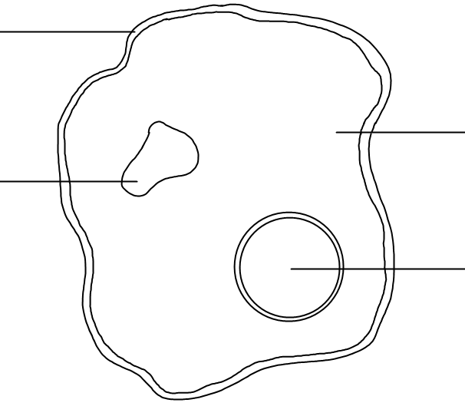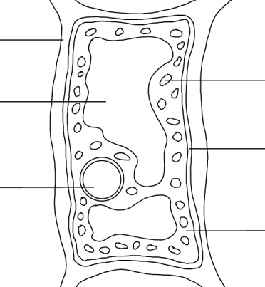
The Body Systems

The Respiratory System

- The respiratory system is the group of organs responsible for carrying oxygen from the air to the bloodstream and for removing the waste product carbon dioxide from our bodies.
- Humans need oxygen to allow our cells to release energy from the food we eat.

- Parts of the respiratory system:
- Larynx (voice box): a muscular structure at the top of the trachea containing the vocal cords
- Trachea (windpipe): the tube through which air travels from the larynx to the lungs
- Bronchi: either of two main branches of the trachea, leading directly to the lungs
- Bronchioles: the system of airways within the lungs, which bring air from the bronchi to the lung's tiny air sacs (alveoli)
- Alveoli (air sacs): a microscopic, thin-walled, capillary-rich sac in the lungs where the exchange of oxygen and carbon dioxide with capillaries takes place
- Left lung & right lung: together with the heart , the lungs job is to remove carbon dioxide from the blood and provide oxygen to the blood.
- Diaphragm: a muscular membrane under the lungs

- Breathing is controlled by the diaphragm. When the diaphragm contracts it flattens out and air flows into the lungs (inhale). When it relaxes, it curves upward and air is forced out of the lungs (exhale).

- Gas exchange: Gas exchange is the process in which oxygen is passed into the blood while carbon dioxide exits the blood. This occurs in the alveoli.
- When a person inhales, air flows into the nose and mouth, through the trachea, to the bronchi, to the bronchioles and fills up the alveoli found at the end of the bronchioles.
- Red blood cells moving through capillaries receive oxygen from the alveoli.
- The alveoli receive carbon dioxide from the red blood cells.

- Diagram of the respiratory system:

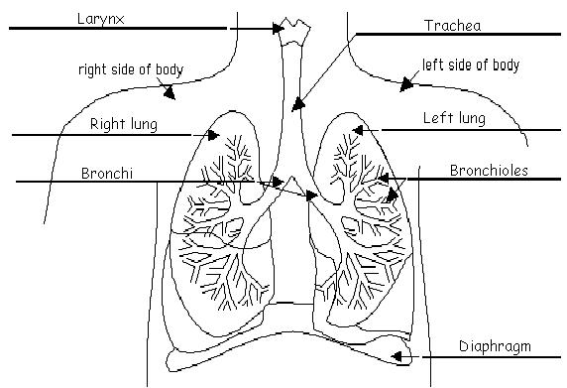

- Location of Gas Exchange in the Lungs:

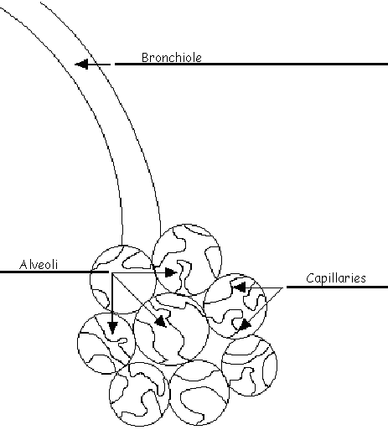
The Circulatory or Cardiovascular System

- The circulatory system’s job is to be the body’s transportation system. It takes needed substances to cells and takes waste products away from cells.

- The circulatory system is made of three parts: the heart, blood vessels and blood.

- The heart: the central organ of the circulatory system. It is a powerful muscle which pumps blood through blood vessels and around the body.
- The heart is divided into four chambers.
- Ventricles: the two lower chambers of the heart
- Atria (singular-atrium): the two upper chambers of the heart

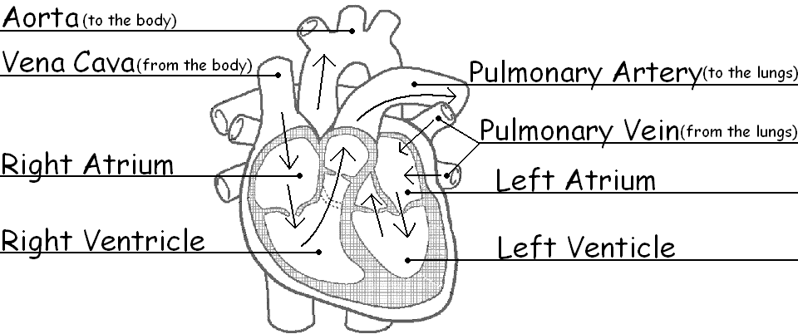

- There are 3 major categories of blood vessels: arteries, veins and capillaries.
- Arteries: blood vessels which carry blood away from the heart
- Veins: blood vessels which carry blood toward the heart.
- Capillaries: tiny blood vessels which allow materials (oxygen, nutrients, wastes) to be exchanged between the blood and the body’s cells

The Digestive System

- The human body requires six types of nutrients. The digestive system helps deliver these nutrients to the rest of the body, in a form that the body’s cells can use.

- The digestive system has 3 jobs:
- It breaks down food into molecules the body can use.
- It helps move nutrients into the bloodstream so it can be carried throughout the body.
- It eliminates solid wastes from the body.

- Parts of the digestive system:
- Food actually moves through the following organs
- Mouth: the first part of the digestive system, where food enters the body. Chewing and salivary enzymes in the mouth are the beginning of the digestive process (breaking down the food).
- Esophagus: the long tube between the mouth and the stomach. It uses rhythmic muscle movements (called peristalsis) to force food from the throat into the stomach.
- Stomach: a sack-like, muscular organ that is attached to the esophagus. When food enters the stomach, it is churned in an acid bath.
- Small intestine: the long, thin winding tube that food goes through after it leaves the stomach. This is where most absorption of nutrients takes place.
- Large intestine: the long, wide tube that food goes through after it goes through the small intestine. This is where absorption of water takes place.
- Rectum: the lower part of the large intestine, where feces are stored before they are excreted from the body.
- Anus: the opening at the end of the digestive system from which feces exit the body.

- The following organs are called accessory organs: they aid in the digestive process by producing enzymes and other digestive chemicals, but the food doesn’t actually move through them
- Pancreas: an enzyme-producing gland located below the stomach and above the intestines. Enzymes from the pancreas help in the digestion of carbohydrates, fats and proteins in the small intestine.
- Gall bladder: a small, sac-like organ located by the duodenum (where the stomach and small intestine connect). It stores and releases bile (a digestive chemical which is produced in the liver) into the small intestine.
- Appendix: a small sac located near the start of the large intestine.
- Liver: a large organ located above and in front of the stomach. It makes bile (which breaks down fats).

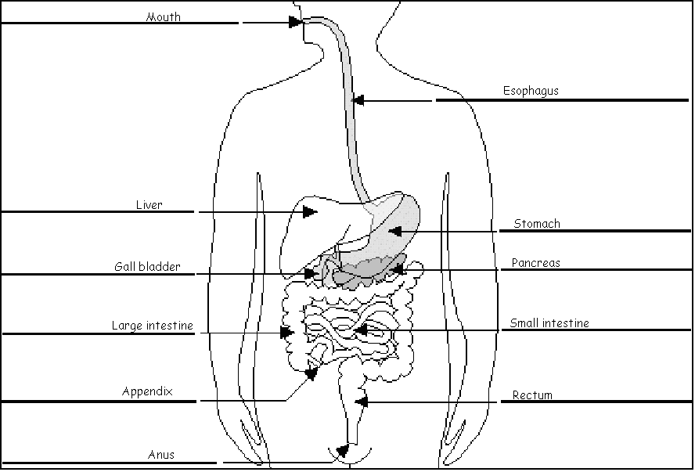

- Types of Digestion:
- The digestive system breaks down food in two ways: mechanical digestion and chemical digestion.
- Mechanical digestion: the breaking up of food into smaller pieces
- Mechanical digestion occurs when muscle is used to break up food. Most mechanical digestion occurs in the stomach, though some occurs in the mouth (teeth and tongue) and esophagus.
- Chemical digestion: using chemicals (enzymes, hydrochloric acid, etc.) to break down food into molecules the body can use
- Most chemical digestion occurs in the small intestine, though some occurs in the mouth (saliva) and stomach.

- When food has been completely broken down into usable molecules it must be absorbed into the blood stream. This happens in the small intestine. There, food is absorbed by capillaries.

The Skeletal System

- The skeletal system is made of bones, cartilage and ligaments.

- The skeletal system has five major functions:
- Provides your body with support and shape
- Many bones give your body the shape you are familiar with. The central part of your skeleton is your vertebral column, or spine. It is made up of 26 disc-shaped vertebrae.
- Allows us to move
- The skeletal and muscular systems rely on each other to allow movement. Muscles pull on bones to allow you to move body parts.
- Protects internal organs
- Some bones, such as the ribs and skull, do not move or provide much support, but they do protect internal organs. The skull surrounds the most important organ in the body, the brain. The ribs and sternum (breastbone) protect your lungs. The vertebrae help in several ways. They aid in movement, support and they protect your spinal cord.
- Makes red blood cells
- Red blood cells are made in the red marrow of certain bones in your body. This is why people who may have a disease of the blood, like leukemia (cancer of the blood), may need a bone marrow transplant.
- Stores certain materials until the body needs them (like calcium)

- Bones have four different parts:
- Compact bone: Strong, dense bone that forms the outer layer of your bones. This is the material which gives bones their strength.
- Spongy bone: Light-weight, porous (full of holes) bone found under the compact bone. Blood vessels and nerves run through spongy bone.
- Red marrow: Soft tissue that makes red blood cells. In adults, it is only found in certain bones (ends of the femurs-thigh bones, skull, pelvis and sternum-breastbone).
- Yellow marrow: Soft tissue found in the center of most bones. It is mostly made of fat.

- Joint: a place where two bones meet; there are several types of joints
- Fixed (immovable) joint: a joint that cannot move (ex. skull)
- Pivot joint: a joint in which one bone rotates in the ring of another bone (ex. the place where the base of the skull meets the top of the spine)
- Hinge joint: a joint that only allows back-and-forth movement (ex. elbow, knee, jaw, knuckles)
- Ball-and-socket joint: a joint in which one bone with a rounded end fits into a cup shaped hole in another bone (ex. shoulder, hip)
- Gliding joints: a joint in which one flat bone moves over another (ex. wrist, ankle)
The Muscular System

The main job of the muscular system is movement. Your skeletal muscles move your bones, and your bones move your body. Your cardiac muscle contracts your heart, and squeezes blood out and forces it through blood vessels around your body, and your stomach muscles churn up your food. The esophagus squeezes food to move it through your digestive system.

- Muscles fall into one of two categories: voluntary and involuntary muscle.
- Involuntary muscle: muscle that cannot consciously control
- Voluntary muscle: muscle that you can consciously control (when you think you want to move it, it moves)

- There are three types of muscle: skeletal, smooth, and cardiac.
- Cardiac muscle: the unique muscle found only in the heart (it is involuntary muscle)
- Skeletal (striated) muscle: muscle that is attached to bones by tendons. They make bones move. It is the only type of muscle you can control.
- Most skeletal muscles are voluntary muscles. However, reflexes that move skeletal muscles are not voluntary (like when the doctor taps your knee with the hammer.) Some skeletal muscles are voluntary and involuntary at the same time, like your diaphragm and your eyelids.
- Smooth muscle: muscle that is found in hollow organs, like your stomach or esophagus. (It is involuntary muscle)
- Muscles work closely with bones to help you move.
- Tendons: tough bands of tissue that attach muscles to bones
- When a muscle contracts (shortens) the tendons pull on the bones making them move. (Like a string puppet. A puppeteer pulls on the strings, making the puppet move. The muscles are like the puppeteer. The strings are like the tendons. The puppet is like the bones.)
- Muscles work in pairs. When one muscle contracts, an opposite muscle relaxes.
- When you pull your hand to your shoulder, your biceps (the muscle in the front of your upper arm) contract and your triceps (the muscle in the back of your upper arm) relax. When you straighten your arm, your triceps contract and your biceps relax.
The Excretory System

The job of the excretory system is to remove waste from the body.

- The excretory system relies on many other body systems to remove waste from the body.

- The urinary system is not really a body system, but part of the excretory system.
- The urinary system removes most of the liquid waste from your body in the form of urine. Urine is mostly made of water, but it obviously contains some other chemicals.
- The urinary system has four major parts.
- Kidney: either one of a pair of organs in the abdominal cavity, which filter wastes from blood, which are then excreted as urine
- Ureter: a long, narrow tube that carries urine from the kidney to the urinary bladder
- Urinary bladder: an elastic (stretchy), muscular sac in which urine collects before excretion
- Urethra: the tube through which urine is released from the bladder

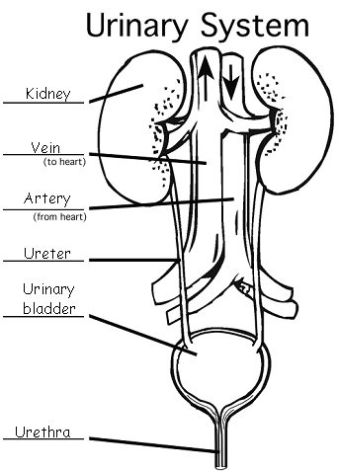

- The respiratory system is also part of the excretory system. Your lungs (and alveoli) remove carbon dioxide and some waste water from your blood.

- The digestive system has several organs which aid in the creation and removal of solid waste. Specifically, the large intestine, rectum and anus are excretory organs.

- The skin also acts as an excretory organ, helping to remove waste water, salts and some urea.

The Nervous System

- The three main parts of the nervous system are the brain, spinal cord and nerves.
- Brain: the part of the nervous system that is located in the skull and controls most functions in the body
- Spinal cord: the thick cord of nerve tissue that is protected by the vertebrae and that links the brain to most of the nerves in the body
- Nerve: a bundle of nerve fibers that carries an impulse (message) through the body. For the most part, nerves carry the impulses using electricity
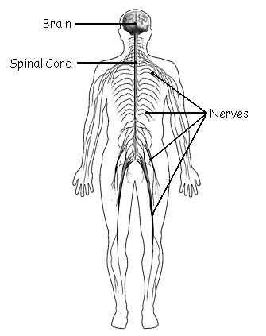

- The job of the nervous system is to receive and interpret messages (stimuli) from our external and internal environments (inside and outside our body). It also directs our body to respond appropriately to these messages.
- Stimulus: any change in the environment that makes an organism react
- Response: an organism’s reaction to a stimulus

- We receive messages using our five senses. The fives senses are sight, hearing, taste, smell and touch.

- Nerves are made up of many individual nerve cells called neurons. Neurons have three main parts.
- Axon: the long extension of a neuron that carries nerve impulses away from the body of the cell.
- Dendrites: the branching structure of a neuron that receives messages (attached to the cell body)
- Nucleus: the organelle in the cell body of the neuron that contains the genetic material of the cell

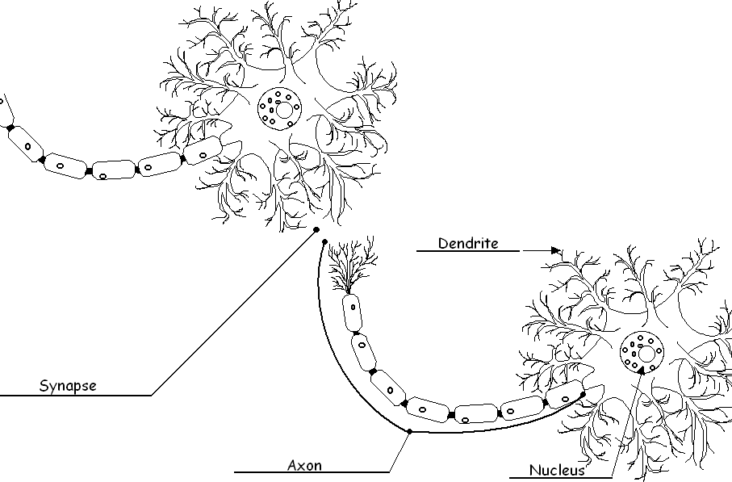

- Synapse: the tiny space between the end of an axon and the next structure (a dendrite, a muscle cell or the cell of another organ). Electrical messages cannot cross synapses. Instead, when an impulse reaches a synapse, chemicals carry the message across.

Reproductive System

Male Reproductive System
The main function of the male reproductive system is to produce sperm.
Sperm is the sex cell produced by the male. It joins with the female sex cell, known as the egg, in a process called fertilization, whereupon a fertilized egg (or zygote) is formed. The zygote is the fertilized egg. Over a period of 9 months this fertilized egg cell develops into a new person.

Parts of the male reproductive system:

-Testes: produce sperm, the male sex cell
-Vas deferens: tube that delivers sperm from testes
-Seminal Vesicle: adds fluids to sperm to make semen
-Prostate gland: adds fluids to sperm
-Penis: deposits semen in female
-Urethra: tube that delivers semen out of the body

Diagram of the male reproductive system

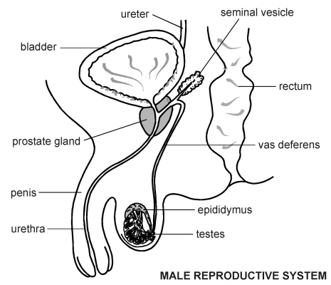

Female Reproductive System
The 2 functions of the female reproductive system are to produce eggs, and to provide a place to protect and nourish the developing baby.
Diagram of the Female Reproductive System

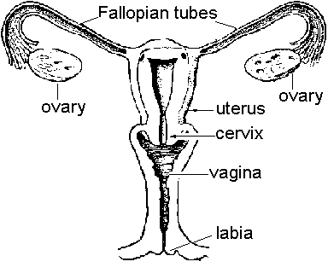
Parts of the Female Reproductive System
-Ovary: The female is born with egg follicles in the ovary. These develop into eggs. One egg is released each month, in a process called ovulation.

-Fallopian Tube: The released egg travels through the fallopian tube to the uterus. Fertilization occurs in the fallopian tube.

-Uterus: The developing baby implants into the wall of the uterus. This is where the baby will develop until it is ready to be born.

-Cervix: The opening of the uterus. The cervix is held tightly closed until the baby is ready to be born.
-Vagina: The baby passes through the vagina, or birth canal. The vagina is also where the semen is deposited in the female.
Immune System

The function of the immune system is to protect your body from infectious disease.

- Disease: an incorrectly functioning organ, tissue, or system of the body. A disease is also called an illness or a sickness
- Pathogen: something that causes a disease (more commonly called a “germ”)

Diagram of Organs of the Immune System
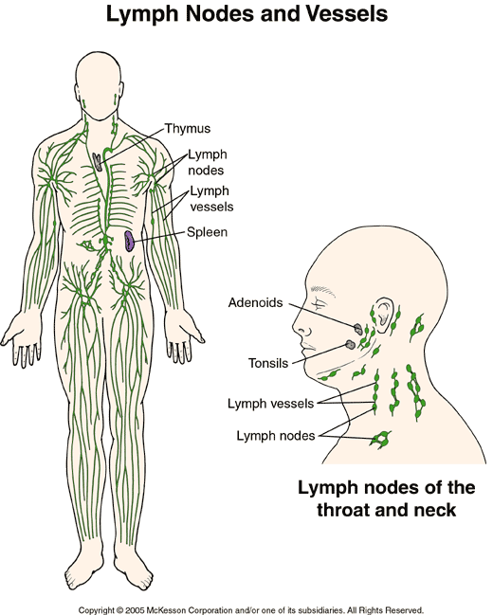
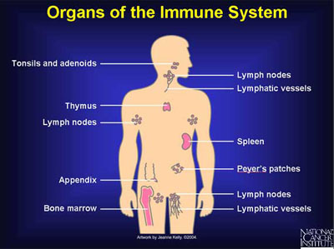

As the body recognizes and fights off invading germs, it goes through three levels of response. The first is:

-Level 1 Response: Keep Out!
- The following body parts and substances prevent pathogens from getting into your body
- Skin
- Tears
- Saliva
- Mucous (In your breathing passages)
- Stomach Acid
- Hair/Cilia (Eyes, nose, throat)
If level 1 response doesn’t successfully get rid of invaders, the body moves to level 2 response:

-Level 2 Response: Inflammatory Response
Fluid and blood cells leak from blood vessels into nearby tissues. The white blood cells then fight the pathogens.
A Phagocyte is a type of white blood cell that engulfs or eats pathogens. It can attack any kind of cell, and is NOT specific to the type of pathogen.
As blood leaks into the area it gets red and hot and swollen.
Inflammation comes from “flame”.
Fever is typical in inflammatory response, as the body tries to heat up to kill off invading pathogens.

Usually this is successful, but occasionally the body will have to go to level 3 response:

-Level 3 Response: Immune Response
Cells can distinguish between different kinds of pathogens and respond with a targeted cell. They remember the particular pathogen to fight it off next time.

Endocrine System
The endocrine system controls daily activity and long term changes such as development. T
The endocrine system is made of glands.
Glands are the organs that make hormones.
Hormones control the activities of the body.

-Glands:

Glands are organs which release chemicals directly into the blood stream.
Endocrine glands are NOT like salivary or sweat glands. Salivary and sweat glands deliver their chemicals through tubes and must act close to the gland.

-Hormones:

They are chemical messengers made by endocrine glands.
Hormones turn on, turn off, speed up, or slow down activities of a specific organ or tissue. Hormones act on target cells like a “lock and key”.
Hormones can work far from glands that make them since they are delivered by the bloodstream.
Hormones are slower to act but longer lasting than nerve impulse response.
Different types of hormones control reproduction, metabolism (food burning and waste elimination), and growth and development. Hormones also control the way you respond to your surroundings, and they help to provide the proper amount of energy and nutrition your body needs to function.

The glands that make up the endocrine system include the thyroid, parathyroid, pancreas, ovaries, testes, adrenal, pituitary and hypothalamus

Diagram of the Endocrine System
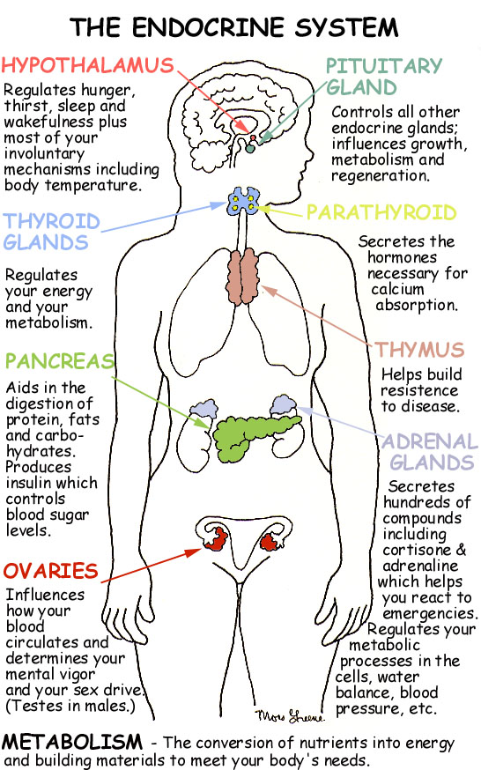
Energy
ENERGY is the ability to do work or cause change.

WORK is when a force moves an object.

A FORCE is a push or a pull.

There are 2 main KINDS of ENERGY:
Potential energy is stored energy.
Kinetic energy is energy of motion.

The total amount of energy never changes, but potential and kinetic energy can change into each other (waterfall, pendulum).

Energy Conversion in a Pendulum
A continuous conversion between kinetic and potential energy takes place in a pendulum. At the highest point in its swing, the pendulum has only potential energy. As it starts to swing downward, it speeds up and its potential energy changes to kinetic energy.

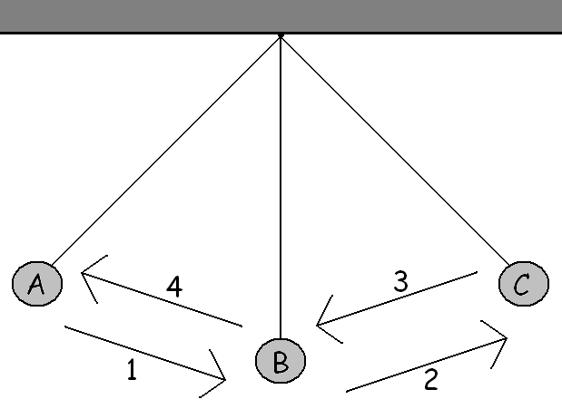

6 DIFFERENT FORMS OF ENERGY
Mechanical energy - energy of moving parts, example: pencil sharpener, running

Thermal energy- energy of moving particles IN an object (heat energy), ex: radiator, toaster

Chemical energy- energy in chemical bonds, ex. Food, batteries

Electrical energy - moving electrical charges, ex: electricity, generator, lightning

Electromagnetic energy - light energy that travels in waves, ex: sunlight, X-rays, microwaves, light

Nuclear Energy - stored in the nucleus of an atom, ex: atomic bomb, stars, nuclear power plants

ENERGY CONVERSIONS

Energy can be converted (changed) from one form to another. As it changes from one form to another, some energy can get lost as heat.

For example:
- Energy conversions in an electric pencil sharpener:

WIRES GEARS & BLADES
Electrical Mechanical

- Energy conversions in an electric hairdryer:
______Electrical_____ → ______Mechanical_____ and ____Heat________
Starting form of energy) (Form of energy produced) (Form of energy produced)

The energy we use must come from somewhere. Energy cannot be created, but is just turned from one form into another. The energy we use comes from many sources: Fossil fuel (coal, oil, and natural gas), nuclear power, the sun, wind, geothermal, hydropower. Much of this we convert into electricity.

Renewable and Non-renewable Resources
Renewable Resources: an energy source that can be easily replenished (refilled, replaced). Renewable energy sources include solar, wind and hydropower.

Non-renewable Resources: an energy source that we are using up and cannot recreate. Coal, natural gas, and nuclear energy are all non-renewable energy sources.

Renewable and nonrenewable energy sources can be used to produce electricity.

Law of Conservation
The law of conservation of energy states that when one form of energy is converted to another, no energy is destroyed in the process.
Energy cannot be created or destroyed, so the total amount of energy is the same before and after any process. All energy is accounted for.
Static Electricity, Circuits and Magnetism

Static Electricity

Static electricity is the buildup of charge on an object.

Like charges repel – unlike charges attract
- Positive (+) and Negative (-) charges attract or pull.
- Positive (+) and Positive (+) charges repel or push.
- Negative (-) and Negative (-) charges repel or push.

Magnetism
- Magnets have 2 poles, North and South
- Opposite poles (North and South) attract
- Like poles (South and South) (North and North) repel
- The area around a magnet where the force is strongest is called the magnetic field.

Electricity and Circuits
- Electricity is a flow of electrons
- An electric circuit is a pathway that allows the flow of electrons.

- An electric circuit has 3 parts:

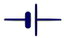 | 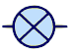 | 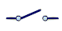
Energy Source (Battery) | Resistor: any object that needs an electric current to work (ex. light bulb, fan, bell.) | Switch

Open and Closed Circuits
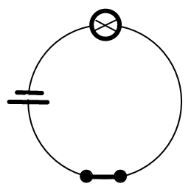 | 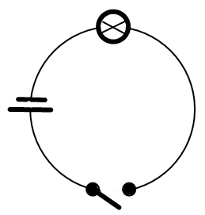
- A closed circuit allows the flow of electricity (lights turned on) | - An open circuit does not allow the flow of electricity (lights turned off)

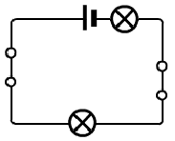Series and Parallel Circuits
Series circuits (old Christmas lights) are all wired together to the power source. If one bulb goes out, they all go out.

Parallel circuits (store signs) are wired separately to the power source. If one bulb goes out, the others stay on. There is still a complete pathway for electricity to flow.
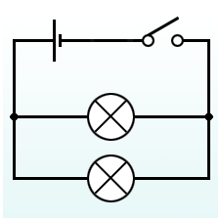
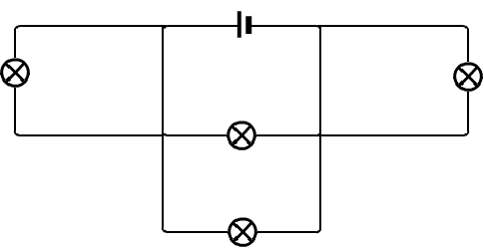

Conductors and Insulators
Metals are good conductors of electricity (that is why we make wires out of it). They CONDUCT electricity, or allow the electrons to move. Plastic, is a poor conductor, or insulator, of electricity (that’s why we use it to cover the wires). Rubber, ceramic and glass are also insulators. INSULATORS do not conduct electricity
Motion, Forces and Simple Machines

- Forces:
- Force: a push or a pull.
- Forces are described by how strong they are and by the direction in which they act.
- Forces are measured in Newtons.

- When two forces act in the same direction, they add together.
- Diagram #1:

- When two forces act in opposite directions, they combine by subtraction. If one force is larger than the other, the net force will be in the direction of the greater force.
- Diagram #2:

- If two forces of equal strength act in opposite directions, the net force will be 0. (They cancel one another out – like in a tug of war where both sides are equal.)
- Diagram #3:

- Balanced forces: Equal forces acting on an object in opposite directions (such as in diagram #3) are called balanced forces.
- If balanced forces are acting on an object, the object will not change its motion. An example of this is a tug of war with 2 equal sides and neither side moves.

- Unbalanced forces: When a net force is acting on an object (such as in diagrams #1 and 2) the force is unbalanced. An unbalanced force acting on an object will change that object’s motion [make that object start moving, stop moving or change direction].

- Reading a Spring Scale in Newtons:
- Force is measured in Newtons. Below is a diagram of the scale you used. Note that Newtons are on the right. The small space between each black line represents a force of .2 N.

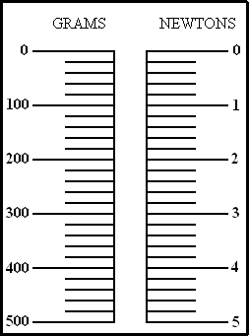

- Forces that resist motion:
- Friction: a force that one surface exerts on another when two surfaces rub together.
- The strength of friction depends on 2 things:
- The types of surfaces involved (how rough they are).
- Ex: Rubbing two pieces of sandpaper together creates more friction than rubbing two pieces of notepaper together.
- How hard the surfaces push together.
- The harder the two surfaces are pressed together, the more friction will be created.
- Friction can be useful. When you walk friction acts between your shoes and the floor so that you don’t slip.
- Friction makes heat. Some mechanical energy is converted into heat energy when two surfaces rub together.

- Gravity: the force that attracts all objects toward each other.
- The more mass an object has, the more gravity it has. The Earth’s gravity is strong enough to keep the objects on the planet from floating away into space.
- Mass does not affect the acceleration of gravity.
- Shape affects the rate at which objects fall.

- Newton’s three laws of motion

- Newton’s first law of motion (inertia): An object at rest (not moving) will stay at rest and an object that is moving will stay moving unless it is acted upon by an unbalanced force. This is called inertia. This is the reason you wear a seatbelt. If the car you are riding in stops suddenly, you will still keep on going if you are not wearing a seatbelt. The seatbelt creates the unbalanced force which keeps you in your seat and prevents injury.
- Inertia: the tendency of an object to resist change in its motion
- An object’s inertia is directly related to its mass. The greater the mass of an object, the greater its inertia will be.

- Newton’s second law of motion: Newton’s second law of motion tells us how force, mass and acceleration are related. (Mass is the amount of matter in an object. Acceleration is the rate at which speed changes.)
- Newton states that Force is the product of an object’s mass times its acceleration. (Force = mass x acceleration, or F = m x a)
- As the mass of an object increases, its force increases.
- As the acceleration of an object increases, its force increases.

- Newton’s third law of motion: Newton’s third law of motion states that if one object exerts a force on another object, then the second object will exert a force of equal strength in the opposite direction on the first object. Another way to say this is for every action there is an equal and opposite reaction. An example of this is when you walk, you push the ground and the ground pushes back on your feet with an equal and opposite force. Remember the skateboard with medicine ball.

- Mass and weight:
- Mass: the amount of matter in an object.
- The mass of an object does not change if gravity changes. For instance, you have the same mass on Earth that you do on the moon.
- Weight: a measure of the force of gravity on an object.
- The weight of an object changes if gravity changes. For instance, you weigh less on the moon than you do on Earth since the gravity on the moon is less.

- Simple Machines:
- A machine is a device that changes the amount of force exerted on an object or the direction in which that force is exerted. This is called an advantage.
- Mechanical advantage: a reduction (decrease) of the force needed to lift a load or overcome a resistance
- Directional advantage: a change in direction. It occurs when a simple machine moves an object in the opposite direction that a force is being exerted.
- Ex: A single-fixed pulley moves an object up when the rope is pulled
down.

- Levers: A lever is a simple machine. It is made of a rigid bar [the lever arm] that is free to move around a fixed point [the fulcrum]. The other 2 parts of a lever are the load and the effort.
- There are 3 types of levers and they are each described by the position of the fulcrum. To make it easier to remember each type of lever, we use the phrase F-L-E 1-2-3. This means that in a first class lever the fulcrum is in the middle. In a second class lever the load is in the middle. In a third class lever the effort is in the middle.

FIRST CLASS LEVER SECOND CLASS LEVER THIRD CLASS LEVER

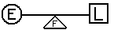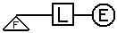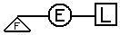

The greatest mechanical advantage is gained when the load is close to the fulcrum and the effort is applied as far away from the fulcrum as possible. (Think of when you tried to lift your teacher off the ground using a lever.)

Pictured below are some everyday uses of levers.
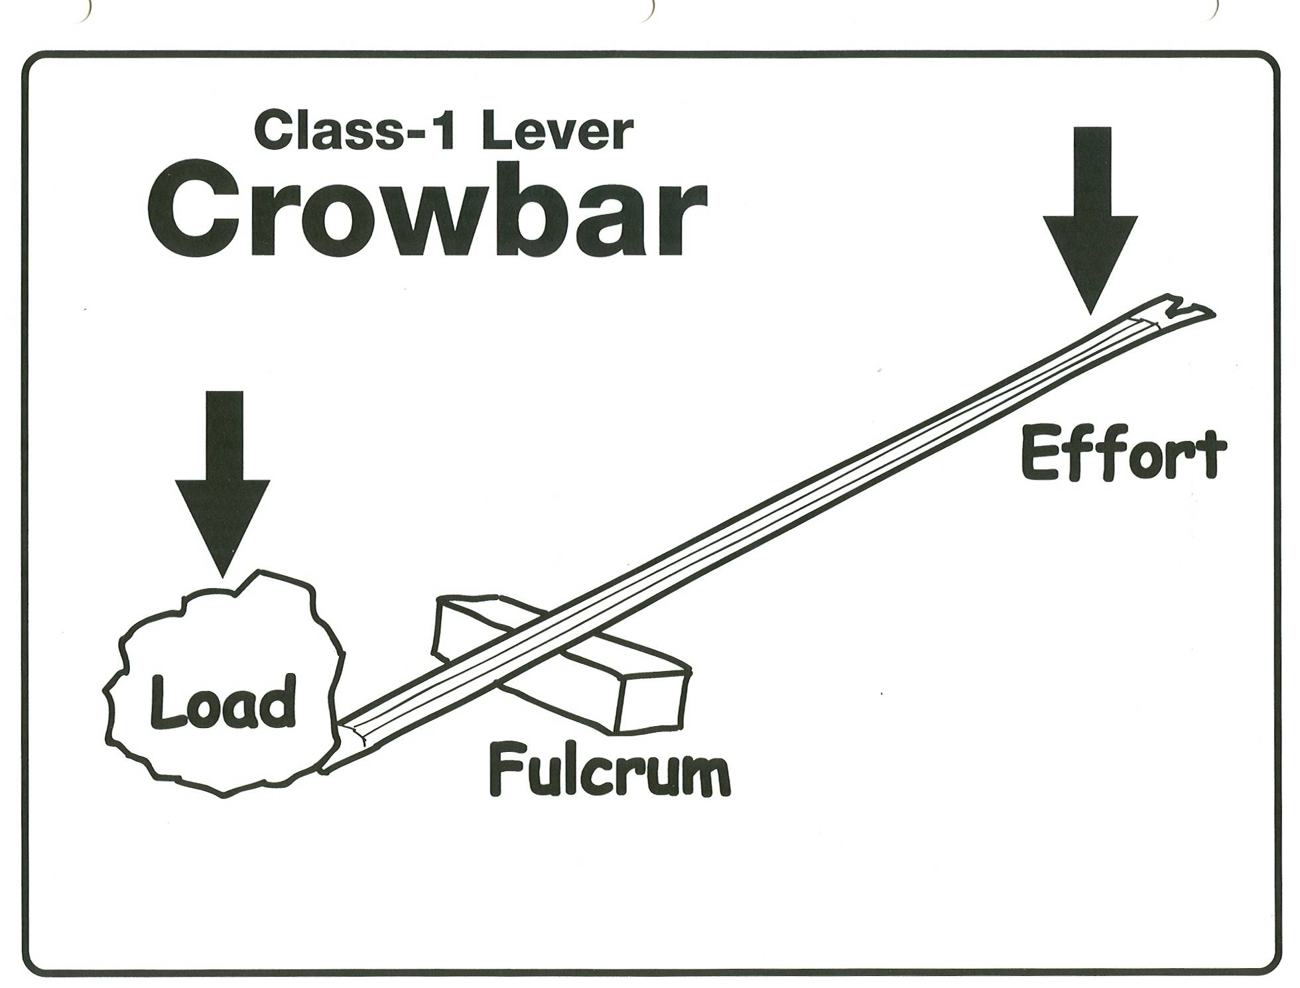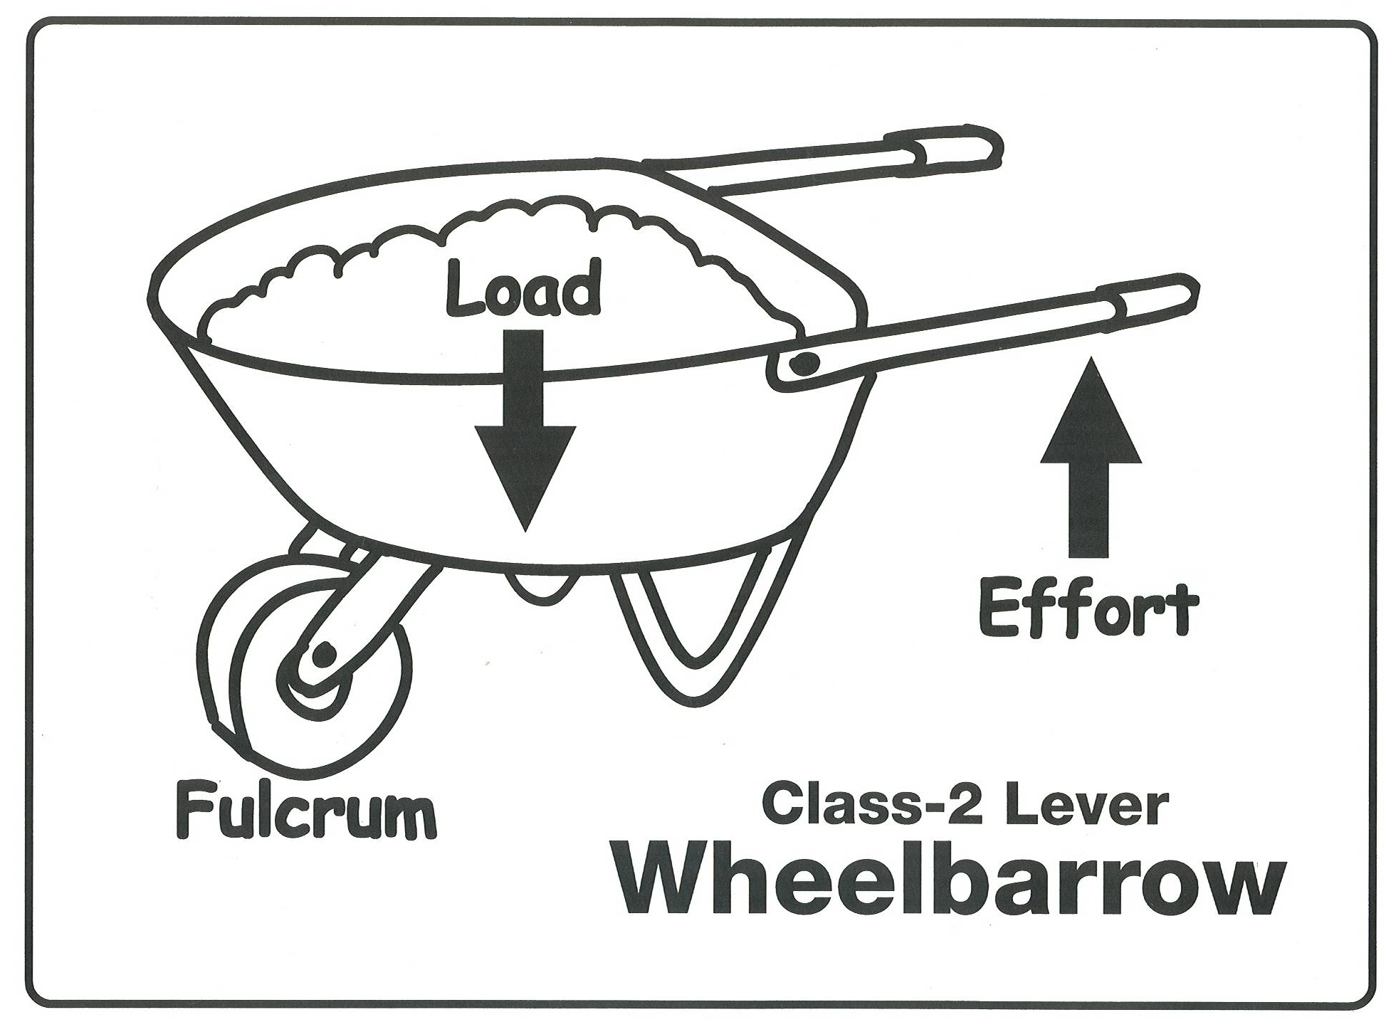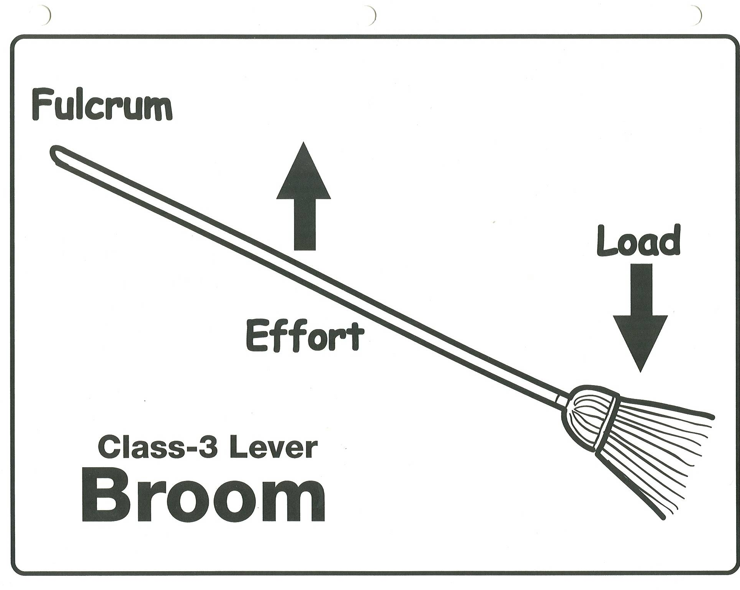

- Pulleys: a wheel with a grooved rim in which a rope can run to change the direction of the pull (force) that lifts a load
- The pulleys that we studied are shown in the diagrams below. (Please note that SF means single-fixed and SM means single-moveable. The arrows indicate the directions of the force.)
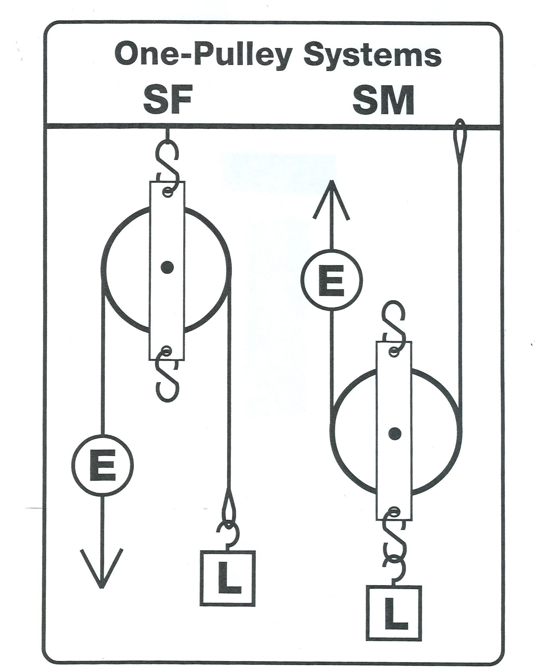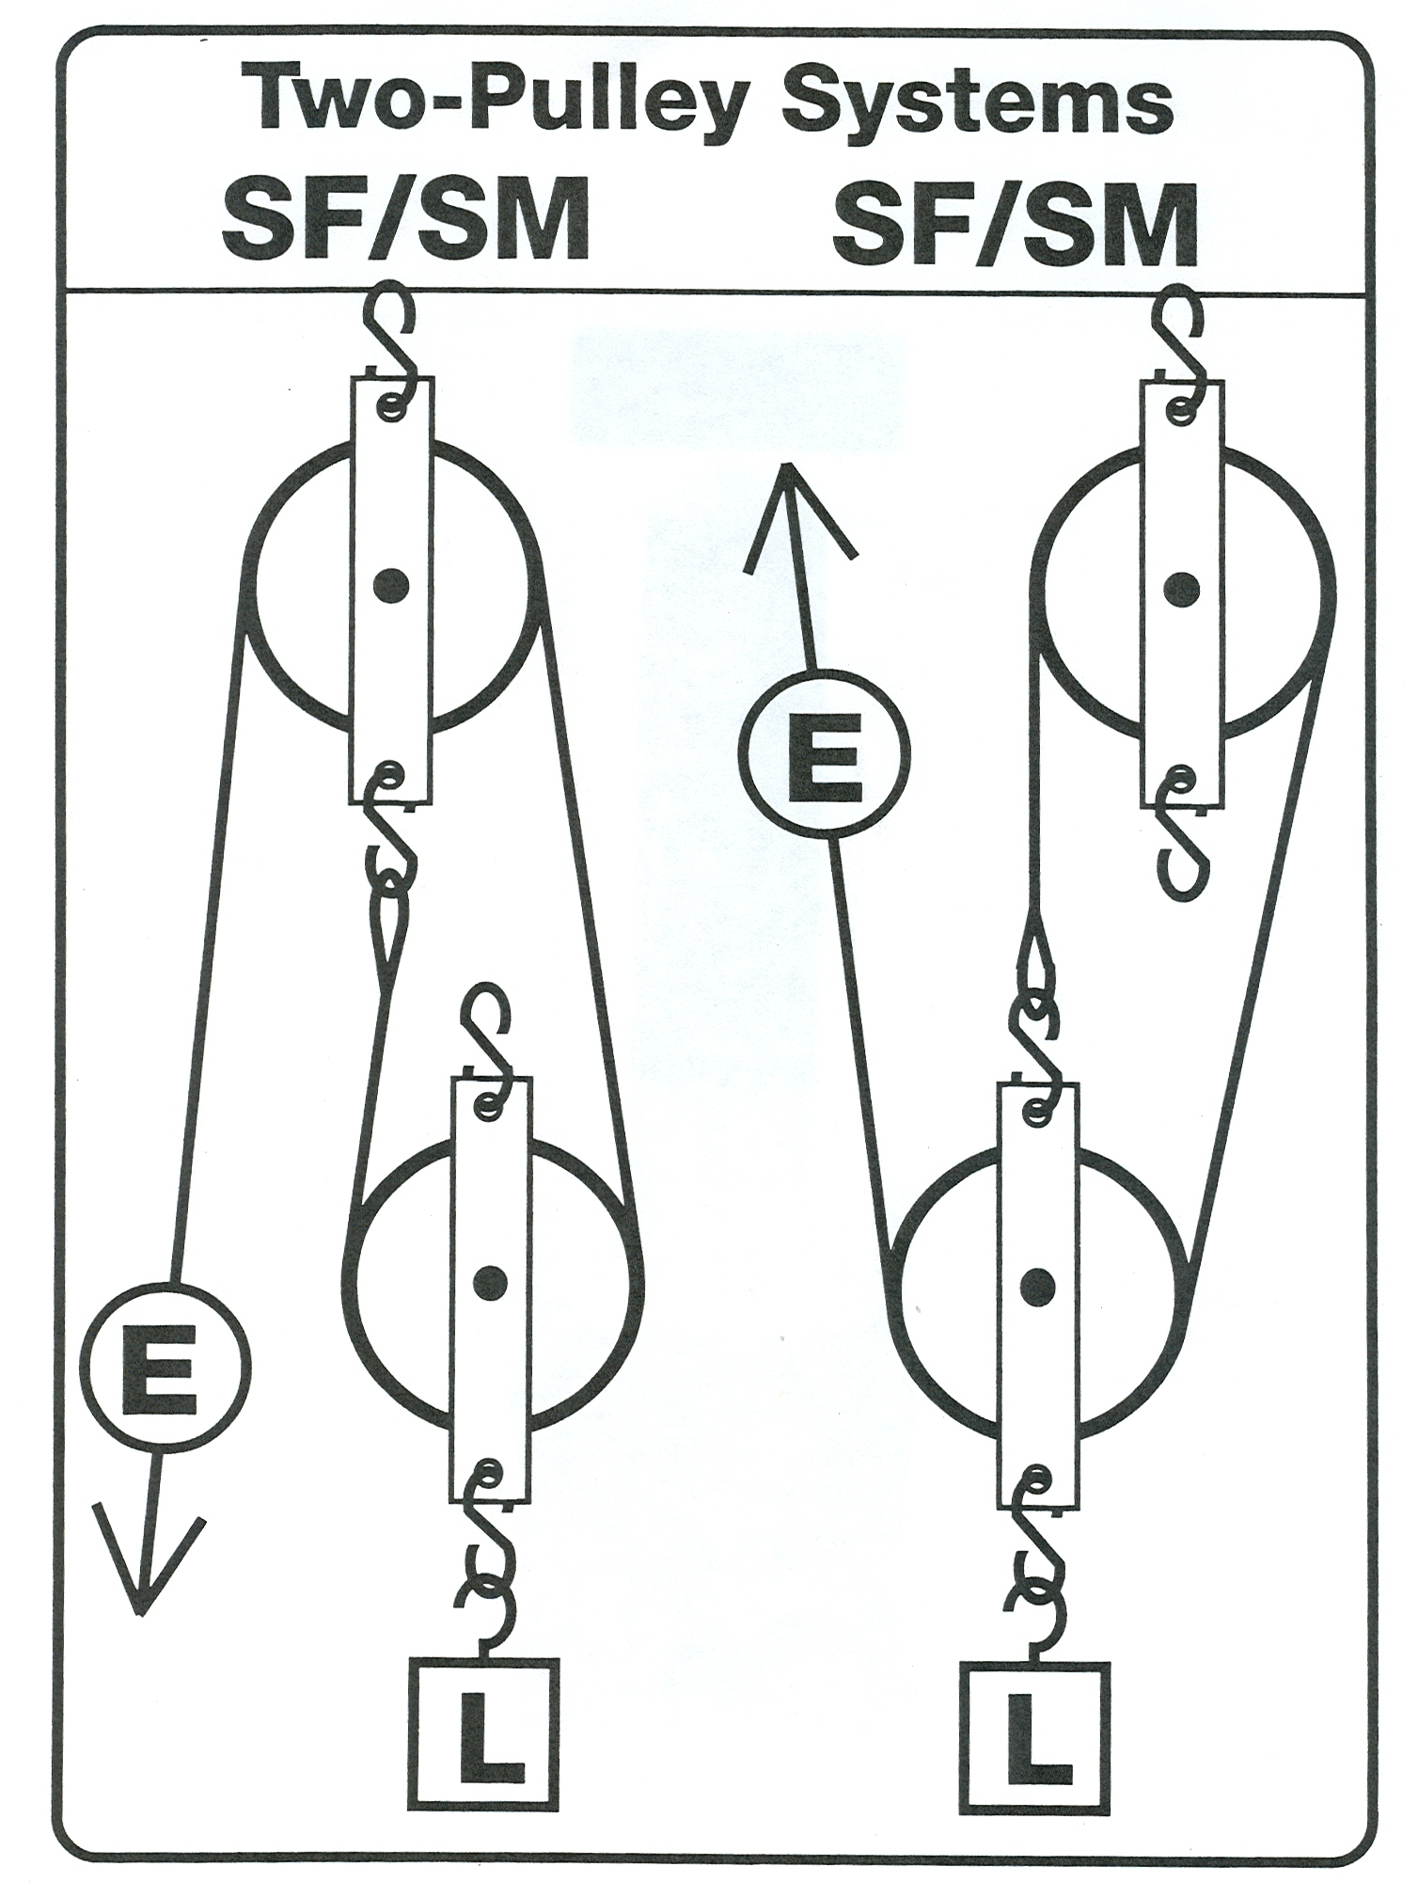

- When using pulleys, the number of ropes that are supporting the load will affect how much effort is needed. The more ropes supporting the load, the less effort will be needed. However, if the effort is less, the distance moving the load will increase.
- Study the diagram above from the “Pulley Data” lab to help you. Observe that the number of ropes directly influences how much effort is needed to lift the load.
- If one rope lifts the load, then the effort will equal the force of the load and the load will move the same distance as the effort.
- If two ropes lift the load, then the effort will equal 1/2 the force of the load, but the effort will have to move twice as far as the load.
- If three ropes lift the load, then the effort will equal 1/3 the force of the load, but the effort will have to move three times as far as the load.

