Name_______________________________________________ Geometry Final Exam Review

Multiple Choice
Identify the choice that best completes the statement or answers the question.

____ 1. The circles are congruent. What can you conclude from the diagram?
a. |  | c.
b. |  | d. | none of these

____ 2.

a. | 13 | b. | 26 | c. | 77 | d. | 38.5

____ 3. What is the value of x?
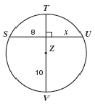
a. | 6 | b. | 8 | c. | 4 | d. | 10

_______ 4. In circle C, , , , and centimeters.
What is the length of ?
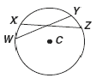
a. | 12 | b. | 24 | c. | 40 | d. | 64

____ 5. Find the value for x.
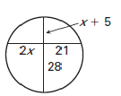
a. | 23 | c. | 21
b. | 10 | d. | 28

____ 6. Find m∠PSQ if m∠PSQ = and m∠PRQ = .
a. | 40° | c. | 105°
b. | 95° | d. | 52.5°

____ 7. Given: m∠IED = 116° and m∠JFG = 100°
Find the measure of each unknown angle. (not drawn to scale)

a.
b.
c.
d.

____ 8. Find and
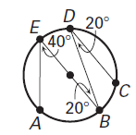
a. | 80º, 80º | c. | 100º, 80º
b. | 40º, 80º | d. | 100º, 100º
____ 9. An artist wants to construct a scale model of the Washington Monument that is 1/20th the height of the original. What fraction of the original’s surface area will the model contain?
a. | 1/40 | c. | 1/400
b. | 1/20 | d. | 1/1600

____ 10. The radii of a softball and baseball are in the ratio of 2:1. If it takes of leather to cover the outside of a baseball, how much will it take to cover the outside of a softball?
a. |  | c.
b. |  | d.

____ 11. 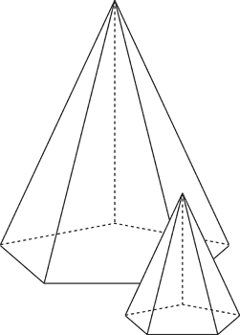
The two hexagonal pyramids shown are similar. If the scale factor from the smaller pyramid to the larger pyramid is 3/5, and the volume of the smaller pyramid is , find the volume of the larger pyramid.
a. |  | c.
b. |  | d.

____ 12. The perimeters of two similar octagons are 120 cm and 80 cm, respectively. One side of the smaller octagon is 16 cm. Find the length of the corresponding side of the larger octagon.

a. | 15 cm | c. | 10.67 cm
b. | 36 cm | d. | 24 cm

____ 13. In , , and . Find AB.
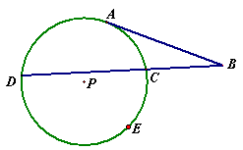
a. |  | c. | 24
b. |  | d.

____ 14. In , , and , and . Find BX.
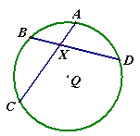
a. | 3 b. 6 | c. | 9.2 d. 10

____ 15. In , , , and . Find .
a. | 30 | c. | 35
b. | 17.5 | d. | 20

____ 16. What is the standard equation of the circle graphed?
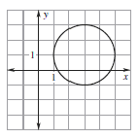
a. | 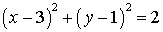 | c. | 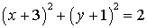
b. | 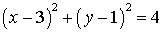 | d. | 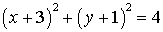

____ 17.
The points and are the endpoints of a diameter of a circle. What is the standard equation of the circle?

a. | 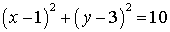 | c. | 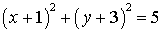
b. | 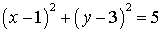 | d. | 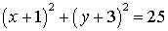

____ 18.
The standard equation of a circle with center and radius 6 is

a. | 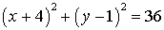 | c. | 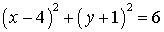
b. | 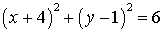 | d. | 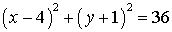

____ 19. The equation of a circle is 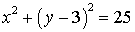. What are the center and the radius of the circle?

a. | center radius 25 | c. | center radius 5
b. | center radius 25 | d. | center radius 5

____ 20. What is the standard equation of a circle with center and a point on the circle is
a. | 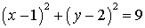 | c. | 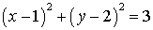
b. | 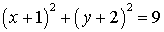 | d. | 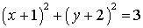

____ 21. Which is the symbolic representation for this argument?
If Max studies, then Max will pass English.
Max studies.
Therefore, Max will pass English.
a. | Assume: p q  q  Conclude: p | c. | Assume: p q  p  Conclude: q
b. | Assume: p q  q r  Conclude: p r | d. | Assume: p q  q  Conclude: r

____ 22. Consider the conditional statement If the light is red, then I stop. Give the name for the related conditional statement If I stop, then the light is red.
a. | biconditional | c. | inverse
b. | converse | d. | contrapositive

____ 23. Which pair of angles forms complementary angles?
a. | and
b. | and
c. | and

____ 24. What is the distance between (3, 4) and (–2, –6)?
a. | 50
b. | 125
c.

____ 25. What is the slope of the line that passes through the points (3, 4) and (5, –6)?
a. | 5
b. | -5
c. | -0.5

____ 26. What are the coordinates of the midpoint of the line that passes through (3, 4) and (5, –6)?
a. | (4, –1)
b. | (1, –4)
c. | (–4, 1)

____ 27. A line has the equation 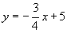. If another line is parallel to this line, what must its slope be?

a. -3/4 b. ¾ c. 4/3 d. -4/3

____ 28. A line has the equation y = 2x + 4. If another line is perpendicular to this line, what is its slope?

- -2 b. ½ c. -1/2 d. 2

____ 29. Which diagram shows ASA congruence?
a. | 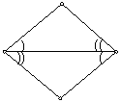
b. | 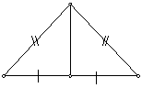
c. | 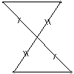

____ 30. From the diagram below, what information guarantees that line A is parallel to line B?
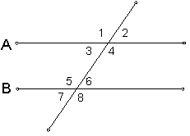
a. | if
b. | if
c. | if

____ 31. is a triangle. Find EG.
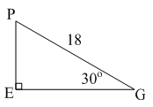
a. | 9
b.
c. | 13

____ 32. MEN is an isosceles right triangle. Find ME.
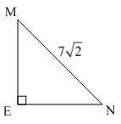
- 9.89
- 3.5
- 7
- 8
____ 33. From the diagram below find the measure of .
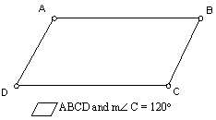
a.
b.
c.

____ 34. What is the contrapositive of the statement, “If p, then q.”?
a. | If not p, then q.
b. | If p, then not q.
c. | If q, then p.
d. | If not q, then not p.

____ 35. What is the measures of each interior and each exterior angle of a regular pentagon?

a. | interior and exterior
b. | interior and exterior
c. | interior and exterior
d. | interior and exterior

____ 36. The rectangular board below is to be cut at an angle of and as shown.
When you cut out, what should the measure of be?
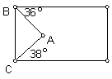
a.
b.
c.
d.

____ 37. A welder is building a triangle from metal rods. One rod is 52 inches long and another is 24 inches long. Which of the four rods listed below could be used?
a. | the 24 inch rod
b. | the 33 inch rod
c. | the 28 inch rod
d. | the 77 inch rod

____ 38. What is the range of lengths for the third side (x) of a triangle where the other two sides are 4 inches and 7 inches long?
a. | 3 < x < 7 b. 3 < x < 11 c. 4 < x < 7 d. 4 < x < 11
____ 39. What is the distance across Lake Dogbone from point A to point B (drawing not drawn to scale)?
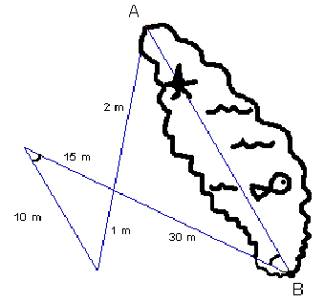
a. | 20 m | c. | 25 m
b. | 45 m | d. | 60 m

____ 40. A flagpole casts a shadow of 150 feet. To the nearest foot, how tall is the flagpole if the angle of elevation from the end of the shadow to the top of the flagpole is ?
a. | 113 feet
b. | 120 feet
c. | 199 feet
d. | 249 feet

____ 41. What is the surface area of a sphere with a diameter of 10 inches?
a. | 100π square inches
b. | 167π square inches
c. | 400π square inches
d. | 420π square inches

____ 42. These are the measures of the sides of a triangle. (0.5, 0.8, 0.9) What type of triangle is formed?
a. | acute | c. | right
b. | obtuse | d. | isosceles

____ 43. What is the value of x to the nearest degree?
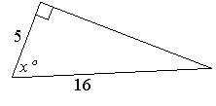
a. | 18° | c. | 15°
b. | 72° | d. | 73°

____ 44. From a point 100 feet from the base of a tree, the angle from ground level to the top of the tree is 37°. Find the height of the tree to the nearest foot.
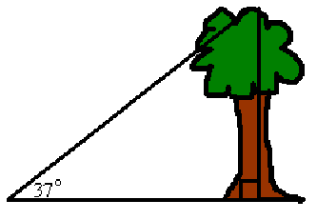
a. | 166.16 | c. | 103.5 feet
b. | 60.18 | d. | 75.3 feet

____ 45. 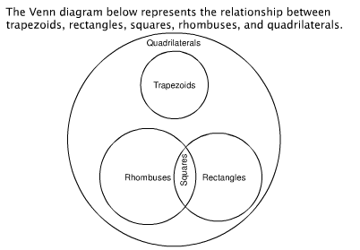
According to the diagram, which statement is not correct?

a. | Every rhombus is a square. | c. | No trapezoid is a rhombus.
b. | Every square is a rectangle. | d. | No rectangle is a trapezoid.

____ 46. What is the inverse of the statement “If two triangles are not similar, their corresponding angles are not congruent”?

a. | If two triangles are similar, then their corresponding angles are not congruent. | c. | If two triangles are similar, then their corresponding angles are congruent.
b. | If corresponding angles of two triangles are not congruent, then the triangles are not similar. | d. | If corresponding anlges of two triangles are congruent, then the triangles are similar.

____ 47. 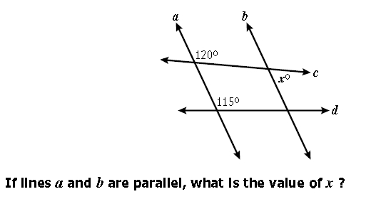
a. | 120 b. 115 | c. | 65 d. 60
____ 48. 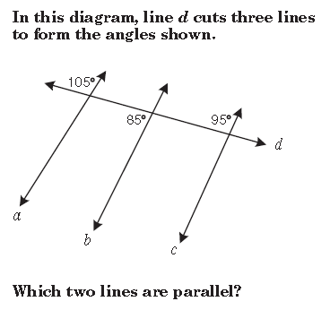
a. | a and b | c. | b and c
b. | a and c | d. | no lines are parallel
____ 49. If the lengths of two sides of an isosceles triangle are 7 cm and 15 cm, what is the perimeter of the triangle?

a. | 29 cm | c. | 30 cm
b. | 35 cm | d. | 37 cm

____ 50. The midpoint of is . If the coordinates of are , what are the coordinates of ?

a. |  | c.
b. |  | d.

51. Complete the argument by filling in the conclusion.

If Mary is a doctor, then she went to medical school.
Mary did not go to medical school

Therefore,___________________________________

52. (a) Write down the triangle congruence statements
(b) Explain why the triangles are congruent. If there are not any pairs of triangles in a given diagram that are congruent, state so.
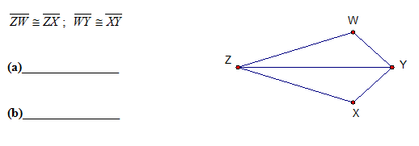

53. Are the triangles similar? Why?

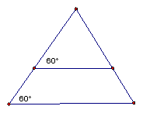
Short Answer

54. What produces a bigger increase in the volume of a cylinder, doubling the radius, or doubling the height? Explain your answer.

55. Two similar cones have slant heights 18 in and 12 in. If the larger cone has lateral area 54 in, find the lateral area of the smaller cone.

56. Find the value of x.
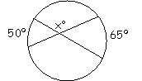

57. Find the value of x.

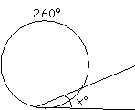

58. Find the value of x.

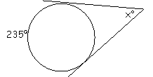

59. Find the value of x.
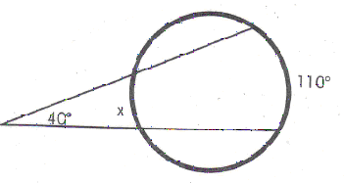
60. What is the value of x?
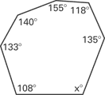

61. List the sides in order from shortest to longest.
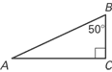
62. Find the volume and surface area of the right cone. Round the result to one decimal place.
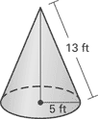

63. Find m and n.
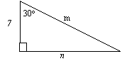
m = _________________

n = __________________

64. Write the converse, inverse, and contrapositive of “If it is hot, then I am tired.”

Converse:________________________________________________________

Inverse:_________________________________________________________

Contrapositive:_____________________________________________________

67. Find the area of the shaded sector.

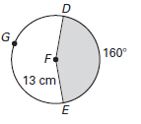
- Find the length of the arc DE.

- Which 3 regular shapes tessellate a plane?

a. square b. regular triangle c. regular pentagon d. regular hexagon e. regular octagon

1. Given:

Prove:

Statements Reasons

1) 1)_______________________

2)___________________ 2) __________________

3) 3)___________________

Given: and  Prove:  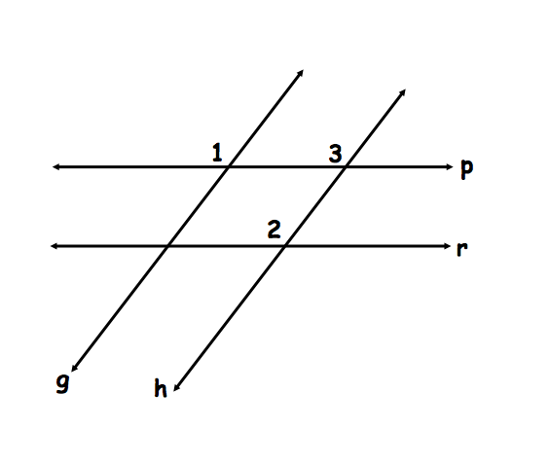 | Statement | Reason
 | 1. | 1. Given
 | 2. | 2.
 | 3. | 3. Given
 | 4. | 4.
 | 5. | 5.

Given: and  Prove:  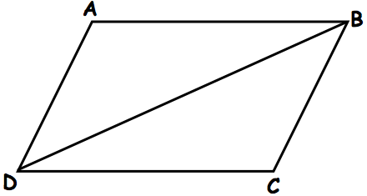 | Statement | Reason
 | 1. | 1. Given
 | 2. | 2. Given
 | 3. | 3.
 | 4. | 4. Reflexive Property
 | 5. | 5.

Given:  Prove:  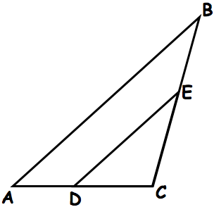 | Statement | Reason
 | 1. | 1. Given
 | 2. | 2. Corresponding angles are congruent.
 | 3. | 3.
 | 4. | 4.
Geometry Final Exam Review
Answer Section

MULTIPLE CHOICE

1. ANS: C PTS: 1 DIF: L3 REF: 12-2 Chords and Arcs
OBJ: 12-2.1 Use congruent chords, arcs, and central angles
TOP: 12-2 Problem 1 Using Congruent Chords
KEY: arc | central angle | congruent circles MSC: DOK 1

2. ANS: C PTS: 1 DIF: L2 REF: 12-2 Chords and Arcs
OBJ: 12-2.1 Use congruent chords, arcs, and central angles
TOP: 12-2 Problem 4 Finding Measures in a Circle KEY: arc | central angle | congruent arcs
MSC: DOK 1

3. ANS: B PTS: 1

4. ANS: B PTS: 1

5. ANS: B PTS: 1

6. ANS: C PTS: 1 DIF: Level B REF: MLGE0103
STA: VA.VASOL.MTH.09.GEO.G.11.a | VA.VASOL.MTH.09.GEO.G.11.b
TOP: Lesson 10.4 Use Inscribed Angles and Polygons
KEY: circle | angle | arc length | measure | inscribed | degrees MSC: Analysis
NOT: 978-0-547-31534-8

7. ANS: A PTS: 1 DIF: Level B REF: MLGE0247
NAT: NCTM.PSSM.00.MTH.9-12.MEA.2.c STA: VA.VASOL.MTH.09.GEO.G.11.b
TOP: Lesson 10.4 Use Inscribed Angles and Polygons
KEY: circle | angle | quadrilateral | inscribed MSC: Application
NOT: 978-0-547-31534-8

8. ANS: D PTS: 1

9. ANS: C PTS: 1

10. ANS: B PTS: 1

11. ANS: D PTS: 1

12. ANS: D PTS: 1 DIF: Level 1 STA: 8.15c
KEY: equation | concept check MSC: Knowledge NOT: PE #1

13. ANS: A PTS: 1 DIF: Level 1 STA: 8.15c
KEY: equation | concept check MSC: Knowledge NOT: PE #1

14. ANS: B PTS: 1 DIF: Level 1 STA: 8.15c
KEY: equation | concept check MSC: Knowledge NOT: PE #1

15. ANS: D PTS: 1 DIF: Level 1 STA: 8.15c
KEY: equation | concept check MSC: Knowledge NOT: PE #1

16. ANS: B PTS: 1

17. ANS: D PTS: 1

18. ANS: A PTS: 1

19. ANS: C PTS: 1

20. ANS: A PTS: 1

21. ANS: C PTS: 1 STA: G.1

22. ANS: B PTS: 1 STA: G.1

23. ANS: B PTS: 1

24. ANS: C PTS: 1

25. ANS: B PTS: 1

26. ANS: A PTS: 1

27. ANS: A PTS: 1

28. ANS: B PTS: 1

29. ANS: A PTS: 1

30. ANS: A PTS: 1

31. ANS: B PTS: 1

32. ANS: C PTS: 1

33. ANS: B PTS: 1

34. ANS: D PTS: 1

35. ANS: A PTS: 1

36. ANS: A PTS: 1

37. ANS: B PTS: 1

38. ANS: B PTS: 1

39. ANS: A PTS: 1

40. ANS: C PTS: 1

41. ANS: A PTS: 1

42. ANS: A PTS: 1

43. ANS: B PTS: 1

44. ANS: D PTS: 1

45. ANS: A PTS: 1

46. ANS: C PTS: 1

47. ANS: D PTS: 1

48. ANS: C PTS: 1

49. ANS: D PTS: 1

50. ANS: B PTS: 1

COMPLETION

51. ANS: Mary is not a doctor.

PTS: 1

52. ANS:

PTS: 1

53. ANS: Yes by AA~

PTS: 1

SHORT ANSWER

54. ANS:
Doubling the radius because the radius is squared in the volume formula, while the height is not.

PTS: 1

55. ANS:
24 in

PTS: 1

56. ANS:
122.5

PTS: 1

57. ANS:
50

PTS: 1

58. ANS:
55

PTS: 1

59. ANS:
30

PTS: 1

60. ANS:
111

PTS: 1 DIF: Level A REF: Geo.08.TestA.Eng.01
TOP: Ch. 8 Test, Level A KEY: Pre-made Test | interior angle measures of polygons
MSC: Application NOT: 978-0-618-65613-4

61. ANS:

PTS: 1 DIF: Level A REF: Geo.05.TestA.Eng.23
TOP: Ch. 5 Test, Level A KEY: Pre-made Test
MSC: Knowledge NOT: 978-0-618-65613-4

62. ANS:

PTS: 1 DIF: Level A REF: Geo.12.TestA.Eng.10
TOP: Ch. 12 Test, Level A KEY: Pre-made Test
MSC: comprehension NOT: 978-0-618-65613-4

63. ANS:
m = 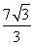

n = 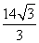

PTS: 1

64. ANS:
Converse: If I am tired, then it is hot

Inverse: If it is not hot, then I am not tired.

Contrapositive: If I am not tired, then I am not hot.

PTS: 1

65. ANS:
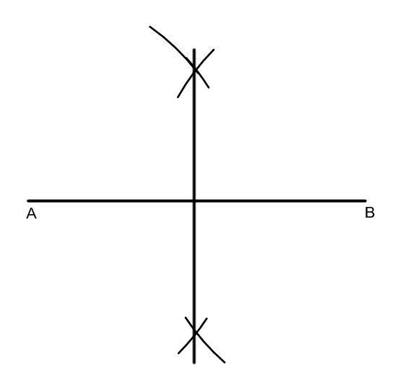

PTS: 1

66. ANS:
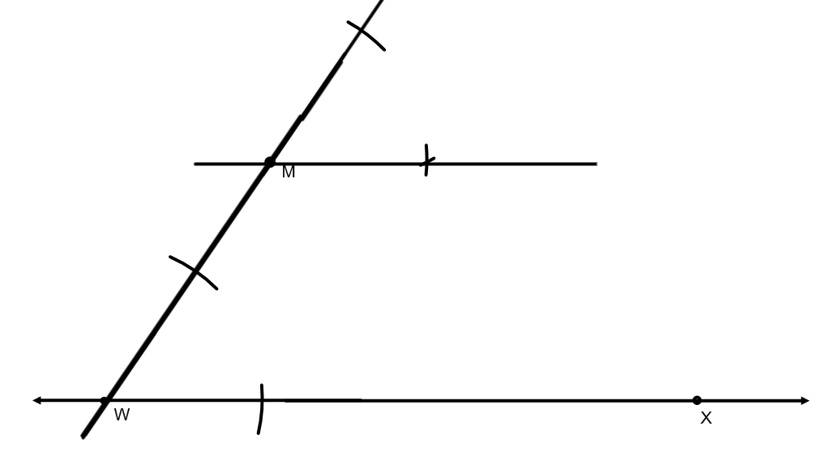

PTS: 1

67. ANS:
235.85 square cm

PTS: 1

68. ANS:
36.28 cm

PTS: 1

