OVERVIEW
These instructions will assist you in completing the State Board of Law Examiners’ (“SBLE”) online electronic Petition (“eBar”) process for the Maryland Out of State Attorney’s Bar Examination. SBLE STRONGLY RECOMMENDS THAT APPLICANTS PRINT THIS DOCUMENT FOR EASY REFERENCE DURING THE ONLINE PETITION PROCESS.
- Please take note that applicants must not only create and submit their Petitions electronically, but also mail or deliver hard copies of the Petition and Request for NCBE Character Report to SBLE with original signatures, notarization, and supplemental documentation, as necessary, along with the appropriate fees.
- Completed hard-copy Petitions, Requests for NCBE Character Report, required supplemental documents, and all applicable fees must be RECEIVED in SLBE’s Office by 4:30 pm on the filing deadline.
- Any hard-copy Petition submitted to SBLE’s office after the deadline or submitted by the deadline but incomplete (and where adequate remediation occurs after the deadline) will not be considered “filed” until accompanied by a request for good cause to file late. Applicants must meet the requirements of Board Rule 2 (“Filing Late for Good Cause”) in order for a good cause request to be considered by SBLE. Non-conforming good cause requests will be denied.
Out-of-State Attorney (Rule 13) Exam
Applicants meeting the requirements of Rule 13 and wishing to sit for the Maryland Out-of-State Attorney exam must file a Petition (RGAB 13(f)). To access eBar for the Out-of-State Attorney’s exam, click on the link for the Out-of-State Attorney Bar Exam Electronic Application from SBLE’s website – www.mdcourts.gov/ble. You may also access the site directly from this document at: https://jportal.mdcourts.gov/ebarapp/login.do?tmpl=o.
General Bar Exam
Recent law school graduates and attorneys who do not meet the eligibility requirements of Rule 13 of the Rules Governing Admission to the Bar of Maryland (“RGAB”) to sit for the Attorney exam must apply to take the Maryland General Bar Examination. Applicants taking the Maryland General Bar Exam for the first time must complete and submit an Application (consisting of Parts I and II) and an Original Petition to Take a Scheduled Examination. These three (3) documents are all generated within eBar.
Applicants who have previously taken the Maryland General Bar exam one (1) or two (2) times need only submit a Retake Petition (but not an application, unless an update is required). Applicants who have previously taken the Maryland General Bar exam on three (3) or more occasions must submit a Retake Order (but not an application, unless an update is required). Retake applicants will follow the same process for filling out an online Petition as those taking the exam for the first time. eBar will produce the appropriate Petition for each applicant.
To access eBar for the General Bar Exam, click on the link for the General Bar Exam Electronic Application from SBLE’s website – www.mdcourts.gov/ble. You may also access the site directly from this document at https://jportal.mdcourts.gov/ebarapp/login.do?tmpl=g. A separate instructional document exists for use in completing the online Application and Petition for the Maryland General Bar Examination.

INSTRUCTIONS FOR FILING A BAR APPLICATION
Creating an Account
Completing the Petition for the Out of State Attorney Exam begins with creating an eBar account. On the Welcome screen, click on the “Create Account” link found near the login boxes or in the left menu bar.
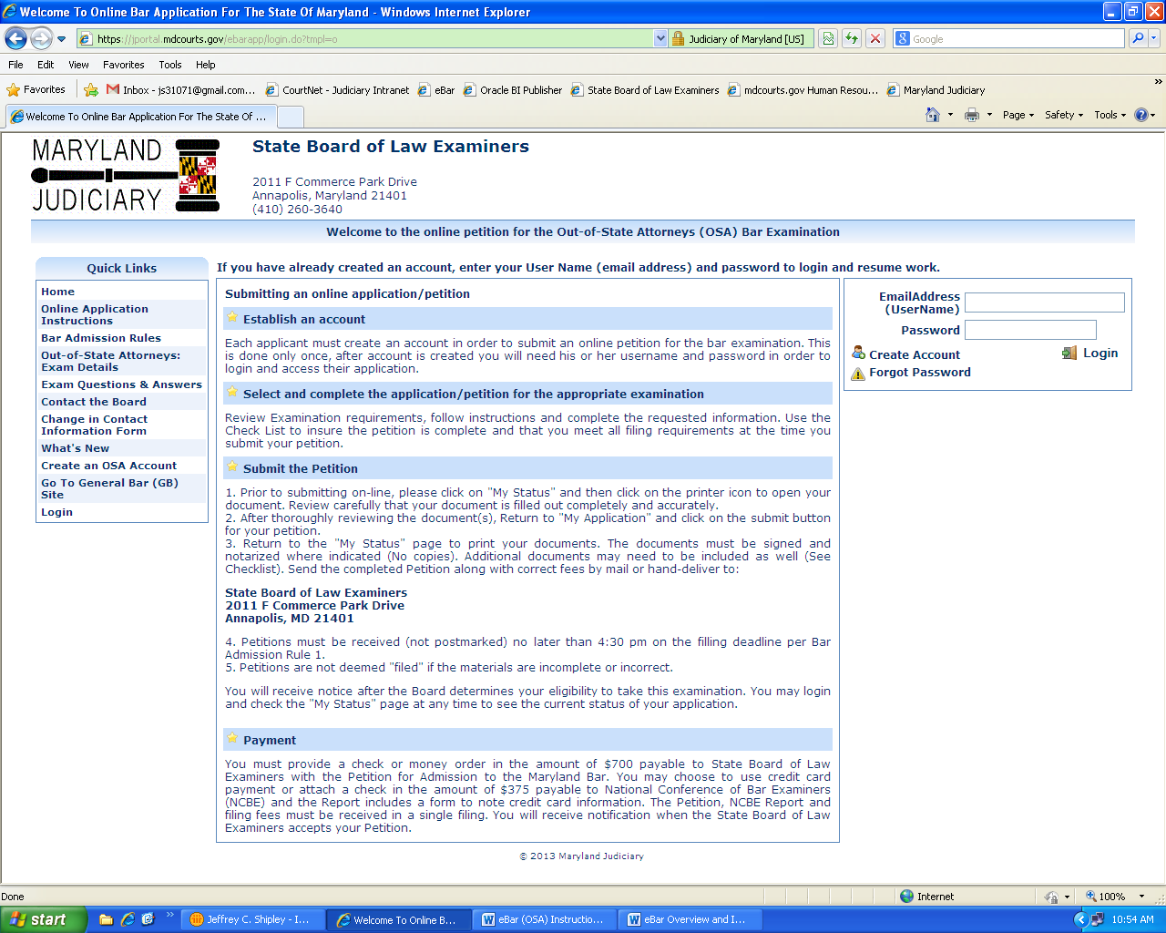
Fig. 1 – Welcome Screen for the eBar system (Out of State Attorney’s Exam)
NOTE: Check carefully to ensure you are creating an account for the exam you intend to take – Out of State Attorney’s (OSA) Examination or General Bar (GB) Examination.

You will be taken to the account creation form:
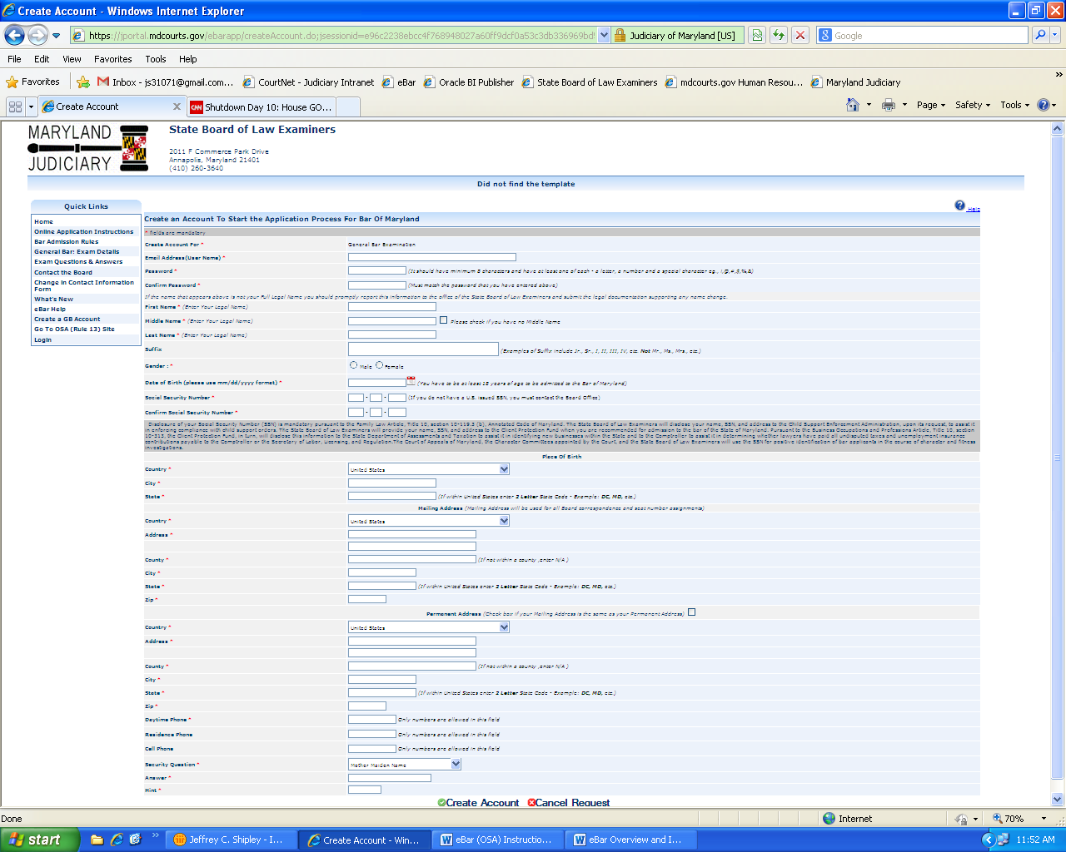
Fig 2 – Account creation form
Complete all required information (marked with a red asterisk “*”). In eBar, your e-mail address becomes your User Name. It is critical that the e-mail address you provide not change during the course of the examination process- from the time you create your account through the date of your admission. Your password must contain a minimum of eight characters and must contain at least one (1) letter, one (1) number, and one (1) special character (! @ # $ % & or *). Please write down your password. Passwords are case sensitive.
NOTE: In order to apply for an eBar account, you must disclose your U.S. Social Security number, pursuant to Md. Code Ann., Family Law, §10-119.3(b). If you do not have a valid Social Security number, you must contact SBLE’s office by telephone (410-260-3640) for instructions on how to proceed.
As you fill out the required fields to create your user account, review your entries carefully before you save your data. Often, applicants will make errors in entering data for their Social Security numbers, date of birth, place of birth, suffix, prefix, etc. After submission, mistakes may only be corrected by sending a signed letter to the Board noting the error and correction to be made.
When all fields have been completed and double-checked, click “Create Account.”
After you submit the required information to create an eBar account, you will receive a confirmation e-mail that you will use to activate your account. Please be aware of the privacy and spam settings on your e-mail account, and ensure that “ebar@mdcourts.gov” is whitelisted in your spam settings. The email text is as follows:
Dear [APPLICANT NAME],

Welcome to Maryland e-bar application process. You have successfully registered to our website. However, to access your account and continue with the application submission process you will have to activate your account.

To activate your account, click on the link "Activate your account" below.
Activate your account

If you cannot click on the link above, please copy and paste the link below to your browser.
https://jportal.mdcourts.gov/ebarapp/account.activate?q=48561&u=c800f932a9044149edc36af64dc9864f&d=c28765dbec337b186ca583e07292b3b

Sincerely,

Jeffrey C. Shipley
Secretary, State Board of Law Examiners
2011-F Commerce Park Drive
Annapolis, MD 21401
jeffrey.shipley@mdcourts.gov

You MUST click on the “Activate your account” link before you can log in to eBar to create your Petition. If you do not receive an activation e-mail within a few hours of creating your user account, contact the SBLE Office at (410) 260-3640 during normal business hours (M–F 8:30am to 4:30pm) to manually activate your account.
CAUTION: E-mail account providers hosted with “.net” domains (e.g., comcast.net, verizon.net, att.net, etc) and AOL DO NOT interface with eBar. SBLE strongly recommends that applicants with “.net” and AOL email addresses create a “.com” email address for use with eBar. SBLE does not endorse any particular “.com” but has noted that Gmail, Yahoo, and Hotmail function properly with eBar.
CAUTION: Applicants using “.edu” email addresses issued by their law schools and/or colleges must ensure that their institution does not “turn off” access to that email address after graduation. If unsure, another email address should be utilized.
CAUTION: Passwords and Security Question Answers are case-sensitive. The system will lock the account after five (5) failed login attempts. Please utilize eBar’s “Forgot Password” system to recover your forgotten password prior to locking yourself out. Applicants who become locked out must contact the Board’s Office by telephone (410-260-3640) during normal business hours (8:30a to 4:30p M-F) to unlock their account. Email requests to unlock eBar user accounts cannot be honored due to RGAB 19 confidentiality safeguards.
Filling Out the Application and/or Petition Online
After activating your account, you will be able to log in to eBar and begin your Petition for the Out of State Attorney Exam.
Upon logging into eBar, the first screen you will see is the “My Status” screen.
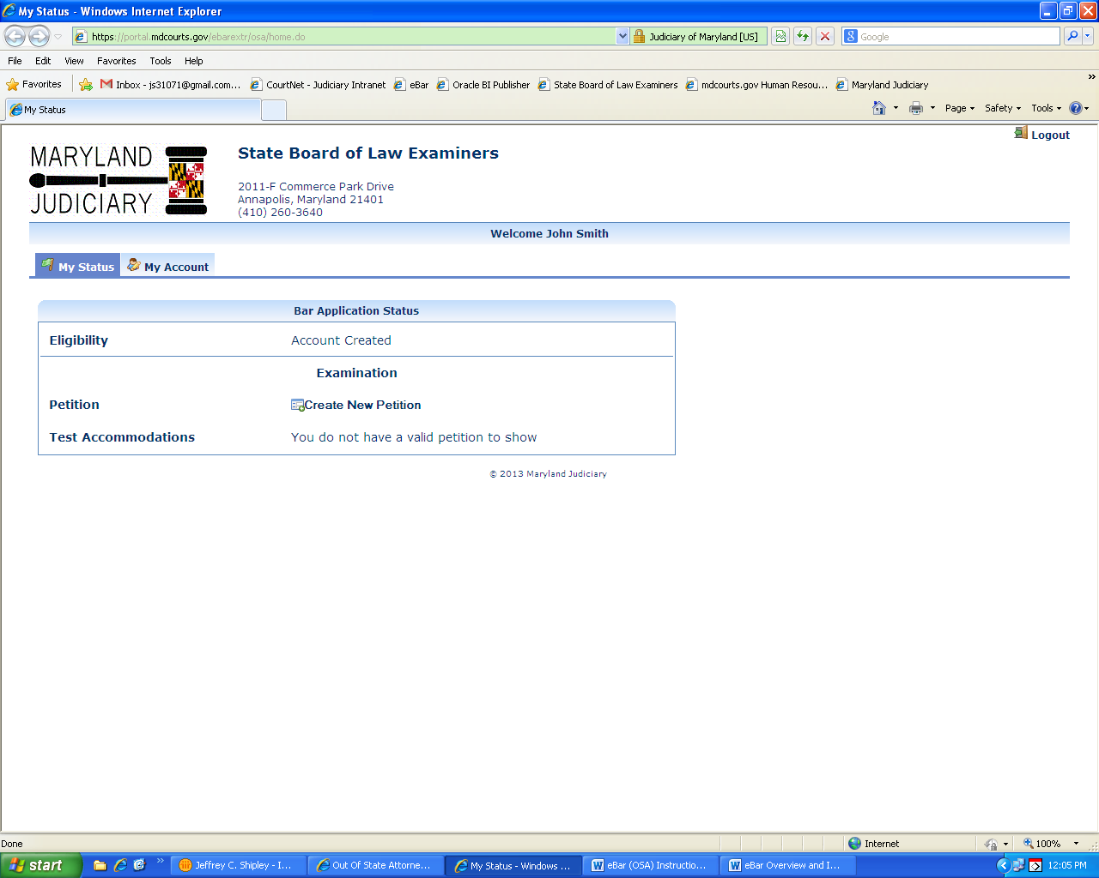
Figure 3 – “My Status” screen
Click on “Create New Petition” to begin the online application process.

Clicking “Create New Petition” automatically moves you into the first page of the Petition.
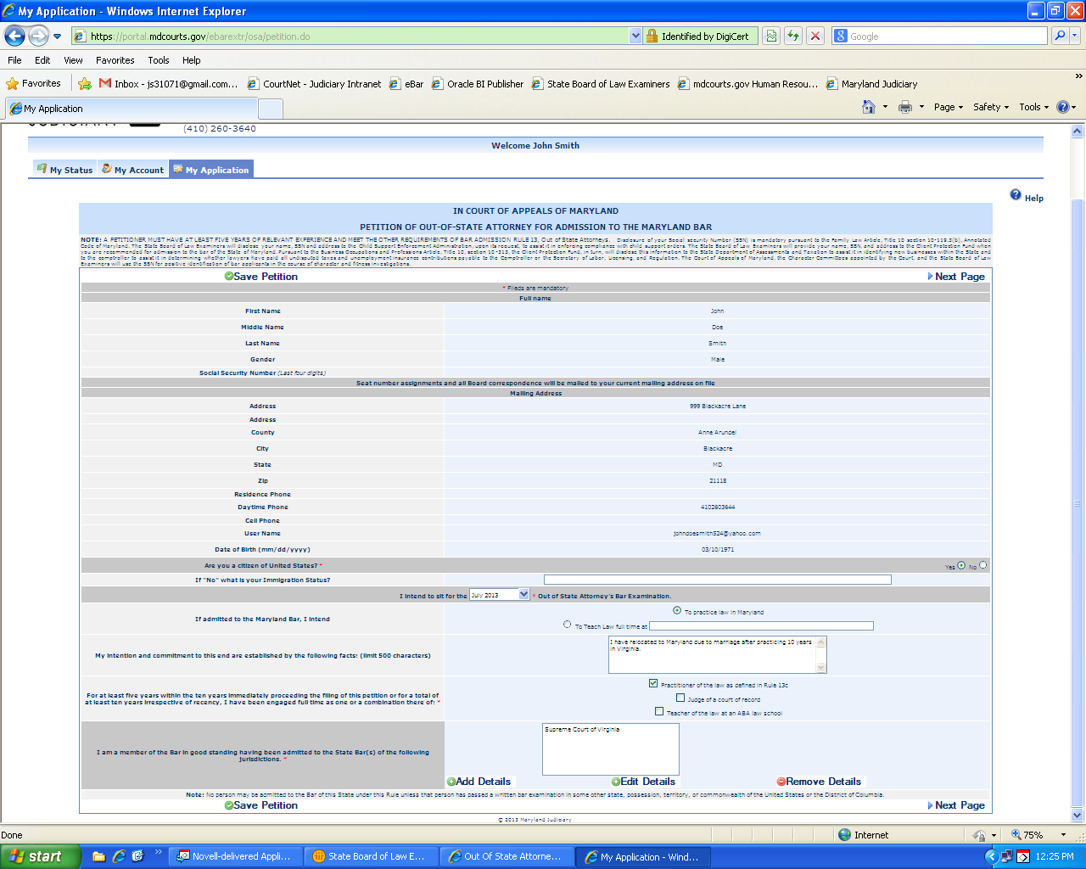
Figure 4 – “My Application” Page 1
The majority of fields on this page are pre-filled with information from the account creation screen. Complete each item marked by a red asterisk “*.” Clicking “Save Petition” at the bottom of the screen will take you to the next page of the Petition, which is the Accommodations Request.

Accommodations Requests
Applicants planning to request an ADA testing accommodation must click the radio button for “Yes” in response to the question, “Are you applying for test accommodations for the bar examination. (Figure 5, below.) You must also check the box indicating review of the terms and conditions even if you checked “No” regarding a request for accommodation.
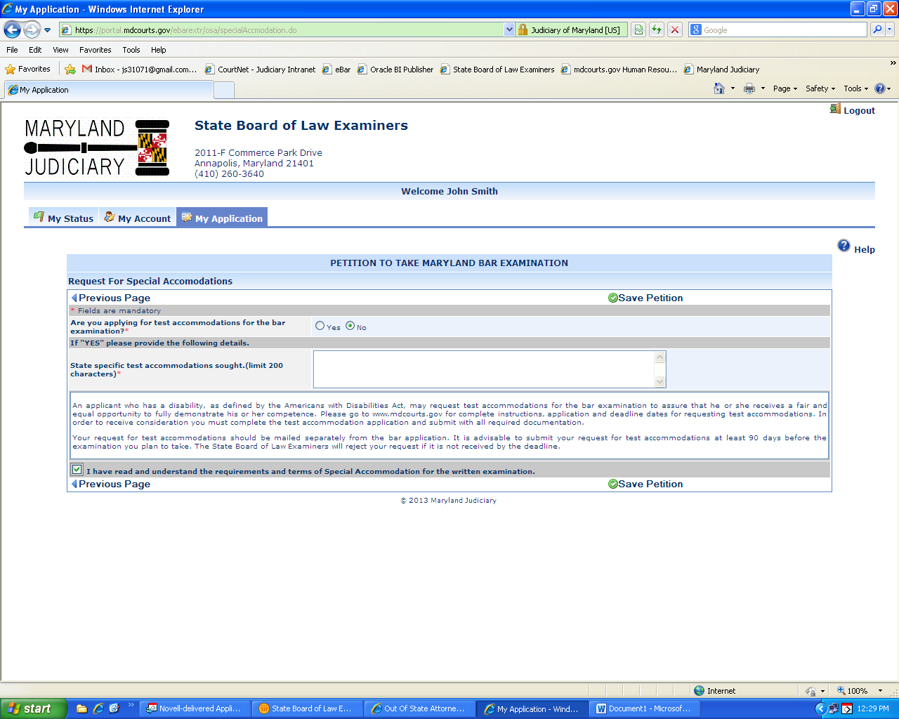
Figure 5 – Request Test Accommodations screen
CAUTION: Applicants who plan to request ADA testing accommodations for the Maryland Bar exam must (1) complete the “Request for Special Accommodations” in eBar first AND (2) print the Instructions and Applicant’s Accommodations Request Form, fulfill all the requirements therein, and mail/hand-deliver a complete and fully documented Request Form to the Board’s Office by the filing deadline. The Applicant’s Accommodations Request Form may be found at:
http://www.courts.state.md.us/ble/pdfs/testaccommodations.pdf.

Then, click “Save Petition,” which will return you to the “My Application Checklist.
On the “My Application” screen, click “Submit Petition” in the middle of the page.
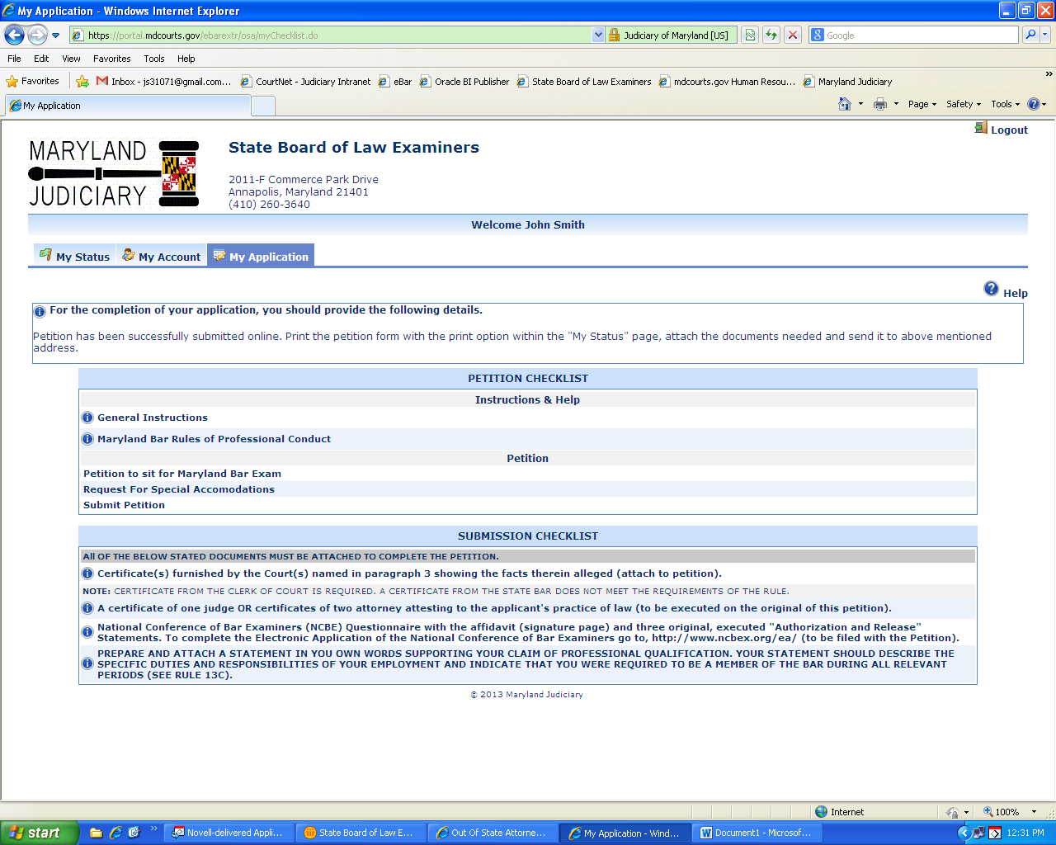
Figure 6 – My Application, ready to “Submit Petition”
You have now completed the process of creating and submitting your Petition online, BUT YOU ARE NOT FINISHED. You must still print and submit a hard copy of your Petition and the Request for NCBE Character Report, with all required signatures and supporting documentation, and all applicable fees.

Once you have submitted your Petition electronically, go to your “My Status” page. You should see a printer icon for the Petition. (See Figure 7, below.)
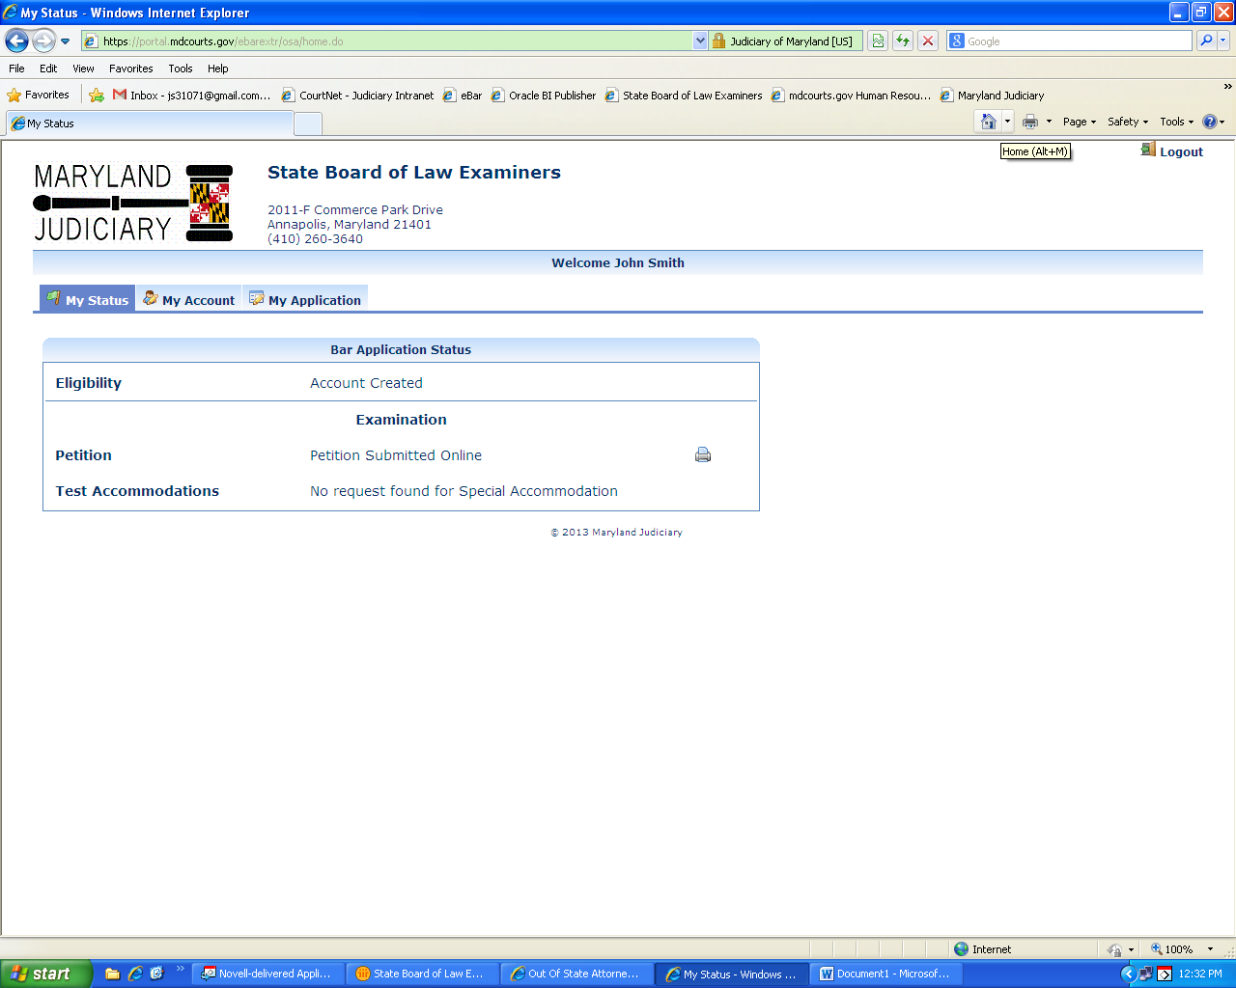
Figure 7 – “My Status” showing printer icon.
Click on the icon(s) to print a copy of your Petition.
CAUTION: If your printed document(s) contain(s) a “VOID” watermark, you did not electronically submit the documents. Go back to “My Application” and look in the middle of the page for “Submit Petition”. Click on Submit and look for your confirmation message. Then return to My Status and re-print the document(s). You should now have no “Void” watermarks.
You must sign the Petition where indicated and have the form notarized as required. You must also provide supplemental documentation as necessary in order for your Petition to be complete. Your “My Application” screen displays a checklist of documents that must be submitted with the Petition (see Figure 6, above). Please review the checklist carefully.
Only complete Petitions submitted online and in hard-copy with the required signatures, notary stamps, supplemental documents and filing fee(s) will be treated as “filed” by SBLE. When SBLE processes your hard copy Petition along with original signatures, notarization and supplemental documents, your “My Status” page will display changes to your status. You may also receive e-mails from the eBar system when your status changes.
Requesting a Character and Fitness Investigation from the National Conference of Bar Examiners:
The Maryland State Board of Law Examiners uses the character investigation services of the National Conference of Bar Examiners to complete the required investigation of each person Petitioning for admission to the Maryland Bar via the Out-of-State Attorney’s Examination under Rule 13. In addition to creating the online and hard-copy Petition discussed on the preceding pages, you must go to the NCBE’s website (www.ncbex.org) and complete the online Request for Character Report.
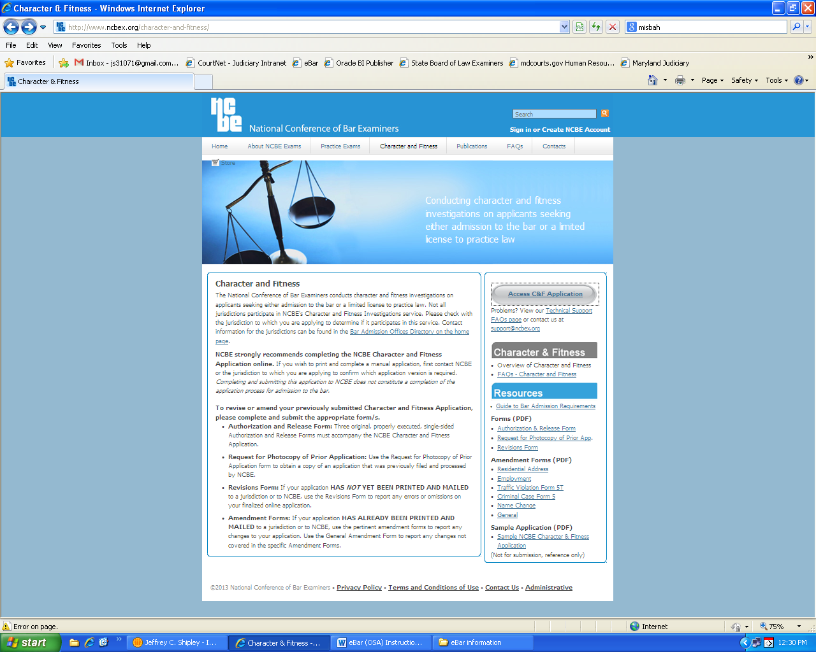
Click the link on the top menu bar for “Character and Fitness. Then click the button at center right for “Access C&F Application.” Complete the NCBE application. You must print, sign and submit your NCBE Character & Fitness Application to SBLE along with your hard copy Petition.

