Masterpiece: Cycle, 1938 by M.C. Escher

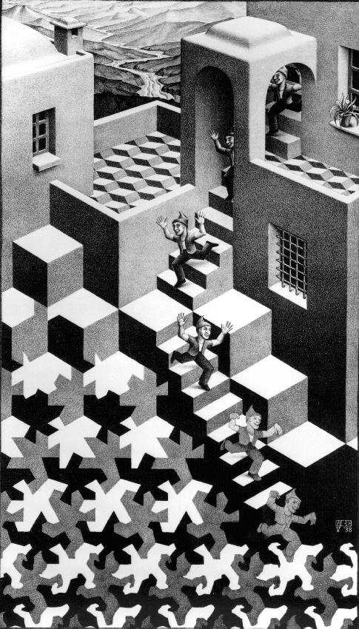
Pronounced: ESH-ER
Keywords: Graphic Art, Tessellations, Metamorphosis
Grade: 6th Grade
Month: December/January
Activity: Tessellation Puzzle
TIME: 1.25 hours

Meet the Artist:
- Escher was born in 1898 in Holland. The MC stands for Maurits Cornelius.
- He did not do very well in school, but he continued through the university level, eventually studying graphic arts.
- Escher was considered the foremost authority on graphic art. Graphic art is the art or the science of drawing, especially according to mathematical rules. His work was a sort of bridge between the scientific world and artistic imagination.
- Escher was Dutch but as a young man moved to Italy and traveled across Europe. While traveling, he met his wife; they had three children and settled just outside of Rome.
- In 1935, he and his family moved to Switzerland. Unhappy in Switzerland, he returned to Belgium and finally to The Netherlands.
- Influenced by the intricate floor tiles he saw in Italian and Spanish architecture, he became very interested in Mosaics. Mosaics are wall or floor art created by placing small tiles in patterns using repetition.
- Escher expanded his study of Mosaics into a mathematical art technique called tessellations.
- He also liked to use the theme of metamorphosis or the complete change of an object, in his work. Birds transform to fish, fish to frogs and night turns into day.
- Escher was not a fan of modern art, and his art did not receive much attention until he was about 52 years old. Although the key to Escher’s art is geometry: spheres, cubes and spirals he did not claim any ability to understand mathematics. His original fans were physicists and mathematicians.
- He died in his home in 1973 of cancer.

Discussion:
What is Tessellations in art? Tessellations are mosaic patterns where the pieces fit together like a visual jigsaw puzzle. There is no background and foreground and the outline of one figure becomes the boundary of another. They are mostly seen in quilts, fabrics and wallpaper. Escher was one of the first to put a recognizable image into tessellations. According to M. C. Escher, a tessellation is "a regular division of the plane".

Possible Questions:
  - Have you seen tessellations before?
  - Where? (floor tiles, rugs, mosaics, quilts, ceiling panels in ornate buildings)
  - Where would you see them, any in the room?
  - What kind of lines do you see?
  - What kind of shapes do you see?
  - What would you title the painting?
  - Do you like it? Why or Why not?
  - Do you see a story in it or is it just nonsense?

Activity: Tessellation Puzzle

Note to Grade Coordinator or Art Guide: Prior to this activity, the 3” squares will need to be cut for each student using the colored FOUZ card stock. (paper that was donated to the Art Masterpiece program)

Materials Needed: 9”x12” white construction paper, 3” square heavy card stock (FOUZ), student’s own pencil, scissors, masking tape, student’s own pencils, colored pencils, colored markers, black fine tipped markers, 12”x18” black construction paper, glue stick

Explain activity – students will transform a 3”square into an unusual shaped template that they will tessellate onto a sheet of white construction paper, color and give their piece a title. Students may follow the directions for the “Nesting Hens” described at the end of lesson or come up with another simple shape.

THE SECRET TO MAKING A TESSELLATION TEMPLATE….is having one side directly equal to the opposite side with no leftover paper. Whatever line squiggle, angle or bump configured on one side is cut out from that side and taped to the opposite side. This cutout can be placed anywhere along the opposite side with the edges “kissing” and NOT overlapping.

Process:
- Show students the tessellation examples at end of lesson for ideas.
- Give each student the following materials: 3” square of heavy card stock, white construction paper, scissors, masking tape, student’s pencils. Place on each workstation the following materials: colored pencils, colored markers, black fine tipped markers, glue sticks.
For students designing their own tessellation.
- Using the 3” square.
  - Lightly draw a line design on one side (i.e. right or left) and number 1.
  - Cut out and tape anywhere along the opposite side with the number reading right and the edges “kissing” and NOT overlapping, tape in place.
  - Lightly draw another line design on top or bottom side and number 2.
  - Cut out and tape along the opposite side with the number reading right and edges “kissing”. Note: if student is designing a fish, this piece will need to be flipped. You now have a template for tracing the tessellation.
- Using the tracing template, align it with a right or left side of the drawing paper (Some students may want to stack their design from corner to corner) and trace the design in one stacking column with “kissing” edges.
- Move the template to the right or left and interlock the fitting shapes to make a second column that interlocks with the first column. Continue tracing all columns until the paper is filled.
- Color the shapes with the colored pencils or markers using black/white or light/dark or alternating complimentary colors. Add details such as eyes, scales, feathers, etc.
- Outline the shape and details in black marker.
- When students are finished with coloring and outlining, hand out the black construction paper and glue stick and have them mount their tessellation paper onto the black construction paper.
- Title and sign it at the bottom of the black construction paper using a white crayon, or a white colored pencil. Sign the back with student name and teacher.
For students using the “Nesting Hen” tessellation.
- Make a diagram on the board that follows the steps illustrated below.
  - Number the corners as shown;
  - Cut the bottom two corners off and move up to the top. With the edges “kissing” and NOT overlapping, tape in place. The numbers should stay right reading (i.e. don’t flip the pieces).
  - Have the students draw a triangle on the left (back) side, label “H” for head, and move to the right and tape in place to make a bird shape.
- Continue process as defined in #4-9 above.
Tessellation Ideas

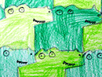 Gators and Crocs

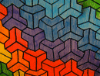 Geometric Rainbow

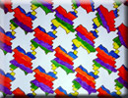 Geometric Spectrum

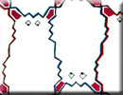 Funny Bunnies

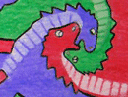 Colored Dragons

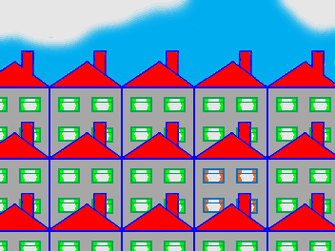 City Block  Template

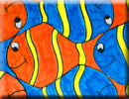 Here’s Nemo

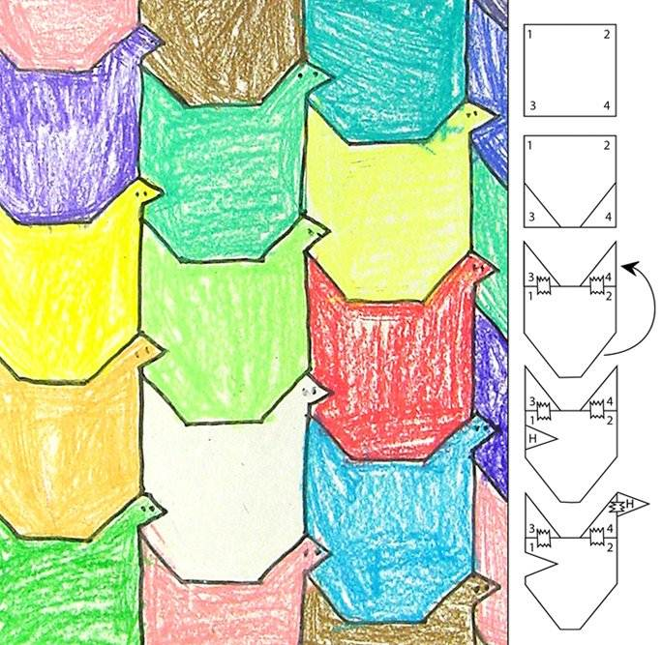 Nesting Hens
Self Portrait of MC Escher and Other works
