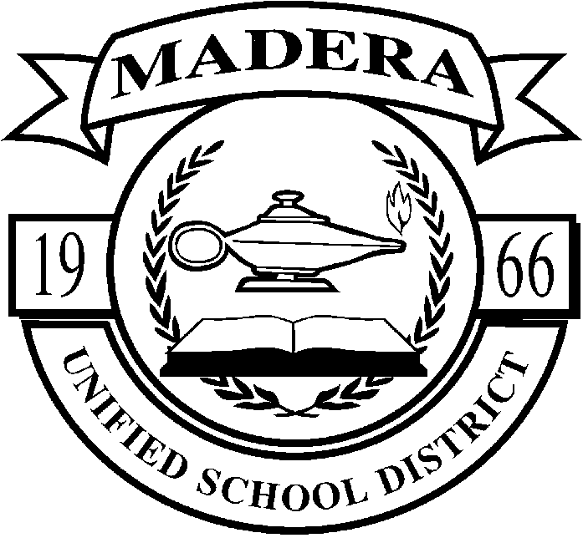
Teacher Support Program
Peer Assistance and Review Program

Consulting Teacher Application

Name of Applicant District School Site Track

_________________________________________________________________________________
Home Address City Zip Code

_________________________________________________________________________________
Current Grade/Content Area Assignment Home Telephone

___________________________ ___________________________
Number of Years in Education In District

Other Grade(s) Taught ____________________________Subject(s) Taught ________________

Mark the following that apply to your growth as a professional:
_________ Doctorate
_________ MA
_________ credentialed classroom teacher with permanent status
_________ English Language Development Specialist Credential
_________ Bilingual Certificate of Competence and/or Bilingual Credential
_________ Special Education Credential
_________ Reading Specialist Credential
_________ Other Credentials: ______________________________________________
_________ BTSA Support Provider
_________ Pre-Intern Coach
_________ mentor teacher : year(s) __________ position(s) ___________________
_________ curriculum committee participant
_________ department chair/team leader
_________ experience as a teacher trainer/staff development leader
_________ site leadership team
_________ subject matter project experience
_________ other: ________________________________________________________

- Why are you interested in applying for a Support Provider Teacher position with the BTSA/PAR program?

- What strategies would you use to assist a beginning teacher?

- What strategies would you use to improve the performance of a veteran teacher?

- Why would you be effective in the position for which you are applying?

In accordance with state board guidelines, I consent to the release of personnel information relating to my experience and performance for review by the PAR Panel.
_______________________________________ ___________________
Signature Date

Submit the following:
*Support Provider Teacher Application
*Letter of Recommendation from Principal (see attached)
*Personal Letter of Application (see attached)
to
Steve Thornton, Teacher Support Program
Madera Unified School District

For additional information, please contact
Steve Thornton, Madera Teacher Support Program
(559) 673-2450 fax 673-4932
stevethornton@maderausd.org

