COLONIAL FOUNDATIONS & SETTLEMENT OF NORTH AMERICA Document Packet

DIRECTIONS:

Using the accompanying documents, your knowledge of the time period and topic, and any other resources you have or care to consult, respond to the following question fully, accurately, and from a variety of viewpoints. Respond to this question using the textual information and the documents.

OVER ARCHING QUESTION:

What brought about the development of colonial North America from 16th to the 18th centuries? Who settled in the colonies and what dictated their settlement pattern?

Historical Context: The sixteenth-century English intellect had plenty of fare for imaginative rumination. Sir Thomas More’s Utopia, translated into English in 1551, beckoned with its perfect society in Paradise, a small island somewhere in the New World. Richard Hakluyt interviewed many of the sailors and adventurers to those new lands and his edited travelogues of the 1580’s sparked expectations of wealth and plunder beyond anyone’s dreams. Even William Shakespeare contributed to this romantic geography with the captivating beauty of Prospero’s island in The Tempest.
The fantasy of far-away visions had a particular appeal to the residents of a troubled, turbulent England. The British Isles (and most of Europe) had rebounded from the catastrophic social and economic effects of the Black Death two centuries earlier and land was at a population-boom premium. Increased prosperity brought increased trade, and worldwide mercantile networks and commercial expansion were underway. A primary English contribution to this new market system was wool, a commodity that made the conversion of formerly open feudal farmlands to the enclosed pasture profitable. Displaced peasants left the countryside and moved to major cities like London in search of livelihood, and the ranks of the urban poor swelled.
Also in the sixteenth century, Henry VIII broke his country’s ties with the Catholic Church and established the Church of England with himself as head. Although this English chapter of the Protestant Reformation had more to do with dynastic succession and Henry’s hope for a son than theological dispute, his actions nonetheless loosed religious dissent and sectarianism in his kingdom. The eventual ascension of his Catholic daughter, Mary, re-established Catholicism in England for a time until Elizabeth I severed ties with Rome a second time in 1558 and rekindled religious differences anew.

Document A:

Source: Magna Carta, June 15, 1215. As quoted by C. Stephenson, Sources of English Constitutional History. (New York: Harper and Row, 1937), pp 115-26.

Editorial comment [Stephenson],
While these nobles wanted to protect their own feudal rights, the document is considered the first major step toward democracy in England. It established the principle that the king is not above the law.

1. …We have. . .granted to God and by this. . .confirmed, for us
and our heirs forever, that the English Church shall be free
and shall have its rights entire and its liberties inviolate…
12. Scutage [military tax] or aid [feudal tax] shall be levied in our kingdom only by the common council of our kingdom..
21. Earls and barons shall be amerced [fined] only by their peers
and only according to the degree of the misdeed.
39. No freeman shall be captured or imprisoned or [dispossessed] or outlawed, or exiled or in any way destroyed…except by the lawful judgment of his peers or by the will of the land.
40 To no one will we sell, to one will we deny or delay right and
justice.

What type of source is this? (Primary or secondary and WHAT is it?) ___________________________________________________________________________________________________________________________

What does this document establish? ___________________________________________________________________________________________________________________________________________________________________________________________________________________________________

Why was going on that required this document? __________________________________________________________________________________________________________________________________________________________________________________________________________________________________

Document B:

Source: John Locke, Second Treatise of Civil Government. Old South Leaflets, No. 208. Boston. Old South Association, n.d.

The state of nature has a law of nature to govern it, which obliges everyone; and reason which is that law, teaches all mankind. . .that being all equal and independent, no one ought to harm another in his life, liberty, or possessions . . . Men being, as has been said, by nature all free, equal, and independent, no one can be put out of this estate and subjected to the political power of another without his own consent…
The supreme power cannot take from any man any part of his property without his own consent . . .
These are the bounds which. . .society, and the law of God and Nature, have set to the legislative power of every commonwealth…
First, they are to govern by. . . established laws, not to be varied in particular cases, but to have one rule for the rich and poor. . .
Secondly, these laws ought to be designed for no other end. . . but the good of the people.
Thirdly, they must not raise taxes on the property of the people without the consent of the people. . .
Whenever the legislators endeavor to take away and destroy the property of the people, or to reduce them to slavery. . .they put themselves in a state of war with the people. . .

What type of source is this? (Primary or secondary and WHAT is it?) ___________________________________________________________________________________________________________________________

How do these ideas potentially effect of change society? ___________________________________________________________________________________________________________________________________________________________________________________________________________________________________

Why is this document included in a discussion about North American colonialism? __________________________________________________________________________________________________________________________________________________________________________________________________________________________________

Document C:

Source: The Mayflower Compact. November 11, 1620

. . . We whose names are underwritten. . . Having undertaken, for the Glory of God and Advancement of the Christian Faith, and the Honour of our King and Country, a Voyage to plant the first colony in the northern part of Virginia, do by these presents solemnly and mutually in the prescience of God, and one of another, covenant and combine ourselves together into a civil body politic for our better ordering and preservation and furtherance of the ends aforesaid; and by virtue here of, to enact, constitute, and frame such just and equal laws, ordinances, acts, constitutions, and offices from time to time, as shall be thought most meet and convenient for the general good of the colony unto which we promise all due submission and obedience. In witness whereof we have hereunto subscribed our names at Cape Cod the eleventh of November, in the reign of our Sovereign Lord King James. . .the fifty-fourth Anno Domini, 1620.

What type of source is this? (Primary or secondary and WHAT is it?) ___________________________________________________________________________________________________________________________

What is the purpose of this document? ___________________________________________________________________________________________________________________________________________________________________________________________________________________________________

How does this document and the previous two (Doc A &B) relate? __________________________________________________________________________________________________________________________________________________________________________________________________________________________________

Document D:

Source: “The Bloody Tenent of Persecution for Cause of Conscience.” 1644. By Roger Williams of Rhode Island.

First. That the blood of so many hundred thousands souls of Protestants and Papists, split in the wars of present and former ages, for their respective consciences, is not required nor accepted by Jesus Christ, the Prince of Peace.
Sixth. It is the will and command of God that a permission of the most pagan, Jewish, Turkish, or anti-Christian consciences and worships be granted to all men in all nations and countries. . .
Eighth: God requires not a uniformity of religion to be enacted and enforced in any civil state. . .enforced uniformity. . .is the greatest occasion of civil war, ravishing of conscience, persecution of Christ Jesus in his servants, and of the hypocrisy and destruction of millions of soul.
Twelfth. Lastly, true civility and Christianity may both flourish in a state or kingdom, not withstanding the permission of divers and contrary consciences, either of Jew or Gentile. . . . the government of the civil magistrate extends no further than over the bodies and goods of their subjects, not over their souls, and therefore they may not undertake to give laws unto the souls and consciences of men. . . .the Church of Christ does not use the arm of secular power to compel men to the true profession of the truth, for this is to be done with spiritual weapons, whereby Christians are to be exhorted and not compelled.

What type of source is this? (Primary or secondary and WHAT is it?) ___________________________________________________________________________________________________________________________

What is this document saying? ___________________________________________________________________________________________________________________________________________________________________________________________________________________________________

What does this document reveal about possible motivations for colonization? __________________________________________________________________________________________________________________________________________________________________________________________________________________________________

Document E:

Source: Gillon & Matson, The American Experiment: A History of the United States. (New York: Houghton Mifflin, 2002), pp 92-93.

Spain , the preeminent colonial power in the 1500s, set the model for imperial economic policy that other nations would follow.

English merchants sought extensive government intervention in the economy to protect now one, now another rising economic interest. Their thinking known (and criticized) as mercantilism, the term used in 1776 by the famous Scottish political economist Adam Smith.

. . .Within the nation, mercantilists said, inhabitants needed a wise government to harness production, to curb the greedy and destructive tendencies of competition, and to promote and channel the exchange of goods through regulation.

By the late 1600s, many mercantilists believed that wealth was not necessarily finite, but that expanding commerce with far-flung peoples helped create strong empires. A commercial empire they wrote, should have one center from which flowed finished goods and many widely distributed satellites that consumed the center’s manufactures and sent back raw materials for additional production in the “home country.”

What type of source is this? (Primary or secondary and WHAT is it?) ___________________________________________________________________________________________________________________________

What is mercantilism? ___________________________________________________________________________________________________________________________________________________________________________________________________________________________________

How is colonization a natural extension of mercantilism ? __________________________________________________________________________________________________________________________________________________________________________________________________________________________________

Document F:

Source: John D. Hicks, The Federal Union. 3rd ed. Vol. I, (New York: Houghton Mifflin Company. 1957). P.19

The generous charters which trading companies received from the English crown reveal a kind of alliance between government and business that is not difficult to explain.

. . .According to the mercantilists, the chief measure of a country’s wealth was the amount of gold and silver it could amass. The trading companies, by exchanging expensive English manufactures for cheap raw materials, might be counted upon to produce for England a
“favorable balance of trade,” because of which a steady stream of precious metals would flow into the country. Indeed, economic dependence might easily lead to the loss of political independence

To thoughtful English officials America seemed ideally fitted to become an independent national source of supply. The Spanish had found abundant wealth [gold and silver] shy should not the English?

What type of source is this? (Primary or secondary and WHAT is it?) ___________________________________________________________________________________________________________________________

Why should the English work to colonize North America? ___________________________________________________________________________________________________________________________________________________________________________________________________________________________________

Document G:

De Lamar Jensen, Reformation Europe: Age of Reform and Revolution. pp. 434-5

In the meantime, the first English penetration of the Spanish colonial monopoly launched English colonization ventures in America. More in spite of James I than through his support. London merchants organized a colonizing company for settling and trading in Virginia. In 1607 its first exploration planted a colony upriver from the Chesapeake Bay, naming Jamestown in honor of the king. Difficult weather, lack of food and little desire to grow their own, harassment by Indians, and rampant disease almost destroyed the colony. Most of the settlers died within the first two years. Reinforcements from the newly chartered Virginia Company, the gradual realization that any wealth acquired would have to come from the sweat and toil rather from picking up gold nuggets, and introduction of tobacco cultivation, combine to salvage the colony and eventually make it a successful enterprise.

The second permanent English settlement was Plymouth Colony, established in 1620 by the Pilgrims, a voluntary joint-stock company composed of religious separatists from London, Southampton, and Leiden, Holland. It was later annexed to the larger Massachusetts Bay Colony, founded a few years later by Puritans from England. Neither colony produced the economic wealth that it expected to, but they did plant a legacy of representative self-government in the colony with the Mayflower Compact, by which its signatories agreed to unite in a political-religious society and obey the Laws that would subsequently by made.

From an economic point of view, other ventures were proving to be more profitable. This period was one of commercial expansion for England as well as France and the Netherlands. The American colonies were only a small part of that activity. The Spanish monopoly in the West Indies was penetrated by English seamen and merchants in the first three decades of the seventeenth century. Saint Kitt was settled in 1624. . .Nevis, Montserrat, Antigua, Trinidad, and Tobago,[sometime later]. Barbados, that hidden jewel of the Caribbean was claimed in 1625. It also produced quick wealth from the sale of cotton, tobacco, and sugar.

What type of source is this? (Primary or secondary and WHAT is it?) ___________________________________________________________________________________________________________________________

During the early colonial period what types of economic activities would you in North America? ___________________________________________________________________________________________________________________________________________________________________________________________________________________________________

Document H:

Curitis P. Nettels, (Cornell University) Roots of American Civilization. [New York: Appleton-Century-Crofts, Inc. 1938,] p

The transition from medieval to modern economy introduced a new economic philosophy which the eighteenth century designated as mercantilism—not a systematic program but a collection of regulations exhibiting a major trend. Political mercantilism was an expression of the militant nationalism which arose upon the ruins of feudalism. Its objects were threefold: to achieve an economic self-sufficiency for the manufacturers, and merchants, and to yield an ample revenue to the Crown.

In the opinion of mercantilists the external trade of a country was similar to the business of private merchant. Imports were analogous to the merchant’s purchases, and exports to his sales; the nation’s gain consisted in an excess of exports over imports, or in favorable balance of trade, likened to the merchants’ profit. Such excess value should, in part assume the form of gold or silver money imported to the country

In English mercantilism the role of agriculture was to supply raw materials and foodstuffs for the country rather than for exportation; to this end the landowners received favors from the government through high duties [tariffs] on imports of foreign grain (the corn laws) and through acts which restricted the importation of foreign wool. Manufactured good preferred as exports as exports because they bore high prices than raw materials and hence to create a more favorable balance of trade.

What type of source is this? (Primary or secondary and WHAT is it?) ___________________________________________________________________________________________________________________________

Under mercantilism how is wealth created? ___________________________________________________________________________________________________________________________________________________________________________________________________________________________________

Document I:

SOURCE: Gerald N. Grob and Robert N. Beck, American Ideas. Vol. I, New York: Free Press, 1963. P.63

Puritanism was largely a middle-class movement that had economic as well as political implications.
There is little doubt that Puritanism was closer to medieval theory than the material goals and values of a growing middle class that was becoming prominent in England and Western Europe after the fifteenth century. While the Puritan never thought of his religion in economic terms, he did emphasize the fact that man could serve God not by withdrawing from the world, but rather by following an occupation or calling that served the world. The Puritan emphasis on industry and enterprise appealed to the middle class in a way that could not appeal to the peasantry or nobility. Although it is difficult to show a causal relationship between capitalism and Puritanism it is probably safe to assert that both movements tended to move closer together because of the affinity and attraction of each toward the other. Undoubtedly Puritan and capitalist ideas went into the formation of the American doctrine of Laissez-faire individualism, a theory that was destined to have momentous repercussions for subsequent economic and social development.
In spite of the proximity of certain Puritan values to the rising capitalistic ethic, Puritanism was more medieval than modern in its economic theory and practice. The idea of unrestrained economic individualism would have seemed a dangerous notion to any self-respecting Puritan. The statue books and court records of seventeenth-century Massachusetts abound in examples of price and wage controls instituted by the government of the colony. The Puritans, furthermore, always looked upon wealth as a gift from God given in the form of a trust; and they emphasized not only the benefits that accrued from work and wealth, but also their duties and responsibilities. In 1639, for example, one of the richest merchants in the colony was fined by the General Court (the highest legislative body) for excessive profiteering, despite the fact that there was no statue against the practice. The Puritans could never separate religion and business, and they often reiterated the medieval conception of the "just price."
In the long run, however, the Puritan ethic, when divorced from its religious background, did serve to quicken and stimulate the spirit of capitalism. The limitations placed by the Puritans on the individual and the freedom of movement within society were subordinated as the time went on in favor of the enterprising and driving individual who possessed the ability and ambition to rise through his own exertions. Thus it is paradoxical that seventeenth-century Puritanism, which was diametrically opposed to economic individualism, should have played a major part in the emergence of a laissez-faire capitalistic ethic.

What type of source is this? (Primary or secondary and WHAT is it?) ___________________________________________________________________________________________________________________________

What point(s) does the Author make about the Puritan movement ? ___________________________________________________________________________________________________________________________________________________________________________________________________________________________________

Why does the author find it strange that puritanism played a role in the rise of capitalism? __________________________________________________________________________________________________________________________________________________________________________________________________________________________________

Document J:

Source: John Winthrop, A Model of Christian Charity (Written aboard the Arbella on the Atlantic Ocean, 1630)

God Almighty in his most holy and wise providence hath so disposed of the condition of mankind, (that) in all times some must be rich, some poor, some high and eminent in power and dignity, other mean and in subjection….(Yet) we must be knit together in this work as one man. We must entertain each other in brotherly affection, we must be willing to abridge ourselves of our superfluities for the supply of others’ necessities. We must uphold a familiar commerce together in all meekness, gentleness, patience, and liberality. We must delight in each other, make others’ conditions our own, rejoice together, mourn together, labor and suffer together, always having before our eyes our commission and community in the work, our community as members of the same body. So shall we keep the unity of the spirit in the bond of peace…..We must consider that we shall be as a city upon a hill. The eyes of all people are upon us, so that if we shall deal falsely with our God in this work we have undertaken, and so cause him to withdraw his present help from us, we shall be made a story and a by-word through the world. We shall open the mouths of enemies to speak evil of the ways of God,….shall shame the faces of many of God’s worthy servants, and cause their prayers to be turned into curses upon us.

What type of source is this? (Primary or secondary and WHAT is it?) ___________________________________________________________________________________________________________________________

What is Winthrop’s overall message in this sermon? ___________________________________________________________________________________________________________________________________________________________________________________________________________________________________

What argument does he use to convince his listeners? __________________________________________________________________________________________________________________________________________________________________________________________________________________________________

Document K:
Source: Historical Society of Southern England.

Ship’s List of Emigrants Bound for New England.
John Porter, Deputy Clerk to Edward Thoroughgood
Weymouth, England. 20th of March, 1635
1. Joseph Hull, of Somerset, a minister, aged 40 years  2. Agnes Hull, his wife, aged 25 years  3. Joan Hull, his daughter, aged 15 years  4. Joseph Hull, his son, aged 13 years  5. Tristram, his son, aged 11 years  6. Elizabeth Hull, his daughter, aged 7 years  7. Temperance, his daughter, aged 3 years  8. Grissel Hull, his daughter, aged 3 years  9. Dorothy Hull, his daughter, aged 3 years  10. Judith French, his servant, aged 20 years  11. John Wood, his servant, aged 20 years  12. Robert Dabyn, his servant, aged 28 years  13. Musachiell Bernard, of Batcombe, clothier in the county of Somerset, aged 24 years  14. Mary Bernard, his wife, aged 28 years  15. John Bernard, his son, aged 3 years  16. Nathaniel, his son, aged 1 year  ***********************  21. Timothy Tabor, in Someret of Batcombe, tailor, aged 35 years  22. Jane Tabor, his wife, aged 35 years  23. Jane Tabor, his daughter, aged 10 years  24. Anne Tabor, his daughter, aged 8 years  25. Sarah Tabor, his daughter, aged 5 years  26. William Fever, his servant, aged 20 years | 27. John Whitmarke, aged 39 years  28. Alice Whitmarke, his wife, aged 35 years  29. James Whitmarke, his son, aged 5 years  30. Jane, his daughter, aged 7 years  31. Onseph Whitmarke, his son, aged 5 years  32. Rich Whitmarke, his son, aged 2 years  ***********************  74. Robert Lovell, husbandman, aged 40 years  75. Elizabeth Lovell, his wife, aged 35 years  76. Zacheus Lovell, his son, aged 15 years  77. Anne Lovell, his daughter, aged 16 years  78. John Lovell, his son, aged 15 years  79. Ellyn, his daughter, aged 1 year  80. James, his son, aged 1 year  81. Joseph Chickin, his servant, 16 years  82. Alice Kinham, aged 22 years  83. Angell Hollard, aged 21 years  84. Katheryn, his wife, 22 years  85. George Land, his servant, 22 years  86. Sarah Land, his kinswoman, 18 years  103. John Hoble, husbandman, 13  104. Robert Huste, husbandman, 40….

What type of source is this? (Primary or secondary and WHAT is it?) _______________________________________________________________________________________________________________________
What overall observations may be made about this list of immigrants? ______________________________________________________________________________________________________________________________________________________________________________________________________________________________________________________________________________________________________________________________________________________________________________________________________

Document L:

Source: Historical Society of Southern England. Ship’s list of immigrants bound for Virginia

July 30, 1635

These underwritten names are to be transported to Virginia, embarked in the ship Merchant’s Hope, Hugh Weston, Master, per examination by the minister of Gravesend touching their conformity to the Church discipline of England, and have taken the oaths of allegiance and supremacy.

Edward Towers 26  Henry Woodman 22  Richard Seems 26  Vyncent Whatter 17  James Whithedd 14  Jonas Watts 21  Peter Loe 22  Geo. Brocker 17  Henry Eeles 26  Jo. Dennis 22  Tho. Swayne 23  Charles Rinsden 27  Jo. Exston 17  Wm. Luck 14  Jo. Thomas 19  Jo. Archer 21  Richard Williams 25  Francis Hutton 20  Savill Gascoyne 29  Rich. Bulfell 29  Rich. Jones 26  Toh. Wynes 30  Humphrey Williams 22  Edward Roberts 20  Martin Atkinson 32  Edward Atkinson 28  Wm. Edwards 30 | Nathan Braddock 31  Jeffrey Gurrish 23  Henry Carrell 16  Tho. Tyle 24  Gamaliel White 24  Richard Marks 19  Tho. Clver 16  Jo. Kitchin 16  Edmond Edwards 20  Lewes Miles 19  Jo. Kennedy 20  Sam Jackson 24  Allin King 19  Rowland Sadler 19  Jo. Phillips 28  Daniel Endick 16  Jo. Chalk 25  Jo. Vynall 20  Edward Smith 20  Jo. Rowlidge 19  Wm. Westlie 40  Jo. Smith 18  Jo. Saunders 22  Tho. Barcherd 16  Tho. Dodderidge 19  Richard Williams 18  Jo. Balance 19 | Wm. Baldin 21  Wm. Pen 26  Jo. Gerie 24  Henry Baylie 18  Rich. Anderson 50  Robert Kelum 51  Richard Fanshaw 22  Tho. Bradford 40  Wm. Spencer 16  Marmaduke Ella 22  Women  Ann Swayne 22  Eliz. Cote 22  Ann Rice 23  Kat. Wilson 23  Maudlin Lloyd 24  Mabell Busher 14  Annis Hopkins 24  Ann Mason 24  Bridget Crompe 18  Mary Hawkes 19  Ellin Hawkes 18

What type of source is this? (Primary or secondary and WHAT is it?) _______________________________________________________________________________________________________________________

What overall observations may be made about this list of immigrants? _________________________________________________________________________________________________________________________________________________________________________________________________________________________________________________________________________________________________________________________________________________________________________________________________________

How does this list compare to the list in Document #2 and how does this information help answer the essay question?
________________________________________________________________________________________________________________________________________________________________________________________________________________________________________________________________________________________________________________________________________________________________________

Document M:

Source: Articles of Agreement, Springfield, Massachusetts, 1636

We whose names are underwritten, being by God’s providence engaged together to make a plantation….do mutually agree to certain articles and orders to be observed and kept by us and by our successors…

- We intend by God’s grace, as soon as we can, with all convenient speed, to procure some Godly and faithful minister with whom we purpose to join in church covenant to walk in all the ways of Christ.
- We intend that our town shall be composed of forty families…..rich and poor.
- That every inhabitant shall have a convenient proportion for a house lot, as we shall see (fit) for everyone’s quality and estate…..
- That everyone shall have a share of the meadow or planting ground….

What type of source is this? (Primary or secondary and WHAT is it?) ___________________________________________________________________________________________________________________________

What is the overall goal of this document? ___________________________________________________________________________________________________________________________________________________________________________________________________________________________________________

What kind of society do these writers hope to create in Springfield, Massachusetts? __________________________________________________________________________________________________________________________________________________________________________________________________________

Document N:

Environment, Disease, and Death in Virginia, 1618–1624 Early Virginia was a deadly place. Historians estimate that at least 28 percent of the population died each year, most of typhoid fever and dysentery (the “bloody flux”). Only a constant stream of migrants allowed the population of the colony to grow at all. Most settlers lived along the James River estuary during this period.

Zone of the James River Estuary | Population of Colony | Annual Mortality Rate | Proportion of all Deaths in Colony
Freshwater | 28.5% | 16.7% | 6.9%
Freshwater/Saltwater | 49.3% | 27.1% | 64.6%
Saltwater | 22.2% | 23.3% | 18.4%

What type of source is this? (Primary or secondary and WHAT is it?) ___________________________________________________________________________________________________________________________

What trends are evident from these figures and what might account for them? _______________________________________________________________________________________________________________________________________________________________________________________________________________

How might these trends effect the development of the Jamestown colony? ____________________________________________________________________________________________________________________________________________________________________________

Document O:

Settlement Patterns in New England Towns, 1630–1700

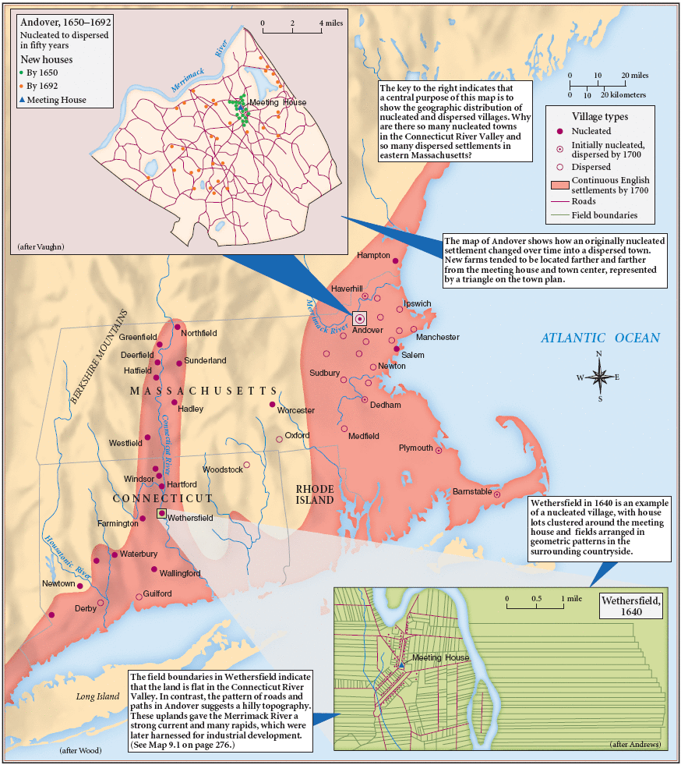

What type of source is this? (Primary or secondary and WHAT is it?) ___________________________________________________________________________________________________________________________

What kind of economy does this map suggest might develop in this area? Why?
________________________________________________________________________________________________________________________________________________________________________________________________________________________________________________________________________________________________________________________________________________________________________

Document P:

River Plantations in Virginia, c. 1640 The first migrants settled in widely dispersed plantations—and different disease environments—along the James River.

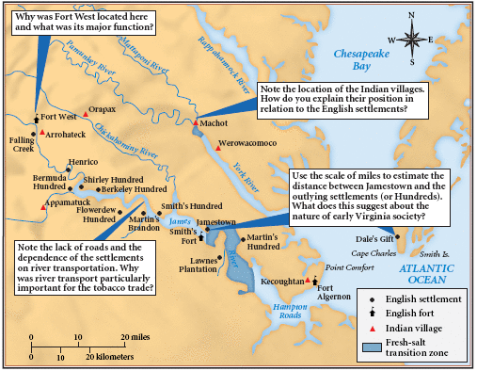

What type of source is this? (Primary or secondary and WHAT is it?) ___________________________________________________________________________________________________________________________

What kind of economy does this map suggest might develop in this area? Why?
________________________________________________________________________________________________________________________________________________________________________________________________________________________________________________________________________________________________________________________________________________________________________

Document Q:

Source: Historical Society of Southern England. Slave Ship Drawing. Date: Unkown

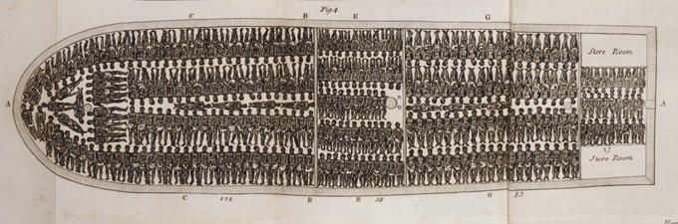

What type of source is this? (Primary or secondary and WHAT is it?) ___________________________________________________________________________________________________________________________

What does this indicate about the makeup of the people in the North American colonies? ___________________________________________________________________________________________________________________________________________________________________________________________________________________________________

The date of the source is unknown. Based on what you have read thus far. When do you think this might have been drawn? Why? __________________________________________________________________________________________________________________________________________________________________________________________________________________________________

Document R:
This Indenture, Made the Fourth Day of August in the Twenty-ninth Year of the Reign of our Sovereign Lord George the Second King of Great Britain, &, And in the Year of our Lord,
One Thousand Seven Hundred and fifty five __
Between William Buckland of Baford Carpenter & Joiner of the one Part, and Thomson Mason of London, Esq. of the other Part, Witnesseth, That the said William Buckland
for the Consideration herein after-mentioned, hath, and by these Presents doth Cove-nant, Grant, and Agree to, and with the said Thomas Mason Executors and assigns, That He the said William Buckland shall and will, as a faithful Cove-nant Servant, well and truly serve the said Thomas Mason his Executors and assigns in the Plantation of Virginia beyond the Seas, for the Space
of Four Years, next ensuing his Arrival in the said Plantation in the Employment of a Carpenter and Joiner. And the said William Buckland doth hereby Covenant and Declare him self, now to be the Age of Twenty two YearsSingle and no Covenant or contracted Servant to any other Person or Per-Sons, And the said Thomas Mason for himself his Executors Or Assigns, in Consideration thereof, doth hereby Covenant, Promise And Agree to and with the said William Buckland his Executors, and Assigns, that He the said Thomas Mason his ___________________ Executors
or Assigns, shall and will at his or their own proper Costs and Charges, with what convenient Speed they may, carry and convey, or cause to be carried and convey-ed over unto the said Plantation, the said Wm Buckland __ and from henceforth, and during the said Voyage, and also during the said Term, shall and will at the like Costs and Charges, provide for and allow the said Wm Buckland all necessary _____________ Meat, Drink, Washing, Lodging, ____________ fit
and convenient for Wm as Covenant Servants in such Cases are usually provided
for and allowed and pay and allow William Buckland Wages on Salary at the Rate of Twenty Pounds Sterling per Annum Payable Quarterly And for the true Performance of the Premisses, the said Parties, the these Presents bind themselves, their Executors and Administrators, the either to the other, in the Penal Sum of Forty Pounds Sterling, firmly by these Presents.
In witness whereof,
they have hereunto interchanged by set their Hands and Seals, the Day and Year
above-written.
Sealed and Delivered
in the Presence of…
What type of source is this? (Primary or secondary and WHAT is it?) ___________________________________________________________________________________________________________________________

What is this document? ___________________________________________________________________________________________________________________________________________________________________________________________________________________________________

How do you reconcile this document with the previous one (Doc. Q)? __________________________________________________________________________________________________________________________________________________________________________________________________________________________________

