IELCE – Section 243
For Currently DLLR Funded IELCE Programs Only.

Integrated English Language and Civics Education/Integrated Education Training
The purpose of WIOA Section 243 IELCE programs is to provide instruction that is designed to prepare adults who are English language learners (ELL) for, and to place such learners in unsubsidized employment in in-demand industries and occupations that lead to economic self-sufficiency and integrate with the local workforce development system.

Programs receiving funds under WIOA 243, must implement integrated English literacy and civics education activities to help English language learners achieve competence in English through contextualized instruction on the rights and responsibilities of citizenship, naturalization procedures, civic participation, and United States history and government to help such learners acquire the skills and knowledge to become active and informed parents, workers and community members. Required components of IELCE services are as follows:
- English Language Acquisition (speaking and comprehension) and
- Literacy (reading and writing) and
- Civics education (the rights and responsibilities of citizenship and civic participation)
The State Plan has placed priority on the IELCE being aligned with Maryland’s ESL content standards taught concurrently with instruction on the rights and responsibilities of citizenship and civic participation, understanding the American systems of government, education, healthcare and the American workplace.

In addition, programs receiving IELCE funds under section 243 of WIOA, must ensure that students in this 243 section have access to integrated education and training (IET). Access to an IET program means that students who are in section 243 funded services are also able to attend an IET program, if interested; however, students enrolled in the IELCE program are not required to participate in such service.
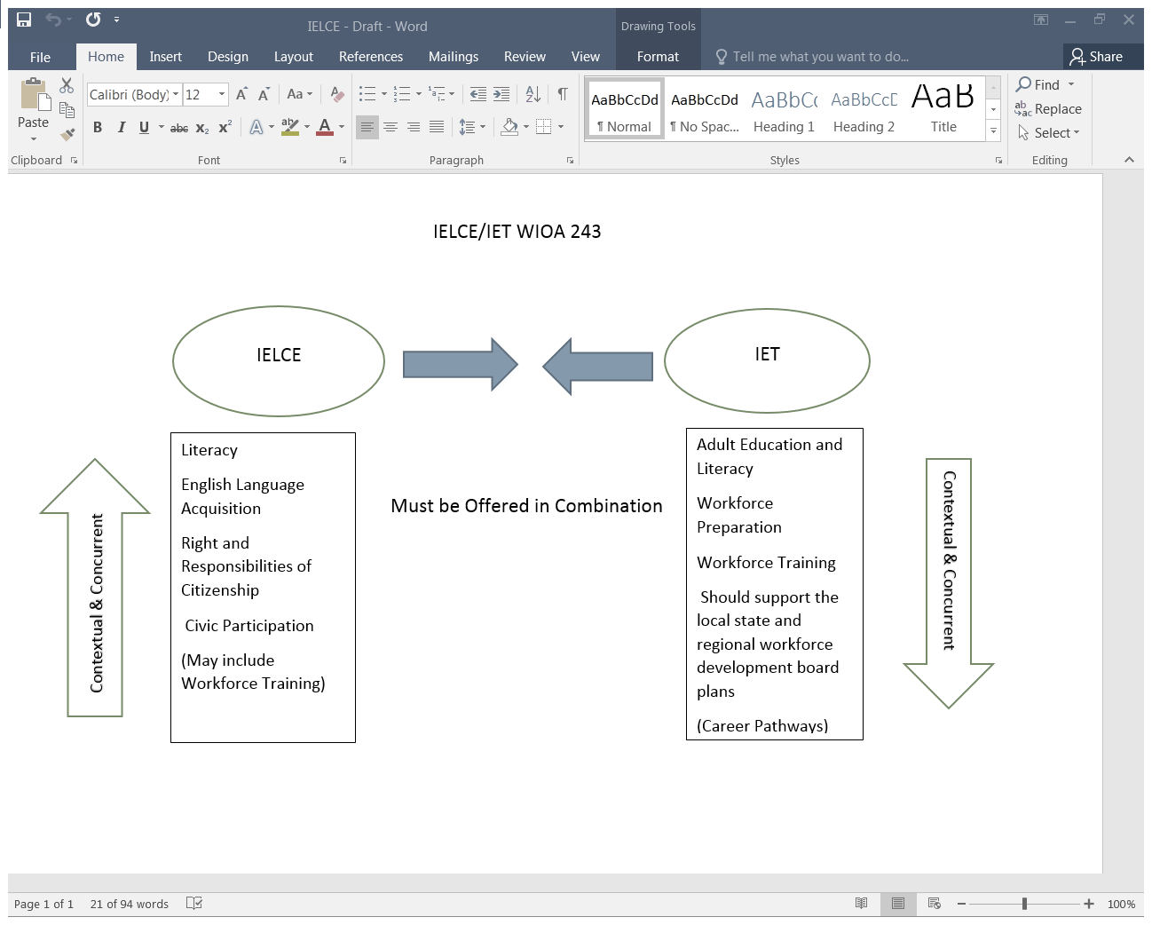
The “in combination” requirement can be met in two possible ways:
- Program provides IELCE and co-enrolls participants in an IET program offered by another provider in the local or regional workforce development(LWD) area.
- Program provider itself offers both kinds of services.
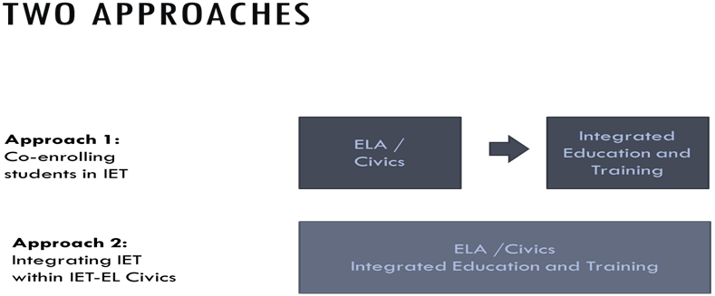

Required components of the IET program are as follows:
- Adult education and literacy activities,
- Workforce preparation activities
- Workforce training
- (Should support the local state workforce development board plans)
These components must be provided contextually and concurrently for a specific occupation or occupation cluster. The instruction must be aligned with the College and Career Readiness Standards (CCRS) and integrate workforce preparation activities.

What is Workforce training? (Must include at least one)
- Occupational skills training, including training for nontraditional employment
- On –the-job training
- Incumbent worker training
- Programs that combine workplace training with related instruction, which may include cooperative education programs
- Training programs operated by the private sector
- Skills upgrading and retraining
- Entrepreneurial training
- Transitional jobs
- Job readiness training
- Adult education and literacy activities, including activities of English language acquisition and integrated education and training programs, provided concurrently or in combination with services described in 1-7 above.
- Customized training conducted with a commitment by an employer or group of employers to employ an individual upon successful completion of the training.
Who is eligible to participate in an IELCE/IET program?
IELCE provides education services to English language learners who are adults, including professionals with degrees and credentials in their native countries, that enables such adults to achieve competency in the English language and acquire the basic and more advanced skills needed to function effectively as parents, workers and citizens in the United States. Such services must include instruction in literacy and English language acquisition and instruction on the rights and responsibilities of citizenship and civic participation. Also note: the NRS levels are not the determiners for student eligibility. Non-native English speakers who are receiving ELA instruction and civics instruction as an integrated component of the IELCE, are still eligible to participate in the IELCE/IET even though they may have tested out of all six ELL levels in NRS.

Describe how your IELCE/IET program will look starting July 1, 2018. Include data to support the local area need for this additional English Language acquisition and civic education program.
Text boxes will expand as needed.
Describe how you have integrated civics education (rights and responsibilities of citizenship, U.S. History and Government) with the English Language Acquisition (ELA), literacy and possibly workforce training components.
Describe how the organization has been able to offer the proposed integrated education and training (IET) in partnership with another organization. Explain this partnership.
Describe what specific occupation or occupational sector the proposed IET(s) covers. How will this lead to a Career Pathway?
Describe what funding is being used for the training portion of the proposed IET.
Describe the program strategy for recruiting and supporting participants ensuring learner retention.

