Earth and Space Science Name ___________________
Mr. Hurm Date ___________________
Pd. _____

Controls of Temperature
Below is the fictitious continent of Arugala located in the Southern Hemisphere. It is the first day of Fall. Answer the following questions using the map and your notes on the Controls of Temperature as guides.

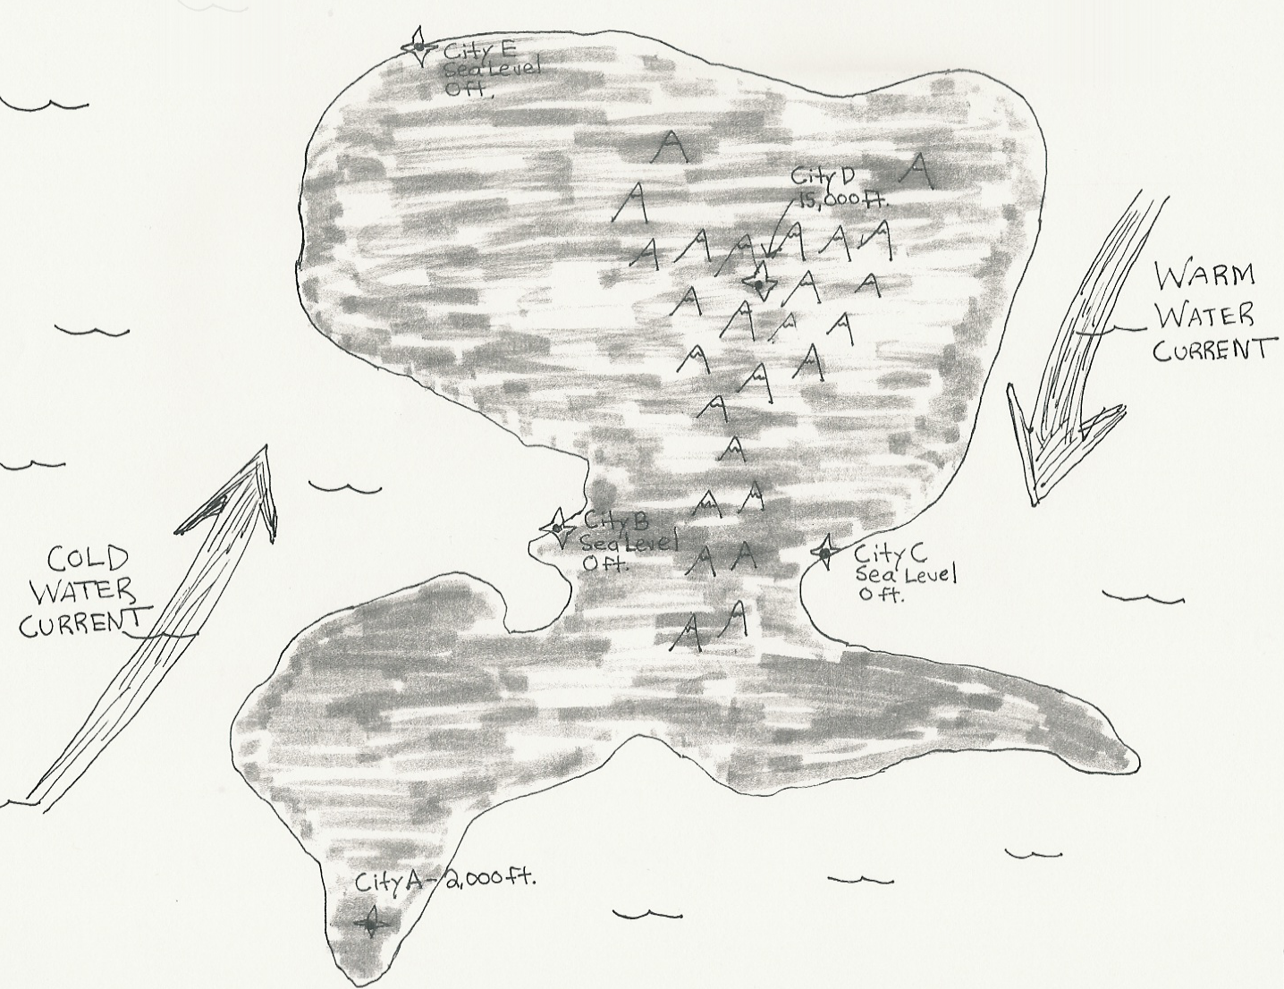
1. All the cities are experiencing sunny conditions at 4pm in the afternoon. List the cities in order from warmest to coolest.
__________ warmest
__________
__________
__________
__________ coolest

2. Explain what the temperature probably feels like in each city and why. An example is written below. Use the words hot, warm, cool, cold, and frigid to describe the temperature. Use the controls of temperature to describe why the temperature probably feels like it does.

City X __________ Why? _____________________________________________
_____________________________________________
City A __________ Why? _____________________________________________
_____________________________________________
City B __________ Why? _____________________________________________
_____________________________________________
City C __________ Why? _____________________________________________
_____________________________________________
City D __________ Why? _____________________________________________
_____________________________________________
City E __________ Why? _____________________________________________
_____________________________________________

3. If the temperature in City D is 40 °F, what is the possible temperature 15,000 feet below at the base of the mountain? (Hint: use the equation for normal lapse rate)

__________

4. If the temperature in City D is 40 °F, what could the temperature be in the following cities at the same time if the weather conditions were the same everywhere? There is more than one correct answer!

City A __________
City B __________
City C __________
City E __________

