Algebra Core – Summer School Name __________________________
Day 5 Session 2 2
Unit 2 – Linear Functions Date ______________ Period _______

Finding Slope from Graphs, Two Points, Tables, and Story Problems

Draw a slope triangle for each line (when possible) and give the slope. Remember to designate if slope is positive or negative. Formula: m = $\frac{\text{rise}}{\text{run}}$ .
Draw a slope triangle for each line (when possible) and give the slope. Remember to designate if slope is positive or negative.



1. 2. 3.

SLOPE = SLOPE = SLOPE =


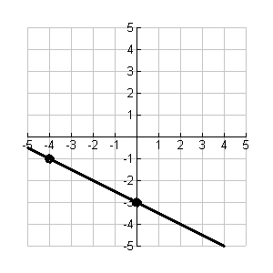


4. 5. 6.

SLOPE = SLOPE = SLOPE =

For each table below, identify (a) ∆ y , (b) ∆ x , and (c) the slope ( m = $\frac{Δy}{Δx}$ ) .

7.
x | 0 | 1 | 2 | 3 | 4 | 5 | 6
y | 3 | 5 | 7 | 9 | 11 | 13 | 15

a) ∆ y = b) ∆ x = c) m =

8.
x | 0 | 1 | 2 | 3 | 4 | 5 | 6
y | 0 | -3 | -6 | -9 | -12 | -15 | -18

a) ∆ y = b) ∆ x = c) m =

9.
x | y
2 | -5
6 | 1
8 | 4
12 | 10

a) ∆ y = b) ∆ x = c) m =

Determine the slope of the line that passes through each pair of points. Write in simplest form.
Formula: m = $\frac{y_{2}−y_{1}}{x_{2}−x_{1}}$ .

10. (3, 2) and (0, 17) 11. (2, −1) and (−6, 3)

12. (5, 7) and (1, 7) 13. (−1, 4) and (−1, 8)

For each story problem, identify the slope.

14. Aya is babysitting my kids for an entire day. I give her $12 for lunch plus $5 per hour.

15. Chris is an awesome student. He received 5 stars for good behavior on the first day of school and 3 stars every day.

16. Maria overdrew her lunch account by $300. She promised to pay back $20 every 5 days until her balance is back to zero.

17. Ryan wrestles at Portland College and notices that he has a fungus growing on his arm. After one day, the size of the fungus was 9 mm². After four days the size was 15 mm².

