Classroom Rules:
- Follow directions the first time!

- Come to class prepared (notebook, folder, pencil/pen, ear buds, etc.)!

- Be seated and ready to begin class when the bell rings.

- Ask to go to the bathroom/fountain. You may throw something away/sharpen your pencil. One at a time.

- No foul language.

- No electronics (unless permitted by teacher).

- Don’t take others’ belongings, raise your hand to speak, and wait to be called on.

- No cheating or allowing others to cheat off you.

- Return all necessary paperwork within the time-frame given.

- Look up class information from our class page: http://www.wbasd.k12.pa.us/MrsRicci.aspx. Make up notes from a classmate. Turn in/make up any missed assignments, projects, etc., within 2 weeks of proposed due date or by the end of the quarter (whichever comes first) – otherwise you receive a ZERO. Make up all work 9th period.

Computer Station Rules:
- Work at your assigned seat using your assigned laptop & tablet. Clean up your station!

- Report any damage, connectivity issues, or malfunctions to the teacher immediately.

- No food/drink.

- Log off your laptop at the end of each session (last class of day will shut down).

- Store student work on your google drive.

- Modifying applications or system software is prohibited.

- Downloading files is prohibited, unless permitted by teacher.

- The laptops/tablets are for instructional purposes only.
- If you are found on a site or application that was not assigned, you will log off for the rest of class and be required to finish all work 9th period that day.

- Always be respectful of others while using wikis, blogs, etc. Use appropriate language!

Consequences: Warning, banned from computer, writing assignment, detention, phone call home, principal visit, central detention, etc. You will receive a failing grade for cheating. Severe clause: Principal visit.

Procedures: Students will receive grades based on the assignments/projects turned in. If students need extra help, I am available during 9th period (except Fridays). Notify me if you wish you stay.

Remind App: Remind is a free, safe, and simple messaging tool that help teachers share important updates and reminders with students & parents. Subscribe using the instructions below. Personal information is kept private. Teachers will never see your phone number, nor will you see theirs. Visit remind.com to learn more.

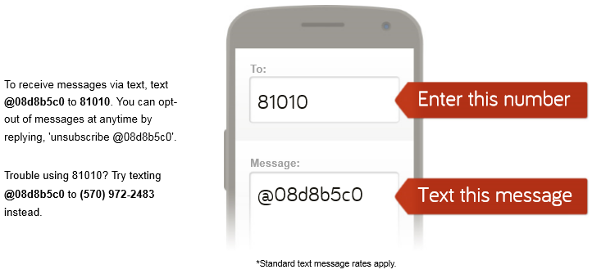

I am looking forward to a successful school year. By all of us working together, a rewarding experience is ahead for all of us. A parent’s role in a child’s education is vital for a child to do well. By you, the parent, knowing about your child’s progress, students will have more of an incentive to do better. If you have any questions or concerns, please contact me at Solomon (570) 826-7224 or via email (preferred) jricci@wbasd.k12.pa.us.

Sincerely,
Mrs. J. Ricci

Mrs J. Ricci
Math & Computer Science Teacher
Math Club Advisor

