Design and Development of an Academic Course in Convergent Communication Systems and Services

G. LIODAKIS⁽¹⁾, I.O. VARDIAMBASIS⁽²⁾, G. GLENTIS⁽³⁾, and K. VASSILAKIS⁽⁴⁾
⁽¹⁾ Department of Electronics /Laboratory of Telecommunication Systems, Networks and Applications/COMNETTA Group
⁽²⁾ Department of Electronics /Microwave Communication & Electromagnetic Applications Lab (MCEMA Lab)
⁽³⁾ Department of Electronics /Automation and Information Technologies Division
⁽⁴⁾ Science Department /Computer Science Division
Technological Educational Institute (T.E.I.) of Crete - Chania Branch,
Romanou 3, Chalepa, 73133 Chania, Crete,
GREECE

Abstract: - This paper describes a senior-level course on convergent communication systems and services designed and developed at the Technological Educational Institute of Crete/Department of Electronics (TEIoC/DoE) in Greece. The course aims to expose students to knowledge and skills required to study, design, integrate, evaluate and manage convergent communication systems and services, in accordance with advancements in the telecommunications industry. Furthermore, during the design of the course, emphasis was given towards a balanced curriculum that includes topics both from traditional communication area and computer networking as well as to research directions for the convergent communications field. The overall course includes laboratory activities, letting students to acquire hands-on experience and examine various scenarios through simulation. This paper covers design issues and goals around this course, the lectures’ and lab activities’ content, and the experience teaching the course.

Keywords: - Convergent communications, Network simulation, Telecommunications course development, Hands-on experimentation.

1 Introduction
The continent of Europe is currently undergoing a profound transformation in its internal structure and in the role it is likely to assume on the world stage of the 21st century. Although some Europeans dream of a kind of free-trade zone, other European citizens are favourably disposed towards the idea of a federal Europe. Furthermore, engineering is a truly international profession and telecommunications, in particular, is already a global business. Therefore, there exists the need to produce multicultural, multilingual telecommunication engineers who also have a solid grasp of the economics of their chosen field, who are capable of adapting to rapidly changing circumstances [1]. However, taking into account the aforementioned issues, most Europeans would agree that a “general convergence” of mutually acceptable interests is highly desirable in areas of research and education. Actually, Greece promotes and takes initiatives, actions and national measures regarding the European and international dimension of education towards the formation of the European Higher Education Area.
The term “convergence”, however, although fairly new, should be also used when discussing the nature of the fundamental paradigm shift currently sweeping the telecom industry [2]-[3]. Converged applications came into widespread use when it became possible to efficiently and predictably convert circuit-switched voice into packets that could be carried over voice and data lines. Actually, the Internet Protocol (IP) is touted as the grand unifier of voice and data networks into the so-called converged network. Indeed it is easy to foresee that a unified network infrastructure coupled with high-bandwidth access technologies will promote the appearance of telecom services and applications that will span multiple network domains (wireline and wireless, voice and data, public and private) (see Fig. 1). As a byproduct of this convergence, the telecom infrastructure that used to be, and still is to large extent, based on proprietary software and protocols is gradually evolving toward an open infrastructure based on open interfaces.

Convergent Comm. Systems & Services

Circuit- and Packet-switched Networks

Public and Private Networks

Wireless and Wireline
Comm. Systems

Voice and Data Transmission

Figure 1. Convergence aspects.
The aforementioned evolution has a dramatic impact on the educational material of electronics engineering programs, in addition to offering the traditional basics of communication theory. As it concerns the TEIoC/DoE in particular, the curriculum consists of a number of courses organised according to the European Credit Transfer System-ECTS (most of them taught in combination with laboratory exercises) which leads to a specialization in the areas of automation and telecommunications (during the 6th and 7th semesters).
The aim of this paper is to present the design and development issues of an elective course for senior-level students of the TEIoC/DoE in the area of convergent communication networks and services. Specifically, in Section 2, the approach followed for the design of this mixed course (comprised of both lectures and laboratory experimentation) taking into account analogous experiences at an international framework, is examined. In Sections 3 and 4, the contents and the organization of the lectures and the description of lab activities are presented, respectively. Finally, in Section 5, further directions about lab activities’ enhancements and a conclusion about our teaching experience, are given.

2 Background
During the design and development of the course, emphasis was given towards a balanced curriculum that includes topics from traditional communications area and computer networking as well as to research directions for the convergent communications field. In particular, communication engineering is one discipline where the material presented often lends itself to appropriate demonstration and experimentation. While students have a feeling for many of the topics discussed, seeing and hearing the signals discussed in lectures reinforces the material in a manner that pure mathematics and description does not. Actually, in most cases, theory is too dry and academical abstracts are just not enough to provide a thorough understanding of a certain matter. Thus, real life situations are ideal to supplement the theory, teaching the student how to interpret and correlate experimental results with a particular hypothesis.
As it concerns computer networking, the ACM model curriculum in computer science has always had a theoretical and mathematical orientation. However, some have felt there was a need for a curriculum with greater focus on the application of information technologies as well as for not relying exclusively on simulation for experimentation purposes. Actually, simulations make complex networking systems easily modeled on desktop computers [4]. Simulations create a discovery-based learning environment, where students interact with the networking system under study and receive immediate response.
Other approaches concerning the experimentation part of our course, include remote lecture demonstrations, animation of computer networking concepts and a networking laboratory for hands-on experimentation. Remote demonstration experiments are carried out by use of National Instrument LabView programming package. LabView is optimized for graphical display, data acquisition and instrument control, while a remote panel feature was recently introduced. In such a way, real experiments (not simulations) can be carried out. As reported in [5], various instruments (oscilloscope, spectrum analyzer, power meter) and a breakout box to connect other signals are properly interfaced to a computer, in order a transceiver structure to be studied. In [6], animation via Java applets were designed for illustrating six network concepts: packet encapsulation, packet fragmentation, error control, media access in Ethernet local area networks, domain name resolution and hypertext transfer protocol. The applets serve two roles: one as a visual representation of different scenarios for the aforementioned concepts, the second as a vehicle for experimentation. The applets are designed to encourage user interaction, as the student can make changes in parameter settings and then restart the applet to see the effect of the changes. Finally, in [7], the experiences in setting up a large computer networking laboratory (set up with a US$ 170,000 budget) to realistically model the hybrid Public Switched Telephone Network (PSTN) and IP network architecture, are described. Although, portions of the whole laboratory infrastructure can be deployed, such an approach is suitable in situations where adequate funds are available.
Taking into account that in our Department hardware systems integration is strongly emphasized throughout our curriculum and the nature of convergent communication systems and services, we addressed the issue of cross-layer networking during the design and development of the course. In essence, by such a cross-layer approach, the physical and MAC layer knowledge of the communications medium is shared with higher layers, in order to provide efficient methods of allocating network resources and support applications which require widely varying and very diverse quality of service (QoS) guarantees for the different types of offered traffic [8].
As a consequence of the issues presented so far, the task of establishing a course on convergent communication systems and services (both the lectures’ content and the laboratory experimentation) was under the following “constraints”:
- bridging the voice and data communications worlds,
- incorporation of research issues to the educational material,
- to meet academic criteria avoiding a training-centered approach,
- follow a cross-layer treatment of the course items,
- to cope with the limited financial resources available,
- best exploitation of existing infrastructure and tools for laboratory experimentation,
- balance between hands-on and simulation for laboratory experimentation,
- to take into account the international experience in analogous curriculum developments.

3 Lecture content
After a preparatory meeting between the instructor of the course and the students for the presentation of the objective and the scope of the overall course, a series of two-hour lectures for the fourteen weeks of the academic semester, is carried out. The lecture outline is given below, followed by the major topics taught:
(a) Introduction:
Introduction and evolution of convergent communi-cation systems. Convergent communication services in the context of the information society. Circuit-switched telephony systems and types of analog and digital trunks.
(b) Signaling in Telephony:
Signaling functions (on-hook/off-hook detection, number identification, call progress tones, answer and disconnected supervision, etc.). Overview of signaling standards (Channel Associated Signaling - CAS, Common Channel Signaling - CCS, Signaling System 7 - SS7, proprietary signaling systems).
(c) Definition and Measuring Voice Quality in Circuit- and Packet-switched networks:
Variables that affect voice quality (background noise, signal level, codec distortion, echo, etc.). Subjective speech quality measurement and QoS criteria for packet telephony (reliability, delay, delay variation, bandwidth).
(d) Wireless Local Area Networks (WLANs) and Physical Layer:
Advantages of wireless area networking and overview of WLANs standards (IEEE 802.11x, HIPERLAN). Physical layer of IEEE 802.11x technology (radio and infrared transmission issues, ad-hoc and infrastructure architectures).
(e) Medium Access Control (MAC) issues for wireless area networking:
Categorization of wireless MAC algorithms (distributed versus centralized MAC protocols, random access algorithms, etc.). Performance measures of MAC protocols (delay, throughput, fairness, stability, robustness against channel fading, power consumption, support for multimedia).
(f) Voice over IEEE 802.11x WLANs:
MAC layer of IEEE 802.11x WLANs (CSMA/CA protocol, Distributed Coordination Function – DCF and Point Coordination Function – PCF). Performance analysis and evaluation of voice over IEEE 802.11x WLANs.
(g) Cross-layer design performance issues for WLANs:
Interrelationship between layers (hidden nodes, exposed nodes, scanning, authentication, security, etc.). Protocol analyzers for IEEE 802.11x WLANs.
(h) Wireless Metropolitan Area Networks (WMANs):
Overview of IEEE 802.16 protocol for wireless MAN networking. Orthogonal Frequency Division Multiplexing (OFDM).
(i) Wide Area Networking (WAN) protocols for convergent transmission:
Overview of Frame Relay (FR) and Asynchronous Transfer Mode (ATM) technologies. Design issues for voice Transmission (VoFR, VoATM).
(j) Voice Transmission over TCP/IP Networks:
Algorithms for voice and data integration (queuing and traffic policies, resource allocation of network resources, etc.). Voice over IP (VoIP) Protocols (Real Time Protocol – RTP, Real Time Control Protocol - (RTCP).
(k) VoIP Signaling through the H.323 Series of protocols:
Overview of the H.323 series of protocols. H.323 system components (terminals, Multipoint Control Unit – MCU, Gateway, Gatekeeper). Addressing and design issues for voice transmission.
(l) VoIP Signaling through the Session Initiation Protocol (SIP):
Overview of SIP and Session Description Protocols (SDP). SIP network system components (user agents, proxy servers, registrar servers, redirect servers). Design issues for voice transmission in SIP networks.
(m) Digital Subscriber Line (DSL) Technologies:
Communication engineering issues for xDSL technologies (modulation, error correction, interleaving, echo cancellation).
(n) Voice transmission and xDSL Technologies:
Design issues for voice over DSL (VoDSL). System components of xDSL technology.
As indicated by the content of the lectures, the students should have a solid background in a variety of topics. Therefore, prerequisites for this course include the following courses of TEIoC/DoE curriculum: Digital Communications, Data Networks, Electromagnetics and Digital Signal Processing. It should be mentioned that, although the course content is advanced for undergraduate students, they are facilitated to the understanding of the theoretical issues as they are acquainted with the operation of real systems. In particular, due to the nature of the lab experimentation (see Section 4), the fact that many students have already implemented a WLAN at their home, the recent introduction of ADSL services in Greece for the retail market, and that many students were carrying out their practice work at various enterprises, the students were able to cope with the requirements of the overall course. The course was offered to students for the first time during the winter semester of the 2004-2005 academic year, while grading policy was as follows: final (50%), theoretical project presentation (20%) and laboratory experimentation described in Section 4 (30%).

4 Description of Lab Experimentation
Laboratory experimentation can be divided in the following three categories: IEEE 802.11x WLAN technology, Voice transmission in circuit- and packet-switched networks, Convergent Services (Fig. 2). The depiction shown in Fig. 2 specifies, also, each individual laboratory activity on a layered architecture.

 | IEEE 802.11x WLAN Technology | Voice Transmission in Circuit- and Packet-Switched Networks | Convergent  Services
Application Layer | IEEE 802.11b Services | Implementation of SIP Signaling | H.323 – based Tele-education
Transport Layer |  | IP/UDP/RTP VoIP Traffic Study
Network Layer
Data Link Layer | IEEE 802.11x MAC Issues |  | DAB System Simulation and Transmission
Physical Layer | IEEE 802.11b RF Issues | PBX Configuration & Signaling | Voice and Data on a Free Space Optics Link
Figure 2. Layer categorization of laboratory experimentation.

4.1 IEEE 802.11x WLAN Technology
Laboratory experimentation for the WLAN technology is based on hands-on activities exploiting the IEEE 802.11 WLAN network (3Com technology) of our laboratory environment as well as on simulation using COMNET software.
A representative set of the issues and tasks during the laboratory experimentation of the students includes:
(a) Configuration of the WLAN in ad-hoc and infrastructure mode.
(b) Relationship between cell radius and supported physical layer rate, by intended obstruction of signal power.
(c) MAC issues by calculation of performance measures (network utilization, user’s throughput, number of collisions, etc.) through simulation. Various scenarios concerning the traffic source types concerning are examined and, in case of VoWLAN transmission, the students consider the question “how many VoIP users will saturate the IEEE 802.11b wireless communication channel?”.
(d) Use of a free software protocol analyzer (www.ethereal.com) to analyze the behavior of our WLAN. Results obtained are compared with the case of real-time voice transmission.
(e) Experimentation on transferring large files in order to analyze the FTP application layer protocol.
(f) Effects of activating and deactivating the security features of our WLAN
(g) Study for the development of a WLAN from scratch, by the use of a simple software tool developed at TEIoC/DoE which takes into account all the associated radio propagation issues.

4.2 Voice Transmission in Circuit- and Packet- switched Networks
The Private Branch Exchange (PBX) of TEIoC/Branch of Chania is used for hands-on experimentation and understanding of circuited-switched telephony (ISDN technology). In particular, the students are familiarized with the configuration, interfaces, signaling issues and activation/deactivation of services of the PBX under consideration.
A software tool is used to introduce students to IP packetized voice transmission. By carrying out traffic studies in a WAN architecture they make bandwidth requirements calculations and quantify the overhead penalty by the use of the RTP protocol. Examination of various scenarios (concerning codec selection, compression of headers, value of the voice activity factor) helps students to be familiar with the emerging convergent communications environment.
Finally, hands-on experimentation on the SIP application layer signaling protocol, is carried out by installing the appropriate software on some of the host computers of our laboratory environment. In particular, free software (www.sipcenter.com) publicly available (registration is needed on a regular basis, however) for research and development purposes was used to emulate a real SIP communication system. The aforementioned software let us implement multiple SIP User Agents, SIP proxies and a register server. The communication scenarios during students’ experimentation include the exchange of SIP messages through one or two SIP proxies. By capturing the content of these messages (through the Ethereal protocol analyzer), the student has a detailed view of procedures taking place and the SIP messages exchanged during the establishment and release of a connection between two users (see Fig. 3 and Fig. 4, respectively).

4.3 Convergent Services
The system used for synchronous distant learning at TEIoC/Branch of Chania is used for hands-on experimentation on the H.323 series of standards. The whole system is based on the VCON’s desktop video platform and includes a system PCI board, a camera, audio handsets and the Meeting Point videoconferencing system. The platform meets all the technical recommendations prescribed in H.323 and H.320 ITU-T standards for networking. Furthermore, as it supports advanced IP technologies (interactive IP multicast and streaming video, QoS guarantees), the students are familiarized with topics examined during the course lectures.
Another paradigm for convergent services provision includes the Eureka Digital Audio Broadcasting (DAB) system. The laboratory experimentation on DAB system’s issues is provided both in software and hardware. In particular, Mathwork’s Simulink software is used to implement the various blocks of the DAB system [9]. When the simulation is done, students have to compare the simulated data with experimental data acquired by the use of the MCEMA Lab’s DAB exciter and experimental receiver (interconnected through a PC with properly developed software).
Finally, by the use of a wireless optical transceiver system developed by the COMNETTA Group, the students can demonstrate voice and data transmission over a Free Space Optics (FSO) link.

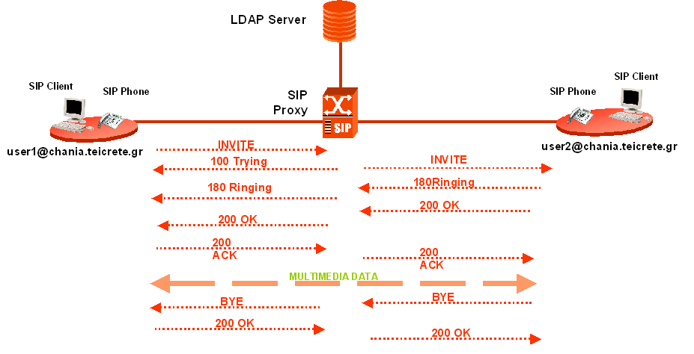
Figure 3. Experimental setup with SIP signaling

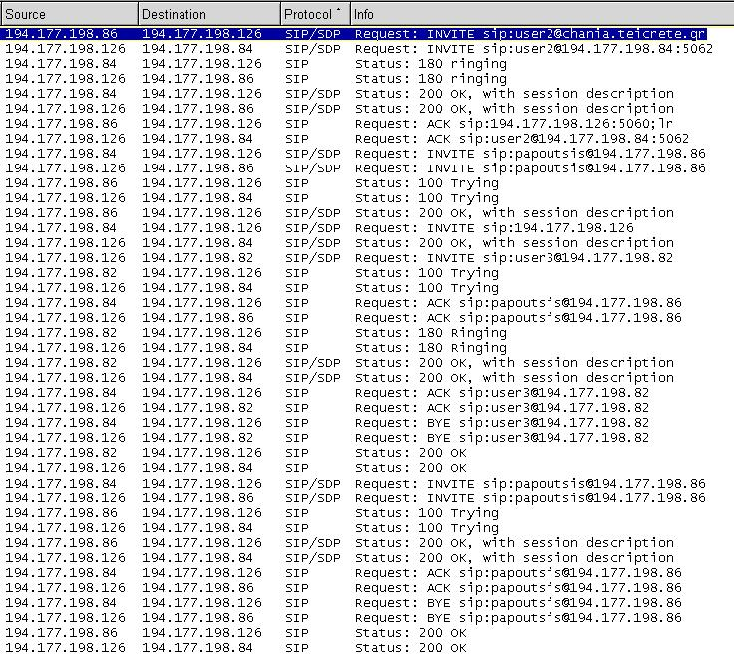
Figure 4. Sequence of SIP messages for a complete call

5 Future Directions and Conclusions
This paper has presented a senior level course on convergent communication systems and services. We have described the course content and philosophy as well as the laboratory environment and experimentation activities. Our effort to provide a course with an academic focus and an emphasis on hands-on experimentation will be completed in the near feature by the following:
(a) To enhance the laboratory part of the course, in case students want to pursue Cisco and network+ certifications.
(b) Further exploitation of the networking infrastructure of the TEIoC/Chania Branch for hands-on experimentation.
(c) To convert PCs of our laboratory environment to IP routers with the free router software Zebra [10]. Therefore, students will be able to understand and practice current and emerging protocols discussed in lectures.
(d) Exploitation of the asynchronous e-learning platform at TEIoCDoE, in order to carry out various activities of the educational process (submission of student’s projects and lab reports, availability of additional educational material, efficient and flexible instructor-student communication, etc.).
Our first experience is that students enjoy and appreciate the opportunity to work with the equipment, which motivates them to learn more about the integration issues of voice and data traffic. We did not proceed to a detailed study of students’ views and evaluation about the overall course , as the number of students who attended its first introduction to our curriculum was relatively small in a statistical sense. Finally, from a third level institution administrative point of view, the course can be regarded as a paradigm for design and development of course with limited financial resources.

Acknowledgment
This work was supported by the Greek Ministry of National Education and Religious Affairs and the European Union under the 3rd Community Support Framework Program (operational program for education and initial vocational training - EPEAEK II) projects: “Reformation of the Electronics Dept’s syllabus” and “Archimedes – Support of Research Groups in TEI of Crete – Smart antenna study & design using techniques of computational electromagnetics and pilot development & operation of a digital audio broadcasting station of Chania (SMART-DAB)”.

References
[1] I. Simpson, “Engineering education in Europe”, IEEE Transactions on Education, vol. 37, no.2, pp. 167-170, May 1994.
[2] Y. de Serres, L. Hegarty, “Value-added services in the converged network”, IEEE Communications Magazine, pp. 146-154, 2001.
[3] R.P Mahowald and D. Jin, “Converged applications and enhanced services market study”, IDC Information and Data Corporation, 2004.
[4] B.H. Cameron and K. Wijekumar, “The effectiveness of simulation in a hybrid and on-Line networking course”, Proceedings of SIGCSE 2003 Conference, Nevada, pp. 117-119, ACM Press.
[5] L. Nargurney, “Remote lecture demonstrations and experiments for communication engineering”, Proceedings of the 34th ASEE/IEEE Frontiers in Education Conference.
[6] M.A Holliday, “Animation of computer networking concepts”, ACM Journal of Educational Resources in Computing, vol. 3, no. 2, 2003.
[7] S.H. Bokhari, M. Ahmed, S. Sohail, R.H. Khan, J.A. Mizra, and M. Ali, “A networking laboratory for the developing world”, IEEE Communications Magazine, pp. 74-80, 2003.
[8] S. Shakkttai, T.S. Rappaport, and P.C Karlsson, “Cross-layer design for wireless networks”, IEEE Communications Magazine, pp. 74-80, 2003.
[9] I.O. Vardiambasis, G. Liodakis, E. Zaoutis, J.P. Makris, I. Kaliakatsos, G. Glentis, and V. Zacharopoulos, “Digital audio broadcasting: A microwave communications’ exercise at the Technological Educational Institute of Crete”, WSEAS Transactions on Advances in Engineering Education, vol. 1, iss. 1, pp. 90-93, Nov. 2004.
[10] S. Yoo and S. Hovis, “Remote access internetworking laboratory”, Proceedings of the SIGCSE 2004 Technical Symposium on Computer Science Education, pp. 311-314, ACM Press.

